**Lab Assignment 1**

***Aim of the practical:***

Create table Customer

|  |  |
| --- | --- |
| Column_name | Characteristics |
| SID | Primary key |
| Last_name |  |
| First_name |  |

Create table Orders

|  |  |
| --- | --- |
| Column_name | Characteristics |
| Order_ID | Primary key |
| Order_date |  |
| Customer_SID | Foreign key |
| Amount | Check>20000 |

# Create table Customer

Create table Customer (

SID int primary key ,

Last_name varchar(55),

First_name varchar(50)

);

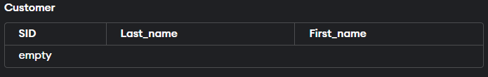

# Create table Orders

Create table Orders (

Order_ID int primary key,

Order_date date,

Customer_SID int,

Amount decimal (10,2),

Check (Amount>20000),

Foreign key (customer_SID) references Customer (SID)

);

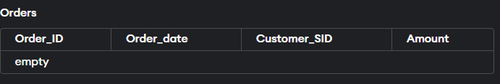

**Lab Assignment 2**

Insert five records for each table

# Insert record in customer table

Insert into Customer values (1, “stokes”, “Ben”);

Insert into Customer values (2, “Joshi”, “Bibek”);

Insert into Customer values (3, “Bhatta”, “Laxi”);

Insert into Customer values (4, “Bhatt”, “Kesi”);

Insert into Customer values (5, “Bohara”, “Mohit”);

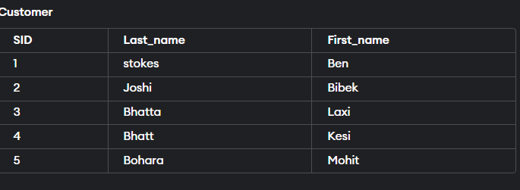

# Insert record in orders table

Insert into Orders values (101, 2024-10-21, 1, 22000);

Insert into Orders values (102, 2024-10-22, 2, 25000);

Insert into Orders values (103, 2024-10-23, 3, 21000);

Insert into Orders values (104, 2024-10-24, 4, 28000);

Insert into Orders values (105,2024-10-25, 5, 30000);

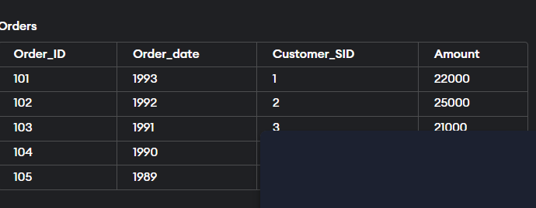

**Lab Assignment 3**

***Aim of the practical:***

List the details of the customer along with the amount

***Task to be done:***

Select Customer.SID,

Customer.Last_Name,

Customer.First_Name,

Orders.Amount

From Customer

Join Orders on Customer.SID= Orders.Customer_SID;

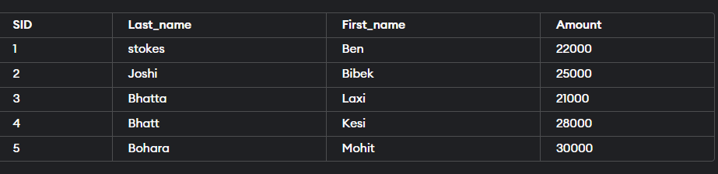

**Lab Assignment 4**

List the customers whose name ends with ‘s’ ***Task to be done:***

Select * from Customer

Where Last_Name like ‘%s’;

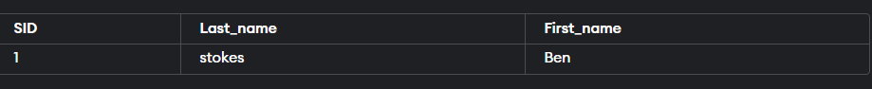

**Lab Assignment 5**

List the orders where amount is between 2100 and 30000;

Select * from Orders

Where Amount between 21000 and 30000;

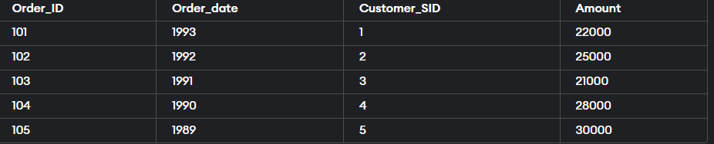

**Lab Assignment 6**

List the orders where amount is increased by 500 and replace with name ‘new amount’

Select Order_ID, Amount + 500 AS “new amount”

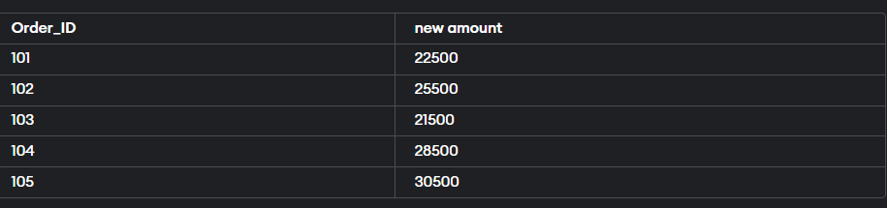From orders;

**Lab Assignment 7**

Display the order_id and total amount of orders

Select Order_ID, sum(Amount) as Total_Amount

From Orders

Group By Order_ID;

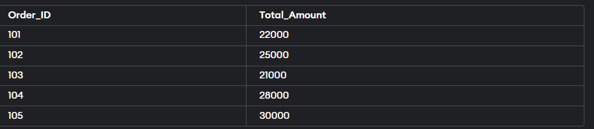

**Lab Assignment 8**

Calculate the total amount of orders that has more than 15000

Select sum(Amount) as Total_Amount

From Orders

Where Amount > 15000;



**Lab Assignment 9**

Q.Update table Orders

Update Orders

Set order_date=2024;

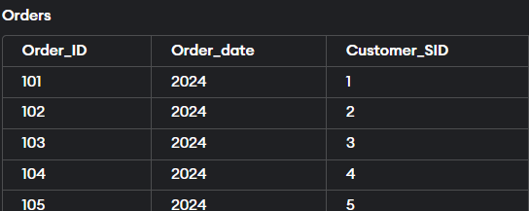

**Lab Assignment 10**

Perform all join operations

Select customer.sid,

Customer.first_name,

Orders.amount

From Customer

Left join Orders on customer.sid=orders.customer_sid;

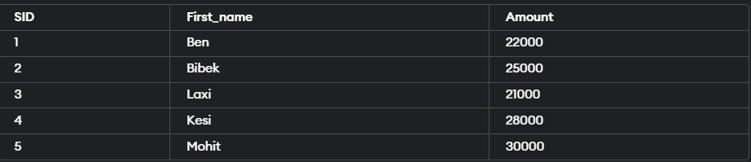

**Lab Assignment 11**

Select customer.sid,

Customer.first_name

Orders.amount

From Customer

Right join Orders on customer.sid=orders.customer_sid;

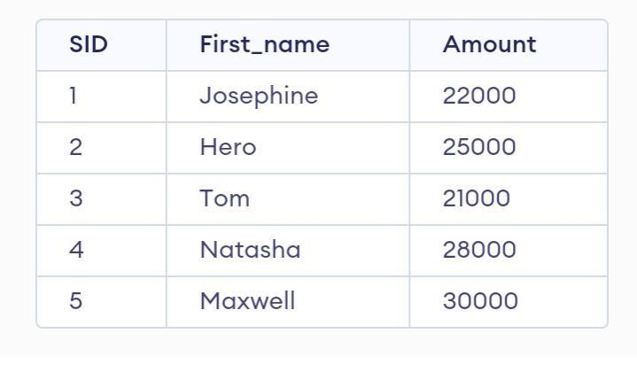

**Lab Assignment 12**

Select customer.sid,

Customer.first_name,

Orders.amount

From Customer

Inner join Orders on customer.sid=orders.customer_sid;

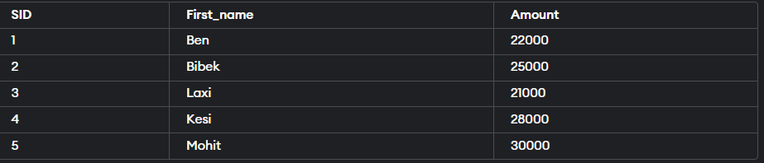

**Lab Assignment 13**

Select customer.sid,

Customer.first_name,

Orders.amount

From Customer

Outer join Orders on customer.sid=orders.customer_sid;

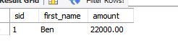

**Extra lab Assignment**

**Q.Create Database of Gym Management System is sql.**

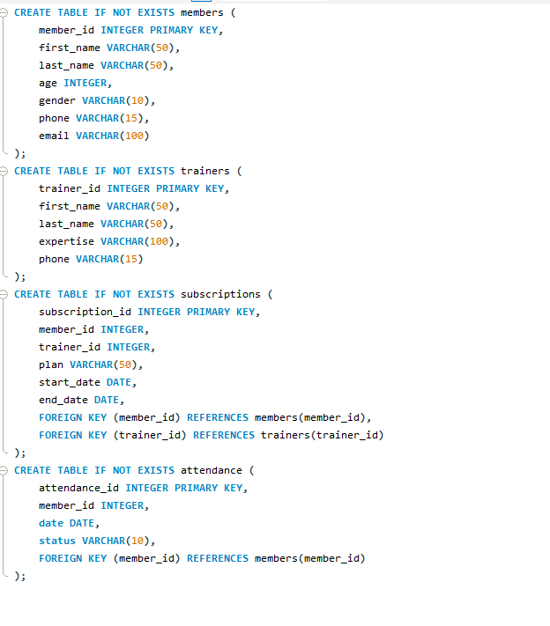

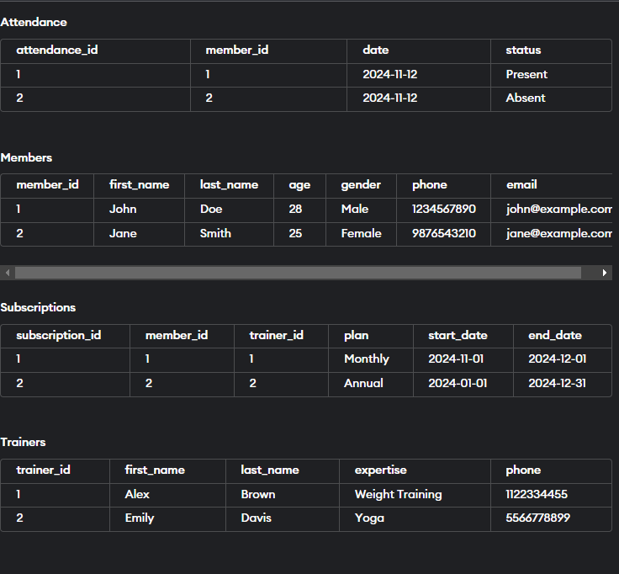

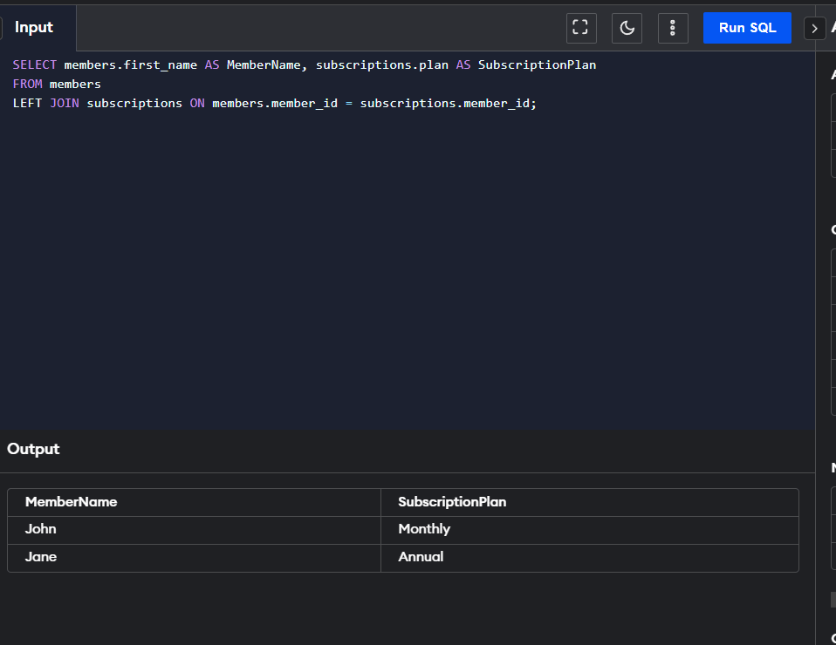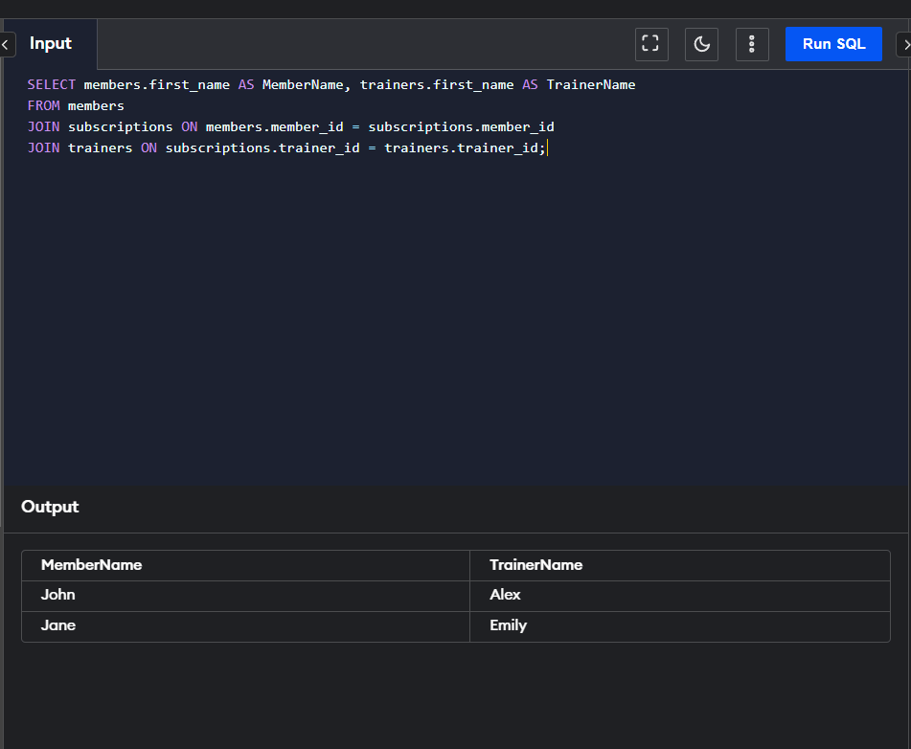 **Using all JOIN operation of sql**

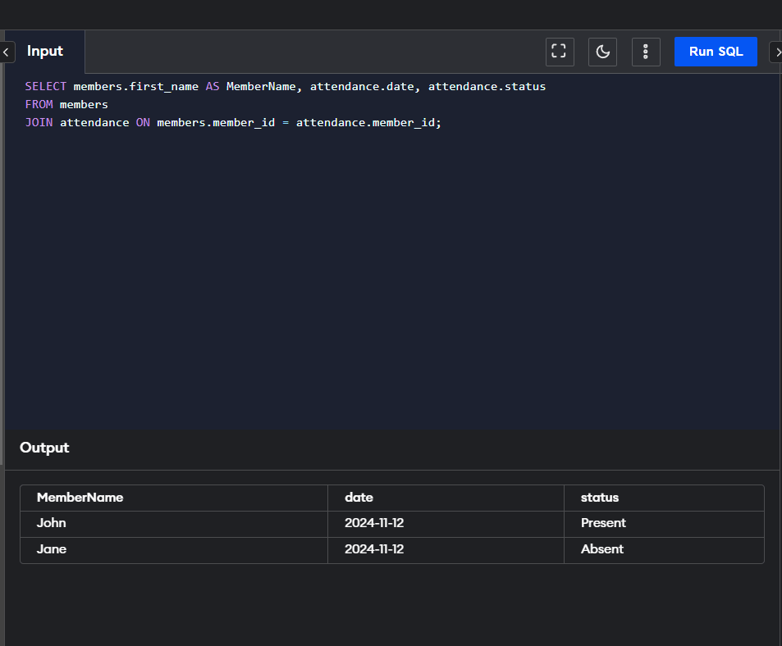

***INDEX***

|  |  |  |  |  |
| --- | --- | --- | --- | --- |
| **S.No*.*** | **Date** | **Aim of experiment** | **Sign** | **Grade** |
| **1** |  | Create table Customer    Create table Orders |  |  |
| **2** |  | Insert five records for each table |  |  |
| **3** |  | List the details of the customer along with the amount |  |  |
| **4** |  | List the customers whose name ends with ‘s’ |  |  |
| **5** |  | List the orders where amount  is between 2100 and 30000 |  |  |
| **6** |  | List the orders where amount is increased by 500 and  replace with name ‘new  amount ‘ |  |  |
| **7** |  | Display the order_id and total amount of orders |  |  |
| **8** |  | Calculate the total amount of orders that has more than  15000 |  |  |
| **9** |  | Update table Orders |  |  |
| **10** |  | Perform all join operations |  |  |