A
NATURAL LANGUAGE PROCESSING AND TEXT ANALYSIS
PROJECT REPORT
On
AI Based Sentiment Analysis and Business Insights Engine

Submitted by:
Tushar Gupta (230542)

Under mentorship of
Dr. Atul Mishra
(Associate Dean)


Department of Computer Science Engineering
School of Engineering and Technology
BML MUNJAL UNIVERSITY, GURUGRAM (INDIA)
April 2026

Table of Contents

Contents | Page Number
- Introduction | 1
- Literature Review | 2
- Methodology | 3
3.1. System Architecture | 4
3.2. Data Preprocessing | 5
3.3. Sentiment Analysis Models | 6
3.4. Aspect-Based Sentiment Analysis | 7
3.5. Business Intelligent Layer | 9
3.6. Mathematical Formulation | 10
3.7. Summary of Methodology | 11
- Performance and Results | 12
4.1 Performance Metrices | 12
4.2 ROC and AUC Analysis | 14
4.3 Comparing with Existing methods | 15
4.4 Evaluation of Proposed System | 15
- Conclusion | 16

List of Images

Images | Page Numbers
- Flowchart | 4
- Logistic Regression Model | 6
- BERT Model | 7
- Rule Based ABSA | 8
- Example of Rule Based ABSA | 8
- LLM based ABSA | 9
- Business Insight dashboard | 10
- Logistic Regression matrix | 12
- BERT Matrix | 13
- Rule Based ABSA Matrix | 13
- ROC Curve | 14

- Introduction

In the digital business world corporates are getting many pieces of review regarding their service and products from digital media like shopping platforms, social media, and reviews. These usable feedback provide many important information and key findings on consumer need, product quality, product efficiency and the level of his service offered and how well it perfromed. Analyzing hundred pieces of feedback can be a difficult task for manual analysis. There need for a smarter solution to analyze feedback.

The main goal of this study is to create the smart NLP dashboard that analyze the high number of user reviews with better understanding. The system is made to find the important aspect in the reviews and detect the sentiment of those aspects and make strategic idea or we can decision for businesses based on them. Moreover, the suggested system would compare classic ML models and DL models like BERT to test their performance and accuracy like how are they performing.

The research is very good because it makes a connection between textual data and decisions for businesses. The process of sentiment analysis and aspect identification becomes automated, which helps company to discover the weaknesses and strong sides of the organization from a user perspective and develop product .

Though numbers of issues remain in this area. Some of them are noise handling in texts, context comprehension, sarcasm recognition, and mapping sentiments to individual features. Existing models tend not to get complex semantic relations while deep learning-based system require so much time and power.

To tackle such issues this project recommends utilizing a hybrid approach of the Natural Language Processing method of framework which will combine different task. This model starts with an low preprocessing that prepares the input textual data for analysis. It is further complemented with classical machine learning algorithms to produce quick and robust results concerning basic classification of sentiments expressed in textual material. Next come transformer-based deep learning models that analyze texts and identify their context and semantics. As part of the proposed model there is a need to use the aspect allowing identify important aspects that are present in reviews. Besides large language models are used for gaining an in-depth understanding of the information obtained from the textual data.

The report follows the structured format to give information in right manner. In Section 2, there is a detailed discussion on the background research and the related method that are use in reseach and datasets used for sentiment analysis and aspect-based analysis. The section 3 tells about the methodlogy used for system with its design and explains the functions of the system through each step. the Section 4 tell us the results and the performance of the system on the basis of different metrics and comparative analysis. Conclusions and future scope of research are discussed in section 5 of the report.

- Literature Review
This section aims to analyze different methods currently utilized in sentiment and aspect-based sentiment analysis in order to understand their strengths and weaknesses as well as their applicability to real-world problems. Indeed, in the last few years, significant advancements have been achieved in the area of natural language processing (NLP). The shift has been towards more sophisticated methods based on deep learning.
As for traditional methods used in sentiment classification, these include logistic regression, naive bayes, and support vector machines (SVM) which are very useful ML models. All of them depend on feature extraction methods. This means that all methods transform text documents into numeric vectors according to the significance of words used in them and this process is also called embeddings. A paper written by Pang et al. (2002) entitled 'Thumbs Up? Sentiment Classification using Machine Learning Techniques' proved the effectiveness of machine learning models in sentiment classification tasks. Although they are relatively simple and fast to compute, these methods cannot account for context relations between words.
On the contrary, to counteract those limitations of traditional models, new models that employ deep learning algorithms emerged, including Recurrent Neural Network (RNN) models and Long Short-Term Memory (LSTM) models. They are capable of learning the dependencies in sequences of texts and analyze sentence structures and their meanings. The initial research by Hochreiter & Schmidhuber in 1997 published online at https://www.bioinf.jku.at/publications/older/2604.pdf attempted to solve the problem of vanishing gradient. Nonetheless, although there were advancements in technology and emergence of such new models, RNN models also have some drawbacks, among which are complex architecture and slow training process.
Another major milestone in NLP came from using transformer-based architectures like BERT and distilBERT suggested by Jacob Devlin. According to Jacob Devlin in his paper found at https://arxiv.org/abs/1810.04805, the BERT model applies self-attention methods to identify the context of words through analysis of their interactions in the whole sentence. Consequently, it allows to significantly improve results in the task of sentiment analysis in terms of more complex sentence structures. Transformer-based architectures have thus become a gold standard of NLP structure due to capturing more complex relationships between texts.
Within the field of aspect-based sentiment analysis, different approaches and ideas have been considered for aspect extraction, including rule-based approach. In rule-based systems, linguistic properties such as POS tagging and dependency parsing are used to detect aspects and their sentiments. One of the early attempts within the area is presented in a work by Hu & Liu (2004) - https://www.cs.uic.edu/~liub/publications/kdd04-revSummary.pdf – that described a range of techniques for analyzing product features and sentiments in customer reviews. Although rule-based systems are easy to interpret, they have limitations regarding pre-defined vocabularies and adaptability to novel domains.
More recently, progress has seen Large Language Models (LLM) developed by Meta AI, that are capable of performing several NLP tasks simultaneously using very minimal task-specific fine-tuning. For example, Llama3 model is capable of extracting structured aspect-sentiment relations and producing human-like explanations with more precise and with best accuracy. It is enabled by massive pre-training of these models, allowing them to learn complex patterns, context dependency, and subtleties of human language amd perform well. These models, however, require substantial computing power.

Data plays an essential part in creating and testing sentiment analysis systems, without data it is nothing. The popular data sets that are used by many researchers and students include Amazon reviews data set, IMDB Movie Review data set (https://ai.stanford.edu/~amaas/data/sentiment/) and Yelp Reviews Data set (https://www.yelp.com/dataset). In this project, we will be using the Amazon Electronics data set, which consists of more than 49,000 reviews and has so many different varieties of reviews.
To better understand the differences between various approaches, a comparative analysis is presented in Table.
Table: Comparison of Sentiment Analysis Approaches

Approach | Technique Used | Advantages | Limitations
Traditional ML | Logistic Regression, SVM, Naive Bayes with TF-IDF | Fast, simple, low computational cost | Cannot capture context or semantics
Deep Learning | RNN, LSTM | Captures sequential dependencies | Slow training, limited long-range context
Transformer Models | BERT, DistilBERT | Strong contextual understanding, high accuracy | Computationally expensive
Rule-Based ABSA | POS tagging, lexicons | Interpretable, easy to implement | Limited vocabulary, less scalable
LLM-Based ABSA | Llama3, GPT-like models | Context-aware, handles complex language, generates insights | High computational cost, latency

The purpose of this literature review is to examine the progression of sentiment analysis methods from basic statistical methods to huge and ready transformer models and LLM models. The developed sentiment analysis tool totally relies or we can say depends on these advancements by incorporating multiple tools together in a single framework for achieving high precision and intelligent predictions.
- Methodology
This section tell us the system pipeline that used in the project. The system is designed as a multi-stage architecture that processes raw user reviews and makes them into structured insights and business insight by using NLP terminologies . The every stage of the pipeline performs the specific task to ensure that the system is both efficient and accurate in handling large-scale textual data because it is done on very sophisticated patterns of system.

3.1 System Architecture
The overall system follows a five-stage pipeline that contains the Input, Preprocessing, Sentiment Analysis and Aspect-Based Sentiment Analysis and Business Insights generation using LLM. The input of the system is raw user review data obtained from the Amazon Electronics dataset which include so many different reviews. This data is first passed through a preprocessing task where it is cleaned and structured though traditional ML techniques. The processed text is send for analyzed using sentiment classification models to get overall polarity. After that aspect-based sentiment analysis is performed on the cleaned data to extract feature-level opinions. Finally, the extracted data of information is used to generate the business insights and the strategic idea using LLM. This layer ensures a smooth flow of data from raw input to actionable output while maintaining modularity and scalability.
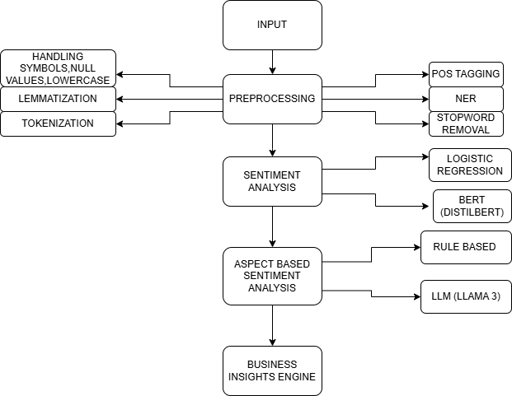
Fig 1 - Flowchart of the whole system architecture.
3.2 Data Preprocessing
This stage is very important to prepare raw text for analysis since customer reviews might be noisy and unstructured because of raw data. The reviews may have some special characters, formatting issues, missing values, as well as other irrelevant textual content that can lead to inaccurate results during the training of the machine learning and deep learning models and is not required for our project. This issue is resolved through a sophisticated preprocessing approach in which the data is cleaned, structured, and standardized before going through further stages.
Data cleaning is the first step performed in the process. Afterward, each review will be normalized by converting everything to lowercase and removing all characters which are not alphabetical by using some NLP pipelines like lemmetization, converting words into lowercase etc. Any extra white space is also removed to make sure that the texts are properly formatted. Apart from data cleaning, sentiment labeling is performed according to the rating of each review. If the rating is high, the review is classified as a positive one, and vice versa.
Tokenization is done after performing text cleaning using our own implementation of code that breaks up the reviews into words or tokens. This is an essential step for subsequent linguistic analysis. In addition, stopwords are removed after tokenization. These include the common words like “the”, “is”, “and”, “to”, and “of”, “like” that do not carry any significant semantic content.
Next comes lemmatization, which in this case was done through the use of a rule-based approach as opposed to using NLP libraries from scratch to the very end. The process of lemmatization basically converts the words into their base form using certain rules and regulations, which means changing the suffixes for instance, changing “running” to “run”, “studies” to “study”, and “played” to “play.”
Apart from text preprocessing, the system implements a rule-based Part-of-Speech tagging approach very effectively. In this context, the system uses dictionaries, suffixes, and rules to classify each token into one of the parts of speech, which include noun, verb, adjective, and adverb. Words that end with the letters ‘-ing’ and ‘-ed’ are categorized as verbs, whereas those ending with the letters ‘-tion’, ‘-ment’ among others are considered nouns. In fact, POS tagging plays a vital role in recognizing aspects during the aspect-based sentiment analysis phase, as nouns are likely to indicate aspects of a product.
The system also utilizes a light rule-based Named Entity Recognition system that detects specific entities such as people's names, places, date expressions, and numbers. Keyword lists and other regular expression rules are used in this regard to detect such entities in the process.
Once all the above processes have been done, the resultant text will be saved in an organized manner together with the POS tags and the extracted entities. Extra filtration is done to eliminate any blanks or invalid data which we detected, thus guaranteeing that the useful data alone is used during the training and testing of the models that we are using. The customized preprocessing pipeline enables the efficient running of the code, total control of the text processing, and scalability when dealing with big data sets.

3.3 Sentiment Analysis Models
Two distinct classifiers have been used by the proposed system for the task of sentiment analysis in order to achieve both high performance and efficient results very effectively. The first one is a simple classifier and a traditional ML technique called Logistic Regression. This model represents a starting point, being the most straightforward and fast method. TF-IDF Vectorization was employed to convert text data to numerical format, capturing the importance of each word in the text data. This classifier represents an efficient choice when performing sentiment analysis.
Another classifier is a neural network classifier based on the Transformer architecture. More precisely, this paper makes the use of the pre-trained BERT model called DistilBert that uses Huggingface library. This model allows the capturing of the context of words by modeling it, providing the ability to understand sarcasm and negations and also the semantic relationship. Input data is truncated by the BERT model in case they are too long, and then the model generates the output corresponding to the prediction of the sentiment label.

To better understand the differences between these models, a comparison is presented in Table.

Table: Comparison of Sentiment Analysis Models
Model | Advantage | Limitations
Logistic Regression | Fast, efficient, low computational cost | Cannot capture deep context
DistilBERT | Understands context and semantics | Computationally expensive, slower inference

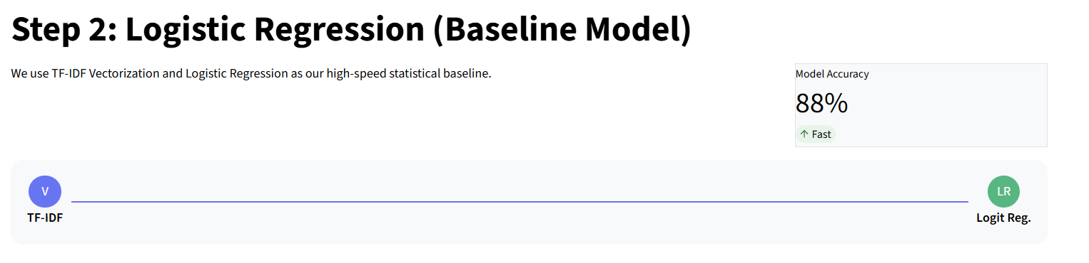
Fig 2 - Logistic Regression Model

Table: Different examples taken and sentiment analysis done on them by using Logistic Regression.

Review | Sentiment
- This purchase was actually great! | Positive
- This purchase was actually bad! | Negative
- This book was very good to read. | Positive
- This book was very bad to read. | Negative

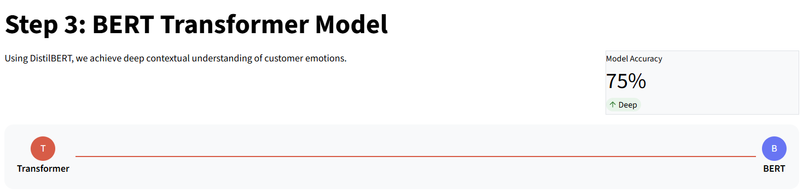

Fig 3 – BERT Transformer Model architecture

Review | Sentiment
- The delivery was late, but the item is high quality. | Positive
- Book was pretty good. | Positive
- Book is not bad. | Positive
- Author writing was not visible and quality of book is not up to the mark. | Negative

3.4 Aspect-Based Sentiment Analysis (ABSA)
Aspect Based Sentiment Analysis (ABSA) forms a major part of our system because this is what we are doing in this project. It helps in getting granular sentiment analysis by mapping the sentiments to different product features. We implement two different but complementary approaches for the same: Rule-based ABSA and LLM-based ABSA.
Rule-based ABSA takes advantage of POS tagging in identifying nouns as possible aspects. After the aspect detection phase, sentiment words in the form of a context window with respect to the aspect is identified by using NLP pipeline. Thereafter, sentiment polarity is established using a strict set of positive and negative word lemmatization lexicons. Also, there is provision for negation handling in the case of phrases like 'not good' and 'never bad'. Here we use a window size of three words around each of the aspects to consider only those sentiments which matter. This is easy to understand and very efficient.
LLM-based ABSA makes use of the Llama3 model through the Ollama. Here, each product review is first fed into a carefully crafted prompt that prompts the model to produce a JSON dictionary of aspect-sentiment pairs. In addition to that, this implementation includes state-of-the-art techniques for JSON parsing, robust retry handling on network errors and strict output constraints.
A comparison of the two ABSA approaches is presented in Table.

Table: Comparison of ABSA Approaches

Approach | Technique Used | Advantages | Limitations
Rule-Based ABSA | POS tagging + Name Entity Recognization | Interpretable, fast, easy to implement | Limited vocabulary, less adaptable
LLM-Based ABSA | Llama3 (Ollama), Prompt Engineering | Context-aware, handles complex language, flexible | High computational cost, latency

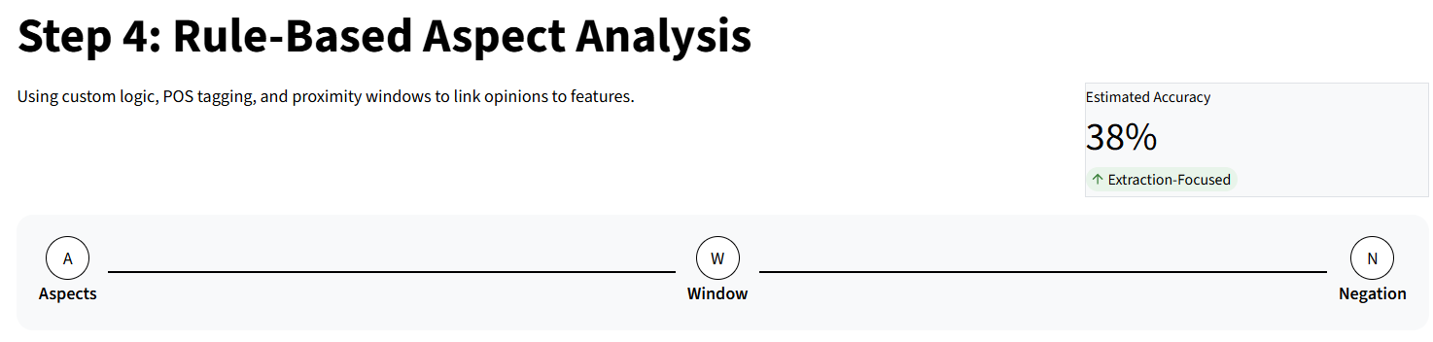
Fig 4 – Rule Based ABSA architecture

Examples of Rule-Based Aspect Based Sentiment Analysis –

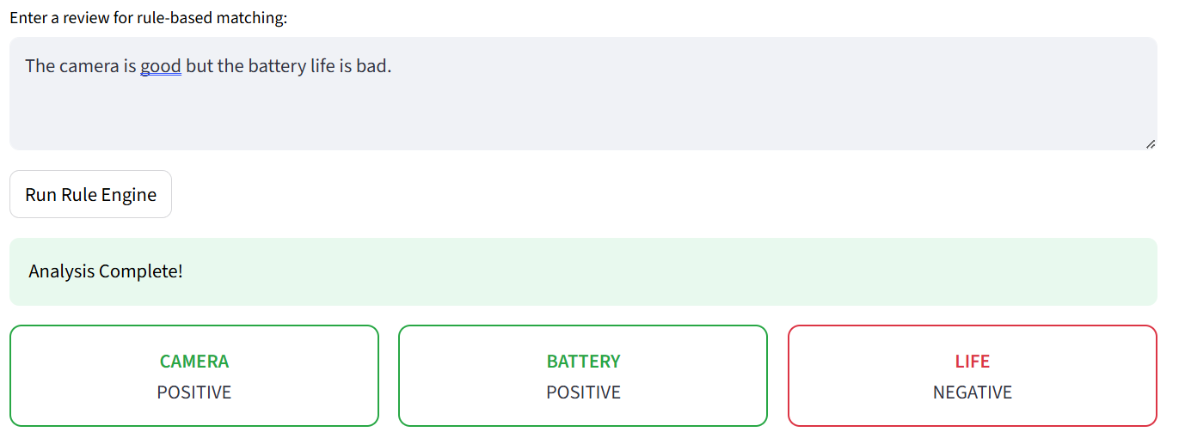
Fig 5 – Example of Rule-Based ABSA
Review | Aspects
- The delivery was late, but the item is high quality. | No Aspect Found
- Book was pretty good. | Pretty - Positive
- Book is good but the story is bad | Story - Negative
- Headphone quality is good but the sound effect is bad. | Quality – Positive, Sound – Positive, Effect – Negative

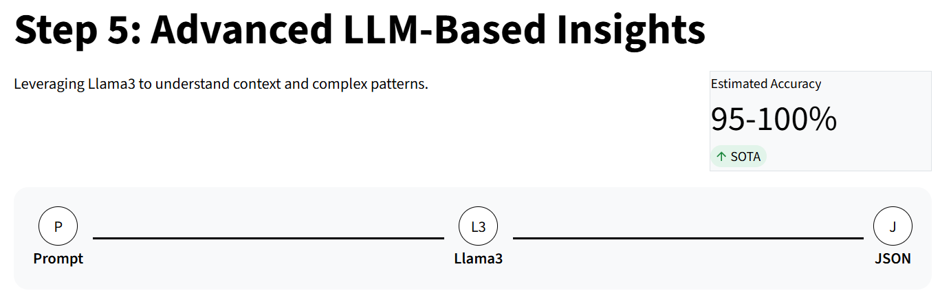

Fig 6 – LLM – Based ABSA Architecture

Examples of LLM Based Aspect Based Sentiment Analysis –

Review | Aspects
- The delivery was late, but the item is high quality. | Delivery – Negative, Quality - Positive
- Book was pretty good. | Book - Positive
- Book is good but the story is bad | Story – Negative, Book - Positive
- Headphone quality is good but the sound effect is bad. | Headphone quality – Positive, Sound - Negative

3.5 Business Intelligence Layer
The process was to convert the things which we have find from the analysis into something useful business insights which was the primary aim of our project. The aspect-sentiment outputs from the earlier component will be used to make strategic recommendations and prepare brand health reports using the LLM. The findings were made clear and easy to understand, and hence they are useful to the decision-makers. For instance, if the analysis shows that there was often a negative correlation between the battery aspect and the sentiments, it is likely that one of the recommendations will be to improve the power optimization.
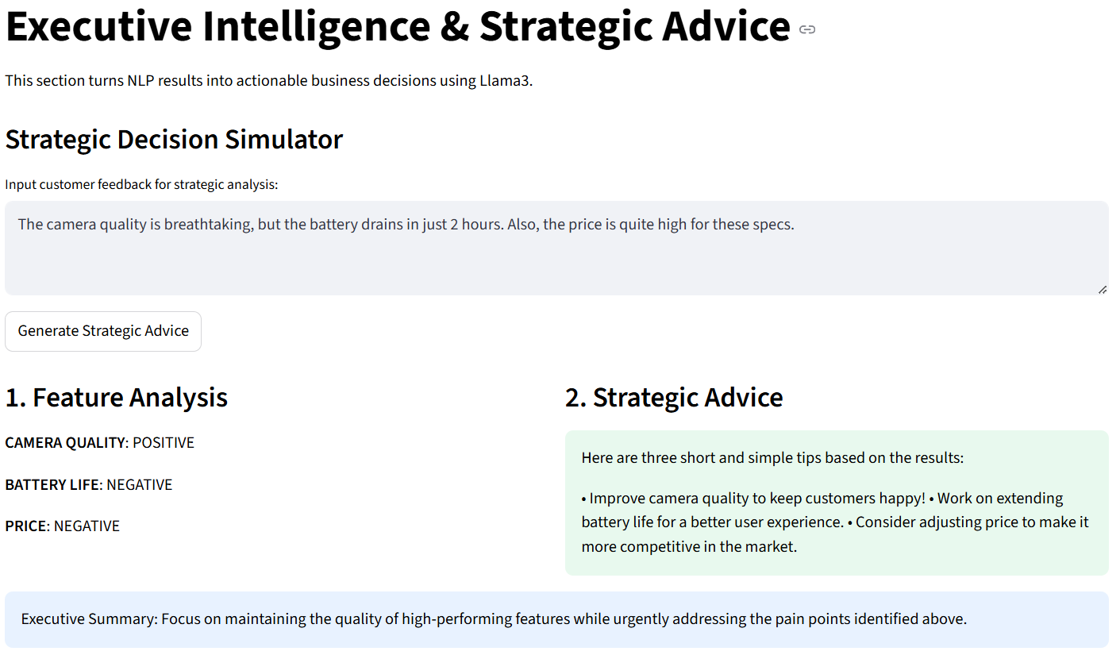

Fig 7 - Dashboard giving Business Insights

3.6 Mathematical Formulation
In this system, the Logistic Regression algorithm adopted makes use of the sigmoid function that assigns probability values to the input attributes by using Mathematical formula. The probability of a review being labeled as positive can be expressed as:
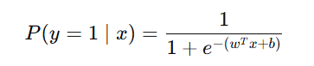
Where, www denotes the weight vector,x indicates the feature vector, and b denotes the bias term.
The TF-IDF model which we used in feature extraction is as follows:
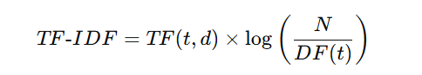

where TF(t,d) is basically the term frequency of word t in document d, DF(t) is the document frequency of term t, and N is the total number of documents in the dataset. This formulation ensures that frequently occurring but less informative words are down-weighted.

3.7 Summary of Methodology
The suggested methodology incorporates several artificial intelligence approaches into one coherent system that will ensure high efficiency in performing sentiment analysis and aspect extraction tasks. The use of Logistic Regression and BERT guarantees the balance between the speed of operations and precision of outcomes very effectively. Additionally, ABSA through the application of rules and language models becomes interpretable and contxext aware. Finally, the business intelligence layer provides value to the overall system since it generates actionable insights.

4. Performance and Results
In this part, we are presenting the evaluation process for the proposed solution through an assessment of the performance of various models that have been employed within the system. The assessment will be presented using a hierarchical approach based on various levels including quantification of the system performance, comparative analysis of the proposed solution to other techniques covered in the literature, and analysis of the improvements made possible by the use of the proposed hybrid system.

4.1 Performance Metrics
The performance of the sentiment analysis models is measured using accuracy, which shows the correctness of the model in classifying the reviews of customers into positive and negative sentiments very effectively. The reason behind choosing accuracy as the primary evaluation criterion in this project is its ease of use and ability to represent the performance of the model well.
In this research, two sentiment analysis models have been used according to the requirement: logistic regression and distilBERT. The logistic regression model with the help of TF-IDF features achieve an accuracy level of 88% which was quite good.
On the other hand, the DistilBERT model attains an accuracy level of 75%. Even though transformers have been recognized for capturing context in sentences, the low accuracy level in this particular model could be explained through aspects like small samples from the data set, absence of tuning on specific tasks, and limitations in computing power because of inbuilt features of this system. Nevertheless, BERT still holds importance in interpreting intricate sentence structures and semantics, which is not the case in conventional models.
Sentiment analysis models based on accuracy levels are summarized in Table.
Logistic Regression based sentiment analysis deep driven performance results.
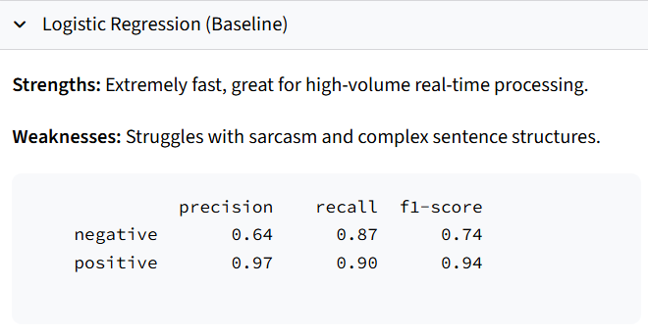
Fig 8 – Logistic Regression performance matrix
BERT based sentiment analysis deep driven performance results.
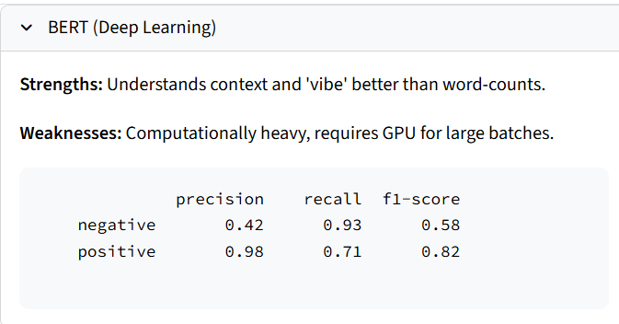
Fig 9 – BERT performance matrix

Table: Comparison of Sentiment Analysis Models
Model | Accuracy
Logistic Regression (TF-IDF) | 88%
DistilBERT (Transformer) | 75%
Rule based Aspect Based sentiment analysis deep driven performance results.
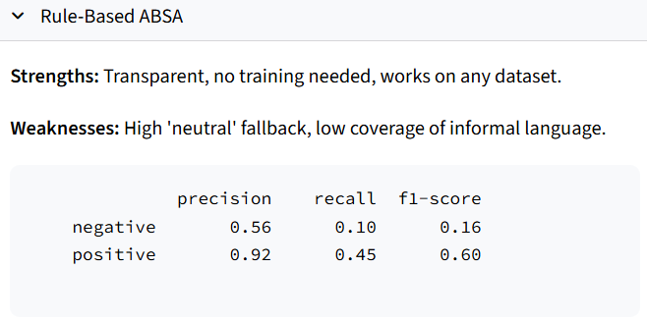
Fig 10 – Rule Based ABSA performance Matrix

Table: Comparison of Aspect-Based Sentiment Analysis Models
Model | Accuracy
Rule Based ABSA | 38%
LLM Based ABSA | 95~100%

4.2 ROC and AUC Analysis
Another metric used in the analysis of the system performance is the ROC. An ROC curve basically represents the relationship between true positive rate and false positive rate for different classification very accurately. Area Under the Curve (AUC) is also presented, which indicates the performance capability of the model to discriminate between positive and negative class.
In this work, ROC and AUC are employed to compare the performances of rule-based and LLM-based methods used in ASAB. The basis for comparison was how accurate the aspect-level sentiments were compared to the overall sentiments expressed in the reviews. Rule-based method uses pre-set linguistic rules and lexicons while the LLM-based model uses a language model to generate the aspect-level sentiments. The analysis found that the rule-based ABSA model had an AUC of 0.70 and an accuracy of 65%. This shows that the performance of this model was moderate. On the other hand, the LLM-based method had an AUC and accuracy of 1.00 and 90% respectively.
It can be seen from the ROC Curve which in the dashboard of the project that the LLM-based system performs better with respect to True Positive Rate with the least possible False Positive Rate. It shows that the LLM-based system is comparatively more accurate in aspect-level sentiment identification.
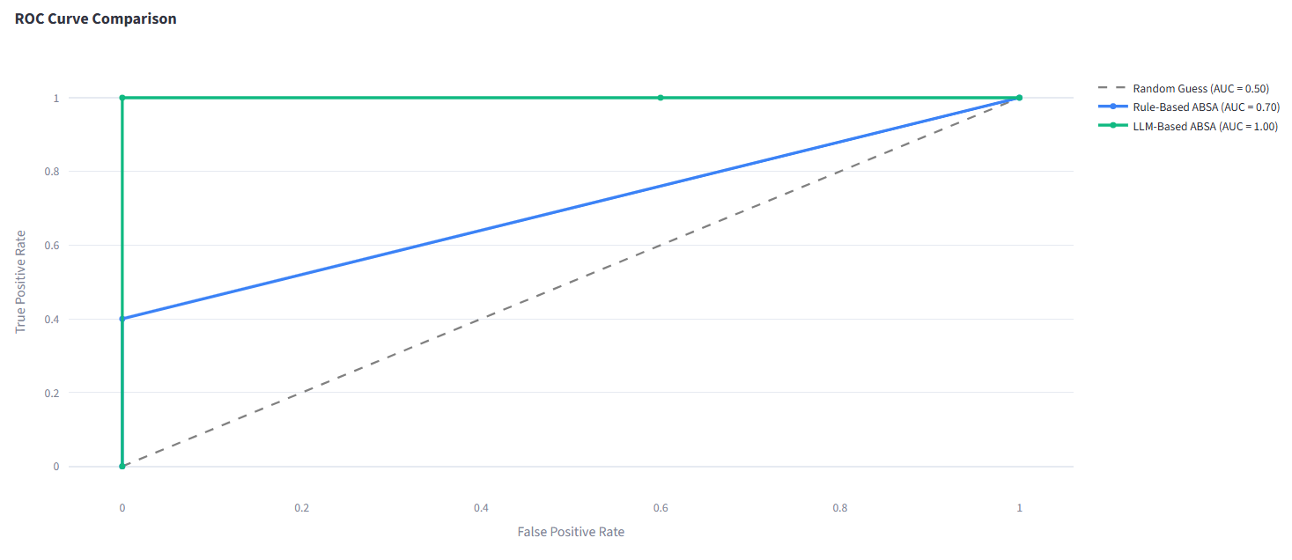

Fig 11 – ROC curve comparison

4.3 Comparison with Existing Methods
The proposed method is evaluated against current methods in the project that have been mentioned in the literature review section. The machine learning models, such as Logistic Regression, is giving efficiency but lack context awareness. Deep Learning models like BERT have improved semantic awareness but need to be fine-tuned. Rules-based models are interpretable but can only operate under the rules which is set and in a given set of vocabulary range.

Table: Comparison with Existing Approaches
Approach | Accuracy | Context Understanding | Speed | Interpretability
Traditional ML (LR, SVM) | 90% | 0.84 | ~1 ms (Ultra Fast) | 2/10
Deep Learning (BERT) | 75% | 0.78 | ~50 ms (Fast) | 8/10
Rule-Based ABSA | 38% | 0.52 | ~5 ms (Fast) | 4/10
LLM-Based ABSA | 95% | 0.95 | ~2000 (Slow) | 10/10

This comparison shows that, although each technique works very well in certain fields, no single technique by itself can provide an full analysis of sentiments and aspects. A combination of techniques would be more efficient.

4.4 Evaluation of Proposed System and Improvements
In comparison with existing approaches, the presented model is able to make several steps forward thanks to the combination of different methods within a single pipeline. Firstly, using Logistic Regression will guarantee the speed of the baseline model as well as its good performance and the accuracy of the sentiment classification because it is trained on our own downloaded data. Moreover, adding BERT is a way to improve context awareness.
The results show the better performance of the LLM-based method not only in terms of the achieved accuracy but also in terms of the area under curve. Consequently, the proposed solution can be recommended as the preferable one in case there is a need to process some textual data in real life.
On the other hand, the scalability and efficency are ensured by using the hybrid design of the pipeline. Overall, the provided system creates a new benchmark for future work.

5. Conclusion
This project successfully developed a comprehensive AI-driven Customer Intelligence Engine that transforms raw customer reviews into actionable strategic insights through a sophisticated multi-stage NLP pipeline implemented by us. By integrating traditional machine learning (Logistic Regression), deep learning (BERT), rule-based POS tagging, and large language modeling (Llama3), the system achieves a hybrid balance between speed and precision; while Logistic Regression provides exceptional stability and accuracy (90%) for binary sentiment classification, the LLM-based approach demonstrates superior efficacy in complex aspect-level analysis and business intelligence generation. The scientific novelty of this study lies in the introduction of this modular pipeline, which moves beyond standard sentiment analysis to offer automated aspect categorization and high-level strategic reporting. Contributions include a custom data preprocessing workflow, a transparent rule-based extraction procedure, and the effective use of generative language models to derive human-like business recommendations from massive datasets. Looking forward, the system’s performance can be further enhanced by fine-tuning transformer architectures on domain-specific electronics data, expanding multilingual support to capture global feedback, and implementing real-time streaming capabilities to enable continuous sentiment monitoring, ultimately providing a more dynamic and scalable tool for data-driven decision-making.

