**SCHOOL OF ENGINEERING & TECHNOLOGY B.TECH. COMPUTER SCIENCE &**

**ENGINEERING**

DESIGN AND ANALYSIS OF ALGORITHMS

# LAB FILE

### AUG - DEC 2024



**SUBMITTED BY**

NAME OF STUDENT: TUSHAR GUPTA

ENROLLMENT NO.: 230542

SECTION: CSE-2

# INDEX

|  |  |  |  |
| --- | --- | --- | --- |
| **S. No.** | **Name of Experiment** | **Date** | **Remarks** |
| 1 | **Sorting Algorithms** |  |  |
| 2 | **Recursion Algorithms** |  |  |
| 3 | **Divide And conquer (merge sort & Binary search)** |  |  |
| 4 | **Comparison between iterative and recursive divide and conquer** |  |  |
| 5 | **Quick sort & Power calculation** |  |  |
| 6 | **Karatsuba's algorithm & Strassen's algorithm** |  |  |
| 7 | **Heap sort & Priority Queue** |  |  |
| 8 | **Greedy Method & Prim’s Algorithm** |  |  |
| 9 | **Disjoint Set Union-Find algorithm and Kruskal's**  **algorithm** |  |  |
| 10 | **Dijkstra's algorithm** |  |  |

|  |  |  |  |
| --- | --- | --- | --- |
| 11 | **Fibonacci number & LCS using dynamic programming approach** |  |  |

### Experiment-1

1. **Aim**

We have to wite a program to compare the time complexities of the following comparison- based sorting algorithms:

* + Bubble Sort
  + Selection Sort
  + Insertion Sort
  + Merge Sort
  + Quick Sort
  + Heap Sort

We need to count the number of times the basic/primitive operations are being performed as a measure of the time complexity.

As, all the above algorithms are comparison-based sorting, the basic operation in this case is "comparison operation" of the elements.

### Objective

The objective of this experiment is to empirically analyze and compare the time complexities of various comparison-based sorting algorithms.

### Algorithm

###### Initialize Random Seed:

* + Set the random seed using srand(time(0)) to ensure different random numbers are generated in each run.

1. **Define Constants:** o Define SIZE as the size of each array (20 elements).
   * Define NUM_TRIALS as the number of trials (10 trials).
2. **Declare Arrays**: o Declare a 2D array arrays[NUM_TRIALS][SIZE] to store the random arrays for each trial.
   * Declare a 2D array results[6][NUM_TRIALS] to store the number of comparisons for each sorting algorithm across all trials.
3. **Fill Arrays with Random Numbers**: o For each trial, fill the corresponding array with random numbers between 0 and 99 using the fillArray function.

###### Run Sorting Algorithms and Count Comparisons:

* + For each trial, perform the following steps:
    - Copy the random array to a temporary array temp.
    - Sort temp using Bubble Sort and store the number of comparisons in results[0][trial].
    - Copy the random array to temp again.
    - Sort temp using Insertion Sort and store the number of comparisons in results[1][trial].
    - Repeat the above steps for Selection Sort, Merge Sort, Quick Sort, and Heap Sort, storing the number of comparisons in the respective rows of results.

1. **Display Results**: o Print the header row with the names of the sorting algorithms.
   * For each trial, print the trial number and the number of comparisons for each sorting algorithm.

### 4.Implementation:

#include

<iostream> #include

<cstdlib> #include

<ctime> #include

<iomanip> using namespace std;

void fillArray(int arr[], int size)

{ for (int i = 0; i < size; i++) { arr[i]

= rand() % 100;

}

}

// 1. BUBBLE SORT

int BS(int arr[], int n) { int comp = 0; for (int i = 0; i < n - 1; i++) { for (int j = 0; j < n - i - 1; j++)

{ if (arr[j] > arr[j + 1]) { int temp = arr[j]; arr[j] = arr[j + 1]; arr[j +

1] = temp; comp++;

}

}

}

return comp;

}

// 2. INSERTION SORT

int IS(int arr[], int n) { int comp = 0; for (int i = 1; i < n; i++) { int key = arr[i]; int j = i - 1; while (j

>= 0 && arr[j] > key) { comp++; arr[j + 1] = arr[j]; j = j - 1;

}

if (j >= 0) comp++; // Count the last comparison arr[j + 1] = key;

}

return comp;

}

// 3. SELECTION SORT

int SS(int arr[], int n) { int comp

= 0; for (int i = 0; i < n - 1; i++)

{ int minIndex = i; for (int j = i

+ 1; j < n; j++) {

if (arr[j] < arr[minIndex])

{

minIndex = j;

}

}

if (minIndex != i) { int temp = arr[i];

arr[i] = arr[minIndex]; arr[minIndex]

=temp; comp++;

}

}

return comp;

}

// 4. MERGE SORT

void merge(int arr[], int left, int mid, int right, int &comp)

{ int n1 = mid - left + 1; int n2 = right - mid;

int *L = new int[n1]; int *R = new int[n2];

for (int i = 0; i < n1; i++) L[i] = arr[left + i];

for (int i = 0; i < n2; i++) R[i] = arr[mid + 1 + i];

int i = 0, j = 0, k = left; while (i < n1 && j < n2)

{

comp++;

if (L[i] <= R[j]) {

arr[k++] = L[i++];

} else { arr[k++] = R[j++];

}

}

while (i < n1) arr[k++] = L[i++]; while (j < n2) arr[k++]

= R[j++];

delete[] L; delete[] R;

}

void mergeSortHelper(int arr[], int left, int right, int &comp) { if (left < right) { int mid = left +

(right - left) / 2; mergeSortHelper(arr, left, mid, comp); mergeSortHelper(arr, mid + 1, right, comp); merge(arr, left, mid, right, comp);

}

}

int mergeSort(int arr[], int n) { int comp = 0; mergeSortHelper(arr, 0, n - 1, comp); return comp;

}

// 5. QUICK SORT

int partition(int arr[], int low, int high, int &comp) { int pivot = arr[high]; int i =

low - 1; for (int j = low; j < high; j++) { comp++;

if (arr[j] < pivot)

{ i++;

int temp =

arr[i]; arr[i] = arr[j]; arr[j] =

temp;

}

}

int temp = arr[i + 1]; arr[i + 1] = arr[high]; arr[high]

= temp; return i + 1;

}

void quickSortHelper(int arr[], int low, int high, int &comp) { if (low < high) { int pi =

partition(arr, low, high, comp); quickSortHelper(arr, low, pi - 1, comp); quickSortHelper(arr, pi + 1, high, comp);

}

}

int quickSort(int arr[], int n) { int comp = 0; quickSortHelper(arr, 0, n - 1, comp); return comp;

}

//6. HEAPIFY

void heapify(int arr[], int n, int i, int &comp) { int largest = i; int

left = 2 * i + 1; int right = 2 * i +

2;

if (left < n)

{

comp++;

if (arr[left] > arr[largest])

{ largest = left; }

}

if (right < n) { comp++; if (arr[right] > arr[largest])

{ largest = right;}

}

if (largest != i) { swap(arr[i], arr[largest]); heapify(arr, n, largest, comp);

}

}

int heapSort(int arr[], int n)

{ int comp = 0;

for (int i = n / 2 - 1; i >= 0; i--)

{ heapify(arr, n, i, comp); }

for (int i = n - 1; i >= 0; i--)

{

swap(arr[0], arr[i]); heapify(arr, i, 0, comp);

}

return comp;

}

int main() { srand(time(0));

// Size of each array const int SIZE

= 20;

// Number of trials

const int NUM_TRIALS = 10;

int arrays[NUM_TRIALS][SIZE]; int results[6][NUM_TRIALS];

for (int i = 0; i < NUM_TRIALS; i++)

{ fillArray(arrays[i], SIZE) }

for (int trial = 0; trial < NUM_TRIALS; trial++) { int temp[SIZE];

copy(begin(arrays[trial]), end(arrays[trial]), temp); results[0][trial] = BS(temp, SIZE); copy(begin(arrays[trial]), end(arrays[trial]), temp); results[1][trial] = IS(temp, SIZE);

copy(begin(arrays[trial]), end(arrays[trial]), temp); results[2][trial]

= SS(temp, SIZE);

copy(begin(arrays[trial]), end(arrays[trial]), temp); results[3][trial]

= mergeSort(temp, SIZE);

copy(begin(arrays[trial]), end(arrays[trial]), temp); results[4][trial]

= quickSort(temp, SIZE);

copy(begin(arrays[trial]), end(arrays[trial]), temp); results[5][trial]

= heapSort(temp, SIZE);

}

cout << left << setw(10) << "Trial"; cout << setw(10) << "Bubble"; cout << setw(10) << "Insertion"; cout << setw(10) << "Selection"; cout << setw(10) << "Merge"; cout << setw(10) << "Quick";

cout << setw(10) << "Heap" << endl;

for (int i = 0; i < NUM_TRIALS; i++) {

cout << setw(10) << (i + 1); for (int j = 0; j < 6; j++)

{ cout << setw(10) << results[j][i];

} cout << endl;

}

return 0;

}

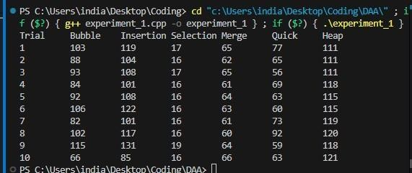

### Experiment-2

1. **Aim**

To learn the use of Stack in the Recursion Algorithms.

### Objective

We need to count the number of times the function is called in order to find the size of the stack.

### Algorithm

We will write the normal code of the recursion and in that we will introduce the count variable and add it before the function is about to be called again in order to get the exact number of times the function was called.

### Implementation

1. **FACTORIAL OF NUMBER-** #include

<iostream> using namespace std;

int factorial(int n, int& count) { count++;

if (n <= 1)

retur n 1;

else return n * factorial(n

- 1, count);

}

int

main(

) { int numb er = 5; int count

= 0;

int result = factorial(number, count);

cout << "Factorial of " << number << " is: " << result << endl; cout << "Number of times the function was called: " << count << endl;

return 0;

}

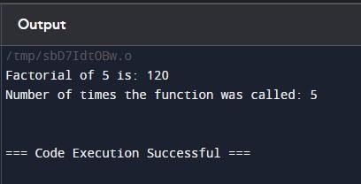

1. Fibonacci

– #include

<iostream> using namespace std;

int fibonacci(int n, int& count) { count++;

if (n

<

= 1)

re t u r n n; el s e

return fibonacci(n - 1, count) + fibonacci(n - 2, count);

}

int

main(

) { int numb er =

5; int count

= 0;

int result = fibonacci(number, count);

cout << "Fibonacci of " << number << " is: " << result << endl;

cout << "Number of times the function was called: " << count << endl;

return 0;

}

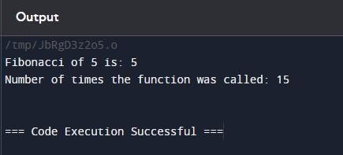

1. **Tower Of Hanoi** #include

<iostream> using namespace std;

void towerOfHanoi(int n, char from_rod, char to_rod, char aux_rod, int& count) { count++;

if (n == 1) { cout << "Move disk 1 from rod " << from_rod << " to rod " << to_rod << endl; return;

}

towerOfHanoi(n - 1, from_rod, aux_rod, to_rod, count); cout << "Move disk " << n << " from rod " << from_rod << " to rod " << to_rod << endl; towerOfHanoi(n - 1, aux_rod, to_rod, from_rod, count);

}

int main() { int n = 3;

int count = 0;

towerOfHanoi(n, 'A', 'C', 'B', count);

cout << "Number of times the function was called: " << count << endl;

return 0;

}

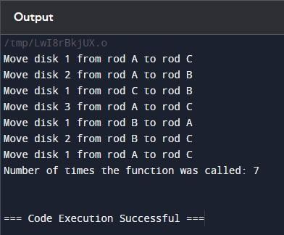

### Experiment-3

1. **Aim:**

To implement and understand the working of the Merge Sort and Binary Search algorithms

using the divide-and-conquer and decrease-and-conquer approaches, respectively.

### Objective:

1. To gain hands-on experience in implementing recursive algorithms.
2. To understand the divide-and-conquer strategy through the Merge Sort algorithm.
3. To understand the decrease-and-conquer strategy through the Binary Search algorithm.
4. To analyze the time complexity and efficiency of these algorithms.
5. To develop problem-solving skills by applying these algorithms to practical problems

### 3.Algorithm:

**Merge Sort Algorithm:**

1. 2. 3. Divide: Split the array into two halves. Conquer: Recursively sort each half.

Combine: Merge the two sorted halves to produce the sorted array.

### Binary Search Algorithm:

1. Input: Sorted array arr, target value target, low index low, high index high.
2. Base Case: If low > high, return -1 (target not found).
3. Calculate Mid: mid = (low + high) // 2.
4. Check Mid:

* If arr[mid] == target, return mid.
* If arr[mid] > target, search in the left half (low to mid-1).
* If arr[mid] < target, search in the right half (mid+1 to high).

**4.Implementation:**

1. **merge sort**

#include <iostream> using namespace std;

void merge(int arr[], int left, int mid, int right) { int

n1 = mid - left + 1; int n2 = right - mid;

int L[n1], R[n2];

for (int i = 0; i < n1; i++)

L[i] = arr[left + i]; for (int j

= 0; j < n2; j++) R[j]

= arr[mid + 1 + j];

int i = 0, j = 0, k = left; while (i < n1 && j < n2) { if (L[i] <= R[j]) { arr[k] = L[i]; i++;

} else { arr[k]

= R[j]; j++;

} k++;

}

while (i < n1) { arr[k] = L[i]; i++;

k++;

}

while (j < n2) { arr[k] = R[j]; j++; k++;

}

}

void mergeSort(int arr[], int left, int right) { if (left < right) { int mid = left + (right

- left) / 2;

mergeSort(arr, left, mid); mergeSort(arr, mid + 1, right);

merge(arr, left, mid, right);

}

}

void printArray(int arr[], int size) { for (int i = 0; i < size; i++) cout

<< arr[i] << " "; cout << endl;

}

int main() { int arr[] =

{625,78,45,89,96,912}; int arr_size = sizeof(arr) / sizeof(arr[0]); cout << "Given array is \n"; printArray(arr, arr_size);

mergeSort(arr, 0, arr_size - 1);

cout << "\nSorted array is \n";

printArray(arr, arr_size); return 0;

}

**For Merge Sort**

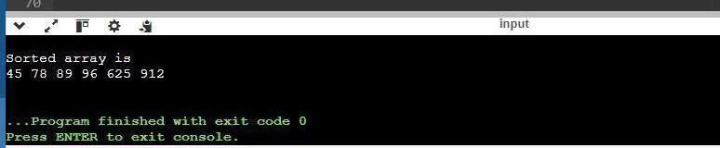

# binary search

#include <iostream>

int binarySearch(int arr[], int left, int right, int x) { if (right >= left) { int mid = left +

(right - left) / 2;

if (arr[mid] == x) return mid;

if (arr[mid] > x)

return binarySearch(arr, left, mid - 1, x);

return binarySearch(arr, mid + 1, right, x);

}

return -1;

}

int main() {

int arr[] = {2, 3, 4, 10, 40}; int n = sizeof(arr) / sizeof(arr[0]); int x = 10;

int result = binarySearch(arr, 0, n - 1, x);

(result == -1) ? std::cout << "Element is not present in array"

: std::cout << "Element is present at index " << result; return 0;

}

### For Binary Search

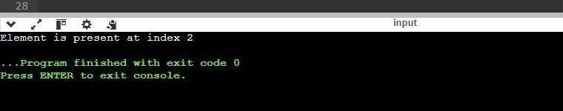

**Experiment-4**

### Aim

To implement and compare two algorithms for finding the minimum and maximum

elements in an unsorted array: an iterative brute-force approach and a recursive divide-and-conquer approach

### Objective

1. Implement an iterative brute-force function to find the minimum and maximum elements in an array.
2. Implement a recursive divide-and-conquer function to find the minimum and maximum elements in an array.
3. Compare the number of comparisons made by each function over 10 test runs with varying array sizes.
4. Tabulate the results to analyze the efficiency of both approaches.

### 3. Algorithm

1. Initialize min to a very large value and max to a very small value.
2. Iterate through each element of the array.
3. Update min if the current element is smaller than min. 4.Update max if the current element is larger than max.

5. Return min and max.

### 4.Implementation

#include <iostream>

#include <cstdlib> #include

<ctime>

#include <climits> #include <algorithm> using namespace

std;

void findMinMaxIterative(int arr[], int n, int &min, int &max, int &comparisons) { min = INT_MAX; max = INT_MIN;

comparisons = 0;

for (int i = 0; i < n; ++i) { if (arr[i] < min) {

min = arr[i];

}

if (arr[i] > max) { max = arr[i];

}

comparisons += 2;

}

}

void findMinMaxRecursive(int arr[], int low, int high, int &min, int &max, int &comparisons) { if (low == high) { if (arr[low] < min) min =

arr[low]; if (arr[low] > max) max = arr[low]; comparisons += 2;

return;

}

if (high == low + 1) { if (arr[low] < arr[high]) { if

(arr[low] < min) min = arr[low]; if (arr[high] > max) max = arr[high];

} else { if (arr[high] < min) min = arr[high];

if (arr[low] > max) max = arr[low];

}

comparisons += 3; return;

}

int mid = (low + high) / 2; findMinMaxRecursive(arr, low, mid, min, max,

comparisons); findMinMaxRecursive(arr, mid + 1, high, min, max, comparisons);

}

void findMinMaxIterative(int arr[], int n, int &min, int &max, int &comparisons);

void findMinMaxRecursive(int arr[], int low, int high, int &min, int &max, int &comparisons);

int main() {

srand(time(0));

const int testRuns = 11;

cout << "Run\tN\tIterative Comparisons\tRecursive Comparisons\n"; for (int run = 1; run <= testRuns; ++run) { int N

= rand() % 100 + 1;

int arr[N];

for (int i = 0; i < N; ++i) { arr[i] = rand() % 1000;

}

int minIter, maxIter, comparisonsIter;

findMinMaxIterative(arr, N, minIter, maxIter, comparisonsIter);

int minRec = INT_MAX, maxRec = INT_MIN, comparisonsRec = 0; findMinMaxRecursive(arr, 0, N - 1, minRec, maxRec, comparisonsRec);

cout << run << "\t" << N << "\t" << comparisonsIter << "\t\t\t" << comparisonsRec << "\n";

}

return 0;

}

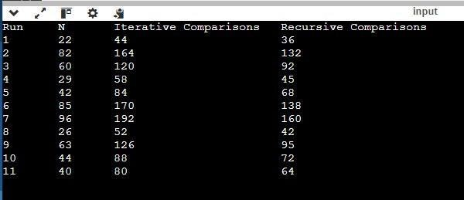

### Experiment-5

**1. Aim**

1. To sort an unsorted array using the Quick Sort algorithm. 2.To compute (X^n) for (n > 0) using the Divide-and-Conquer approach

### Objective

1.Understand the Quick Sort algorithm and its implementation. 2.Learn the Divide-and-Conquer approach for solving problems.

1. Implement the Quick Sort algorithm to sort an array in ascending order.
2. Implement the Divide-and-Conquer approach to compute (X^n).

### 3. Algorithm

**1. Quick Sort Algorithm**

Algorithm:

1.**Choose a Pivot**: Select a pivot element from the array. 2**.Partition**: Rearrange the array such that elements less than the pivot are on the left, elements greater than the pivot are on the right.

3.**Recursively Apply**: Apply the same process to the left and right subarrays.

### 2. Compute (X^n) using Divide-and-Conquer

Algorithm:

1. **Base Case**: If (n = 0), return 1.

###### Recursive Case:

* If (n) is even, compute (X^{n/2}) and return ((X^{n/2}).2).
* If (n) is odd, compute (X^{(n-1)/2}) and return (X \times(X^{(n-1)/2}).2)

### Implementation:

* 1. **quick sort**

#include <iostream> using namespace std;

void swap(int* a, int* b) { int t = *a; *a = *b;

*b = t;

}

int partition(int arr[], int low, int high) { int pivot

= arr[high];

int i = (low - 1);

for (int j = low; j <= high - 1; j++) { if (arr[j] < pivot) { i++;

swap(&arr[i],

&arr[j]);

}

}

swap(&arr[i + 1], &arr[high]); return (i + 1);

}

void quickSort(int arr[], int low, int high) { if (low < high) { int pi = partition(arr,

low, high); quickSort(arr, low, pi

- 1); quickSort(arr, pi + 1, high);

}

}

int main() { int arr[] = {65, 69, 75, 72, 34, 5}; int n = sizeof(arr) / sizeof(arr[0]); quickSort(arr, 0, n - 1); cout << "Sorted array: "; for

(int i = 0; i < n; i++) { cout

<< arr[i] << " ";

}

return 0;

}

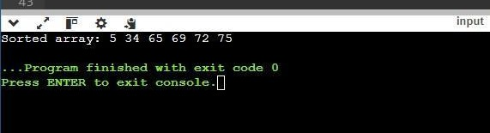

### power calculation :

#include <iostream> using namespace std;

double power(double x, int n) { if (n == 0) return 1; double half = power(x, n / 2); if (n % 2

== 0) return half * half; else return half * half * x;

}

int main() { double x = 2.0;

int n = 8; cout << x << "^" << n << " = " << power(x, n) << endl; return 0;

}

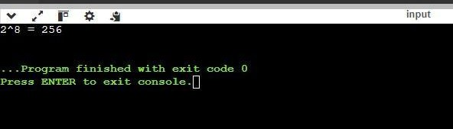

### Experiment-6

1. **Aim**

To efficiently multiply two large integers using the Karatsuba algorithm, which reduces the multiplication complexity compared to the traditional method and efficiently multiply two large square matrices using Strassen’s algorithm, which reduces the number of

multiplications compared to the traditional method**.**

### Objective

Implement in C++.

Achieve a time complexity of (O(n^{\log_2 3}) \approx O(n^{1.585})) instead of the traditional (O(n^2)).

Achieve a time complexity of (O(n^{\log_2 7}) \approx O(n^{2.81})) instead of the traditional (O(n^3))Algorithm

### Algorithm

* 1. **Karatsuba’s Algorithm**
     1. **Divide**: Split each number into two halves.
     2. **Conquer**: Recursively compute three products of the smaller numbers.
     3. **Combine**: Use the three products to construct the final result.

**Algorithm**

**2.Strassen’s**

1. **Divide**: Split each matrix into four submatrices.
2. **Conquer**: Recursively compute seven products of the submatrices.
3. **Combine**: Use the seven products to construct the final result.

# Implementation

#### Karatsuba’s Algorithm

#include <iostream> #include <string> #include <algorithm>

using namespace std;

int makeEqualLength(string &str1, string &str2) { int len1 = str1.size(); int len2 = str2.size();

if (len1 < len2) { str1.insert(0,

len2 - len1, '0'); return len2;

} else if (len1 > len2) { str2.insert(0, len1 - len2, '0');

}

return len1;

}

string addBitStrings(const string &first, const string &second) { string result;

int length = makeEqualLength(const_cast<string&>(first), const_cast<string&>(second)); int carry = 0;

for (int i = length - 1; i >= 0; i--) { int firstBit

= first[i] - '0';

int secondBit = second[i] - '0'; int sum = (firstBit ^ secondBit ^ carry) + '0'; result.insert(0, 1, sum); carry = (firstBit & secondBit) | (secondBit & carry) | (firstBit & carry);

}

if (carry) { result.insert(0, 1, '1');

}

return result;

}

int multiplySingleBit(const string &a, const string &b) { return (a[0] - '0') * (b[0] - '0');

}

long long multiply(const string &X, const string &Y) {

int n = makeEqualLength(const_cast<string&>(X), const_cast<string&>(Y));

if (n == 0) return 0;

if (n == 1) return multiplySingleBit(X, Y);

int fh = n / 2;

int sh = n - fh;

string Xl = X.substr(0, fh); string Xr = X.substr(fh, sh); string Yl = Y.substr(0, fh); string Yr = Y.substr(fh, sh);

long long P1 = multiply(Xl, Yl); long long P2 = multiply(Xr, Yr); long long P3 = multiply(addBitStrings(Xl, Xr), addBitStrings(Yl, Yr)); return P1 * (1LL << (2 * sh)) + (P3 - P1 - P2) * (1LL << sh) + P2;

}

int main() { string num1 = "1100";

string num2 = "1011";

cout << "Product: " << multiply(num1, num2) << endl; return 0;

}

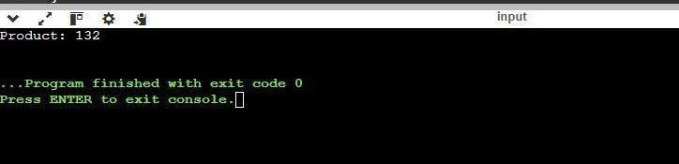

#### Strassen’s Algorithm

#include <iostream> #include <vector>

using namespace std;

typedef vector<vector<int>> matrix;

matrix add(const matrix &A, const matrix &B) { int n

= A.size(); matrix C(n, vector<int>(n)); for (int i = 0; i < n; ++i) for

(int j = 0; j < n; ++j) C[i][j] = A[i][j] + B[i][j];

return C;

}

matrix subtract(const matrix &A, const matrix &B) { int n = A.size(); matrix C(n, vector<int>(n));

for (int i = 0; i < n; ++i) for

(int j = 0; j < n; ++j) C[i][j] = A[i][j] - B[i][j];

return C;

}

matrix strassen(const matrix &A, const matrix &B) {

int n = A.size(); if (n == 1) {

return {{A[0][0] * B[0][0]}};

}

int newSize = n / 2; matrix A11(newSize,

vector<int>(newSize)); matrix A12(newSize, vector<int>(newSize)); matrix A21(newSize, vector<int>(newSize)); matrix A22(newSize, vector<int>(newSize)); matrix B11(newSize, vector<int>(newSize)); matrix B12(newSize, vector<int>(newSize)); matrix B21(newSize, vector<int>(newSize));

matrix B22(newSize, vector<int>(newSize));

for (int i = 0; i < newSize; ++i) { for (int j = 0; j < newSize; ++j) {

A11[i][j] = A[i][j];

A12[i][j] = A[i][j + newSize];

A21[i][j] = A[i + newSize][j];

A22[i][j] = A[i + newSize][j + newSize]; B11[i][j] = B[i][j];

B12[i][j] = B[i][j + newSize];

B21[i][j] = B[i + newSize][j];

B22[i][j] = B[i + newSize][j + newSize];

}

}

matrix M1 = strassen(add(A11, A22), add(B11, B22)); matrix M2 = strassen(add(A21, A22), B11); matrix M3 = strassen(A11, subtract(B12, B22)); matrix M4 = strassen(A22, subtract(B21, B11)); matrix M5 = strassen(add(A11, A12), B22); matrix M6 = strassen(subtract(A21, A11), add(B11, B12));

matrix M7 = strassen(subtract(A12, A22), add(B21, B22));

matrix C11 = add(subtract(add(M1, M4), M5), M7);

matrix C12 = add(M3, M5); matrix C21 = add(M2, M4);

matrix C22 = add(subtract(add(M1, M3), M2), M6);

matrix C(n, vector<int>(n));

for (int i = 0; i < newSize; ++i) { for (int j = 0; j < newSize; ++j) {

C[i][j] = C11[i][j];

C[i][j + newSize] = C12[i][j];

C[i + newSize][j] = C21[i][j];

C[i + newSize][j + newSize] = C22[i][j];

}

}

return C;

}

void printMatrix(const matrix &M) { for (const auto &row : M) {

for (int val : row) { cout

<< val << " ";

}

cout << endl;

}

}

int main() { int n = 4; matrix A = {{1, 2, 3, 4}, {5, 6, 7, 8}, {9, 10, 11, 12}, {13,

14, 15, 16}}; matrix B = {{1, 2, 3, 4}, {5, 6, 7, 8}, {9, 10, 11, 12}, {13, 14,

15, 16}};

matrix C = strassen(A, B);

cout << "Result matrix:" << endl; printMatrix(C);

return 0;

}

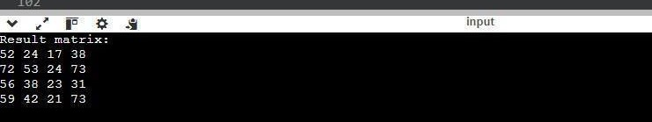

# Aim

### Experiment-7

To implement a Heap data structure (Max or Min Heap), use it to perform Heap-Sort, and build a Priority Queue.

# Objective

1.Understand the properties and operations of a Heap. 2.Implement a Max Heap or Min Heap.

3.Use the Heap to perform Heap-Sort. 4.Utilize the Heap to construct a Priority Queue.

# Algorithm

* 1. Implementing a Heap (Max or Min Heap) Max Heap:
     1. Insert Element:
        + Add the element to the end of the heap.
        + Compare the added element with its parent; if the added element is greater, swap them.
        + Repeat the process until the heap property is restored.
     2. Delete Element:
        + Remove the root element.
        + Replace the root with the last element in the heap.
        + Compare the new root with its children; if the new root is smaller, swap it with the larger child.
        + Repeat the process until the heap property is restored.

Min Heap:

1. Insert Element:

0 Add the element to the end of the heap.

* + Compare the added element with its parent; if the added element is smaller, swap them.
  + Repeat the process until the heap property is restored.

1. Delete Element:

0 Remove the root element.

* + Replace the root with the last element in the heap.
  + Compare the new root with its children; if the new root is larger, swap it with the smaller child.
  + Repeat the process until the heap property is restored.

1. Heap-Sort Algorithm
   1. Build a Max Heap from the input data.
   2. Extract the maximum element (root of the heap) and swap it with the last element of the heap.
   3. Reduce the heap size by one and heapify the root element to restore the heap property.
   4. Repeat the process until all elements are sorted.
2. Priority Queue using Heap
   1. Insert Element:

0 Add the element to the heap.

* + - Restore the heap property by comparing the added element with its parent and swapping if necessary.
  1. Extract Maximum/Minimum:

0 Remove the root element (highest priority).

* + - Replace the root with the last element in the heap.
    - Restore the heap property by comparing the new root with its children and swapping if necessary

# Implementation

* 1. **heap**

#include <iostream> #include <vector> using namespace

std; class MaxHeap { private:

vector<int> heap; void heapifyUp(int index) { int parentIndex = (index - 1) / 2; if (index > 0 && heap[index] > heap[parentIndex]) { swap(heap[index], heap[parentIndex]); heapifyUp(parentIndex); } }

void heapifyDown(int index) { int leftChild = 2 * index + 1; int rightChild = 2 * index + 2; int largest = index; if (leftChild < heap.size() && heap[leftChild] > heap[largest]) { largest = leftChild; } if (rightChild < heap.size() && heap[rightChild] > heap[largest]) { largest = rightChild; }

if (largest != index) { swap(heap[index], heap[largest]); heapifyDown(largest); } }

public:

void insert(int element) { heap.push_back(element); heapifyUp(heap.size() - 1); } int

extractMax() { if (heap.size() == 0) return 1; int maxElement = heap[0]; heap[0] = heap.back(); heap.pop_back(); heapifyDown(0); return maxElement; } void printHeap() { for (int i : heap) {

cout << i << " "; } cout << endl; }}; int main() {

MaxHeap maxHeap; maxHeap.insert(5)

;

maxHeap.insert(25); maxHeap.insert(4); maxHeap.insert(3); maxHeap.insert(4); maxHeap.insert(8); maxHeap.printHeap ();

cout << "Max Element: " << maxHeap.extractMax() << endl; return 0;

}

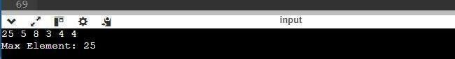

* 1. **heap implement the Heap-Sort algorithm.**

#include <iostream> #include <vector> using namespace

std; class MaxHeap { private:

vector<int> heap; void heapifyUp(int index) { int parentIndex = (index - 1) / 2; if (index > 0 && heap[index] > heap[parentIndex]) { swap(heap[index], heap[parentIndex]);

heapifyUp(parentIndex); } }

void heapifyDown(int index) { int leftChild = 2 * index + 1; int rightChild = 2 * index + 2; int largest = index; if (leftChild < heap.size() && heap[leftChild] > heap[largest]) { largest = leftChild; } if (rightChild <

heap.size() && heap[rightChild] > heap[largest]) { largest = rightChild; }

if (largest != index) { swap(heap[index], heap[largest]); heapifyDown(largest); } }

public:

void insert(int element) { heap.push_back(element); heapifyUp(heap.size() - 1); } int

extractMax() { if (heap.size() == 0) return 1; int maxElement = heap[0]; heap[0] = heap.back(); heap.pop_back(); heapifyDown(0); return maxElement; } void buildHeap(vector<int>& arr) { heap = arr; for (int i = heap.size() / 2 - 1; i >= 0; i-

-) { heapifyDown(i); } } void heapSort(vector<int>&

arr) { buildHeap(arr);

for (int i = arr.size() - 1; i >= 0; i--) {

arr[i] = extractMax(); } }

};

int main() { vector<int> arr = {3, 1, 4, 1, 5, 9, 2,

6, 5, 3,

5}; MaxHeap maxHeap; maxHeap.heapSort(arr); for (int i : arr) {

cout << i << " "; } cout << endl; return 0;

}

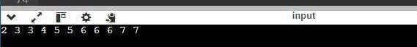

* 1. **heap to build a Priority Queue.**

#include <iostream> #include <vector> using namespace

std; class MaxHeap { private:

vector<int> heap; void heapifyUp(int index) { int parentIndex = (index - 1) / 2; if (index > 0 && heap[index] > heapifyUp(parentIndex);

}

}

void heapifyDown(int index) { int leftChild = 2 * index + 1; int rightChild = 2 * index + 2; int largest = index; if (leftChild < heap.size() && heap[leftChild] > heap[largest]) { largest = leftChild; } if (rightChild < heap.size() && heap[rightChild] > heap[largest]) { largest = rightChild; } if (largest != index) {

swap(heap[index], heap[largest]); heapifyDown(largest);}} public:

void insert(int element) { heap.push_back(element); heapifyUp(heap.size() - 1); } int

extractMax() { if (heap.size() == 0) return 1; int maxElement = heap[0]; heap[0] = heap.back(); heap.pop_back(); heapifyDown(0); return maxElement;

}

void printHeap() {

for (int i : heap) { cout << i << " ";

}cout << endl; } }; class PriorityQueue { private: MaxHeap maxHeap;

public:

void enqueue(int element) { maxHeap.insert(element); } int

dequeue() {

return maxHeap.extractMax(); } void printQueue() {

maxHeap.printHeap(); } }; int

main() { PriorityQueue pq; pq.enqueue(4); pq.enqueue(1); pq.enqueue(3); pq.enqueue(2); pq.printQueue(); cout << "Dequeued: " << pq.dequeue() << endl; pq.printQueue(); return 0;

}

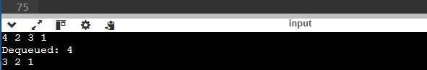

**Experiment-8**

1. **Aim**

To maximize the total value of items placed in a knapsack with a given capacity, allowing for the inclusion of fractional parts of items and Minimum Spanning Tree (MST) for a weighted connected graph, ensuring that all vertices are connected with the minimum possible total edge weight.

### Objective

1. Determine the value-to-weight ratio of each item. 2.Sort items based on their value-to-weight ratios.

1. Select items to fill the knapsack in a greedy manner, taking whole items first and then fractions if necessary
2. Construct a spanning tree that includes all vertices.
3. Ensure that the total weight of the edges in the spanning tree is minimized.
4. Use a greedy approach to build the MST step-by-step.

### 3. Algorithm

###### Fractional Knapsack Problem

Calculate the value-to-weight ratio for each item.

Sort the items in descending order based on the ratio. Initialize total value to 0 and iterate through the sorted items:

* If the item can fit entirely in the knapsack, add its full value and reduce the remaining capacity. ● If the item cannot fit, take the fraction that fits and add the corresponding value.

Return the total value accumulated in the knapsack.

###### Prim's Algorithm for Minimum Spanning Tree

Initialize a key array to store the minimum weight edge for each vertex and a parent array to reconstruct the MST.

Set the key of the first vertex to 0 and all others to infinity. Mark all vertices as not included in the MST.

For V-1 iterations (where V is the number of vertices): ● Select the vertex with the minimum key that has not yet been included in the MST.

* + Mark this vertex as included.
  + Update the key and parent for adjacent vertices if a smaller edge weight is found.

After constructing the MST, print the edges along with their weights

### Implementation

###### Fractional Knapsack Problem

#include <iostream> #include <vector> #include

<algorithm> using namespace std; struct Item { int value; int weight; double ratio;

};

bool compare(Item a, Item b) { return a.ratio > b.ratio;

double fractionalKnapsack(int capacity, vector<Item> items) { for (auto &item : items) {

item.ratio = (double)item.value / item.weight;

}

sort(items.begin(), items.end(), compare); double totalValue = 0.0; for (auto &item : items) { if (capacity <= 0)

break; if (item.weight <= capacity) { totalValue += item.value;

capacity -= item.weight;

} else {

totalValue += item.ratio * capacity; capacity = 0;

}

}

return totalValue;

}

int main() { int n, capacity; cout

<< "Enter number of items: "; cin

>> n;

cout << "Enter capacity of knapsack:

"; cin >> capacity; vector<Item> items(n); for (int i = 0; i < n; i++) {

cout << "Enter value and weight for item " << i + 1 << ": "; cin

>> items[i].value >> items[i].weight;

}

0;

double maxValue = fractionalKnapsack(capacity, items);

cout << "Maximum value in the knapsack;”<<maxValue<<endl;return 0;

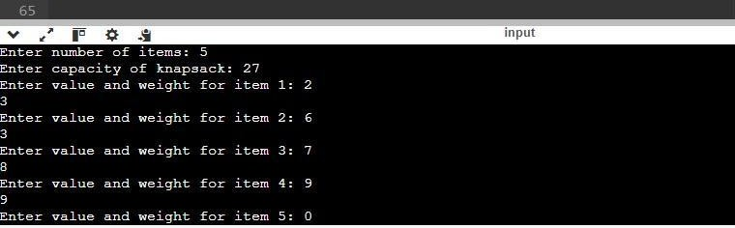

###### Prim's Algorithm for Minimum Spanning Tree

#include <iostream> #include <vector> #include <climits> using namespace std; const int V = 5;

int minKey(int key[], bool mstSet[]) { int min = INT_MAX, min_index;

for (int v = 0; v < V; v++) { if

(!mstSet[v] && key[v] < min) { min = key[v];

min_index = v;

}

}

return min_index;

}

void primMST(int graph[V][V]) { int parent[V];

int key[V];

bool mstSet[V];

for (int i = 0; i < V; i++) { key[i] = INT_MAX;

mstSet[i] = false;

}

key[0] = 0;

parent[0] = -1;

for (int count = 0; count < V - 1; count++) { int u = minKey(key,

mstSet); mstSet[u] = true; for (int v = 0; v < V; v++) {

if (graph[u][v] && !mstSet[v] && graph[u][v] < key[v]) { parent[v] = u;

key[v] = graph[u][v];

}

}

}

cout << "Edge \tWeight\n"; for (int i = 1; i < V; i++) { cout << parent[i] << "

-

" << i << "\t" << graph[i][parent[i]] << " \n";

}

}

int main() { int graph[V][V] = {

{0, 2, 0, 6, 0},

{2, 0, 3, 8, 5},

{0, 3, 0, 0, 7},

{6, 8, 0, 0, 9},

}

{0, 5, 7, 9, 0}

};

primMST(graph); return 0;

}

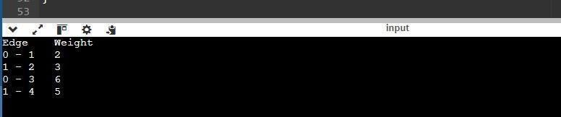

### Experiment-9

1. **Aim**

To efficiently manage and query the connected components of a graph and to find the

Minimum Spanning Tree (MST) for a given weighted connected graph**.**

### Objective

1. Implementing the Union-Find algorithm to detect cycles in an undirected graph.
2. Utilizing the Union-Find data structure to execute Kruskal's algorithm, ensuring efficient cycle detection during the edge selection process

### Algorithm

Initialize: Create parent and rank arrays for all vertices. Find Operation: find(x):

If x is its own parent, return x.

Otherwise, recursively find the root parent of x and apply path compression.

Union Operation: union(x, y):

Find roots of x and y.

Attach the tree with a lower rank to the root of the tree with a higher rank. If

ranks are the same, attach one to another and increment the rank.

###### 2.Kruskal's algorithm for finding the Minimum Spanning Tree

Sort Edges: Sort all edges of the graph in non-decreasing order of their weight.

Initialize: Create a disjoint-set for all vertices. Edge Selection:

For each edge (u, v):

If find(u) != find(v): This ensures no cycle is formed.

Add the edge to the MST. Perform union(u, v).

### 4.Implementation 1. Disjoint Set Data Structure (Union-Find algorithm)

#include <iostream> #include <vector> using namespace std; class DisjointSet { public:

DisjointSet(int n) : parent(n), rank(n, 0) { for (int i = 0; i < n; ++i)

parent[i] = i;

}

int find(int u) { if (u != parent[u]) parent[u] = find(parent[u]); return parent[u];

}

void unionSets(int u, int v)

{ int pu = find(u); int pv = find(v); if (pu != pv) { if

(rank[pu] > rank[pv]) parent[pv] = pu; else if (rank[pu] < rank[pv]) parent[pu] = pv; else { parent[pv] = pu; rank[pu]++;

}

}

}

private:

vector<int> parent; vector<int> rank;

};

bool hasCycle(int V, vector<pair<int, int>>& edges)

{ DisjointSet ds(V); for (auto& edge : edges) { int u = edge.first; int v = edge.second; if (ds.find(u) == ds.find(v)) return true;

ds.unionSets(u, v);

}

return false;

}

int main() { int V = 5;

vector<pair<int, int>> edges = { {0, 1}, {1, 2}, {2, 3}, {3, 4}, {4, 1}

};

if (hasCycle(V, edges)) cout << "Graph contains cycle" << endl;

else

cout << "Graph does not contains cycle" << endl; return 0;

}

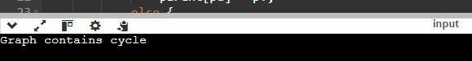

1. **Kruskal's algorithm for finding the Minimum Spanning Tree**

#include

<iostream> #include <vector> #include

<algorithm> using namespace std;

class DisjointSet { public:

DisjointSet(int n) : parent(n), rank(n, 0)

{ for (int i = 0; i < n; ++i) parent[i] = i;

}

int find(int u) { if (u != parent[u]) parent[u] = find(parent[u]); return parent[u];

}

void unionSets(int u, int v) { int pu = find(u); int pv = find(v); if (pu

!= pv) { if (rank[pu]

> rank[pv]) parent[pv] = pu;

else if (rank[pu] < rank[pv]) parent[pu] = pv; else {

parent[pv] = pu; rank[pu]++;

}

}

}

private:

vector<int> parent; vector<int> rank;

};

struct Edge { int u, v, weight;

bool operator<(const Edge& other) const { return weight < other.weight;

}

};

vector<Edge> kruskalMST(int V, vector<Edge>& edges) { DisjointSet ds(V); vector<Edge> mst;

sort(edges.begin(), edges.end()); for (auto& edge :

edges) { if (ds.find(edge.u) != ds.find(edge.v)) { ds.unionSets(edge.u, edge.v); mst.push_back(edge);

}

}

return mst;

}

int main() { int V = 4; vector<Edg e> edges =

{ {0, 1, 10},

{0, 2, 6}, {0,

3, 5}, {1, 3,

15}, {2, 3,

4} };

vector<Edge> mst = kruskalMST(V, edges); cout << "Edges in the Minimum Spanning Tree:" << endl; for (auto& edge : mst)

{ cout << edge.u << " - " << edge.v << " : " << edge.weight << endl;

}

return 0;

}

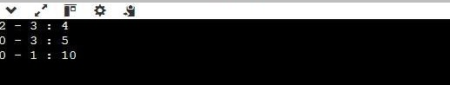

**Experiment-10**

# Dijkstra's algorithm

## Aim

To implement Dijkstra's Algorithm to find the shortest path from a specific source vertex to all other vertices in a weighted connected graph. The graph will be represented in two different formats: a **Weighted Matrix** and an **Adjacency List**..

# Objective

* + 1. **Understand Dijkstra's Algorithm**:
* Review the theory behind Dijkstra's Algorithm, its mechanics, and how it guarantees finding the shortest path in a weighted, connected graph.
  + 1. **Implement Dijkstra’s Algorithm**:
* Develop a working solution for Dijkstra’s Algorithm that finds the shortest path from a single source vertex to all other vertices in a graph.

**2. Graph Representation**:

* **Weighted Matrix Representation**: Implement the algorithm using a 2D matrix where each entry represents the weight of the edge between two vertices. If no edge exists, the weight can be set to infinity.
* **Adjacency List Representation**: Implement the algorithm using a list where each vertex has a list of its neighboring vertices and the corresponding edge weights.

**2. Compare the Two Representations**:

* Compare the performance and ease of implementation of Dijkstra's algorithm using both the **Weighted Matrix** and the **Adjacency List** representations.

1. **Evaluate the Algorithm**:

* Evaluate the time complexity, memory usage, and overall efficiency of the algorithm in both graph representations.

# Algorithm

###### weighted matrix representation

Step1-Initialize dist[] as described above.

Step2-Initialize the priority queue with pairs (dist[u],u)(dist[u], u)(dist[u],u).

Step3-Extract the vertex with the minimum distance dist[u]dist[u]dist[u] from the priority queue.

Step4-For each vertex v, check if there is an edge between u and v (i.e., W[u][v]<∞W[u][v] < \inftyW[u][v]<∞).

* + If so, update the distance dist[v] if a shorter path is found.

Step5-Continue until the priority queue is empty

###### Adjacency List Representation

**Initialize Data Structures**:

* Create an array dist[] of size V to store the shortest distance from the source to each vertex. Initialize all elements to infinity (inf), except for the source vertex, which is initialized to

1. ● Create a boolean array visited[] to track which vertices have been processed.

###### Priority Queue:

* Use a priority queue (min-heap) to store the vertices and their current shortest distance, where the priority is the smallest distance.

###### Main Loop:

* Extract the vertex u with the smallest tentative distance from the priority queue.
* For each neighbor v of vertex u (which is obtained from the adjacency list), calculate the tentative distance dist[u] + weight(u, v). If this distance is smaller than the current distance to v, update dist[v] and add v to the priority queue with the new distance.

###### End Condition:

* Repeat the process until all vertices have been processed or the priority queue is empty.

# 4.Implementation

##### Represent the graph as Weighted

**Matrix**

(Dijkstra's

algorithm) #include

<iostream>

#include <climits> #include <vector> using namespace

std;

int minDistance(const vector<int>& dist, const vector<bool>& sptSet, int

V) {

int min = INT_MAX; int minIndex = -1;

for (int v = 0; v < V; v++) {

if (!sptSet[v] && dist[v] <= min) { min = dist[v];

minIndex = v;

}

}

return minIndex;

}

vector<int> dijkstra(const vector<vector<int>>& graph, int source) {

int V = graph.size(); vector<int> dist(V, INT_MAX);

dist[source] = 0; vector<bool> sptSet(V, false);

for (int count = 0; count < V - 1; count++)

{

int u = minDistance(dist,

sptSet, V); sptSet[u] = true; for (int v = 0; v < V; v++) {

if (!sptSet[v] && graph[u][v] != 0 && dist[u] != INT_MAX && dist[u] + graph[u][v] < dist[v]) {

dist[v] = dist[u] + graph[u][v];

}

}

}

return dist;

}

int main() { vector<vector<int>> graph = {

{0, 2, 0, 1, 0},

{2, 0, 3, 0, 0},

{0, 3, 0, 4, 6},

{1, 0, 4, 0, 2},

{0, 0, 6, 2, 0}

};

int source = 0;

vector<int> shortest_distances

= dijkstra(graph, source);

cout << "Shortest distances from vertex "

<< source << ":\n";

for (int i = 0; i < shortest_distances.size(); i++) {

cout << "To vertex " << i << ":

" << shortest_distances[i] << endl;

}

return 0;

}

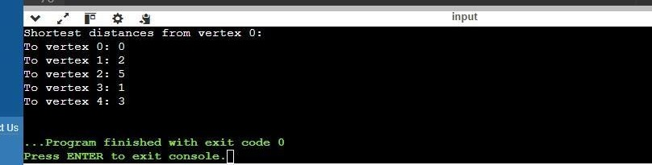

##### Represent the graph as Adjacency List

#include

<iostream>

#include <vector> #include <queue> #include <climits> #include

<functional>

using namespace std; typedef pair<int, int>

pii;

class Graph

{

public:

int V;

vector<vector<pii>> adjList;

Graph(int V)

{ this->V = V;

adjList.resize(V);

}

void addEdge(int u, int v, int weight) { adjList[u].push_back({v, weight}); adjList[v].push_back({u, weight});

}

vector<int> dijkstra(int source) { vector<int> dist(V, INT_MAX); dist[source] = 0;

priority_queue<pii, vector<pii>, greater<pii>> pq; pq.push({0, source});

while

(!pq.empty()) { int u = pq.top().secon d; int d = pq.top().first;

pq.pop();

if (d > dist[u]) { continue

;

}

for (auto& edge : adjList[u]) {

int v = edge.first;

int weight = edge.second;

if (dist[u] + weight < dist[v]) { dist[v] = dist[u] + weight; pq.push({dist[v], v});

}

}

}

return dist;

}

};

int main() {

Graph g(5);

g.addEdge(0, 1, 10);

g.addEdge(0, 2, 5);

g.addEdge(1, 2, 2);

g.addEdge(1, 3, 1);

g.addEdge(2, 3, 9);

g.addEdge(2, 4, 2);

g.addEdge(3, 4, 4);

vector<int> dist = g.dijkstra(0);

cout << "Shortest distances from source (vertex 0):"

<< endl; for (int i = 0; i < dist.size(); ++i) { if (dist[i] == INT_MAX) {

cout << "Vertex " << i << " is unreachable." << endl;

} else { cout << "Vertex " << i << ": " << dist[i] << endl;

}

}

return 0;

}

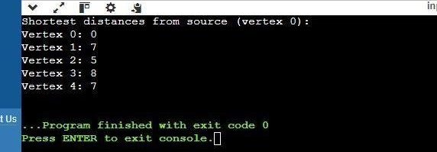

**Experiment -11**

**Fibonacci**

1. **Aim:**

To find the n-th Fibonacci number using the Dynamic Programming approach in C++. The approach will efficiently calculate Fibonacci numbers by storing previously calculated values to avoid redundant calculations, which significantly improves performance over the naive recursive method.

## Objective:

The primary objective of this program is to:

1. Implement the Fibonacci sequence using Dynamic Programming to minimize time complexity.
2. Store intermediate Fibonacci values in a table (array) to reuse them, avoiding redundant calculations.
3. Output the n-th Fibonacci number.

### 3.Algorithm:

###### Initialization:

* Create an array dp[] where dp[i] will store the i-th Fibonacci number.
* Initialize the first two Fibonacci numbers:
* dp[0] = 0 (Fibonacci number 0)
* dp[1] = 1 (Fibonacci number 1)

###### Iterative Calculation:

* For each i from 2 to n, calculate the i-th Fibonacci number using the recurrence relation: dp[i]=dp[i−1]+dp[i−2]dp[i] = dp[i-1] + dp[i-2]dp[i]=dp[i−1]+dp[i−2]
* Store the result of each calculation in the array dp[].

###### Return the n-th Fibonacci number:

* After the loop, the value dp[n] will hold the n-th Fibonacci number.

###### Edge Case:

* If n is 0, return 0.
* If n is 1, return 1

### 4.IMPLEMENTATION:-

**#**include <iostream> #include <vector> using namespace std; int fibonacci(int n) { if (n <= 1) return n; vector<int> dp(n + 1); dp[0] = 0; dp[1] =

1;

for (int i = 2; i <= n; i++) { dp[i]

= dp[i - 1] + dp[i - 2];

}

return dp[n];

}

int main() { int n;

cout << "Enter a number: "; cin >> n;

cout << "The " << n << "-th Fibonacci number is: " << fibonacci(n) << endl; return 0;

}

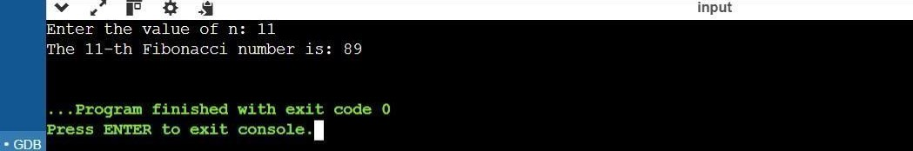

##### Aim:

**LCS**

To implement the Longest Common Subsequence (LCS) algorithm using the Dynamic Programming approach in C++. The goal is to find both the length of the LCS and the actual subsequence(s). If multiple LCS solutions are possible, the algorithm should find and print all such subsequences.

##### Objective:

The main objectives of this program are:

1. To implement the LCS algorithm using Dynamic Programming to efficiently compute the longest common subsequence between two strings.
2. To determine the length of the LCS.
3. To reconstruct and print all possible LCSs if multiple solutions exist.

**3.Algorithm:**

The algorithm for solving the LCS problem using Dynamic Programming can be broken down as follows:

###### Initialization:

* + Given two strings X of length m and Y of length n, create a 2D table dp[m+1][n+1] where dp[i][j] will store the length of the LCS of the first i characters of string X and the first j characters of string Y.

###### Filling the DP Table:

* + If X[i-1] == Y[j-1], then dp[i][j] = dp[i-1][j-1] + 1 (i.e., the current characters are part of the LCS, so we add 1 to the length from the previous characters).
  + If X[i-1] != Y[j-1], then dp[i][j] = max(dp[i-1][j], dp[i][j-1]) (i.e.,

we take the maximum length from either excluding the current character from X or from Y).

###### Length of the LCS:

* + The length of the LCS will be stored in dp[m][n], which represents the length of the longest common subsequence between the two strings.

###### Reconstructing the LCS:

* + Starting from dp[m][n], backtrack to find the actual subsequence(s). If multiple subsequences are possible, follow both possible paths when characters match and store the LCSs.

###### Handling Multiple LCSs:

* + If multiple LCSs are possible, use backtracking to generate all subsequences. Every time we encounter a match, we follow both possible paths (i.e., move up or left in the DP table).

###### Edge Cases:

* + If one or both strings are empty, the LCS length is 0, and the LCS is an empty string.

**4.IMPLEMENTATION:-**

###### #include <iostream> #include <vector> #include <string>

**#include <set> #include <algorithm> using namespace std; int LCSLength(const string& X, const string& Y, vector<vector<int>>& dp) { int m = X.size(); int n = Y.size(); for (int i = 0; i <= m; ++i) { for (int j = 0; j <= n;**

###### ++j) { if (i == 0 || j == 0) { dp[i][j] = 0; // base case } else if (X[i-1] == Y[j-1])

**{ dp[i][j] = dp[i-1][j-1] + 1;**

###### } else { dp[i][j] = max(dp[i-1][j], dp[i][j-1]);

**}**

###### }

**}**

###### return dp[m][n];

**}**

###### void findLCS(int i, int j, const string& X, const string& Y, const vector<vector<int>>& dp, string& currentLCS, set<string>& result) { if (i == 0 || j == 0) { result.insert(currentLCS); // Reached the top-left, insert LCS return;

**} if (X[i - 1] == Y[j - 1]) {**

###### currentLCS.push_back(X[i - 1]); findLCS(i - 1, j

**- 1, X, Y, dp, currentLCS, result); currentLCS.pop_back(); // Backtrack**

###### } else {

**if (dp[i - 1][j] == dp[i][j]) { findLCS(i - 1, j, X, Y, dp, currentLCS, result);**

###### } if (dp[i][j - 1] == dp[i][j]) { findLCS(i, j - 1, X, Y, dp, currentLCS, result);

**}**

###### }

**}**

###### int main() { string X, Y; cout << "Enter first string: "; cin >> X; cout << "Enter second string: "; cin >> Y; int m = X.size(); int n = Y.size();

**// Create DP table for storing lengths of LCS vector<vector<int>> dp(m + 1, vector<int>(n + 1, 0));**

###### // Compute the length of the LCS int lcsLength

**= LCSLength(X, Y, dp); cout << "Length of LCS: " << lcsLength << endl; // Set to store all LCS (to avoid duplicates) set<string> result;**

###### // String to store the current LCS during backtracking string currentLCS; // Backtrack to find all LCS findLCS(m, n, X, Y, dp, currentLCS, result); cout << "All LCS sequences:" << endl; for (const string& lcs : result) { cout << lcs << endl;

**}**

###### return 0;

**}**

**Output** —

