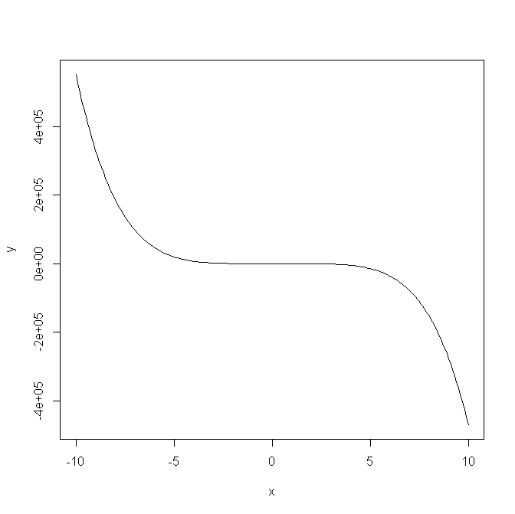Given function

y= -5x5+4x4-12x3+11x2-2x+1

Plot of function: f(x) = y = -5x5+4x4-12x3+11x2-2x+1

# To prove that this function is not a convex function:

For a function to be convex, the following condition must hold:  
**f’’(x) >=0 for all x in the interval [x1,x2]**

Now,  
f(x)=- 5x5+4x4-12x3+11x2-2x+1  
f’(x)= -25x4+16x3-36x2+22x-2  
f’’(x)=-100x3+48x2-72x+22

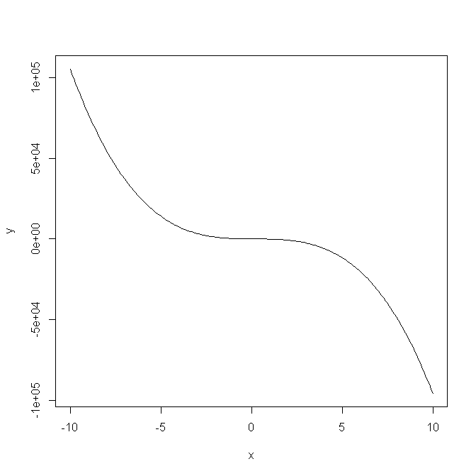So consider the plot for the function: f’’(x)=-100x3+48x2-72x+22

Plot of function: f(x) = y = -100x3+48x2-72x+22

From the graph, it can be seen that function f’’(x) possesses negative values. This proves that the function f(x) is not a convex function..

New Function used for the 3 optimization techniques

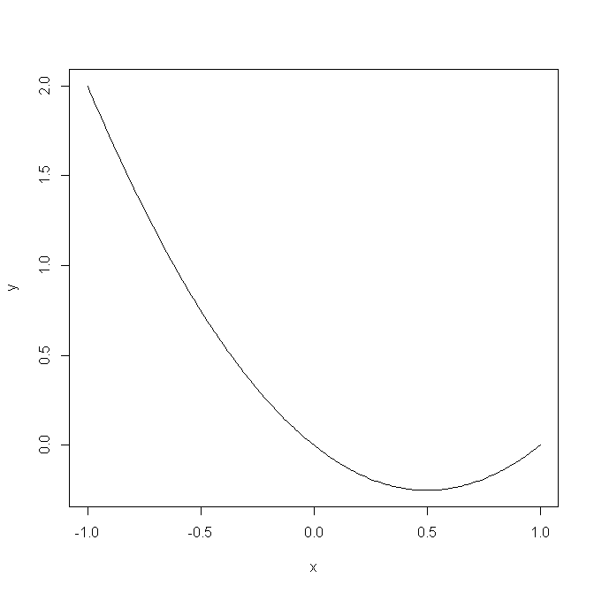y= x2-x

Plot of function: y= x2-x

min(y)= -0.25