Note: beaware of using -> ‘ ‘ …change it

* Launch hive from folder

Ex: 1.create one folder on client side … myhivedata…

2.Load data(txt file, csv file) on that folder

3.Launch hive terminal from that folder…..here launch hive from myhivedata

4.Create database …. Create database mydb

5.Use database

6.Create table…..sample

6.Load data -> load data local inpath ‘abc.txt’ into table sample

Note : in step 6 no need to give path becoz we are launching hive shell from that folder.

**To clear hive terminal : -> !clear;**

Hive Illustration : Basics

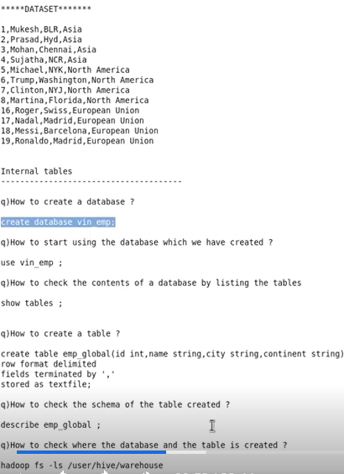

* *To get started with the hive shell,*

hive

* *To check what is present in the HDFS,*

hadoop fs – ls

* *To create a directory in the current path (let’s say the name is ‘foo’),*

hadoop fs - mkdir foo

* *To create a database, in the hive shell (let’s say the name is ‘vin_emp’),*

create database vin_emp;

* *To see existing databases,*

show databases;

* *To start using the database,*

use vin_emp;

* *To check the tables present in the database,*

show tables;

* *To come out of the hive shell,*

quit;

* *to list contents of the current working directory,*

ls

* *To create a directory,*

mkdir myhivedata

* *To navigate into that data,*

cd myhivedata

* *To check the present working directory*

pwd

* *To check the contents of a file (name of the file is employees.txt),*

cat employees.txt

* *To create a table within the hive shell,*

**create table emp_global(id int,name string,city string,continent string)**

**row format delimited**

**fields terminated by ‘ , ‘**

**stored as textfile ;**

* *To check the tables,*

show tables ;

* *To query the table,*

select * from emp_global ;

* *To load data into the table,*

load local inpath ‘employees.txt’ into table emp_global;

* *To drop all tables inside a database,*

drop database vin_emp cascade,

* *To know the schema of the table,*

describe emp_global ;

* *To drop a table,*

drop table emp_global ;

Hive Illustration : External tables in hive

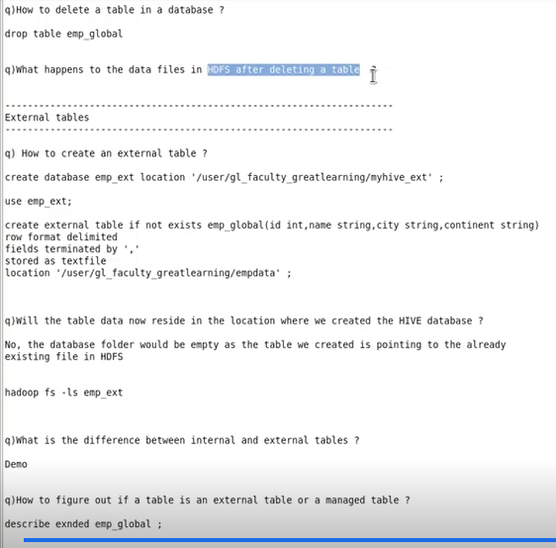

* *To create a database in a certain desired location,*

create database vin_emp_loc location ‘/user/cloudera/myhivedata’ ;

* *To copy a file from local file system to hdfs location,*

hadoop fs – put empglobal.csv empdata

* *To see the contents of the file,*

hadoop df – cat empdata/empglobal.csv

Hive Illustration : Loading different file formats

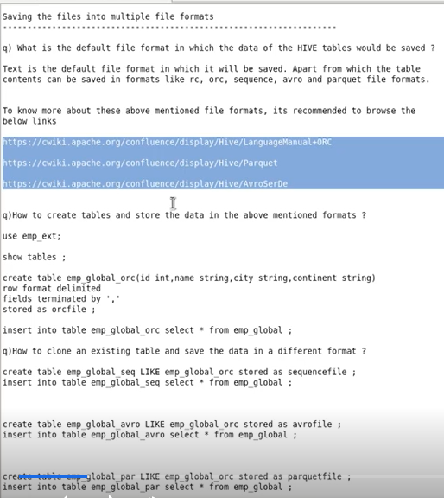

* *How to know what the table type is, whether internal or external,*

describe extended emp_global ;

* *To load the data into orc table,*

insert into table emp_global_orc select * from emp_global ;

* *Create a table whose schema is exactly like an existing table,*

create table emp_global_seq LIKE emp_global_orc stored as sequencefile ;

Hive Illustration : Loading data into Hive tables

**----Load Data (siblings.txt)-----**

Ram,43,India,Laxman

Alice,55,USA,Alex#Tim

Somu,22,India,Sham#Ram

Ted,67,Australia,Kevin#Jincy#Tanya#Kate

* *Create table only if another table of the same name doesn’t exist and an input multiple values in a single column using an array,*

**create table if not exists sibling_data (**

**name string,**

**age int,**

**country string,**

**siblings array<string>)**

**row format delimited**

**fields terminated by '#'**

**collection items terminated by '#'**

**lines terminated by '\n'**

**stored as textfile;**

load data iocal inpath 'siblings.txt' into table sibling_data;

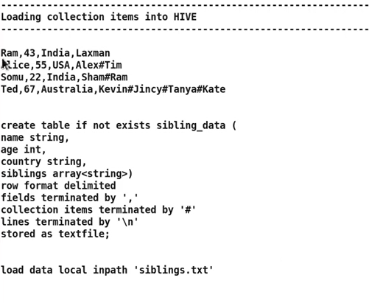

-----------Structure Item loading into hive--------

Maruthi-Suzuki,Swift,Petrol,hatchback#5#5,1197#85.00

Maruthi-Suzuki,Swift,Diesel,hatchback#5#5,1248#83.14

Renault,Duster,Diesel,compact-suv#6,1498#106

* *To create table with multiple inputs of different data type in a single column,*

**create table auto_details(company string, model string, fuel string,**

**basic_specs struct<vehicle_type : string, doors : int, gears : int>,**

**engine_specs struct<cc : int, bhp : double>)**

**row format delimited**

**fields terminated by ‘ , ‘**

**collection items terminated by ‘#’ ;**

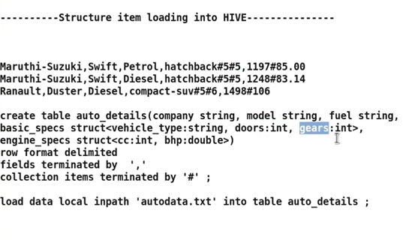

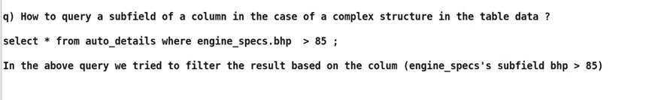

Hive Illustration : Simple Operations on Hive tables

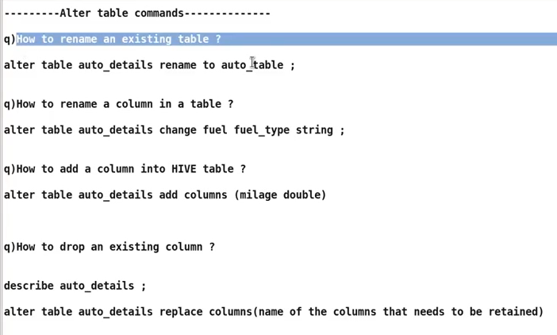

* *To rename an existing table,*

alter table auto_details rename to auto_table ;

* *To change the name of any column,*

alter table auto_details change fuel fuel_type string ;

* *To add a new column to an existing table,*

alter table auto_details add columns (milage double) ;

* *To drop columns,(mention columns which need to remain inside the brackets after “replace” keyword)*

alter table auto_details replace (company string, model string, fuel_type string) ;

Hive Illustration : Query Operations on Hive tables

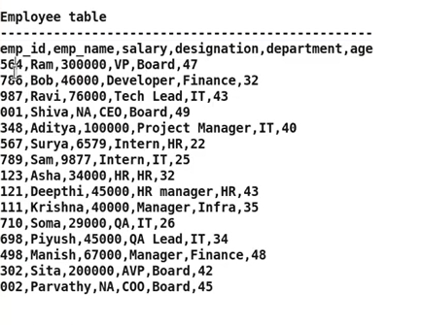

* *To create a table inside a desired pre-existing database, without navigating into the database first*

create table if not exists company.empdata (

empid int,

empname string,

salary double,

designation string,

department string,

salary double,

designation string,

department string,

age int)

row format delimited

fields terminated by ','

lines terminated by '\n'

tblproperties('skip.header.line.count' = '1') ;

load data local inpath ‘empl.txt’ into table empdata;

* *To select all columns and only those rows which satisfy a certain condition,*

select * from empdata where department = “HR” ;

* *To select all columns and only those rows which satisfy more than one condition,*

select * from empdata where department =”HR” and salary > 25000 ;

* *To select only desired columns and only those rows which satisfy more than one condition,*

select empname, age from empdata where department =”HR” and salary > 25000 ;

* *To select all columns and sort the rows based on a desired column,*

select * from empdata order by salary ;

* *To select all columns and sort the rows based on a desired column in descending order,*

select * from empdata order by salary desc ;

* *To count the total number of rows in the dataset,*

select count(*) from empdata ;

* *To use ‘groupby’ to count number of rows based in each category of a certain column,*

select department, count(*) from empdata group by department ;

* *To select all column but only those rows which do not have null value in a desired column,*

select * from empdata where salary is not null ;

* *To select rows by matching a substring with a desired column value,*

select * from empdata where designation rlike “Manager” or rlike “manager” or “Lead” ;

* *To find the average of a desired numerical column, grouped by a categorical column,*

select department, avg(salary) from empdata group by department;

Hive Illustration : Querying complex structures

***# Join Operation on two tables;***

**

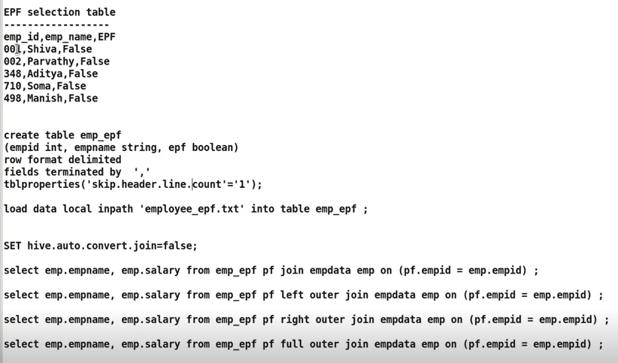

* *To enable join operations in the hive shell,*

SET hive.auto.conveert.join = False;

* *To perform a join operation,*

select emp.empname, emp.salary from emp_epf pf join empdata emp on (pf.empid = emp.empid) ;

* *To perform a left outer join operation,*

select emp.empname, emp.salary from emp_epf pf left outer join empdata emp on (pf.empid = emp.empid) ;

* *To perform a right outer join operation,*

select emp.empname, emp.salary from emp_epf pf right outer join empdata emp on (pf.empid = emp.empid) ;

* *To perform a full outer join operation,*

select emp.empname, emp.salary from emp_epf pf full outer join empdata emp on (pf.empid = emp.empid) ;

Hive Illustration : Views

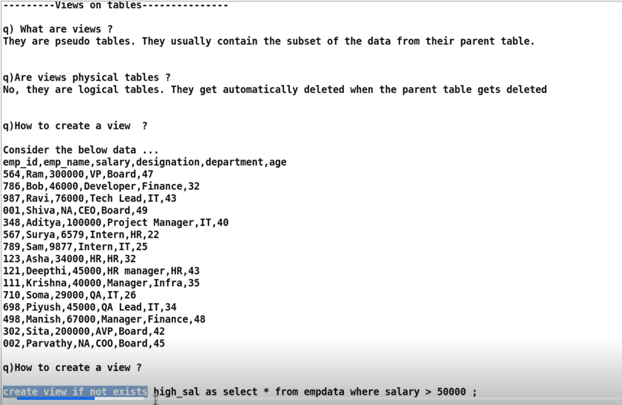

*Note: If parent table (empdata) is deleted then child table(high_sal… view table) will also deleted*

* *To create view,*

create view if not exists high_sal as select * from empdata where salary > 50000 ;

* *To query data from view,*

select * from high_sal ;

* *To see if view is created,*

show tables ;

* *To see the table type, (virtual or Managed),*

describe formatted high_sal ;

* *To create a table, partitioned by a desired column,*

**create table emp_global_part(id int, name string, city string, country string)**

**portioned by (continent string)**

**row format delimited**

**fields terminated by ‘ , ‘**

**stored as textfile ;**

For Practice DATASET:->

Emp_id,Last_name,designation,job_id,hire_date,base_salary,commission,increment_pct

7369,SMITH,CLERK,7902,17-Dec-80,800,\000,20

7499,ALLEN,SALESMAN,7698,20-Feb-81,1600,300,30

7521,WARD,SALESMAN,7698,22-Feb-81,1250,500,30

7566,JONES,MANAGER,7839,02-Apr-81,2975,\000,20

7654,MARTIN,SALESMAN,7698,28-Sep-81,1250,1400,30

7698,BLAKE,MANAGER,7839,01-May-81,2850,\000,30

7782,CLARK,MANAGER,7839,09-Jun-81,2450,\000,10

7788,SCOTT,ANALYST,7566,09-Dec-82,3000,\000,20

7839,KING,PRESIDENT,\000,17-Nov-81,5000,\000,10

7844,TURNER,SALESMAN,7698,08-Sep-81,1500,0,30

7876,ADAMS,CLERK,7788,12-Jan-83,1100,\000,20

7900,JAMES,CLERK,7698,03-Dec-81,950,\000,30

7902,FORD,ANALYST,7566,03-Dec-81,3000,\000,20

7934,MILLER,CLERK,7782,23-Jan-82,1300,\000,10

7333,ALAN,CLERK,7783,30-Apr-80,1600,\000,10

7342,MAYIM,ANALYST,7566,30-Apr-80,3150,\000,10

7975,KUNAL,SALESMAN,7698,15-Sep-82,1300,250,20

7432,FROST,MANAGER,7839,15-Sep,2600,\000,30

7916,GILL,CLERK,7782,19-Jan-81,800,\000,10

7730,NAOMI,CLERK,7902,01-Jan-80,1000,\000,20