Synopsis
Heart Disease Prediction Using Machine Learning Techniques

PBL Phase-3 Report

Problem Id: 13

Student Name | Tushar Srivastava  Yuvraj Singh  Udit Joshi
University Roll number | 2028887  2028915  2028891
Section | Section-P
Project Topic | Heart Disease Prediction Using Machine Learning Techniques

1. Problem Description
The third phase of the project focuses on final model selection, testing different train-test split ratios and creating a simple user input based heart disease prediction system. The project uses the final_data.csv dataset prepared in Phase 1 and the best performing approach observed in Phase 2.

1.1 Dataset Used
Item | Value
Dataset file | final_data.csv
Input features | blood_pressure, cholesterol, blood_sugar, max_heart_rate, oldpeak, smoking, family_history, chest_pain
Target | heart_disease
Final model | Logistic Regression

2. Final Phase Workflow
- Load final_data.csv.
- Separate features and target column.
- Test Logistic Regression with different split ratios: 80-20, 70-30 and 60-40.
- Use StandardScaler before model training.
- Generate confusion matrices for each split ratio.
- Plot split ratio vs accuracy comparison graph.
- Train final Logistic Regression model.
- Create a prediction function that takes user input for health parameters and predicts heart disease risk.

3. Final Model Used
Logistic Regression is selected as the final model because it achieved the highest accuracy in Phase 2. It is simple, fast, interpretable and suitable for binary classification tasks like heart disease prediction.

4. Evaluation Metrics Used
- Accuracy: Used to compare the performance of different train-test split ratios.
- Classification Report: Used to display precision, recall and F1-score for both classes.
- Confusion Matrix: Used to show correct and incorrect predictions.

5. Results and Visualizations from Code
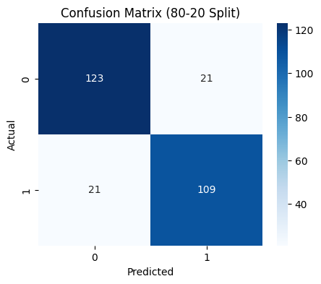
Figure 1: Confusion matrix for 80-20 train-test split.
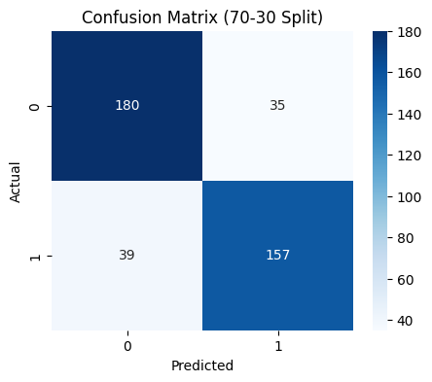
Figure 2: Confusion matrix for 70-30 train-test split.
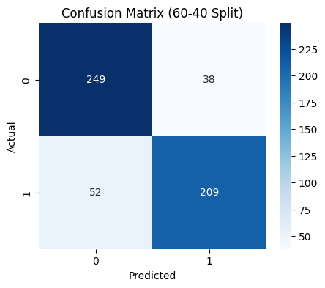
Figure 3: Confusion matrix for 60-40 train-test split.
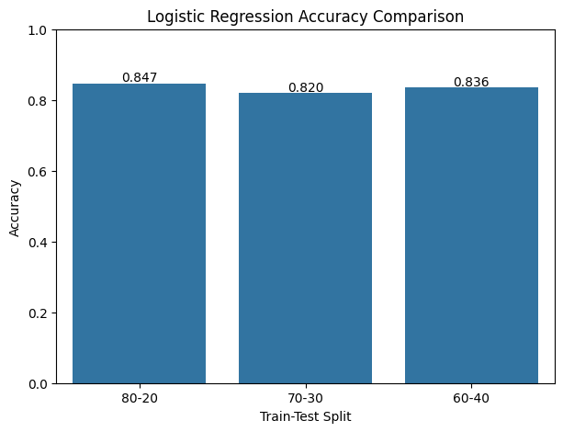
Figure 4: Accuracy comparison for different train-test split ratios.

6. Final Prediction System
The final code includes a function named predict_heart_disease(). This function asks the user to enter values such as blood pressure, cholesterol, blood sugar, maximum heart rate, oldpeak, smoking, family history and chest pain. These values are converted into a DataFrame, scaled using the trained StandardScaler and passed to the final Logistic Regression model for prediction.
If the model output is 1, the system predicts that heart disease may be present. If the model output is 0, the system predicts no heart disease.

7. Conclusion and Future Scope
This project successfully builds a heart disease prediction system using machine learning. After cleaning and selecting important features, several models are trained and compared. Logistic Regression is selected as the final model because it provides the best accuracy in the project code. The final phase also demonstrates how the model can be used for user input based prediction.
In future, the project can be improved by using real medical datasets, adding more clinical features, applying hyperparameter tuning and deploying the prediction system as a web application.

8. References
- Scikit-learn Official Documentation
- Pandas Official Documentation
- Matplotlib Documentation
- Seaborn Documentation
- GeeksforGeeks Machine Learning Tutorials

