Synopsis
Heart Disease Prediction Using Machine Learning Techniques

PBL Phase-1 Report

Problem Id: 13

Student Name | Tushar Srivastava  Yuvraj Singh  Udit Joshi
University Roll number | 2028887  2028915  2028891
Section | Section-P
Project Topic | Heart Disease Prediction Using Machine Learning Techniques

1. Problem Statement
The aim of this project is to develop a machine learning based system that can predict the presence of heart disease using patient health parameters. The system uses a synthetic heart disease dataset generated and processed in the project code. The dataset contains medical and lifestyle-related features such as blood pressure, cholesterol, blood sugar, maximum heart rate, oldpeak, smoking, family history and chest pain.
In Phase 1, the main focus is dataset creation, loading, cleaning, exploratory data analysis and feature selection. The code checks the shape of the dataset, column names, missing values, duplicate records, statistical summary and outliers. After cleaning, the processed dataset is saved as final_data.csv for model training in the next phase.

2. Dataset Description
Item | Value
Total rows before cleaning | 3000
Total columns | 16
Rows after null and outlier handling | 1370
Target column | heart_disease
Final saved file | final_data.csv
The original dataset contains 16 columns. After correlation analysis and feature selection, 8 important input features are retained for final model training.
- blood_pressure
- cholesterol
- blood_sugar
- max_heart_rate
- oldpeak
- smoking
- family_history
- chest_pain

3. Phase 1 Workflow
- Import required libraries: NumPy, Pandas, Matplotlib, Seaborn and Scikit-learn preprocessing tools.
- Load dataset.csv into a Pandas DataFrame.
- Display dataset head, shape, columns and statistical summary.
- Check missing values and duplicate rows.
- Drop null values and remove outliers using numeric columns.
- Select important features using correlation with the target variable.
- Visualize data using box plots, histograms, KDE plots, heatmap and count plot.
- Save the final cleaned dataset as final_data.csv.

4. Libraries Used
- NumPy: Used for numerical operations and array handling.
- Pandas: Used for reading CSV files, cleaning data and working with DataFrames.
- Matplotlib: Used for basic visualization and plotting.
- Seaborn: Used for statistical visualizations like box plot, heatmap and count plot.
- Scikit-learn: Used for preprocessing and feature selection support.

5. Exploratory Data Analysis and Visualizations
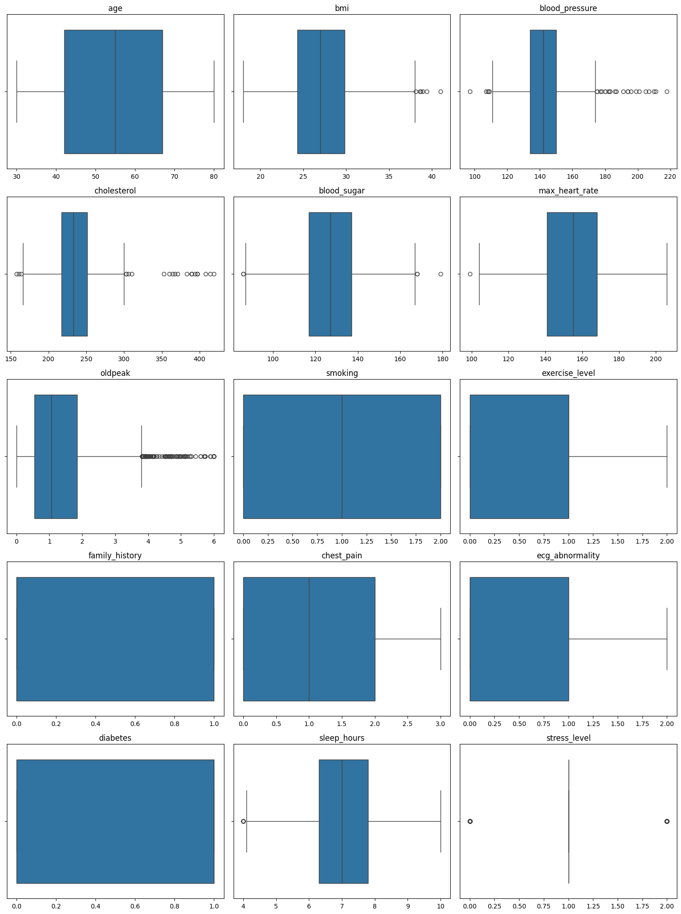
Figure 1: Box plots of numerical columns before outlier removal.
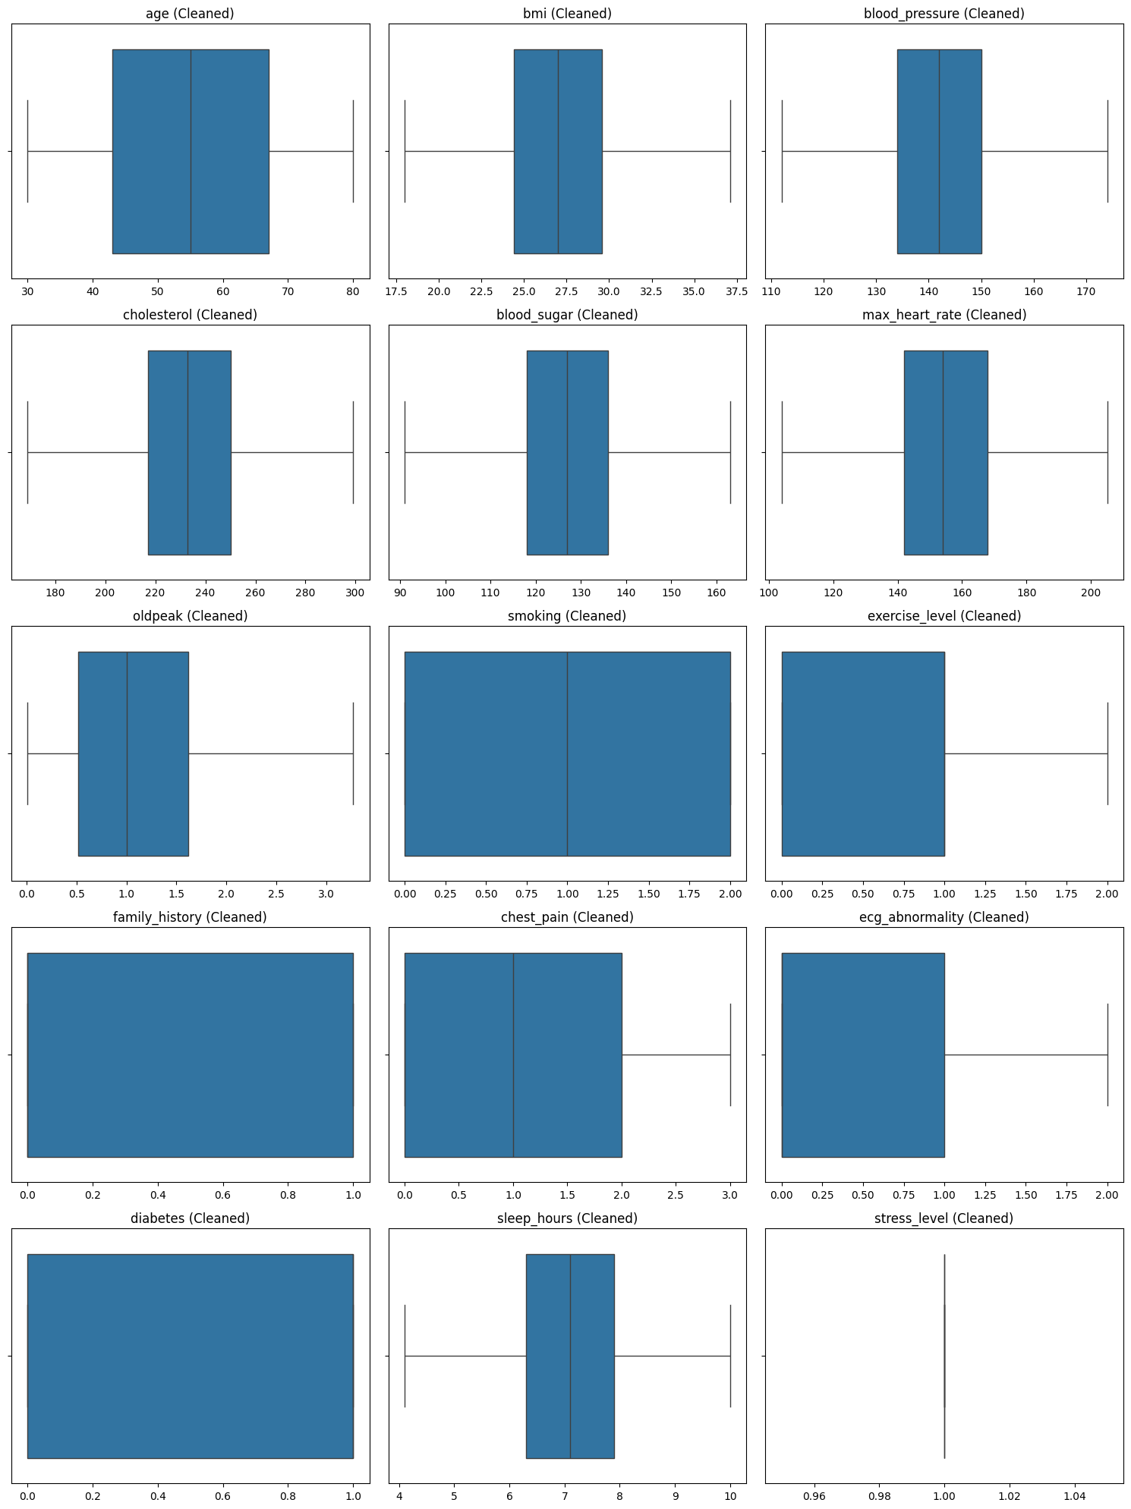
Figure 2: Box plots of numerical columns after outlier removal.
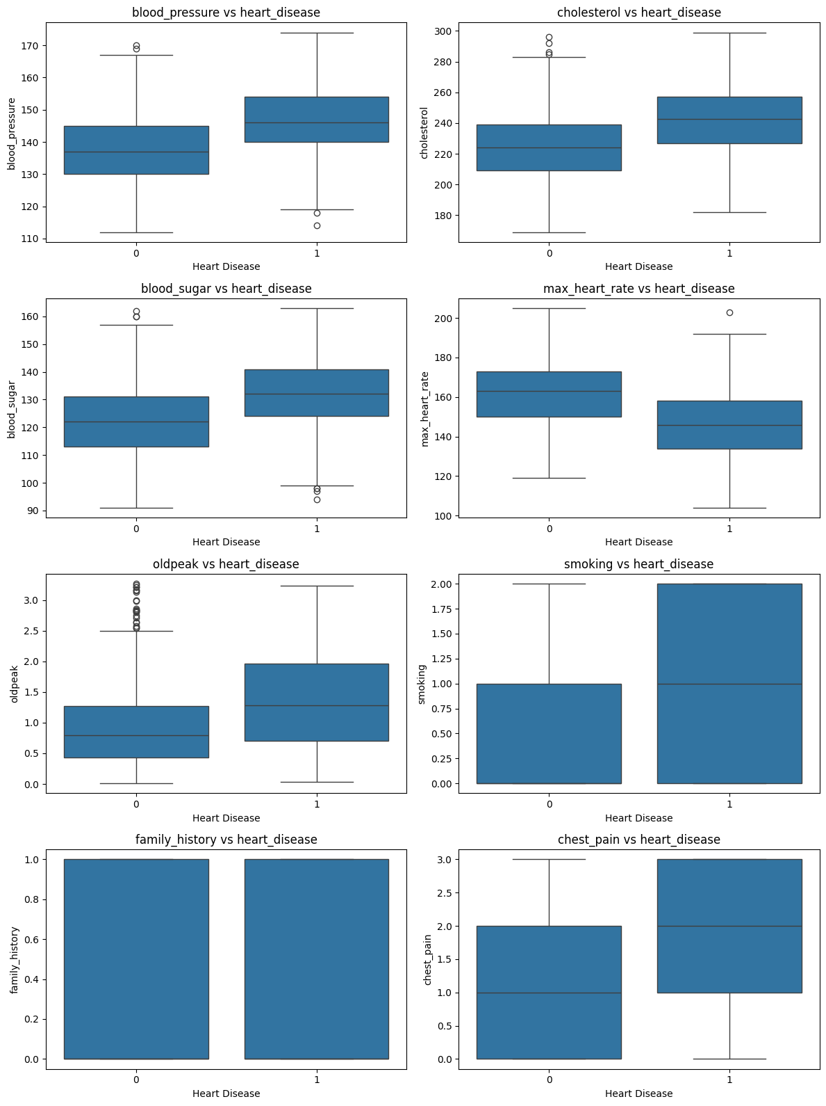
Figure 3: Histogram plots of selected final features.
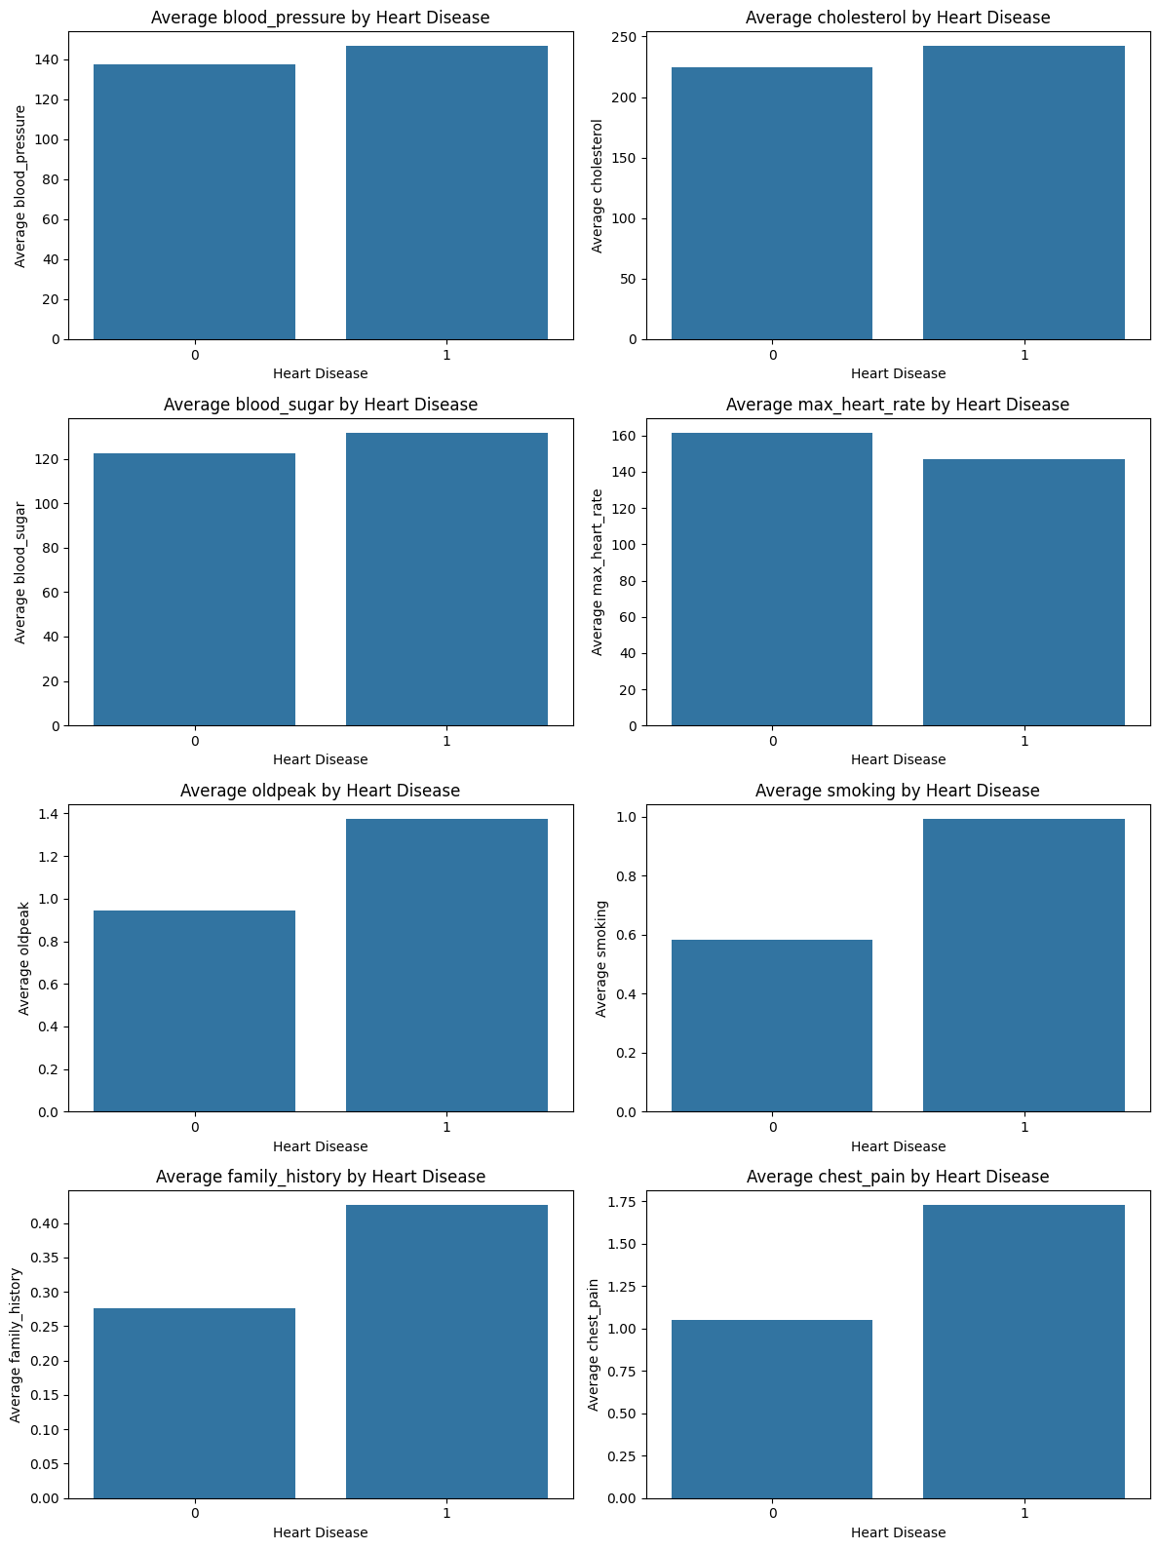
Figure 4: KDE plots of selected final features.
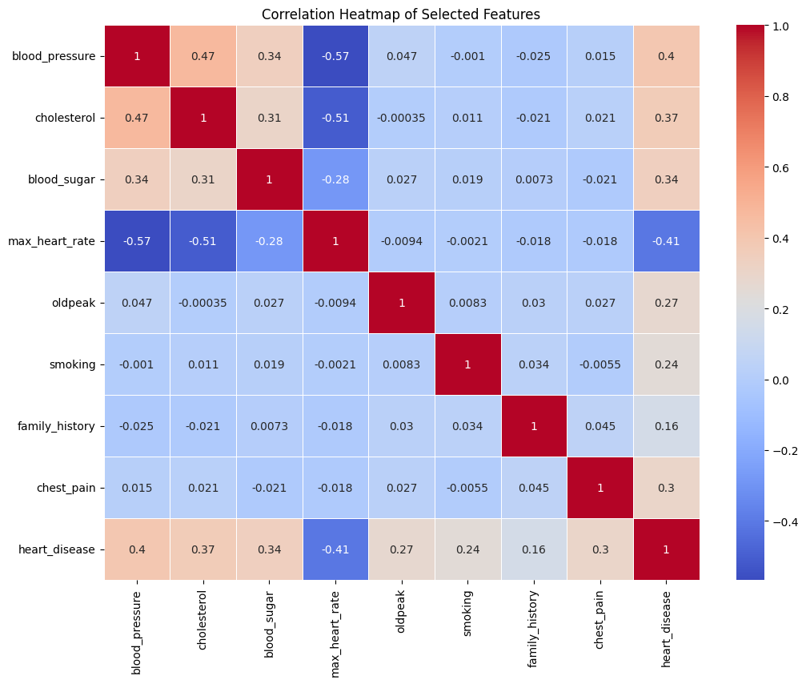
Figure 5: Correlation heatmap of final features and target column.
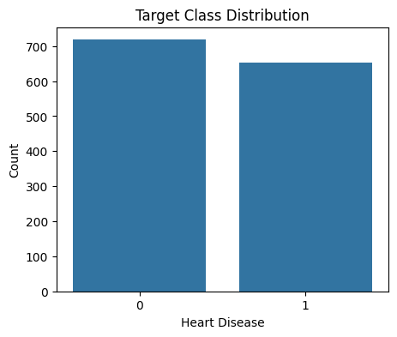
Figure 6: Target class distribution for heart_disease.

6. Conclusion
Phase 1 successfully prepares the heart disease dataset for machine learning. Missing values are removed, outliers are handled, important features are selected and the final cleaned dataset is saved for Phase 2 model training. The graphs used in this report are taken from the project notebook outputs.

7. References
- Scikit-learn Official Documentation
- Pandas Official Documentation
- Matplotlib Documentation
- Seaborn Documentation
- GeeksforGeeks Machine Learning Tutorials

