Synopsis
Heart Disease Prediction Using Machine Learning Techniques

PBL Phase-2 Report

Problem Id: 13

Student Name | Tushar Srivastava  Yuvraj Singh  Udit Joshi
University Roll number | 2028887  2028915  2028891
Section | Section-P
Project Topic | Heart Disease Prediction Using Machine Learning Techniques

1. Problem Description
The second phase of the project focuses on training and comparing multiple machine learning classification models for heart disease prediction. The cleaned dataset generated in Phase 1 is loaded from final_data.csv. The selected features are used as input variables and the target column heart_disease is used as the output variable.
The code performs train-test splitting, feature scaling using StandardScaler, model training, prediction and evaluation. The models used in the code are Logistic Regression, Support Vector Classifier, Random Forest Classifier, K-Nearest Neighbors and Decision Tree Classifier.

1.1 Dataset Used
Item | Value
Dataset file | final_data.csv
Rows | 1370
Input features | 8
Target | heart_disease
Train-test split | 80-20 with stratify=y

2. Architecture / Workflow
- Load final_data.csv.
- Separate features X and target y.
- Apply train_test_split with 20% test data.
- Scale training and testing data using StandardScaler.
- Train five classification models.
- Predict output on the test set.
- Evaluate models using accuracy, precision, recall, F1-score, classification report and confusion matrix.
- Compare model performance using bar graphs.

3. Models Used
1. Logistic Regression: Logistic Regression is used as a baseline classification model. It predicts the probability of heart disease and gives strong performance on the cleaned dataset.
2. Support Vector Classifier (SVC): SVC is used to classify the data by finding an effective separating boundary between classes after scaling the features.
3. Random Forest Classifier: Random Forest is an ensemble learning method that combines multiple decision trees to improve prediction reliability.
4. K-Nearest Neighbors (KNN): KNN classifies a new data point based on the majority class among its nearest neighbors.
5. Decision Tree Classifier: Decision Tree creates rule-based splits in the data to classify patients into heart disease or no heart disease categories.

4. Evaluation Metrics Used
- Accuracy: Overall percentage of correct predictions.
- Precision: Out of all predicted positive cases, how many are actually positive.
- Recall: Out of all actual positive cases, how many are correctly identified.
- F1-score: Harmonic mean of precision and recall.
- Confusion Matrix: Shows true positives, true negatives, false positives and false negatives.

5. Model Performance Results
Model | Accuracy | Precision | Recall | F1 Score
Logistic Regression | 0.8504 | 0.8450 | 0.8385 | 0.8417
SVC | 0.8467 | 0.8385 | 0.8385 | 0.8385
Random Forest | 0.8358 | 0.8295 | 0.8231 | 0.8263
KNN | 0.8175 | 0.8390 | 0.7615 | 0.7984
Decision Tree | 0.7445 | 0.7500 | 0.6923 | 0.7200
According to the code output, Logistic Regression gives the best accuracy among the tested models.

6. Visualizations from Code
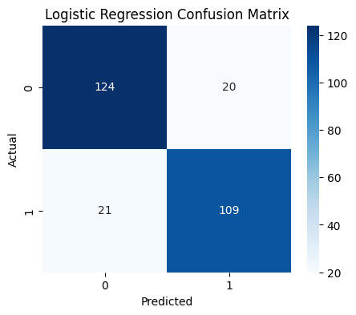
Figure 1: Logistic Regression confusion matrix.
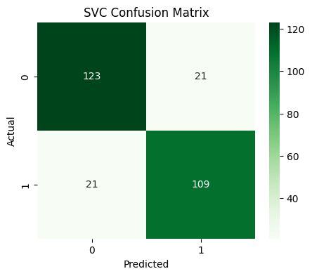
Figure 2: SVC confusion matrix.
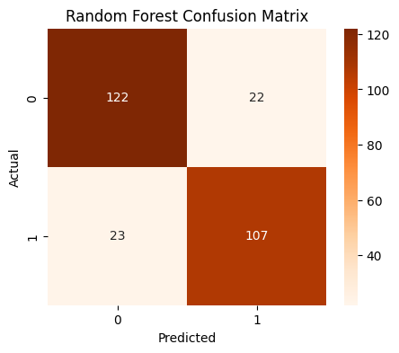
Figure 3: Random Forest confusion matrix.
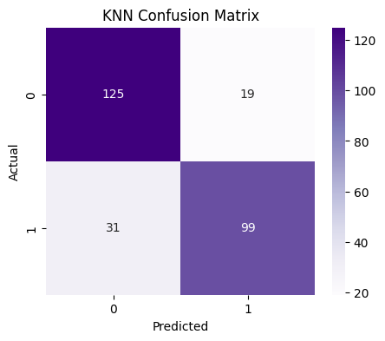
Figure 4: KNN confusion matrix.
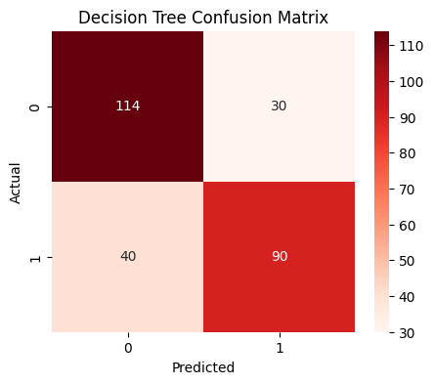
Figure 5: Decision Tree confusion matrix.
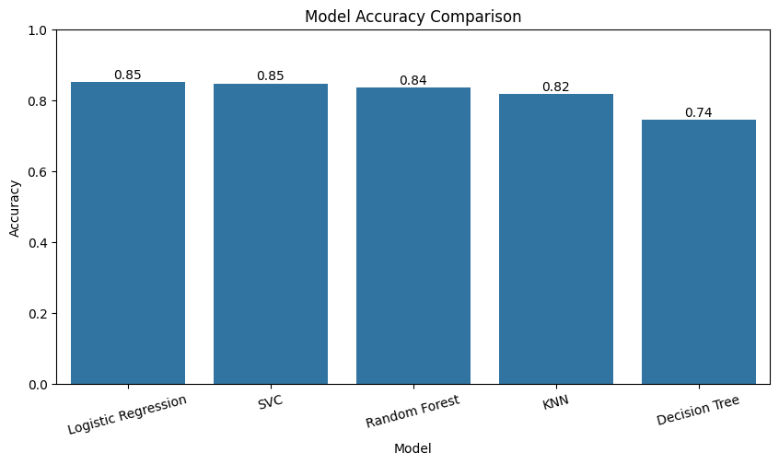
Figure 6: Model accuracy comparison graph.
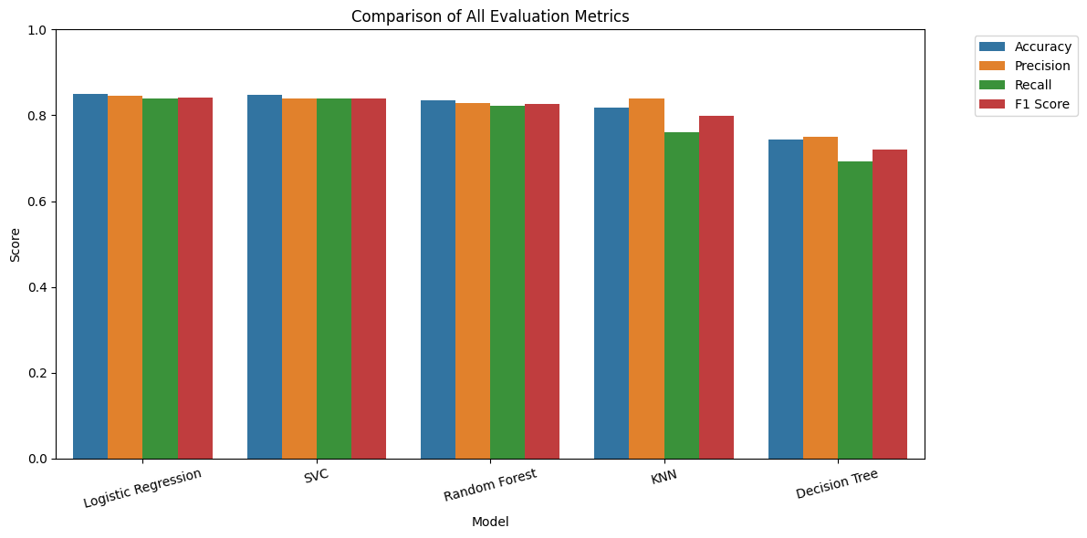
Figure 7: Comparison of accuracy, precision, recall and F1-score for all models.

7. Conclusion
Phase 2 compares multiple machine learning models using the same cleaned dataset. Logistic Regression performs best with approximately 85.04% accuracy, followed by SVC and Random Forest. These results show that proper preprocessing and scaling help classification models perform effectively on the heart disease prediction task.

8. References
- Scikit-learn Official Documentation
- Pandas Official Documentation
- Matplotlib Documentation
- Seaborn Documentation
- GeeksforGeeks Machine Learning Tutorials

