To login you have to input emplyee’s ID and press login button.

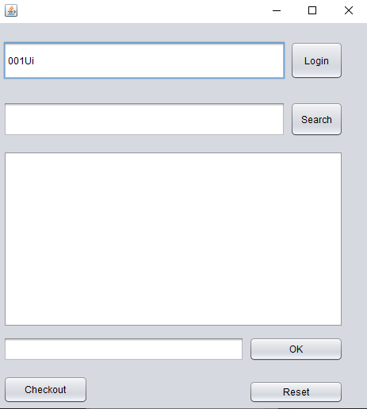

After you log in you can search by product key. It will show the stock and unit price.

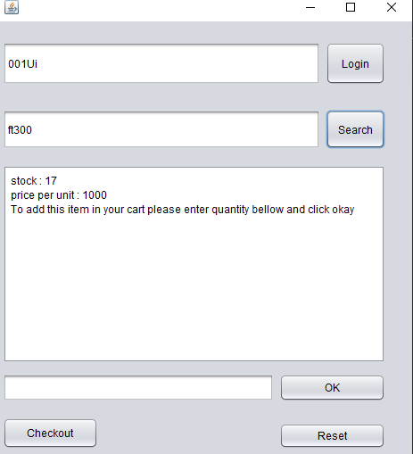

After that you have to select the quantity and press okay. It will add to a checkout.txt file.

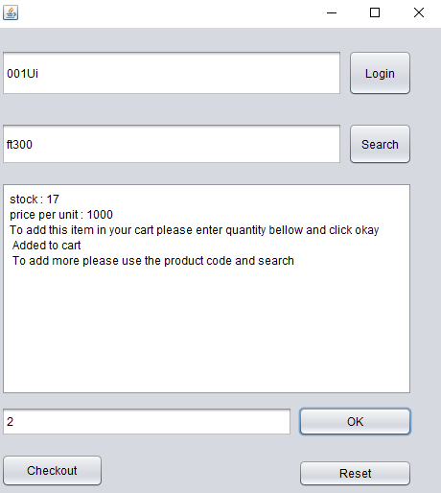

Then when you will proceed to checkout it will show you the entire cart.

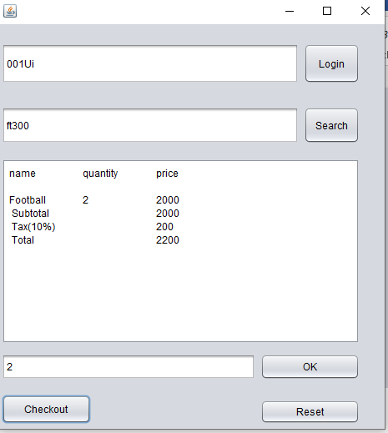

It will be final checkout and using reset button you can reset everything.