**DE-CENTRALISED G DRIVE**

**A PROJECT REPORT**

***Submitted by***

Tushar (20BCS3793)

***in partial fulfilment for the award of the degree of***

**BACHELOR OF ENGINEERING**

**IN**

COMPUTER SCIENCE ENGINEERING



### Chandigarh University

MARCH 2023



**BONAFIDE CERTIFICATE**

Certified that this project report **“DE-CENTRALISED G DRIVE”** is the bonafide work of “**Tushar”** who carried out the project work under my/our supervision.

|  |  |
| --- | --- |
| <<Signature of the HoD>>  **SIGNATURE**    Dr. Sandeep Singh Kang    **HEAD OF THE DEPARTMENT**    Department of Computer Science and  Engineering | <<Signature of the Supervisor>>  **SIGNATURE**    Ms. Malik Anum Manzoor    **SUPERVISOR**  Assistant Professor    Department of Computer Science |

and Engineering

Submitted for the project viva-voce examination held on

**INTERNAL EXAMINER EXTERNAL EXAMINER**

### ACKNOWLEDGEMENT

I would like to express my profound gratitude to Ms. Malik Anum Manzoor (E14644) (Supervisor of Chandigarh University for their contributions to the completion of my project titled De-Centralised G Drive.

I would like to express my special thanks to our mentors for the time and efforts they provided throughout the year. Your useful advice and suggestions were really helpful to me during the project’s completion. In this aspect, I am eternally grateful to them.

I would like to acknowledge that this project was completed entirely by us and not by someone else.

**TABLE OF CONTENTS**

List of Figures i

List of Tables ii

Abstract iii

Graphical Abstract iv

Abbrevations v

### Chapter 1 Introduction 09

**1.1** Client Identification/Need Identification/Identification 09

of relevant Contemporary issue

**1.2** Identification of Problem 10

**1.3** Identification of Tasks 10

**1.4** Timeline 11

**1.5** Organization of report 11

### Chapter 2Literature Survey

**2.1** Introduction to De centralized g drive 13

**2.2** Functionalities provided by De centralized g drive. 14

**2.3** Scope of the project 15

**2.4** Modules of De centralized g drive 16

**2.5** Conclusion 16

**List of Figures**

**Figure 1.** Graphical abstract **………………………………………………………….07**

**Figure 2**. Project timeline **…………………………………………………………….11**

**ABSTRACT**

The project entitled “Decentralized G drive” is a P2P network where each node provides the storage service to the client’s data. The developed system is concerned with storing parts of a single encrypted file, each part being stored on different nodes such that only client can retrieve the parts to remake the original file.

The purpose of the system is to experiment and demonstrate a working Secure File Storage System for small sized credential files, based upon the Cryptography and Blockchain technology. The P2P network is designed using the Kademlia protocol that allows each node to join and leave the network anytime, identify it’s closest nodes, update it’s routing table and search for any node. Using different cryptography and network algorithms a new protocol for such a system has been implemented in this project. Using blockchain to apply Service Term Agreement, files can be chunked and distributed to a completely decentralized storage network without any loss of accountability and integrity.

The project has been successfully deployed and tested for Android client by maintaining a P2P network of several nodes. However it is evident that a web application can be more feasible for large size files and Android application for small sized files and portability

**GRAPHICAL ABSTRACT**

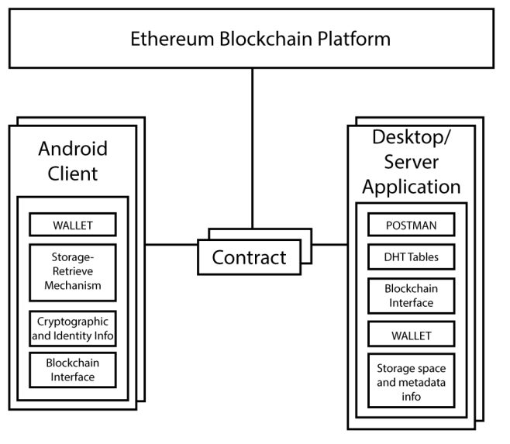

*Figure 1: Graphical abstract*

**ABBREVIATIONS**

**Abbreviation Description**

# CHAPTER 1.

# INTRODUCTION

# 1.1. Client Identification/Need Identification/Identification of relevant Contemporary issue

* **Client Identification:**

The client in this scenario is likely to be a company or organization that uses Google Drive as a central storage location for their files and documents. The client may be experiencing issues with the centralized nature of Google Drive, such as slow access times, limited storage space, or security concerns.

* **Need Identification:**

The need for a decentralized Google Drive arises from the limitations of a centralized system. With a centralized system, all files and documents are stored in one location, which can lead to slow access times, limited storage space, and security concerns. By decentralizing Google Drive, files and documents can be stored on multiple servers or devices, improving access times, increasing storage space, and enhancing security.

* **Identification of relevant contemporary issue:** One relevant contemporary issue for decentralizing Google Drive is the growing concern over data privacy and security. As more and more organizations store sensitive data in the cloud, there is an increased risk of data breaches and cyber-attacks. Decentralizing Google Drive can help to mitigate these risks by distributing files and documents across multiple devices and servers, making it more difficult for hackers to access sensitive information. Additionally, decentralization can help to address concerns over government surveillance and data ownership by putting control back in the hands of the individual user.

‘

# 1.2. Identification of Problem

One of the main problems with a centralized Google Drive is that it can lead to slow access times and limited storage space. When all files and documents are stored in one central location, it can become difficult for multiple users to access them simultaneously, leading 8 to slow loading times and delays in productivity. Additionally, as more files and documents are added to the central location, storage space can become limited, making it necessary to purchase additional storage or delete older files to make room for new ones.

Another problem with a centralized Google Drive is security concerns. If all files and documents are stored in one location, it can become a target for cyber-attacks and data breaches. Hackers can gain access to the central location and steal sensitive information or even delete important files. This can lead to a loss of data and can have serious consequences for the organization, such as legal liabilities, financial losses, and damage to reputation.

Furthermore, a centralized Google Drive can create issues with data ownership and control. When an organization relies on a centralized system, they are essentially putting their data in the hands of a third-party provider, which can create issues around ownership and control. Additionally, government surveillance can also be a concern, as centralized systems can be more easily targeted by government agencies seeking access to sensitive data.

# 1.3. Identification of Tasks

The whole project is divided into three modules. And the description of the modules is given below –

* The first module is the smart contract part of the project that includes instructions and rules on which the block chain project work
* The second module is the back-end part and hardhat part in which we debug and deploy all components together to work successfully.
* The third module is the review, then testing and hosting.

# 1.4. Timeline

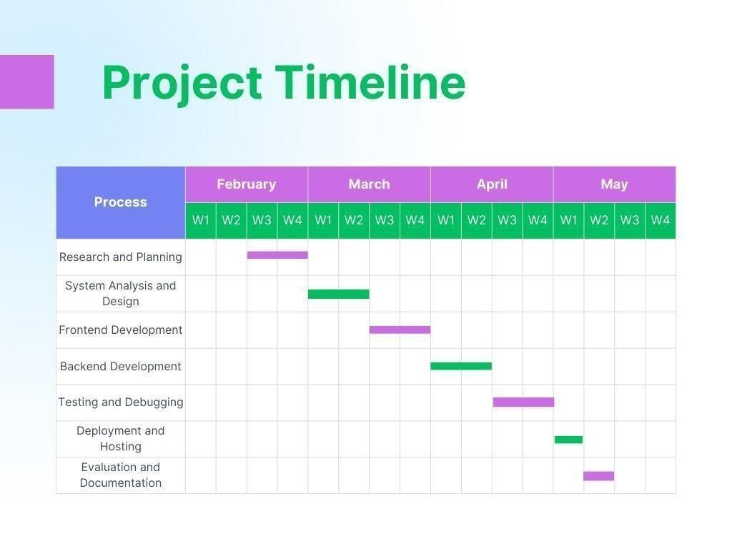

*Figure 2: Project timeline*

# 1.5. Organization of the Report

* Introduction: This chapter will provide an overview of the project, including the background and problem statement, objectives, scope and limitations, and methodology.
* Literature Review: This chapter will review the existing literature on online de centralized cloud storage, and identify the technologies and tools that are relevant to the project.
* System Analysis and Design: This chapter will describe the system requirements and use case analysis, as well as the design of the system architecture and database.
* Implementation: This chapter will discuss the development of the frontend and backend of the web application, as well as their connectivity with the database.
* Results and Evaluation: This chapter will present the evaluation of the system's performance, including user feedback and satisfaction, and comparison with existing solutions.
* Conclusion and Future Work: This chapter will summarize the project, discuss the limitations and challenges, and provide recommendations for future work and improvements.

# CHAPTER 2

# LITERATURE SURVEY

## 2.1 Introduction to the De Centralized G drive.

A decentralized G drive is a cloud storage system that operates on the principles of decentralization, making it distinct from centralized cloud storage services. The decentralized G drive enables users to store data and files on a decentralized network of computers, also known as nodes, instead of relying on a single centralized server.

Centralized cloud storage services are often controlled by a single entity, which is responsible for storing and managing user data. In contrast, decentralized cloud storage systems rely on a network of nodes that work together to store, manage, and retrieve user data. Each node on the network stores a small portion of the data, making it nearly impossible for any single entity to control or manipulate the data stored on the network.

The decentralized G drive offers several advantages over centralized cloud storage services. First, it offers greater security and privacy. Decentralized storage systems use encryption to secure user data and ensure that it remains private. Unlike centralized cloud storage services, where user data can be accessed by the service provider and third-party entities, decentralized storage systems give users complete control over their data.

Second, decentralized storage systems offer greater reliability and availability. In a centralized storage system, if the server goes down, users are unable to access their data. In contrast, decentralized storage systems distribute data across multiple nodes, ensuring that the data remains available even if some nodes go offline.

Finally, decentralized storage systems offer greater scalability. In a centralized storage system, the server has a limited amount of storage space, which can quickly become filled. In contrast, decentralized storage systems can easily scale to accommodate additional users and data by adding more nodes to the network.

One example of a decentralized G drive is Storj, a cloud storage platform that enables users to store data on a distributed network of nodes. Storj uses a combination of encryption, erasure coding, and blockchain technology to ensure that user data remains secure, private, and accessible.

Storj works by breaking user data into small pieces and distributing it across multiple nodes on the network. Each node stores a small portion of the data, and the network uses erasure coding to ensure that even if some nodes go offline, the data can still be retrieved. Storj also uses blockchain technology to manage access to user data and ensure that only authorized users can access it.

Another example of a decentralized G drive is IPFS, or the InterPlanetary File System. IPFS is a peer-to-peer network that enables users to store and share files in a decentralized manner. IPFS works by breaking files into small pieces, known as content-addressed chunks, and distributing them across multiple nodes on the network. IPFS also uses encryption to ensure that user data remains private and secure.

In conclusion, a decentralized G drive is a cloud storage system that offers several advantages over centralized cloud storage services. Decentralized storage systems are more secure, reliable, and scalable than centralized storage systems, and they give users greater control over their data. Examples of decentralized G drives include Storj and IPFS, which use a combination of encryption, erasure coding, and blockchain technology to ensure that user data remains secure, private, and accessible.

# Functionalities provided by De Centralized G drive.

* Distributed Storage: A decentralized Google Drive could store files across a distributed network of computers, rather than on a centralized server. This could help to increase security and resilience, as there is no single point of failure.
* End-to-end Encryption: To protect the privacy of user data, a decentralized Google Drive could offer end-to-end encryption, meaning that files would be encrypted on the user's device and could only be decrypted by the recipient.
* Blockchain-based Authentication: Decentralized authentication using blockchain technology could help to eliminate the need for centralized authentication servers and make it easier for users to maintain control over their own data.
* Decentralized Collaboration: A decentralized Google Drive could enable users to collaborate on files without the need for a centralized server. This could be achieved through peer-to-peer networking, where users communicate directly with one another.
* Cryptocurrency Integration: With the use of blockchain technology, a decentralized Google Drive could potentially integrate a cryptocurrency payment system to enable users to pay for storage and other services.
* Open Source: A decentralized Google Drive could be developed as an open-source project, allowing developers to contribute and customize the software to suit their needs. This could help to foster innovation and enable the platform to evolve over time.

# 2.3 Scope of the project

In this project, we propose a limited version of a working decentralised database system using decentralized network and blockchain. This project however does not include the complete bandwidth optimization algorithms, sophisticated NAT traversal algorithms and complete analysis of the security in each layer of the network stack. The scope of the project is limited to show viability of decentralized database system using blockchain and smart contracts. We will discuss the optimization techniques in the report at the end of the project but the implementation is out of scope. Decentralized Secure Storage is a very needed feature in today’s world where high value data needs to be securely stored in web.

* The scope of this project can be found in any organisation or individual needs where security of the data or information is paramount. For example: Banks, Individuals, different Organizations etc.
* It can also be used in saving the Bandwidth of the Central Server.
* User can register for the Postman and earn reward coins by renting their Storage Devices. Thus can be also used as a earning source by any node.
* Most of the features developed here can be used fully or partially in many other applications like End-to-End Messenger, different Storage Service etc.

# 2.4 Modules of de centralized G drive

The Online Food Ordering System consists of several modules for managing various aspects of the system:

* The first module is the smart contract part of the project that includes instructions and rules on which the block chain project work
* The second module is the back-end part and hardhat part in which we debug and deploy all components together to work successfully.
* The third module is the review, then testing and hosting.

### 2.6 Conclusion:

The project consists of a P2P network where a node can join the network and provide the storage services for the client. The system uses several Cryptography and Network algorithms and provides two major services to client : Secure File Storage and Secret Sharing. The agreement between the parties are bound by Smart Contract and uses ERC20 token as a value for service. The two layers of the system can also be implemented separately as components for different use cases. The project was completed with a exciting exploration and research in Cryptography and Blockchain field. There is always room for the improvements in any projects. The project can be further enhanced including following features:

* Currently, we have only mobile app for clients to use. Therefore, web app can be made for client purposes so that large sized files can be easily encrypted, splitted and merged.
* Compensation mechanism for faulty party can be further added in our system. The one approach for this could be the introduction of a central authority. Or it can also be achieved by using a third auditor node selected at random from the network.
* Algorithms and the protocols used in the cryptography processes could further be fine-tuned.