**Preliminary Research Questions**

**Q1. List the top 3 and bottom 3 makers for the fiscal years 2023 and 2024 in terms of the number of 2-wheelers sold.**

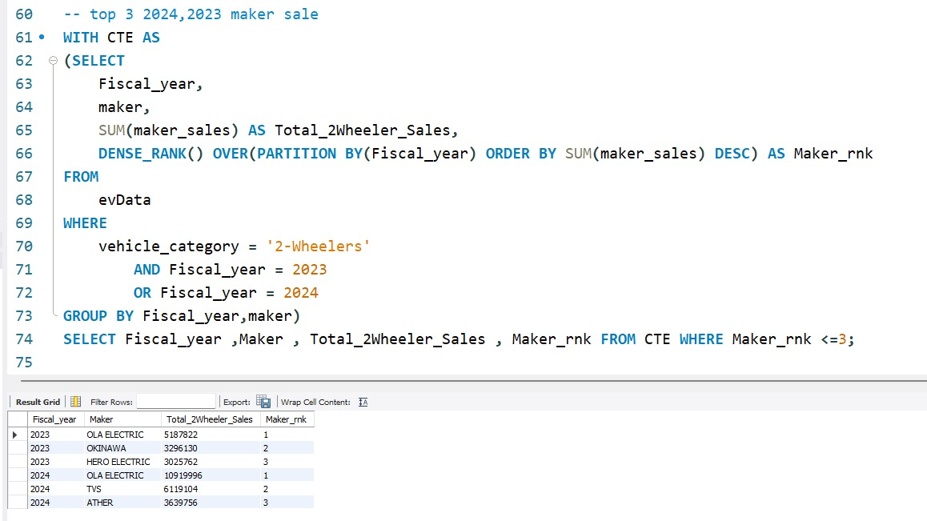

**Sol:** **Top 3 Maker for 2023, 2024 in terms of 2-wheeler.**

The above SQL query retrieves the top 3 two-wheeler manufacturers based on sales for the fiscal years 2023 and 2024. It works in two steps:

1. **CTE (Common Table Expression)**: It calculates the total two-wheeler sales per manufacturer for each fiscal year and assigns a rank (Maker_rnk) based on sales, with the highest sales ranked first.
2. **Final Selection**: It filters the results to show only the top 3 manufacturers (Maker_rnk <= 3) for each fiscal year.

This helps in identifying the leading two-wheeler manufacturers in terms of sales for 2023 and 2024.

**Top 3, 2-wheeler makers of 2023 are:**

1. **OLA ELECTRIC** with total sales of **5187822**.
2. **OKINAWA** with total sales of **3296130**.
3. **HERO** **ELECTRIC** with total sales of **3025762**.

**Top 3, 2-wheeler makers of 2024 are:**

1. **OLA ELECTRIC** with total sales of **10919996**.
2. **TVS** with total sales of **6119104**.
3. **ATHER** with total sales of **3639756**.

**Bottom 3 Maker for 2023, 2024 in terms of 2-wheeler.**

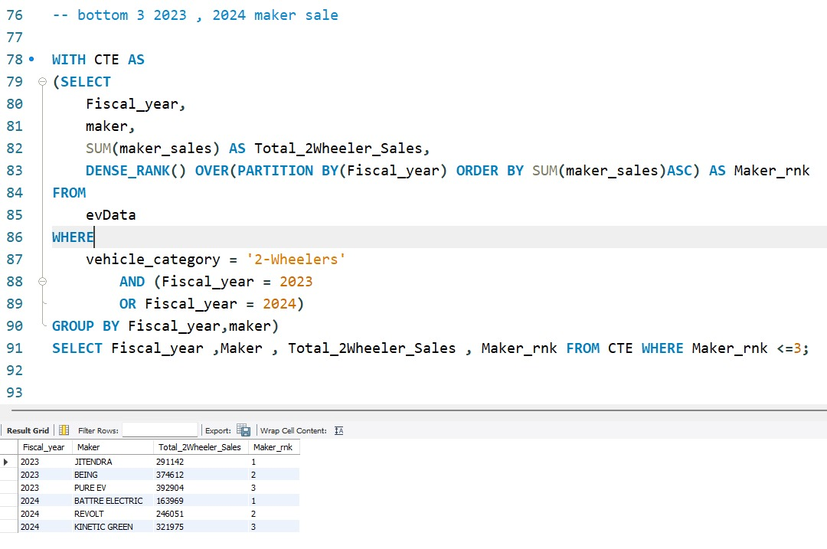

The above SQL query identifies the **bottom 3 two-wheeler manufacturers** in terms of sales for the fiscal years 2023 and 2024. It follows these steps:

1. **CTE (Common Table Expression)**:
   * Groups data by Fiscal_year and maker to calculate total sales (Total_2Wheeler_Sales).
   * Uses DENSE_RANK() to rank manufacturers in **ascending order** based on sales within each fiscal year (i.e., manufacturers with the **lowest** sales get the lowest rank).
2. **Final Selection**:
   * Retrieves only the **bottom 3 manufacturers** (Maker_rnk <= 3) for each fiscal year.

This analysis helps in identifying underperforming two-wheeler manufacturers in the EV sector for 2023 and 2024.

**Bottom 3, 2-wheeler makers of 2023 are:**

1. **JITENDRA** with total sales of **291142**.
2. **BEING** with total sales of **374612**.
3. **PURE EV** with total sales of **392904**.

**Bottom 3, 2-wheeler makers of 2024 are:**

1. **BATTRE ELETRIC** with total sales of **163969**.
2. **REVOLT** with total sales of **246051**.
3. **KINITIC GREEN** with total sales of **321975**.

**Q2**. **Identify the top 5 states with the highest penetration rate in 2-wheeler and 4-wheeler EV sales in FY 2024.**

**Sol: The top 5 states with the highest penetration rate in 2-wheeler and 4-wheeler EV sales in FY 2024.**

**NOTE:** In this context, "**highest penetration rate**" refers to the adoption or **market share of EVs (Electric Vehicles)** compared to the **total vehicle sales** in each **state**.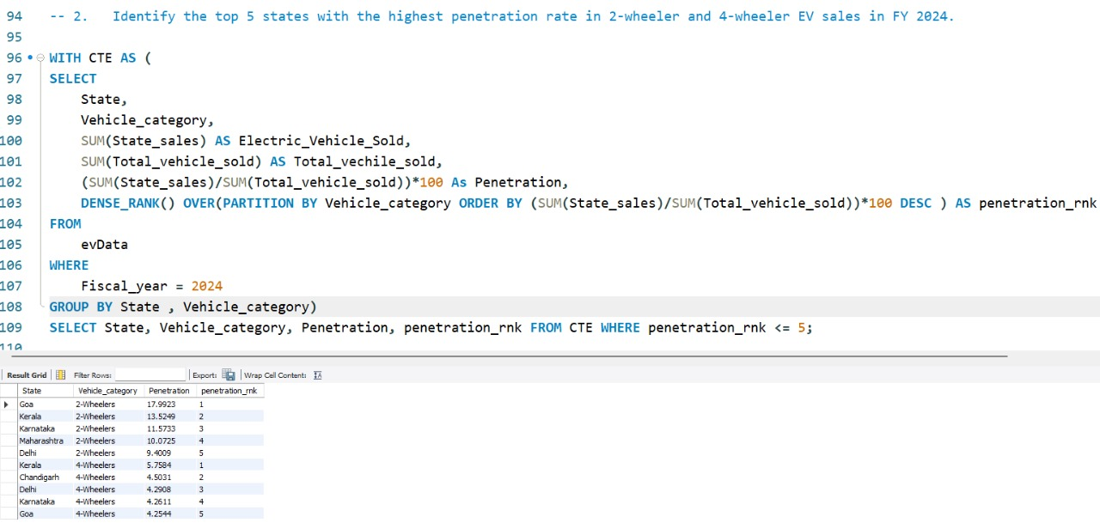

The above query identifies the **top 5 states** with the **highest EV penetration rate** in **2-wheeler and 4-wheeler categories** (Gives separate rankings for 2W & 4W) for **FY 2024**. Here's how it works:

**Step 1: Creating the CTE (Common Table Expression)**

* Groups data by **State** and **Vehicle Category (2W/4W)**.
* Calculates:
  + **Total EVs Sold** (Electric_Vehicle_Sold) per state and category.
  + **Total Vehicles Sold** (Total_vehicle_sold) per state and category.
  + **Penetration Rate = (Total Vehicle/SalesEV Sales​) × 100**
  + **Ranks states** (penetration_rnk) based on the **highest penetration rate** for each vehicle category using DENSE_RANK().

**Step 2: Final Selection**

* Filters out only the **top 5 states** (penetration_rnk <= 5) for **each vehicle category (2W & 4W EVs)**.

**What This Query Helps With**

* **Finds the leading states in EV adoption** for both **2-wheelers and 4-wheelers**.
* **Gives separate rankings for 2W & 4W** instead of combining them.

**TOP 5, 2-wheeler Penetration Rate of 2024 are:**

1. **GOA** with penetration rate of **17.99%**.
2. **KERALA** with penetration rate of **13.52%**.
3. **KARANATAKA** with penetration rate of **11.57%**.
4. **MAHARASHTRA** with penetration rate of **10.07%**.
5. **DELHI** with penetration rate of **9.40%**.

**TOP 5, 4-wheeler Penetration Rate of 2024 are:**

1. **KERALA** with penetration rate of **5.75%**.
2. **CHANDIGARH** with penetration rate of **4.50%**.
3. **DELHI** with penetration rate of **4.29%**.
4. **KARANATAKA** with penetration rate of **4.26%**.
5. **GOA** with penetration rate of **4.25%**.

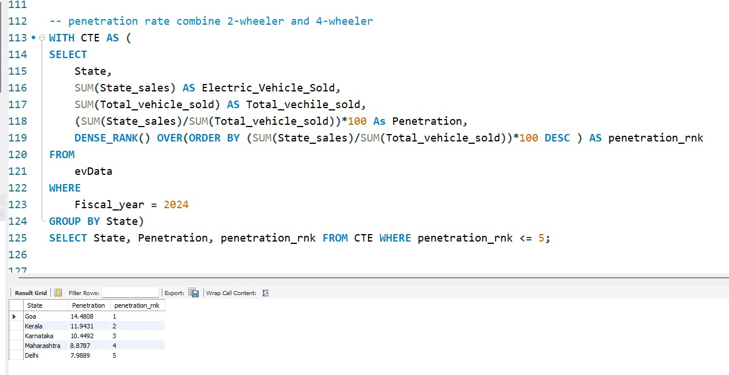

The above query identifies the **top 5 states** with the **highest overall EV penetration rate** (combining both 2-wheelers and 4-wheelers) for **FY 2024**.

* Groups data by **State** (without separating 2W and 4W).

**What This Query Helps With**

* **Finds the leading EV states overall**, without splitting 2W and 4W.
* **Gives a single ranking** for states based on total EV market penetration.

**TOP 5, Penetration Rate of 2024 for both (2 & 4 Wheeler’s) are:**

1. **GOA** with penetration rate of **14.48%**.
2. **KERALA** with penetration rate of **11.93%**.
3. **KARANATAKA** with penetration rate of **10.44%**.
4. **MAHARASHTRA** with penetration rate of **8.87%**.
5. **DELHI** with penetration rate of **7.98%**.

**Q3. List the states with negative penetration (decline) in EV sales from 2022 to 2024?** 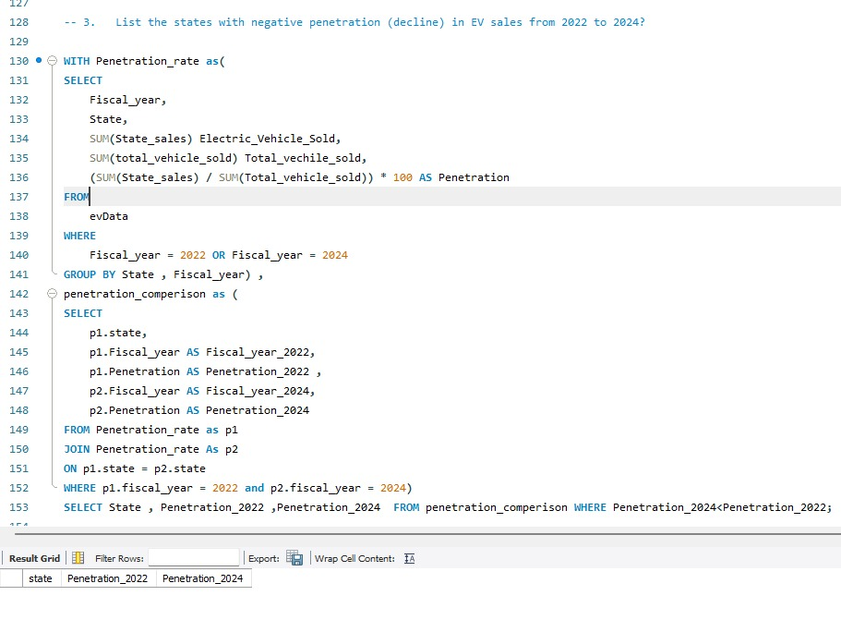

The above query identifies **states where EV penetration has decreased** from **FY 2022 to FY 2024**.

**Step 1: CTE Penetration_rate**

* Extracts **EV sales and total vehicle sales** for states in **FY 2022 & 2024**.
* **Penetration Rate = (Total Vehicle/SalesEV Sales​) × 100**
* Groups data by **state and fiscal year**.

**Step 2: CTE penetration_comparison**

* Self-joins Penetration_rate to compare **FY 2022 vs. FY 2024** for each state.
* Ensures we get **only states that have data for both years**.
* Selects penetration rates for **both years**.

**Step 3: Final Selection**

* Filters states where **Penetration_2024 is lower than Penetration_2022** (Penetration_2024 < Penetration_2022).

There are **no states** with a decline in EV sales from **2022** to **2024** based on the provided data. Every state either maintained or increased its sales over this period.

**Q4. What are the quarterly trends based on sales volume for the top 5 EV makers (4-wheelers) from 2022 to 2024?**

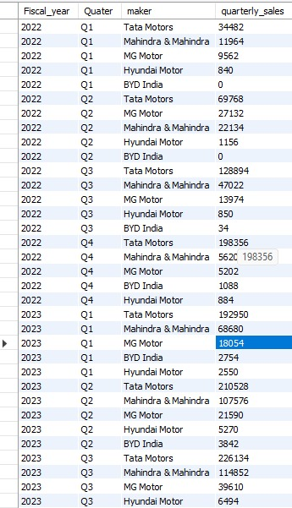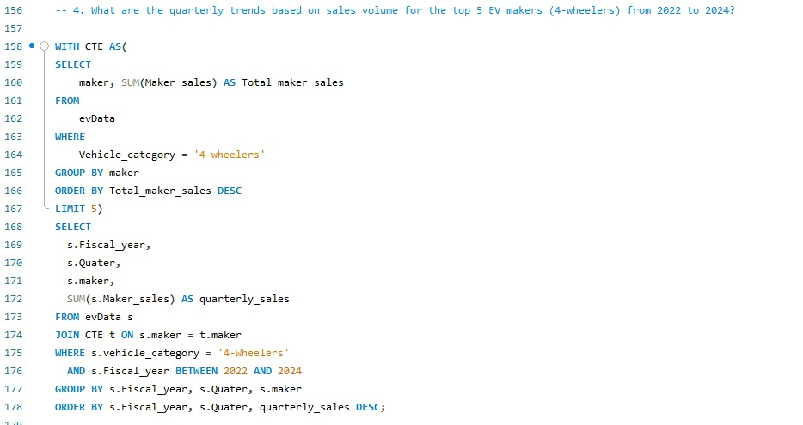

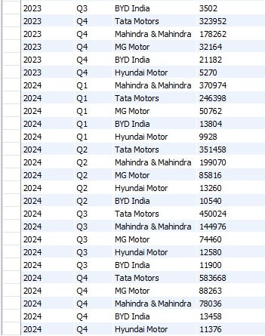

The above query finds the **top 5 four-wheeler EV manufacturers** based on total sales and then tracks their **quarterly sales performance** from **FY 2022 to FY 2024**.

**Step 1: CTE (CTE) - Identifying the Top 5 Manufacturers**

* Filters records where **Vehicle_category = '4-Wheelers'**.
* Groups data by maker and calculates **total sales (Total_maker_sales)** for each manufacturer.
* Orders manufacturers by **total sales in descending order**.
* Uses LIMIT 5 to **select the top 5 manufacturers**.

**Step 2: Main Query - Fetching Quarterly Sales for Top 5 Manufacturers**

* Joins evData with CTE to filter records **only for the top 5 manufacturers**.
* Filters data for **Fiscal Years 2022 to 2024**.
* Groups sales data by **Fiscal Year, Quarter, and Maker** to get **quarterly sales**.
* Orders the output by **Fiscal Year, Quarter, and Sales (descending order)**.

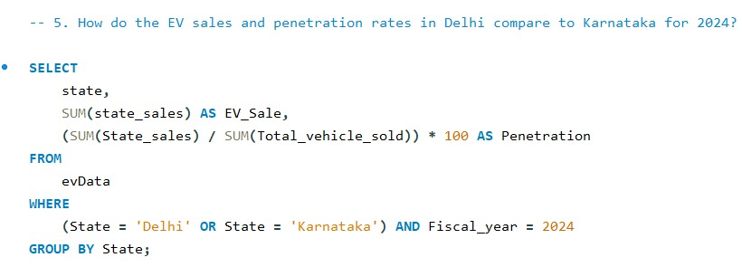**Q5. How do the EV sales and penetration rates in Delhi compare to Karnataka for 2024?**



The above query retrieves **EV sales and penetration rates** for **Delhi and Karnataka** in **FY 2024**.

**Query Breakdown**

1. **Filters Data for Delhi & Karnataka**
   * WHERE (State = 'Delhi' OR State = 'Karnataka') AND Fiscal_year = 2024
   * Ensures data is only for the selected states and the year 2024.
2. **Aggregates EV Sales and Calculates Penetration Rate**
   * SUM(state_sales) AS EV_Sale → Total EV sales per state.
   * (SUM(State_sales) / SUM(Total_vehicle_sold)) * 100 AS Penetration
     + Calculates **EV penetration rate** as a percentage of total vehicle sales.
3. **Groups Data by State**
   * GROUP BY State ensures results are calculated separately for **Delhi and Karnataka**.

**Q6. List down the compounded annual growth rate (CAGR) in 4-wheeler units for the top 5 makers from 2022 to 2024.**

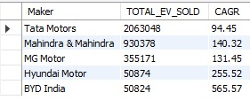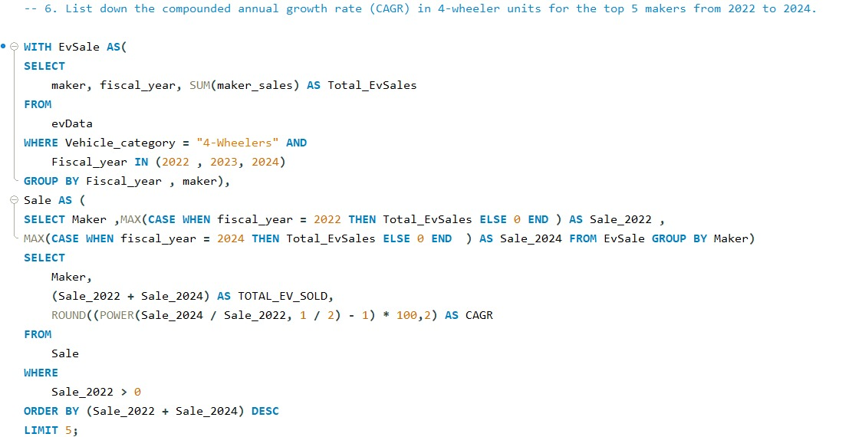

This query calculates the **Compound Annual Growth Rate (CAGR)** for **4-wheeler EV sales** of different manufacturers from **2022 to 2024**, and identifies the **top 5 manufacturers** based on total EV sales.

**Step 1: CTE EvSale (Aggregating EV Sales by Year & Maker)**

* Filters data for **4-wheeler EV sales** for **2022, 2023, and 2024**.
* Groups data by **maker and fiscal year**.
* Calculates **total EV sales per maker per year** (Total_EvSales).

**Step 2: CTE Sale (Extracting Sales for 2022 & 2024)**

* Uses MAX(CASE WHEN fiscal_year = 2022 THEN Total_EvSales ELSE 0 END) to extract sales for 2022.
* Uses MAX(CASE WHEN fiscal_year = 2024 THEN Total_EvSales ELSE 0 END) to extract sales for 2024.
* Groups by **maker** to ensure only one row per manufacturer.

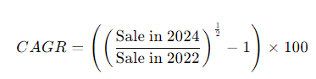**Step 3: Final Selection (CAGR Calculation & Ranking)**

* **CAGR Formula:**
  + This measures the **average annual growth rate** over two years (2022–2024).
  + The formula uses **POWER(Sale_2024 / Sale_2022, 1 / 2)** to calculate the square root (as it's a 2-year period).
  + ROUND(..., 2) ensures the CAGR is rounded to **two decimal places**.
* **Filters out manufacturers with zero sales in 2022** (WHERE Sale_2022 > 0).
* **Ranks the top 5 manufacturers** based on **total EV sales (2022 + 2024)**.

**Q7. List down the top 10 states that had the highest compounded annual growth rate (CAGR) from 2022 to 2024 in total vehicles sold.**

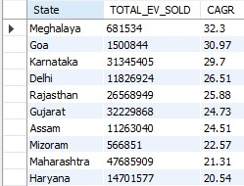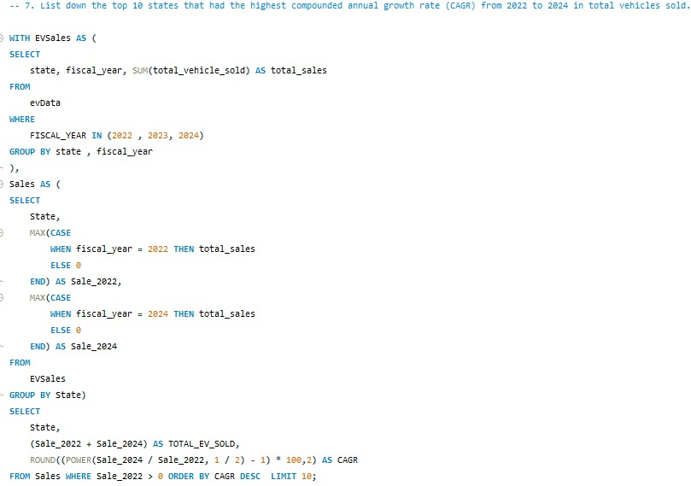

The above calculates the **Compound Annual Growth Rate (CAGR)** of **total vehicle sales (EV + non-EV)** for each **state** from **2022 to 2024**, and ranks the **top 10 states with the highest growth**.

**Step 1: CTE EVSales (Aggregating Total Vehicle Sales by State & Year)**

* Filters records for **fiscal years 2022, 2023, and 2024**.
* Groups data by **state and fiscal year**.
* Calculates **total vehicle sales** (total_sales) per state per year.

**Step 2: CTE Sales (Extracting Sales for 2022 & 2024 per State)**

* Uses MAX(CASE WHEN fiscal_year = 2022 THEN total_sales ELSE 0 END) to extract **2022 sales**.
* Uses MAX(CASE WHEN fiscal_year = 2024 THEN total_sales ELSE 0 END) to extract **2024 sales**.
* Groups by **state** to ensure one row per state.

**Step 3: Final Selection (CAGR Calculation & Ranking)**

* **Calculates CAGR** using the formula:
  + The formula uses POWER(Sale_2024 / Sale_2022, 1 / 2) to compute the **square root** (since it's a 2-year period).
  + ROUND(..., 2) ensures the CAGR is rounded to **two decimal places**.
* **Filters out states with zero sales in 2022** (WHERE Sale_2022 > 0).
* **Ranks the top 10 states** based on **highest CAGR** (ORDER BY CAGR DESC LIMIT 10)

**Q8. What are the peak and low season months for EV sales based on the data from 2022 to 2024?**

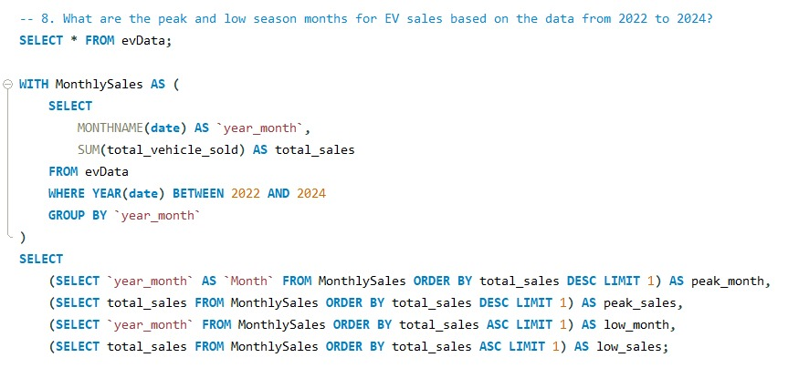



This query identifies the **peak and lowest sales months** for total vehicle sales (EV + non-EV) from **2022 to 2024**.

**Step 1: CTE MonthlySales (Aggregating Total Sales by Month)**

* Extracts the **month name** from the date column (MONTHNAME(date) AS year_month).
* Filters data for the **years 2022 to 2024** (WHERE YEAR(date) BETWEEN 2022 AND 2024).
* Groups data by **month name** (GROUP BY year_month).
* Computes **total vehicle sales per month** (SUM(total_vehicle_sold) AS total_sales).

**Step 2: Final Selection (Finding Peak & Lowest Sales Months)**

* Uses **subqueries** to identify:
  + **Peak sales month** → SELECT year_month FROM MonthlySales ORDER BY total_sales DESC LIMIT 1
  + **Peak sales count** → SELECT total_sales FROM MonthlySales ORDER BY total_sales DESC LIMIT 1
  + **Lowest sales month** → SELECT year_month FROM MonthlySales ORDER BY total_sales ASC LIMIT 1
  + **Lowest sales count** → SELECT total_sales FROM MonthlySales ORDER BY total_sales ASC LIMIT 1

**Q9. What is the projected number of EV sales (including 2-wheelers and 4-wheelers) for the top 10 states by penetration rate in 2030, based on the compounded annual growth rate (CAGR) from previous years?**