**Public Section:**

Home or index (Commented)

Admin login (Commented)

User registration (Commented)

User login (Commented)

Interaction among them:

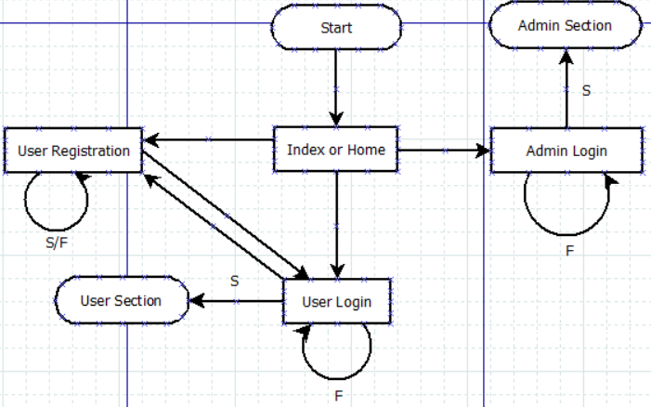

Note:

* When Index or Home is opened it checks if the list of Names of the Pokémon are present in the server, if not it loads it.
* If any registration or login form gets invalid input, user will be redirected to the same form and some error message will be shown there.
* User and Admin section must be completely isolated and none of the webpages there can be accessed from outside of those sections.
  + These secure sections can only be entered via successful login.
  + Any attempt to inappropriately access them will lead user to Index or home page.
* Index page destroys any existing session.
* Both of the login pages check for existing session if found they redirect to index or home page.

**Admin Section:**

Admin index (commented)

Quiz input (commented)

Quiz display (commented)

Quiz update (commented)

Interaction among them:

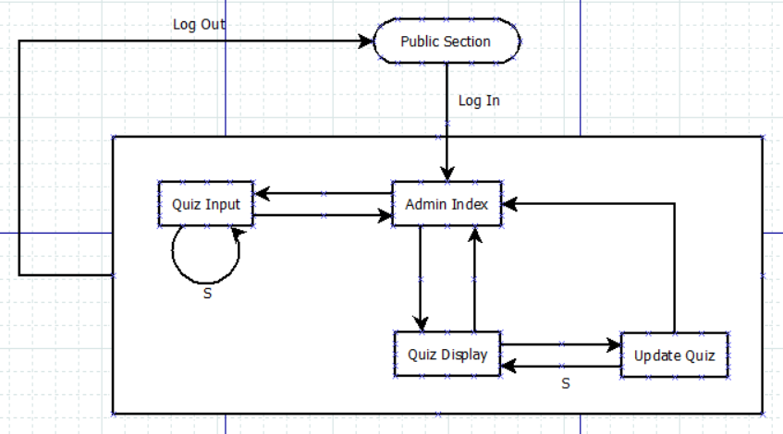

Note:

* Security is very important for this section; hence I mention how the webpages in this section can be accessed in details in following points.
  + Only way to enter admin section is via admin login in public section.
  + Any attempt to access the admin section webpages directly from outside will be redirected to Index or Home page in the public section.
  + Inside the admin section,
    - Update Quiz form can be accessed from Quiz Display page only, any attempt to illegally access it from inside admin section will lead to Quiz Display page.
    - If user tries to go back to an Update Quiz form from Quiz Display or reloads Update Quiz form, he will be directed to the last updated quiz.
* Quiz Input page should be made in a way that,
  + After entering a quiz if user goes back to the previous Quiz Input form, he must be prevented from reentering the same quiz again.
  + If the input quiz can’t be entered into the quiz table, user will be forced to head back to Admin Index page (this is annoying but easy to make, apart from that it’s very unlikely that quiz input will fail).
* Quiz Display page will hold all the quizzes entered by the admin; hence it must have,
  + A way to indicate past, current and future quizzes and their hosting dates.
  + A way to update (current and future quizzes) (by Quiz Update form) and delete (last quiz) future quizzes.
  + A navigation system to easily navigate through the page.
  + Quiz update or deletion failure will lead back to Quiz Display page (this is very unlikely to happen).
  + If the quiz to be updated doesn’t exist in quiz table, head back to Quiz Display page (this is very unlikely to happen).

**User Section:**

User profile (commented)

Detailed history (commented)

Game (commented)

Outcome (commented)

Interaction among them:

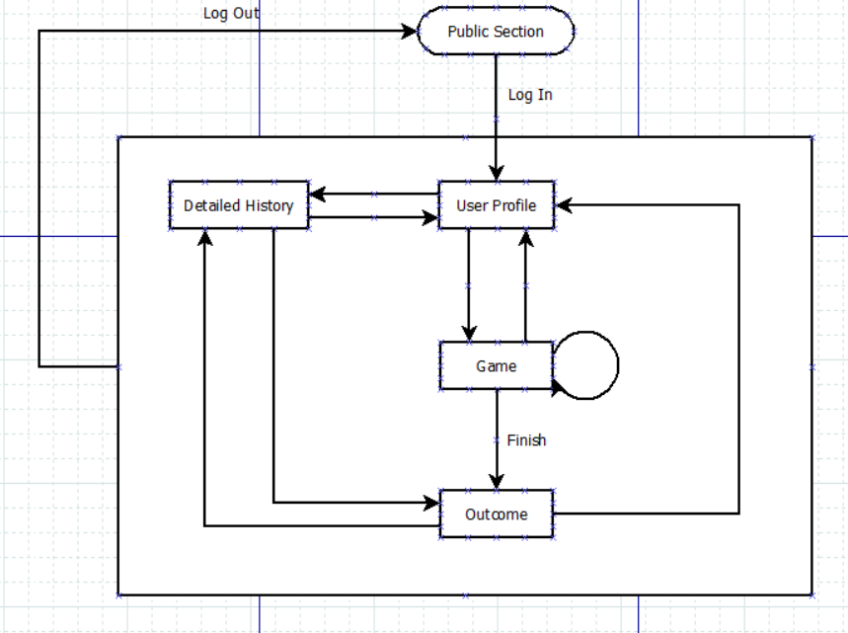

Note:

* Security is very important for this section; hence I mention how the webpages in this section can be accessed in details in following points.
  + Only way to enter user section is via user login in public section.
  + Any attempt to access the user section webpages directly from outside will be redirected to Index or Home page in the public section.
  + Inside the user section,
    - Game webpage will contain the quiz, user can open this page only if he has not finished the quiz of today. If he tries to access this page after completing current quiz he will be redirected to user profile page.
    - Outcome page can be accessed from Detailed History and Game (after finishing the quiz) pages , any attempt to illegally access it from inside user section will lead to Detailed History page.
    - If user tries to go back to an Outcome page from Detailed History or User Profile page or reloads Outcome page, he will be directed to the corresponding outcome in Detailed History page.
* User Profile page should contain achievements of the user in details.
* Game page should be made in a way that,
  + After all the hints are revealed, reveal next button will be disabled.
  + Incorrect guess of Pokémon name will reveal next hint.
  + Loading this page (including going back to this page) must,
    - Clear out the previously entered Pokémon name.
    - Read and display revealed hints directly from database.
  + Users are not allowed to play the game again once they have finished the quiz, If they try to open this page after finishing the quiz they will be redirected to User Profile.
  + If the quiz for that day is not uploaded yet i.e., missing, user will be forced to head back to User Profile page and wait.
* Detailed History page will hold outcomes of all the quizzes solved by the user; hence it must have,
  + A navigation system to easily navigate through the page.
  + A hidden button at each outcome box that takes directly to the outcome page.
* Outcome page is generated dynamically to display outcome of each quiz solved by user and a picture of the answer Pokémon.
  + It only takes ‘qid’ of the quiz for which the outcome will be generated and uses ‘uid’ of current user to retrieve outcome and answer Pokémon name from database.
  + If the outcome or Pokémon name can’t be retrieved, we head back to Detailed History page.