[1]

SUPER MARKET SALES PREDICTION

Tushar (E20CSE113) , Advait Kumar (E20CSE117) , Vaibhav Singh (E20CSE112)

# **Block Diagram**

# **Proposed Methodology**

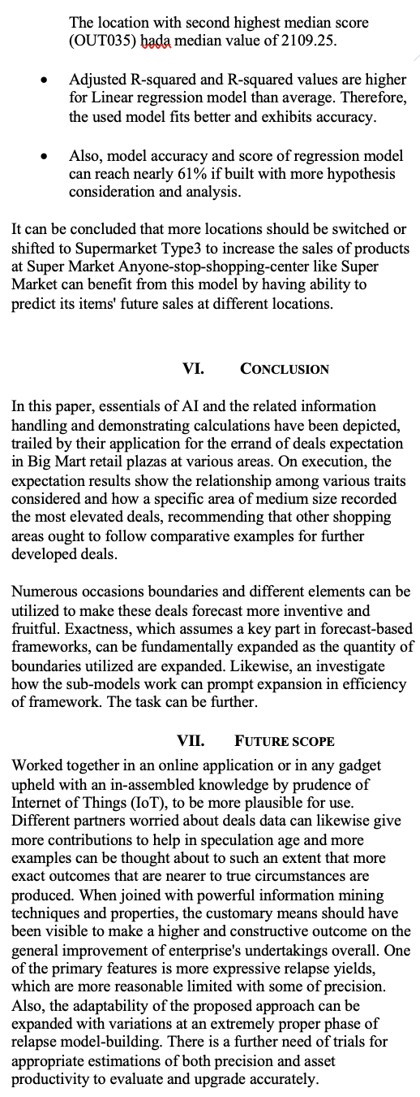

1.