* typeof(1) //number
* typeof(1.1) // number
* typeof("1.1") //string
* typeof(true) //boolean
* typeof(null) //object
* typeof(undefined) //undefined
* typeof([]) //object
* typeof({}) //object

Q. How do you copy by value a composite data type?

To copy an object in JavaScript, you have three options:

Use the spread (...) syntax

Use the Object.assign() method

Use the JSON.stringify() and JSON.parse() methods

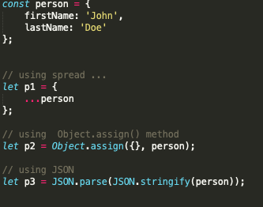

Q. Why there is a difference in behaviour for copying contents in primitive and non primitive type?

JavaScript provides different data types to hold different types of values. There are two types of data types in JavaScript.

Primitive data type

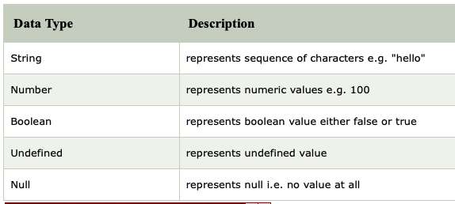

Non-primitive (reference) data type

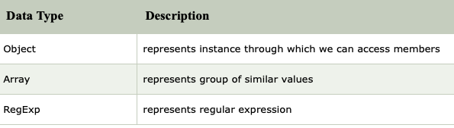

Objects are not compared by value. This means that even if two objects have the same properties and values, they are not strictly equal. Same goes for arrays. Even if they have the same elements that are in the same order, they are not strictly equal.

Const obj1={ ‘animal’:dog}

Const obj2={ ‘animal’:dog}

obj1=== obj2 // false

const arr1=[10,20]

const arr2=[10,20]

arr1=arr2; // false

Non primitive values can also be referred to as reference types because they are being compared by reference instead of value. Two objects are only strictly equal if they refer to the same underlying object.

Const obj3={ ‘animal’:dog}

Const obj4=obj3

Obj3===obj4 // true

Q.What is the difference between window, screen, and document in Javascript?

DIFFERENCE BETWEEN WINDOW DOCUMENT AND SCREEN IN JAVASCRIPRT

WINDOW:

Window is an top level heirarchy in javascript and window consist of number of objects in it as properties and DOCUMENT and SCREEN are one of the objects in Window among all. Window represent the complete things about browsers window.All global JavaScript objects, functions, and variables automatically become members of the window object.Global variables are properties of the window object.Global functions are methods of the window object.

There are lot of properties in window object lets see one example, we can determine the size of the browser window by using below property.

window.innerHeight ->gives height of browser in pixels.

so Hierarchy is as below

* DOCUMENT:

DOCUMENT is the actual content of the page i.e the html page you are loading is converted to the DOM object [Document object Model].

When a web page is loaded, the browser creates a Document Object Model of the page.

The HTML DOM will be created as TREE MODEL as below

DOM TREE MODEL

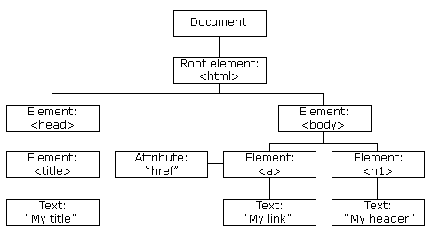

Java script connects with the HTML and CSS using the DOM OBJECT.Java Script can manipulate all the elements using DOM object. There are several properties in DOCUMENT. Lets see one example below.

document.getElementById(“header”);// gives the value of header

As document is property of window the above code is same as

window.document.getElementById(“header”);// gives the value of header.

SCREEN:

SCREEN is an property of WINDOW where we can see the content about the users screen.It can be used to display screen width, height etc.

Properties

screen.width

screen.height

screen.availWidth

screen.availHeight

Q. Write a blog about objects and its internal representation in Javascript ?

[https://tushar10agarwal.medium.com](https://tushar10agarwal.medium.com/)