**CODE:**

import java.util.*;

import java.io.*;

class AandSSM{

public static String add(String a,String b){

int l1=a.length();

int l2=b.length(),cd;

String o=new String();

StringBuilder sb=new StringBuilder();

cd=(l1>l2)?l1-l2:l2-l1;

if(cd!=0){

String n=(l1>l2)?b:a;

sb.append(n.charAt(0));

for(int i=0;i<cd;i++){

sb.append('0');

}

for(int i=0;i<n.length()-1;i++){

sb.append(n.charAt(i+1));

}

if(l1>l2)

b=sb.toString();

else

a=sb.toString();

}

sb=new StringBuilder();

char c='0';

char s='0',d;

System.out.println(a.length());

for(int i=a.length()-1;i>0;i--){

d='0';

if(a.charAt(i)=='0' && b.charAt(i)=='0')

s='0';

else if(a.charAt(i)=='0' && b.charAt(i)=='1')

s='1';

else if(a.charAt(i)=='1' && b.charAt(i)=='0')

s='1';

else if(a.charAt(i)=='1' && b.charAt(i)=='1'){

s='0';

d='1';

}

if(s=='0' && c=='0');

else if(s=='1' && c=='0');

else if(s=='0' && c=='1')

s='1';

else if(s=='1' && c=='1'){

d='1';

s='0';

}

c=d;

sb.append(s);

}

if(c=='1')

sb.append('1');

sb.append(a.charAt(0));

sb=sb.reverse();

o=sb.toString();

return o;

}

public static String sub(String a,String b){

int l1=a.length();

int l2=b.length(),cd;

String o=new String();

StringBuilder sb=new StringBuilder();

cd=(l1>l2)?l1-l2:l2-l1;

if(cd!=0){

String n=(l1>l2)?b:a;

sb.append(n.charAt(0));

for(int i=0;i<cd;i++){

sb.append('0');

}

for(int i=0;i<n.length()-1;i++){

sb.append(n.charAt(i+1));

}

if(l1>l2)

b=sb.toString();

else

a=sb.toString();

}

sb=new StringBuilder();

char c='0';

char s='0',d;

for(int i=a.length()-1;i>0;i--){

d='0';

if(a.charAt(i)=='0' && b.charAt(i)=='0')

s='0';

else if(a.charAt(i)=='1' && b.charAt(i)=='1')

s='0';

else if(a.charAt(i)=='1' && b.charAt(i)=='0')

s='1';

else if(a.charAt(i)=='0' && b.charAt(i)=='1'){

s='1';

d='1';

}

if(s=='0' && c=='0');

else if(s=='1' && c=='0');

else if(s=='1' && c=='1')

s='0';

else if(s=='0' && c=='1'){

d='1';

s='1';

}

c=d;

sb.append(s);

}

if(c=='1'){

o=sub(b,a);

sb=new StringBuilder();

sb.append((a.charAt(0)=='0')?'1':'0');

for(int i=1;i<o.length();i++){

sb.append(o.charAt(i));

}

}

else{

sb.append(a.charAt(0));

sb=sb.reverse();

}

o=sb.toString();

return o;

}

public static boolean check(String a){

for(int i=0;i<a.length();i++){

int c=a.charAt(i)-'0';

if(!(c>=0&&c<2))

return false;

}

return true;

}

public static void main(String args[]){

Scanner sc =new Scanner(System.in);

boolean k=true;

String i1,i2;

StringBuilder sb;

int i=3;

while(k){

System.out.println("Enter the operation:\n1:Addition\n2:Subtraction\n3:Exit");

i=3;

i=sc.nextInt();

switch(i){

case 1:

sb=new StringBuilder();

System.out.println("Enter first Binary input number:=");

i1=sc.next();

if(!check(i1)){

System.out.println("Wrong Input....");

break;

}

System.out.println("Enter second Binary input number:=");

i2=sc.next();

if(!check(i2)){

System.out.println("Wrong Input....");

break;

}

if(i1.charAt(0)==i2.charAt(0)){

String Out =add(i1,i2);

System.out.println("The Result is := "+Out);

}

else{

sb.append((i2.charAt(0)=='0')?'1':'0');

for(i=i2.length()-1;i>0;i--){

sb.append(i2.charAt(i));

}

sb=sb.reverse();

String Out =sub(i1,sb.toString());

System.out.println("The Result is := "+Out);

}

break;

case 2:

sb=new StringBuilder();

System.out.println("Enter first Binary input number:=");

i1=sc.next();

if(!check(i1)){

System.out.println("Wrong Input....");

break;

}

System.out.println("Enter second Binary input number:=");

i2=sc.next();

if(!check(i2)){

System.out.println("Wrong Input....");

break;

}

if(i1.charAt(0)==i2.charAt(0)){

String Out =sub(i1,i2);

System.out.println("The Result is := "+Out);

}

else{

for(i=i2.length()-1;i>0;i--){

sb.append(i2.charAt(i));

}

sb.append((i2.charAt(0)=='0')?'1':'0');

sb=sb.reverse();

String Out =add(i1,sb.toString());

System.out.println("The Result is := "+Out);

}

break;

case 3:

k=false;

break;

default:

System.out.println("Wrong Input.....");

}

}

}

}

**OUTPUT:**

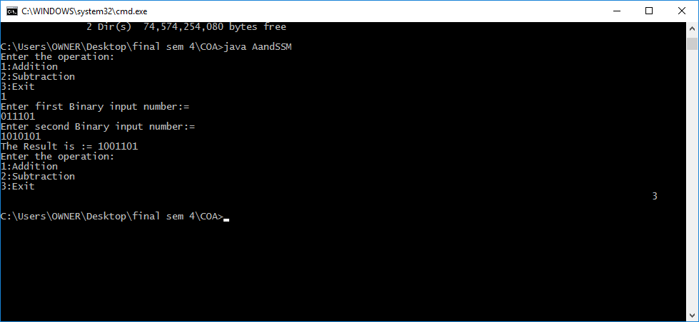

**CODE:**

import java.util.*;

import java.io.*;

class AandSSM{

public static String add(String a,String b){

int l1=a.length();

int l2=b.length(),cd;

String o=new String();

StringBuilder sb=new StringBuilder();

cd=(l1>l2)?l1-l2:l2-l1;

if(cd!=0){

String n=(l1>l2)?b:a;

sb.append(n.charAt(0));

for(int i=0;i<cd;i++){

sb.append('0');

}

for(int i=0;i<n.length()-1;i++){

sb.append(n.charAt(i+1));

}

if(l1>l2)

b=sb.toString();

else

a=sb.toString();

}

sb=new StringBuilder();

char c='0';

char s='0',d;

System.out.println(a.length());

for(int i=a.length()-1;i>0;i--){

d='0';

if(a.charAt(i)=='0' && b.charAt(i)=='0')

s='0';

else if(a.charAt(i)=='0' && b.charAt(i)=='1')

s='1';

else if(a.charAt(i)=='1' && b.charAt(i)=='0')

s='1';

else if(a.charAt(i)=='1' && b.charAt(i)=='1'){

s='0';

d='1';

}

if(s=='0' && c=='0');

else if(s=='1' && c=='0');

else if(s=='0' && c=='1')

s='1';

else if(s=='1' && c=='1'){

d='1';

s='0';

}

c=d;

sb.append(s);

}

if(c=='1')

sb.append('1');

sb.append(a.charAt(0));

sb=sb.reverse();

o=sb.toString();

return o;

}

public static String sub(String a,String b){

int l1=a.length();

int l2=b.length(),cd;

String o=new String();

StringBuilder sb=new StringBuilder();

cd=(l1>l2)?l1-l2:l2-l1;

if(cd!=0){

String n=(l1>l2)?b:a;

sb.append(n.charAt(0));

for(int i=0;i<cd;i++){

sb.append('0');

}

for(int i=0;i<n.length()-1;i++){

sb.append(n.charAt(i+1));

}

if(l1>l2)

b=sb.toString();

else

a=sb.toString();

}

sb=new StringBuilder();

char c='0';

char s='0',d;

for(int i=a.length()-1;i>0;i--){

d='0';

if(a.charAt(i)=='0' && b.charAt(i)=='0')

s='0';

else if(a.charAt(i)=='1' && b.charAt(i)=='1')

s='0';

else if(a.charAt(i)=='1' && b.charAt(i)=='0')

s='1';

else if(a.charAt(i)=='0' && b.charAt(i)=='1'){

s='1';

d='1';

}

if(s=='0' && c=='0');

else if(s=='1' && c=='0');

else if(s=='1' && c=='1')

s='0';

else if(s=='0' && c=='1'){

d='1';

s='1';

}

c=d;

sb.append(s);

}

if(c=='1'){

o=sub(b,a);

sb=new StringBuilder();

sb.append((a.charAt(0)=='0')?'1':'0');

for(int i=1;i<o.length();i++){

sb.append(o.charAt(i));

}

}

else{

sb.append(a.charAt(0));

sb=sb.reverse();

}

o=sb.toString();

return o;

}

public static boolean check(String a){

for(int i=0;i<a.length();i++){

int c=a.charAt(i)-'0';

if(!(c>=0&&c<2))

return false;

}

return true;

}

public static void main(String args[]){

Scanner sc =new Scanner(System.in);

boolean k=true;

String i1,i2;

StringBuilder sb;

int i=3;

while(k){

System.out.println("Enter the operation:\n1:Addition\n2:Subtraction\n3:Exit");

i=3;

i=sc.nextInt();

switch(i){

case 1:

sb=new StringBuilder();

System.out.println("Enter first Binary input number:=");

i1=sc.next();

if(!check(i1)){

System.out.println("Wrong Input....");

break;

}

System.out.println("Enter second Binary input number:=");

i2=sc.next();

if(!check(i2)){

System.out.println("Wrong Input....");

break;

}

if(i1.charAt(0)==i2.charAt(0)){

String Out =add(i1,i2);

System.out.println("The Result is := "+Out);

}

else{

sb.append((i2.charAt(0)=='0')?'1':'0');

for(i=i2.length()-1;i>0;i--){

sb.append(i2.charAt(i));

}

sb=sb.reverse();

String Out =sub(i1,sb.toString());

System.out.println("The Result is := "+Out);

}

break;

case 2:

sb=new StringBuilder();

System.out.println("Enter first Binary input number:=");

i1=sc.next();

if(!check(i1)){

System.out.println("Wrong Input....");

break;

}

System.out.println("Enter second Binary input number:=");

i2=sc.next();

if(!check(i2)){

System.out.println("Wrong Input....");

break;

}

if(i1.charAt(0)==i2.charAt(0)){

String Out =sub(i1,i2);

System.out.println("The Result is := "+Out);

}

else{

for(i=i2.length()-1;i>0;i--){

sb.append(i2.charAt(i));

}

sb.append((i2.charAt(0)=='0')?'1':'0');

sb=sb.reverse();

String Out =add(i1,sb.toString());

System.out.println("The Result is := "+Out);

}

break;

case 3:

k=false;

break;

default:

System.out.println("Wrong Input.....");

}

}

}

}

**OUTPUT:**

