Transmission Media

Aim: To study different types of transmission media.

Theory:

# Guided media:

## Twisted pair:

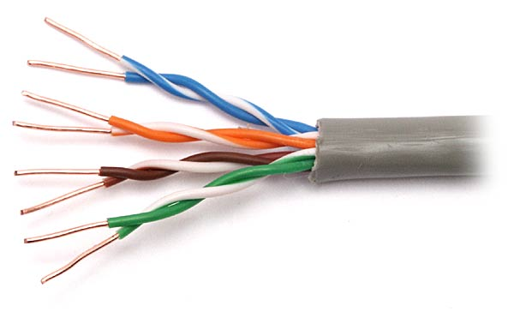

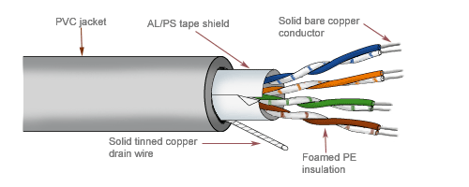

Unshielded twisted pair Shielded Twisted pair

A twisted pair cable is made of two plastic insulated copper wires twisted together to form a single media. Out of these two wires, only one carries actual signal and another is used for ground reference. The twists between wires are helpful in reducing noise (electro-magnetic interference) and crosstalk.

There are two types of twisted pair cables:

Shielded Twisted Pair (STP) Cable:

1. STP is made up of pairs of copper wires that are twisted together.
2. The pairs are covered in a foil or braided mesh, as well as outer PVC jacket.
3. This foil or mesh prevents the penetration of electromagnetic noise and eliminate cross talk.
4. This shielding must be grounded to prevent the foil or braided mesh from becoming a magnet for electricity.

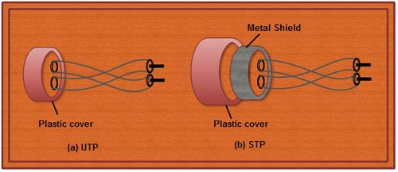

Unshielded Twisted Pair (UTP) Cable:

1. It consists of color-coded copper wires, but does not include any foil or braiding as insulator to protect against interference.
2. Wire pairs within each cable have varied amounts of twists per foot to produce cancellation.
3. There are different categories of UTP.
4. The following table shows the UTP categories, the no. of pairs in each, and the grade of cable each uses and how they are implemented.

In computer networks, Cat-5, Cat-5e, and Cat-6 cables are mostly used.

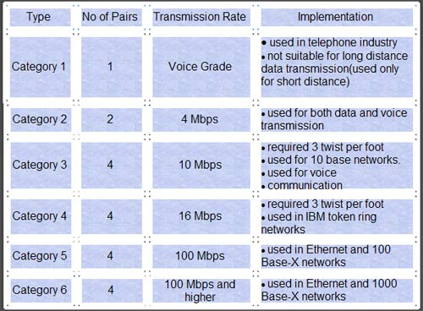

**Advantage of STP over UTP:**

STP is less susceptible to noise as compared to UTP and therefore reduces the cross talk and interference.

**Disadvantages of STP:**

1. It must be properly grounded.

2. It is more expensive than UTP.

3. It is difficult to terminate.

Purpose of twist in cable:

1. Purpose of twisting the wire is to reduce the electrical interference from the similar pairs in surroundings. The performance of the wire improves with the increase in the number of twist per foot.
2. If the two wires are parallel, then the electromagnetic interference from the devices such as motor can create a noise or interference on the wire that is closer to the source of noise. This results in high voltage level in one wire than the other.
3. This further leads to uneven load and damaged signal and there will be difference at the receiver side.
4. If two wires are twisted, then the cumulative effect of the interference on both the wires is equal.
5. In such a way, each wire is closer to the noise source for half of the time and farther away for the other half i.e. in one twist one wire is closer to the noise source and the other is farther; in next twist the reverse is true.
6. In this way, there will be no difference at the receiver side as unwanted signals are cancelled out.
7. An Important property of twisted pair is its gauge. Gauge is a measure of thickness of the conductor. The thicker the wire the less the resistance, the stronger the signal over a given distance and the better the performance of the medium.
8. The effective bandwidth of twisted pair depends on several factors including, the gauge of the conductor, and the length of the circuit and the spacing of the amplifiers (repeaters).

**Data transmission rate, range and type:**

Twisted pair can be used for transmitting either analog or digital signal and frequency range for twisted pair cable is 100 Hz to 5 Mhz. @ 4-16 Mbps

**Advantages:**

1. It can be used to carry both analog and digital data.

2. It is relatively easy to implement and terminate.

3. It is the least expensive media of transmission for short distances.

4. If portion of a twisted pair cable is damaged it does not affect the entire network.

**Disadvantages:**

1.It offers poor noise immunity as a result signal distortion is more?

2. Attenuation is very high.

3. It supports lower bandwidth as compared to other Medias. It supports 10 mbps up to a distance of 100 meters on a 10BASE-T.

4. It offers very poor security and is relatively easy to tap.

5. Being thin in size, they are likely to break easily.

**Application:**

1. The most common application of twisted pair cable is in telephone system.
2. In the local loop.
3. In the DSL line (ADSL)
4. Local area networks such as 10 Base-T and 100 Base-T. Use the twisted pair cables.
5. In the ISDN (Integrated Services Digital Network).

## Coaxial cable:

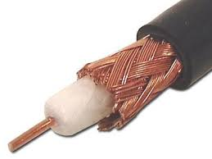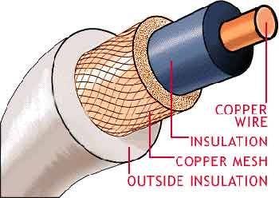

Coaxial cables are a type of cable that is used by cable TV and that is common for data communications. Taking a round cross-section of the cable, one would find a single centre solid wire symmetrically surrounded by a braided or foil conductor. Between the centre wire and foil is an insulating dielectric.

There are two types of coaxial cables:

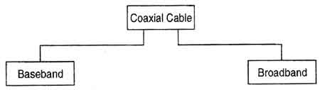

**Baseband:**

A baseband coaxial cable transmits a single signal at a time at very high speed. A baseband cable is mainly used for LANs.Baseband coaxial cable supports frequency range of a-4kHz and are used for digital signaling.Baseband coaxial cables are 50 ohm cables used for 'digital transmission'. For 1Km cables the bandwidth is 1-2 Gbps .The baseband co-axial cable was originally used for the Ethernet system that operates at 10 Mbps.

**Broadband:**

A broadband coaxial cable can transmit many simultaneous signals using different frequencies. Broadband coaxial cable supports the frequency range above 4kHz and are used for analog signals. So it must be used with a modem. Broadband coaxial cables are 75 ohm cables used for analog transmission. Since broadband is used for large area, it requires amplifiers which are unidirectional.

**Features:**

1. It provides better immunity than twisted pair.
2. This cable is able to transmit data at higher rates.

**Limitations:**

1. High installation cost
2. High maintenance cost.

**Data transfer rates, range and type:**

Rate: 10 Mbps.

Range i.e. Bandwidth: 300-3400 Hz

Type of data signals: Both analog and digital signals are transmitted.

**Advantages of Coaxial Cables:**

1. It can be used for both analog and digital transmission.

2. It offers higher bandwidth as compared to twisted pair cable and can span longer distances.

3. Because of better shielding in coaxial cable, loss of signal or attenuation is less.

4. Better shielding also offers good noise immunity.

5. It is relatively inexpensive as compared to optical fibres.

6. It has lower error rates as compared to twisted pair.

7. It is not as easy to tap as twisted pair because copper wire is contained in plastic jacket.

**Disadvantages of Coaxial Cables:**

1. It is usually more expensive than twisted pair.

**Applications of Co-axial Cables**:

1. Analog telephone networks.
2. Digital telephone network.
3. Cable TV
4. Traditional Ethernet LANs
5. Digital transmission
6. Thick Ethernet .

## Fibre optic cable:

* A very thin glass rod (cylindrical dielectric waveguide made of SiO2)
* Operate at optical frequency about 1014 Hz
* Compose of a core, cladding and jacket (a plastic sheathing for mechanical protection)
* Light injected into the core of a glass fibre will follow the physical path of the fibre due to the internal reflection of the light between the core and the cladding.

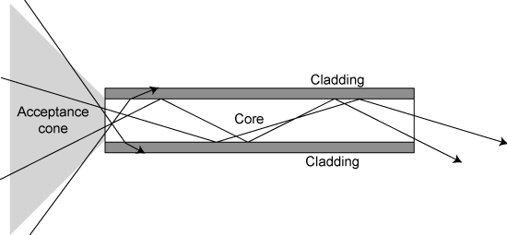 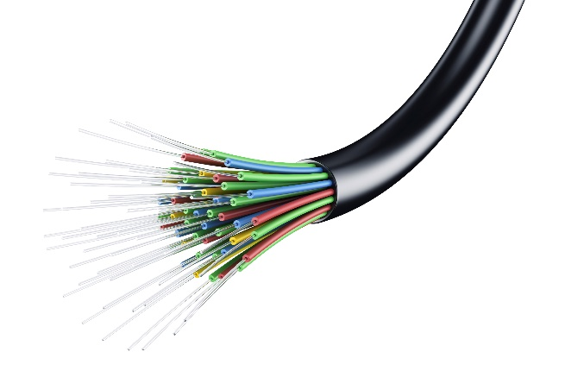

Working of fibre optic cable. Real image of fibre optic cable

**Advantages:**

* High bandwidth & large capacity: transmit large amount of information; over 2million simultaneous telephone conservations on two optical fibres, and a optical cable contains over 200 optical fibres. For microwave or satellite links, only 2000 conversations
* Small size, light weight, flexible, easy installation
* Immunity to interference: not effected by electrical magnetic interference (EMI) or radio frequency (RFI). It does not create its own interference.
* Free of cross talk between fibres
* Insulation & Hazardous environment resistant: optical fibre is an insulator, provide total electrical isolation for many applications. It eliminates inference caused by ground loop and electrical discharge.
* Security: signals cannot be tapped easily
* Stress and heat resistant & reliability and maintenance: constant medium, not subject to fading, adverse temperature, moisture and can be used for underwater cable, long service life span, not affected by short circuit, power surges or static electricity
* Versatility: available for most of data, voice and video communication formats
* Scalable: easily expanded. Only change electronics, no change on fibres
* Low cost, low loss and signal regeneration: optical fibres can travel over 70km before repeating the signals, save cost for repeater and maintenance.

**Disadvantages**:

* Electrical-to-optical conversion: signal must be converted to light wave and back to electrical signal. Cost on electronics in all applications
* Physical right of way is required for the cable installation
* Optical fibre is predominantly silica glass, special techniques are needed for engineering installation of the fibre cable
* repairs: difficult to repair broken optical cable
* Network interface card and cabling is expensive
* Connection to network is difficult.

**Data transfer rates and bandwidth:**

Rate: up to 10 gbps.

Bandwidth: usually 500-1000 MHz over a length of 1 km. A single optical fibre can carry over 3,000,000 full-duplex voice calls or 90,000 TV channels.

**Applications:**

Optical fibre is used by many telecommunications companies to transmit telephone signals, Internet communication, and cable television signals. Due to much lower attenuation and interference, optical fibre has large advantages over existing copper wire in long-distance and high-demand applications. However, infrastructure development within cities was relatively difficult and time-consuming, and fibre-optic systems were complex and expensive to install and operate. Due to these difficulties, fibre-optic communication systems have primarily been installed in long-distance applications, where they can be used to their full transmission capacity, offsetting the increased cost. Since 2000, the prices for fibre-optic communications have dropped considerably

# Unguided media:

Wireless transmission is a form of unguided media. Wireless communication involves no physical link established between two or more devices, communicating wirelessly. Wireless signals are spread over in the air and are received and interpreted by appropriate antennas.

|  |  |  |  |
| --- | --- | --- | --- |
| [**Frequency**](https://en.wikipedia.org/wiki/Frequency) | [**Wavelength**](https://en.wikipedia.org/wiki/Wavelength) | **Designation** | **Abbreviation**[**[6]**](https://en.wikipedia.org/wiki/Radio_frequency#cite_note-beasley-6) |
| 3–30 Hz | 105–104 km | [Extremely low frequency](https://en.wikipedia.org/wiki/Extremely_low_frequency) | ELF |
| 30–300 Hz | 104–103 km | [Super low frequency](https://en.wikipedia.org/wiki/Super_low_frequency) | SLF |
| 300–3000 Hz | 103–100 km | [Ultra low frequency](https://en.wikipedia.org/wiki/Ultra_low_frequency) | ULF |
| 3–30 kHz | 100–10 km | [Very low frequency](https://en.wikipedia.org/wiki/Very_low_frequency) | VLF |
| 30–300 kHz | 10–1 km | [Low frequency](https://en.wikipedia.org/wiki/Low_frequency) | LF |
| 300 kHz – 3 MHz | 1 km – 100 m | [Medium frequency](https://en.wikipedia.org/wiki/Medium_frequency) | MF |
| 3–30 MHz | 100–10 m | [High frequency](https://en.wikipedia.org/wiki/High_frequency) | HF |
| 30–300 MHz | 10–1 m | [Very high frequency](https://en.wikipedia.org/wiki/Very_high_frequency) | VHF |
| 300 MHz – 3 GHz | 1 m – 10 cm | [Ultra high frequency](https://en.wikipedia.org/wiki/Ultra_high_frequency) | UHF |
| 3–30 GHz | 10–1 cm | [Super high frequency](https://en.wikipedia.org/wiki/Super_high_frequency) | SHF |
| 30–300 GHz | 1 cm – 1 mm | [Extremely high frequency](https://en.wikipedia.org/wiki/Extremely_high_frequency) | EHF |
| 300 GHz – 3 THz | 1 mm – 0.1 mm | [Tremendously high frequency](https://en.wikipedia.org/wiki/Tremendously_high_frequency) | THF |

The electromagnetic spectrum is as follows:

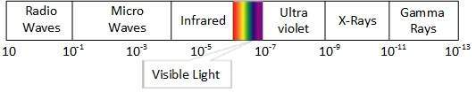

A little part of electromagnetic spectrum can be used for wireless transmission.

## Radio wave:

Radio frequency is easier to generate and because of its large wavelength it can penetrate through walls and structures alike. Radio waves can have wavelength from 1 mm – 100,000 km and have frequency ranging from 3 Hz (Extremely Low Frequency) to 1 GHz (Extremely High Frequency). Radio frequencies are sub-divided into six bands.

Radio waves at lower frequencies can travel through walls whereas higher RF can travel in straight line and bounce back. The power of low frequency waves decreases sharply as they cover long distance. High frequency radio waves have more power.

Lower frequencies such as VLF, LF, MF bands can travel on the ground up to 1000 kilometres, over the earth’s surface.

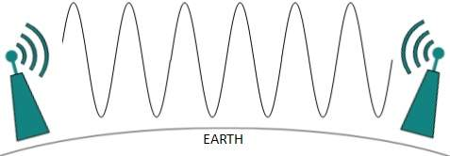

Radio waves of high frequencies are prone to be absorbed by rain and other obstacles. They use Ionosphere of earth atmosphere. High frequency radio waves such as HF and VHF bands are spread upwards. When they reach Ionosphere, they are refracted back to the earth.

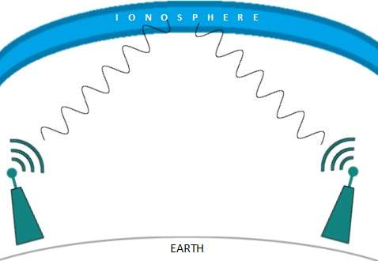

**Features:**

* Radio waves use omnidirectional antennas that send out signals in all directions.
* Based on the wavelength, strength, and the purpose of transmission, we can have several

types of antennas.

* Radio waves, particularly those waves that propagate in the sky mode, can travel

long distances. This makes radio waves a good candidate for long-distance broadcasting

such as AM radio.

* Radio waves, particularly those of low and medium frequencies, can penetrate walls.
* This characteristic can be both an advantage and a disadvantage. It is an advantage

because, for example, an AM radio can receive signals inside a building.

* It is a disadvantage because we cannot isolate a communication to just inside or outside a building.
* The radio wave band is relatively narrow, just under 1 GHz, compared to the microwave

band.

* When this band is divided into sub bands, the sub bands are also narrow, leading to a low data rate for digital communications.

**Advantages:**

* Not affected by interstellar dust.
* It offers mobility.
* Ease of communication over difficult terrain.
* Low energy cost.
* Low noise background.
* Travel at speed of light(unlike guided media)

**Disadvantages:**

* Radio wave communication is an insecure mode of communication.
* Radio wave propagation is susceptible to weather effects like rain, thunder storm, etc.

## Microwave:

Microwaves can have wavelength ranging from 1 mm – 1 meter and frequency ranging from 1 to 300 GHz.

Microwaves are unidirectional. When an antenna transmits microwave waves, they

can be narrowly focused. This means that the sending and receiving antennas need to

be aligned. The unidirectional property has an obvious advantage. A pair of antennas

can be aligned without interfering with another pair of aligned antennas. The following

describes some characteristics of microwave propagation:

* Microwave propagation is line-of-sight. Since the towers with the mounted antennas

need to be in direct sight of each other, towers that are far apart need to be very tall.

* The curvature of the earth as well as other blocking obstacles do not allow two short

towers to communicate by using microwaves. Repeaters are often needed for long-distance

communication.

* Very high-frequency microwaves cannot penetrate walls. This characteristic can be

a disadvantage if receivers are inside buildings.

* The microwave band is relatively wide, almost 299 GHz. Therefore, wider sub bands

can be assigned, and a high data rate is possible

* Use of certain portions of the band requires permission from authorities.

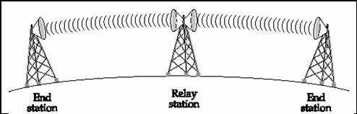

**Features:**

* Microwaves need unidirectional antennas that send out signals in one direction.
* Microwave antennas concentrate the waves making a beam of it. As shown in picture above, multiple antennas can be aligned to reach farther. Microwaves have higher frequencies and do not penetrate wall like obstacles.
* Microwave transmission depends highly upon the weather conditions and the frequency it is using.

**Advantages:**

* It proves to be cheaper than digging trenches for laying cables and maintaining repeaters and cables if they get broken because of variety of causes.
* It offers ease of communication over difficult terrain.
* Ability to communicate over oceans (not possible with radio waves)
* Wide bandwidth.
* Multi-channel transmission.
* Requires fewer amplifiers or repeaters.

**Disadvantages:**

* Insecure mode of communication.
* Requires that the antennas (the receiver and the transmitter) be in line of sight.
* Expensive towers and repeaters required.
* Subject to interference such as airplanes (physical moving barrier) or rain (weather effects) .
* Frequency bands are regulated by the government or a competent authority.

**Applications**

Microwaves, due to their unidirectional properties, are very useful when unicast

(one-to-one) communication is needed between the sender and the receiver. They are

used in cellular phones, satellite networks and wireless LANs

## Infrared:

* Infrared waves, with frequencies from 300 GHz to 400 THz (wavelengths from 1 mm

to 770 nm), can be used for short-range communication.

* Infrared waves, having high frequencies, cannot penetrate walls. This advantageous characteristic prevents interference between one system and another; a short-range communication system in one room cannot be affected by another system in the next room.
* When we use our infrared remote control, we do not interfere with the use of the remote by our neighbours.
* However, this same characteristic makes infrared signals useless for long-range communication.
* In addition, we cannot use infrared waves outside a building because the sun's rays contain

infrared waves that can interfere with the communication

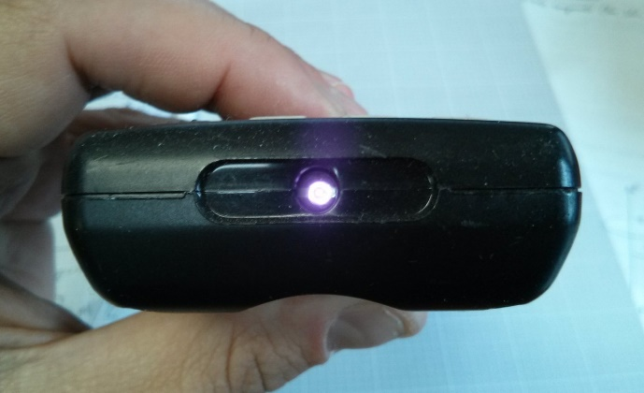 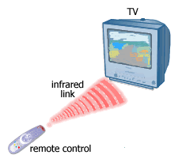

**Advantages:**

* Simple, cheap and easy to configure devices and circuits required for its setup.
* No costly licences needed.
* Simple shielding and confining of signals easily possible.

**Disadvantages:**

* Interference by sunlight, heat, and other sources of IR give rise to noise in signal.
* Also IR is easily absorbed by a variety of materials
* Low usable bandwidth.

**Applications:**

* Infrared waves are used in communication between devices like the keyboard, printers, etc
* Also IR is used in remote controlled devices where the remote generate the IR radiations

Light Transmission:

Highest most electromagnetic spectrum which can be used for data transmission is light or optical signalling. This is achieved by means of LASER.

Because of frequency light uses, it tends to travel strictly in straight line. Hence the sender and receiver must be in the line-of-sight. Because laser transmission is unidirectional, at both ends of communication the laser and the photo-detector needs to be installed. Laser beam is generally 1mm wide hence it is a work of precision to align two far receptors each pointing to lasers source.

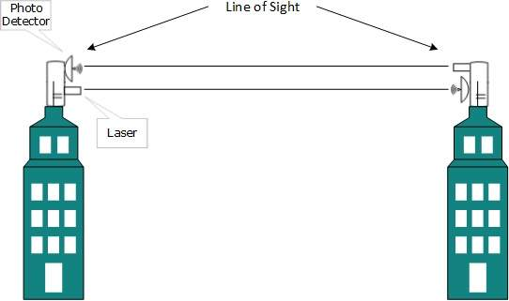

Laser works as Tx (transmitter) and photo-detectors works as Rx (receiver).

Lasers cannot penetrate obstacles such as walls, rain, and thick fog. Additionally, laser beam is distorted by wind, atmosphere temperature, or variation in temperature in the path.

Laser is safe for data transmission as it is very difficult to tap 1mm wide laser without interrupting the communication channel.

Conclusion:

Thus, variety of transmission media are studied in detail ; their structure advantages, disadvantages and applications are understood and analysed to look for the pitfalls and usability of a given communication medium.