DATA CLEANING AND PREPROCESSING REPORT
Public Titanic Passenger Dataset — Python

Submitted as an Academic Data Analytics / Python Project

Field | Details
Student Name | ____________________________
Course / Class | BCA / Data Analytics
College | ____________________________
Academic Year | 2026–27
Tools | Python, Pandas, NumPy, Matplotlib, Jupyter Notebook

Prepared using a reproducible, documented data-quality workflow.
Report date: 12 September 2026

Executive Summary
This report demonstrates a complete data acquisition, cleaning, and preprocessing workflow using the publicly available Titanic passenger dataset. The project focuses on practical data-quality problems that commonly occur in real analytical work: missing values, inconsistent categorical text, potential outliers, skewed numerical variables, and fields that are not suitable for a baseline analytical model.
The raw dataset contains 891 passenger records and 12 columns. The main missing-data problems are Age (177 values), Cabin (687 values), and Embarked (2 values). No exact duplicate rows were found. Fare contains a long right tail and 116 observations exceed the standard 1.5×IQR upper threshold; these observations are treated as potentially valid high-fare records rather than automatically deleted.
Age is imputed with medians calculated within Sex × Passenger Class groups, which preserves important demographic structure better than using one global median. Embarked is filled with the mode. Cabin is removed from the baseline feature set because approximately 77% of its values are missing. Fare outliers are flagged and a log-transformed Fare variable is created to reduce skew without discarding potentially meaningful observations. Categorical variables are standardized and encoded for downstream machine-learning use.
The final processed file contains 891 rows, zero missing values in the retained/derived fields, and explicit quality flags. The report also discusses how preprocessing decisions can influence distributions, relationships, model performance, and interpretation.

Table of Contents
- 1. Introduction and Objectives
- 2. Dataset Selection and Data Collection
- 3. Dataset Description and Data Dictionary
- 4. Initial Data Exploration
- 5. Data Quality Assessment
- 6. Missing-Value Treatment
- 7. Inconsistency and Erroneous-Entry Checks
- 8. Outlier Detection and Treatment
- 9. Data Transformation and Preprocessing
- 10. Validation of the Cleaned Dataset
- 11. Before-and-After Comparison
- 12. Potential Impact on Subsequent Analysis
- 13. Challenges and Solutions
- 14. Reflective Commentary
- 15. Reproducibility and Execution Guide
- 16. Conclusion
- 17. References
- Appendix A — Complete Python Code

1. Introduction and Objectives

1.1 Background
Data analysis is only as reliable as the data used to produce it. A dataset can contain blank cells, invalid categories, duplicated records, extreme observations, incorrect data types, or variables that are unsuitable for a particular analytical objective. Data cleaning is therefore not simply a technical step; it is a reasoning process in which each change should be justified and recorded.

1.2 Project objectives
- Acquire a relevant public dataset from a reliable, reproducible source.
- Understand the dataset structure, variable types, distributions, and missingness before modifying the data.
- Identify missing values, duplicates, inconsistencies, and potentially erroneous values.
- Detect numerical outliers using a transparent statistical rule and decide whether to retain, flag, transform, or remove them.
- Prepare categorical and numerical variables for downstream analysis or machine learning.
- Validate that the cleaned dataset satisfies the intended quality requirements.
- Document every important decision with Python code and explanatory commentary.
- Evaluate how preprocessing choices may change later statistical analysis or predictive modeling.

1.3 Scope
The scope is data preparation rather than building a final predictive model. The survival variable is retained as a target/outcome field for possible future analysis, but no claim is made here that preprocessing alone establishes causal relationships.

2. Dataset Selection and Data Collection

2.1 Selected dataset
The selected dataset is the Titanic passenger dataset, a well-known public dataset containing passenger demographics, ticket class, fare, embarkation information, and survival outcome. It is particularly suitable for a data-cleaning assignment because it contains substantial missingness in Age and Cabin and a small number of missing Embarked values.

2.2 Source and collection method
For reproducibility, the dataset can be loaded directly from the public seaborn-data repository using pandas.read_csv(). The repository identifies Titanic as one of the datasets used for seaborn examples and lists Kaggle as the dataset's source/origin. The raw CSV used in this report has 891 records and 12 columns.
Dataset URL used in the Python workflow:
https://raw.githubusercontent.com/mwaskom/seaborn-data/master/raw/titanic.csv
Python collection code:
import pandas as pd
url = "https://raw.githubusercontent.com/mwaskom/seaborn-data/master/raw/titanic.csv"
df = pd.read_csv(url)
print("Rows:", df.shape[0])
print("Columns:", df.shape[1])

2.3 Why this dataset was selected
- Publicly accessible and easy to reproduce.
- Contains both numerical and categorical variables.
- Contains genuine missing-value patterns suitable for demonstrating imputation.
- Contains high-fare observations that demonstrate the difference between an outlier and an error.
- Small enough for a beginner to inspect but rich enough for meaningful preprocessing.

2.4 Data acquisition challenges
A practical challenge is that public datasets can move, change, or become unavailable. The solution is to record the exact source URL, preserve the raw file before editing, and keep the transformation code separate from the source data. In a production setting, a checksum/version identifier would also be stored.

3. Dataset Description and Data Dictionary
The raw dataset contains the following 12 columns:
Column | Type | Meaning | Role
PassengerId | Integer | Unique passenger identifier | Identifier
Survived | Integer | 0 = did not survive; 1 = survived | Target/outcome
Pclass | Integer | Passenger class: 1, 2, or 3 | Categorical/ordinal
Name | Text | Passenger name | Text
Sex | Text | male/female | Categorical
Age | Float | Passenger age in years | Numerical
SibSp | Integer | Number of siblings/spouses aboard | Count
Parch | Integer | Number of parents/children aboard | Count
Ticket | Text | Ticket number | Identifier/text
Fare | Float | Passenger fare | Numerical
Cabin | Text | Cabin identifier | Categorical/text
Embarked | Text | Port code: C, Q, or S | Categorical

3.1 Raw dataset sample
PassengerId | Survived | Pclass | Name | Sex | Age | SibSp | Parch | Ticket | Fare | Cabin | Embarked
1 | 0 | 3 | Braund, Mr. Owen Harris | male | 22 | 1 | 0 | A/5 21171 | 7.25 | nan | S
2 | 1 | 1 | Cumings, Mrs. John Bradley (Florence Briggs Thayer) | female | 38 | 1 | 0 | PC 17599 | 71.28 | C85 | C
3 | 1 | 3 | Heikkinen, Miss. Laina | female | 26 | 0 | 0 | STON/O2. 3101282 | 7.92 | nan | S
4 | 1 | 1 | Futrelle, Mrs. Jacques Heath (Lily May Peel) | female | 35 | 1 | 0 | 113803 | 53.10 | C123 | S
5 | 0 | 3 | Allen, Mr. William Henry | male | 35 | 0 | 0 | 373450 | 8.05 | nan | S
6 | 0 | 3 | Moran, Mr. James | male | NaN | 0 | 0 | 330877 | 8.46 | nan | Q
7 | 0 | 1 | McCarthy, Mr. Timothy J | male | 54 | 0 | 0 | 17463 | 51.86 | E46 | S
8 | 0 | 3 | Palsson, Master. Gosta Leonard | male | 2 | 3 | 1 | 349909 | 21.07 | nan | S

4. Initial Data Exploration
Initial exploration is performed before cleaning so that the analyst can distinguish real data characteristics from problems introduced by preprocessing. The main checks are shape, data types, missing values, duplicate records, descriptive statistics, unique values, and basic distributions.

4.1 Structure and data types
df.shape
df.info()
df.head()
df.tail()
Expected raw shape: 891 rows × 12 columns.

4.2 Missing-value profile
Column | Missing | Missing %
Age | 177 | 19.87%
Cabin | 687 | 77.10%
Embarked | 2 | 0.22%
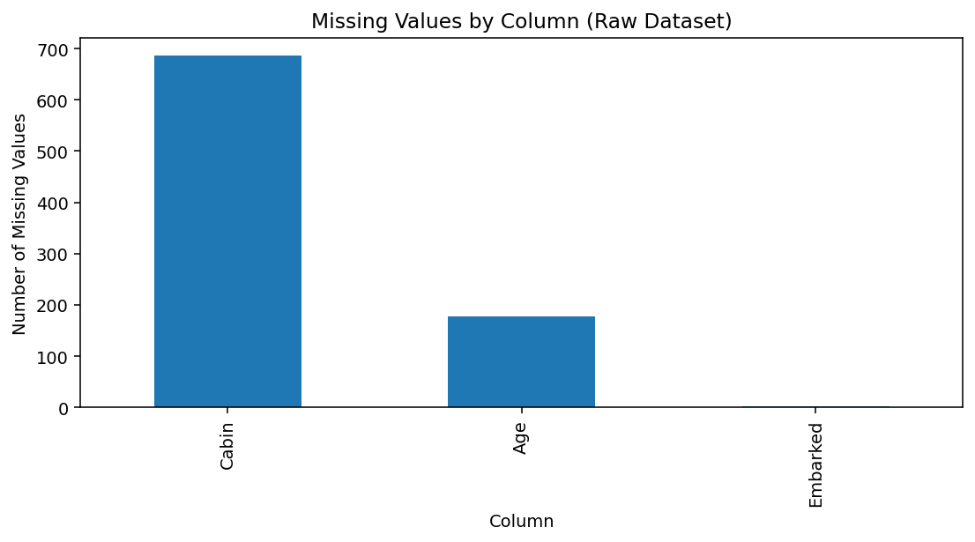
Figure 1. Missing values in the raw dataset.

4.3 Descriptive statistics
Statistic | Age | SibSp | Parch | Fare
count | 714.0 | 891.0 | 891.0 | 891.0
mean | 29.7 | 0.52 | 0.38 | 32.2
std | 14.53 | 1.1 | 0.81 | 49.69
min | 0.42 | 0.0 | 0.0 | 0.0
25% | 20.12 | 0.0 | 0.0 | 7.91
50% | 28.0 | 0.0 | 0.0 | 14.45
75% | 38.0 | 1.0 | 0.0 | 31.0
max | 80.0 | 8.0 | 6.0 | 512.33
The descriptive statistics show a wide Fare range, from 0 to 512.33, and an Age range from 0.42 to 80 among non-missing observations. The large gap between the median Fare (14.45) and maximum Fare (512.33) indicates strong right skew.

5. Data Quality Assessment
The quality assessment is organized into four categories: completeness, validity, consistency, and uniqueness.
Quality dimension | Field(s) | Finding | Action
Completeness | Age, Cabin, Embarked | 177, 687, and 2 missing values respectively | Impute/drop with justification
Uniqueness | All rows | 0 exact duplicate rows | No duplicate removal required
Validity | Age | No negative ages or ages above 100 found | No age correction required
Validity | Pclass | Only 1, 2, 3 observed | Valid
Validity | Survived | Only 0 and 1 observed | Valid binary target
Consistency | Sex | male/female values | Standardize to lowercase
Consistency | Embarked | C/Q/S plus 2 blanks | Standardize and impute mode
Numerical distribution | Fare | 116 IQR-flagged high values | Flag; log-transform rather than delete

5.1 Duplicate check
duplicate_count = df.duplicated().sum()
print("Duplicate rows:", duplicate_count)
Result: 0 exact duplicate rows. Therefore, no rows were removed on the basis of exact duplication.

5.2 Validity checks
print("Invalid ages:", ((df["Age"] < 0) | (df["Age"] > 100)).sum())
print("Invalid classes:", (~df["Pclass"].isin([1, 2, 3])).sum())
print("Invalid survival values:", (~df["Survived"].isin([0, 1])).sum())
These checks found no values that violated the basic domain rules above.

6. Missing-Value Treatment
Missing values require context. Removing every row containing a blank would discard a large proportion of the dataset, especially because Cabin is missing for most passengers. Instead, each variable is handled according to its analytical meaning and missingness level.

6.1 Age — group-wise median imputation
Age has 177 missing observations (19.87%). A global median would be simple, but age varies across passenger class and sex. Therefore, the median is calculated for each Sex × Pclass group and used to fill missing ages. The group medians are:
Sex | Pclass | Median Age
female | 1 | 35.0
female | 2 | 28.0
female | 3 | 21.5
male | 1 | 40.0
male | 2 | 30.0
male | 3 | 25.0
group_medians = df.groupby(["Sex", "Pclass"])["Age"].transform("median")
df["Age"] = df["Age"].fillna(group_medians)
df["Age"] = df["Age"].fillna(df["Age"].median())
Rationale: the median is less sensitive to extreme ages than the mean. Group-wise imputation also avoids pretending that the typical age is identical across all passenger groups. Limitation: imputed ages are estimates, not recovered original values, so variance in the Age column becomes slightly understated.
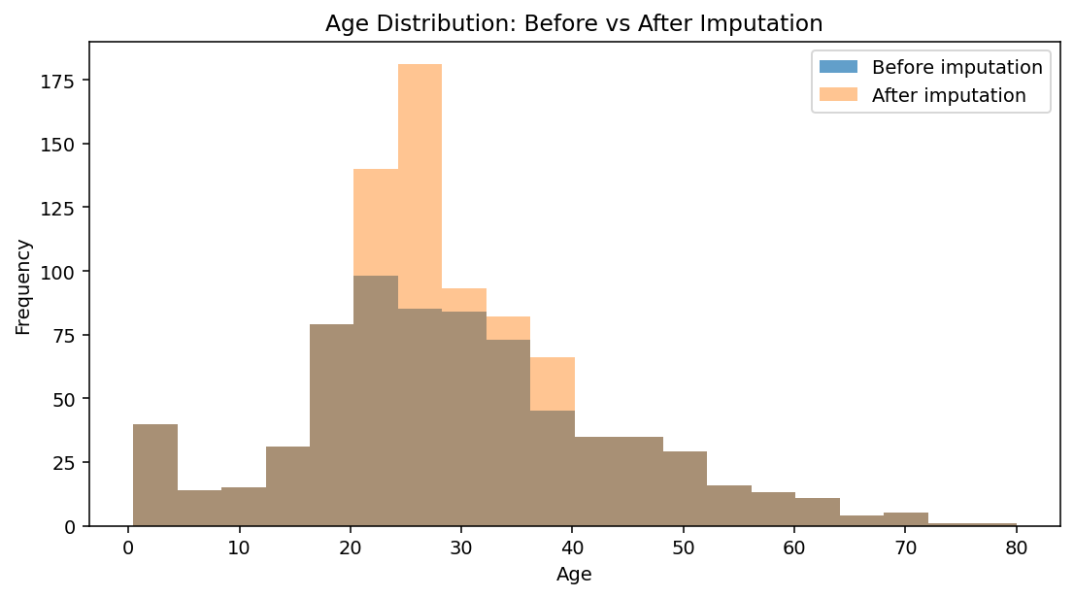
Figure 2. Age distribution before and after imputation.

6.2 Embarked — mode imputation
Only 2 Embarked values are missing (0.22%). The mode is S, so the two missing values are replaced with S.
df["Embarked"] = df["Embarked"].fillna(df["Embarked"].mode()[0])
Rationale: the missing proportion is extremely small and Embarked is categorical. Mode imputation is transparent and has minimal effect on overall counts.

6.3 Cabin — removal from baseline features
Cabin has 687 missing values (77.10%). Filling cabin identifiers with an arbitrary value would create a large artificial category. For the baseline cleaned dataset, Cabin is therefore removed. A more advanced project could extract Deck from Cabin before dropping the original field, but that would require an additional feature-engineering decision.
df = df.drop(columns=["Cabin"])
This decision prioritizes analytical reliability over retaining a highly incomplete field.

7. Inconsistency and Erroneous-Entry Checks

7.1 Categorical standardization
Text fields can contain leading/trailing spaces or inconsistent capitalization in real-world datasets. The cleaning workflow standardizes Sex and Embarked by trimming whitespace and converting values to lowercase.
for col in ["Sex", "Embarked"]:
df[col] = df[col].astype("string").str.strip().str.lower()
print(df["Sex"].value_counts(dropna=False))
print(df["Embarked"].value_counts(dropna=False))
After standardization, Sex contains female and male; Embarked contains c, q, and s after missing-value treatment.

7.2 Domain validation
The following logical rules were tested: age should not be negative or implausibly high; Pclass should be 1–3; Survived should be 0 or 1; and categorical fields should belong to their expected sets. No invalid age, class, or survival values were detected.

7.3 Zero-fare observations
There are 15 records with Fare = 0. A zero fare is unusual, but it is not automatically an error because historical passenger datasets may contain complimentary or otherwise exceptional fares. These records are retained rather than deleted without evidence. Analysts using Fare as a monetary predictor should treat zero fares as a business/domain question and investigate their provenance if the use case requires it.

8. Outlier Detection and Treatment

8.1 Why outliers need interpretation
An outlier is an observation that is unusually far from the rest of a distribution. It is not synonymous with an error. In passenger data, a very high fare can represent a real first-class booking, so deleting it solely because it is statistically unusual could remove meaningful information.

8.2 IQR method
For Fare, the interquartile range method is used. Q1 = 7.91, Q3 = 31.00, and IQR = 23.09. The upper threshold is Q3 + 1.5×IQR = 65.63. There are 116 Fare observations above this threshold.
Q1 = df["Fare"].quantile(0.25)
Q3 = df["Fare"].quantile(0.75)
IQR = Q3 - Q1
lower = Q1 - 1.5 * IQR
upper = Q3 + 1.5 * IQR
df["Fare_Outlier"] = (
(df["Fare"] < lower) | (df["Fare"] > upper)
).astype(int)
print("Outliers:", df["Fare_Outlier"].sum())
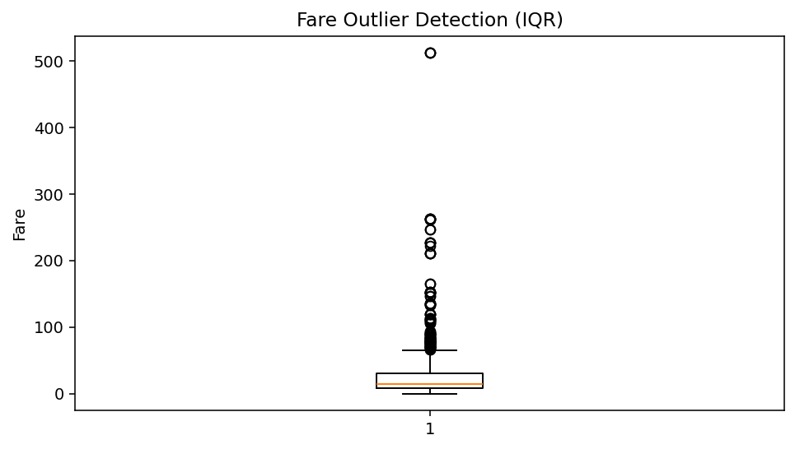
Figure 3. Fare boxplot showing high-value observations.

8.3 Treatment decision
The project does not delete the 116 flagged Fare observations. Instead, it keeps the original Fare, creates Fare_Outlier as an audit/quality flag, and adds Fare_Log = log(1 + Fare). This preserves information while providing a less-skewed numerical representation for analyses that are sensitive to skew.
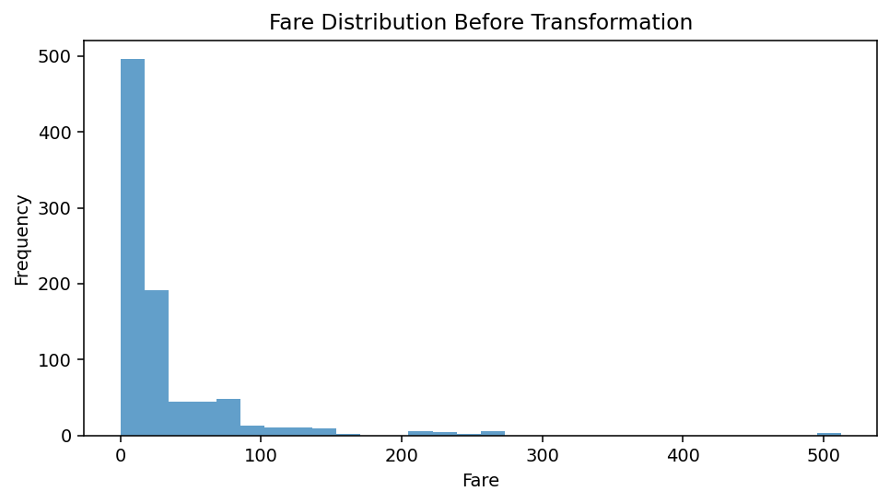
Figure 4. Strong right skew in Fare before transformation.

8.4 Other numerical variables
IQR rules also flag some high SibSp and Parch counts, but these are counts of family members and can be legitimate. Parch has Q1 = 0 and Q3 = 0, so the mechanical IQR rule is not especially informative. For this reason, these variables are retained and interpreted as discrete count variables rather than blindly deleting rows.

9. Data Transformation and Preprocessing

9.1 Feature selection
For a baseline modeling-ready table, the original Name and Ticket text identifiers are not encoded because they are high-cardinality identifiers and are outside the scope of this basic cleaning assignment. PassengerId is retained as an identifier for traceability. Cabin is removed because of extreme missingness.

9.2 Categorical encoding
df["Sex_Encoded"] = df["Sex"].map(
{"female": 0, "male": 1}
).astype(int)
df["Embarked_Code"] = df["Embarked"].map(
{"c": 0, "q": 1, "s": 2}
).astype(int)
For Sex, binary encoding is appropriate. Embarked_Code is provided for simple demonstration, although one-hot encoding is generally safer for nominal categories because the numeric labels do not represent a meaningful order.

9.3 Fare transformation
import numpy as np
df["Fare_Log"] = np.log1p(df["Fare"])
The log1p transformation is safe for Fare = 0 because log(1 + 0) = 0. It compresses very large values and can make the distribution more suitable for algorithms that respond strongly to scale or skew.

9.4 Optional scaling for machine learning
Scaling is not necessary for every analysis. Tree-based models generally do not require standardized numeric features, whereas distance-based methods and many gradient-based models can benefit from scaling. If scaling is required, it should be fitted on the training set only to avoid data leakage.
from sklearn.preprocessing import StandardScaler
scaler = StandardScaler()
X_train_scaled = scaler.fit_transform(X_train)
X_test_scaled = scaler.transform(X_test)

9.5 Final preprocessing pipeline
- Load and preserve the raw dataset.
- Inspect structure and data quality.
- Standardize categorical text.
- Impute Age using Sex × Pclass medians.
- Impute Embarked using the mode.
- Drop Cabin from the baseline feature set.
- Detect and flag Fare outliers with IQR.
- Create log-transformed Fare.
- Encode selected categorical fields.
- Validate missingness, ranges, duplicates, and data types.
- Export the cleaned dataset.

10. Validation of the Cleaned Dataset
Validation confirms that the cleaning operations achieved their intended goals and did not unexpectedly change row counts or introduce new invalid values.
print("Shape:", df.shape)
print("Total missing values:", df.isna().sum().sum())
print("Duplicate rows:", df.duplicated().sum())
print(df["Age"].describe())
print(df["Fare_Log"].describe())
Quality metric | Raw | Processed | Interpretation
Rows | 891 | 891 | No rows removed
Columns | 12 | 15 | 3 derived fields; Cabin removed
Missing Age | 177 | 0 | Group median imputation
Missing Embarked | 2 | 0 | Mode imputation
Missing Cabin | 687 | N/A | Column removed
Exact duplicate rows | 0 | 0 | No duplicate action
Fare IQR flags | 116 | 116 | Retained and flagged
Invalid age values | 0 | 0 | No invalid ages found

10.1 Post-cleaning quality checks
assert df["Age"].isna().sum() == 0
assert df["Embarked"].isna().sum() == 0
assert df.duplicated().sum() == 0
assert df["Pclass"].isin([1, 2, 3]).all()
assert df["Survived"].isin([0, 1]).all()
print("All validation checks passed.")
Assertions are useful because they convert quality expectations into executable tests. If a future version of the dataset violates a rule, the script can fail early instead of silently producing a questionable output.

11. Before-and-After Comparison

11.1 Dataset size and completeness
The number of passenger records remains 891 because missing values were handled without row deletion. This is important: complete-case deletion would have unnecessarily reduced the sample, especially due to the highly incomplete Cabin field.

11.2 Survival distribution
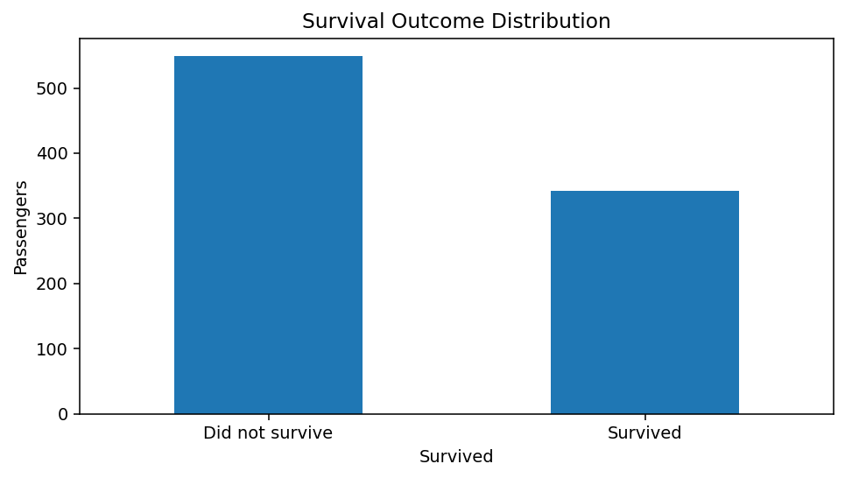
Figure 5. Survival outcome distribution in the raw data.
The raw survival rate is 38.38% (342 survivors out of 891 passengers).

11.3 Descriptive context for later analysis
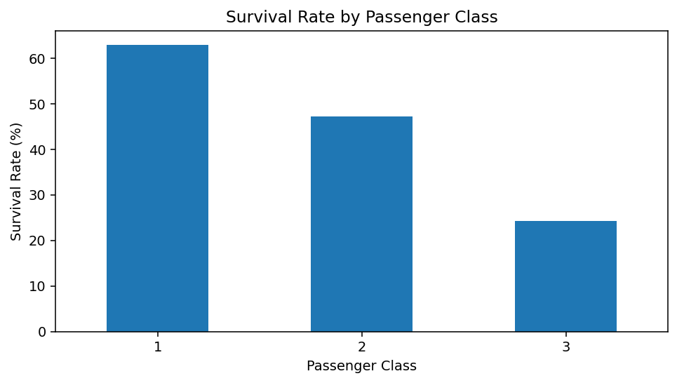
Figure 6. Survival rate by passenger class.
Class survival rates are approximately 62.96% for first class, 47.28% for second class, and 24.24% for third class.
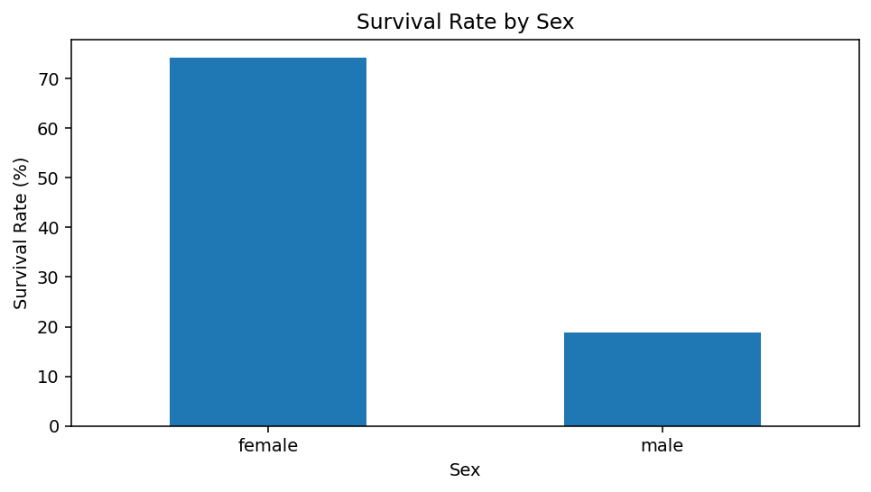
Figure 7. Survival rate by sex.
Female survival is approximately 74.20%, compared with 18.89% for males. These are descriptive associations only; this report does not infer causation.

12. Potential Impact on Subsequent Analysis
Decision | Benefit | Potential risk | Recommended follow-up
Age imputation | Preserves sample size and demographic structure | Can reduce natural age variance and weaken uncertainty if treated as observed values. | Consider multiple imputation or missingness indicators in advanced work.
Cabin removal | Avoids a huge artificial missing category | Loses cabin/deck information that may be predictive. | Extract Deck before dropping if the project needs it.
Embarked mode fill | Minimal effect because only 2 values are missing | May slightly alter category counts. | Use explicit missing category when missingness itself is meaningful.
Fare outlier flagging | Preserves potentially real high fares | Flagged values can still influence means and regression coefficients. | Use robust statistics, log Fare, or a justified winsorization strategy.
Fare log transform | Reduces skew and compresses extreme values | Changes the scale and interpretation of Fare. | Use original Fare when business interpretation requires currency units.
Categorical encoding | Makes selected fields machine-readable | Numeric codes can imply order where none exists. | Prefer one-hot encoding for nominal variables in many ML models.
Dropping identifiers | Reduces noise and high-cardinality features | May remove information embedded in names/tickets. | Engineer meaningful features only when justified.

12.1 Statistical interpretation
Preprocessing can change distributions and therefore change means, variances, correlations, and model coefficients. Median imputation adds repeated values at group medians, while log transformation changes the scale of Fare. Outlier flagging preserves records but gives later analysts a way to compare results with and without flagged observations.

12.2 Model-development interpretation
If the cleaned data is later used for machine learning, preprocessing must be fitted only on the training data for steps that learn parameters (such as medians, scaling parameters, or encoding vocabularies). This prevents information from the test set from leaking into training.

13. Challenges and Solutions
Challenge | Evidence / risk | Solution
High Cabin missingness | 687 of 891 values are missing. | Dropping Cabin for the baseline dataset; documenting the information loss.
Age missingness | 177 ages are unavailable. | Use Sex × Pclass group medians rather than one global value.
Extreme Fare values | 116 values exceed the IQR upper threshold. | Treat them as potential real observations; flag and log-transform rather than delete.
Zero Fare values | 15 fares are exactly zero. | Retain until domain evidence proves they are erroneous.
Categorical consistency | Text fields may have formatting differences in public datasets. | Strip whitespace and normalize case before validation.
Reproducibility | Public datasets can change location or version. | Record the exact URL and keep raw and processed files separate.
Data leakage risk | Scaling/imputation can accidentally use all data. | Fit learned preprocessing steps on training data only in later modeling.

13.1 General lesson
The central challenge is not writing a pandas command; it is deciding what that command means. A good cleaning process makes the smallest justified change, preserves traceability, and avoids treating unusual but valid observations as mistakes.

14. Reflective Commentary
The most important decision in this project was to avoid aggressive deletion. A simple approach would be to drop every row with missing data and remove every IQR outlier. Although that approach is easy to code, it would not be defensible for this dataset because Cabin is highly incomplete and high fares may represent legitimate passengers.
The group-wise median strategy for Age is a compromise between preserving records and avoiding an unrealistic global replacement. It uses observed structure in the data, but it still introduces uncertainty. If the project were being developed for publication or high-stakes prediction, I would test multiple imputation methods and compare sensitivity of conclusions.
The treatment of Fare illustrates the distinction between data quality and data distribution. A value can be statistically extreme without being wrong. The final workflow therefore retains Fare, marks outliers, and provides a transformed version. This gives future analysts more options instead of permanently deleting information.
Another reflection is that preprocessing should be connected to the intended analysis. Encoding, scaling, imputation, and feature selection are not universally correct or incorrect. Their suitability depends on whether the next step is descriptive statistics, visualization, hypothesis testing, regression, classification, clustering, or another task.
Overall, the workflow improved completeness and consistency while preserving the full set of passenger rows. The remaining responsibility is to document assumptions so that a future analyst can reproduce the dataset and understand exactly how each field was changed.

15. Reproducibility and Execution Guide

15.1 Software requirements
- Python 3.x
- pandas
- numpy
- matplotlib
- scikit-learn (optional for scaling/modeling)
- Jupyter Notebook or VS Code

15.2 Installation
pip install pandas numpy matplotlib scikit-learn jupyter

15.3 Run the project
# Save the script as titanic_data_cleaning.py
python titanic_data_cleaning.py
# Or run interactively
jupyter notebook

15.4 Recommended project folder
titanic_data_cleaning/
│
├── data/
│ └── titanic_raw.csv
├── output/
│ └── titanic_cleaned_preprocessed.csv
├── notebooks/
│ └── titanic_cleaning.ipynb
├── titanic_data_cleaning.py
└── Data_Cleaning_and_Preprocessing_Titanic_Report.docx

15.5 Reproducibility checklist
- Keep the original raw dataset unchanged.
- Record the public source URL.
- Run the same cleaning script from a clean environment.
- Validate row count and missing-value counts.
- Store a dated copy of the processed output.
- Record any manual edits separately from automated transformations.

16. Conclusion
This project demonstrates a complete, transparent workflow for preparing a public dataset for further analysis. The Titanic dataset was acquired from a reproducible public URL and examined before modification. The analysis identified 177 missing Age values, 687 missing Cabin values, and 2 missing Embarked values, while finding no exact duplicate rows and no basic domain violations in Age, Pclass, or Survived.
Age was imputed using Sex × Pclass medians, Embarked was imputed using the mode, and Cabin was removed from the baseline feature set because of its high missingness. Fare was analyzed with the IQR method, producing 116 flagged high values. Instead of deleting these potentially valid observations, the workflow preserved them and created both an outlier flag and a log-transformed Fare feature.
The final dataset keeps all 891 passenger records and contains no missing values in the retained fields. It is suitable as a starting point for exploratory analysis or as a foundation for a carefully designed machine-learning pipeline. Most importantly, every transformation is documented so that another analyst can reproduce, review, and challenge the decisions.

Final quality statement
The processed dataset should be considered 'analysis-ready for the defined baseline scope', not universally 'perfect'. Data preparation is purpose-dependent, and further work may be required before specialized statistical modeling or production deployment.

17. References
Resource | URL | Use in project
Seaborn-data repository | https://github.com/mwaskom/seaborn-data | Public repository containing the Titanic CSV and source information.
Titanic raw CSV | https://raw.githubusercontent.com/mwaskom/seaborn-data/master/raw/titanic.csv | Reproducible CSV endpoint used by the Python example.
Pandas documentation | https://pandas.pydata.org/docs/ | Reference for DataFrame loading, missing-value handling, grouping, and transformations.
NumPy documentation | https://numpy.org/doc/ | Reference for numerical operations including log1p.
Matplotlib documentation | https://matplotlib.org/stable/ | Reference for plots used to inspect data quality and distributions.
Accessed / documented for this report: 12 September 2026. Dataset provenance should be rechecked before a future rerun because public repositories can change.

Appendix A — Complete Python Code
The following script reproduces the main data-cleaning workflow described in this report.
# Titanic Data Cleaning and Preprocessing Project
import pandas as pd
import numpy as np
# 1. Collect / load public dataset
url = "https://raw.githubusercontent.com/mwaskom/seaborn-data/master/raw/titanic.csv"
df = pd.read_csv(url)
# 2. Initial exploration
print(df.shape)
print(df.info())
print(df.isna().sum())
print(df.describe(include="all"))
# 3. Standardize categorical text
for col in ["Sex", "Embarked"]:
df[col] = df[col].astype("string").str.strip().str.lower()
# 4. Handle missing Embarked values using the mode
df["Embarked"] = df["Embarked"].fillna(df["Embarked"].mode()[0])
# 5. Handle missing Age using group-wise medians
group_medians = df.groupby(["Sex", "Pclass"])["Age"].transform("median")
df["Age"] = df["Age"].fillna(group_medians)
df["Age"] = df["Age"].fillna(df["Age"].median())
# 6. Remove high-missingness Cabin field for the baseline analysis
df = df.drop(columns=["Cabin"])
# 7. Detect Fare outliers with IQR
Q1 = df["Fare"].quantile(0.25)
Q3 = df["Fare"].quantile(0.75)
IQR = Q3 - Q1
lower = Q1 - 1.5 * IQR
upper = Q3 + 1.5 * IQR
df["Fare_Outlier"] = ((df["Fare"] < lower) | (df["Fare"] > upper)).astype(int)
# 8. Reduce Fare skew without deleting valid passengers
df["Fare_Log"] = np.log1p(df["Fare"])
# 9. Encode categorical variables for downstream ML
df["Sex_Encoded"] = df["Sex"].map({"female": 0, "male": 1}).astype(int)
df["Embarked_Code"] = df["Embarked"].map({"c": 0, "q": 1, "s": 2}).astype(int)
# 10. Validation
print("Missing values after cleaning:")
print(df.isna().sum())
print("Duplicate rows:", df.duplicated().sum())
# 11. Save the processed dataset
df.to_csv("titanic_cleaned_preprocessed.csv", index=False)
print("Saved: titanic_cleaned_preprocessed.csv")

Appendix B — Key Outputs
Metric | Value
Raw rows | 891
Raw columns | 12
Age missing | 177
Cabin missing | 687
Embarked missing | 2
Exact duplicates | 0
Fare IQR outliers | 116
Processed rows | 891
Processed missing values | 0
Supporting file: titanic_cleaned_preprocessed.csv
This report includes analytical figures generated from the same raw dataset used for the cleaning calculations.

Appendix C — Additional Visual Evidence

C.1 Correlation Matrix
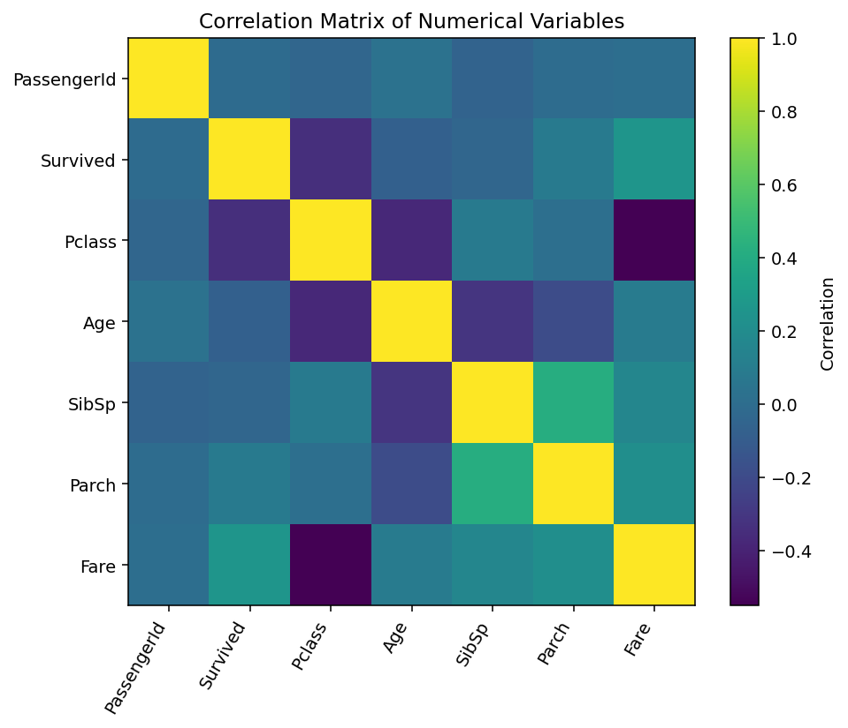
Figure 8. Numerical correlation matrix.
The correlation matrix is included as a diagnostic aid, not as proof of causation. Correlations can be affected by missing-value treatment, encoding choices, and the underlying structure of the sample.

