Week 5 Report
Development of Data Dashboards and Reporting

Contents
1. Introduction and Objectives
2. Planning: Users, Questions and Decisions
3. Data Sources and Data Model
4. KPI Selection
5. Research: Choosing the Right Visualization
6. Dashboard Design
7. Design Rationale and Component Selection
8. From Insight to Action: How the Dashboard Improves Decisions
9. Implementation Plan
10. Evaluation and Reflection
11. Conclusion
References

1. Introduction and Objectives
Modern supply chains generate enormous volumes of data: orders, shipments, inventory snapshots, supplier confirmations, freight invoices and demand signals. On its own this data has little value. Managers need to see it as a small number of clear, comparable and timely signals that tell them whether the supply chain is performing, where it is drifting, and what they should do next. A well-designed dashboard is the tool that makes this possible.
This report presents the plan and design of an interactive Supply Chain Performance Dashboard. It builds on the earlier internship work: the data collection exercise (Week 1), the identification of supply chain KPIs (Week 2), the process map (Week 3) and the conceptual demand forecasting model (Week 4). The dashboard is the point where these pieces come together in a form that decision-makers can actually use.

1.1 Objectives
- Translate complex supply chain data into a visual format that can be understood in seconds by a non-technical decision-maker.
- Highlight performance metrics, trends and areas that need attention, using analysis based on publicly available data sources.
- Provide a layout plan with wireframe and high-fidelity mock-ups showing the charts, graphs and tables used.
- Explain how each KPI and visualization supports better supply chain decisions.
- Reflect on real-world implementation challenges and propose an iterative improvement path.

1.2 Scope
The dashboard covers the end-to-end flow of a typical product supply chain: inbound supply (suppliers and lead times), inventory (stock levels and turnover), and outbound delivery (orders, transport cost and service level). The design is tool-independent and can be built in Power BI, Tableau or Looker Studio. The mock-ups in this report use illustrative sample data.

2. Planning: Users, Questions and Decisions
The most common reason dashboards fail is that they are designed around the data that is available rather than around the decisions that must be made. I therefore began by identifying who will use the dashboard and what questions each group needs answered. Every component added later has to trace back to one of these questions.
User group | Key questions | Typical decisions | Review rhythm
Executives / Head of Supply Chain | Are we meeting service and cost targets? Where is the biggest risk? | Approve investment, change strategy, escalate supplier issues | Weekly / Monthly
Supply chain / Operations managers | Which lanes, regions or suppliers are underperforming this week? | Reallocate volume, expedite shipments, adjust staffing | Daily / Weekly
Procurement / Supplier managers | Which suppliers are late or unstable? Is lead time improving? | Supplier reviews, dual sourcing, contract renegotiation | Weekly / Monthly
Inventory planners | Which items are at risk of stock-out or overstock? | Change reorder points, safety stock, order quantities | Daily
Logistics / Transport managers | Is freight cost per unit rising? Which carriers or lanes are late? | Carrier selection, mode change, consolidation | Weekly

2.1 Design Principles Adopted
- Decision first: every chart must answer a named question and point to a possible action.
- Few, meaningful metrics: a single screen shows six headline KPIs, not thirty. Detail sits one click deeper.
- Context for every number: each KPI is shown with a target, a prior-period comparison and a status colour so the viewer knows whether the number is good or bad.
- Exceptions over averages: averages hide problems, so a dedicated exception table lists the specific items needing attention.
- Consistency: the same colours, time axis and filter behaviour apply on every page.

3. Data Sources and Data Model

3.1 Publicly Available Data Sources
As the task requires analysis based on public data, the following types of open sources are suitable for building or testing this dashboard. The structure of the dashboard stays the same if they are later replaced with a company's own ERP, WMS and TMS data.
Source | What it provides | Used for
DataCo Smart Supply Chain dataset (public, Mendeley Data / Kaggle) | Order-level data: order dates, shipping mode, scheduled vs actual shipping days, delivery status, sales, region, product category | OTIF / on-time delivery, lead time, order status mix, regional comparison
New York Fed Global Supply Chain Pressure Index (GSCPI) | Monthly index of global supply chain pressure | External context line on the trend chart
World Bank Logistics Performance Index (LPI) | Country-level scores for customs, infrastructure, timeliness and tracking | Benchmarking of regions / lanes
US Bureau of Transportation Statistics and UN Comtrade | Freight volumes, trade flows by commodity and country | Volume context and transport cost analysis
Week 1 collected dataset (internship) | Dataset gathered and cleaned in the earlier task | Base data for KPIs identified in Week 2

3.2 Data Flow
Figure 1 shows how data moves from source to dashboard. Cleaning and calculation happen before visualization, so that every chart reads from one consistent, tested set of measures.
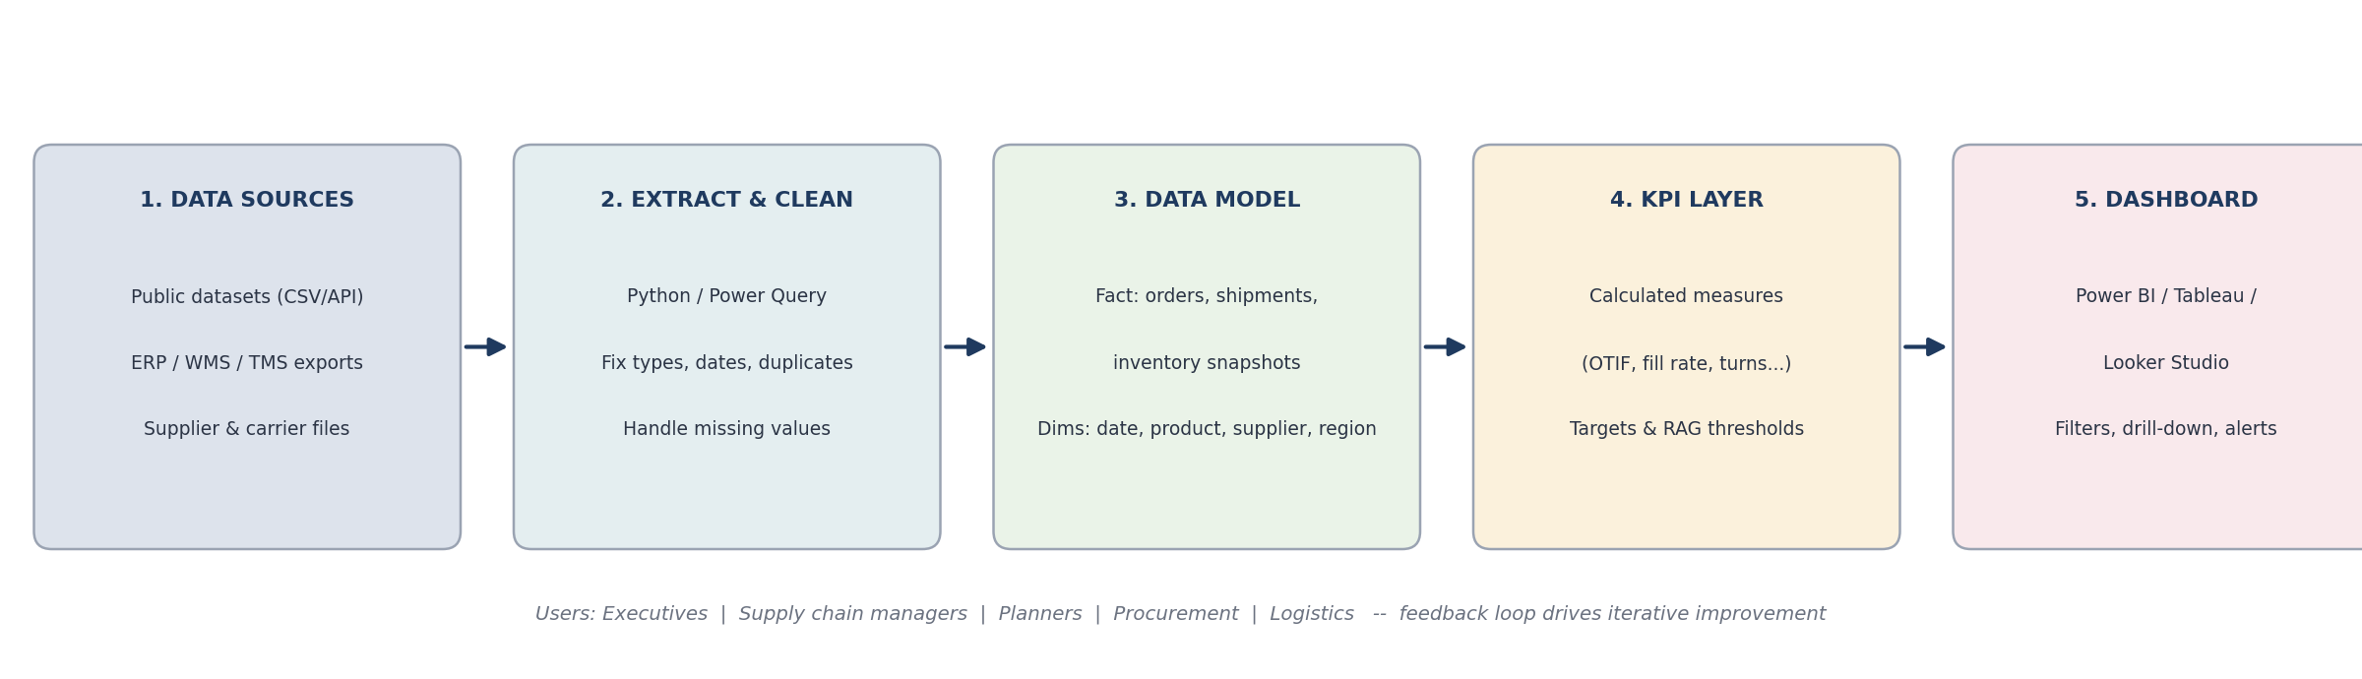
Figure 1: End-to-end data flow from sources to dashboard users

3.3 Proposed Data Model
A star schema is recommended. It keeps the model simple, makes filters behave predictably and performs well in all common BI tools.
Table | Type | Key fields
Fact_Orders | Fact | Order ID, order date, promised date, delivered date, quantity ordered, quantity shipped, order value, delivery status
Fact_Shipments | Fact | Shipment ID, carrier, mode, origin, destination, freight cost, units, actual vs planned transit days
Fact_Inventory | Fact (snapshot) | Date, product ID, on-hand units, on-order units, safety stock, average daily demand
Dim_Date | Dimension | Date, week, month, quarter, year, holiday flag
Dim_Product | Dimension | Product ID, category, unit cost, supplier ID
Dim_Supplier | Dimension | Supplier ID, name, country, contractual lead time
Dim_Region | Dimension | Region, country, warehouse / DC

4. KPI Selection
KPIs were chosen so that the dashboard covers the main attributes of supply chain performance defined in the SCOR model: reliability, responsiveness, agility, cost and asset management. Choosing at least one KPI from each attribute prevents the dashboard from over-emphasising one dimension (for example cost) at the expense of another (for example service).

4.1 Selection Criteria

- Relevance: the KPI links directly to a decision a user can make.
- Measurability: the data needed is available or can be collected reliably.
- Actionability: the user can influence the number through their own actions.
- Balance: the set of KPIs covers service, speed, cost and assets so that trade-offs become visible.
- Clarity: the definition is simple enough to be understood and trusted by every user.

4.2 Headline KPIs (Executive Page)
KPI | Formula | Why it matters | SCOR attribute | Example target
OTIF (On-Time In-Full) | Orders delivered on time and complete / Total orders | Single best measure of customer service reliability | Reliability | ≥ 95%
Order Fill Rate | Units shipped from stock / Units ordered | Shows whether stock availability meets demand | Reliability | ≥ 97%
Average Lead Time | Mean days from order (or PO) to delivery | Speed of response; driver of safety stock | Responsiveness | ≤ 5.5 days
Inventory Turnover | Cost of goods sold / Average inventory value | Efficiency of working capital | Asset management | ≥ 8x
Stock-out Rate | Order lines or days with zero stock / Total | Lost sales and customer dissatisfaction risk | Reliability | ≤ 2%
Freight Cost per Unit | Total freight cost / Units shipped | Transport efficiency and cost control | Cost | ≤ $4.20

4.3 Supporting KPIs (Drill-down Pages)
KPI | Formula | Used on page
Supplier On-Time Delivery % | Supplier deliveries on or before promise date / Total deliveries | Inbound / Suppliers
Lead Time Variability | Standard deviation of lead time (or coefficient of variation) | Inbound / Suppliers
Days of Supply (DOS) | On-hand inventory / Average daily demand | Inventory
Perfect Order Rate | Orders on time, in full, undamaged and with correct documents / Total orders | Outbound / Service
Forecast Accuracy (1 - MAPE) | 1 - mean absolute percentage error of forecast vs actual demand | Planning (link to Week 4 model)
Order Cycle Time | Average time from order placement to delivery | Outbound / Service
Freight Cost as % of Sales | Total freight cost / Total sales value | Transport

5. Research: Choosing the Right Visualization
Visualization choice should follow the type of question being asked, not personal preference. Research on visual perception (Cleveland and McGill) shows that people read position and length along a common scale most accurately, and read angle, area and colour intensity less accurately. Practical design guidance from Stephen Few, Edward Tufte and Cole Nussbaumer Knaflic reaches the same conclusion: favour simple charts based on position and length, and remove decoration that carries no information.
Question type | Best-fit chart | Used in this dashboard for | Avoid
How is a metric changing over time? | Line chart with target line | OTIF trend, freight cost trend | 3D area, too many lines
Which items rank best / worst? | Sorted horizontal bar | Supplier lead time ranking | Unsorted bars, pie charts
How do categories compare to a limit? | Column chart with reference line | Days of supply by category vs policy | Radar charts
What share is made of which parts? | 100% stacked bar | Order status by region (on time / late / failed) | Pie / donut with many slices
How do two measures relate? | Combo chart (bar + line) or scatter | Freight cost per unit vs volume | Dual axes without clear labelling
Where is performance geographically weak? | Map or heat map | Regional OTIF (drill-down page) | Map for data with no spatial meaning
What exactly needs attention now? | Table with RAG status and conditional formatting | Exception report | Large unformatted tables
What is the single current value? | KPI card with delta and target | Six headline KPIs | Gauges that waste space

5.1 Colour and Visual Rules
- Status colours (RAG): green = on target, amber = within tolerance, red = action needed. Colour is always paired with a number or label so the dashboard remains readable for colour-blind users.
- Neutral base: navy and grey for normal data so that the red and amber highlights stand out and attract attention only when required.
- One message per chart: each chart has a descriptive title and a reference line (target or policy limit) so the viewer instantly sees the gap.
- Readable by default: minimum font sizes, direct labels instead of legends where possible, no 3D, no gradients, light gridlines.

6. Dashboard Design

6.1 Tools and Design Process
The design was produced in three stages, moving from low to high fidelity so that structural decisions were made before visual polish.

- Paper sketch / whiteboard: rough blocks drawn to decide which questions deserve the most space and in what reading order.
- Wireframe: a grey-box layout (Figure 2) that fixes the position, size and chart type of each component without colour or data. This is where layout can be reviewed cheaply. Tools suitable for this stage are Figma, draw.io or PowerPoint.
- High-fidelity mock-up: a coloured version with realistic sample values (Figure 3) showing final fonts, colour rules, targets and exceptions. For this report the mock-up was generated programmatically in Python (Matplotlib) so that every element is reproducible and easy to adjust.
- Build tool (planned): Power BI Desktop is the recommended tool for implementation because of its star-schema modelling, DAX measures, conditional formatting and scheduled refresh. Tableau or Looker Studio are valid alternatives with the same layout.

6.2 Layout Plan (Wireframe)
The executive page uses a Z-shaped reading pattern: the eye moves from the header and filters, across the KPI cards, then down through trend and ranking charts to the exception table. The most important information is therefore at the top and the most actionable detail at the bottom right, where the reader finishes.
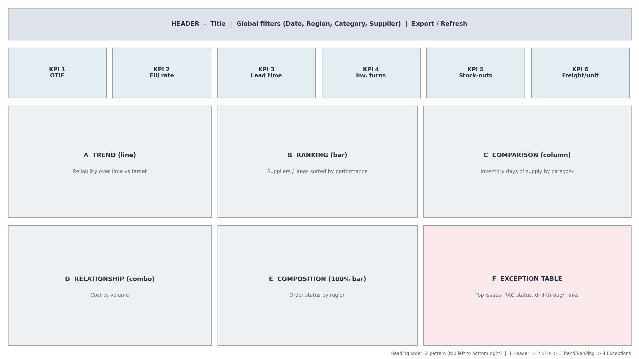
Figure 2: Wireframe of the Executive Overview page with zones A-F
Zone | Component | Chart type | Question answered
Header | Title, global filters, refresh date, export | Slicers / buttons | What period, region, category and supplier am I viewing?
KPI row | Six headline KPI cards | Card with delta, target and RAG strip | Are we on target right now?
A | OTIF trend vs target | Line chart | Is service improving or deteriorating?
B | Supplier lead time ranking | Sorted horizontal bar with target line | Which suppliers are slowing us down?
C | Days of supply by category | Column chart with policy limit | Where do we hold too much or too little stock?
D | Freight cost per unit vs volume | Combo bar + line | Is cost rising because of volume or inefficiency?
E | Order status mix by region | 100% stacked bar | Which region has the most late or failed orders?
F | Exception table | Table with RAG indicators | What specific items need action today?

6.3 High-Fidelity Mock-up
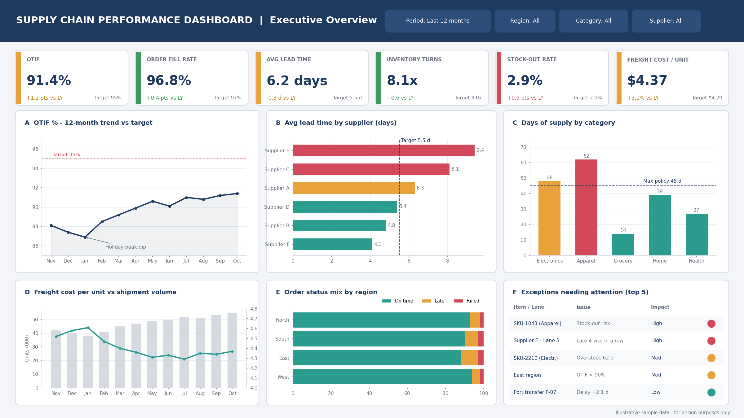
Figure 3: High-fidelity mock-up of the Executive Overview page (illustrative sample data)
In the mock-up, the headline cards immediately show that OTIF (91.4%) and the stock-out rate (2.9%) are the weakest areas, while fill rate and inventory turns are on target. The supporting charts then explain why: Supplier E and Supplier C have the longest lead times, Apparel holds 62 days of supply against a 45-day policy, and the East region has the lowest on-time share. The exception table converts these observations into a short list of items for follow-up.

6.4 Page Structure and Navigation
The dashboard is organised in layers, so that the first screen stays simple but users can go deeper when a signal needs investigation.
Page | Audience | Content
1. Executive Overview | Leadership | Six KPI cards, trend, ranking, exceptions (Figure 3)
2. Inbound and Suppliers | Procurement | Supplier on-time %, lead time and variability, supplier scorecard, PO status
3. Inventory | Planners | Days of supply, turnover by category, stock-out and overstock list, ABC classification
4. Outbound and Service | Operations | OTIF and perfect order by region / customer, order cycle time, delay reasons
5. Transport and Cost | Logistics | Freight cost per unit, cost by mode and carrier, transit time, lane map
6. Planning (future) | Demand planners | Forecast vs actual, forecast accuracy, predicted stock-outs (Week 4 model)

6.5 Interactivity
- Global filters (date, region, category, supplier) that apply across all pages so every chart stays consistent.
- Cross-filtering: clicking a bar (for example Supplier E) filters all other visuals to that supplier.
- Drill-down and drill-through: from a region to its warehouses, or from an exception row to the order-level detail page.
- Tooltips: hovering shows exact values, change vs previous period and the KPI definition.
- Conditional formatting and alerts: cards and table rows change colour when thresholds are crossed; email or Teams alerts are sent for red status.
- Time comparison toggle: month-on-month, year-on-year, or vs target.

7. Design Rationale and Component Selection
This section explains why each component was selected and what it contributes to the holistic view.
Component | Selection reason | Alternatives rejected
KPI cards | Give the current value in one glance, with context (delta, target, colour). Executives can decide within seconds if intervention is needed. | Gauges and speedometers: use more space and show less information
Line chart with target (OTIF) | Trends reveal direction, seasonality and the effect of past actions. The target line makes the performance gap obvious. | Column chart for time series: weaker for showing continuity
Sorted horizontal bar (suppliers) | Ranking by length is the easiest comparison for the eye; long supplier names fit on the left axis. | Pie chart: poor for comparing similar values
Column chart with policy line (inventory) | Directly compares each category to the stock policy limit; overstock is seen immediately. | Treemap: attractive but harder to read precisely
Combo chart (cost vs volume) | Shows whether unit cost moves with scale; helps separate volume effects from true efficiency problems. | Two separate charts: harder to compare over the same time axis
100% stacked bar (order status) | Shows share of on-time, late and failed orders in each region on a common scale. | Donut charts per region: too many shapes to compare
Exception table | Turns the dashboard from descriptive to action-oriented by listing exactly what needs attention. | No table: users would have to hunt for problem items

7.1 How the Components Give a Holistic View
The six KPIs and charts together cover the chain from supplier to customer, and cover all five SCOR performance attributes. Reading them together is more powerful than reading each alone:
- A fall in OTIF (reliability) combined with long supplier lead times (responsiveness) points to an inbound problem rather than a warehouse problem.
- High inventory days of supply (asset management) together with a high stock-out rate (reliability) signals that stock is in the wrong place or wrong items, not that the company simply needs more stock.
- Rising freight cost per unit (cost) while volume also rises suggests expediting or poor consolidation, rather than a normal scale effect.
- A regional drop in on-time share indicates a local carrier or DC issue and shows where to drill down.
Key idea
The dashboard is designed to show trade-offs. Improving one metric in isolation (for example cutting inventory to improve turns) usually harms another (stock-out rate). Showing them side by side keeps decisions balanced.

8. From Insight to Action: How the Dashboard Improves Decisions
A dashboard only creates value if what it shows leads to a decision. The table below links typical signals on the dashboard to the investigation path and the actions available to the user.
Signal on dashboard | Likely cause (to verify via drill-down) | Possible decision / action | Benefit
OTIF below target and falling for three months (Chart A) | Late inbound supply, warehouse backlog, carrier delays | Check suppliers (Chart B), regions (Chart E); expedite critical orders; change carrier | Better customer service, fewer penalties
Supplier E lead time 9.4 days vs 5.5 target (Chart B) | Supplier capacity issue, long transit lane | Supplier review meeting; qualify backup supplier; raise safety stock temporarily | Lower disruption risk, lower expediting cost
Apparel days of supply 62 vs 45 policy (Chart C) | Over-ordering, slow-moving SKUs, forecast bias | Reduce open POs, run promotion, review forecast and reorder points | Release working capital, lower holding cost
Stock-out rate 2.9% vs 2.0% target (KPI card) | Under-forecast items, long lead times, wrong safety stock | Recalculate safety stock by SKU; prioritise A-class items; improve forecast (Week 4 model) | Recover lost sales
Freight cost per unit up 3.1% while volume grows (Chart D) | Expedited shipments, partial loads, mode shift | Consolidate shipments; renegotiate rates; reduce air freight use | Cost saving
East region 88% on-time (Chart E) | Local carrier or DC performance | Review carrier SLA; add capacity or change DC allocation | Closes regional service gap

8.1 Reporting Cadence
Report | Frequency | Format | Recipients
Operational exception alert | Daily (automatic) | Email / Teams message with top exceptions | Planners, logistics
Weekly performance review | Weekly | Dashboard pages 2-5 in review meeting | Operations and procurement managers
Monthly executive report | Monthly | Page 1 exported as PDF with commentary | Leadership
Quarterly supplier scorecard | Quarterly | Supplier page with trend and rating | Procurement and suppliers

9. Implementation Plan
Although this task focuses on design, a realistic implementation path was also considered so the design is feasible.

- Define: confirm KPI definitions, targets and owners with stakeholders and document them in a data dictionary.
- Collect and clean: load data using Power Query or Python; standardise dates, remove duplicates, handle missing values and flag outliers.
- Model: build the star schema (section 3.3) and relationships; create a date table.
- Calculate: create measures (for example OTIF = DIVIDE(OTIF orders, Total orders)) and target tables for RAG logic.
- Visualise: build the pages according to the wireframe; apply theme, formatting and interactions.
- Test: reconcile dashboard numbers with source data; test filters; run user acceptance testing with sample users.
- Publish and refresh: publish to the service workspace, set up scheduled refresh and role-based access.
- Train and support: short user guide, KPI glossary page, feedback channel.

10. Evaluation and Reflection

10.1 Challenges in Real-World Implementation
Challenge | Why it happens | Mitigation
Data quality and completeness | Missing dates, duplicate orders, inconsistent product codes across systems | Data validation rules, automated quality checks, data owners, clear data dictionary
Data silos and integration | ERP, WMS, TMS and supplier data sit in separate systems with different keys | Common master data (product, supplier IDs); central data warehouse or lake; API connections
Inconsistent KPI definitions | OTIF or lead time calculated differently by each team | One agreed definition per KPI, documented on a glossary page and enforced in one measure
Data latency | Dashboard refreshed too slowly for operational decisions | Different refresh rates by page: near-real-time for operations, daily or weekly for strategic views
Information overload | Stakeholders request too many metrics and charts | Strict KPI selection criteria; layered pages; remove visuals nobody uses (track usage)
Low user adoption | Users do not trust the numbers or do not see value | Involve users in design, reconcile numbers publicly, train users, link meetings to the dashboard
Performance and scalability | Large datasets slow down reports | Aggregation tables, incremental refresh, efficient data model
Security and access | Sensitive cost and supplier data | Role-level security, audit logs, sharing policy
Changing business needs | New products, regions or strategy | Modular design, version control, regular review of KPI set

10.2 Limitations of This Design
- The mock-ups use illustrative sample data; real data may reveal different patterns and require adjusting scales, targets and thresholds.
- Targets shown (for example 95% OTIF) are examples; real targets must be set from customer commitments, benchmarks and company strategy.
- Public datasets do not contain every field a real company holds (for example supplier cost, or warehouse labour data), so some KPIs could only be fully calculated in an internal implementation.

10.3 Suggestions for Iterative Improvement
Version | Focus | Improvements
v1.0 (MVP) | Core visibility | Executive page and four drill-down pages with the KPIs in section 4; manual data refresh; basic RAG
v1.1 | Usability | Collect user feedback; improve filters and tooltips; add KPI glossary; mobile layout; usage tracking
v1.2 | Automation | Scheduled refresh, automated alerts and exception emails, automated monthly PDF report
v2.0 | Predictive | Add forecast vs actual and predicted stock-out risk using the Week 4 demand forecasting model; supplier risk score
v2.5 | Prescriptive | What-if scenarios (for example lead time +20% or demand +10%); recommended reorder quantities; cost-to-serve analysis
v3.0 | Extended view | Add sustainability metrics (CO2 per shipment), external signals such as GSCPI, weather and port congestion

10.4 Personal Reflection
Working on this task changed how I think about reporting. At the start I focused on the number of charts I could include. During the planning and wireframe stages I realised that a good dashboard is defined as much by what it leaves out as by what it contains. Starting from the user and the decision, and only then choosing the KPI and chart, produced a much cleaner design than starting from the data.
I also learned that visual choices are not cosmetic: a sorted bar chart, a target line or a red highlight can change how quickly a manager notices a problem. Finally, the exercise showed me that the hardest part of real dashboards is rarely the visualization itself. It is agreeing on definitions, getting clean data from several systems and keeping users engaged. Planning for these challenges early, and releasing the dashboard in small iterations, is what makes the difference between a report that is admired and one that is actually used.

11. Conclusion
This report set out a complete plan for a Supply Chain Performance Dashboard: the users and decisions it supports, the public data sources and data model behind it, the selection of six headline and seven supporting KPIs, the research-based choice of visualizations, and the layout shown through a wireframe and a high-fidelity mock-up. Each component was linked to a specific decision, and the combined view covers reliability, responsiveness, cost and asset management across the chain from supplier to customer.
The design demonstrates the link between data visualization and supply chain efficiency: clear, contextualised and actionable visuals shorten the time between a problem appearing and a decision being made. With the proposed implementation steps and improvement roadmap, the design can be developed from a prototype into a reliable decision-support tool.

References
- Few, S. (2013). Information Dashboard Design: Displaying Data for At-a-Glance Monitoring (2nd ed.). Analytics Press.
- Knaflic, C. N. (2015). Storytelling with Data: A Data Visualization Guide for Business Professionals. Wiley.
- Tufte, E. R. (2001). The Visual Display of Quantitative Information (2nd ed.). Graphics Press.
- Cleveland, W. S. and McGill, R. (1984). Graphical Perception: Theory, Experimentation, and Application to the Development of Graphical Methods. Journal of the American Statistical Association.
- ASCM (APICS). Supply Chain Operations Reference (SCOR) Model: performance attributes and metrics.
- Constante, F., Silva, F. and Pereira, A. (2019). DataCo Smart Supply Chain for Big Data Analysis. Mendeley Data.
- Federal Reserve Bank of New York. Global Supply Chain Pressure Index (GSCPI).
- World Bank. Logistics Performance Index (LPI).
- US Bureau of Transportation Statistics; UN Comtrade Database.

