SUPPLY CHAIN ANALYTICS INTERNSHIP
Week 4 Task
Predictive Analytics for Demand Forecasting
A Conceptual Model Design Using Historical Trends, Seasonality and Market Indicators
Item | Detail
Prepared by | [Your Name]
Task | Week 4 – Predictive Analytics for Demand Forecasting
Report type | Conceptual model design (no internal company data used)
Data used | Illustrative pseudo-data; public data sources proposed for a real build
Date | October 2026

Note on data: All numbers in this report are synthetic pseudo-data created only to demonstrate how the model works. Demand is expressed in thousand (000) units per month. They are not real company results and should not be read as evidence of real-world forecast accuracy.

1. Executive Summary
Demand forecasting is the starting point of almost every supply chain decision: how much to buy, how much to produce, where to hold stock and how many people and trucks are needed. A forecast that is too low causes stock-outs and lost sales, while one that is too high locks cash in inventory and creates waste. This report designs a conceptual, practical demand-forecasting model that combines three sources of information: (1) historical sales patterns (trend), (2) recurring calendar effects (seasonality, festivals, promotions) and (3) external market indicators (such as consumer confidence and price levels).
Four candidate methods were reviewed in the literature and compared: Seasonal Naive (baseline), Holt-Winters exponential smoothing, regression with ARIMA errors and market indicators (ARIMAX), and machine-learning approaches (gradient boosting / deep learning). After comparing them against the data characteristics and business needs, the recommended design is a hybrid ensemble of Holt-Winters and ARIMAX, wrapped in a repeatable process with back-testing, prediction intervals and monthly monitoring.
On the illustrative pseudo-data, the hybrid approach reduced back-test error (MAPE) from 5.0% for the naive baseline to 1.1%. The report also explains how such forecasts translate into safety-stock levels, capacity utilisation and procurement decisions, and lists the assumptions and limitations that a practitioner must keep in mind.

2. Business Context and Objectives

2.1 Scenario
The model is designed for a typical fast-moving consumer goods (FMCG) manufacturer-distributor that sells a family of packaged products through wholesalers and retailers. Demand for such products is influenced by long-run growth, strong festive-season peaks, promotions and general economic sentiment. The same design can be adapted to retail, pharmaceuticals or e-commerce by changing the drivers.

2.2 Objectives
- Produce a monthly demand forecast for the next 6 months (planning horizon aligned with the Sales and Operations Planning, S&OP, cycle).
- Capture trend, seasonality and external drivers explicitly so planners can understand why the forecast moves.
- Quantify uncertainty with prediction intervals instead of a single number.
- Support decisions on inventory, production, procurement and logistics capacity.

2.3 Public data that can be used
No internal data is needed for this conceptual task. For a real implementation, the following public sources could supply the market indicators and calendar information:
Driver | Example public source | Use in the model
Consumer sentiment / confidence | RBI Consumer Confidence Survey; FRED (global) | External regressor (demand rises with confidence)
Inflation / price level | MoSPI Consumer Price Index; data.gov.in | Price-sensitivity indicator
Industrial / economic activity | MoSPI Index of Industrial Production | Macro trend indicator
Search interest | Google Trends | Leading indicator of demand shifts
Weather | India Meteorological Department (IMD) | Seasonal products (beverages, apparel)
Festivals & holidays | Government holiday calendars | Calendar flags (moving festival dates)

3. Literature Review of Forecasting Approaches
The forecasting literature can be grouped into four families of methods. Each is summarised below with its strengths, weaknesses and typical use. References are listed in Section 13.

3.1 Statistical time-series methods
Exponential smoothing (Holt-Winters). Holt extended simple exponential smoothing to include a trend, and Winters (1960) added a seasonal component. The method keeps three running estimates, level, trend and seasonal index, and updates them each period, giving more weight to recent observations. It is simple, fast and works well on short, stable series (Hyndman & Athanasopoulos, 2021).
ARIMA / SARIMA. Box and Jenkins (1970) formalised AutoRegressive Integrated Moving Average models, which describe a series through its own past values and past forecast errors. Seasonal versions (SARIMA) handle repeating yearly patterns. When external variables are added the model becomes ARIMAX (regression with ARIMA errors), allowing market indicators and promotions to enter the forecast directly.

3.2 Machine-learning methods
Tree-based ensembles such as random forests and gradient boosting (e.g., XGBoost; Chen & Guestrin, 2016) learn non-linear relationships between demand and many features (lags, calendar flags, price, promotions). In the M5 forecasting competition on retail sales, the top-performing approaches were largely gradient-boosting models using rich feature sets (Makridakis et al., 2022). Their weakness is a need for more data, careful feature engineering and lower transparency.

3.3 Deep-learning methods
Recurrent networks such as LSTM (Hochreiter & Schmidhuber, 1997) and attention-based models such as the Temporal Fusion Transformer (Lim et al., 2021) can learn complex patterns across thousands of related series. They are powerful for large-scale, multi-product problems but need large datasets, specialised skills and computing resources, and are harder to explain to planners.

3.4 Specialised and combination methods
Croston’s method (1972) is designed for intermittent demand (many zero-demand periods, typical of spare parts). Forecast combination (averaging several models) is one of the most consistent findings in the literature: the M4 competition showed that combinations of statistical and machine-learning methods outperformed most single models (Makridakis et al., 2020).

3.5 Summary of the literature
Family | Main idea | Strengths | Weaknesses
Holt-Winters | Smoothed level + trend + seasonal index | Simple, fast, little data needed | Cannot use external drivers
ARIMA / ARIMAX | Past values & errors, plus regressors | Rigorous, explainable, uses indicators | Needs stable data; linear
ML (RF, XGBoost) | Learn non-linear feature patterns | Flexible, many drivers, M5 winners | Needs more data; less transparent
Deep learning (LSTM, TFT) | Neural sequence models | Scales to many series | Data-hungry; complex; black box
Croston / combinations | Intermittent demand; model averaging | Robust; reduces model risk | Croston only for sparse demand

4. Data Characteristics and Business Needs
The choice of method must follow from the data and from how the forecast will be used. The scenario in this report has the following characteristics:
Characteristic | Description | Implication for method choice
History length | 3–4 years of monthly data (about 36–48 points) | Too short for deep learning; suits statistical models
Trend | Gradual upward growth | Model needs a trend component
Seasonality | Yearly cycle with festive peak in Oct–Dec | Needs seasonal terms (12-month period)
External drivers | Promotions and consumer confidence matter | Needs regressors (ARIMAX) rather than pure smoothing
Noise / outliers | Moderate random variation, occasional promo spikes | Needs cleaning and promo flags
Granularity | Monthly, product family level | Intermittent-demand methods not required

Business needs: (a) accuracy good enough to set inventory and production plans, (b) explainability so that planners and managers trust the numbers, (c) a six-month horizon, (d) low maintenance cost, and (e) an uncertainty range for safety-stock calculation. These needs favour transparent statistical models with market indicators over complex black-box models for this scenario.

5. Conceptual Model Design
The proposed model is a pipeline with seven stages. Each stage has a clear input, activity and output so that the process is repeatable every month.
Stage | Activity | Output
1. Data collection | Gather 3–4 years of monthly demand plus public indicators (consumer confidence, CPI), promotion calendar and festival dates | Raw dataset
2. Cleaning | Fix missing values, treat stock-out months (lost sales), cap outliers, align dates | Clean series
3. Exploration | Plot trend, decompose seasonality, test correlation with indicators and promotions | Pattern insights
4. Feature engineering | Create seasonal terms (sine/cosine), time trend, promo flag, lagged indicators | Feature table
5. Model library | Fit Seasonal Naive, Holt-Winters, ARIMAX (and ML as challenger) | Candidate forecasts
6. Evaluation & selection | Rolling back-test on the latest months; compare MAE, RMSE, MAPE; build hybrid | Selected model + intervals
7. Deployment & monitoring | Feed forecast to S&OP; track bias and error monthly; retrain regularly | Planning forecast + alerts

5.1 Core structure of the model
Demand in month t is described as the sum of four building blocks:
Demand(t) = Trend(t) + Seasonality(t) + Market effects(t) + Random error(t)
- Trend: long-run growth in demand (new customers, distribution gains, price/market growth).
- Seasonality: repeating yearly pattern, e.g., festive-season peak and post-festival dip.
- Market effects: promotions (flag = 1 in promo months) and macro indicators such as consumer confidence.
- Random error: unexplained variation that sets the limit of forecast accuracy.

5.2 The two methods used

Method A – Holt-Winters (additive) exponential smoothing
Updates level (L), trend (T) and seasonal index (S) each month with smoothing weights α, β, γ (between 0 and 1):
Level: L(t) = α·[Y(t) − S(t−12)] + (1−α)·[L(t−1) + T(t−1)]
Forecast: F(t+h) = L(t) + h·T(t) + S(t+h−12)
It captures trend and seasonality from the demand history alone and reacts quickly to recent changes.

Method B – ARIMAX (regression with ARIMA errors) using market indicators
Y(t) = c + β₁·Trend(t) + β₂·Seasonal terms(t) + β₃·ConsumerConfidence(t) + β₄·Promo(t) + e(t)
e(t) = φ·e(t−1) + ε(t) (autoregressive error term)
Seasonality is represented by sine and cosine terms (Fourier terms) with a 12-month period. The regression part measures the effect of each driver in units, e.g., “a promotion adds about X thousand units”, which makes the model easy to explain. The autoregressive error term corrects for momentum that the drivers do not explain.

Hybrid ensemble
Forecast(hybrid) = 0.5 × Forecast(Holt-Winters) + 0.5 × Forecast(ARIMAX)
Averaging reduces the risk that one model fails in a particular period: Holt-Winters adapts quickly to recent level shifts, while ARIMAX reacts to market signals and promotions. Weights can later be tuned from back-test errors.

6. Illustration with Pseudo-Data
To show how the model works, a synthetic monthly series of 48 months (Jan 2023 – Dec 2026) was generated with a built-in trend, festive seasonality, promotions and consumer-confidence effects plus random noise. The first 36 months (Jan 2023 – Dec 2025) were used for training, the next 6 months (Jan – Jun 2026) for back-testing, and the model was then refitted on 42 months to forecast Jul – Dec 2026.

6.1 Input data (excerpt)
Month | Demand (000 units) | Consumer confidence index | Promo (1 = yes)
Jan 2025 | 213 | 98.6 | 0
Feb 2025 | 215 | 98.3 | 0
Mar 2025 | 223 | 99.0 | 0
Apr 2025 | 230 | 98.5 | 0
May 2025 | 230 | 98.2 | 0
Jun 2025 | 250 | 98.0 | 1
Jul 2025 | 240 | 99.8 | 0
Aug 2025 | 230 | 96.6 | 0
Sep 2025 | 237 | 96.4 | 0
Oct 2025 | 239 | 96.0 | 0
Nov 2025 | 268 | 97.8 | 1
Dec 2025 | 253 | 98.5 | 0
Jan 2026 | 222 | 97.1 | 0
Feb 2026 | 225 | 96.5 | 0
Mar 2026 | 230 | 96.7 | 0
Apr 2026 | 241 | 98.8 | 0
May 2026 | 263 | 99.3 | 1
Jun 2026 | 253 | 99.4 | 0
Table 1: Last 18 months of the pseudo-data used for training and back-testing (illustrative).

6.2 Step 1 – Understanding seasonality
Decomposing the first three years shows a clear yearly pattern: demand is well above trend in November (about +27 thousand units) and December, and well below trend in February (about -17.1 thousand units).
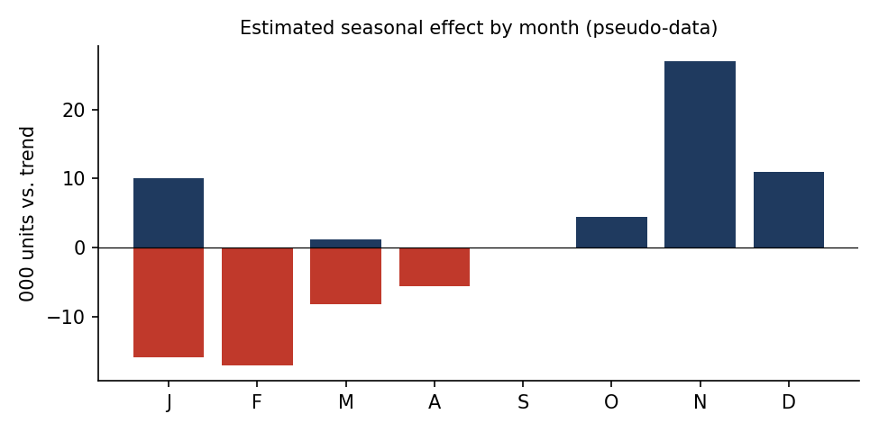
Figure 1: Estimated seasonal effect by month (pseudo-data).

6.3 Step 2 – Estimating driver effects
The ARIMAX model estimated the following effects from the training data: each month adds about 1.2 thousand units of trend growth, each 1-point rise in the consumer confidence index adds about 2.0 thousand units, and a promotion month adds about 14.5 thousand units. These are the kind of statements a planner can discuss and challenge.

6.4 Step 3 – Back-test on the held-out months
Month | Actual | Seasonal Naive | Holt-Winters | ARIMAX | Hybrid
Jan 2026 | 222 | 213 | 224 | 231 | 227
Feb 2026 | 225 | 215 | 224 | 225 | 224
Mar 2026 | 230 | 223 | 233 | 229 | 231
Apr 2026 | 241 | 230 | 240 | 243 | 242
May 2026 | 263 | 230 | 245 | 267 | 256
Jun 2026 | 253 | 250 | 255 | 253 | 254
Table 2: Actual vs. forecast demand, Jan–Jun 2026 (000 units, pseudo-data).

6.5 Step 4 – Compare accuracy
Method | MAE | RMSE | MAPE (%)
Seasonal Naive | 12.2 | 15.5 | 4.97
Holt-Winters | 4.6 | 7.7 | 1.83
ARIMAX + indicators | 2.7 | 4.0 | 1.14
Hybrid (average) | 2.7 | 3.8 | 1.12
Table 3: Back-test error metrics (lower is better). MAE = mean absolute error; RMSE = root mean squared error; MAPE = mean absolute percentage error.
Both advanced methods clearly beat the naive baseline. ARIMAX improves on Holt-Winters because it “sees” promotions and market sentiment, and the hybrid achieves the lowest RMSE and MAPE, confirming the value of combining methods.
Important caution: the accuracy here is unrealistically high because the pseudo-data was generated from the same structure the model assumes. In real data, forecast errors are usually larger (monthly MAPE of roughly 5–15% is common at product-family level, and higher for individual SKUs). The purpose of this table is to demonstrate the comparison procedure, not to promise a specific accuracy.

6.6 Step 5 – Forward forecast with prediction interval
The hybrid model was refitted on all 42 months. Future values of the market indicator and promo flag are planning assumptions (e.g., a promotion is planned for October 2026). The range is an approximate 80% prediction interval built from back-test error.
Month | Forecast (000 units) | Lower bound | Upper bound | Assumed CCI | Promo
Jul 2026 | 247 | 242 | 252 | 98.4 | 0
Aug 2026 | 247 | 242 | 251 | 99.9 | 0
Sep 2026 | 254 | 249 | 259 | 100.1 | 0
Oct 2026 | 269 | 264 | 274 | 100.7 | 1
Nov 2026 | 276 | 271 | 282 | 101.9 | 0
Dec 2026 | 265 | 260 | 270 | 101.5 | 0
Table 4: Six-month forward forecast, Jul–Dec 2026 (pseudo-data).
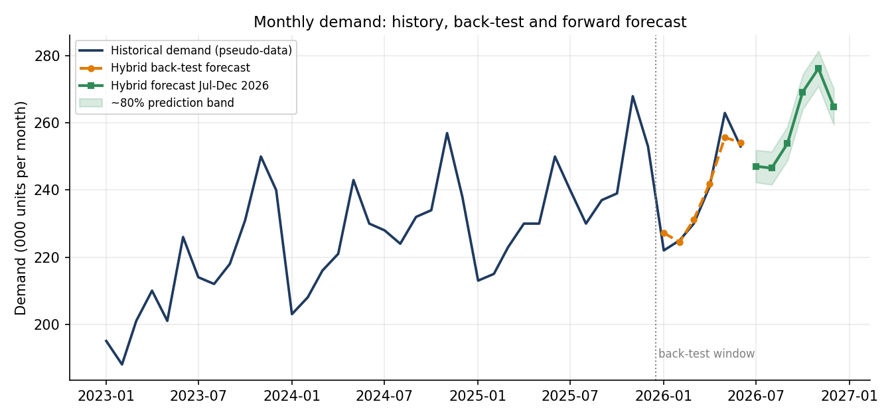
Figure 2: Historical demand, back-test and forward forecast with prediction band.
Reading the result: demand is expected to rise from about 247 thousand units in July to a festive peak of about 276 thousand units in November, with a promotion-driven step-up in October. The prediction band tells planners the realistic range around each point.

7. Comparison of Methods and Justification of Choice
Each method was scored from 1 (poor) to 5 (excellent) against criteria derived from the data characteristics and business needs in Section 4. The scores are qualitative judgements based on the literature, not measured values.
Criterion | Seasonal Naive | Holt-Winters | ARIMAX | ML (XGBoost) | Deep learning | Hybrid (chosen)
Works with 36–48 data points | 5 | 5 | 4 | 2 | 1 | 5
Captures trend & seasonality | 2 | 5 | 5 | 4 | 5 | 5
Uses market indicators | 1 | 1 | 5 | 5 | 5 | 4
Explainable to planners | 5 | 4 | 4 | 2 | 1 | 4
Prediction intervals | 2 | 4 | 5 | 2 | 3 | 4
Low cost / easy upkeep | 5 | 5 | 4 | 3 | 1 | 4
Robustness (model risk) | 2 | 3 | 3 | 3 | 3 | 5
Total (max 35) | 22 | 27 | 30 | 21 | 19 | 31
Table 5: Qualitative scoring of candidate methods.

Justification
- Data fit: with only 3–4 years of monthly history, ML and deep-learning models risk over-fitting; statistical models are better suited.
- Business fit: planners need to know why the forecast changes. ARIMAX provides driver-level explanations (promo, confidence), and Holt-Winters is easy to monitor.
- Robustness: combining two different model types follows the evidence from the M4 competition that combinations are consistently strong (Makridakis et al., 2020).
- Future path: as more data and more SKUs become available, a gradient-boosting model can be added as a third ensemble member or challenger.

8. Assumptions
- Past patterns continue: the trend and yearly seasonality seen in history will broadly repeat.
- Demand data reflects true demand: stock-out periods and one-off events are identified and adjusted.
- Stable relationships: the effect of promotions and consumer confidence on demand is reasonably stable over the forecast horizon.
- Known future drivers: the promotion calendar and festival dates are available in advance; future values of macro indicators are taken from published forecasts or scenarios.
- Additive structure: trend, seasonality and market effects add together (a multiplicative form could be tested if seasonal swings grow with volume).
- Consistent definitions: product hierarchy, units of measure and calendar do not change during the period.
- Approximately normal errors: used to build prediction intervals and safety stock.

9. Limitations and Risk Mitigation
Limitation / risk | Why it matters | Mitigation
Short history (36–48 months) | Seasonal patterns estimated from only 3–4 cycles are uncertain | Use simple models; pool similar products; update monthly
Structural breaks (pandemic, policy change, new competitor) | History becomes a poor guide | Judgemental overrides; scenario planning; shorter training window
Unknown future indicators | ARIMAX needs future values of its drivers | Use official forecasts/scenarios; sensitivity analysis
Moving festival dates | Peaks shift between months in lunar-calendar years | Add festival-timing flags; move to weekly data if needed
Promotion effects vary | A single promo coefficient is a simplification | Separate promo types; review effect after each campaign
Lost sales in stock-outs | Recorded sales understate true demand | Adjust history; track fill rate and stock availability
New products / intermittent SKUs | No history or many zero periods | Use analogue products; Croston-type methods
Product-level noise | Family-level accuracy does not carry to each SKU | Forecast at family level and allocate down by mix
Over-reliance on the model | Forecasts can be wrong with high confidence | Human review in S&OP; monitor bias and tracking signal

10. Impact on Supply Chain Planning and Resource Allocation
A forecast has value only when it changes decisions. This section shows how the forecast and its uncertainty feed the main planning areas.

10.1 Inventory and safety stock
Safety stock protects against forecast error during the replenishment lead time. A common formula is:
Safety stock = z × σ(forecast error) × √(lead time in months)
For a 95% service level (z ≈ 1.65), a one-month lead time and a realistic planning error of about 8% of demand (σ ≈ 22 thousand units on ~270), safety stock is about 36 thousand units. If the company relied on a weaker method with about 12% error (σ ≈ 32), safety stock would be about 53 thousand units. A better forecast therefore releases roughly 17 thousand units (about 32%) of buffer stock, reducing working capital and warehouse space without lowering service. (These error levels are planning assumptions for illustration.)

10.2 Production and capacity planning
Assuming a monthly capacity of 300 thousand units, the forecast implies the following utilisation:
Month | Forecast (000 units) | Capacity (000 units) | Utilisation | Planning action
Jul 2026 | 247 | 300 | 82% | Normal operations; maintenance window
Aug 2026 | 247 | 300 | 82% | Normal operations; maintenance window
Sep 2026 | 254 | 300 | 85% | Normal operations; maintenance window
Oct 2026 | 269 | 300 | 90% | Monitor; prepare flexible labour
Nov 2026 | 276 | 300 | 92% | Pre-build stock, add shift/overtime
Dec 2026 | 265 | 300 | 88% | Monitor; prepare flexible labour
Table 6: Capacity utilisation implied by the forecast (illustrative).
The forecast shows capacity running close to 90% or above in October–November, so the plan should include pre-building stock in the lower-demand months (Jul–Sep), scheduling maintenance early, and arranging temporary labour in advance instead of reacting at the last minute.

10.3 Procurement and supplier management
- Raw-material orders can be placed earlier and in better-sized batches, improving negotiating power with suppliers.
- The prediction interval helps decide how much to commit firmly and how much to keep as flexible supplier capacity.

10.4 Warehousing, transport and workforce
- Warehouse space, pickers and loading slots can be scheduled according to the expected peak.
- Transport contracts (fleet, third-party carriers) can be booked before peak-season rates rise.

10.5 Financial and service impact
- Lower inventory holding cost and obsolescence from more accurate stock levels.
- Higher fill rate / on-time-in-full (OTIF) because stock is available where and when demand occurs.
- Fewer expedited shipments and emergency purchases, reducing logistics cost.
- Better cash planning since demand and inventory needs are known further ahead.

10.6 Link with supply chain KPIs
KPI | Expected effect of better forecasting
Forecast accuracy (MAPE / bias) | Direct measure of model quality; track monthly
Inventory turnover / days of inventory | Improves (lower buffer stock for the same service)
Fill rate / OTIF | Improves (fewer stock-outs)
Capacity utilisation | Smoother, with fewer emergency overtime peaks
Total logistics cost | Falls through fewer expedites and better contract timing

11. Implementation Roadmap and Monitoring
- Month 1 – Foundation: collect data, define product hierarchy, build promo and festival calendar, download public indicators.
- Month 2 – Build: implement Holt-Winters and ARIMAX, run rolling back-tests, select weights.
- Month 3 – Pilot: run forecasts in parallel with the existing planning method for one S&OP cycle and compare.
- Ongoing – Monitor and improve: review MAPE and bias monthly; use a tracking signal to detect drift; retrain at least quarterly; test an ML challenger model as data grows.
A simple governance rule is to flag any product family whose bias or tracking signal stays outside agreed limits for three consecutive months for model review and planner discussion.

12. Conclusion
This report presented a conceptual demand-forecasting model that combines trend, seasonality and market indicators in a clear seven-stage process. After reviewing statistical, machine-learning and deep-learning approaches, a hybrid of Holt-Winters and ARIMAX was selected because it fits short monthly histories, can use external drivers, is explainable to planners and is robust through model combination. The pseudo-data illustration demonstrated how the model is trained, back-tested, compared against a baseline and used to produce a forecast with an uncertainty range.
The practical value lies in the decisions the forecast supports: right-sized safety stock, early capacity and labour planning, better procurement timing and improved service levels. With stated assumptions, known limitations and ongoing monitoring, the model offers a realistic, low-cost starting point that can evolve towards more advanced machine-learning methods as data maturity grows.

13. References
Box, G. E. P., & Jenkins, G. M. (1970). Time Series Analysis: Forecasting and Control. Holden-Day.
Chen, T., & Guestrin, C. (2016). XGBoost: A scalable tree boosting system. Proceedings of the 22nd ACM SIGKDD International Conference on Knowledge Discovery and Data Mining, 785–794.
Chopra, S., & Meindl, P. Supply Chain Management: Strategy, Planning, and Operation. Pearson.
Croston, J. D. (1972). Forecasting and stock control for intermittent demands. Operational Research Quarterly, 23(3), 289–303.
Hochreiter, S., & Schmidhuber, J. (1997). Long short-term memory. Neural Computation, 9(8), 1735–1780.
Hyndman, R. J., & Athanasopoulos, G. (2021). Forecasting: Principles and Practice (3rd ed.). OTexts. https://otexts.com/fpp3/
Hyndman, R. J., & Koehler, A. B. (2006). Another look at measures of forecast accuracy. International Journal of Forecasting, 22(4), 679–688.
Lim, B., Arık, S. Ö., Loeff, N., & Pfister, T. (2021). Temporal Fusion Transformers for interpretable multi-horizon time series forecasting. International Journal of Forecasting, 37(4), 1748–1764.
Makridakis, S., Spiliotis, E., & Assimakopoulos, V. (2020). The M4 Competition: 100,000 time series and 61 forecasting methods. International Journal of Forecasting, 36(1), 54–74.
Makridakis, S., Spiliotis, E., & Assimakopoulos, V. (2022). M5 accuracy competition: Results, findings, and conclusions. International Journal of Forecasting, 38(4), 1346–1364.
Silver, E. A., Pyke, D. F., & Thomas, D. J. (2016). Inventory and Production Management in Supply Chains (4th ed.). CRC Press.
Winters, P. R. (1960). Forecasting sales by exponentially weighted moving averages. Management Science, 6(3), 324–342.

