Week 3 Report
Supply Chain Process Mapping and Visualization
From procurement to distribution: mapping the flow and finding where data analytics can help

1. Introduction and Objective
A supply chain is a network of activities that moves materials, products and information from suppliers to end customers. Because it involves many parties and many steps, problems in one stage often show up as delays or costs in another. A process map makes this network visible on one page, so that each step, its data and its possible problems can be studied together.
The objective of this task is to design a process map of a typical supply chain covering procurement, inventory management and distribution, to explain each step, to link each step to specific data points and analytical challenges, and to show how data analytics can identify bottlenecks and improve performance. The map is based on publicly available, general supply chain knowledge and does not use any private or company data.

2. Research: Typical Stages of a Supply Chain
Standard supply chain literature (for example the SCOR model of plan, source, make, deliver and return, and common operations management textbooks) describes a supply chain as a sequence of linked stages. For this task, seven stages were selected to cover the flow from the first supplier to the final customer:
- Supplier / Sourcing
- Procurement
- Inbound Logistics
- Warehouse and Inventory Management
- Order Fulfilment
- Distribution and Transportation
- Customer and Returns
These go beyond the minimum of three stages required by the task, so that both the physical flow of goods and the flow of information are captured.

3. Tools and Method Used
The process map was built in a structured, repeatable way:
- Step 1, Research: stages of a typical supply chain were listed from public sources and then grouped into seven stages.
- Step 2, Data points: for each stage, the KPIs and data fields that are normally recorded were identified.
- Step 3, Drawing: the map was drawn programmatically using Python and the Matplotlib library and exported as a PNG image. Any diagram tool such as Microsoft Visio, PowerPoint or draw.io could be used for the same purpose.
- Step 4, Documentation: the image was placed in this Word document and each stage was explained with its data points and analytical challenges.
Colour is used to group the stages: blue for the supply side, orange for inventory and fulfilment, and green for delivery and the customer. Solid arrows show the flow of goods, the dashed red arrow shows the flow of information back to planning, and dashed boxes list the KPIs captured at each stage.

4. The Supply Chain Process Map
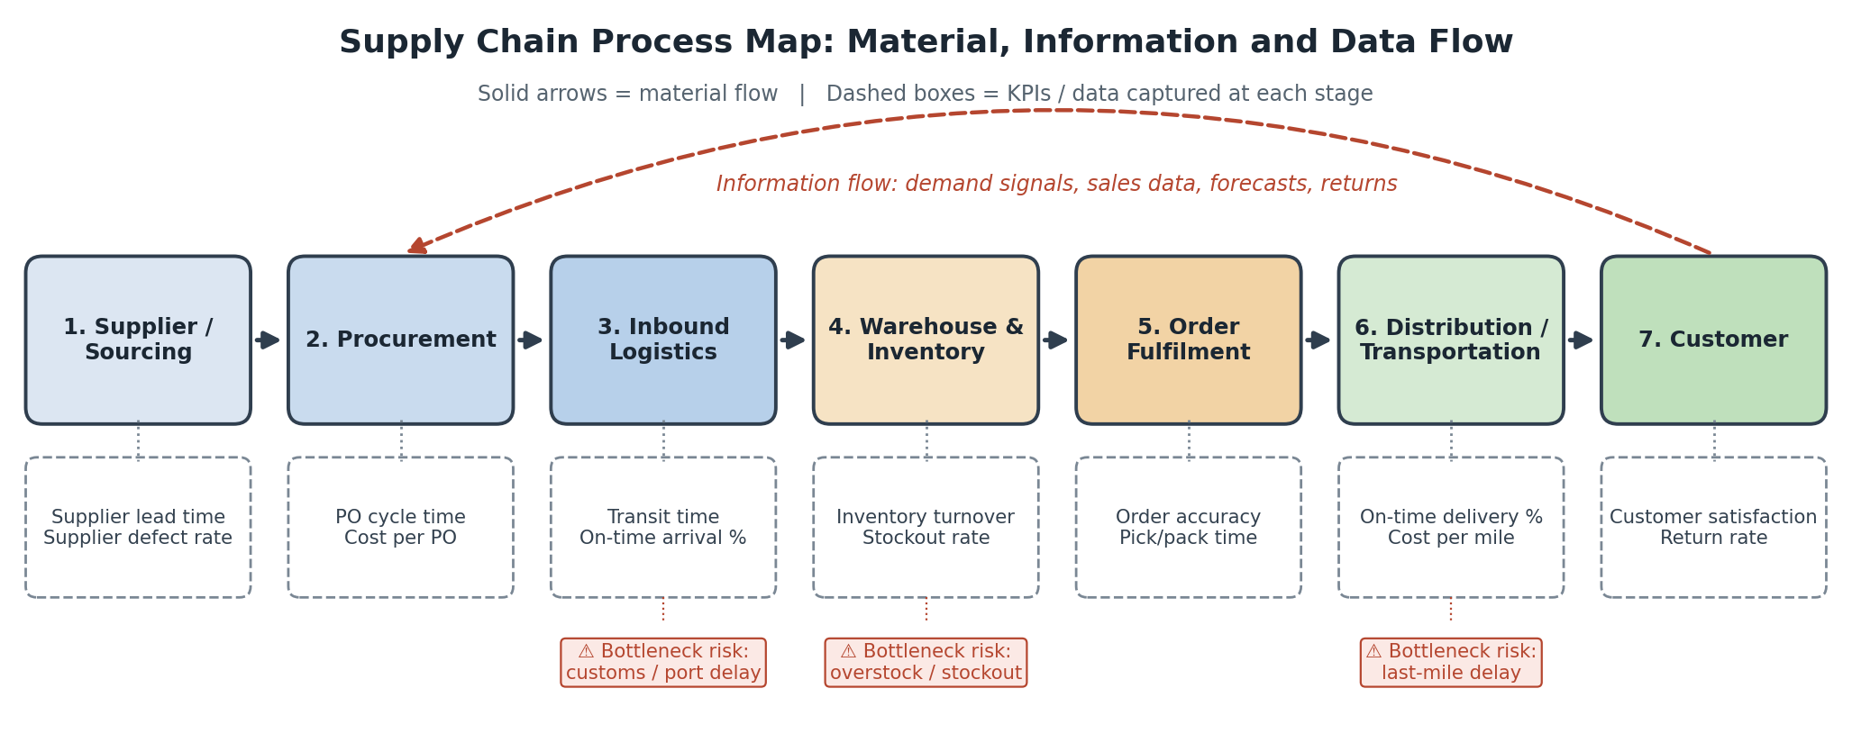
Figure 1: Seven-stage supply chain process map with KPIs and typical bottleneck points

5. Explanation of Each Stage
Each stage below is described together with the data normally collected there and the analytical challenge it raises.

Stage 1: Supplier / Sourcing
The chain starts with raw material or finished goods suppliers. Companies select suppliers on cost, quality, reliability and location. Decisions here fix the lead time and quality level that every later stage inherits.
- Key data points: Supplier lead time, supplier defect rate, share of orders delivered in full by each supplier.
- Analytical challenge: Supplier performance is uneven and often recorded in different formats, so comparing suppliers fairly needs cleaned, standardised data.

Stage 2: Procurement
Procurement turns demand into purchase orders (POs): raising requisitions, getting approvals, negotiating prices and placing orders. It decides how much to order and when.
- Key data points: PO cycle time, cost per PO, price variance versus contract, share of spend with approved suppliers.
- Analytical challenge: Slow approvals and poor demand forecasts lead to late or oversized orders. Analytics can compare forecast versus actual demand to tune order quantities.

Stage 3: Inbound Logistics
Goods move from the supplier to the company warehouse by road, rail, sea or air, including customs clearance where needed.
- Key data points: Transit time, on-time arrival percentage, freight cost per unit, dwell time at ports and border points.
- Analytical challenge: Transit time varies with weather, port congestion and customs. Averages hide this, so the spread (standard deviation) of transit time should be tracked, not just the mean.

Stage 4: Warehouse and Inventory Management
Received goods are checked, stored and tracked. The aim is to hold enough stock to serve demand without tying up cash in excess inventory.
- Key data points: Inventory turnover, days of inventory on hand, stockout rate, storage utilisation, inventory accuracy.
- Analytical challenge: Too much stock raises holding cost; too little causes stockouts. ABC analysis and reorder-point models help decide where to focus.

Stage 5: Order Fulfilment
When a customer order arrives, items are picked, packed, labelled and handed over to the carrier.
- Key data points: Order accuracy, pick and pack time, order cycle time, perfect order rate.
- Analytical challenge: Errors and delays at picking and packing are hard to see without timestamps at each step. Scan data from the warehouse system can show where orders wait.

Stage 6: Distribution and Transportation
Packed orders are shipped to distribution centres or directly to customers. This stage includes route planning and last-mile delivery.
- Key data points: On-time delivery percentage, cost per mile or per shipment, delivery lead time, failed delivery rate.
- Analytical challenge: Last-mile delivery is usually the costliest and least predictable leg. Route and delivery-time data can reveal problem areas and peak-day overload.

Stage 7: Customer and Returns
The customer receives the product. Feedback, returns and repeat orders flow back to the company as information.
- Key data points: Customer satisfaction score, return rate, complaint rate, repeat purchase rate.
- Analytical challenge: Return and complaint data is a valuable but delayed signal. Linking it back to specific suppliers, warehouses or carriers shows where problems began.

6. Identifying Bottlenecks Using Data Analytics
A bottleneck is a step where work builds up or slows down and limits the speed of the whole chain. Analytics can find bottlenecks by measuring time, quantity and variation at each stage. The table below shows typical methods.
Stage | Bottleneck signal in the data | Analytical method
Procurement | PO approval time much higher than the average; frequent late orders | Cycle-time analysis, distribution of approval times, Pareto chart of delay causes
Inbound logistics | High variation in transit time; long dwell time at ports | Control charts, standard deviation of lead time, carrier and route comparison
Warehouse and inventory | Rising days of inventory on one side, repeated stockouts on the other | ABC and XYZ analysis, inventory turnover trend, reorder-point and safety-stock calculation
Order fulfilment | Orders waiting between pick, pack and dispatch; rising error rate | Timestamp analysis of each step, queue analysis, error-rate trend by shift or product
Distribution | Late deliveries concentrated on certain routes, days or regions | Route-level on-time analysis, heat maps, peak-day load analysis
Customer and returns | Returns or complaints traced to a specific supplier or carrier | Root-cause analysis, linking return data back to earlier stages

A simple general approach is to (1) collect timestamps and quantities at each step, (2) calculate the time spent in each stage, (3) find the stage with the longest or most variable time, and (4) drill down by product, supplier, route or period to find the cause. Dashboards that update regularly help managers see problems early instead of after customers complain.

7. Challenges Observed
- Data availability: detailed operational data is rarely public, so the map relies on general, commonly reported KPIs. Real analysis would need company data.
- Data consistency: different stages and partners record data in different formats and units, which makes joining the data difficult.
- Visibility gaps: goods in transit and at third-party carriers often have little real-time tracking.
- Simplification: a real supply chain is a network with many suppliers and warehouses, not a single line. The map shows one representative path so that it stays readable.
- Cause and effect: a delay seen in one stage may have started earlier, so stage-wise KPIs must be read together.

8. Where Further Data Analysis Can Improve Performance
- Demand forecasting: better forecasts using sales history and seasonality reduce both overstock and stockouts, and improve procurement decisions.
- Supplier scorecards: ranking suppliers on lead time, quality and reliability supports better sourcing choices.
- Inventory optimisation: setting safety stock and reorder points from actual demand variation instead of fixed rules.
- Route and delivery optimisation: using delivery data to plan routes, group orders and reduce last-mile cost.
- Predictive alerts: using past delay patterns to warn of likely late shipments before they happen.
- End-to-end visibility: a single dashboard that connects the KPIs of all seven stages so trade-offs between cost, speed and service level are visible.

9. Conclusion
The process map shows how goods and information move through seven connected stages, from supplier to customer and back through returns and demand signals. Linking each stage to specific KPIs makes it clear what to measure, and the analytical methods in Section 6 show how bottlenecks in procurement, inventory and distribution can be found with data. The main lesson is that supply chain performance depends on the whole chain, so analytics is most useful when data from all stages is brought together and reviewed regularly.

