**Bangabandhu Sheikh Mujibur Rahman Science and Technology University, Gopalganj-8100.**



**Student Management System**

**Course Code : CSE278 18 May, 2022**

**By:** Tushar SarkarID:18CSE035

**Department of Computer Science & Engineering Bangabandhu Sheikh Mujibur Rahman Science and Technology University**

**Student Management System**

Submitted to the Department of Computer Science and Engineering, Bangabandhu Sheikh Mujibur Rahman Science and Technology University in partial fulfillment to the requirements for the degree of B.Sc. Engineering.

**By:** Tushar SarkarID:18CSE035

**Supervised By:**  Md. Monowar Hossain Assistant Professor

**Department of Computer Science & Engineering Bangabandhu Sheikh Mujibur Rahman Science and Technology University**

# **DECLARATION**

I, **Tushar Sarkar** , **ID : 18CSE035** declare that the project consideration of degree of Bachelor of Computer Science & Engineering (CSE) embodies our own work with suggestion received during the work, which have been suitably acknowledge.

**Tushar Sarkar ID: 18CSE035**

…………………………. ………………….……...

Signature Date

# **APPROVAL**

I certify that this project “Student Management System” is the original work of the above named candidate and has been done under my supervision. To the best of my knowledge and belief, this work which embodies the work of candidates themselves, has been duly completed, fulfills the requirement of the ordinance relating to the first year of Bangabandhu Sheikh Mujibur Rahman Science and Technology University and is up to standard in respect of content, presentation and language for being referred to the examiner. The work has never been submitted anywhere. It’s only submitted to Bangabandhu Sheikh Mujibur Rahman Science and Technology University.

**Project Supervisor :**

**Md. Monowar Hossain**

Assistant Professor

Department of Computer Science and Engineering

Bangabandhu Sheikh Mujibur Rahman Science and Technology University, Gopalganj.

Signature:……………………. Date:……………….

# **ACKNOWLEDGEMENT**

Firstly I would like to express my deprest sense of gratitude to my reverend teacher and supervisors **Md. Monowar Hossain**, Assistant Professor of Department of Computer Science & Engineering (CSE), Bangabandhu Sheikh Mujibur Rahman Science and Technology University. And for her untiring guidance, constant supervision, enthusiastic encouragement, sagacious advice and an effective surveillance throughout the entire period of my project and preparation of the manuscript. I greatly say thank you. Wish to express my heart full thanks to all of my honorable teachers of the department of Computer Science and Engineering (CSE), Bangabandhu Sheikh Mujibur Rahman Science and Technology University.

Secondly I would like to thank my department senior brother **MD Tushar Ahmed** who helped me a lot in finalizing this project within a limited time frame.

Tushar Sarkar

18CSE035

18 May, 2022

# **ABSTRACT**

The idea of developing a student management system is to improve communication between professors and parents. The student management system can be used by teachers, parents, and students. It aids in the tracking of a student’s development so that the optimal decisions for the student’s learning path may be made. Many educational institutions currently employ computer systems to arrange a student’s data. The software assists the admissions department in keeping track of students’ information and admissions. The software also keeps track of changes in the profiles of qualified students as well as their performances. Students form a main part of any institution that concerns with. But the institutions find it difficult to keep of so many students of the organization just in one stretch. It will involve a lot of pen paper work. Sometimes there will be some huge heap of files bundled up and kept together in some corner off the office. If you want any information regarding the particular student then it can be obtained by just entering the roll number of the name of the student to be searched. This student management system will make the work of storing the data in an organized way. The student management system application will help in managing the student’s reports, results and exams will become easier with one such system. It will also help in saving time and effort. The user interface must be user friendly and easy to understand.

Our main focus is design a unique Student Management system System that will improve Data

maagement in Institutes experience for both Students and the Adminstartion authorities. The whole

system will run on internet

report entitled “Bank Account Management System” submitted to City University **TABLE OF CONTENT**

**Table of Contents**

**DECLARATION** 1

**APPROVAL** 2

**ACKNOWLEDGEMENT** 3

**ABSTRACT** 4

**CHAPTER - 1 INTRODUCTION** 7

**1.1 Introduction:** 7

**1.2 Purpose:** 7

**1.3 Scope:** 8

**CHAPTER - 2 SYSTEM ANALYSIS** 9

**2.1 Existing System:** 9

**2.2 Proposed System:** 10

**2.3 Feasibility Analysis:** 10

**2.3.1 Technical Feasibility:** 10

**2.3.2 Economical Feasibility:** 11

**CHAPTER - 3 IMPLEMENTATION** 12

**3.1 Implementation:** 12

**3.1.1 Java:** 12

**3.1.2 Java Swing:** 13

**3.1.3 XAMPP:** 13

**3.1.4 MySQL:** 13

**3.2 System Design:** 14

**CHAPTER - 4 LIMITATION AND FUTURE SCOPE** 19

**4.1 Limitation:** 19

**4.2 Future Work:** 20

**CHAPTER - 5 CONCLUSIONS** 21

**CHAPTE - 6** **REFERENCES** 22

**List of Figure :**

Figure 1: First Look of Program 15

Figure 2: New User Create 15

Figure 3: Login Form 16

Figure 4: Add Student 16

Figure 5: Manage Student 17

Figure 6: Course Add 17

Figure 7: Student & Course Add 18

Figure 8: Localhost/phpmyadmin 18

# **CHAPTER - 1**

# **INTRODUCTION**

## **1.1 Introduction:**

Student Management System is software which is helpful for students as well as the school authorities. In the current system all the activities are done manually. It is very time consuming and costly. Our Student Management System deals with the various activities related to the students.

There are mainly 2 modules in this software

* User module
* Student Module

In the Software we can register as a user and user has of two types, student and administrator. Administrator has the power to add new user and can edit and delete a user. A student can register as user and can add edit and delete his profile. The administrator can add edit and delete marks for the student. All the users can see the marks.

Management of students and classes information is very important, because it is the foundation of good education process. If this process is provided manually - there are big issues to handle big amount of student, teachers and classes. To update the classes information or to make changes in schedule you should make a lot of work.

## **1.2 Purpose:**

The objective of **Student Management System** is to allow the administrator of any organization to edit and find out the personal details of a student and allows the student to keep up to date his profile .It’ll also facilitate keeping all the records of students, such as their id, name, mailing address, phone number, DOB etc. So all the information about a student will be available in a few seconds.

Overall, it’ll make Student Information Management an easier job for the administrator and the student of any organization. The main purpose of this SRS document is to illustrate the requirements of the project **Student Management System** and is intended to help any organization to maintain and manage its student’s personal data.

## **1.3 Scope:**

Without a Student information System, managing and maintaining the details of the student is a tedious job for any organization. Student Information system will store all the details of the students including their background information, educational qualifications, personal details and all the information related to their resume .

# **CHAPTER - 2**

# **SYSTEM ANALYSIS**

## **2.1 Existing System:**

System Analysis is a detailed study of the various operations performed by a system and their relationships within and outside of the system. Here the key question is- what all problems exist in the present system? What must be done to solve the problem? Analysis begins when a user or manager begins a study of the program using existing system.

During analysis, data collected on the various files, decision points and transactions handled by the present system. The commonly used tools in the system are Data Flow Diagram, interviews, etc. Training, experience and common sense are required for collection of relevant information needed to develop the system. The success of the system depends largely on how clearly the problem is defined, thoroughly investigated and properly carried out through the choice of solution. A good analysis model should provide not only the mechanisms of problem understanding but also the frame work of the solution. Thus it should be studied thoroughly by collecting data about the system. Then the proposed system should be analyzed thoroughly in accordance with the needs.

System analysis can be categorized into four parts.

* System planning and initial investigation
* Information Gathering
* Applying analysis tools for structured analysis
* Feasibility study
* Cost/ Benefit analysis.

In the current system we need to keep a number of records related to the student and want to enter the details of the student and the marks manually. In this system only the teacher or the school authority views the mark of the student and they want to enter the details of the student. This is time consuming and has much cost.

## **2.2 Proposed System:**

In our proposed system we have the provision for adding the details of the students by themselves. So the overhead of the school authorities and the teachers is become less. Another advantage of the system is that it is very easy to edit the details of the student and delete a student when it found unnecessary. The marks of the student are added in the database and so students can also view the marks whenever they want.

Our proposed system has several advantages

* User friendly interface
* Fast access to database
* Less error
* More Storage Capacity
* Search facility
* Look and Feel Environment
* Quick transaction

All the manual difficulties in managing the student details in a school or college have been rectified by implementing computerization.

## **2.3 Feasibility Analysis:**

Whatever we think need not be feasible .It is wise to think about the feasibility of any problem we undertake. Feasibility is the study of impact, which happens in the organization by the development of a system. The impact can be either positive or negative. When the positives nominate the negatives, then the system is considered feasible. Here the feasibility study can be performed in two ways such as technical feasibility and Economical Feasibility.

### **2.3.1 Technical Feasibility:**

We can strongly say that it is technically feasible, since there will not be much difficulty in getting required resources for the development and maintaining the system as well. All the resources needed for the development of the software as well as the maintenance of the same is available in the organization here we are utilizing the resources which are available already.

### **2.3.2 Economical Feasibility:**

Development of this application is highly economically feasible .The organization needed not spend much money for the development of the system already available. The only thing is to be done is making an environment for the development with an effective supervision. If we are doing so, we can attain the maximum usability of the corresponding resources .Even after the development, the organization will not be in condition to invest more in the organization .Therefore, the system is economically feasible.

# **CHAPTER – 3**

# **IMPLEMENTATION**

## **3.1 Implementation:**

Student Management System in java is planned to collect students from many Schools, Colleges and University in short from various sources. To do all this we require high quality software to manage those jobs. The government spending lot of money to develop high quality Student management System project.

### **3.1.1 Java:**

As the project is developing a PC Application, the default programming language is Java. All Android applications are built using Java in Android Studio or Eclipse or both. Java is a popular and widely used language throughout the world. As mentioned in, Java is one of the powerful programming languages like C, C++ developed by Sun Microsystems which has many powerful features as described below. After the development of C, C++, Java has come into evolution by addressing their drawbacks. It is one of the open source projects that could be easily installed in our machine. The language is also easy to learn, understand and implement. Java is used in various kinds of applications like Web, Desktop, Mobile, and Big Data. Many powerful features are supported by Java including various libraries, application services, graphics library for 2D/3D applications. The language is flexible enough to maintain code complexity, test, implementation, integration and support. Apart from these, there are other key features which make Java more special. It is object oriented programming language, one of the important hierarchies in the programming languages which is used to implement real time applications, it provides for code reusability, it has a platform independence feature including any virtual machines(Write Once Read Everywhere), as in no need to write the 20 code for different OS as the Java Compliers convert the java source les to bytecode and this could be interpreted by any machine and the actual code is compiled irrespective of any machine, OS. It is more secured as the compilers are designed efficiently to figure out any kind of errors.

### **3.1.2 Java Swing:**

Swing is a GUI widget toolkit for Java. It is part of Oracle's Java Foundation Classes (JFC) an API for providing a graphical user interface (GUI) for Java programs.

Swing was developed to provide a more sophisticated set of GUI components than the earlier Abstract Window Toolkit (AWT). Swing provides a look and feel that emulates the look and feel of several platforms, and also supports a pluggable look and feel that allows applications to have a look and feel unrelated to the underlying platform. It has more powerful and flexible components than AWT. In addition to familiar components such as buttons, check boxes and labels, Swing provides several advanced components such as tabbed panel, scroll panes, trees, tables, and lists.

### **3.1.3 XAMPP:**

XAMPP is a free and open-source cross-platform web server solution stack package developed by Apache Friends, consisting mainly of the Apache HTTP Server, Maria DB database, and interpreters for scripts written in the PHP and Perl programming languages.[3][4] Since most actual web server deployments use the same components as XAMPP, it makes transitioning from a local test server to a live server possible.

XAMPP's ease of deployment means a WAMP or LAMP stack can be in- stalled quickly and simply on an operating system by a developer, with the advantage that common add-in applications such as Word Press and Joomla! can also be installed with similar ease using Bitnami.

### **3.1.4 MySQL:**

MySQL is a relational database management system (RDBMS) that runs as a server providing multi-user access to a number of databases. MySQL is a popular choice of database for use in web applications and is an open source product. A table is a section of the database for storing related information. In a table we will set up the different fields which will be used in that table. Creating a table in phpMyAdmin is simple, we just type the name, select the number of fields and click the ‘go’ button. We will then be taken to a setup screen where you must create the fields for the database. Another way of creating databases and tables in phpMyAdmin is by executing simple SQL statements. We have used this method in order to create our database and tables.

**3.2 System Design:**

System design is a process through which requirements are translated into a representation of software. Initially the representation depicts a holistic view of software. Subsequent refinement leads to a design representation that is very close to source code. Design is a place where quality fostered in software development. Design provides us with representation of software that can be assessed for quality; this is the only way that can accurately translate the customer requirements into finished software product or system. System design serves as the foundation for all software engineering and software maintenance steps that follow.

**The deigns are :**

* First Look of Program Code
* New User Create
* Login Page
* Add Student
* Student Manage
* Add Course
* Student and Course Count
* Localhost/phpAdmin

**First Look of Program:**

Here is main project code

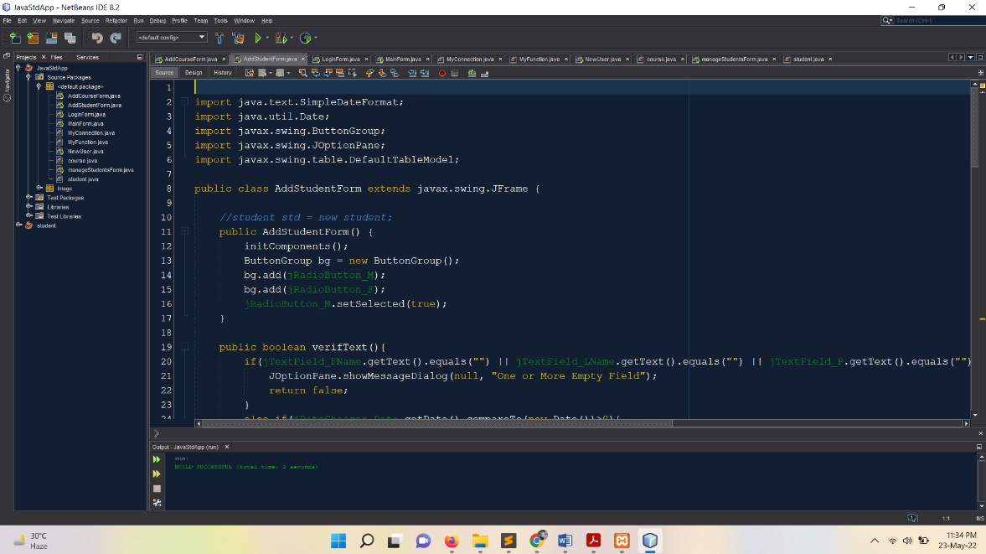

Figure 1: First Look of Program

**New User Create :**

Clicking on the “Add” with username, password and confirm password will open the new User Create and if you click “Cancel”, it will be cancel.

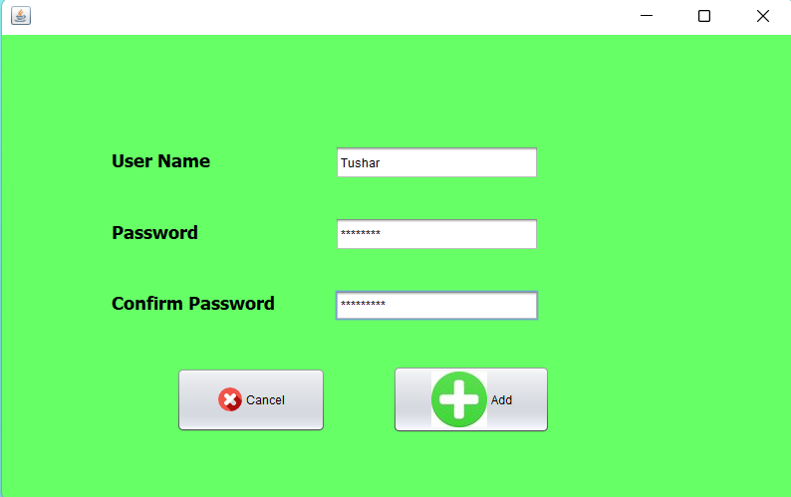

Figure 2: New User Create

**Login Page :**

If you have a Username and Password, you can login or cancel with the information. If you do not have a User ID, click New User to create a new User ID.

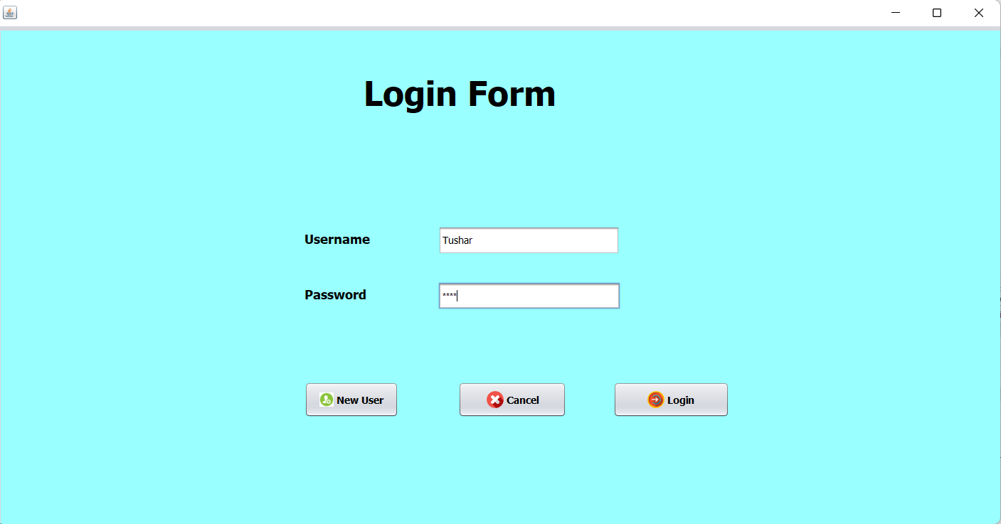

Figure 3: Login Form

**Add Student:**

If you want to collect data of some new students then first name, last name, date of birth, gender, phone number, address can be done by clicking on the “Add” button otherwise clicking on the “Cancel” button will be canceled.

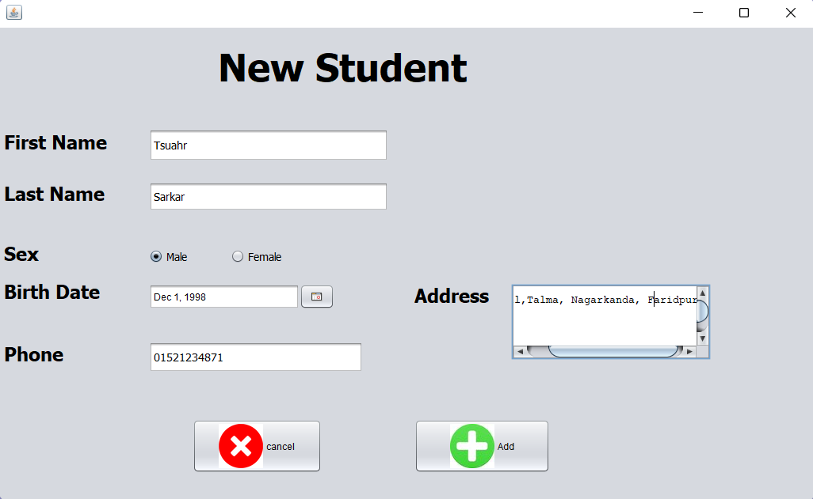

Figure 4: Add Student

**Student Manage:**

Your student data will be stored here. If you want, you can edit, remove and add new information.

# 

Figure 5: Manage Student

**Course Add:**

If you want to add a new course then by setting the label and time, click on the “Add” button, it will be added, otherwise if you click on the “Cancel” button, it will be canceled.

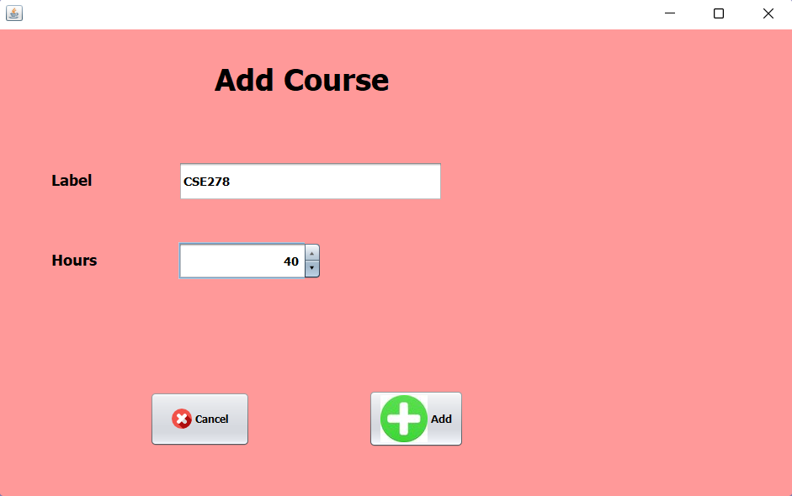

Figure 6: Course Add

**Student and Course Count:**

Here will show the total student and course number.

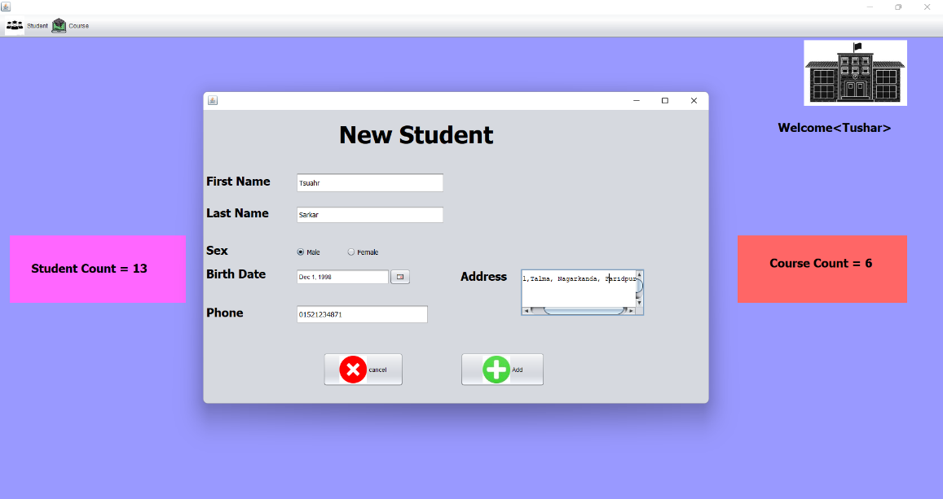

Figure 7: Student & Course Add

**Localhost/phpmyadmin:**

All data are store here.

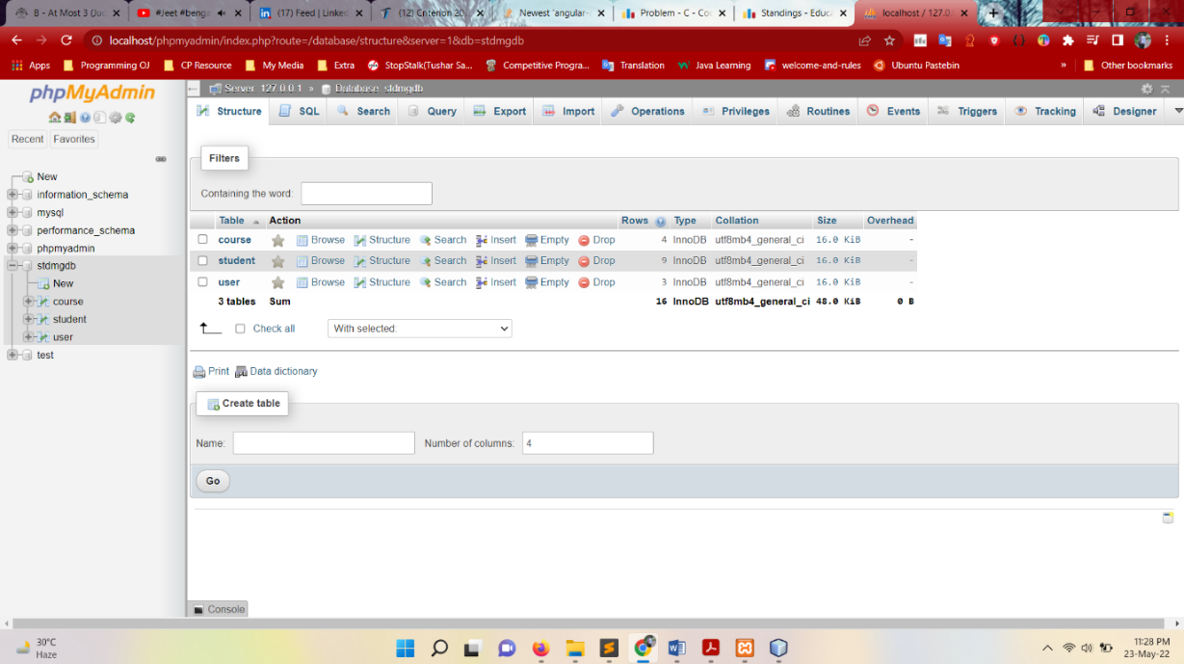

Figure 8: Localhost/phpmyadmin

# **CHAPTER - 4**

# **LIMITATION AND FUTURE SCOPE**

## **4.1 Limitation:**

Although I have put my best efforts to make the software flexible, easy to operate but limitations cannot be ruled out every by me. Though the software presents a board range of options to its users some intricate options could not be covered into it; partly because of logistic and party due to lack of sophistication. Paucity of time was also major constraint, thus it was not possible to make the software foolproof and dynamic. Lack of time also compelled me to ignore some part such as storing old result of the candidate etc.

Considerable efforts have made the software easy to operate even for the people not related to the field of computers but it is acknowledged that a layman may find it a bit problematic at the first instance. The user is provided help at each step for his convenience in working with the software.

**List of limitation:**

* Excel export has not been developed for Student, Result due to some critically.
* The transactions are executed in off-line mode, hence on-line data for Subject, Class capture and modification is not possible.
* Off-line reports of Student, semester, Subject cannot be generated due to batch mode execution.

## **4.2 Future Work:**

In a nutshell, it can be summarized that the future scope of the project circles around maintaining information regarding:

* We can add printer in future.
* We can give more advance software for Student Management System including facilities.
* We will host the platform on online servers to make it accessible worldwide.
* Integrate multiple load balancers to distribute the loads of the system.
* Create the master and slave database structure to reduce the overload of the database queries.
* Implement the backup mechanism for taking backup of codebase and database on regular basis on different servers.

The above mentioned points are the enhancement which can be done to increase the applicability and usages of this project. Here we can maintain the records of Students. Also, as it can be seen that now-a-days the players are versatile, i.e. so there is a scope for introducing a method to maintain all the Student management System. Enhancements can be done to maintain all the Student.

We have left all the options open so that if there is any other future requirement in the system by the user for the enhancement of the system then it is possible to implement them. In the last we would like to thanks all the persons involved in the development of the system directly or indirectly. We hope that the project will serve its purpose for which it is develop there by underlining success of process.

Our project is only a humble venture to satisfy the needs in an Institution. Several user-friendly

coding has also adopted. This package shall prove to be a powerful package in satisfying all the

requirements of the organization.

The objective of software planning is to provide a frame work that enables the manger to make

reasonable estimates made within a limited time frame at the beginning of the software project and

should be updated regularly as the project progresses. Last but not least it is no the work that played the

ways to success but ALMIGHTY

# **CHAPTER - 5**

# **CONCLUSIONS**

Our project is only a humble venture to satisfy the needs in an Institution. Several user-friendly coding has also adopted. This package shall prove to be a powerful package in satisfying all the requirements of the organization.

The objective of software planning is to provide a frame work that enables the manger to make reasonable estimates made within a limited time frame at the beginning of the software project and should be updated regularly as the project progresses. Last but not least it is no the work that played the ways to success but ALMIGHTY

# **CHAPTE - 6**

# **REFERENCES**

1. https://www.w3schools.com/html/
2. <https://www.w3.shools.com/php/default.asp>

***The End***