by: Tushar Chugh

Robotics Institute

Carnegie Mellon University

Marker based Tracking for Augmented Reality

Project Proposal

Computer Vision

Instructor: Prof. Deva Ramanan

March 17, 2016

# Project Proposal

## Introduction

Computers have already become a fabric of our everyday life. The future of computing is even more engaging and exciting. Astronauts using virtual aid to walking off the Earth, mechanical engineers using gestures to design the vehicles and doctors performing the surgery from a remote location sounds more like a science fiction at present. But with the research and advancements in augmented reality domain, it is all set to make this a reality sooner that what we might think. Companies like Microsoft (Holo-Lens), Facebook (Oculus), Qualcomm and Apple are already on their way to give shape to some of the ideas mentioned above. I would like to explore Augmented Reality from the knowledge I have gained in this course.

## Description

As a part of this project, I want to work on marker based tracking for Augmented Reality. The project would include the tracking of binary markers and overlaying a 3D geometry/annotation on the top of the marker. Some of the examples taken from web are shown in figure 1.

In order to achieve the goal, the first requirement is to find parameters which can give 3d/2D correspondence i.e. we need to know intrinsic parameters of the camera. Once we know the intrinsic parameters we need to detect pattern's position (i.e. corners) in the captured frame. After that, we need to warp the pattern region of interested and compare it to the loaded patterns. Once we identify the pattern, we need to estimate the transformation between the camera coordinate system and the pattern coordinate system. This requires the knowledge of intrinsic parameters. Then we need to use this transformation matrix to render/augment the geometry on the marker. Finally step would be to augment the geometry which would be depending on the geometry/scene selected. There are several papers and libraries available which explains on how it is to be done. These resource are mentioned in references section.

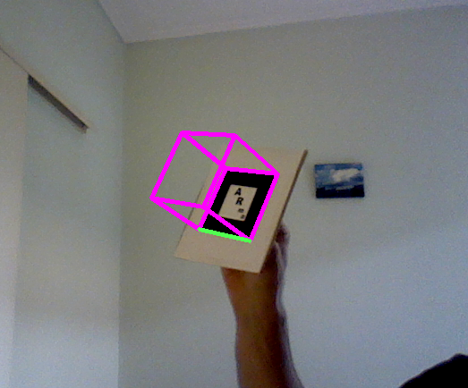 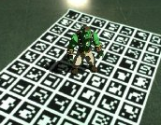 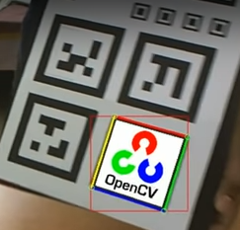

*Figure 1: Some examples of overlaying 3D geometry on the markers*

## Coding platform:

OpenCV, C++ (If time permits I will try to create an Android application for it)

## References/Papers to Read

1. [Marker Tracking method for Augmented Reality](http://ieeexplore.ieee.org/xpl/articleDetails.jsp?arnumber=6019986&contentType=Conference+Publications)
2. [Marker Based Application in Augmented Reality](http://www.ijircce.com/upload/2015/sacaim/26_107.pdf)
3. [Marker Based Augmented Reality](http://www.ijarcsse.com/docs/papers/Volume_3/5_May2013/V3I4-0388.pdf)
4. [Visual Tracking for Augmented Reality](http://www.robots.ox.ac.uk/~gk/publications/Klein2006Thesis.pdf)
5. [Pattern Tracking for Augmented Reality](http://xanthippi.ceid.upatras.gr/people/evangelidis/arma/)
6. [Bringing Augmented Reality to Mobile Phones](http://liu.diva-portal.org/smash/get/diva2:16967/FULLTEXT01.pdf)