Presented by: Tushar Chugh

Robotics Institute

Carnegie Mellon University

Feature Descriptor and Homographies

Computer Vision

Instructor: Prof. Deva Ramanan

February 18, 2016

# Feature Descriptor and Homographies

## Gaussian Pyramid

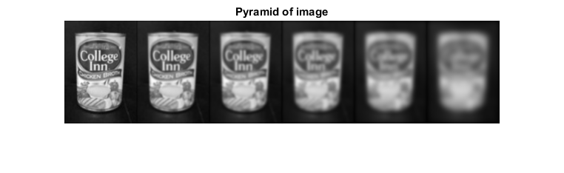

## Dog Pyramid

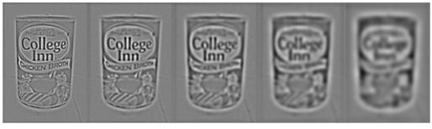

## Detected Keypoints (For Chicken Box and Computer vision book)

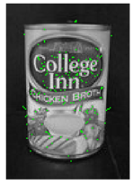

## Make Test Pattern

Included testPattern.mat in results folder.

## Descriptor Matching

* Chicken

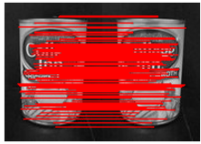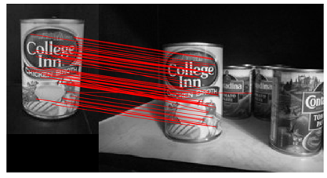

* Computer Vision Book

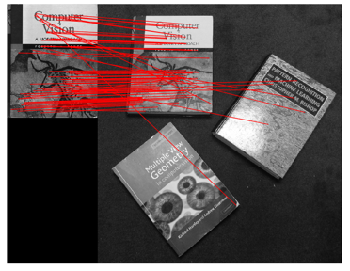

* Incline

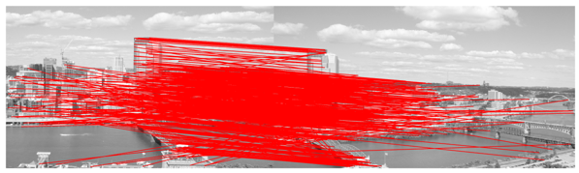

Cases that are performing better:

1. Where we are able to detect corners

Cases that are performing worse

1. In case the images are rotate with respect to each other
2. Some of the edges are still getting detected which are creating problems
3. Cases where there is a lot of texture and is similar (Like in CV textbook)

## BRIEF Rotational TEST

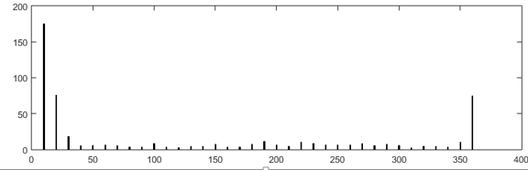

We see maximum good matches in the case where angle is near to 0 degree and near to 360 degree (0 and 360 are same). Also we can see some with a little better performance when the angles are 90, 180 and 270. But in most of the case where the image is un-rotated the performance is quite bad

The reason for these that the descriptor do not perform in case of rotation. This is because of the way the brief descriptor creates descriptions of patches (in our case 9x9 patched).

## 4 Planar Homographies theory

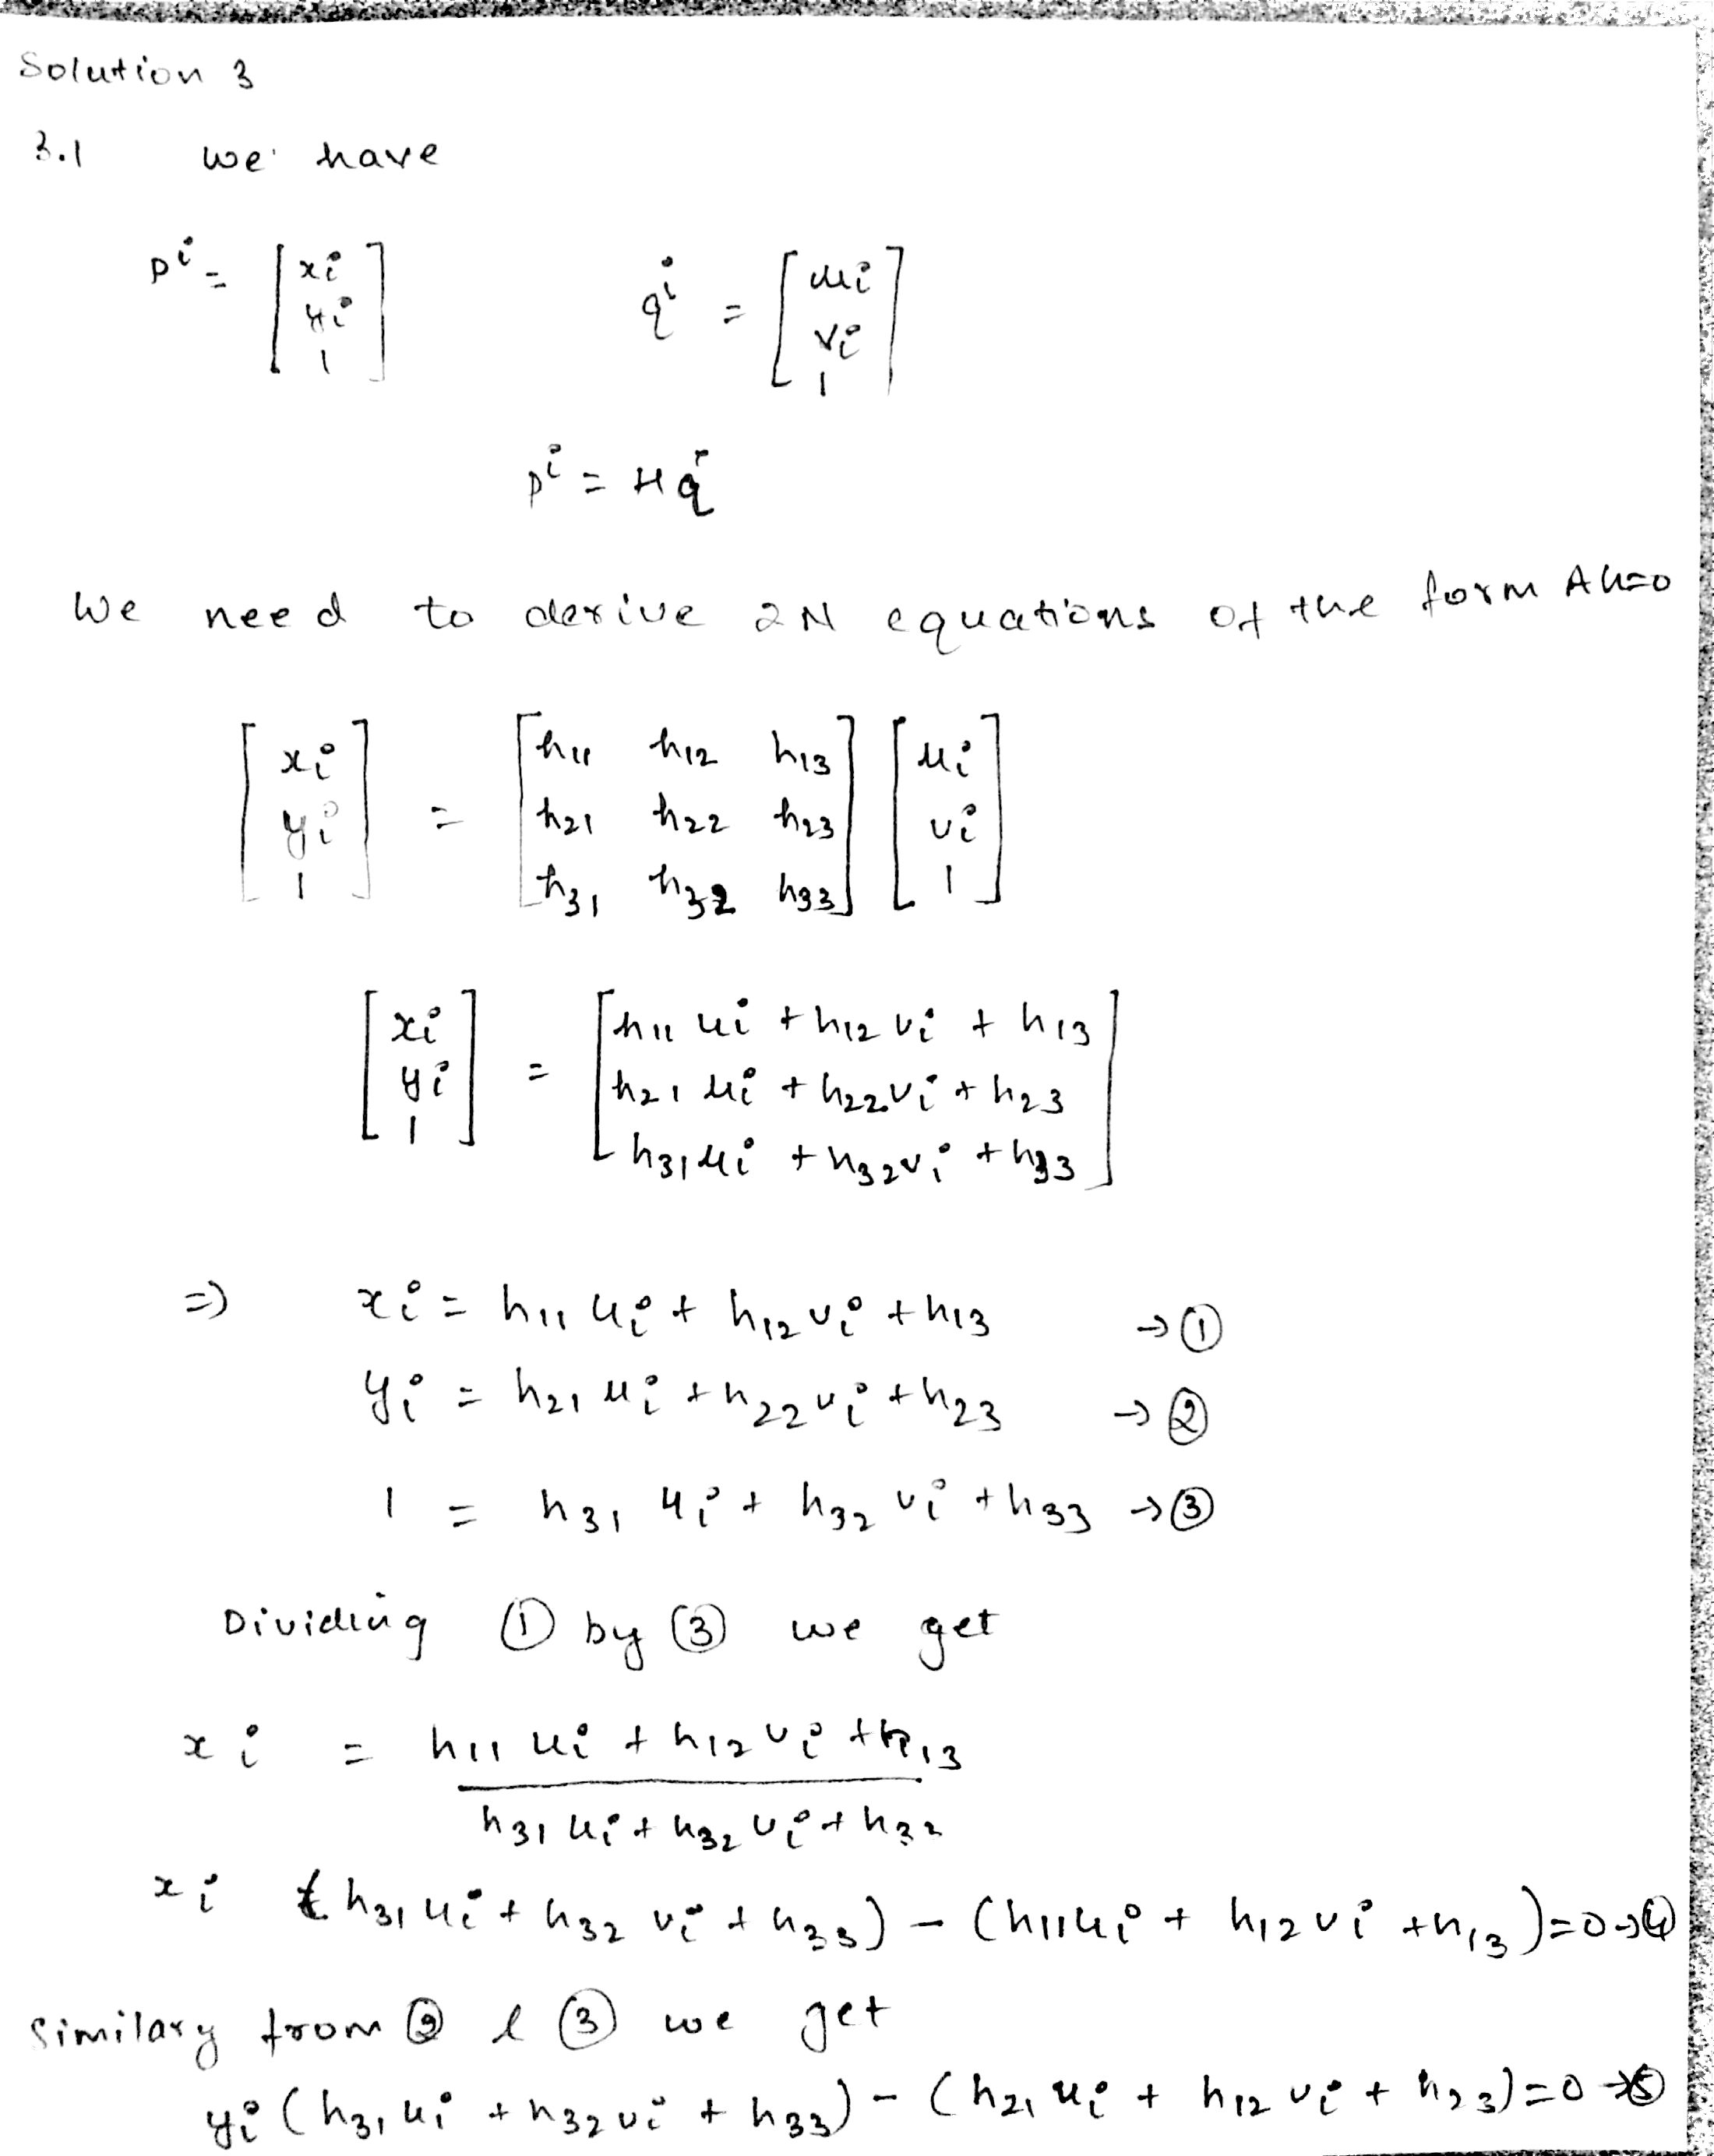

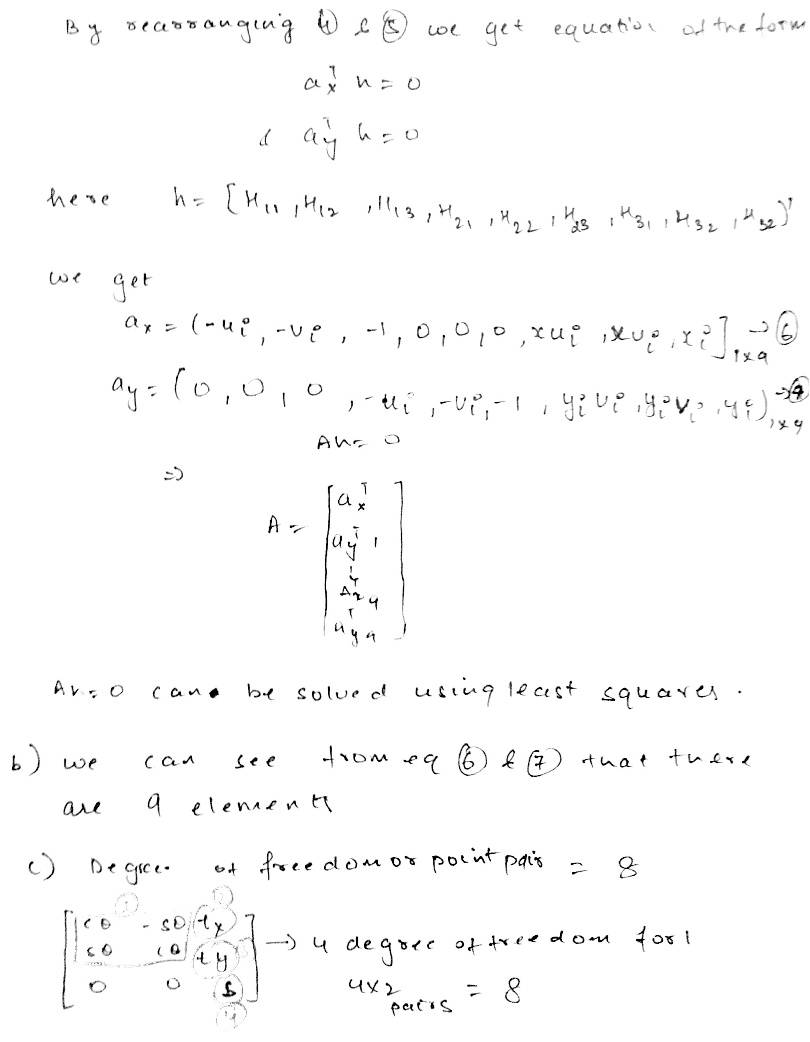

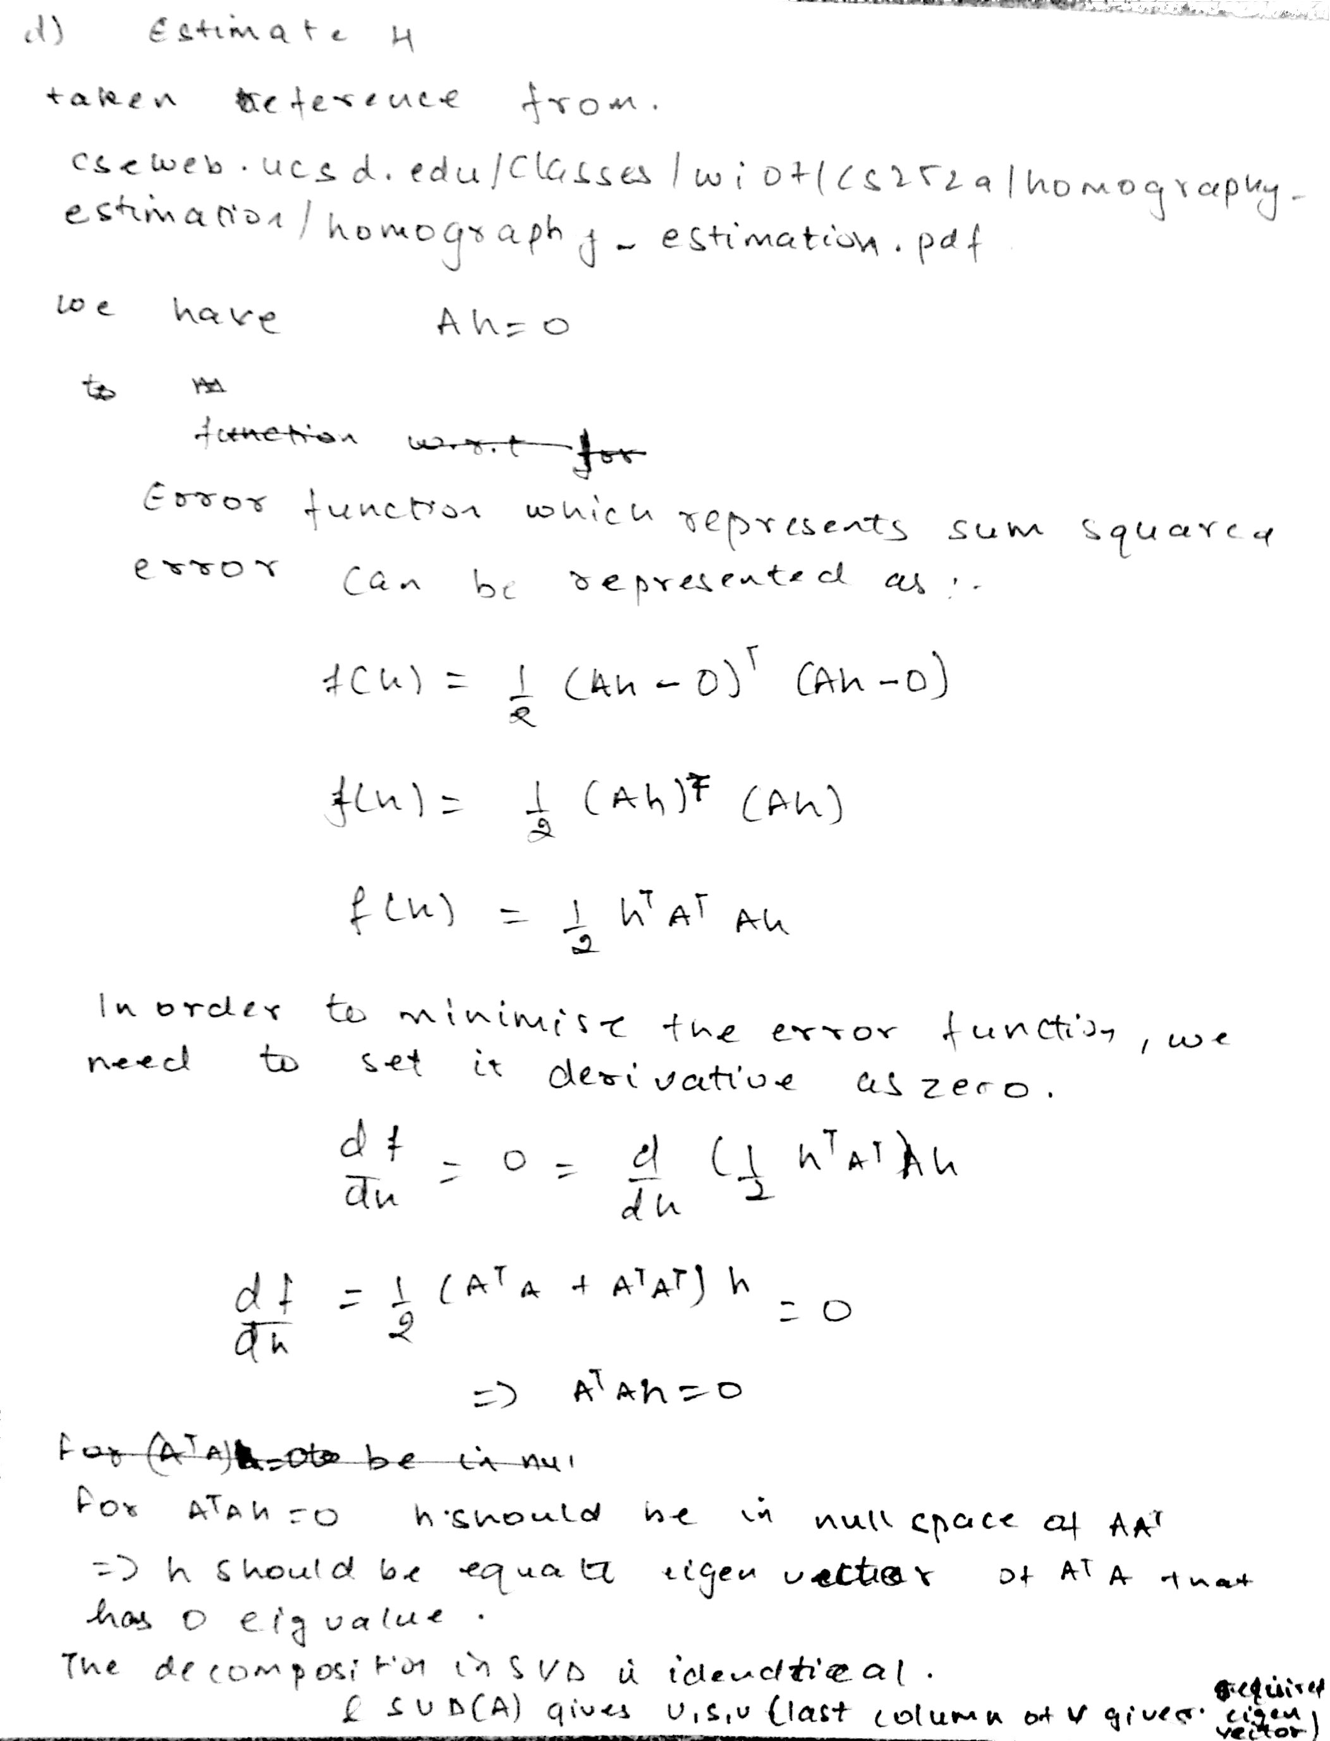

## Image Stiching

Q5_1.mat is attached

Image 2 warped to image 1 is below (without ransac)



(with ransac)



Image 2 added to image 1 (We can that the top and bottom portions have been clipped)



## Image Stiching with no clipping

Without RANSAC



With RANSAC but without maintaining aspect ration



## Image Stiching with RAnsac and no clipping (maintaining aspect ratio)

