by: Tushar Chugh

Robotics Institute

Carnegie Mellon University

3d Reconstruction

Computer Vision

Instructor: Prof. Deva Ramanan

March 25, 2016

# 3d Reconstruction

## Theory

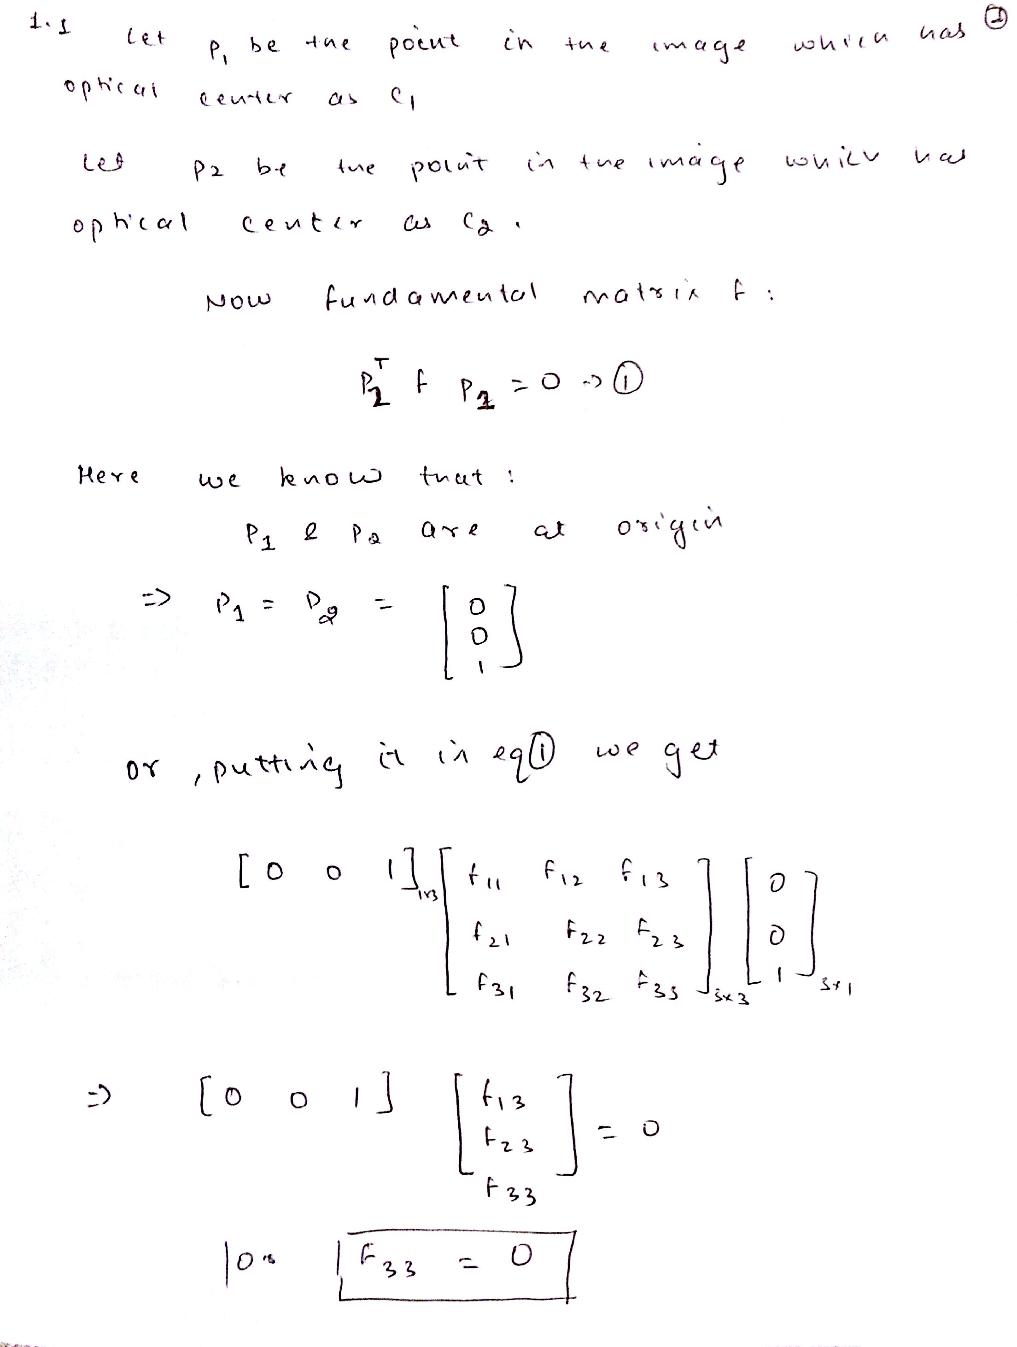

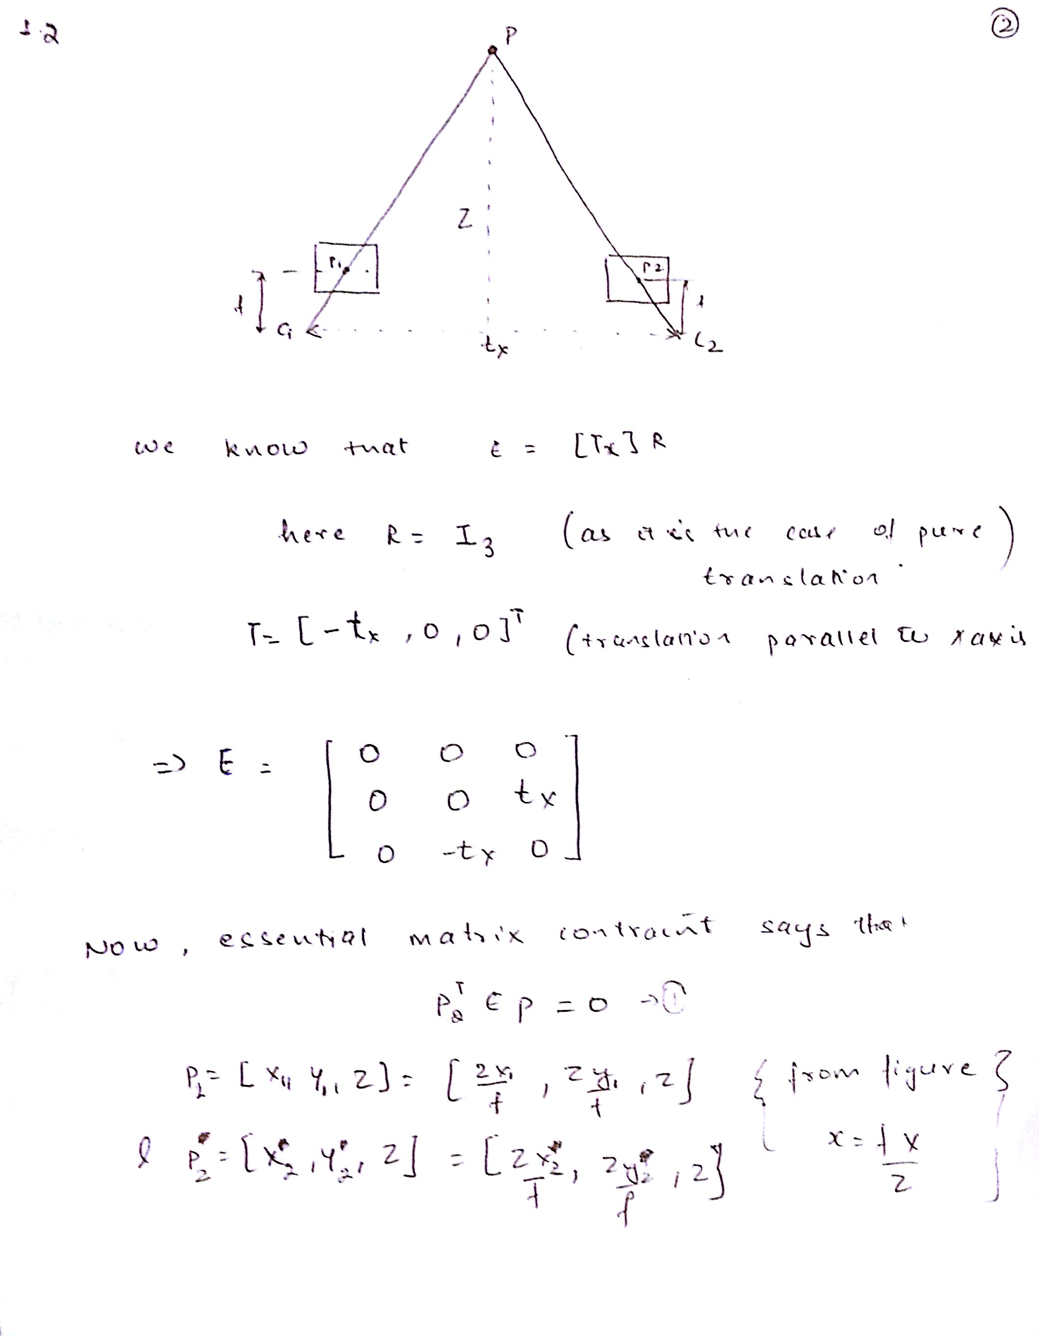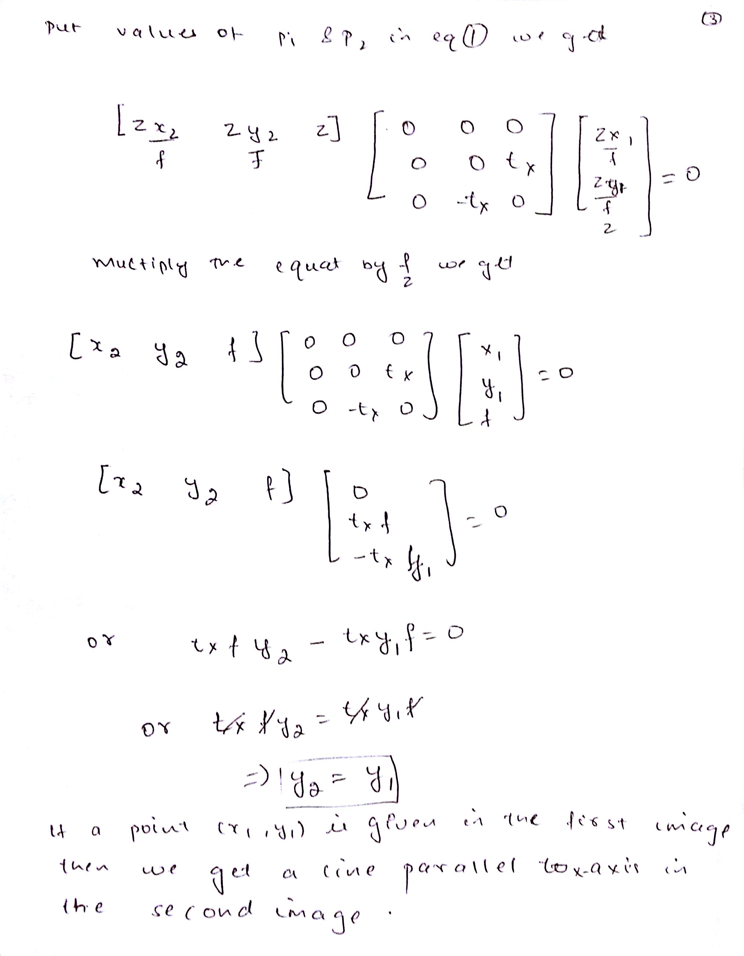

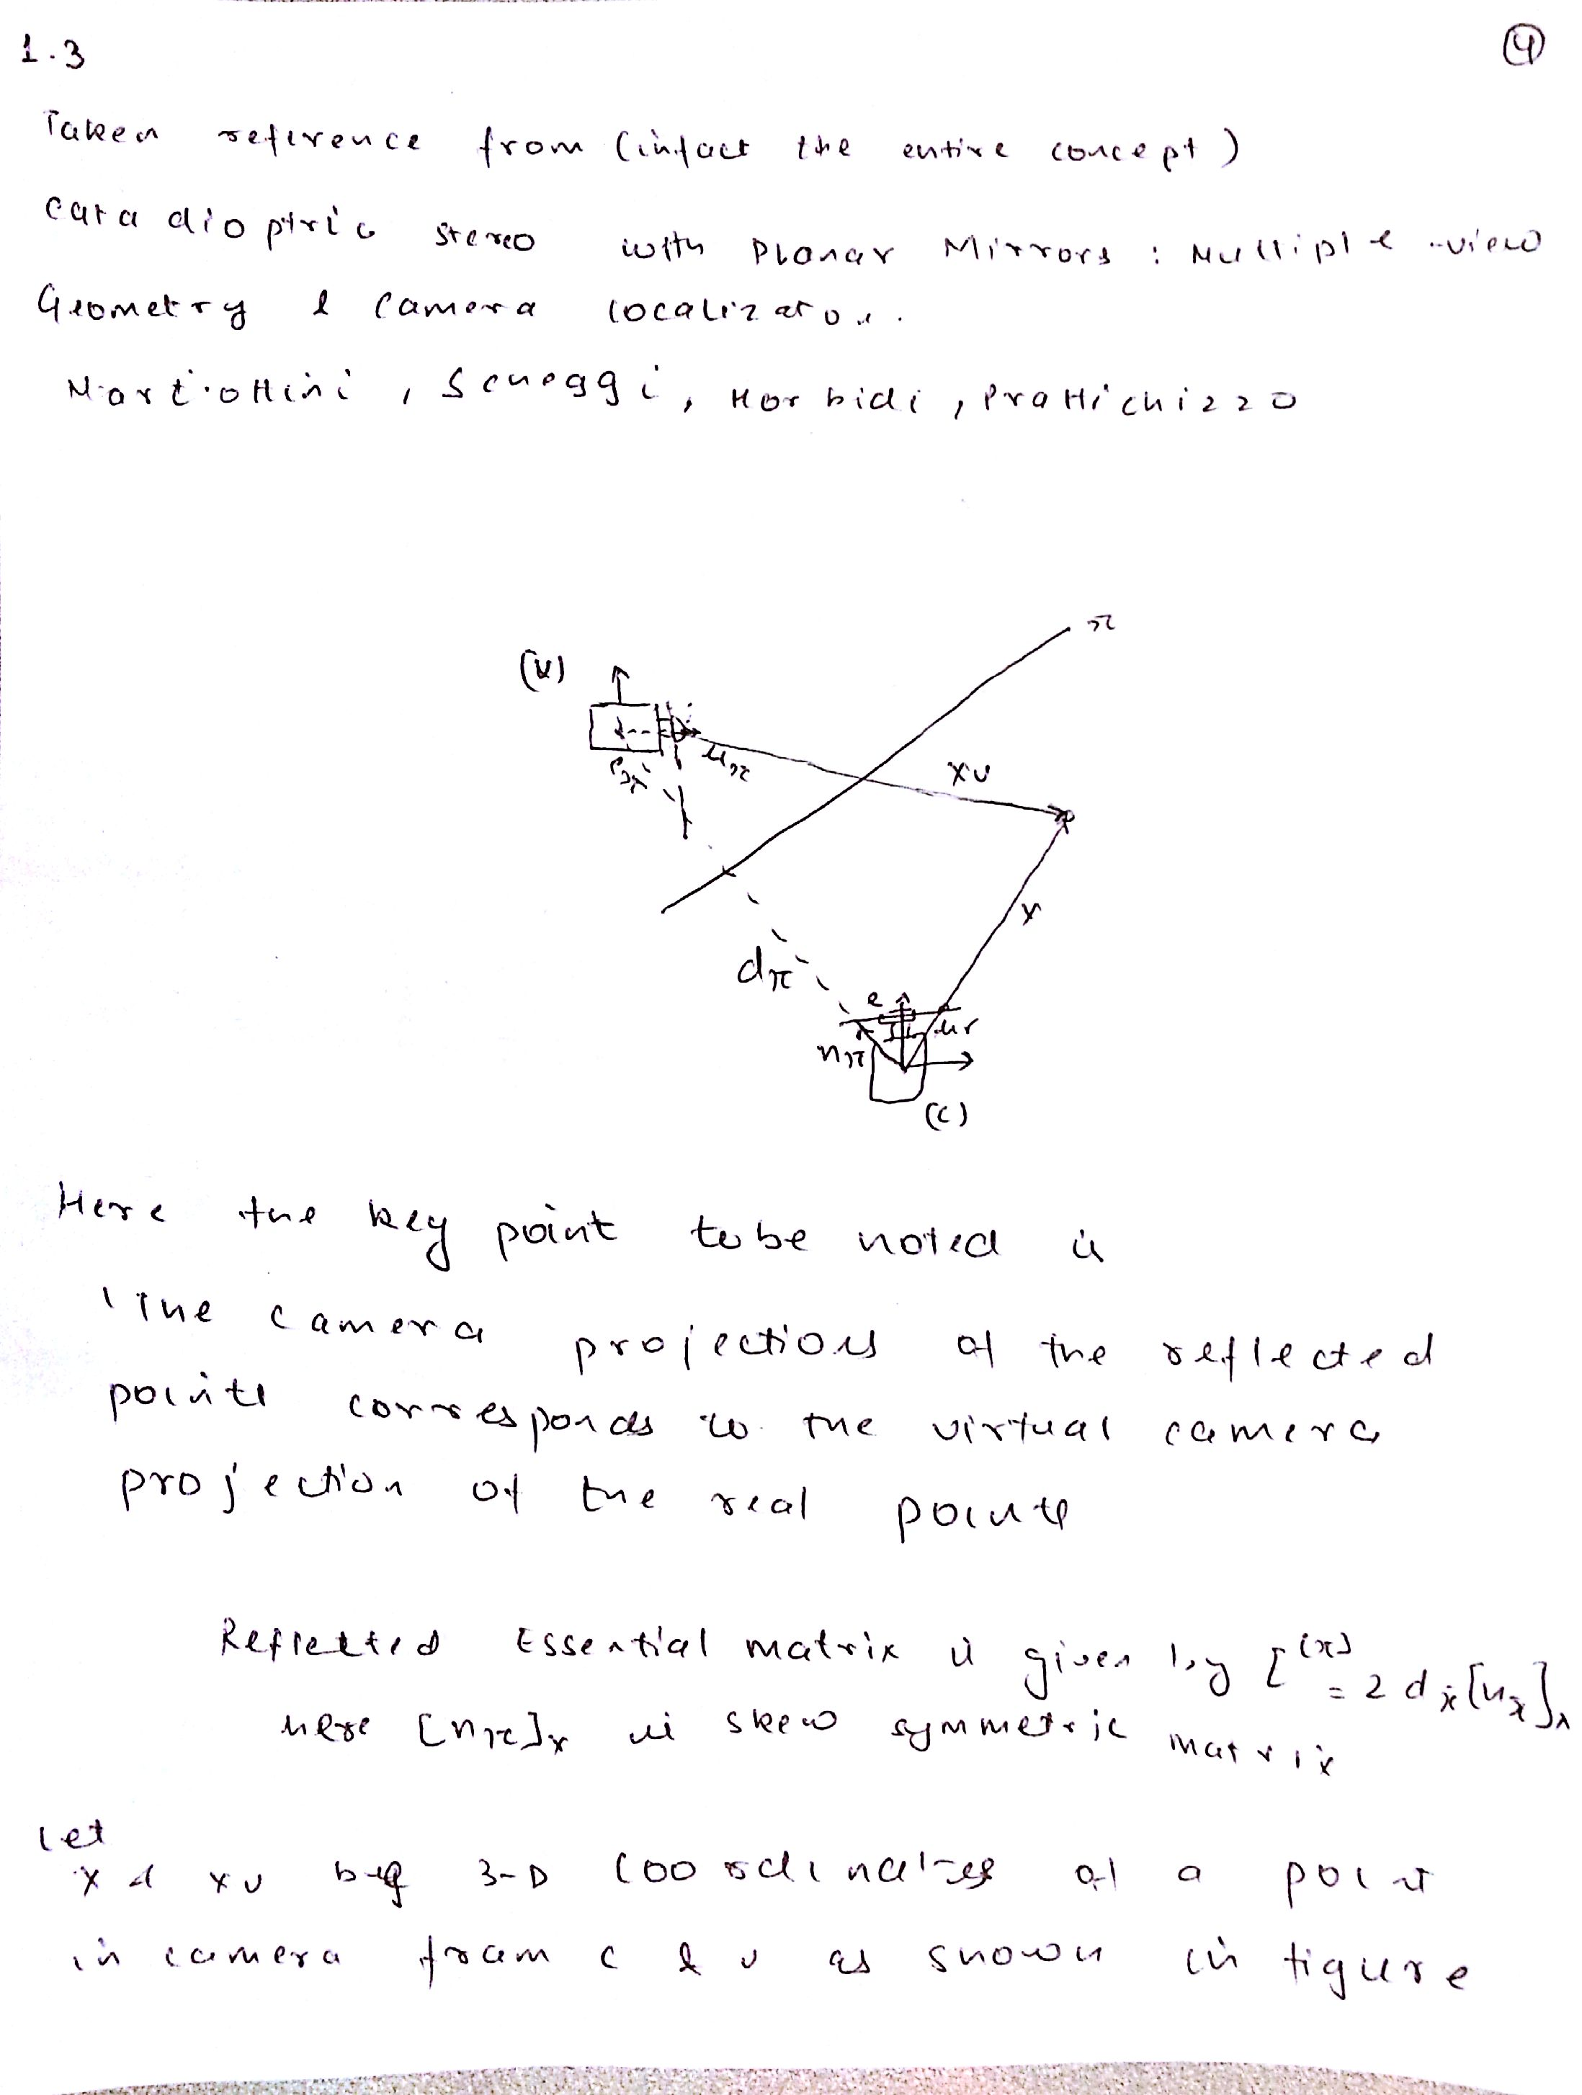

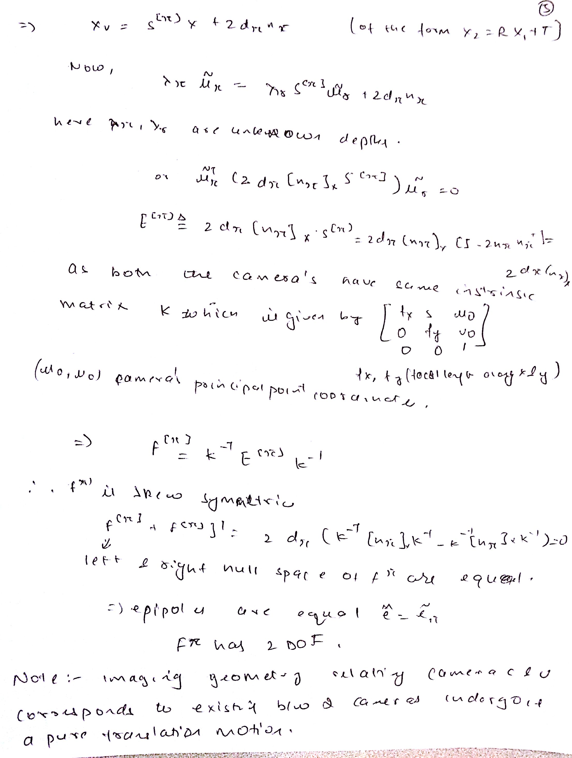

## 2.1 EightPoint

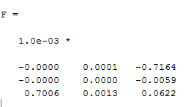

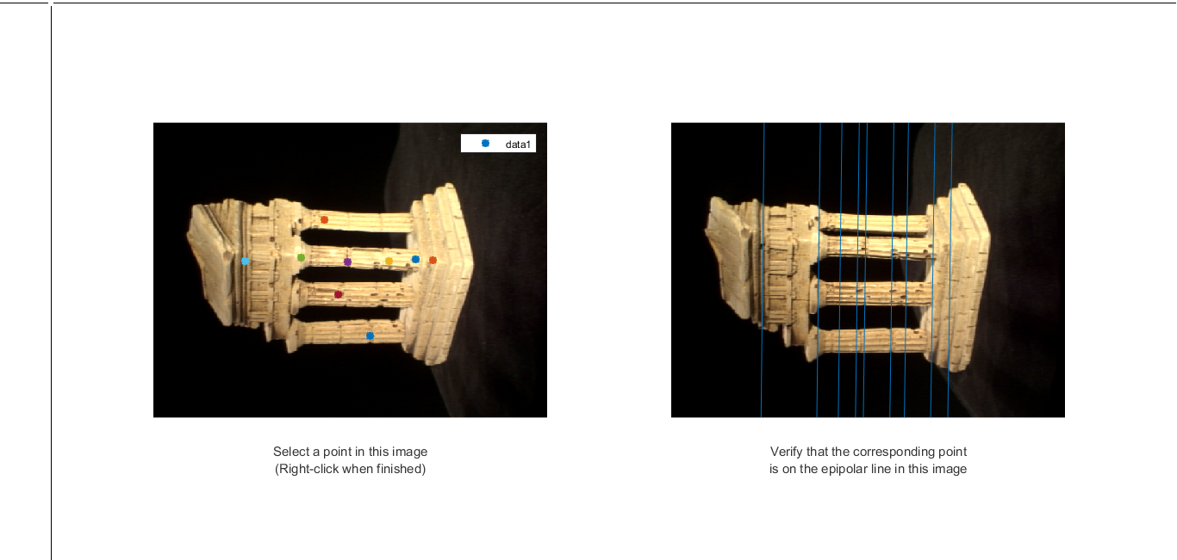

## 2.2 SevenPoint

% Taken reference from https://www8.cs.umu.se/kurser/TDBD19/VT05/reconstruct-4.pdf

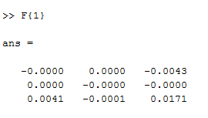 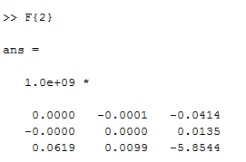 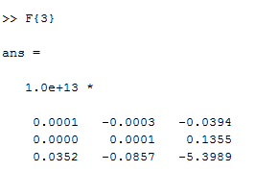

The images for these are attached in the serial order.

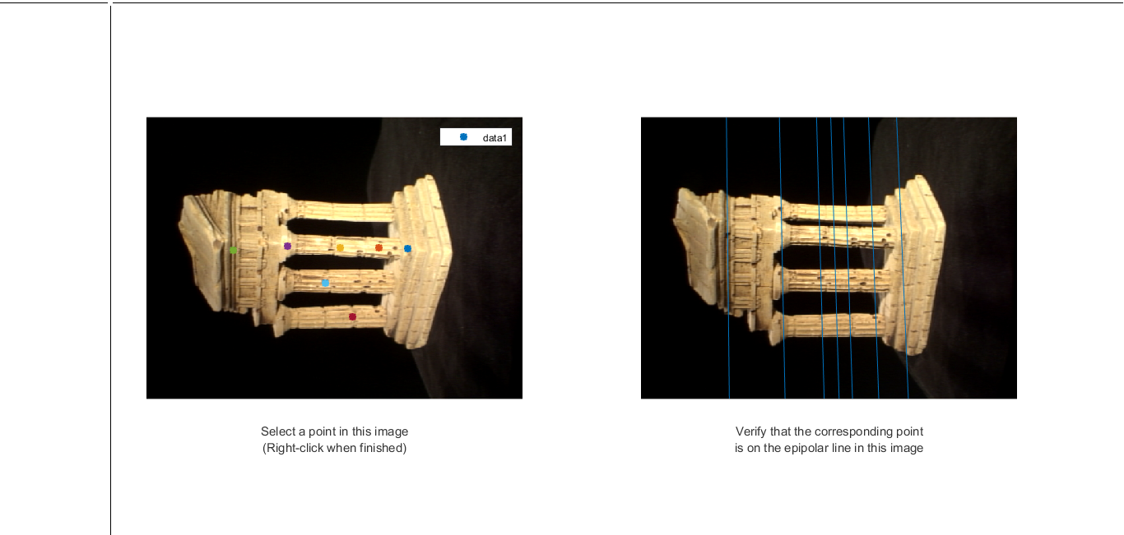

F{1}

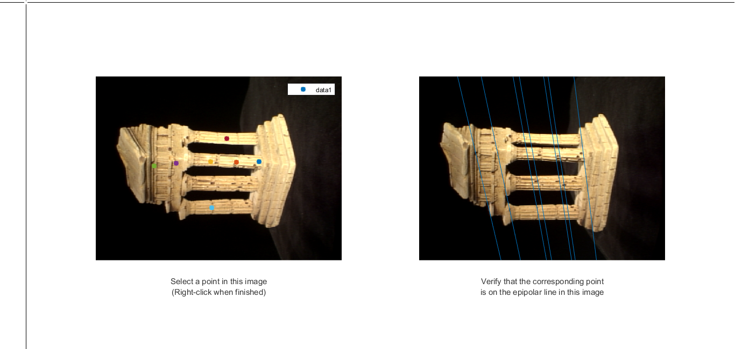

F{2}

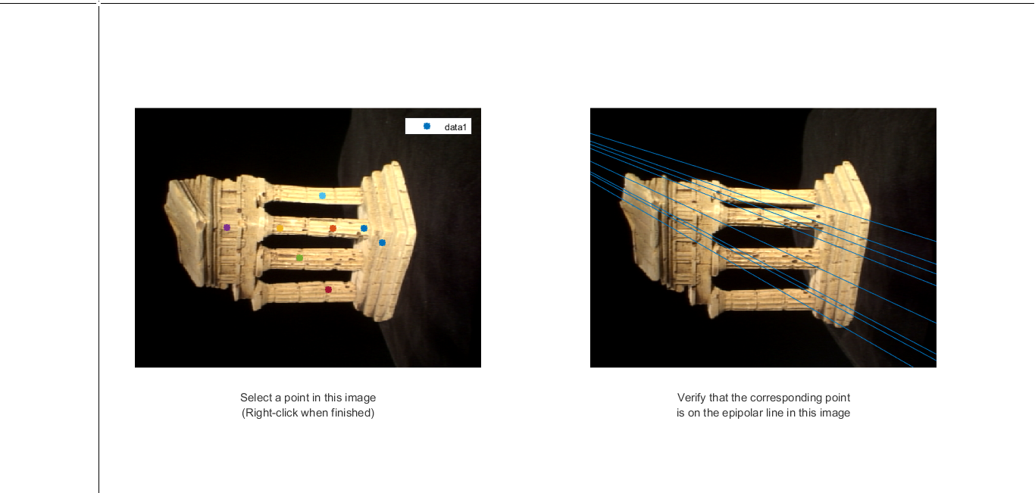

F{3}

## 2.X RANSACF

%Taken reference from Learning Computer Vision with OpenCV book

Error matrix used is Sampson distance:

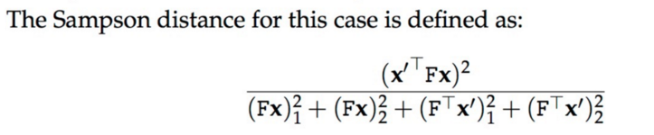

Took the error threshold to be the following. Points having distance less than threshold value are considered as inliers. error_thresh = 1e-3;

Output of Ransac:

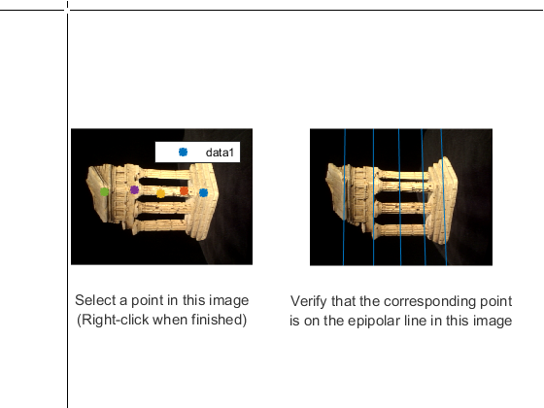

Output of eight point in the noisy case

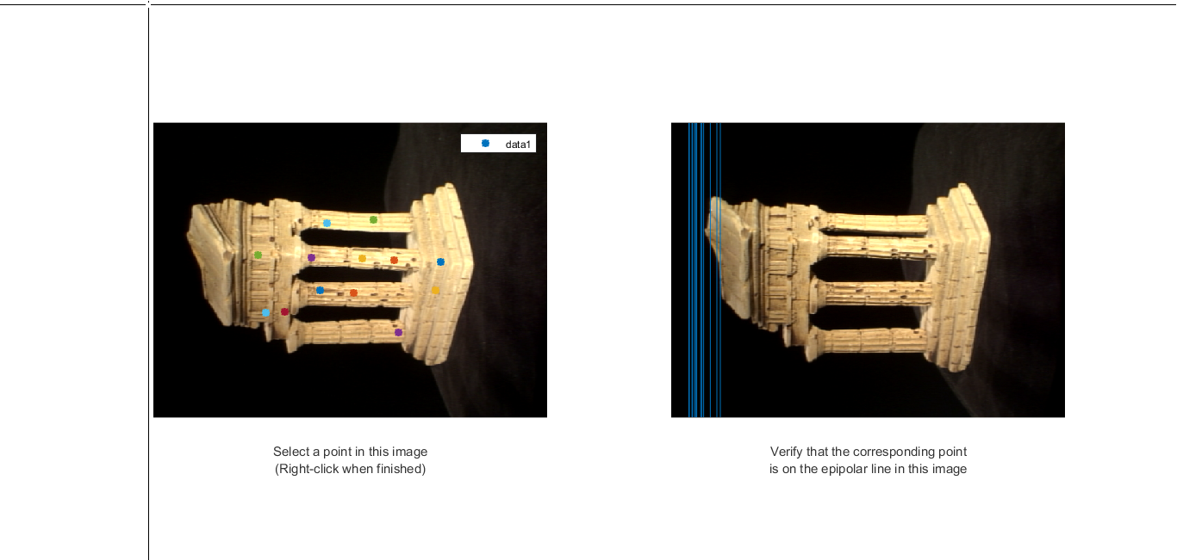

Output of Ransac in noisy case

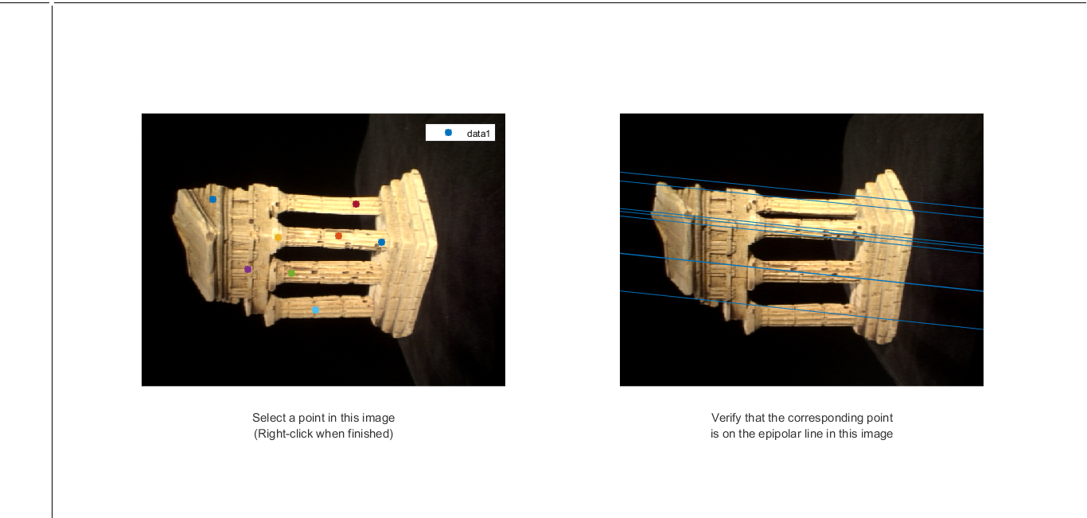

## 2.3 Essential Matrix

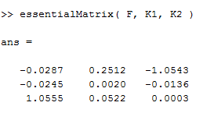

## 2.6 EpipolarCorrespondance

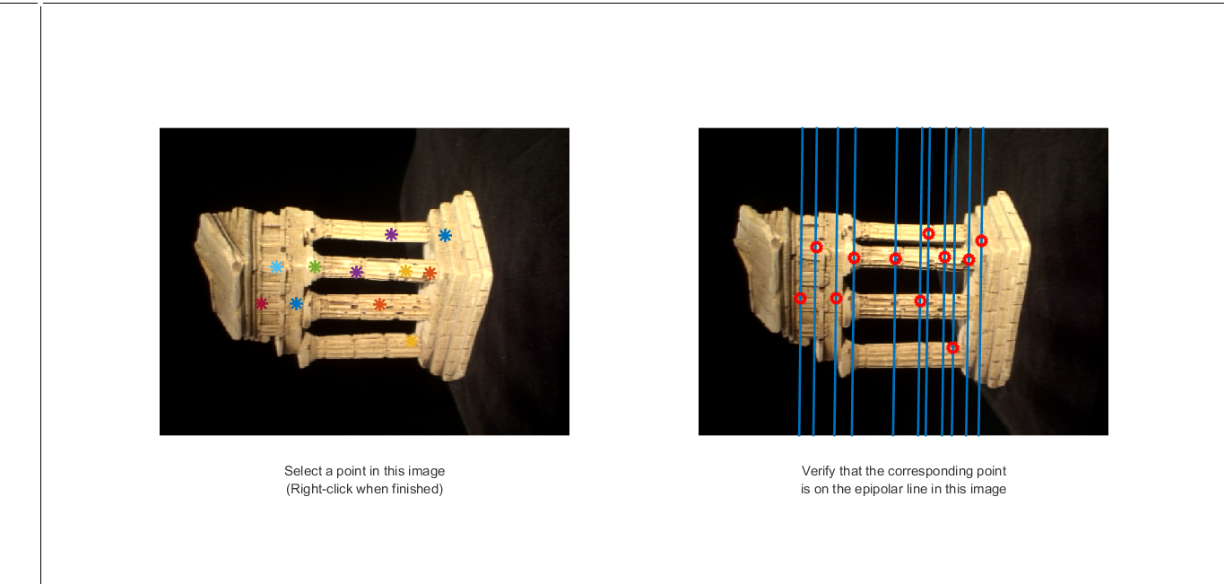

## 2.7 Point Cloud

