Calculator
Project Documentation
Author: Tushar Jhunjhunwala | Web Dev Internship Task

1. Project Overview
A clean, responsive browser-based calculator built with vanilla HTML, CSS, and JavaScript — no frameworks, no build tools, no external dependencies. The project was developed as part of a Web Development Internship task.

2. Screenshots

2.1 Default State
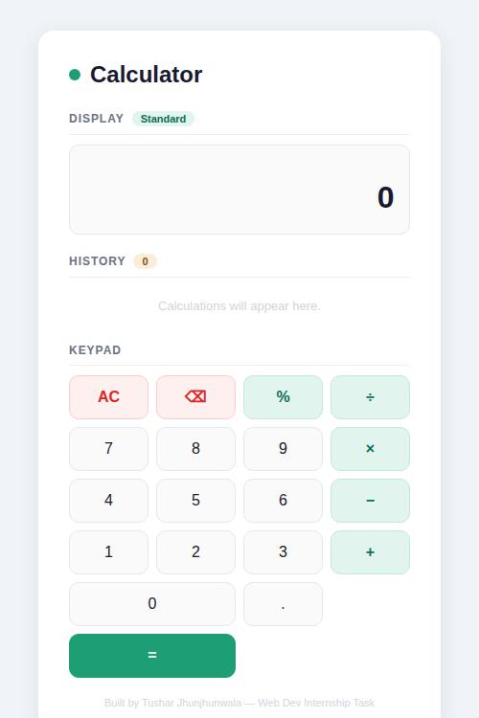
Figure 1 — Calculator on load

2.2 With Calculation History
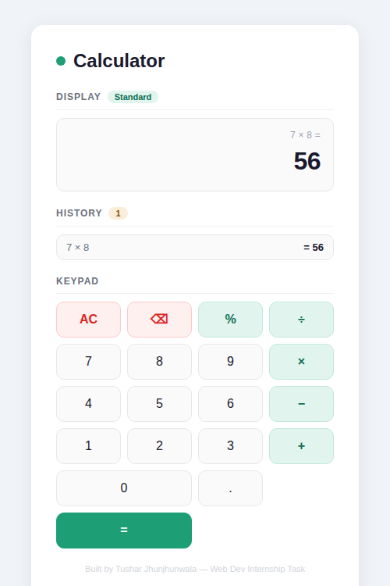
Figure 2 — Calculator after several operations

3. Features
- Standard arithmetic: addition, subtraction, multiplication, division
- Percentage operator — converts the current value to its decimal equivalent
- Chained operations — chain multiple operators without pressing = each time
- Calculation history — last 10 results stored; tap any entry to reuse the result
- Backspace — delete the last digit without clearing the full expression
- Error handling — displays 'Error' on division by zero
- Keyboard support — full keyboard input (digits, operators, Enter, Backspace, Escape)
- Responsive layout — fits desktop and mobile screens (max-width 420 px)

4. Keyboard Shortcuts
Key | Action
0 – 9 | Input digit
. | Decimal point
+ - * / | Operators
% | Percentage
Enter or = | Calculate result
Backspace | Delete last digit
Escape | Clear all (AC)

5. File Structure
File | Description
index.html | Single self-contained file — HTML markup, CSS styles, and JavaScript logic
README.md | Project overview and quick-start guide

6. Implementation Notes
- State is managed in plain JS variables: expr, current, operator, and prevVal.
- Floating-point results are rounded to 10 decimal places using Math.round(n * 1e10) / 1e10 to suppress IEEE 754 noise.
- Display values are capped at 12 characters to prevent layout overflow.
- History is capped at 10 entries; the oldest entry is dropped when the limit is exceeded.
- A justCalc flag prevents the current number from being appended after pressing =.

7. Design System
The UI follows a minimal card-based design. Key design tokens:

Token | Value | Usage
Primary green | #1D9E75 | Equals button, focus rings, dots
Dark green | #0F6E56 | Operator labels, hover states
Light green | #E1F5EE | Operator button backgrounds
Dark navy | #1a1a2e | Result text, headings
Error red | #dc2626 | Clear button, error display
Background | #f0f4f8 | Page background

8. How to Run
No build step or server is required. Simply open index.html in any modern browser (Chrome, Firefox, Edge, Safari).

The app is fully self-contained — all styles and scripts are embedded inline in the HTML file.

