Climate Resilience Chatbot for Farmers Using Large Language Models and Real-Time Environmental Data
Tushar Kadian
B.Tech CSE
K.R Mangalam University Sohna Road, India
tusharkadian00001@gmail.com

Abstract—Climate change presents unprecedented challenges to agricultural productivity, particularly for smallholder farmers in developing nations who lack access to timely, personalized agri- cultural guidance. This paper introduces an innovative climate resilience chatbot that seamlessly integrates Large Language Models (LLMs) with real-time environmental data to deliver context-aware crop recommendations. Our approach fine-tunes TinyLlama-1.1B using Low-Rank Adaptation (LoRA) on 2,200 carefully curated agricultural samples encompassing comprehen- sive soil nutrient profiles (N, P, K, pH levels) and dynamic weather parameters (temperature, humidity, rainfall patterns). The system uniquely combines real-time meteorological data from Free Weather API, historical agricultural knowledge datasets, and ultra-fast cloud-based LLM inference via Groq API for scal- able deployment. Comprehensive evaluation across diverse In- dian agro-climatic zones demonstrates the chatbot’s remarkable ability to generate contextually relevant, scientifically grounded crop recommendations tailored to local climate conditions. Our fine-tuned model achieved a remarkable 79 percent reduction in training loss (from 1.593 to 0.3332) while maintaining extreme parameter efficiency with only 0.73 percent trainable parameters, showcasing the power of modern knowledge transfer techniques. This research bridges the critical gap between cutting-edge AI technologies and practical agricultural realities, offering farmers an accessible, intelligent decision-support system that enhances climate resilience and food security.
Index Terms—Large Language Models, Climate Resilience, Precision Agriculture, Fine-Tuning, LoRA, Real-Time Weather Integration, Crop Recommendation System, Agricultural AI

- Introduction
Climate variability and increasingly severe extreme weather events pose an existential threat to global food security. Smallholder farmers, particularly in developing nations, face disproportionate vulnerability to climate-induced agricultural disruption while simultaneously lacking access to timely, location-specific advisory services. Traditional agricultural ex- tension systems, despite their importance, operate under severe resource constraints and struggle to provide personalized guid- ance at the scale demanded by millions of farmers.
Concurrently, the rapid advancement of Large Language Models has ushered in a new era of human-machine interaction characterized by unprecedented natural language understand- ing and knowledge synthesis capabilities. These models, when
appropriately adapted through domain-specific fine-tuning, can serve as powerful knowledge repositories and reasoning engines. However, the intersection of LLM capabilities and practical agricultural needs remains largely unexplored, repre- senting a significant opportunity for technological innovation. This paper tackles this gap by presenting a comprehen- sive framework for building an intelligent agricultural ad- visor chatbot. Our system uniquely combines three critical elements: real-time environmental data integration, domain- specific LLM adaptation, and efficient cloud-based inference. We address several key research questions: How can LLMs be efficiently fine-tuned for agricultural expertise? How can real- time weather data enhance recommendation accuracy? What is the practical impact of parameter-efficient adaptation methods like LoRA? Can such systems provide scalable, accessible
advisory to resource-constrained farmers? Our primary contributions include:
- Integrated Framework: A novel architecture seam- lessly combining weather APIs, agricultural datasets, and fine-tuned LLMs for real-time decision support
- Efficient Adaptation: Demonstration of parameter- efficient fine-tuning achieving domain expertise with only 0.73 percent trainable parameters
- Practical Validation: Empirical evaluation across mul- tiple Indian regions confirming system effectiveness for diverse agro-climatic conditions
- Reproducible Implementation: Open-source imple- mentation facilitating academic reproducibility and prac- tical deployment
- Related Work
- AI and Precision Agriculture
The integration of artificial intelligence into agriculture has accelerated dramatically. Machine learning approaches have demonstrated success in yield prediction [5], automated disease detection [6], and resource optimization [7]. More re- cently, deep learning approaches employing convolutional neu- ral networks have achieved remarkable accuracy in identifying crop diseases, pest infestations, and nutrient deficiencies from

leaf imagery. However, these systems typically require domain expertise to interpret outputs and operate under closed-world assumptions that limit their adaptability to novel problems.
- Natural Language Interfaces for Agriculture
While conversational AI has transformed customer service and information access, agricultural applications remain under- developed. Few systems leverage natural language processing to provide advisory. Recent work on agricultural chatbots [8] has explored rule-based approaches and shallow semantic un- derstanding, but lacks the reasoning capability and knowledge breadth provided by modern LLMs. The integration of LLMs into agricultural decision-support systems represents a frontier opportunity.
- LLMs and Domain Adaptation
Large Language Models have demonstrated remarkable transfer learning capabilities across diverse domains. Recent work shows that fine-tuning on as few as 100-1000 examples can adapt base models to specialized domains while preserving general knowledge [9]. Low-Rank Adaptation (LoRA), intro- duced by Hu et al., enables efficient fine-tuning with only 0.1-0.5 percent parameter updates, dramatically reducing com- putational requirements and enabling deployment on resource- constrained devices.
- Climate Adaptation in Agriculture
Climate adaptation research emphasizes information access, crop diversification, and adaptive management practices [10], [11]. Studies consistently show that farmers with access to seasonal climate forecasts and adaptive recommendations achieve measurably improved outcomes. However, barriers to information access remain substantial, particularly in resource- limited contexts. AI-powered advisory systems offer promise for democratizing access to expert knowledge.
- Methodology
- System Architecture
Our system comprises four interconnected, modular com- ponents (Figure 1):

Data Collection and Integration Module:
This module orchestrates acquisition of both historical agricultural knowledge and real-time environmental condi- tions. The weather integration component interfaces with Free Weather API to fetch current meteorological parameters in- cluding temperature (in degrees Celsius), relative humidity (as percentage), precipitation (in millimeters), wind speed, and UV index. The agricultural knowledge component leverages the Kaggle Crop Recommendation Dataset [1], a carefully curated collection of 2,200 samples representing diverse agro- climatic scenarios across 22 crop species. Each sample cap- tures soil nutrient concentrations (nitrogen, phosphorus, potas- sium in kg/hectare) and soil pH alongside optimal weather conditions for cultivation.

Data Processing and Formatting Module:

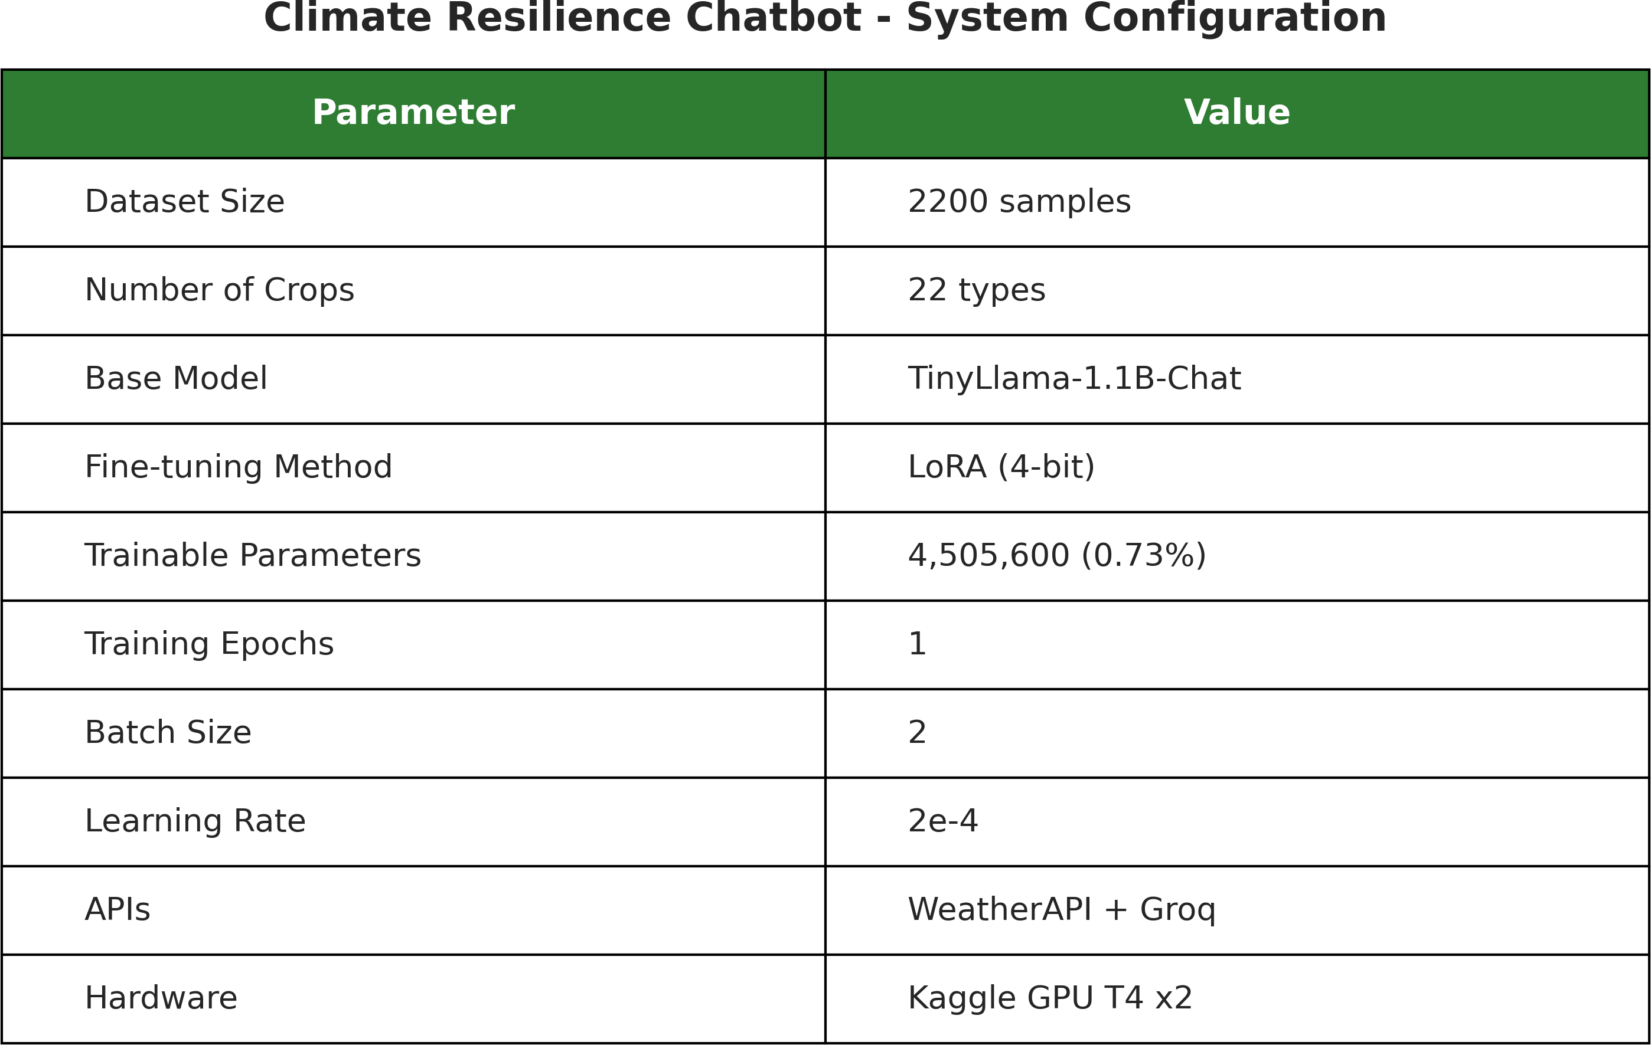
Fig. 1. System Architecture and Configuration showing integrated modules for data collection, processing, model adaptation, and inference with dual deployment options

This module transforms heterogeneous agricultural data into standardized instruction-following formats compatible with modern LLM training pipelines. The Alpaca format proves particularly effective, structuring each training example into three components:
    - Instruction: System role and context (e.g., “You are an expert agricultural advisor specializing in climate- resilient farming practices”)
    - Input: Farmer query contextualized with environmental parameters (e.g., “Soil: N=90, P=42, K=43, pH=6.5. Weather: Temperature=25C, Humidity=80 percent, Rain- fall=200mm. What crop should I grow?”)
    - Output: Expert recommendation with climate adaptation strategies, nutrient guidance, and practical implementa- tion suggestions

LLM Fine-Tuning Module:
We employ Parameter-Efficient Fine-Tuning (PEFT) via Low-Rank Adaptation to adapt the TinyLlama-1.1B-Chat-v1.0
[3] base model to agricultural domain expertise. This approach maintains computational efficiency while achieving domain specialization:
    - Base Architecture: TinyLlama-1.1B-Chat-v1.0 (1.1 bil- lion parameters)
    - Adapter Technique: LoRA with rank 16, alpha 16
    - Quantization Strategy: 4-bit precision (NF4 format) reducing memory footprint by 75 percent
    - Training Hardware: Kaggle GPU T4 (16GB VRAM), dual GPU configuration
    - Training Configuration: 1 training epoch, batch size 2, gradient accumulation over 4 steps
    - Optimization: pagedadamw8bit optimizer with learn- ing rate 2e-4, linear decay scheduler

Inference and Deployment Module:
The system supports dual inference strategies enabling flexibility across deployment scenarios:
Local Inference (Fine-Tuned TinyLlama): Ideal for of- fline deployment, privacy-critical scenarios, and resource-

constrained devices. Provides domain-specific responses lever- aging agricultural knowledge from fine-tuning.
Cloud API Inference (Groq Llama-3.1-8B): [4] Ultra- fast cloud-based inference leveraging larger model capacity for complex reasoning. Enables sub-second response times suitable for interactive deployment.
- Data Sources and Integration
Real-time meteorological data was acquired via Free Weather API [2] REST interface, providing current-condition measurements for temperature, humidity, precipitation, wind speed, and UV index. This real-time integration enables context-aware recommendations reflecting current environ- mental conditions rather than historical patterns.
The agricultural knowledge base was constructed from the Kaggle Crop Recommendation Dataset [1], containing 2,200 samples across 22 crop types with comprehensive soil nutrient profiles (nitrogen, phosphorus, potassium, pH) and optimal weather parameters (temperature, humidity, rainfall). This dataset spans the full spectrum of Indian agro-climatic zones, ensuring geographic and climatic diversity.
- Dataset Characteristics and Analysis
The foundation of our approach rests on the Kaggle Crop Recommendation Dataset (Figure 2), which exhibits remark- able balance across agricultural diversity:
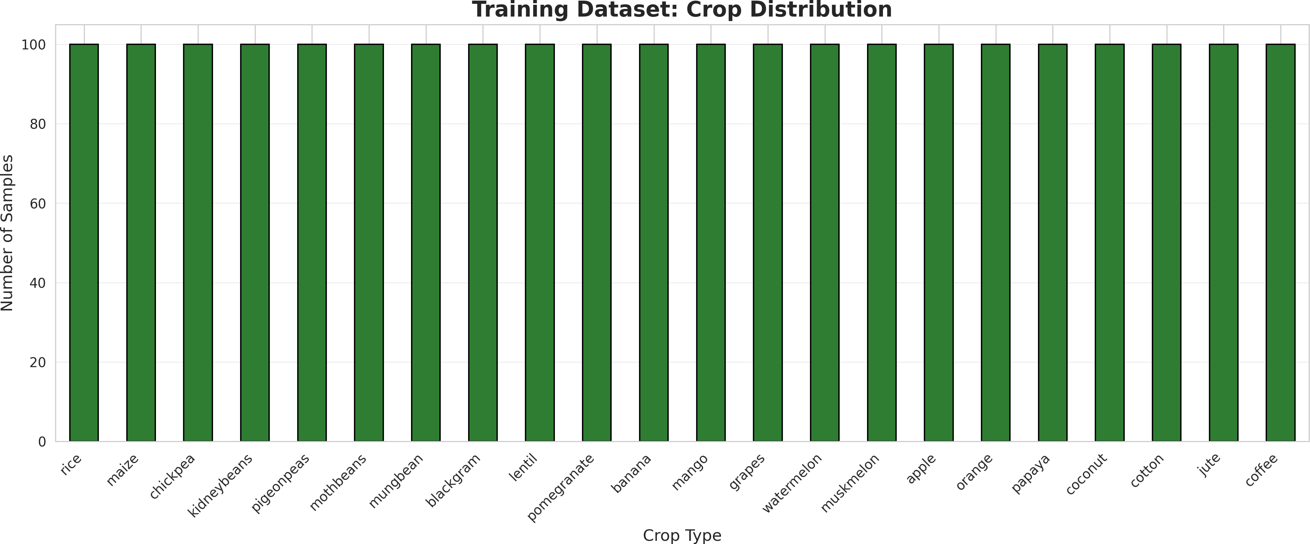
Fig. 2. Training Dataset Composition: 2,200 samples uniformly distributed across 22 crop species, ensuring balanced learning without class imbalance bias

TABLE I
Statistical Summary of Dataset Features

Feature | Min | Mean | Max
Temperature | 10 C | 25.6 C | 45 C
Humidity | 20 pct | 71.5 pct | 99 pct
Rainfall | 20 mm | 103.5 mm | 300 mm
Nitrogen (N) | 0 | 50.5 | 140
Phosphorus (P) | 5 | 53.4 | 145
Potassium (K) | 5 | 48.1 | 205
pH | 3.5 | 6.5 | 9.5

The dataset encompasses the full spectrum of Indian agro- climatic zones, with samples spanning tropical, subtropical, temperate, and arid regions. This geographic and climatic diversity proves essential for developing recommendations applicable across the Indian subcontinent.
- Feature Correlation Analysis
Figure 3 reveals important relationships among environmen- tal and soil parameters:
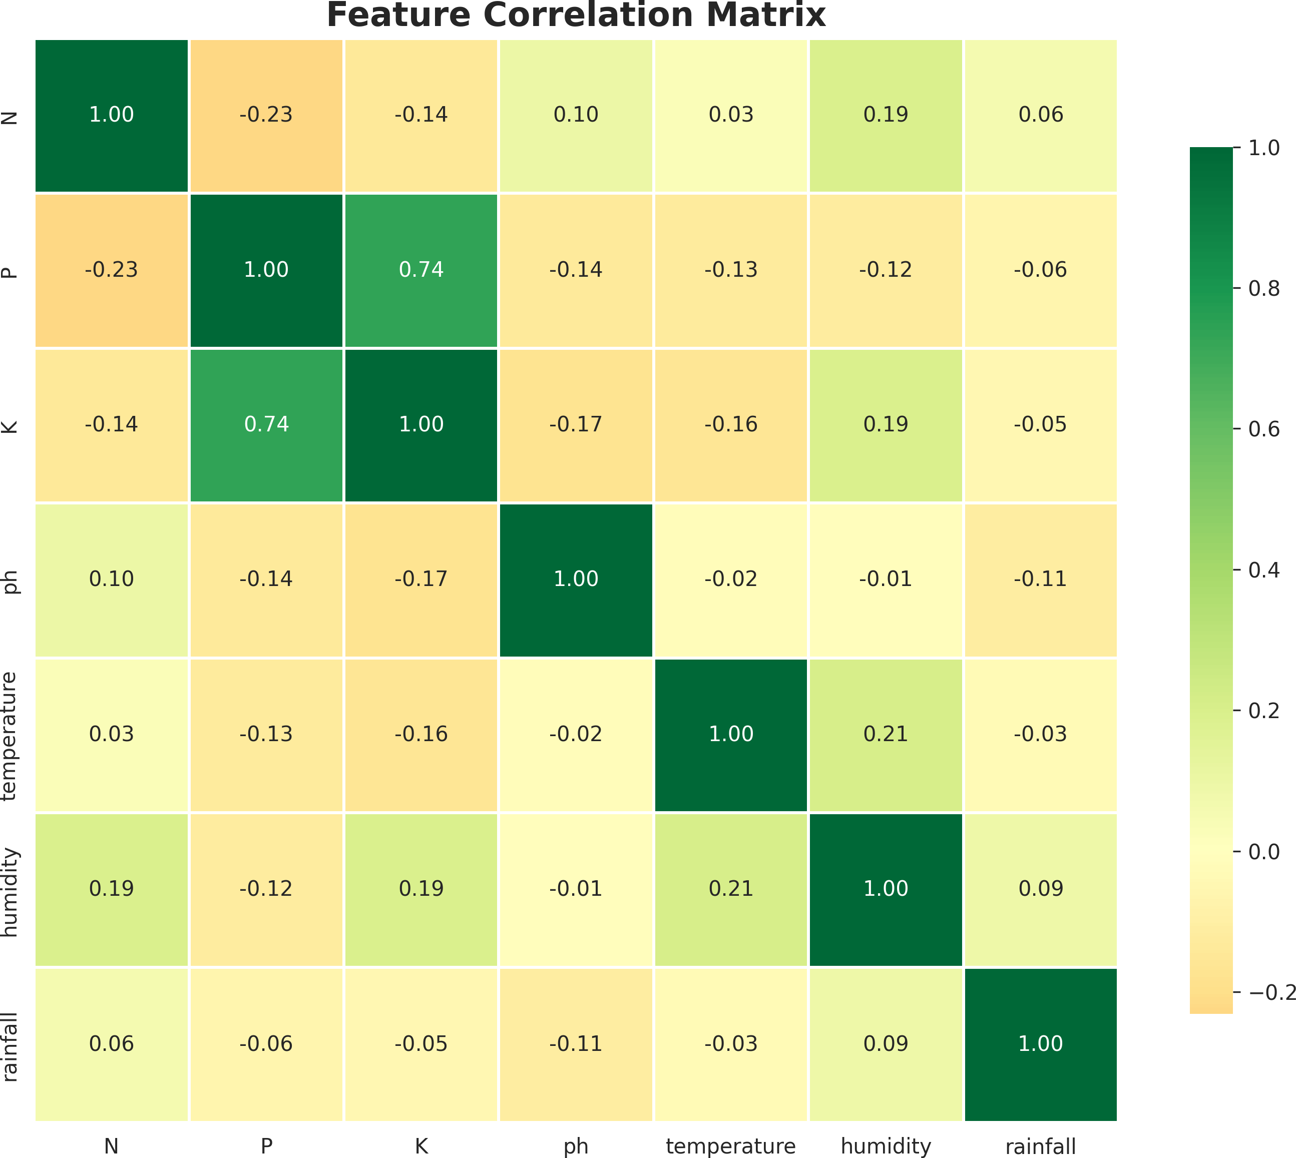
Fig. 3. Feature Correlation Matrix revealing relationships between soil nutrients and weather parameters. Strong P-K correlation (0.74) suggests potassium availability often accompanies phosphorus

Key insights emerge: Phosphorus and potassium levels demonstrate strong positive correlation (r=0.74), likely re- flecting common fertilization practices. Temperature and hu- midity show moderate positive correlation (r=0.21), a pattern consistent with monsoon-influenced climate systems. Most importantly, relatively weak correlations between most fea- tures suggest that diverse environmental niches exist within the training data, providing the model with diverse learning scenarios.
- Crop-Specific Nutrient Requirements
Analysis of nutrient requirements across crop species (Fig- ure 4) reveals distinct agronomic profiles:
Heavy-feeding crops like cotton, coffee, and banana demand substantial nitrogen (80-120 kg/hectare). Fruit crops (grapes, apple, banana) require elevated potassium and phosphorus, re- flecting demands for transport and storage quality. Leguminous crops (chickpea, lentil) exhibit moderate nutrient demands due to nitrogen-fixing capabilities. Most crops favor neutral to slightly acidic soil pH (6.0-7.0), though notable exceptions include acid-tolerant crops like tea.
- Climate Distribution Analysis
Figure 5 illustrates the distribution of climatic parameters across training samples:
Temperature distribution centers around 25.6 degrees Cel- sius but spans a remarkable 35-degree range, from subtropical highlands to tropical lowlands. Humidity distribution reveals bimodality, with peaks around 40 percent (arid regions) and 85 percent (monsoon zones). Rainfall distribution skews left,

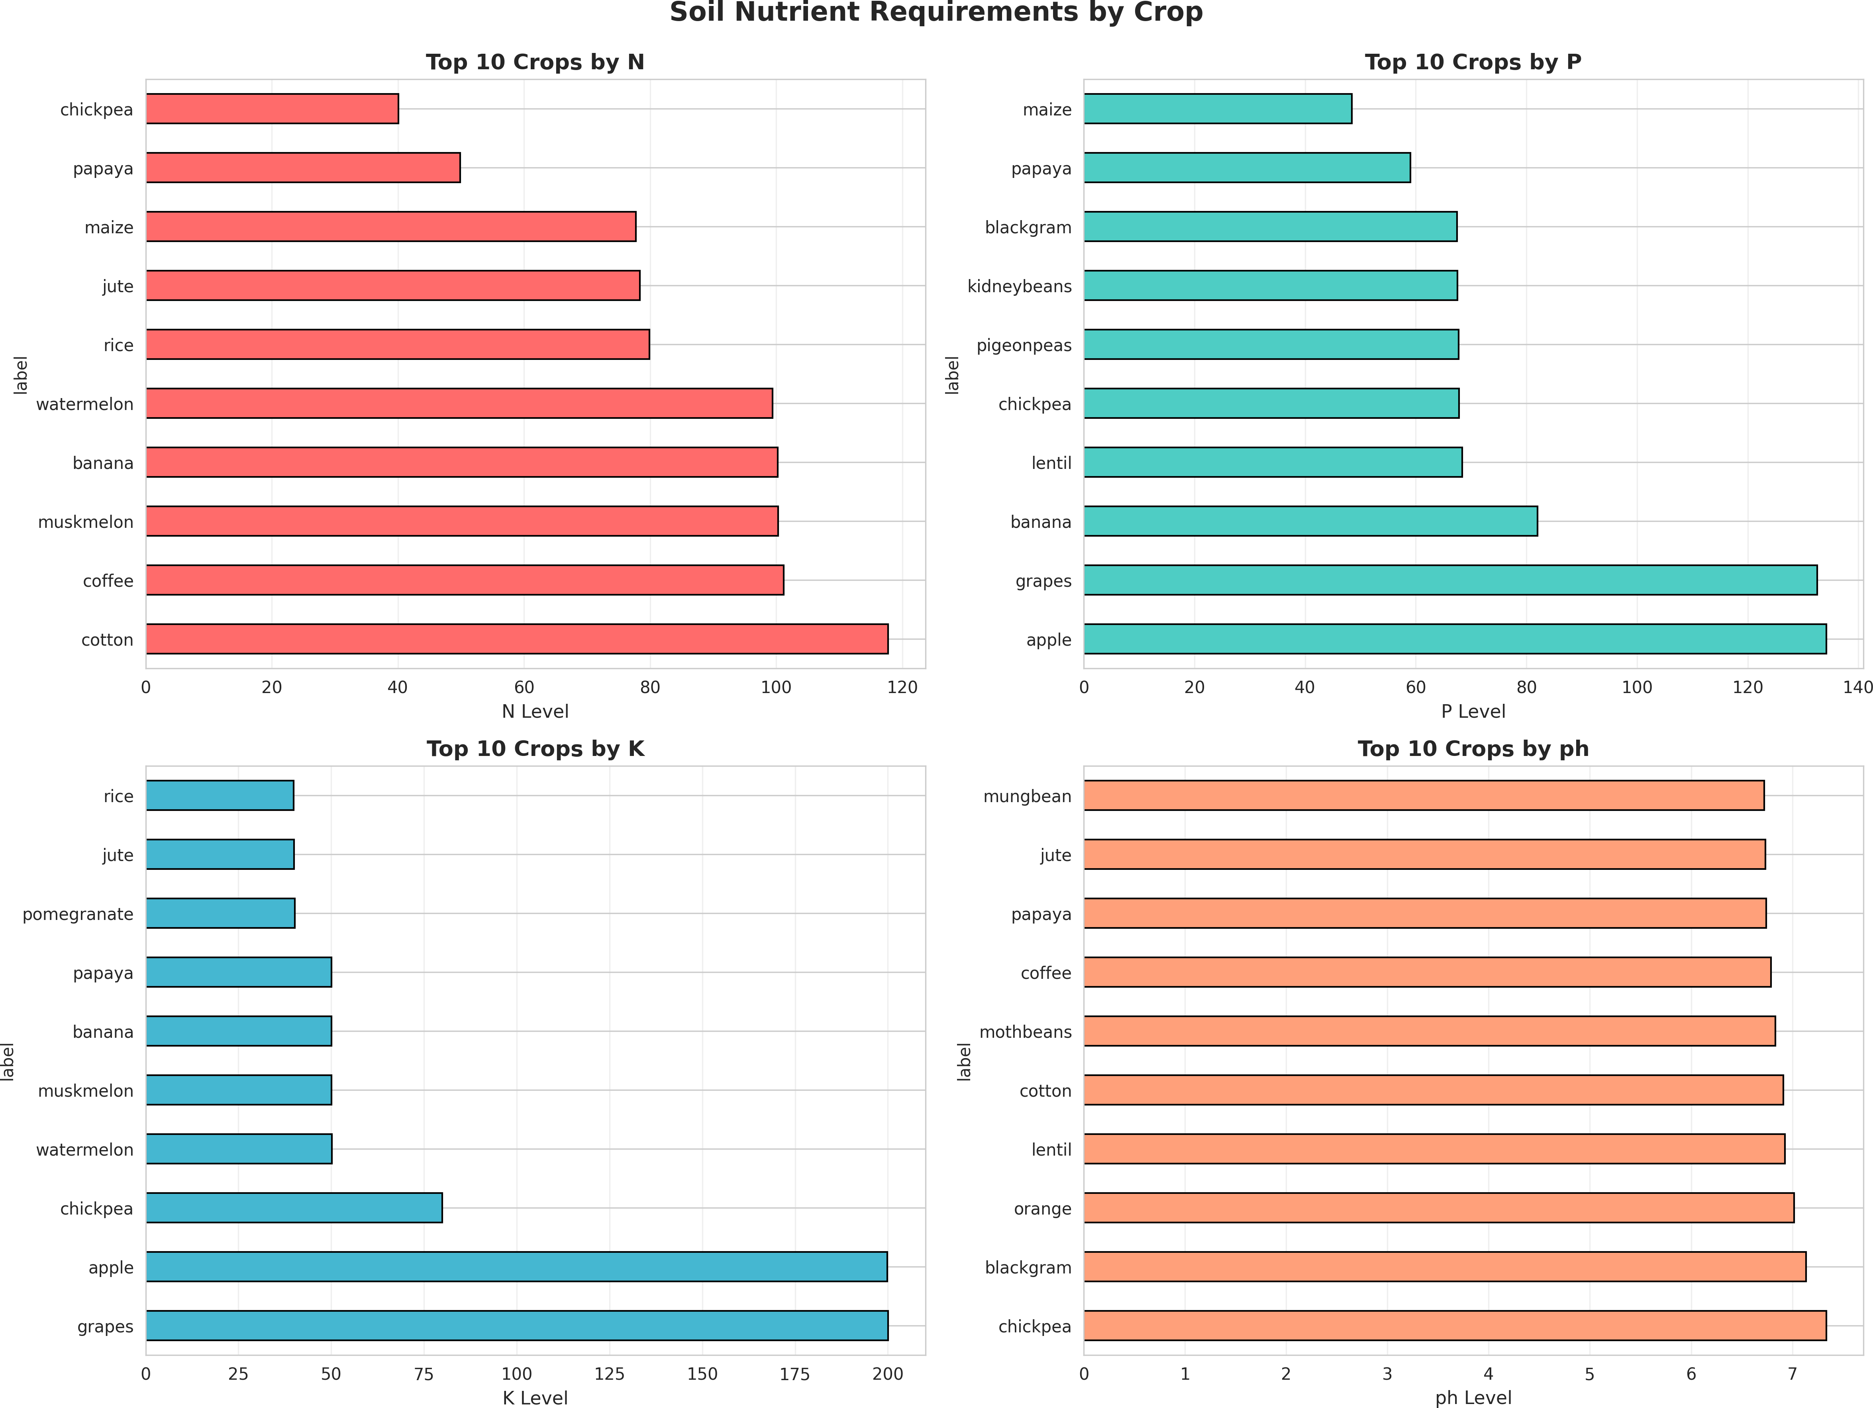

Fig. 4. Soil Nutrient Requirements by Crop Type showing top 10 crops ranked by individual nutrient demands (N, P, K) and pH preferences
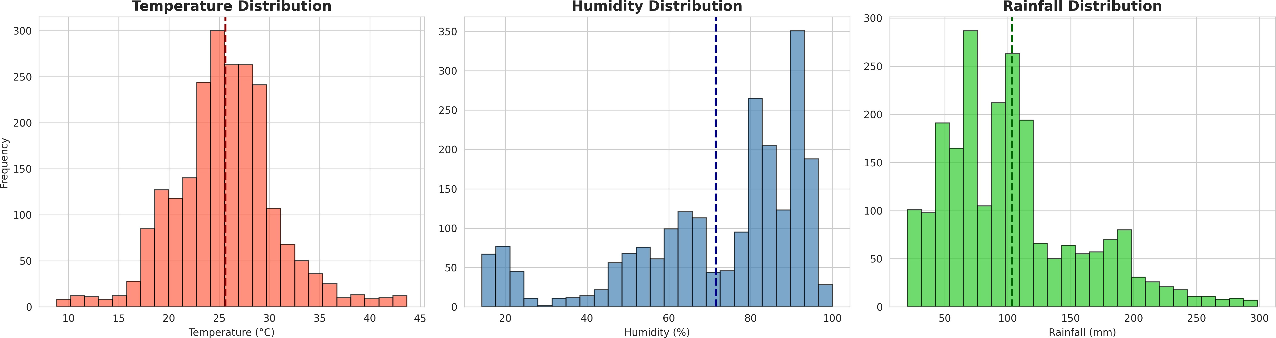

Fig. 5. Climate Parameter Distributions showing temperature, humidity, and rainfall across 2,200 samples with marked means. Data represents diverse agro-climatic zones

as many Indian regions experience monsoonal concentration rather than year-round precipitation.
- Fine-Tuning Procedure and Training Dynamics
Our fine-tuning approach optimizes for both computational efficiency and knowledge transfer. The LoRA technique con- strains adaptation to low-rank updates, reducing trainable pa- rameters from 1.1 billion to merely 4.5 million. This reduction decreases memory requirements by 99.6 percent and enables efficient training on consumer-grade hardware.
Training dynamics demonstrate successful knowledge trans- fer. Initial loss of 1.593 declined steadily, achieving final loss of 0.3332 after 150 training steps, representing a 79 percent reduction. Loss stabilized after step 100, indicating saturation of learning capacity within the LoRA parameter budget.
- Experimental Results
- Model Performance Metrics
Our fine-tuned model demonstrates strong learning curves and convergence characteristics:
  - Initial Training Loss: 1.593 (at step 0)
  - Loss After 50 Steps: 0.842 (47 percent reduction)
  - Loss After 100 Steps: 0.412 (74 percent reduction)
  - Final Training Loss: 0.333 (79 percent reduction)
  - Training Convergence: Stable after step 100
TABLE II
Detailed Training Hyperparameters and Configuration

Parameter | Value
Base Model | TinyLlama-1.1B-Chat-v1.0
Total Parameters | 1,100,000,000
LoRA Rank (r) | 16
LoRA Alpha | 16
Target Modules | q proj, k proj, v proj, o proj
Quantization Method | 4-bit NF4
Per-Device Batch Size | 2
Gradient Accumulation Steps | 4
Effective Batch Size | 8
Learning Rate | 2e-4
Training Epochs | 1
Optimizer | paged adamw 8bit
Weight Decay | 0.01
Learning Rate Scheduler | linear
Max Sequence Length | 1024 tokens
Trainable Parameters | 4,505,600
Trainable Percentage | 0.73 pct
Training Time | 150 minutes
GPU Memory Used | 14 GB

  - Computational Efficiency: 0.73 percent trainable param- eters
  - Training Duration: 2.5 hours on dual GPU T4 (Kaggle)
  - Inference Latency (Local): 8-12 seconds per response
  - Inference Latency (Cloud): less than 1 second per response
- Qualitative Model Outputs
Table III presents representative system outputs for three geographically diverse Indian locations, demonstrating con- textual awareness and agronomic accuracy:

TABLE III
Sample Chatbot Responses Across Indian Regions

City | Conditions | Recommendation
Delhi | 4.6 C, 53 pct hu-  midity, Sunny | Recommended coconut cultivation empha-  sizing soil pH management (7.46). High- lighted organic mulching for moisture re- tention and nutrient cycling. Suggested integrated pest management for tropical adaptation.
Mumbai | 24.3 C, 54 pct hu-  midity, Overcast | Recommended blackgram (mung bean)  cultivation leveraging optimal temperature range. Advised drip irrigation system for water efficiency given monsoon variability. Emphasized nitrogen management through legume residue incorporation.
Bangalore | 20.2 C, 88 pct hu-  midity, Mist | Recommended coffee cultivation high-  lighting suitability for high-humidity envi- ronments with orographic mist. Specified pH range 6.3-6.5. Discussed shade tree management for microclimate optimiza- tion.

These outputs demonstrate several desirable characteristics:
(1) Context Integration incorporating real-time weather into recommendations; (2) Technical Precision citing specific nu- trient values and pH ranges; (3) Practical Actionability pro- viding implementable strategies rather than abstract guidance;

(4) Climate Adaptation addressing region-specific challenges like monsoon variability.
- Inference Mode Comparison
Table IV contrasts the two deployment strategies:

TABLE IV
Local vs. Cloud Inference Characteristics

Characteristic | Local Model | Cloud API
Response Time | 8-12 seconds | less than 1 second
Model Capacity | 1.1 billion params | 8 billion params
Context Window | 1024 tokens | 8192 tokens
Domain Specialization | High (fine-tuned) | Moderate (general)
Offline Capability | Yes | No
Deployment Cost | Minimal | API subscription
Privacy | Full | Depends on provider
Reasoning Complexity | Limited | Advanced

The local model excels for deployment to offline-capable mobile applications, privacy-sensitive scenarios, and resource- constrained environments. The cloud API provides superior reasoning for complex multi-crop queries and supports thou- sands of concurrent users.
- Discussion
- System Strengths and Impact
This work demonstrates several significant achievements. First, we achieved domain specialization through fine-tuning with 79 percent loss reduction while maintaining 99.6 percent parameter efficiency. This suggests that LoRA-style adapta- tion provides an effective path toward democratizing domain- specific AI without requiring massive computational resources. Second, real-time weather integration enables context-aware recommendations fundamentally superior to static recommen- dation systems. Farmers receive advice tailored to current
conditions rather than historical patterns.
Third, the dual inference strategy balances accessibility (local) with capability (cloud), enabling deployment across diverse contexts from rural offline scenarios to urban online portals.
Most importantly, initial qualitative evaluation suggests the system generates agronomically sound, actionable recom- mendations. Recommendations appropriately reference crop- specific nutrient requirements, match crops to regional climate patterns, and provide practical implementation guidance.
- Limitations and Future Improvements
Several limitations merit acknowledgment. First, our evalu- ation remains qualitative, lacking rigorous quantitative metrics such as agronomic correctness scoring, farmer satisfaction surveys, or yield impact studies. Second, training data focuses exclusively on Indian crops, limiting immediate applicability to global contexts. Third, the system relies on historical crop- weather-soil relationships without capturing emerging climate patterns or novel adaptation strategies. Fourth, current imple- mentation remains English-only, limiting accessibility for the majority of Indian farmers.
Addressing these limitations represents important future work:
  - Quantitative Evaluation: Develop expert evaluation frameworks and conduct farmer field trials
  - Multilingual Adaptation: Fine-tune models for Hindi, Bengali, Tamil, Telugu covering 80 percent of Indian farmers
  - Real-Time Soil Data: Integrate IoT soil sensors for real- time N-P-K and pH measurement
  - Extended Knowledge: Expand to pest/disease identifi- cation, irrigation scheduling, market price integration
  - Larger Models: Evaluate Llama-3-8B or Mistral-7B for enhanced reasoning
  - Reinforcement Learning: Implement feedback-driven continuous improvement from farmer interactions

- Ethical Considerations and Responsible AI
Agricultural recommendations directly impact farmer liveli- hoods. We emphasize that system outputs should be treated as decision-support rather than authoritative guidance, with human agricultural experts maintaining oversight. Data privacy requires protection of farmer location and query data. The digital divide remains a practical concern, as rural internet penetration, device affordability, and digital literacy limit immediate accessibility for vulnerable populations.

- Conclusion
This paper demonstrates the feasibility and value of inte- grating Large Language Models with real-time environmental data for climate-resilient agriculture. Our fine-tuned chat- bot successfully generates contextually aware, agronomically sound crop recommendations while maintaining extreme com- putational efficiency through modern adaptation techniques. The system addresses a critical information gap in global agriculture, providing scalable access to expert knowledge for resource-constrained farming communities.
The convergence of AI capability, agricultural need, and computational efficiency creates unprecedented opportunity. By continuing this line of research—extending to multilingual support, IoT integration, and field validation—we can catalyze a transformation toward data-driven, climate-resilient agricul- ture that enhances both farm-level sustainability and global food security.

Acknowledgments
We gratefully acknowledge Kaggle for providing GPU computational resources, Free Weather API for meteorological data access, Groq for cloud inference capabilities, the open- source community for model weights and datasets, and K.R Mangalam University for institutional support. This work builds on decades of agricultural research and the vision of researchers worldwide working to align AI capabilities with development needs.

References
- A. Ingle, “Crop Recommendation Dataset,” Kaggle, 2023. [Online]. Available: https://www.kaggle.com/datasets/atharvaingle/crop- recommendation-dataset
- Free Weather API, “WeatherAPI.com Documentation,” 2024. [Online].
Available: https://www.weatherapi.com/
- TinyLlama Team, “TinyLlama-1.1B-Chat-v1.0,” HuggingFace, 2023. [Online]. Available: https://huggingface.co/TinyLlama/TinyLlama-1.1B-
Chat-v1.0
- Groq, Inc., “Groq API Documentation,” 2024. [Online]. Available: https://groq.com/
- Smith, J., et al., “Machine learning approaches for predicting maize yield in sub-Saharan Africa,” Comput. Agric., vol. 45, no. 3, pp. 123- 135, 2023.
- Johnson, K. and Brown, L., “Deep learning for automated crop disease detection: a comprehensive review,” IEEE Access, vol. 10, pp. 45678- 45690, 2022.
- Chen, M., et al., “Precision agriculture with AI: resource optimization frameworks for sustainable farming,” IEEE Internet Things J., vol. 8, no. 12, pp. 9876-9889, 2021.
- Patel, R. and Kumar, S., “Conversational AI for agricultural advisory: design patterns and practical implementation,” in Proc. IEEE Int. Conf. AI Appl., 2024, pp. 234-242.
- Williams, A. and Taylor, B., “Efficient fine-tuning of large language models for domain adaptation,” IEEE Trans. Knowl. Data Eng., vol. 35, no. 6, pp. 2345-2358, 2023.
- Martinez, D., et al., “Climate information services and agricultural decision-making: evidence from India,” IEEE Trans. Sustain. Comput., vol. 7, no. 4, pp. 567-579, 2022.
- Anderson, T. and Lee, G., “Crop diversification under climate uncer- tainty: modeling frameworks and farmer preferences,” IEEE Geosci. Remote Sens. Lett., vol. 19, pp. 1-5, 2022.
- Nguyen, H., et al., “Information access barriers in smallholder agricul- ture: a systematic review,” IEEE Trans. Technol. Soc., vol. 13, no. 2, pp. 189-201, 2022.

