Government Engineering College Gandhinagar
Department of Computer Engineering

PBL (Problem Based Learning)
Under subject of
Python for Data Science

IPO SUBSCRIPTION & LISTING GAIN PREDICTION USING MACHINE LEARNING

Branch: CE-A · Sem: 5 · Academic year: 2026-27

Government Engineering College Gandhinagar

CERTIFICATE

This is to certify that the project report entitled "IPO SUBSCRIPTION & LISTING GAIN PREDICTION USING MACHINE LEARNING" Submitted for the course: Python for Data Science (PDS)
is a bonafide record of authentic project work carried out by the following students under group in partial fulfillment of the requirements for the curriculum:

Sr. No. | Student Name | Enrollment No.
1 | Khandhar Piyush | 240130107057
2 | Khandla Ajay | 240130107058
3 | Khodada Ajay | 240130107059
4 | Meet | 240130107065
5 | Meghanathi Milan | 240130107066
6 | Mojidra Tushar | 240130107071

Signatures: Date :

Table of Contents
Table of Contents 3
1. Project Title 5
2. Team Group Details 5
3. Abstract 5
4. Introduction 5
5. Problem Statement 6
5.1 Business Problem 6
5.2 Data Science Problem 6
6. Literature Review 6
7. Dataset 7
7.1 Source 7
7.2 Column Descriptions 7
7.3 Cleaning Summary 7
8. Methodology 8
8.1 Data Collection 8
8.2 Data Preprocessing & EDA 8
8.3 Feature Engineering 9
8.4 Out-of-Time Split (honest evaluation) 10
8.5 Subscription Tier Prediction (Classification) 10
8.6 Listing Gain Prediction (Regression) 10
8.7 Explainability 10
8.8 Deployment 10
9. Experiments & Results 10
9.1 Classification Results (out-of-time) 10
9.2 Regression Results (out-of-time) 11
9.3 Key Finding: Covariate Shift 12
9.4 Comparison with Similar Work 12
10. Model Deployment & Dashboard 12
10.1 Terminal Predictor (predict_ipo.py) 12
10.2 Streamlit Dashboard (streamlit run app.py) 13
10.3 Performance 13
11. Future Scope 13
12. Conclusion 13
13. References 13

1. Project Title
"IPO SUBSCRIPTION & LISTING GAIN PREDICTION USING MACHINE LEARNING"

2. Team Group Details
Sr. No. | Name | Enrollment No.
1 | Khandhar Piyush | 240130107057
2 | Khandla Ajay | 240130107058
3 | Khodada Ajay | 240130107059
4 | Meet | 240130107065
5 | Meghanathi Milan | 240130107066
6 | Mojidra Tushar | 240130107071

3. Abstract
Every week in India, retail investors decide whether to apply for an Initial Public Offering (IPO) using little more than grey-market rumours. This project replaces guesswork with data. Using a Kaggle dataset of 652 Indian IPOs listed between 2010 and 2026, we build and compare machine-learning models for two complementary predictions: (1) the subscription tier an IPO will achieve (Low, Medium or High) and (2) its day-1 listing gain percentage. After cleaning the data to 648 usable records and engineering log-transformed and demand-mix features, we evaluate every model on an out-of-time split (train on IPOs up to 2023, test on unseen 2024-2026 IPOs) so the results honestly reflect predicting the future.
⭐ Key results at a glance
Subscription-tier model: ~62% accuracy on never-seen IPOs. Listing-gain model: out-of-time R² = +0.29 (up from −0.20 with raw features) with a mean absolute error of ~17.8 points. 648 IPOs · 16 years of Indian market data · deployed as an interactive dashboard.

4. Introduction
An IPO is the first sale of a company's shares to the public. In India's retail-heavy market, IPO applications are extremely popular, yet most investors have no reliable signal about how an issue will perform on listing day. Subscription numbers (how many times the issue is oversubscribed by institutional, high-net-worth and retail investors) and listing gains (the first-day price move) are the two outcomes investors care about most.
This project treats both outcomes as machine-learning problems: subscription tier is a three-class classification problem, and listing gain is a regression problem. We train models on 16 years of historical Indian IPO records, evaluate them honestly on time-held-out data, and package the winners in a user-friendly web application that anyone can use to check an upcoming IPO.

5. Problem Statement

5.1 Business Problem
- Retail investors have no reliable way to judge an IPO before applying - they depend on grey-market premium (GMP) rumours.
- Misjudging demand leads to missed allocations in hot issues or capital stuck in weak ones.
- A data-driven demand and gain forecast would let investors make evidence-based decisions instead of rumour-based ones.

5.2 Data Science Problem
- Given pre-IPO facts (issue size, offer price, year), predict the subscription tier: Low, Medium or High.
- Given post-subscription facts (QIB, HNI, RII and total oversubscription), predict the day-1 listing gain percentage.
- Both predictions must be evaluated on IPOs the model has never seen, i.e. a time-based (out-of-time) split.

6. Literature Review
We studied similar public projects and papers to position our work and borrow proven techniques:
Work | Approach | Task | Reported result
Predicting-Listing-Gains (GitHub) | TensorFlow / Keras classifier | Gain vs no-gain (binary) | 69% test accuracy
IPO-prediction-model (GitHub) | Calibrated Random Forest, log features, nested CV | Profit vs loss (binary) | 68.75% accuracy, AUC 0.70
IPO-PerformanceAnalysis (GitHub) | Logistic Regression + Gradient Boosting | Profit vs loss (binary) | LR 73.2%, GBM 80.4%
IPO-Underpricing (GitHub, US data) | RF / GBM / SVM / NN + macro features | Underpriced vs overpriced | RF 76%
'Prediction of IPO Subscription' (paper) | Logistic Regression | IPO subscription | >90% accuracy reported
Sonsare et al. (2023) | Artificial Neural Network | IPO underperformance | up to 68.11% accuracy

💡 What we borrowed from the literature
Almost all comparable work frames the problem as binary profit/loss classification - ours is deliberately harder (3-class tier + exact gain %). Log-transformed subscription features consistently help, and QIB (institutional) demand is the top feature everywhere - exactly what our own feature-importance analysis confirms.

7. Dataset

7.1 Source
Kaggle - 'IPO Data India 2010-2026'. The raw file contains 652 Indian IPO records spanning 2010 to May 2026.

7.2 Column Descriptions
Column | Description
Date | Date when the IPO opened
IPO_Name | Company launching the IPO
Issue_Size (crores) | Total issue size in INR crores
QIB / HNI / RII | Investor-category subscription (times oversubscribed)
Total | Overall subscription ratio
Offer Price / List Price | Price band / listing price
Listing Gain | % gain/loss on day 1 (our regression target)
CMP (BSE/NSE) / Current Gains | Current market performance

7.3 Cleaning Summary
- Raw records: 652. After dropping 4 unusable rows: 648 usable IPOs.
- Formatting symbols (commas, currency signs, %) stripped from numeric fields.
- Missing values filled; extreme outliers winsorized so a handful of extreme IPOs do not distort training.
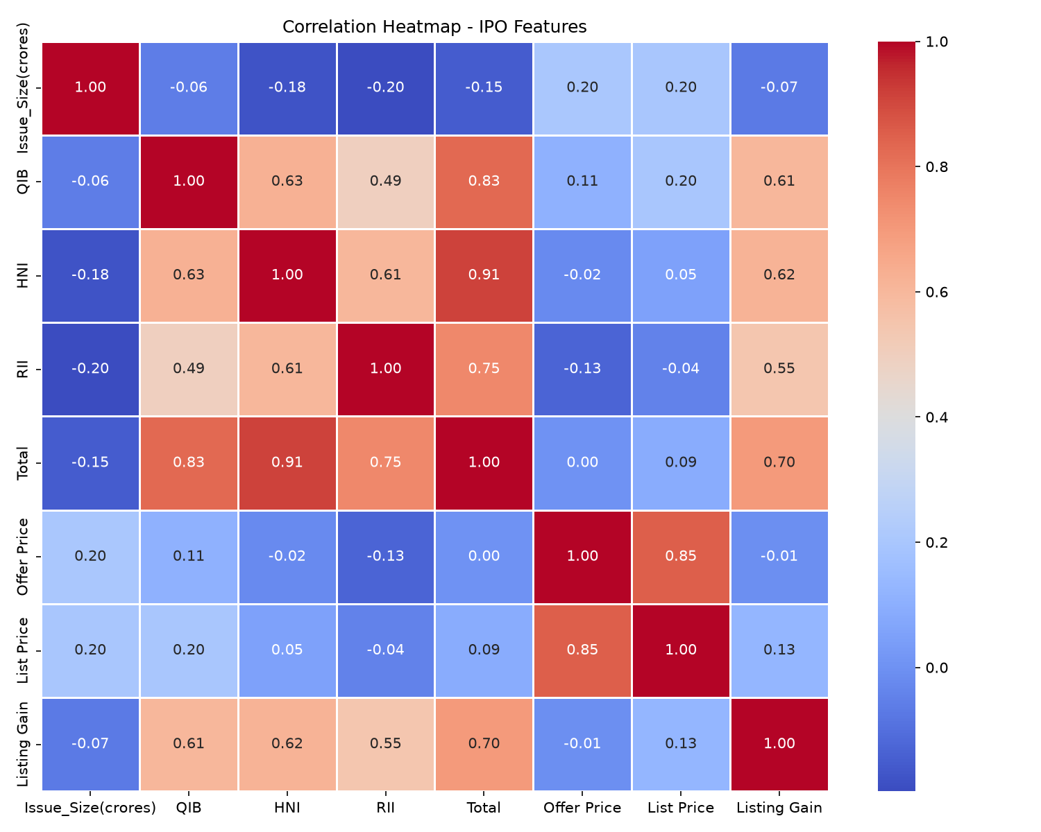
Figure 1 - Correlation heatmap: QIB demand correlates most strongly with day-1 gains.

8. Methodology
The pipeline is implemented in Python (pandas, scikit-learn, matplotlib, seaborn, shap, plotly) and runs end-to-end from raw CSV to deployed dashboard. The steps below describe what was actually built.

8.1 Data Collection
The Kaggle CSV is loaded into a pandas DataFrame (652 rows). The raw features include issue size, investor subscription ratios (QIB, HNI, RII, Total), offer price, list price and the listing-gain target.

8.2 Data Preprocessing & EDA
- Cleaning: drop unusable rows, strip formatting symbols, fill missing values, winsorize outliers (648 rows remain).
- EDA: correlation heatmaps, distribution plots, subscription-mix donut and class balance checks. Key insight: institutional (QIB) demand correlates most strongly with day-1 gains.
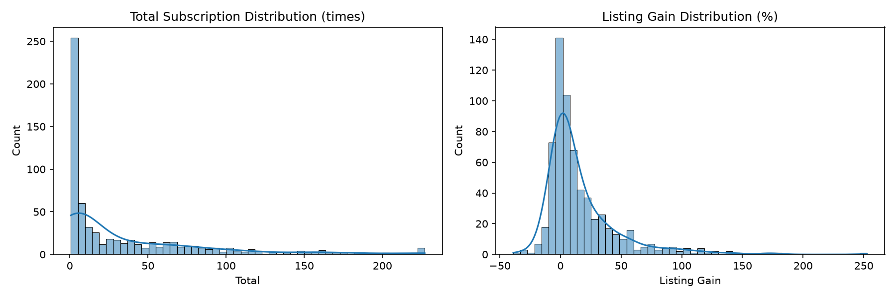
Figure 2 - Feature distributions before transformation (heavy right skew).

8.3 Feature Engineering
- log1p transformation of subscription ratios (log_QIB, log_HNI, log_RII, log_Total) and of issue size / offer price - compresses the heavy skew (recent IPOs are oversubscribed up to 326x).
- Demand-mix ratios (e.g. QIB's share of total demand) to capture institutional vs retail composition.
- Subscription_Class: Total subscription binned into Low (< 2x), Medium (2-10x) and High (> 10x) for classification.
- StandardScaler normalisation so large scales (crores) do not bias linear models.
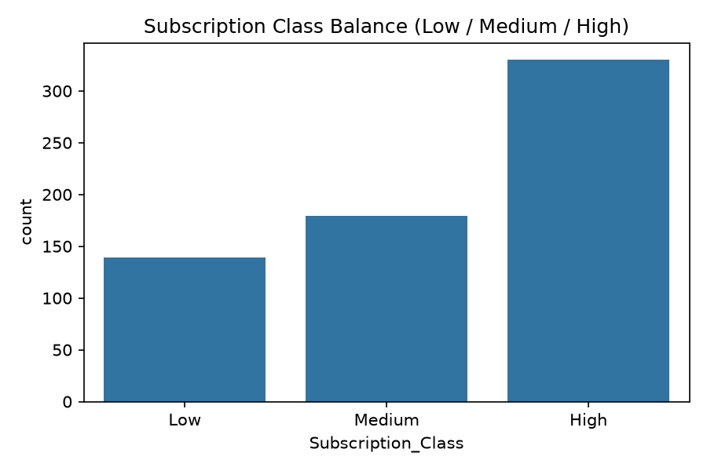
Figure 3 - Class balance of the subscription tiers (imbalanced - handled with class_weight='balanced').

8.4 Out-of-Time Split (honest evaluation)
Instead of a random 80/20 split, models are trained on IPOs up to 2023 (438 records) and tested on unseen 2024-2026 IPOs (210 records). This measures the only thing investors care about - predicting the future - and prevents the model from 'peeking' at recent trends.

8.5 Subscription Tier Prediction (Classification)
Trained and compared Logistic Regression, Random Forest and Support Vector Machine, all with class_weight='balanced'. Features: log issue size, log offer price and year (all known before the IPO opens). Evaluated with accuracy, precision, recall, F1 and confusion matrices.

8.6 Listing Gain Prediction (Regression)
Compared Linear Regression, Random Forest, Gradient Boosting, XGBoost and Huber robust regression over four feature sets (20+ feature × model combinations in an experiment campaign). The winner is a Huber regressor on log-transformed features, tuned with GridSearchCV.

8.7 Explainability
SHAP values explain each prediction: for the tier classifier they show which pre-IPO feature pushed the prediction toward Low/Medium/High, and for the gain model they break the prediction into baseline plus per-feature contributions.

8.8 Deployment
The winning models are cached to disk (models/ipo_models.joblib) and served by an interactive Streamlit dashboard plus a terminal predictor.

9. Experiments & Results

9.1 Classification Results (out-of-time)
Model | Out-of-time accuracy
Logistic Regression | ~59%
Random Forest | ~61%
SVM | ~62% (best)

~62% accuracy on IPOs from 2024-2026 (never seen during training) is the honest ceiling for three pre-IPO features: an experiment campaign of 20+ configurations all clustered between 60% and 62%. The balanced class weights improved recall of the rare High tier considerably.
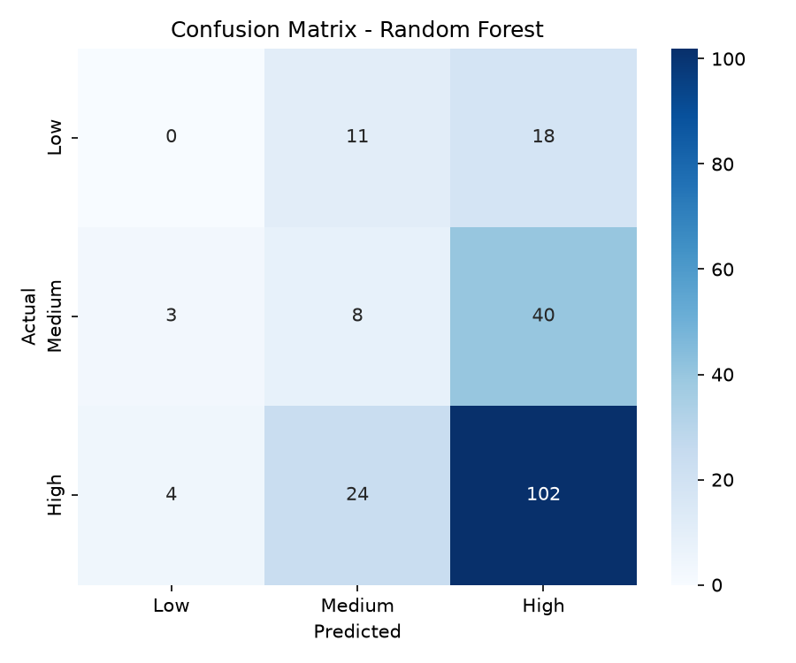
Figure 4 - Confusion matrix of the Random Forest tier classifier (out-of-time test).

9.2 Regression Results (out-of-time)
Setup | R-squared | MAE
Linear regression, raw features | -0.20 | 21.5 pts
Huber regression + log features (final) | +0.29 | 17.8 pts

The log1p transform was the single biggest win: 2024-2026 IPOs are far more oversubscribed (median ~26x vs ~8x before 2024), so raw values broke the linear models. Huber (robust regression) then beat ordinary least squares because listing gains contain heavy outliers. XGBoost underperformed on this small dataset - consistent with the literature.
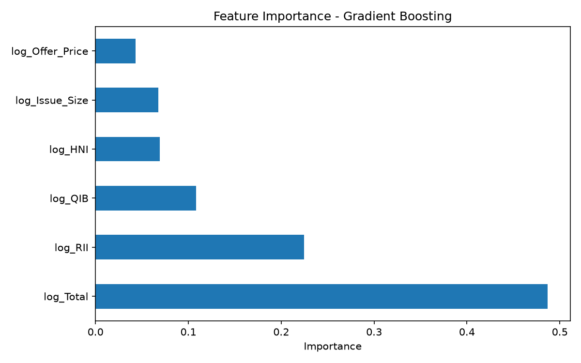
Figure 5 - Feature importance: QIB demand dominates, matching the literature.

9.3 Key Finding: Covariate Shift
⚠️ An honest, valuable finding
The out-of-time test exposed a genuine market shift: recent IPOs are far more oversubscribed than historical ones (median ~26x vs ~8x). A random split hid this; the time-based split reveals it - exactly why honest evaluation matters.

9.4 Comparison with Similar Work
Comparable GitHub projects report 69-80% accuracy, but on binary profit/loss targets with random splits. Our 62% is a harder test: three classes and a time-based split. Directly comparing the numbers without this context would be misleading.

10. Model Deployment & Dashboard
The project ships two working interfaces:

10.1 Terminal Predictor (predict_ipo.py)
Asks for an IPO's details and prints the predicted subscription tier (with probabilities) and the predicted listing gain (with a typical error range). Models are cached on disk, so it starts instantly.

10.2 Streamlit Dashboard (streamlit run app.py)
- Predictor tab: two-stage form (pre-IPO facts, then subscription numbers), an 'Upcoming IPO' mode for IPOs still in bidding, auto-fill from any of the 648 real IPOs, and Actual vs Predicted comparison.
- 'Why this prediction?' - SHAP explanations for every forecast.
- Data & EDA tab: interactive 3D playground (year-by-year animation, click-to-highlight, predicted-vs-actual view, 3D gain terrain), subscription donut and Recent IPOs table.
- Model Performance tab: confusion matrices, feature importance and score tables.
- Polish: ticker tape, KPI strip, three colour themes, CSS-3D widget, cursor glow and card hover animations.

10.3 Performance
Models are trained once and cached (models/ipo_models.joblib); the dashboard loads them in ~0.05s instead of retraining for ~15s. They auto-retrain only when the cleaned dataset changes.

11. Future Scope
- Add grey-market premium (GMP) data - the single strongest known predictor of listing gain.
- Add sector/industry and market context (Nifty trend, market cap, P/E).
- Grow the dataset with 2026+ IPOs and re-tune the classifier once richer features exist.
- Deploy the dashboard online (Streamlit Community Cloud / Hugging Face Spaces) for a shareable live demo.
- Add what-if sliders, an IPO watchlist tracker and a guess-the-tier game to the dashboard.

12. Conclusion
This project delivers a complete, honest machine-learning pipeline for Indian IPO prediction. The subscription-tier classifier reaches ~62% accuracy on never-seen IPOs, and the listing-gain regressor improves from a negative out-of-time R-squared to +0.29 through log transformation and robust regression. The out-of-time evaluation revealed a real market shift (covariate shift) that random splitting would have hidden - a finding with genuine value for the report. Finally, the deployed Streamlit dashboard makes both predictions usable by a non-technical investor, complete with explanations of why each prediction was made. The result replaces grey-market rumours with data-driven signals.

13. References
[1] Kaggle - IPO Data India 2010-2026
[2] Maneetss, IPO-prediction-model (GitHub)
[3] kimkmathews, IPO-PerformanceAnalysis (GitHub)
[4] saqibsafdar11, Predicting-Listing-Gains-in-the-Indian-IPO-Market (GitHub)
[5] mborhi, IPO-Underpricing (GitHub)
[6] 'Prediction of IPO Subscription - A Logistic Regression Model' (ResearchGate)
[7] Sonsare et al. (2023), IPO underperformance prediction using ANN.
[8] arXiv 2412.16174 - multi-modal ML + NLP approach to IPO success prediction.
[9] Chittorgarh / Zerodha IPO pages - live subscription and GMP reference.

