Q.1 How are inline and block elements different from each other?

Ans . Block level elements takes up all available space while inline elements lies inside the block level elements.

For ex- Paragraph is a block line element and the span inside it is known as inline element.

Q.2 Explain the difference between visibility:hidden and display:none

Ans . display:none means the tag will not appear at all . No space allocated for it.

Visibility:hidden means that tag is not visible but space is allocated for it on the page.

Q.3.Explain the clear and float properties.

Ans. The CSS float property specifies how an element should float.

The CSS clear property specifies what elements can float beside the cleared element and on which side.

Q.4 explain difference between absolute, relative,fixed and static.

Ans. A) HTML elements are positioned static by default.

Static positioned elements are not affected by the top, bottom, left, and right properties.

An element with position:static; is not positioned in any special way; it is always positioned according to the normal flow of the page:

This <div> element has position: static;

B) An element with position : relative ; is positioned relative to its normal position.

Setting the top, right, bottom, and left properties of a relatively-positioned element will cause it to be adjusted away from its normal position. Other content will not be adjusted to fit into any gap left by the element.

This <div> element has position: relative;

C) An element with position : fixed ; positioned relative to the viewport, which means it always stays in the same place even if the page is scrolled. The top, right, bottom, and left properties are used to position the element.

A fixed element does not leave a gap in the page where it would normally have been located.

D) An element with position : absolute ; positioned relative to the nearest positioned ancestor (instead of positioned relative to the viewport, like fixed).

However; if an absolute positioned element has no positioned ancestors, it uses the document body, and moves along with page scrolling.

Q.5 Write the HTML code to create a table in which there are 4 columns( ID , Employee Name, Designation, Department) and at least 6 rows. Also do some styling to it.

Ans.

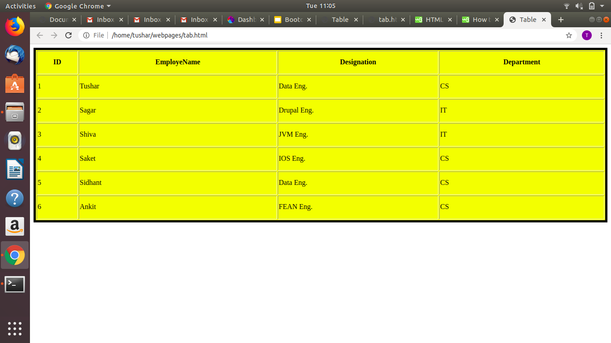

Q.6 Why do we use meta tags?

Ans. Metadata is data (information) about data.The <meta> tag provides metadata about the HTML document. Metadata will not be displayed on the page, but will be machine parsable.Meta elements are typically used to specify page description, keywords, author of the document, last modified, and other metadata.The metadata can be used by browsers (how to display content or reload page), search engines (keywords), or other web services.HTML5 introduced a method to let web designers take control over the viewport (the user's visible area of a web page), through the <meta> tag (See "Setting The Viewport" example below).

Q.7 Explain box model.

Ans. All HTML elements can be considered as boxes. In CSS, the term "box model" is used when talking about design and layout.

The CSS box model is essentially a box that wraps around every HTML element. It consists of: margins, borders, padding, and the actual content. The image below illustrates the box model:

Explanation of the different parts:

**· Content**- The content of the box, where text and images appear

**· Padding**- Clears an area around the content. The padding is transparent

**· Border**- A border that goes around the padding and content

**· Margin**- Clears an area outside the border. The margin is transparent

Q.8 What are the different types of CSS Selectors?

Ans.**There are several different types of selectors in CSS.**

**· CSS** Element **Selector**.

**· CSS** Id **Selector**.

**· CSS** Class **Selector**.

**· CSS** Universal **Selector**.

**· CSS** Group **Selector**.

Q.9 Define Doctype.

Ans. The <!DOCTYPE> declaration must be the very first thing in your HTML document, before the <html> tag.

The <!DOCTYPE> declaration is not an HTML tag; it is an instruction to the web browser about what version of HTML the page is written in.

In HTML 4.01, the <!DOCTYPE> declaration refers to a DTD, because HTML 4.01 was based on SGML. The DTD specifies the rules for the markup language, so that the browsers render the content correctly.

HTML5 is not based on SGML, and therefore does not require a reference to a DTD.

Q.10 Explain 5 HTML5 semantic tags.

Ans. Many web sites contain HTML code like: <div id="nav"> <div class="header"> <div id="footer">

to indicate navigation, header, and footer.

HTML5 offers new semantic elements to define different parts of a web page:

<article>

· <aside>

· <details>

· <figcaption>

· <figure>

· <footer>

· <header>

· <main>

· <mark>

· <nav>

· <section>

· <summary>

· <time>

Ans 11.

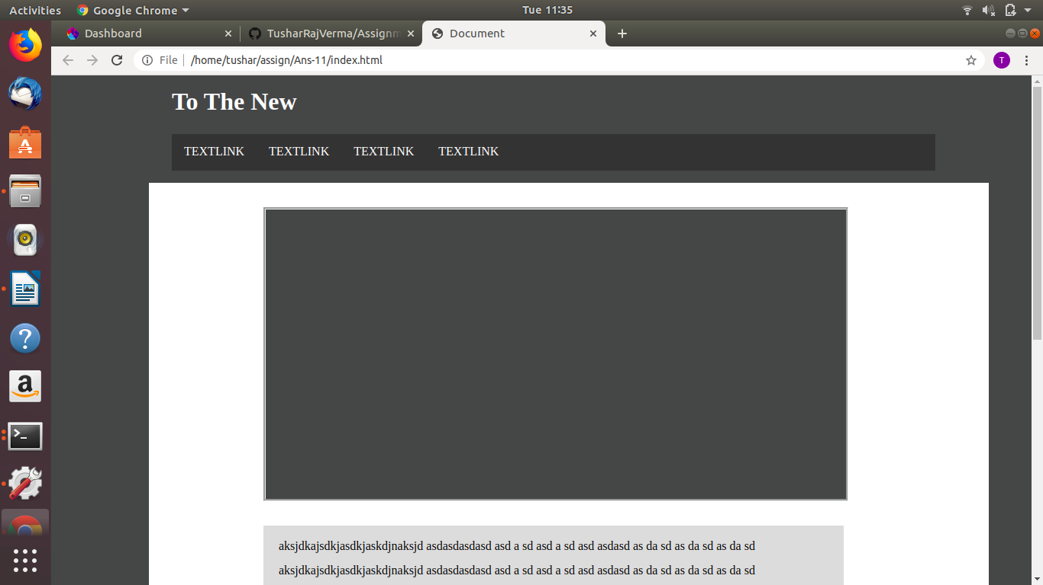

Ans 12.

