**UNDERTAKING**

We hereby declare that the work presented in this project titled, “Energy Audit for household”, by our team, “THE DEFENDERS”, submitted for IBM Hack Challenge is our original work. We have not plagiarized or submitted the same work for any other cause.

Date: July 20, 2019

Signature of Team Leader

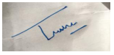

(Tushar Raj Verma)

(TEAM- The Defenders)