Summer Internship on
Web Development

Submitted By:
Tushar Saini

B. Tech CSE Section-4, 3nd Year

To
Ms. Neetu Mourya
Academic Year
2025-26



Department of Computer Science & Engineering
Quantum University, Roorkee

Certificate
This is to certify that the internship report titled “Web Development”, submitted by Mr. Tushar Saini, is the result of the work completed during the 2025–26 academic year. The internship was carried out through an online Udemy course on Web Development, undertaken as part of the Industry Internship Program for the Bachelor of Technology (B.Tech) degree in Computer Science and Engineering (CSE) at Quantum University, Roorkee

Student Details
Name: Tushar Saini
Program: B.Tech CSE, Section-4
Year: 3nd Year
Date: __________

Approved and Verified
(Ms. Neetu Mourya)

Table of Content

S.No. | Item | Page
1. | Introduction | 4
2. | Course Profile | 5
3. | Course Certificate | 6
4. | Project | 7
5. | Objective & Scope | 7
6. | Technology used | 8
7. | Project Database | 9
8. | Project Code | 10
9 | Project Image | 11
10. | Technical Challenges | 12
11. | Solutions and Learning Outcomes | 13
12. | Methodology | 14
13. | Future Enhancements | 15
14. | Conclusions | 16
15. | Acknowledgements | 17

Introduction
The internship program is an essential component of the Bachelor of Technology (B.Tech) curriculum at Quantum University, Roorkee, designed to integrate theoretical knowledge with practical industry exposure. This report documents the work undertaken by Mr. Tushar Saini during an 8-week internship on Web Development, conducted under the supervision of Ms. Neetu Mourya, Assistant Professor, Department of Computer Science and Engineering.
The internship was completed through an online professional training course by Mr. Hitesh Choudhary on Udemy, a globally recognized e-learning platform. The course provided in-depth learning of front-end and back-end web technologies, focusing on building dynamic and responsive web applications. It helped the intern understand the complete process of modern web development—from design and development to deployment.
As part of the internship, the student developed a project titled “Quick Post”, a responsive web application built using React.js and Firebase. The project focused on creating a real-time platform for posting, storing, and retrieving user-generated content efficiently. React.js was used for developing the interactive user interface, while Firebase handled backend services such as database, authentication, and hosting.
Through this internship, the student gained hands-on experience in modern web frameworks, cloud integration, and real-time application development. It improved coding skills, analytical thinking, and practical understanding of software development processes, building a strong foundation for future growth in Computer Science and Engineering.

Course Profile: Web Development Course
Course Provider: Udemy
Instructor: Mr. Hitesh Choudhary
Course Duration: 8 Weeks
Mode of Training: Online
About the Course
The Complete Web Development Course is a comprehensive program that teaches modern web development from basics to advanced levels. It covers frontend, backend, full-stack development, and AI integration, providing practical, hands-on experience through projects.
Skills and Technologies Learned
- Frontend: HTML, CSS, Tailwind CSS, JavaScript, React.js (component-based development, state management, API handling)
- Backend & Cloud: Node.js, Express, Firebase, Mongoose, Prisma, PostgreSQL, Authentication systems, API development
- Full-Stack Projects: Combining frontend and backend to build real-world applications
- Additional Skills: Responsive UI/UX design, cloud integration, debugging, Git version control, project deployment, and freelance-ready project development
- AI Integration: Introduction to AI-driven web apps using TensorFlow.js and LangChain
The course allowed the student to build projects like “Quick Post”, gaining hands-on experience in React.js and Firebase, and developing the skills necessary for professional web development.

Course Certificate
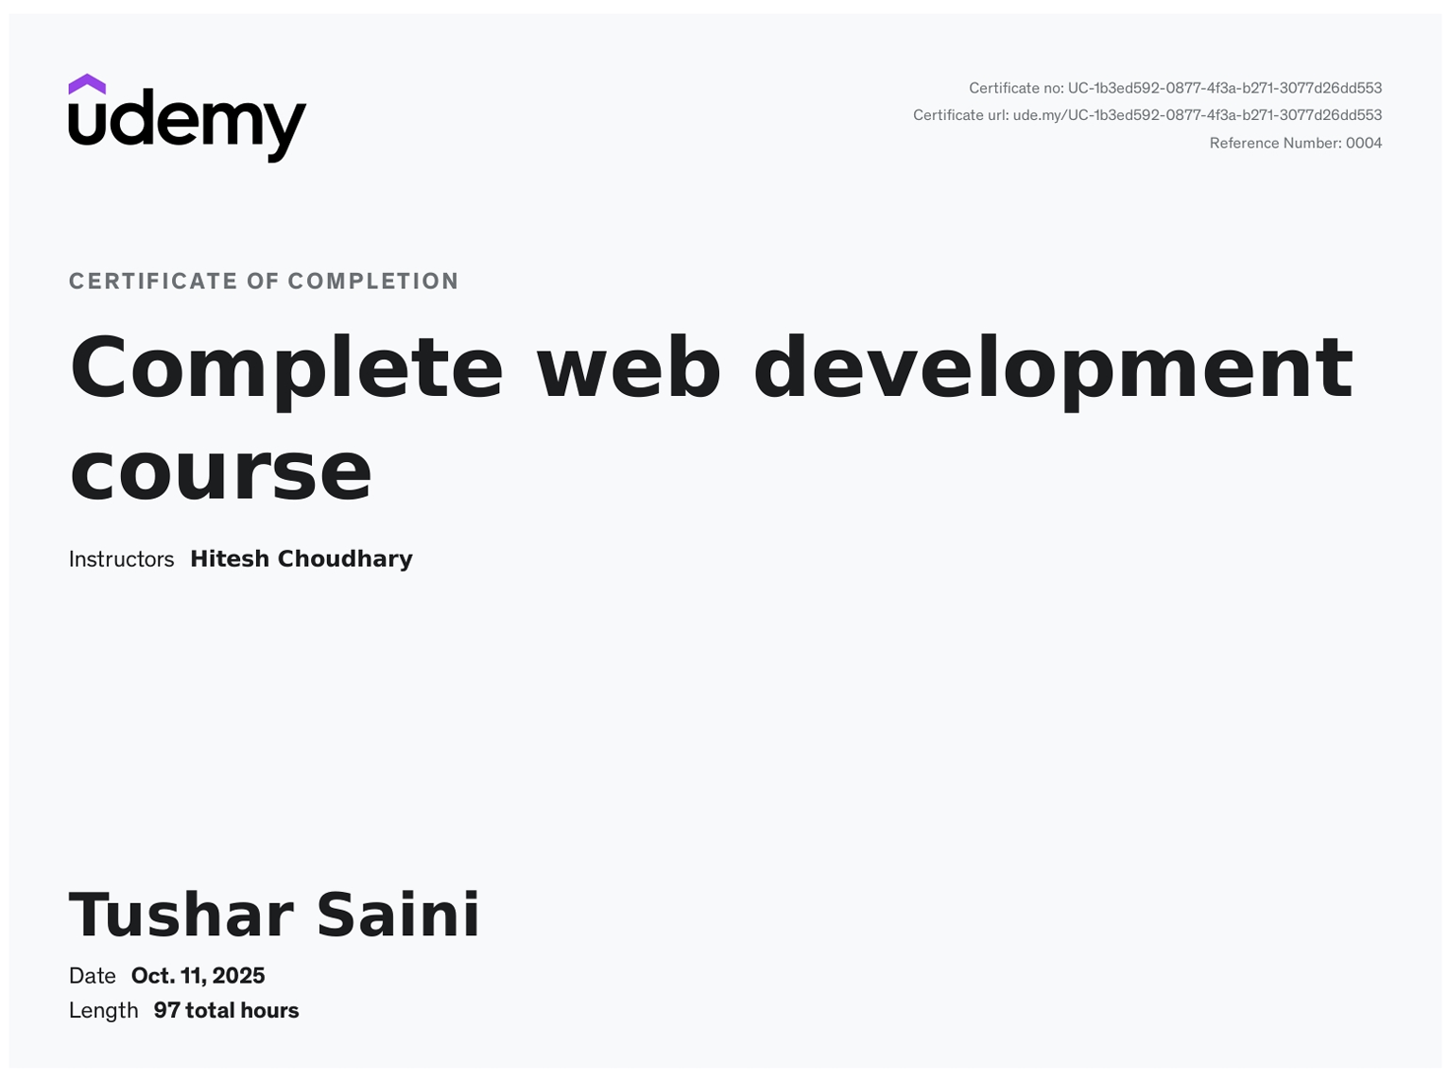

Quick Post Project
Quick Post is a web-based blogging platform developed to simplify the process of creating, editing, and publishing blog posts. It provides a clean and responsive interface where users can perform all operations—like creating, editing, or deleting posts—with a single click, handled automatically in the background for a smooth experience.
The platform uses React.js for the frontend, along with React Hook Form for form handling, Redux for state management, and TinyMCE for rich text editing. The backend is powered by Appwrite, a secure and scalable Backend-as-a-Service (BaaS) that manages authentication, databases, and file storage.
Objective
The main goal of this project is to build an easy-to-use blogging system where users can manage their content efficiently. The focus is on speed, usability, and integration of modern web technologies to create a seamless content management experience.
Scope
This project demonstrates a complete blogging workflow including:
- User authentication
- Blog post creation and editing
- Category and tag management
- One-click background operations
- Responsive UI for all devices

Technologies Used
Frontend Technologies
- React.js: Used for building the interactive and component-based user interface.
- React Hook Form: Simplifies form handling and validation with minimal re-rendering.
- Redux Toolkit: Manages global application state efficiently across components.
- TinyMCE Editor: Provides a rich text editor for creating and formatting blog posts.
- Tailwind CSS: Ensures a responsive and modern UI design with utility-first styling.
- React Toastify: Displays instant success or error notifications after operations.
Backend Technologies
- Appwrite (Backend-as-a-Service): Handles user authentication, database management, and file storage through secure REST APIs.
- Appwrite Cloud Functions: Used for background processing and post management automation.
- Node.js (Runtime Environment): Supports frontend build tools and integration scripts.
Database
- Appwrite Database Service:
  - Stores user profiles, posts, comments, and categories.
  - Supports real-time CRUD operations with automatic indexing.
Version Control & Deployment
- Git & GitHub: For source code management and version control.
- Vercel: For deploying the React frontend.
- Appwrite Cloud: Hosts and manages backend services, database, and storage.

Project Database
The database for the Quick Post project is structured to manage dynamic blogging content effectively. It includes three main collections:
- QuickPost.articles: Stores all blog posts created by users, including titles, content, feature images, author IDs, tags, visibility, status, short descriptions, and timestamps.
- QuickPost.contact: Handles messages submitted through the contact form, including the sender’s name, email, message, and timestamps.
- QuickPost.profile: Contains user profile information such as phone, date of birth, gender, website, bio, expertise, profile ID, user ID, location, profile image ID, and timestamps.

Key Features of the Database
- Dynamic Content Management: Supports creation, editing, and deletion of posts in real-time.
- Scalability: Appwrite manages the backend database and file storage efficiently.
- Security: Role-based access ensures that only authorized users can modify content.
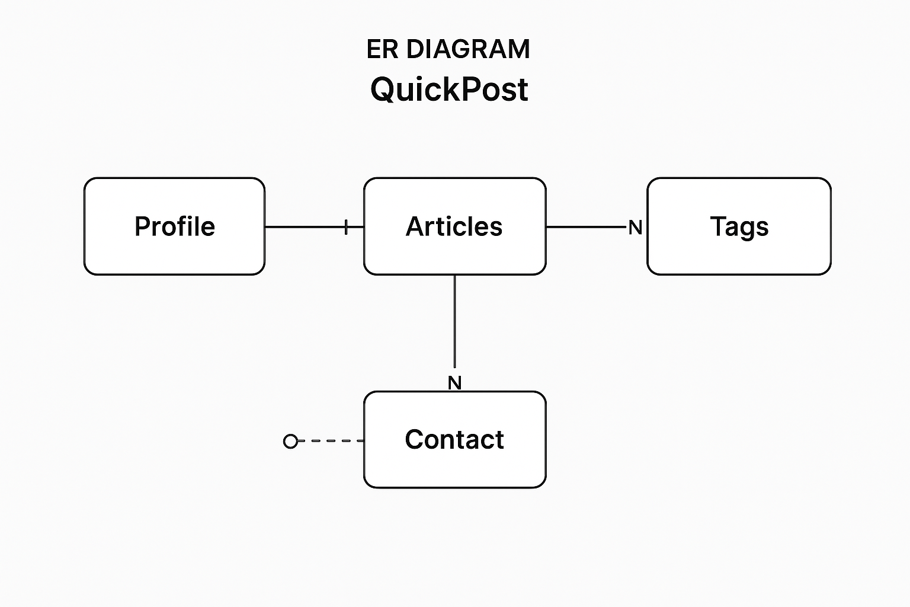
- Indexing: Appwrite automatically indexes collections for optimized query performance.

Project Code
The project code for Quick Post is designed to provide a dynamic and interactive blogging platform.
- Frontend: Built using React.js for a component-based architecture, ensuring a responsive and modern UI.
- State Management: Redux Toolkit is used for managing global application state across components efficiently.
- Form Handling: React Hook Form simplifies form validation and data submission for blog posts and user input.
- Rich Text Editing: TinyMCE Editor allows users to create and format blog content with images, links, and styles.
- Backend: Powered by Appwrite (Backend-as-a-Service), handling authentication, database operations, file storage, and server-side logic.
- Database: Appwrite Database securely stores user profiles, articles, and contact messages with structured collections.
- Notifications: React Toastify is integrated to provide instant feedback for user actions like create, edit, or delete.
The code follows a modular and scalable structure, ensuring maintainability and easy integration of new features in the future.
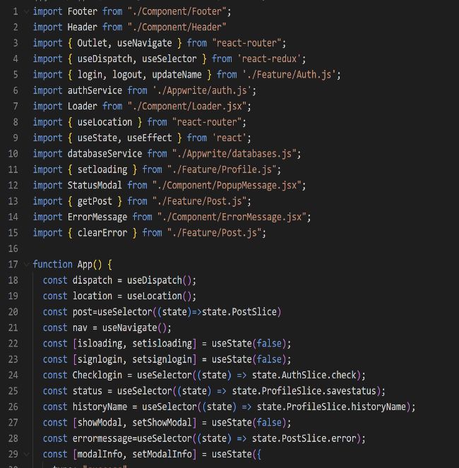
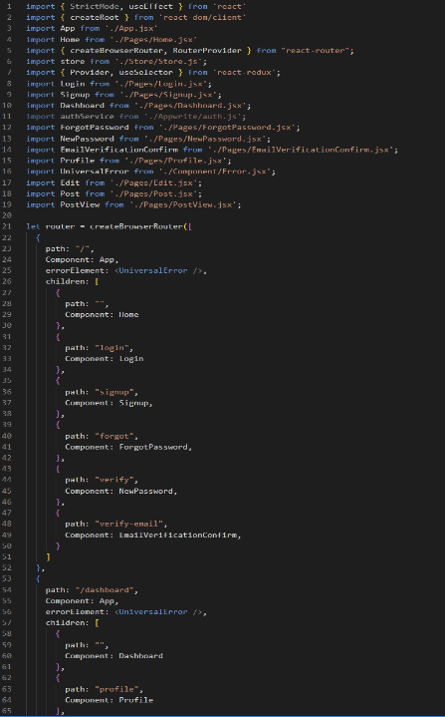
Project Image
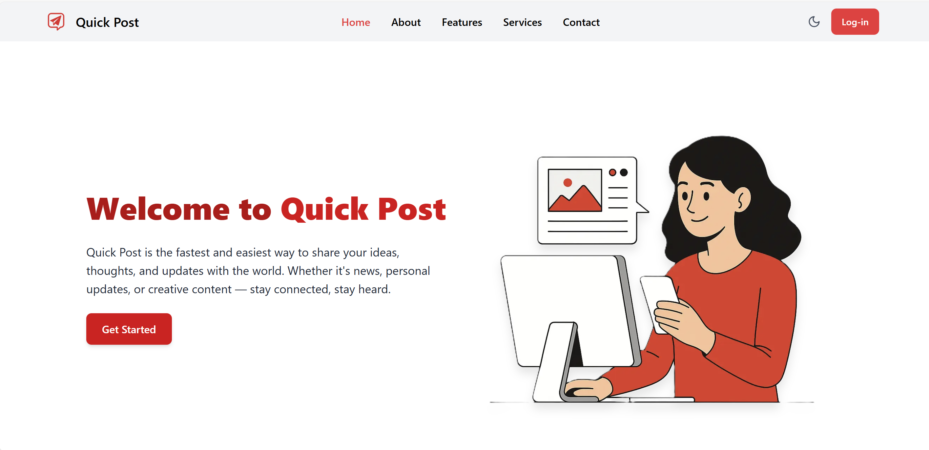
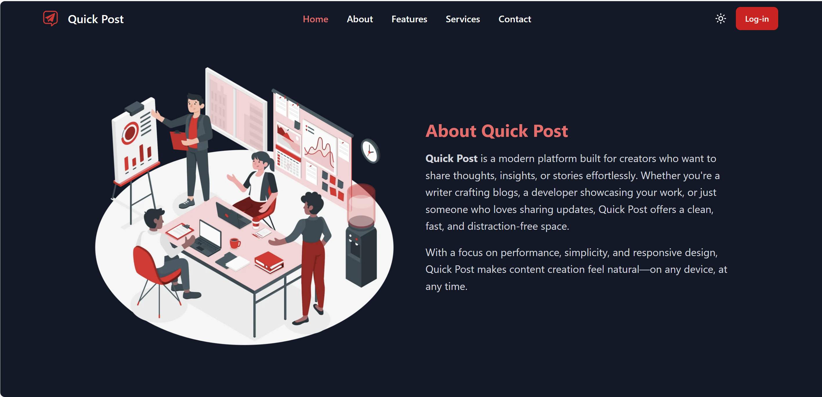
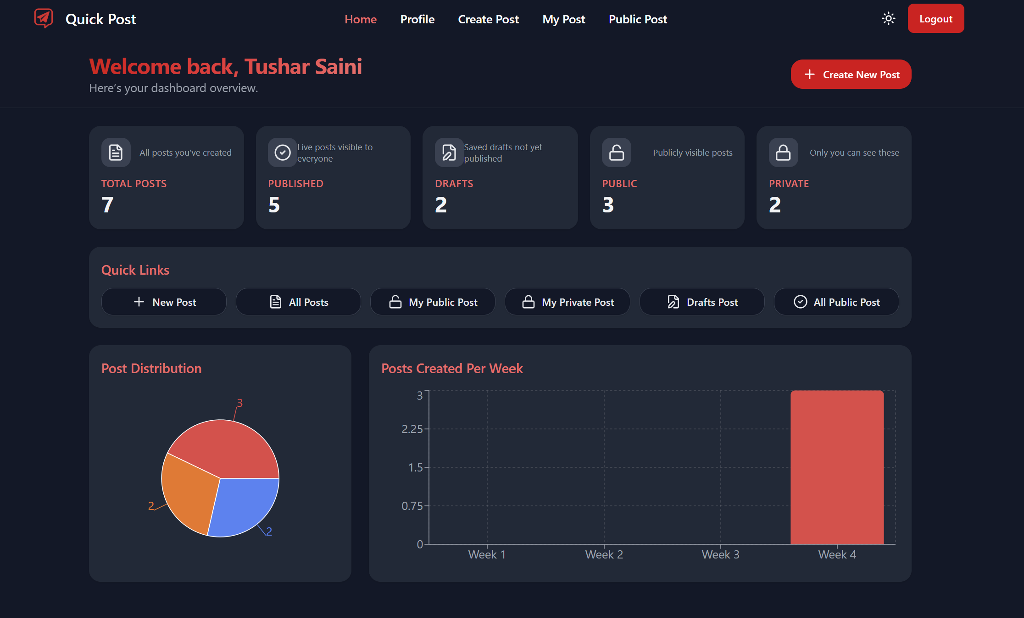
Technical Challenges
1. Integration of Appwrite Backend
Connecting the React frontend with Appwrite for authentication, database, and storage was challenging. Proper configuration of endpoints and API keys was required to ensure secure and smooth communication between the frontend and backend.
2. State Management
Managing global state across multiple components, including posts, user profiles, and notifications, required careful handling. Redux Toolkit was used to maintain consistent state updates and improve performance.
3. Form Handling and Validation
Dynamic forms for blog posts and profiles needed proper validation and error handling. React Hook Form simplified form state management, ensuring smooth data submission and preventing invalid inputs.
4. Rich Text Editor Integration
Integrating TinyMCE for editing blog content, including images and formatting, required careful setup. Ensuring seamless operation and secure content storage was essential.
5. One-Click Background Operations
Implementing instant operations like create, edit, delete, and publish required asynchronous calls to update the backend without blocking the UI, along with real-time notifications for users.
6. Responsive Design
Making the platform fully responsive across devices using Tailwind CSS was important to ensure a consistent and user-friendly experience on desktops, tablets, and mobiles.
Solutions and Learning Outcomes
Solutions to Challenges
- Responsive Design: Used Tailwind CSS along with media queries and flexible layouts to ensure compatibility across devices and screen sizes.
- Backend Integration: Configured Appwrite SDK for secure and efficient communication between frontend and backend APIs.
- State Management: Implemented Redux Toolkit to handle global state for posts, user profiles, and notifications, ensuring real-time updates.
- Form Handling: Used React Hook Form to validate user input efficiently and manage form submissions with minimal re-rendering.
- Rich Text Editing: Integrated TinyMCE Editor for blog content with secure image uploads and formatting.
- One-Click Operations: Applied asynchronous API calls using Axios to perform create, edit, delete, and publish actions instantly in the background.
Learning Outcomes
- Gained practical experience in React.js, Redux, React Hook Form, TinyMCE, and Appwrite BaaS.
- Learned full-stack integration, including connecting frontend forms with backend APIs and handling real-time data.
- Improved understanding of asynchronous programming, state management, and user experience design.
- Developed skills in responsive design, dynamic content management, and debugging complex workflows.
- Strengthened problem-solving, adaptability to modern tools, and project structuring for scalability and maintainability.
Methodology
The development of Quick Post followed a structured approach to ensure a smooth workflow and high-quality output.
- Requirement Analysis: Identified the core functionalities needed, such as user authentication, blog creation, editing, publishing, and contact management. User roles and access levels were defined.
- Design Phase: Created wireframes and UI mockups for the frontend. Planned database collections in Appwrite and structured data for posts, profiles, and contact messages.
- Frontend Development: Built the user interface using React.js, implemented form handling with React Hook Form, and managed global state with Redux Toolkit. Integrated TinyMCE Editor for rich text blog content.
- Backend Development: Configured Appwrite for authentication, database operations, and file storage. Developed APIs to handle CRUD operations for articles, profiles, and messages.
- Integration & Testing: Connected frontend and backend using Appwrite SDK and Axios for asynchronous operations. Conducted unit testing, functional testing, and responsiveness testing across devices.
- Deployment & Maintenance:Deployed the frontend on Vercel and used Appwrite Cloud for backend services. Monitored application performance, handled bug fixes, and ensured smooth operation of one-click background functionalities.
Future Enhancements
The Quick Post platform can be further improved with the following features:
- AI-Powered Writing Assistance:
Integrate AI tools to provide grammar checks, style suggestions, and content improvement while writing blog posts.
- Post Scheduling and Drafts:
Allow users to save drafts and schedule posts to be published automatically at a later date.
- Multi-Author Collaboration:
Enable multiple authors to collaborate on a single post, with version control and change tracking.
- Mobile Application:
Develop a mobile app version of Quick Post using React Native for on-the-go content management.
- Social Media Integration:
Add features to share blog posts directly to social media platforms like Facebook, Twitter, and LinkedIn.
- Multilingual Support:
Implement translation and localization to allow content creation in multiple languages.
- Advanced Analytics:
Provide users with detailed insights into post views, engagement, and reader behavior for better content planning.

Conclusion
The Quick Post project successfully demonstrates the development of a modern, dynamic, and interactive blogging platform. It integrates a robust React.js frontend, Redux Toolkit for state management, React Hook Form for efficient form handling, TinyMCE Editor for rich text content creation, and Appwrite Backend-as-a-Service for authentication, database management, and file storage.
The project achieves several key objectives:
- One-Click Background Operations: All major actions, including creating, editing, deleting, and publishing blog posts, are performed instantly in the background, enhancing user experience.
- Secure User Management: Users can register, log in, and manage their profiles securely, with proper role-based access control.
- Dynamic Content Handling: Articles, tags, profiles, and contact messages are stored in structured database collections, ensuring efficient retrieval and management.
- Responsive and User-Friendly Design: The platform is fully responsive across devices, offering a seamless experience on desktops, tablets, and mobile devices.
- Scalability and Maintainability: The modular code structure and use of modern web technologies allow easy maintenance, future feature enhancements, and integration with additional services.
Through this project, practical skills in full-stack development, frontend-backend integration, asynchronous operations, state management, and responsive UI design were strengthened. It demonstrates how modern tools and frameworks can be combined to create a professional, scalable, and efficient blogging system.
Overall, Quick Post provides a comprehensive solution for content creation and management, offering both developers and users an intuitive and powerful platform for modern blogging.
Acknowledgment
I would like to express my heartfelt gratitude to everyone who has guided and supported me throughout the development of the Quick Post project.
First and foremost, I am deeply thankful to the Udemy course instructors, whose detailed lectures and practical exercises on React.js, Redux, React Hook Form, TinyMCE, and modern full-stack development provided me with the essential knowledge and hands-on experience necessary to bring this project to life. Their guidance helped me understand complex concepts, adopt best practices, and implement efficient solutions effectively.
I would also like to extend my sincere thanks to my mentors and teachers, who provided valuable advice, constructive feedback, and encouragement at every stage of the project. Their insights greatly improved the quality and functionality of my work.
My gratitude also goes to my peers and the online developer community, whose discussions, suggestions, and shared resources were instrumental in overcoming technical challenges and exploring innovative approaches.
Finally, I am thankful to my family and friends for their unwavering support, patience, and motivation, which inspired me to complete this project successfully.
This project would not have been possible without the guidance, encouragement, and inspiration provided by all these individuals, and I am truly grateful to each one of them.

