Catchee’s Retrospectives
This document contains information about our retrospectives as a group. It’s a summary of what went well, what can be improved and some personal points.

Sprint 0
Tuesday September 16th 2025

Positive points
The group dynamic is great and there’s a good mix of humour and fun that motivates us to be productive. There’s no hard time with communication between each other. We know when/how to properly address issues, take accountability and improve. The time spent productively and the less serious moments compensate each other well. Finally the vibe within our group is lighthearted and we have a good time working together.

Improvement points
As a group we can dive deep into creating quickly, but we need to improve on actual scheduling. There’s also a role division in the team charter but we need to stick to it more. We also need to focus on creating a good task division during the next sprints. As mentioned before, good time and productivity compensate each other well, but we want to balance it even further to get more work done.

Personal points
Tina is going to work more on getting to school earlier. Erem is going to work on methodical feedback towards the group and helping the rest figure out design choices with examples instead of also doing the task. Eline is going to work more on making bigger differences in designs and iterations instead of a lot of smaller ones. A better balance in quantity and quality. Dimo is going to work on being mentally present more and speaking his thought processes out loud. Michelle is going to work on letting herself go, be herself instead of masking, which will help her creative flow.

Accountability
Our goal is to keep our groupwork up and improving ourselves in the best way possible. To make sure everyone sticks to their word, we keep each other in check. The feedback we get from one another and the feelings/emotions that come with it are enough to make us want to improve.

Sprint 1 summary (Monday 6/10/2025)

What went well
Communicating
Client meetings
Productivity
Sketching
Processing feedback
Team agreement

What could have gone better
Being present (attention span)
Task sharing/division
Preparations for client meetings

How do we improve
Take others into consideration more
If needed or you are too out of it, take a small break
Prepare better for client meetings beforehand by practicing and discussing what and what we're not going to mention
Use our Trello more and better

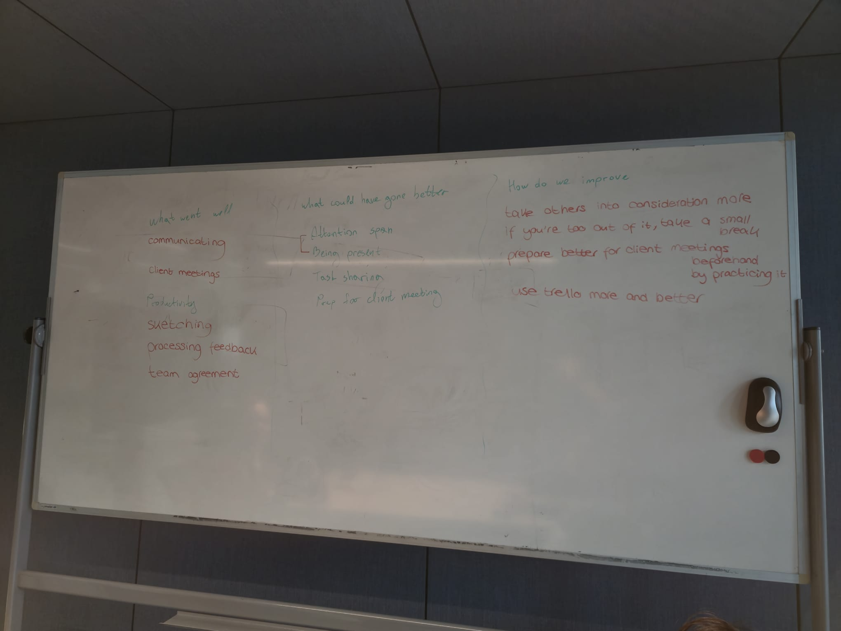

Sprint 2 summary (tuesday 28/10/2025)

What went well
Concepting and presenting the concept
Communication with the client and feedback
Sticking to the smaller schedules within the bigger one
Communication within the team
Client meeting preparations

What could have gone better
Task management and division
Being on time
Time management
Personal motivation
Informing the group about a task instead of asking for permission to do it

How do we improve
Every morning do a stand-up and discuss the trello during it
Enforce the rules from the team charter, especially when people are late
Set up more deadlines within the week
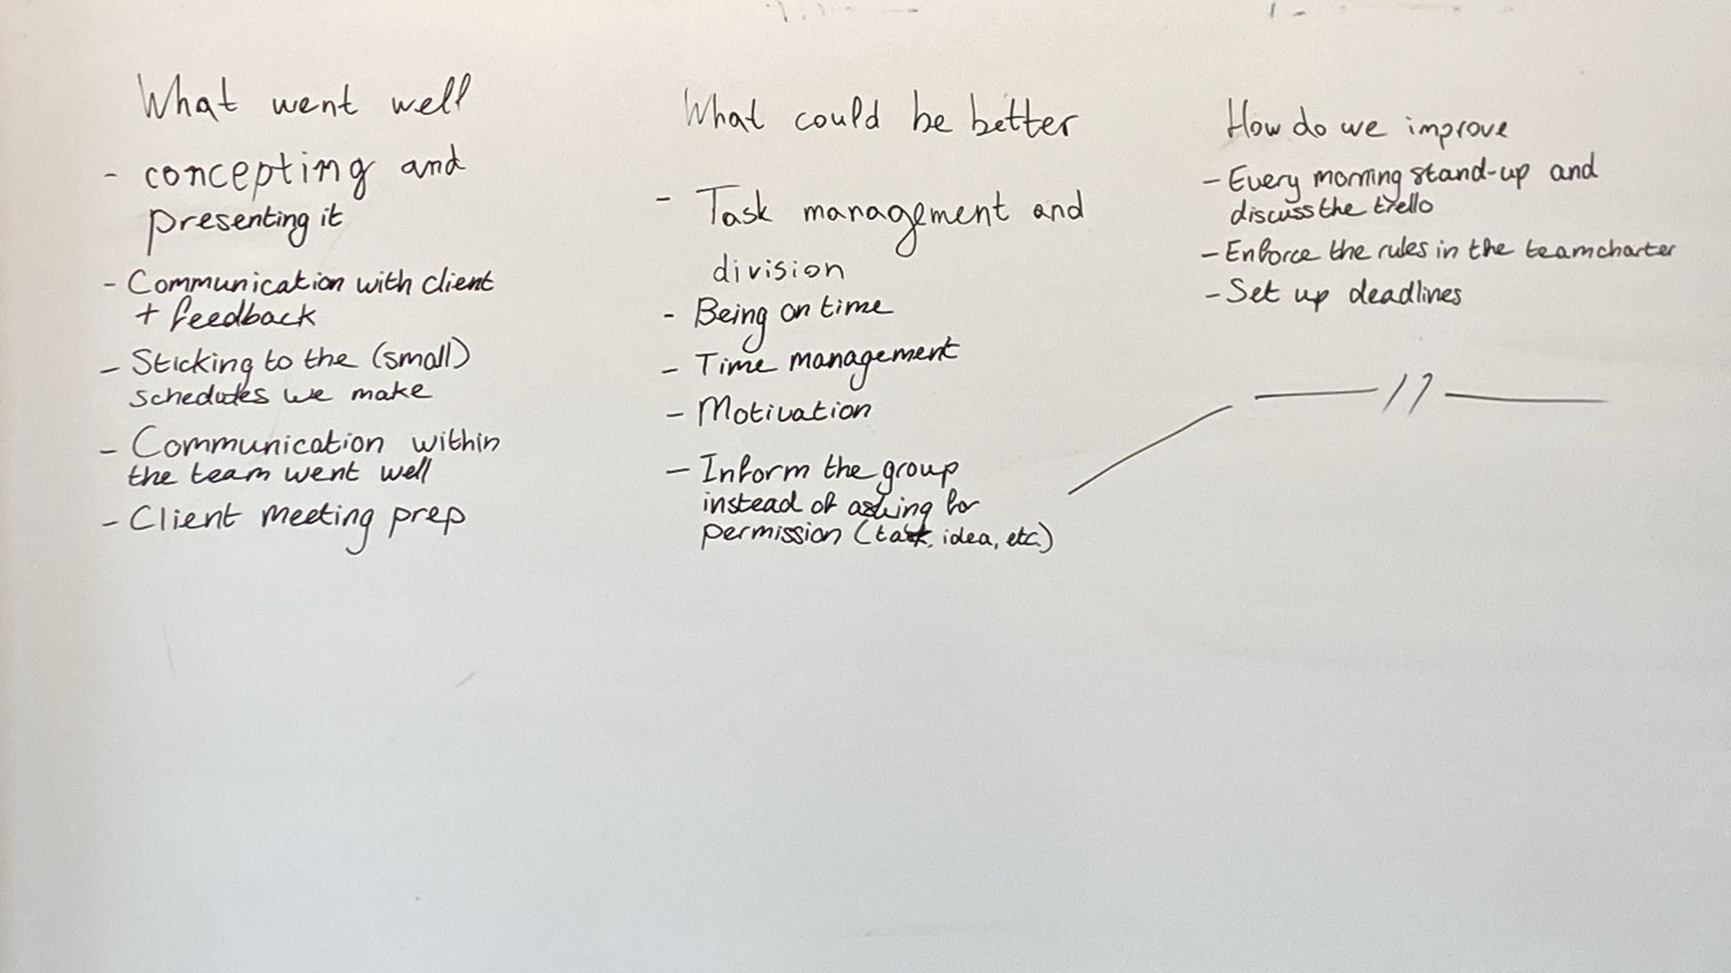

Sprint 3 summary (monday 10/11/2025)

What went well
Handling group issues professionally
Workflow/task divisions
Scoping (as an example the tasks)
User testing
Giving peer feedback
Productivity

What could have gone better
Communication within handling our group issues professionally

How do we improve
Check in with semester coach before making important decisions
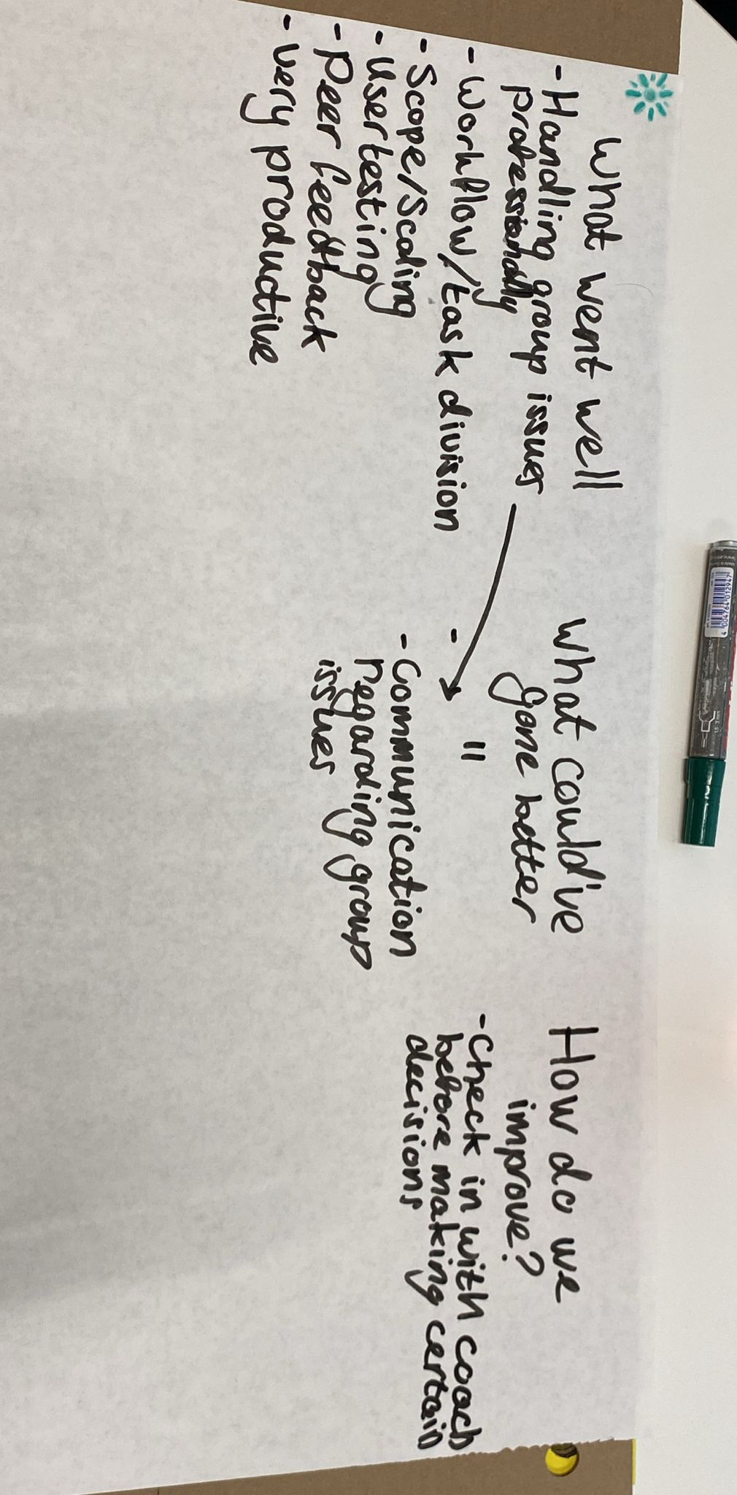

Sprint 4 summary (monday 24/11/2025)

What went well
Workflow/using Trello
Being present
Communication within the group
First part of sprint getting feedback from peers and teachers

What could have gone better
Productivity
When a task isn't done before a deadline, reassigning the task
Communication due to wording tasks in trello
Seeking feedback in the last part of the sprint
Doing stuff on time/making a deadline
Professionality with the client meeting

How do we improve
Properly word the tasks in trello, if a task isn't done within the deadline it should be reassigned
Do daily standups
Document more clearly about the client meetings and document more clearly about gotten feedback

