**SOFTWARE REQUIREMENT SPECIFICATION FOR ONLINE SNEAKERHEADS SHOPPING**

**1.) INTRODUCTION :**

**Purpose :**

Sneakers are an integral part of our dressing up routine, and you can go from formal to party, simple to stylish, casual to trendy in minutes by simply switching your shoes. A huge variety and design of sneaker shoes are now available in the market for various activities. The value of a good pair of shoes is constant. Whatever the occasion may be fitting sneaker shoes paired with an outfit is the need. The Online Shopping System (OSS) for sneaker heads web application is intended to provide complete solutions for vendors as well as customers through a single gateway using the internet. Online shopping is the process preferred by many these days. This sneaker shopping website is a good collection of sneakers for men and women paired with extremely profitable offers and deals to choose from this website. Customer can also quickly find the nearest sneaker stores by selecting the area in the search tools. Thus, this online sneaker shopping will relieve people by providing access for purchasing, renting sneakers just by sitting at home.

The Purpose of the project is to build an application program to reduce the manual work for managing Sneaker Shoes and Customer.

**1.2 Scope :**

This project is an online sneaker shopping web application. This online sneaker shopping application has two actors namely, Admin and Customer. First is Admin login, Admin can add products, view products and delete products.

Admin can register and login his personal account using id and password. As soon as the data is filled by the admin, he gets redirect to add product page. Admin will add new sneakers, second hand sneakers, rental sneakers and new arrivals.

Second module is Customers, in this customers can register and login using credentials. He/she can view products, can add products to the cart and place order. He/ She can also buy second hand sneakers or rent sneakers for one month.

**Overview :**

This system provides an easy solution for customers to buy the sneakers without going to the shop and also to shop owner to sell the sneakers. This proposed system can be used by any naïve user and it does not require any educational level, experience or technical expertise in computer field but it will be of good use if user has good knowledge of how to operate a computer.

**2.) Functional Requirement:**

This section provides requirement overview of the system. Various functional modules that can be implemented by the system will be

Description:

* Registration : If customer wants to buy the product then he/she must be registered, unregistered user can’t go to the shopping cart.

Admin also needs to register. And then only he can manage the products.

* Login : Customer logins to the system by entering valid user id and password for the shopping.
* Category : In category, there are 2 options. Customer can select Men or Women as per their requirement.
* Second Hand Buy : In this system we are providing second hand sneakers. Admin will add the second hand sneakers in this. And customer who wish to buy second hand sneakers can buy from here.
* Rent A Shoe : In this, Customer can buy sneakers on rent. Rent for each product will be different which will be 10% of that particular product. We have also added a status attribute. In this attribute there will be 2 option, status on rent and status on released means if a customer has rented a sneaker it will show status on rent, and if a customer has returned that particular sneaker then it will show status on released.

* Changes to Cart : Changes to cart means the customer after login can make order or cancel order of the sneaker from the shopping cart.
* Logout : After ordering or surfing for the product customer can logout.

**Admin:**

Admin can get logged into the application by entering valid username and password. Admin can add the details of the sneakers. Admin can view all the details of the sneakers and also delete them.

**Customers:**

Customer can register and login using credentials. He/she can view the sneakers and can buy the sneakers. There is also a delete option so if a customer wants to delete particular sneaker he can do it by using delete option.

**3.) DIAGRAMS :**

* **ER Diagram :**

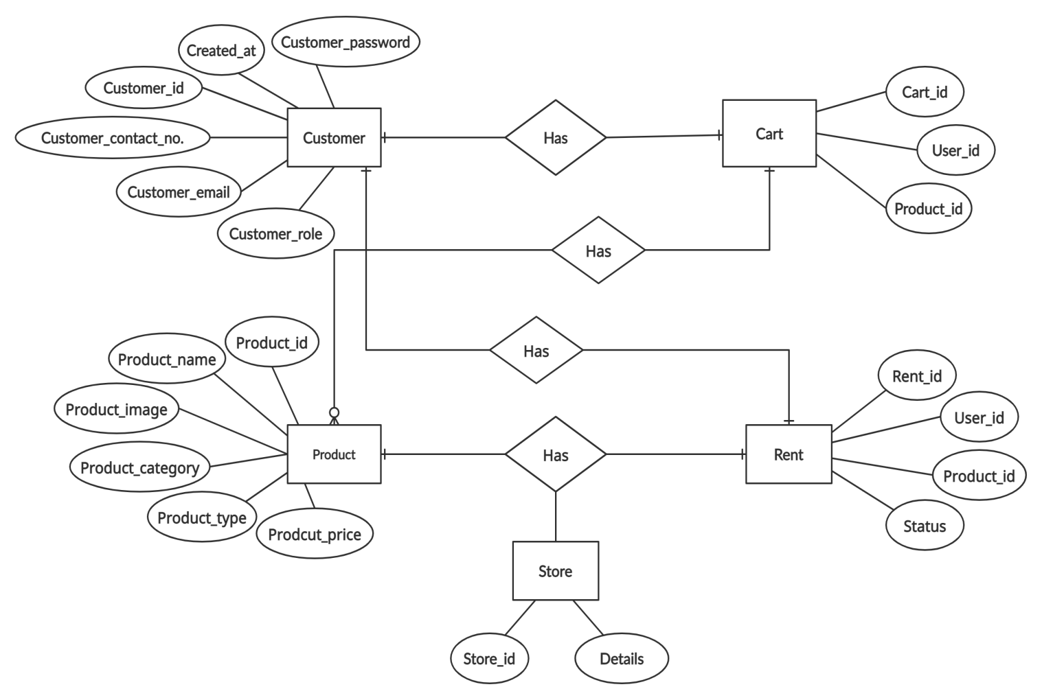

* **Use Case Diagram :**

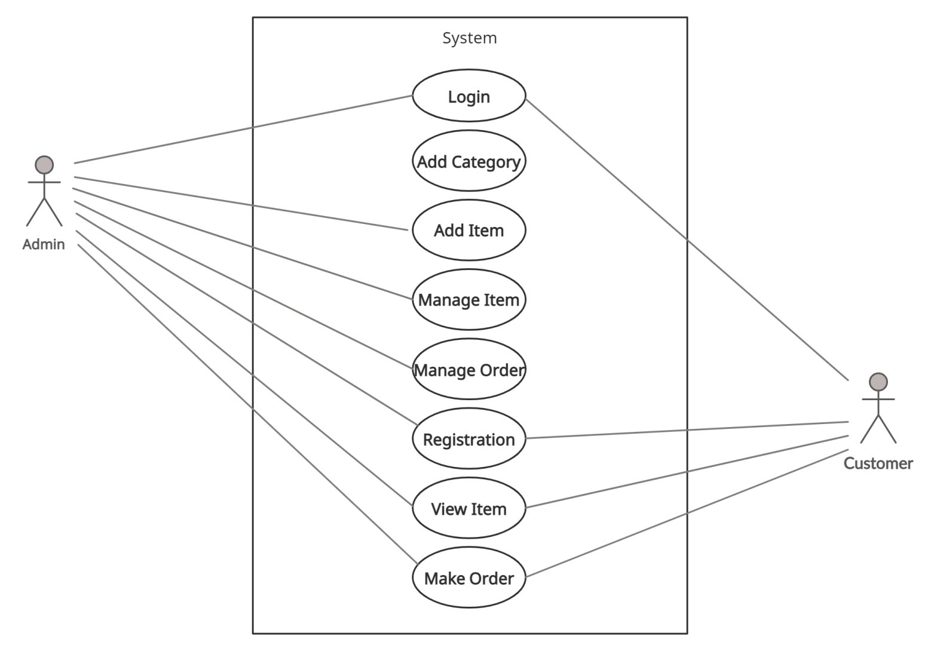

**4.)Technical Issues:**

This system will work on client-server architecture. It will require an internet server, and which will be able to run java web application. The system should support some commonly used browser such as IE, Mozilla Firefox, Chrome etc.

**5.)Software Interface:**

Operating System: Windows7 Ultimate which supports networking, Windows8, Windows 10, Windows 11.

JAVA development toolkit.

**6.)Hardware Interface:**

Hardware requirements for insurance on internet will be same for both parties which are as follows:

Processor: Dual Core

RAM:2 GB

Hard Disk:320 GB

**7.)Non-Functional Requirements:**

Following Non-Functional Requirements will be there in the insurance to the internet:

Secure access to consumer’s confidential data.

24X7 availability.

Better component design to get better performance at peak time.

Flexible service-based architecture will be highly desirable for future extension. Non-Functional Requirements define system properties and constraints.

Various other Non-Functional Requirements are :

Security

Reliability

Maintainability

Portability

Extensibility

Reusability

Compatibility

Resource Utilization