 

INSTITUTE FOR ADVANCED COMPUTING AND SOFTWARE DEVELOPMENT AKURDI, PUNE

Documentation On

**“SNEAKER HEADS”**

PG-DAC MAY 2021

*Submitted By:*

**Group No: 105 Tushar Shitre: 1190 Monica Shewale: 1175**

**Prashant Karhale Mr.**

**Centre Coordinator Project Guide**

# Table of Contents

1. Introduction 1

Document Purpose 2

Problem Statement 2

Product Scope 2

Aim & Objectives 2

1. Overall Description 3

Product Perspective 3

Benefits of Society Management System 3

User and Characteristics 3

Operating Environment 3

Design and Implementation Constraints 3

1. Requirements Specification 4

External Interface Requirements 4

Non-Functional Requirements 12

1. System Diagram 11

Activity Diagram 11

Data Flow Diagram 13

Class Diagram 15

Use Case Diagram 16

ER Diagram 16

1. Table Structure 17

Address 17

Cart 17

Category 17

Order Address 18

Order Details 18

Order 18

Payment 18

Product Image 18

Products 18

Supplied Products 18

Supplier 18

Users 18

1. Conclusion 19

Future Scope 19

1. References 20

**List of Figures**

Figure 1 Activity Diagram 11

Figure 2 Level 0 Data Flow Diagram 13

Figure 3 Level 1 Data Flow Diagram 13

Figure 4 Level 2 Data Flow Diagram 13

Figure 5 Class Diagram 15

Figure 6 Use Case Diagram 16

Figure 7 ER Diagram 16

**1.Introduction**

 In today’s busy world, people don’t have time for their personal needs. And the technology is so fast that anyone can do anything by just sitting in a room. The internet is the way that helps a person in all aspects. If someone wish to buy and view things, he can buy online with the help of internet. Today there are very least organizations which are manual. Everything is going to be computerized and online whether it is shopping, advertising or banking. We are trying to help people to make their life easier by proving online sneakers shopping. Sneakers are an integral part of our dressing up routine, and you can go from formal to party, simple to stylish, casual to trendy in minutes by simply switching your shoes. A huge variety and design of sneaker shoes are now available in the market for various activities. The value of a good pair of shoes is constant. Whatever the occasion may be fitting sneaker shoes paired with an outfit is the need. This documentation for Sneaker heads web application is intended to provide complete solutions for vendors as well as customers through a single gateway using the internet. Online shopping is the process preferred by many these days. This sneaker shopping website is a good collection of sneakers for men and women paired with extremely profitable offers and deals to choose from this website. Customer can also quickly find the nearest sneaker stores by selecting the area in the search tools. Thus, this online sneaker shopping will relieve people by providing access for purchasing, renting sneakers just by sitting at home.

**Document Purpose**

The Purpose of the project is to build an application program to reduce the manual work for managing Sneaker Shoes and Customer. To provide data security, making searching process easier and saving space & time. This Sneaker Head System is developed to provide the following services:

Enhance Business Processes:

To be able to use internet technology to project to the global world instead of limiting their services to their local domain alone, thus increase their return on investment (ROI).

Online Sneaker Management:

Admin can get logged into the application by entering valid username and password. Admin can add the details of the sneakers. Admin can view all the details of the sneakers. The admin also receives some set of functionalities which help in managing the application. Also if the user wishes to sneakers from offline market the details for our offline store are also provided in the system itself.

Rent A Shoe:

This system’s key functionality is that a user can rent a shoe for a particular time of one month by paying a sum of 10% of the total price of the product.

**Problem Statement**

## In order to increase online shopping, customer online shopping behavior while shopping online should be given priority. The Current shopping System is critical to set up online shops, customers to browse through the shops, and a system administrator to approve and reject requests for new shops and maintain lists of shop categories. This is a small scale project for Online Sneakers shopping System. The basic idea is that the customer can buy sneakers from anywhere during any time by using their email and password through which they have been logged in. Some sneakers are too expensive for getting a hands-on, so we have provided a feature of buying a secondhand sneaker and also a rental system which is not present in existing systems.

**Product Scope**

This project is an online sneaker shopping web application. This online sneaker shopping application has three actors namely :

• CUSTOMER

• ADMINISTRATOR

• SUPPLIER

ADMINISTRATOR ROLE: The role of he admin is to add suppliers and manage them. Also the admin has to approve products added by the supplier before the products are displayed to the customer.

CUSTOMER ROLE: The customer’s can register and login/logout to the system using credentials. He/ She can view his/her product details, can add products to the cart and buy their product. He/ She can also buy second hand sneakers or rent sneakers for one month. The customer can just view the information where as he/ she could not make changes in the database.

SUPPLIER : The supplier can display and add the products by filling the form of adding products. Before the products are added to the homepage the products goes to the admin for verification and are added if approved

**Aims & Objectives**

Shopping Sneakers has long been considered a recreational activity by many. Shopping online is no exception. The goal of this application is to develop a web based interface for online retailers. The system would be easy to use and hence make the shopping experience pleasant for the users. The goal of this application is

• To develop an easy to use web based interface where users can search for products, view a complete description of the products and order the products.

• A search engine that provides an easy and convenient way to search for products specific to their needs. The search engine would list a set of products based on the search term and the user can further filter the list based on various parameters.

• A user can view the complete specification of the product along with image.

• If a user doesn’t want to pay the full price and buy the product for lifetime he can rent it for a particular period of time.

• Also a user can buy a second hand sneaker from the website if he intends to do so.

**2. Overall Description**

**2.1Product Perspective:**

Existing system function:

Traditionally if anyone wanted to buy a sneaker, he/ she would have to physically go a store and buy a sneaker which was good for older days when technology was not that improved but as time passed .Online Systems were developed which consisted of an online application for buying sneakers without physically going to the place. The products were then shipped to the customers address according after buying the products. But some of the sneakers are too costly for some people to afford so we have proposed a system in which a user can rent a sneaker or buy them second hand at lower price from the actual one. Also if the customer wants to still buy any product from an offline outlet of ours the details of the same are provided in the system itself which provides a seamless experience for sneaker lover.

**2.2 Proposed System:**

* Product functionality: SneakerHeads provides the features for admin, supplier and customer.

It includes several functionalities describe as below:

* Registration: If customer wants to buy the product then he/she must be registered, unregistered user can’t go to the shopping cart. Admin also needs to register. And then only he can manage the products.
* Login: Customer logins to the system by entering valid user id and password for the shopping.
* Category: In category, there are 2 options. Customer can select Men or Women as per their requirement.
* Second Hand Buy: In this system we are providing second hand sneakers. Admin will add the second hand sneakers in this. And customer who wishes to buy second hand sneakers can buy from here.
* Rent A Shoe: In this, Customer can buy sneakers on rent. Rent for each product will be different which will be 10% of that particular product. We have also added a status attribute. In this attribute there will be 2 options, status on rent and status on released means if a customer has rented a sneaker it will show status on rent, and if a customer has returned that particular sneaker then it will show status on released.
* Changes to Cart : Changes to cart means the customer after login can make order or cancel order of the sneaker from the shopping cart.
* Logout : After ordering or surfing for the product customer can logout.

**2.3 Benefits of SneakerHead System:**

**2.3.1 Convenience of online shopping**

Customers can purchase items from the comfort of their own homes or work place. Shopping is made easier and convenient for the customer through internet. It is also easy to cancel the transactions.

The following table depicts the factors which motivate the online shoppers to buy products online.

Top 6 reasons given by shoppers in buying through internet :

* Saves time and efforts.
* Convenience of Shopping at home.
* Wide variety / range of products are available.
* Good discounts / lower prices.
* Get detailed information of the product.
* We can compare various models / brands.

**2.3.2 No pressure shopping**

Generally, in physical stores, the sales representatives try to influence the buyers to buy the product. There can be some kind of pressure, whereas the customers are not pressurized in any way in online stores.

**2.3.3 Online shopping saves time**

Customers do not have to stand in queues in cash counters to pay for the products that have been purchased by them. They can shop from their home or work place and do not have to spend time traveling. The customers can also look for the products that are required by them by entering the key words or using search engines.

**2.3.4 Comparisons**

Companies display the whole range of products offered by them to attract customers with different tastes and needs. This enables the buyers to choose from a variety of models after comparing the finish, features and price of the products on display. Sometimes price comparisons are also available online.

**2.3.5 Availability of online shop**

The mall is open on 365 x 24 x 7. So, time does not act as a barrier, wherever the vendor and buyers are.

**2.3.6 Online shopping saves money**

To attract customers to shop online, e-trailers and marketers offer discounts to the customers. Due to elimination of maintenance, real-estate cost, the retailers are able to sell the products with attractive discounts through online. Sometimes, large online shopping sites offer store comparison.

It provides custom features development and support with the application.

**2.3.7 Second hand and Rental System:**

Some of the sneakers are too costly for some people to afford so we have proposed a system in which a user can rent a sneaker or buy them second hand at lower price from the actual one.

**Users and Characteristics:**

**Admin:**

* Admin can add suppliers, view suppliers and delete suppliers.
* Admin can register and login his personal account using id and password.
* As soon as the data is filled by the admin, he gets redirect to the add suppliers page.
* Admin will add new suppliers.
* Admin can view the products added by the suppliers and approve or reject them before adding the product to the home screen.

**Suppliers:**

* Suppliers are added by the admin according to the products they supply.
* Supplier has to fill a new form add product for adding a product.
* The product then goes to the admin for approval and then added accordingly.
* The supplier can also delete the product if needed.

**Customer:**

* Customer can register and login using credentials.
* He/she can view the sneakers and can buy the sneakers.
* There is also a delete option so if a customer wants to delete particular sneaker he can do it by using delete option.

**Operating Environment:**

Server Side:

**Processor:** Intel® Xeon® processor 3500 series

**HDD:** Minimum 500GB Disk Space

**RAM:** Minimum 2GB **OS:** Window 8.1

**Database:** Oracle 11g

Client Side (minimum requirement):

**Processor:** Intel Dual Core

**HDD:** Minimum 80GB Disk Space

**RAM:** Minimum 1GB

**OS:** Windows 7, Linu**x.**

**Design and Implementation Constraints:**

* The application will use React, HTML, CSS, for frontend and Spring Boot for writing the backend code and My-SQL for storing the data.
* We use Apache Tomcat as local server to run the application on local host.
* Several types of validations make this web application a secured one and SQL Injections can also be prevented.
* Since SneakerHeads is a web-based application, internet connection must be established.
* The SneakerHeads System will be used on PCs and will function via internet or intranet in any web browser.

**3. Requirement Specification**

**3.1 External Interface Requirements:**

User Interfaces:

* All the users will see the same page when they enter in this website. This page asks the users a username and a password.
* After being authenticated by correct username and password, user will be redirect to their corresponding profile where they can do various activities.
* The user interface will be simple and consistence, using terminology commonly understood by intended users of the system. The system will have simple interface, consistence with standard interface, to eliminate need for user training of infrequent users.

Hardware Interfaces:

* No extra hardware interfaces are needed.
* The system will use the standard hardware and data communication resources.
* This includes, but not limited to, general network connection at the server/hosting site, network server and network management tools.

Application Interfaces:

* **OS:** Windows 7, Linux
* **Web Browser:**

The system is a web-based application; clients need a modern web browser such as Mozilla Firebox, Internet Explorer, Opera, and Chrome. The computer must have an Internet connection in order to be able to access the system.

Communications Interfaces:

* This system uses communication resources which includes but not limited to, HTTP protocol for communication with the web browser and web server and TCP/IP network protocol with HTTP protocol.
* This application will communicate with the database that holds all the booking information. Users can contact with server side through HTTP protocol by means of a function that is called HTTP Service. This function allows the application to use the data retrieved by server to fulfill the request fired by the user.

**3.2 Non Functional Requirements:**

Following Non-Functional Requirements will be there in the insurance to the internet:

Secure access to consumer’s confidential data.

24X7 availability.

Better component design to get better performance at peak time.

Flexible service-based architecture will be highly desirable for future extension. Non-Functional Requirements define system properties and constraints.

Various other Non-Functional Requirements are :

* Security.
* Reliability.
* Maintainability.
* Portability.
* Extensibility.
* Reusability.
* Compatibility.
* Resource Utilization

**4. System Diagram**

**4.1 Activity Diagram:**

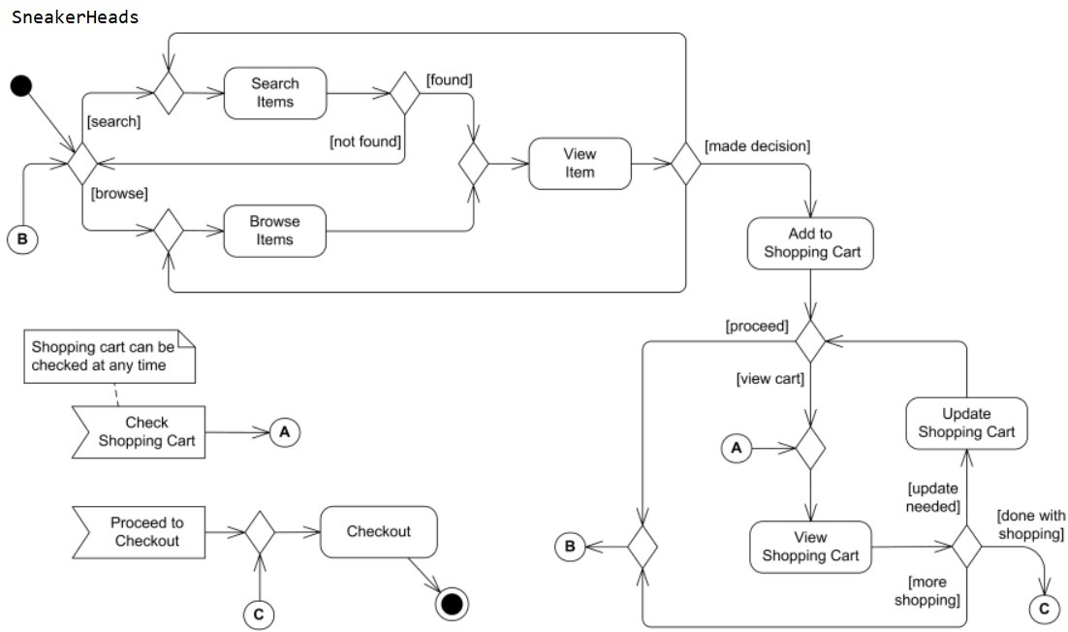

Figure 4.1: Activity Diagram

**4.2 Data Flow Diagram:**

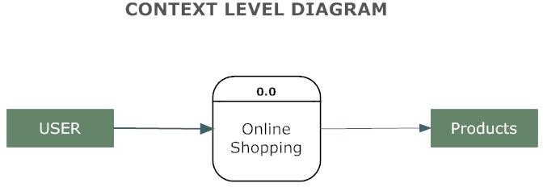

Figure 4.2.1: A Context Level Diagram

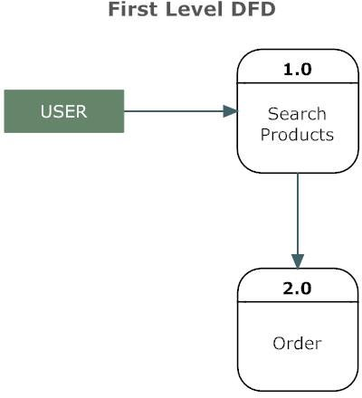

Figure 4.2.2: A First Level Diagram

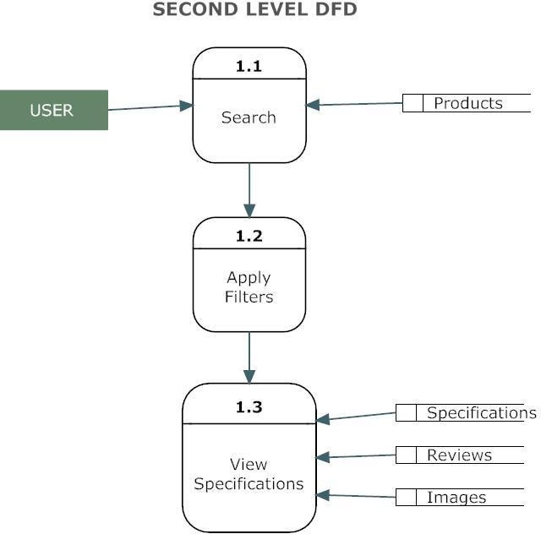

Figure 4.2.3: A Second Level Diagram

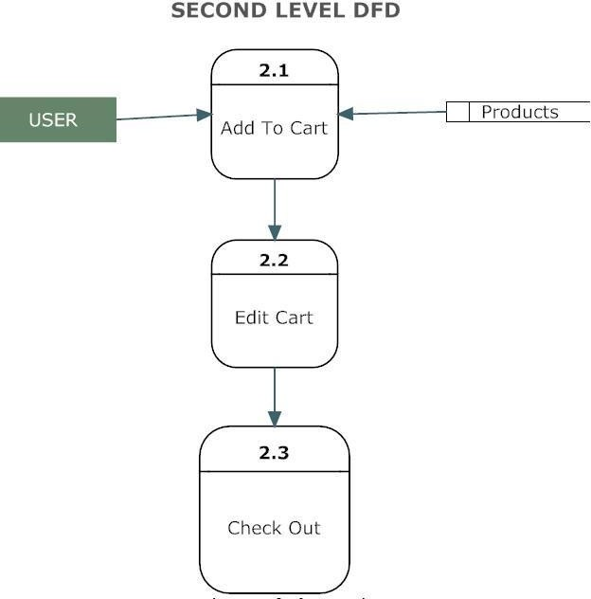

Figure 4.2.4: A Second Level Diagram

**4.3 Use Case Diagram:**

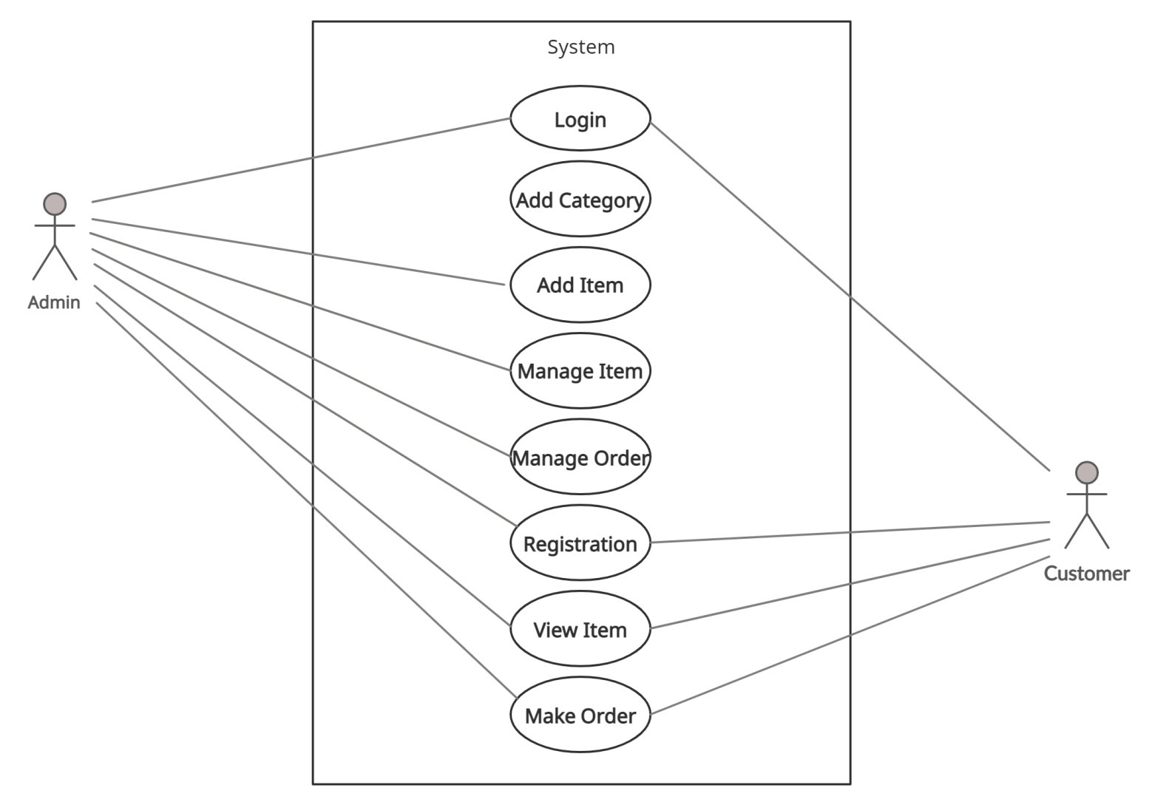

Figure 4.3: Use Case Diagram

**4.4 ER Diagram:**

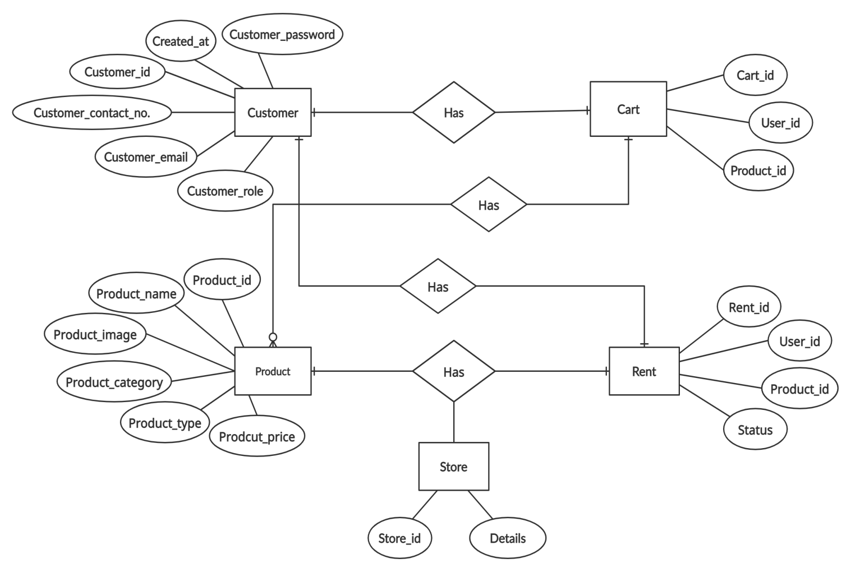

Figure 4.4: ER Diagram

**4.5 Class Diagram:**

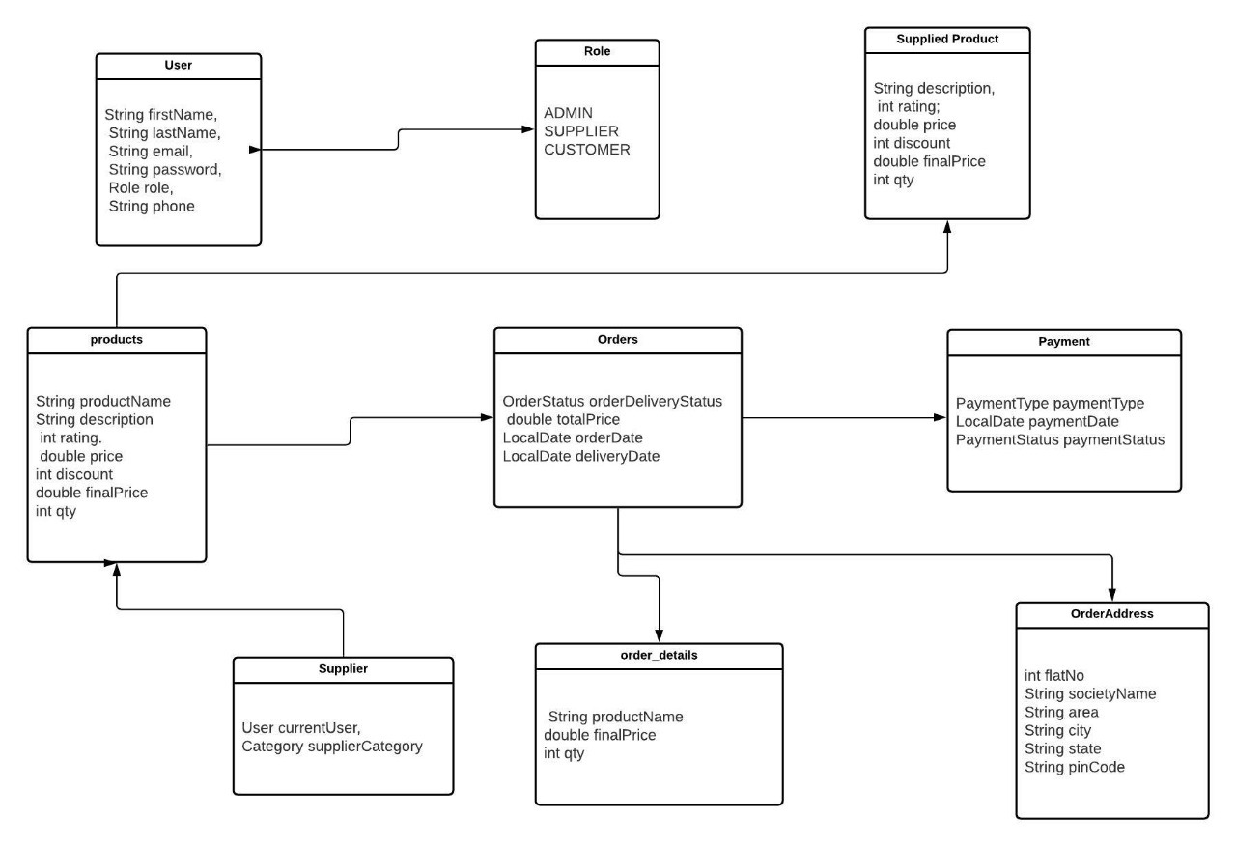

Figure 4.5: Class Diagram

**5. Table Structure :**

## 

**Users:**

|  |  |  |  |  |  |
| --- | --- | --- | --- | --- | --- |
| Field | Type | Null | Key | Default | Extra |
| Id | int | NO | PRI | NULL | auto increment |
| Email | varchar(30) | NO | UNI | NULL |  |
| First_name | varchar(20) | NO |  | NULL |  |
| Last_name | varchar(20) | NO |  | NULL |  |
| Password | varchar(20) | NO |  | NULL |  |
| Phone | varchar(20) | YES |  | NULL |  |
| Role | varchar(20) | YES |  | NULL |  |

**Address:**

|  |  |  |  |  |  |
| --- | --- | --- | --- | --- | --- |
| Field | Type | Null | Key | Default | Extra |
| User_id | int | NO | PRI | NULL |  |
| Area | varchar(20) | YES |  | NULL |  |
| city | varchar(20) | YES |  | NULL |  |
| Flat_no | int | NO |  | NULL |  |
| Pin_code | varchar(20) | YES |  | NULL |  |
| Society_name | varchar(20) | YES |  | NULL |  |
| State | varchar(20) | YES |  | NULL |  |

**Cart:**

|  |  |  |  |  |  |
| --- | --- | --- | --- | --- | --- |
| Field | Type | Null | Key | Default | Extra |
| Id | int | NO | PRI | NULL | auto increment |
| Discription | varchar(100) | YES |  | NULL |  |
| Discount | int | NO |  | NULL |  |
| Final_price | double | NO |  | NULL |  |
| Price | double | NO |  | NULL |  |
| Product_id | int | NO |  | NULL |  |
| Product_name | varchar(20) | YES |  | NULL |  |
| Qty | int | NO |  | NULL |  |
| Rating | int | NO |  | NULL |  |
| User_id | int | NO |  | NULL |  |

**Category:**

|  |  |  |  |  |  |
| --- | --- | --- | --- | --- | --- |
| Field | Type | Null | Key | Default | Extra |
| Id | int | NO | PRI | NULL | auto increment |
| Category_name | varchar(20) | YES |  | NULL |  |

**Order_Address:**

|  |  |  |  |  |  |
| --- | --- | --- | --- | --- | --- |
| Field | Type | Null | Key | Default | Extra |
| Id | int | NO | PRI | NULL | auto increment |
| Area | varchar(20) | YES |  | NULL |  |
| City | varchar(20) | NO |  | NULL |  |
| Flat_no | int | NO |  | NULL |  |
| Order_id | int | NO |  | NULL |  |
| Pin_code | varchar(20) | NO |  | NULL |  |
| Society_name | varchar(20) | YES |  | NULL |  |
| State | varchar(20) | NO |  | NULL |  |
| User_id | int | NO |  | NULL |  |

**Orders:**

|  |  |  |  |  |  |
| --- | --- | --- | --- | --- | --- |
| Field | Type | Null | Key | Default | Extra |
| Id | int | NO | PRI | NULL | auto increment |
| Delivery_date | date | YES |  | NULL |  |
| Order_date | date | YES |  | NULL |  |
| Order_delivery_status | varchar(255) | YES |  | NULL |  |
| Total_price | double | NO |  | NULL |  |
| Customer_id | int | NO |  | NULL |  |
| Delivery_boy_id | int | NO |  | NULL |  |

**Payment:**

|  |  |  |  |  |  |
| --- | --- | --- | --- | --- | --- |
| Field | Type | Null | Key | Default | Extra |
| Id | int | NO | PRI | NULL | auto increment |
| Payment_date | date | YES |  | NULL |  |
| Payment_status | varchar(20) | YES |  | NULL |  |
| Payment_type | varchar(20) | YES |  | NULL |  |
| Delivery_boy_id | int | NO |  | NULL |  |
| Order_id | int | YES | MUL | NULL |  |

**Product Image:**

|  |  |  |  |  |  |
| --- | --- | --- | --- | --- | --- |
| Field | Type | Null | Key | Default | Extra |
| Id | int | NO | PRI | NULL | auto increment |
| Image | longblob | YES |  | NULL |  |
| Image_content_type | varchar(30) | YES |  | NULL |  |
| Product_name | varchar(20) | YES | UNI | NULL |  |

**Products:**

|  |  |  |  |  |  |
| --- | --- | --- | --- | --- | --- |
| Field | Type | Null | Key | Default | Extra |
| Id | int | NO | PRI | NULL | auto increment |
| Description | varchar(100) | YES |  | NULL |  |
| | Discount | int | NO |  | NULL |  |
| | Final_price | double | NO |  | NULL |  |
| Price | double | NO |  | NULL |  |
| Product_name | varchar(20) | YES |  | NULL |  |
| Qty | int | NO |  | NULL |  |
| Rating | int | NO |  | NULL |  |
| Category_id | int | NO |  | NULL |  |

**Supplied Product:**

|  |  |  |  |  |  |
| --- | --- | --- | --- | --- | --- |
| Field | Type | Null | Key | Default | Extra |
| Id | int | NO | PRI | NULL | auto increment |
| Description | varchar(100) | YES |  | NULL |  |
| | Discount | int | NO |  | NULL |  |
| | Final_price | double | NO |  | NULL |  |
| Price | double | NO |  | NULL |  |
| Product_name | varchar(20) | YES |  | NULL |  |
| Qty | int | NO |  | NULL |  |
| Rating | int | NO |  | NULL |  |
| Category_id | int | NO | MUL | NULL |  |

**Supplier:**

|  |  |  |  |  |  |
| --- | --- | --- | --- | --- | --- |
| Field | Type | Null | Key | Default | Extra |
| Id | int | NO | PRI | NULL | auto increment |
| User_id | int | YES | MUL | NULL |  |
| Category_id | int | YES | MUL | NULL |  |

**Users:**

|  |  |  |  |  |  |
| --- | --- | --- | --- | --- | --- |
| Field | Type | Null | Key | Default | Extra |
| Id | int | NO | PRI | NULL | auto increment |
| Email | varchar(30) | NO | UNI | NULL |  |
| First_name | varchar(20) | NO |  | NULL |  |
| Last_name | varchar(20) | NO |  | NULL |  |
| Password | varchar(20) | NO |  | NULL |  |
| Phone | varchar(20) | YES |  | NULL |  |
| Role | varchar(20) | YES |  | NULL |  |

**6. Conclusion:**

**Future Scope :**

**8.Reference:**