**SaaS Products Import:**

**Points to consider:**

1. **Install Extensions:**

* CommandLine Parser:

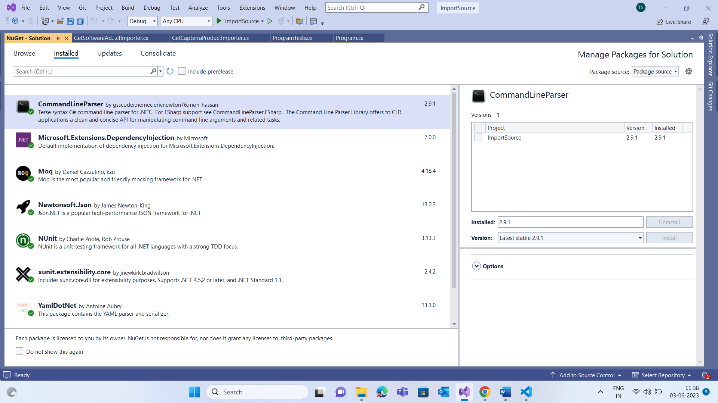

* Microsoft.Extensions.DependencyInjection:

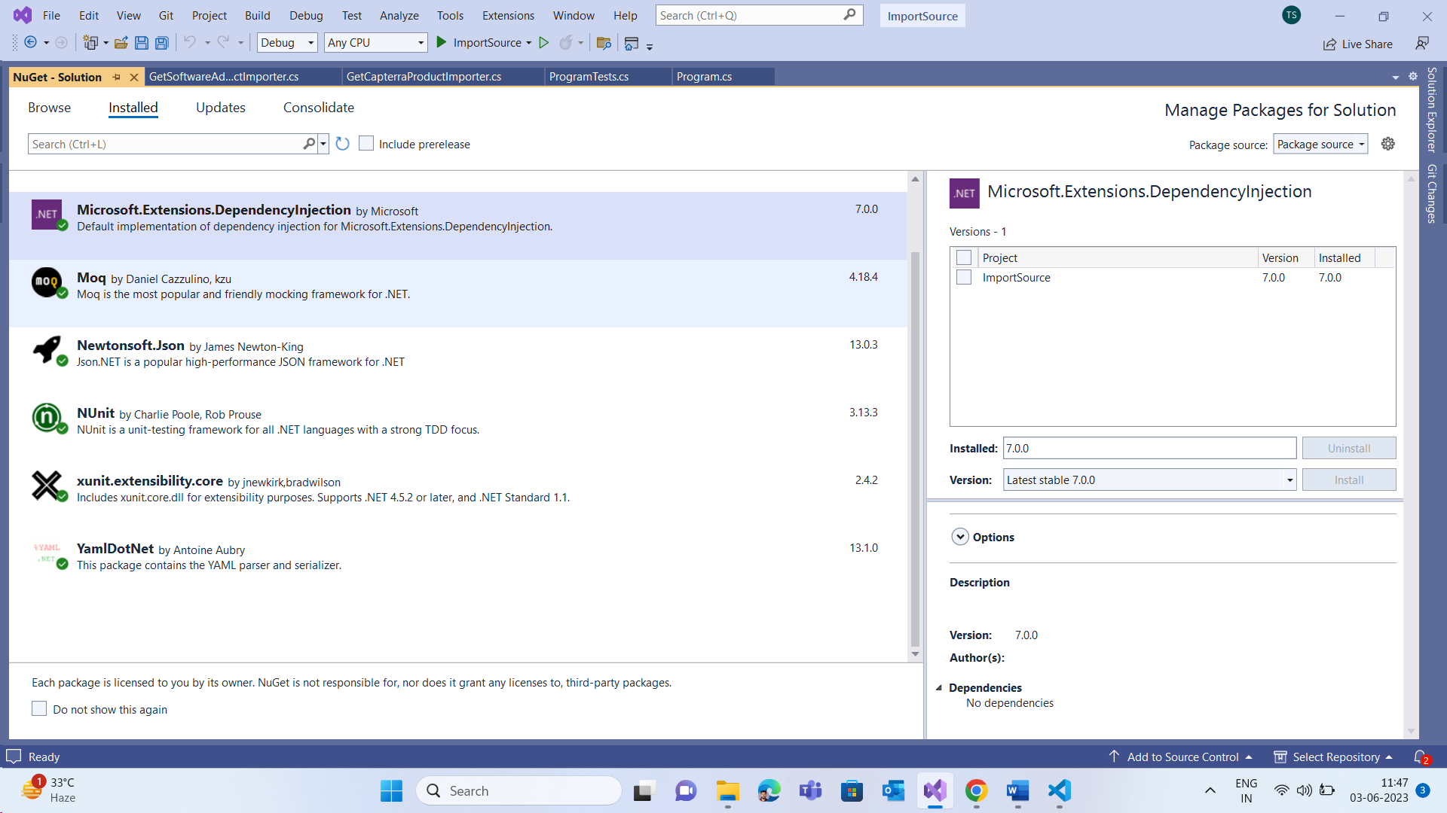

* Moq:

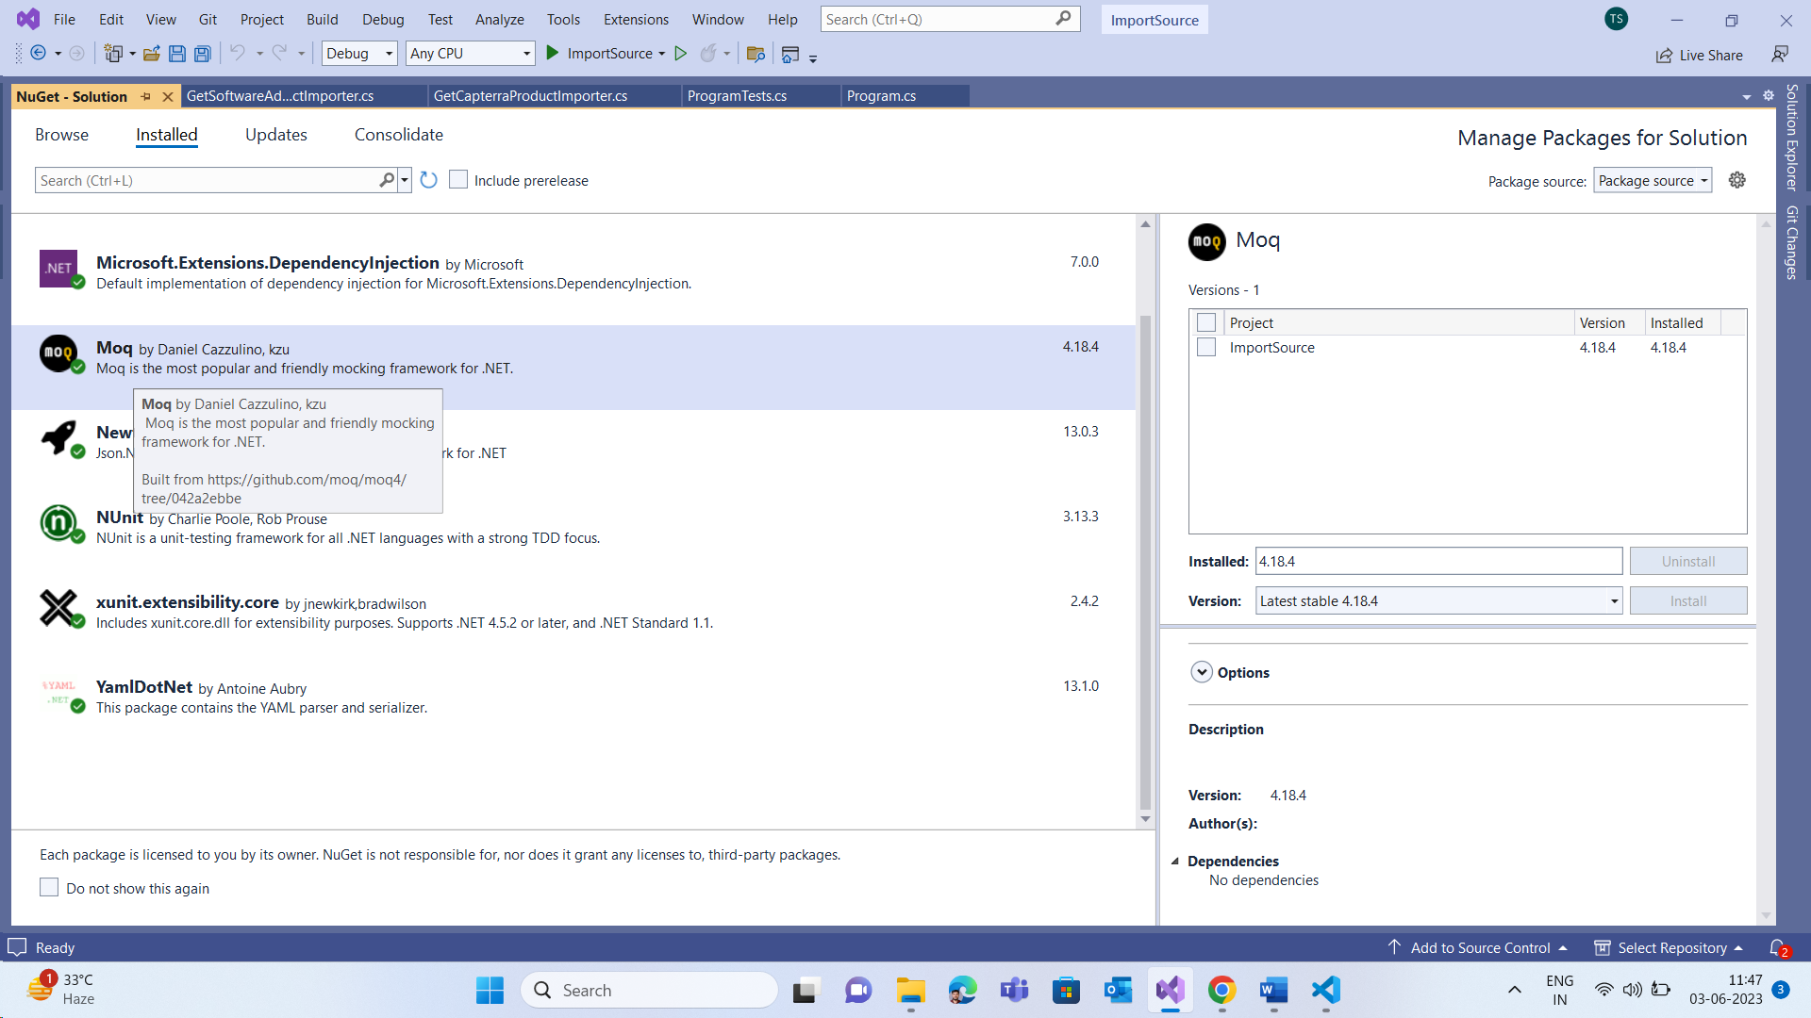

* Newtonsoft.Json:

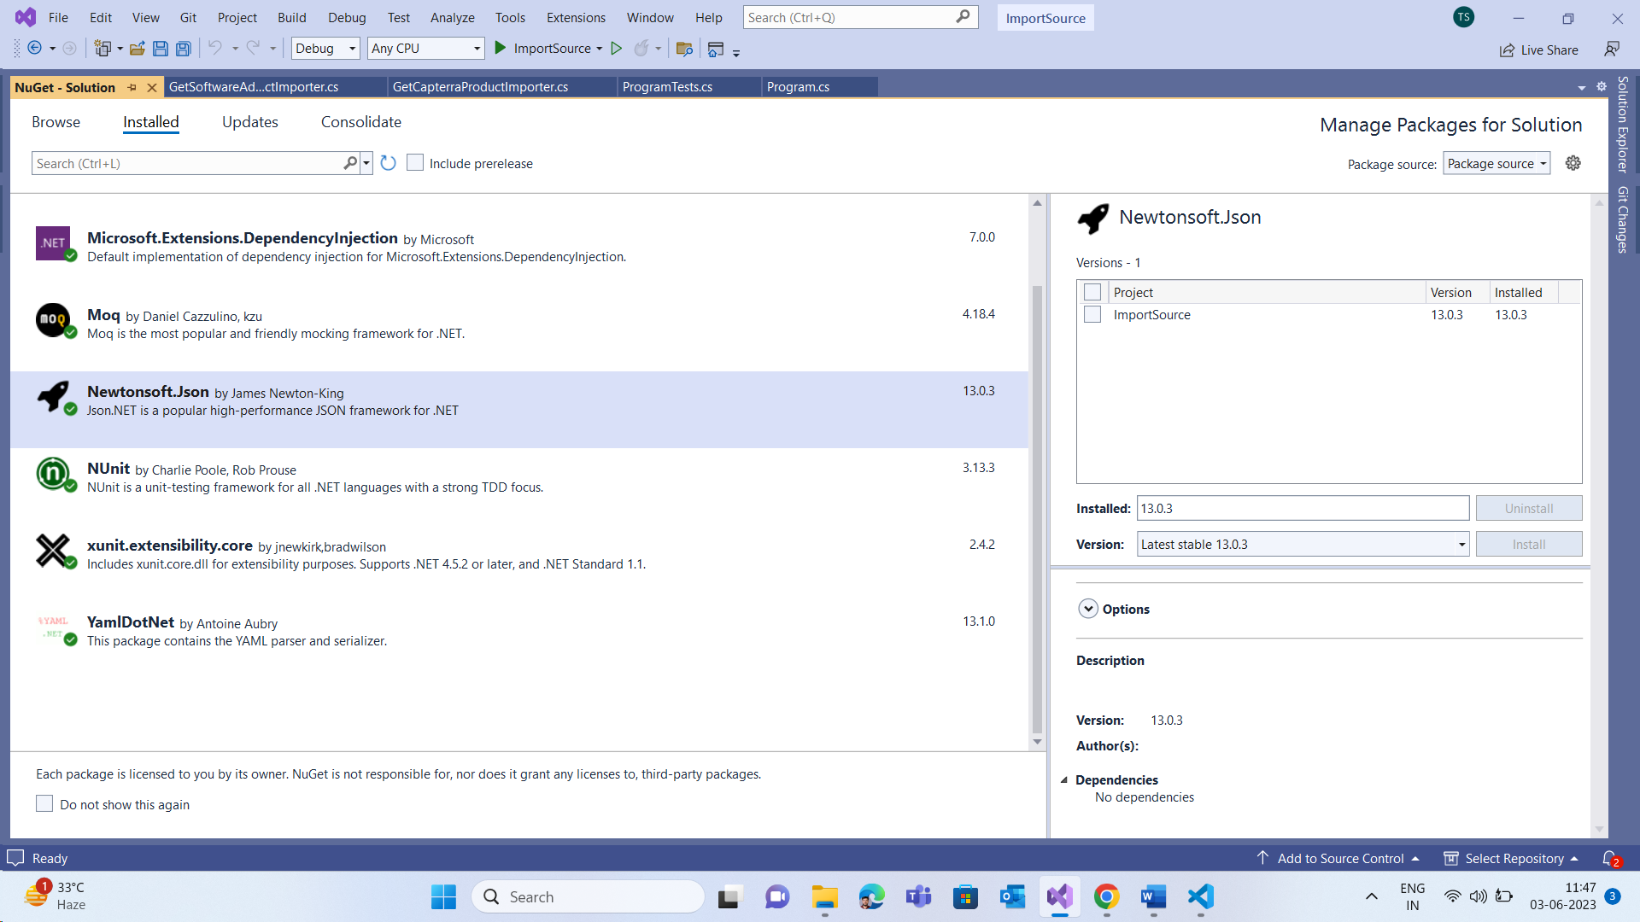

* NUnit:

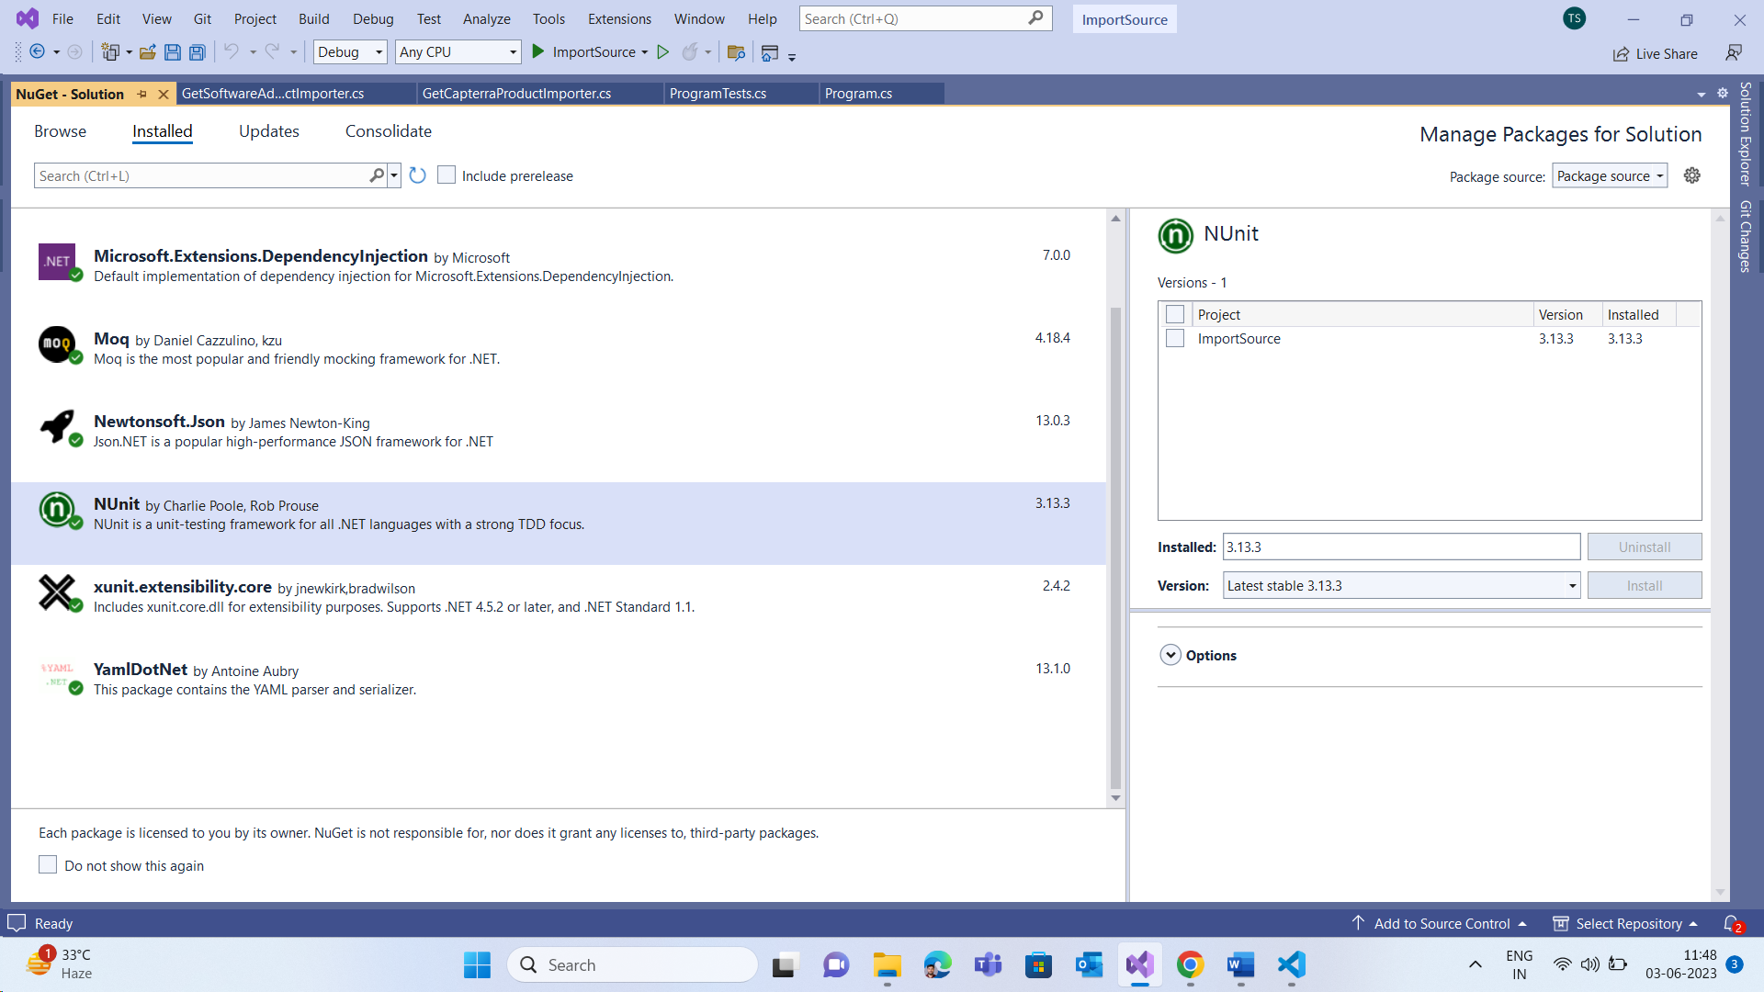

* YamlDotNet:

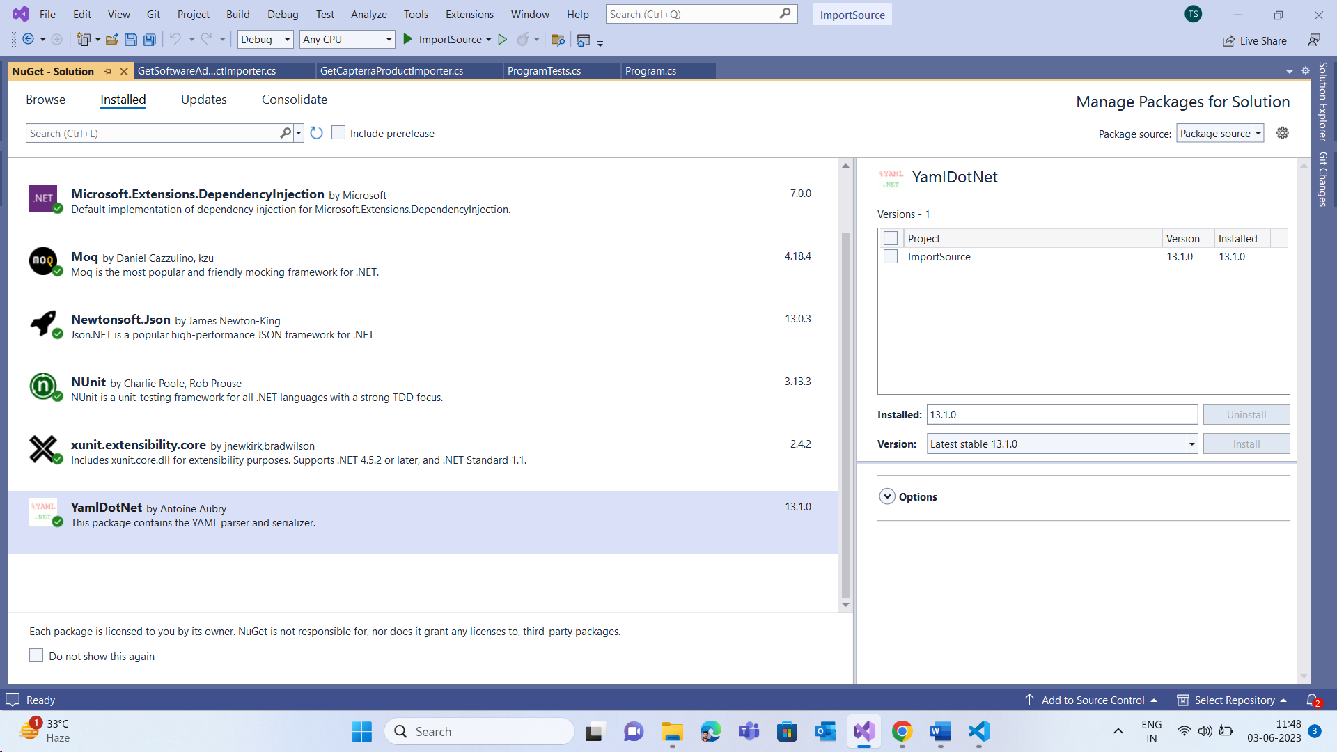

1. **How to Run Application:**

* Go to location where exe is present:

“D:*ImportSource*\ImportSource\bin\Debug\net6.0”

* Open Command Prompt on location:

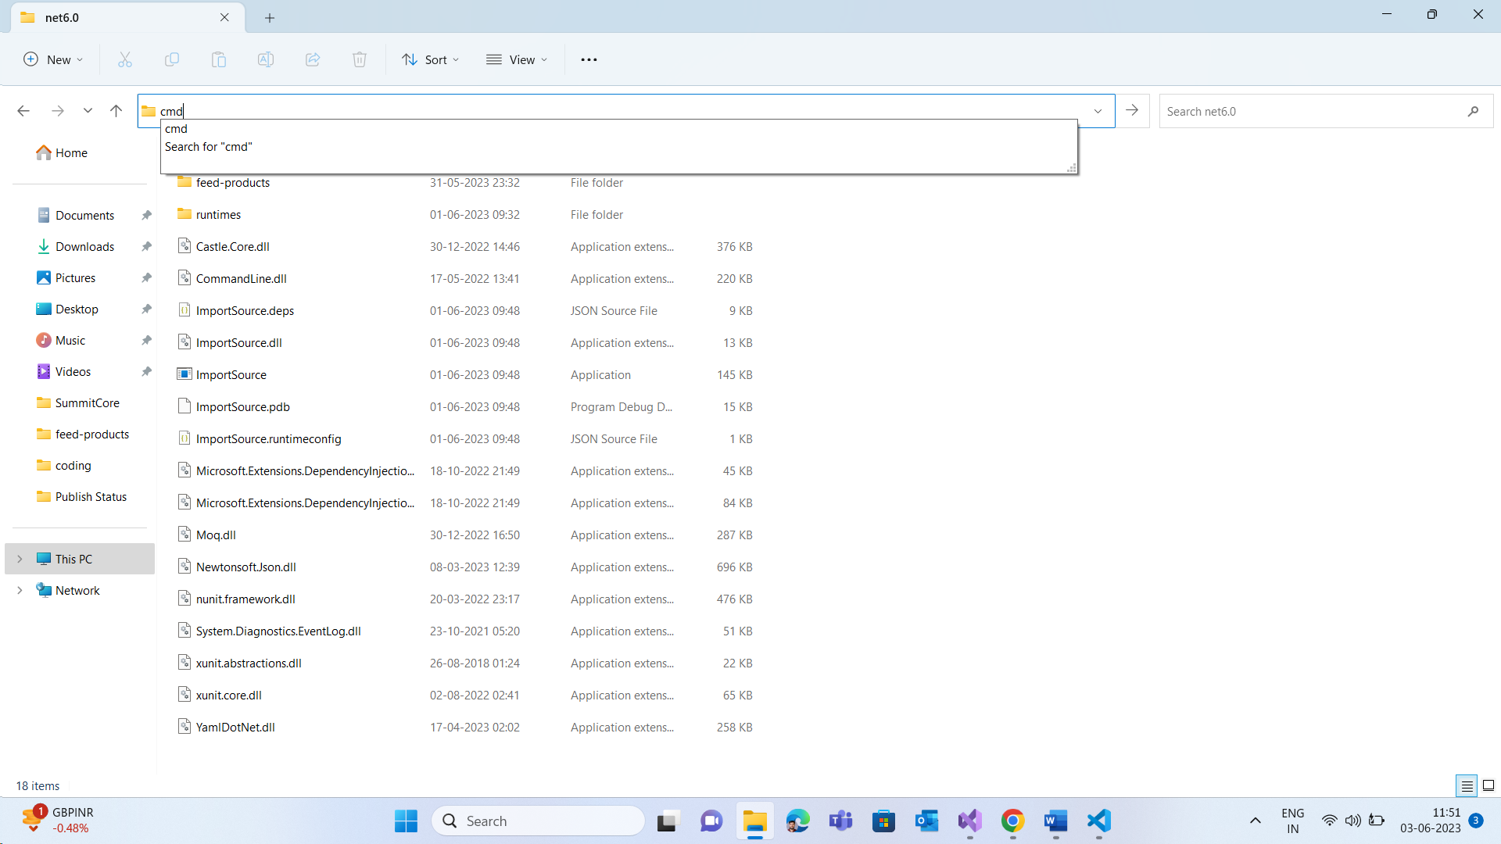

* Give Input as per requirement:
* Imput: “ImportSource.exe capterra feed-products/capterra.yaml”

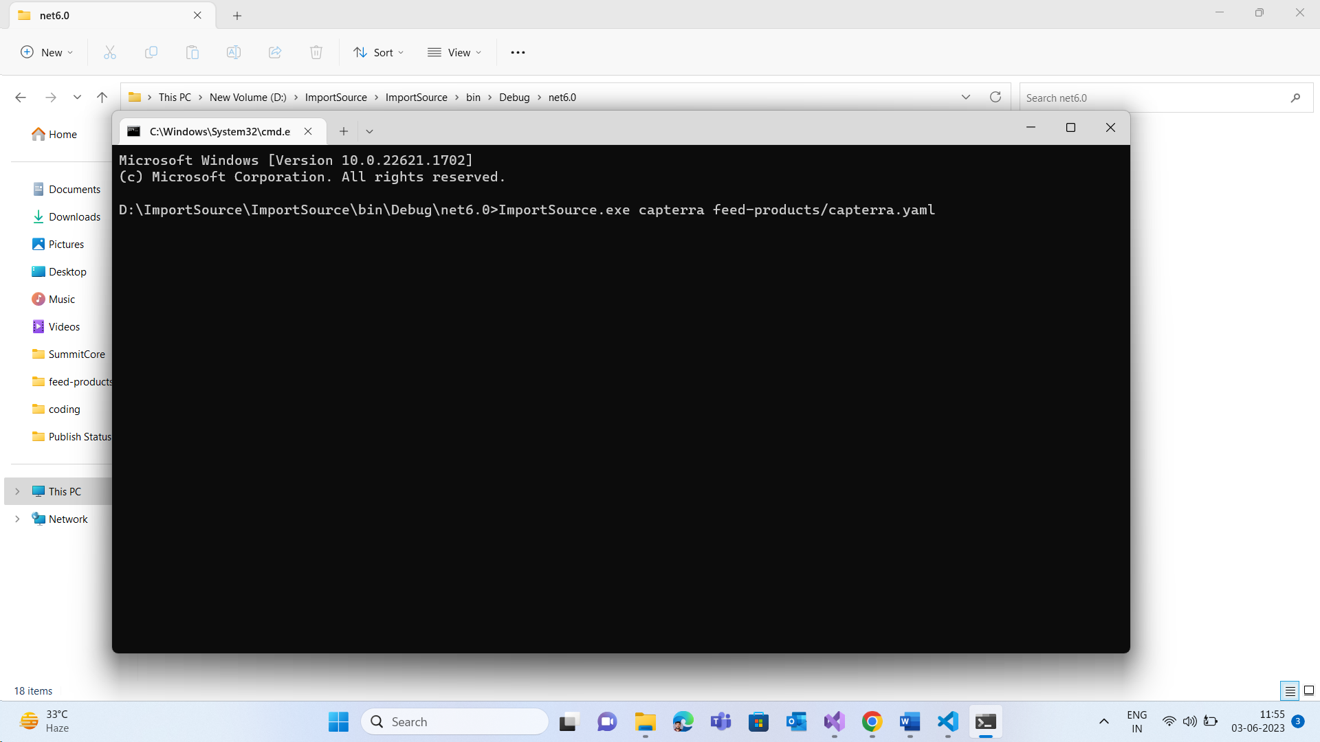

* Gives required Output:

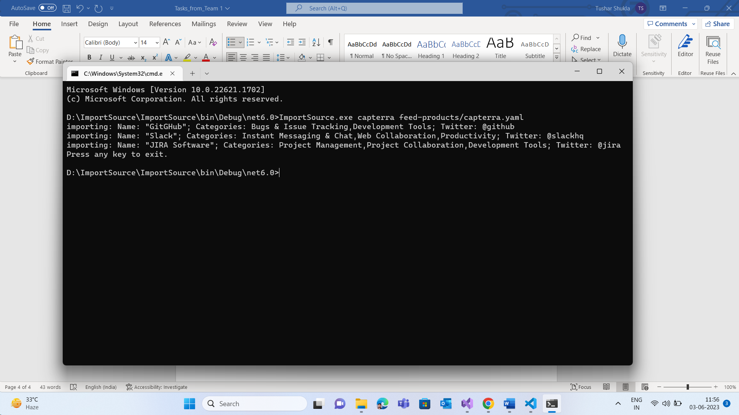

1. **Where to find code:**

* Download the zip file ImportSources.
* Extract all files in it and go inside Folder Import Source where you will see ImportSource.sln

Location: “*D:\ImportSource.zip\ImportSource*”

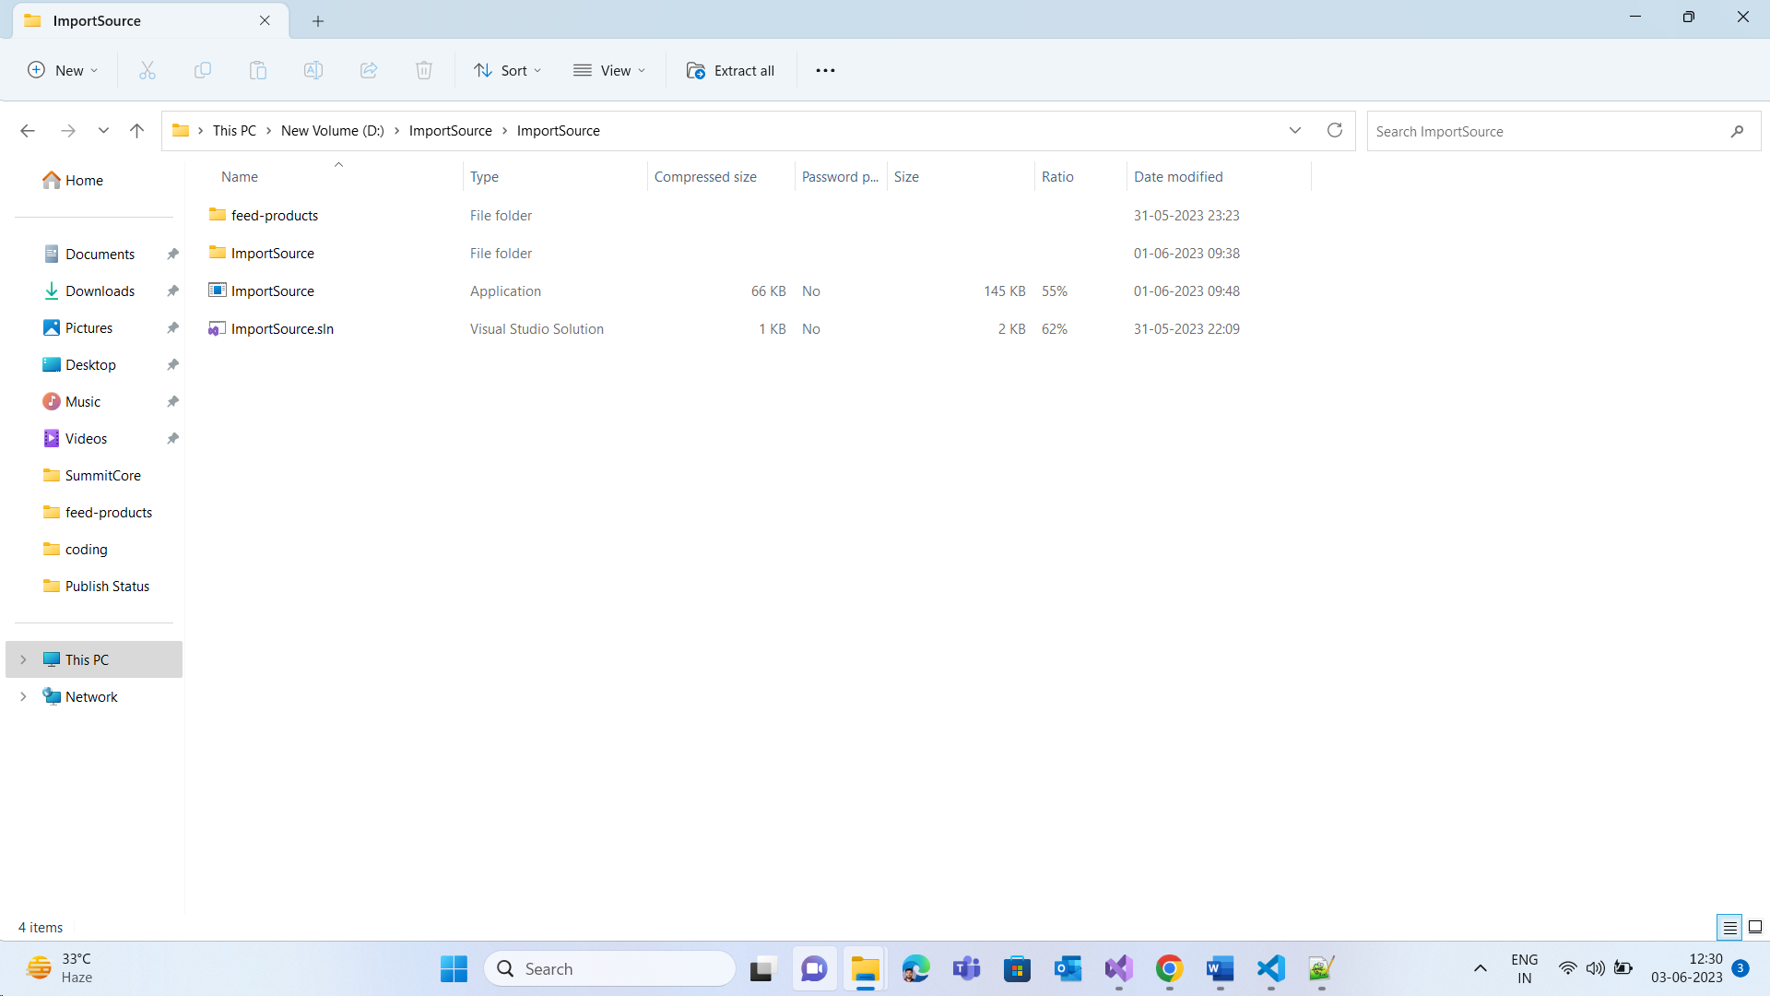

1. **Testing:**

I have included Test Cases in this solution. I am using n-unit testing which I have used before. I don’t have much experience in writing unit test cases.

1. **Improvements (In case of more time given):**

If I had more time I would have created made this application more compatible for other file types as well.