**Login Screen - user can login using his/her Gmail….**

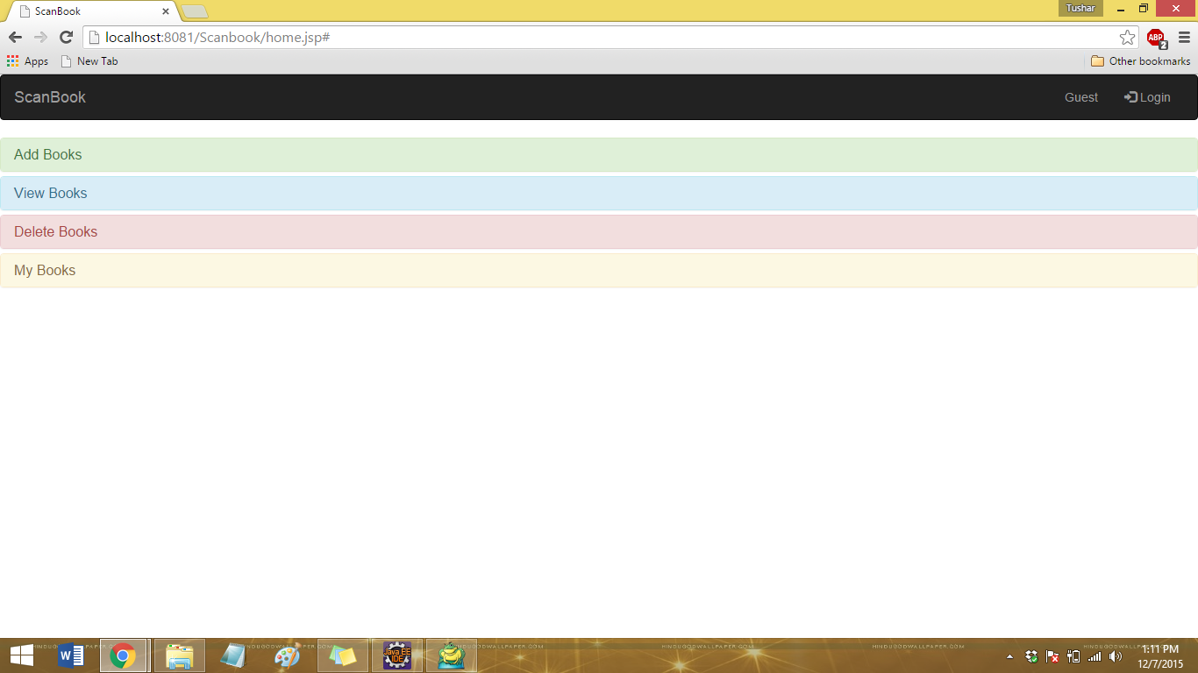

**Logged in as User – User Profile in Navigation Bar**

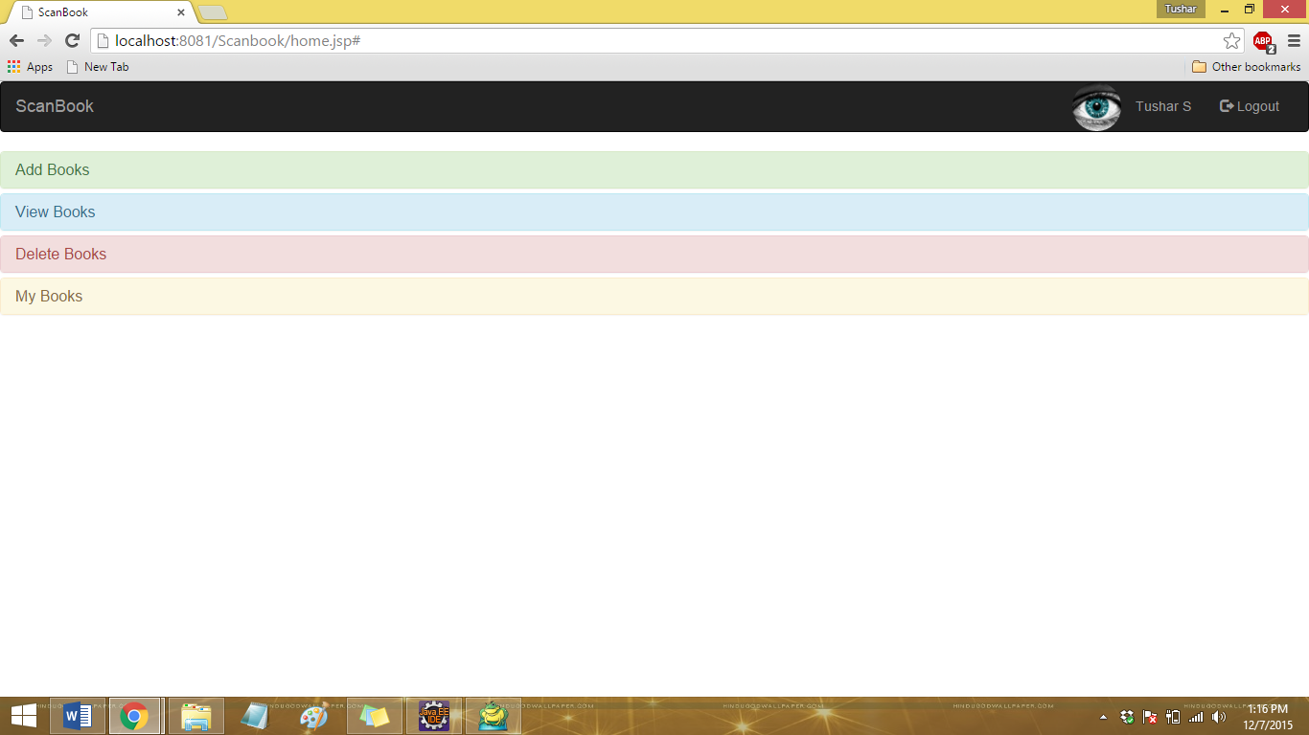

**Add Books – User can Save a Book with all attributes… (Includes User Rating)**

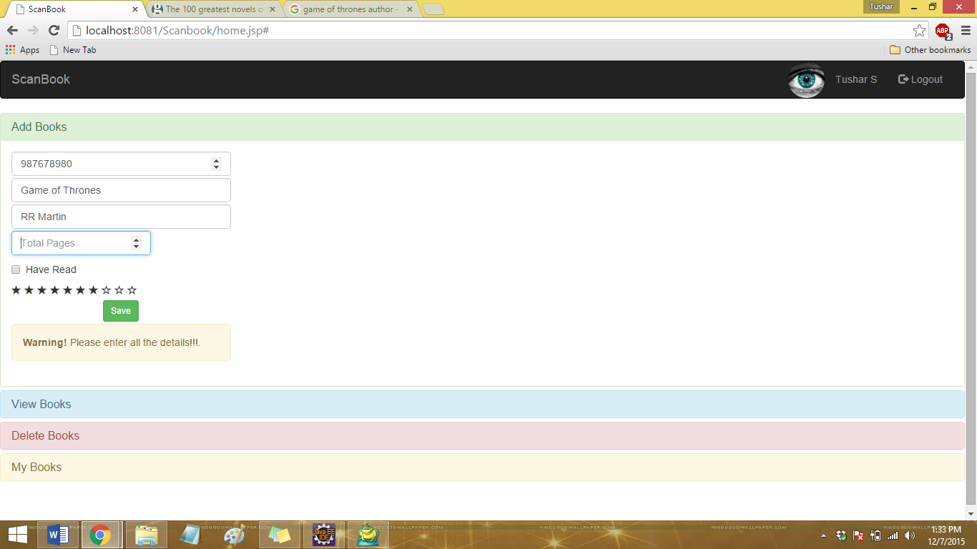

**Add Books – Books Saved Successfully – Prompt after entering all the details and saving.**

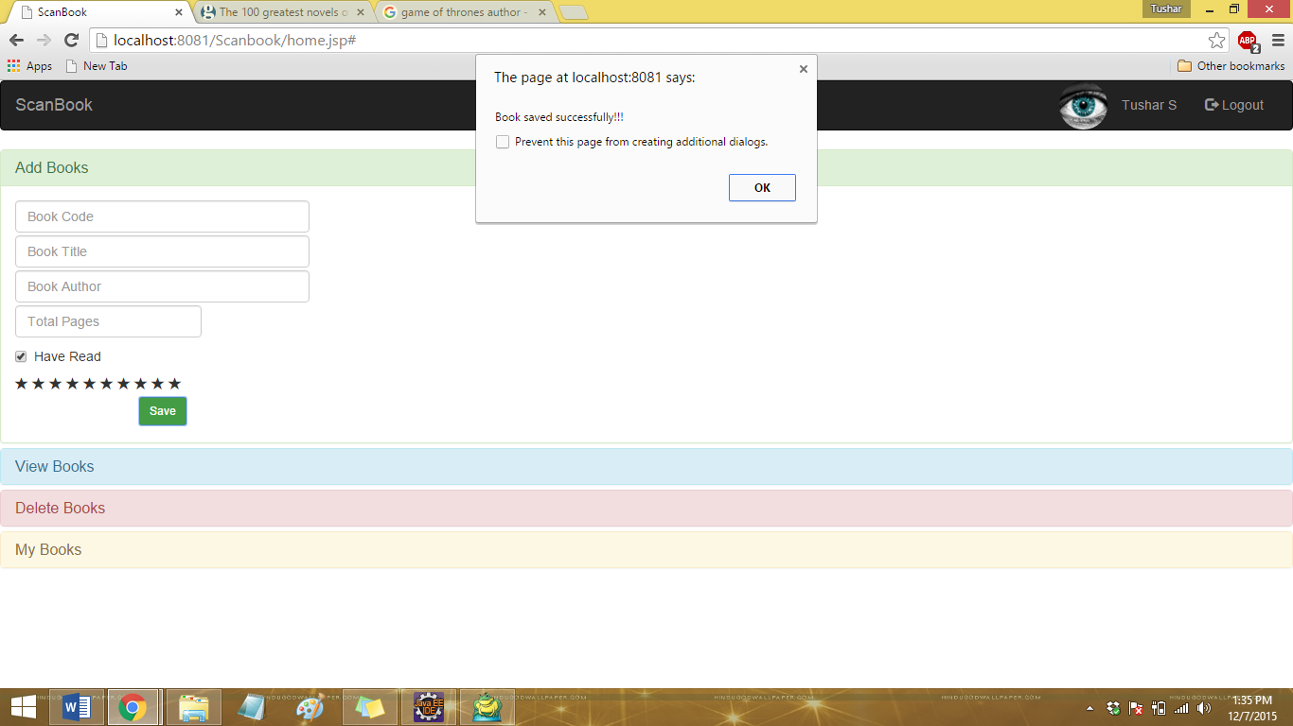

**View Books – Display a book based on barcode search**

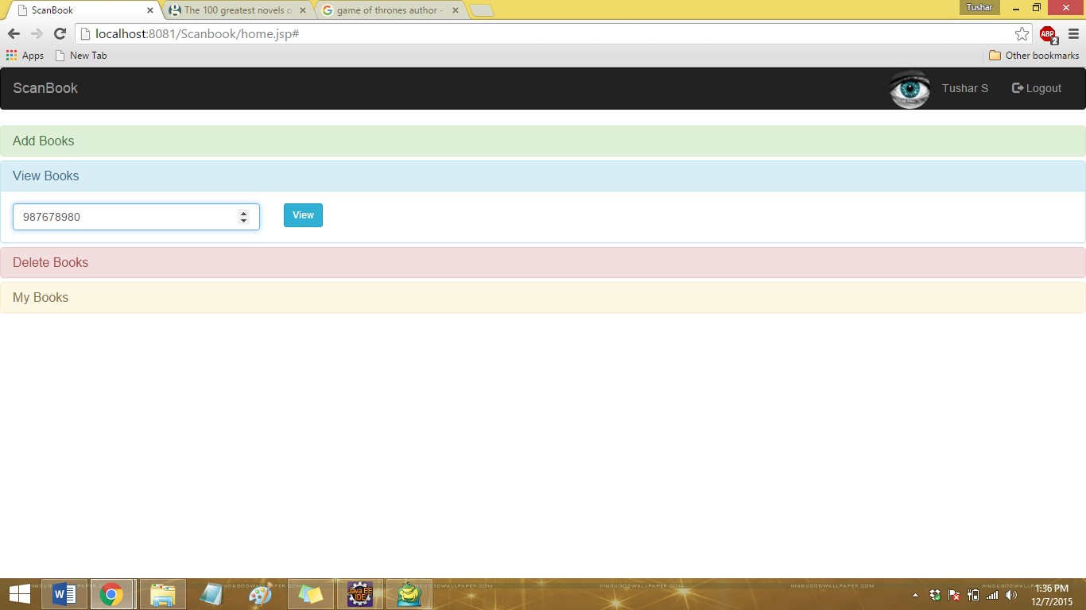

**View Books – Details of the book displayed along with user rating (Clear Search for removing the details from view)**

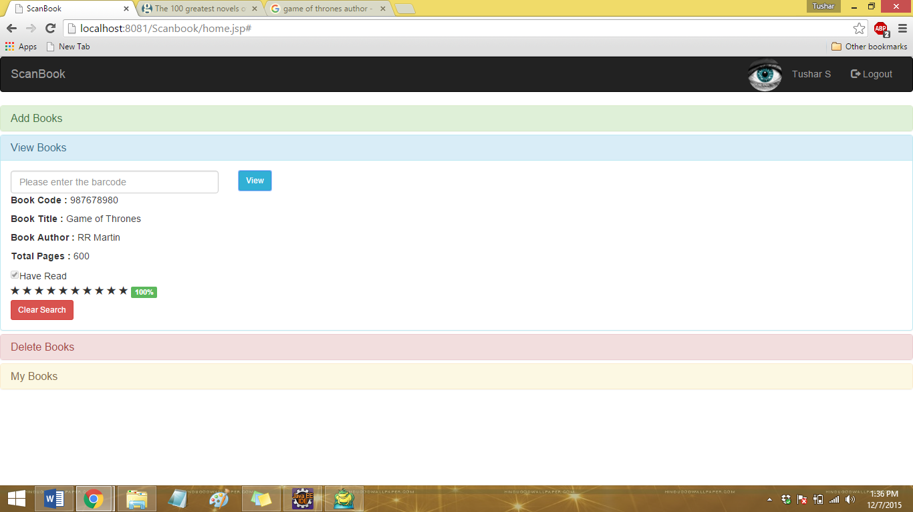

**My Books – User Inventory – To display the list of books user has added**

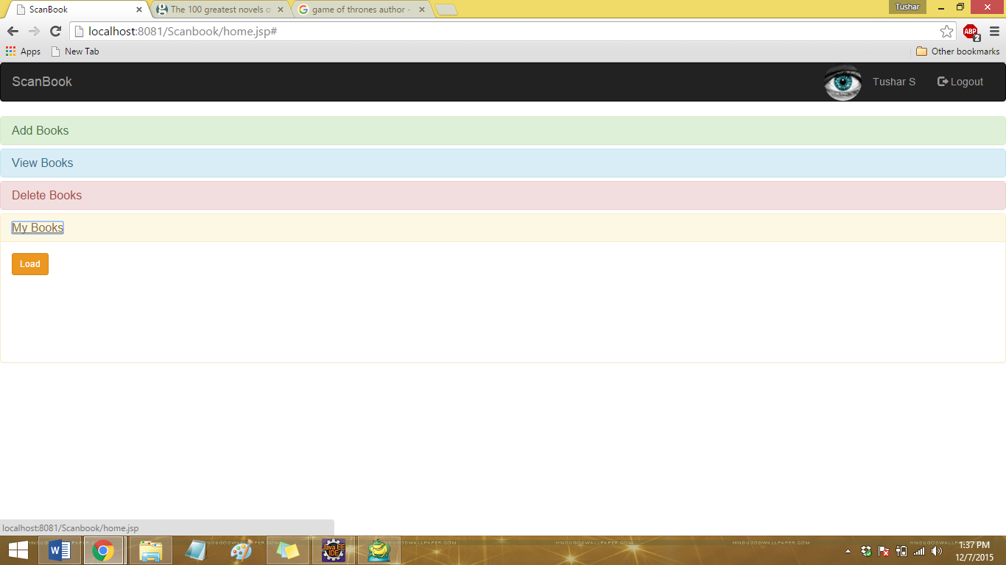

**Inventory display and can be reloaded**

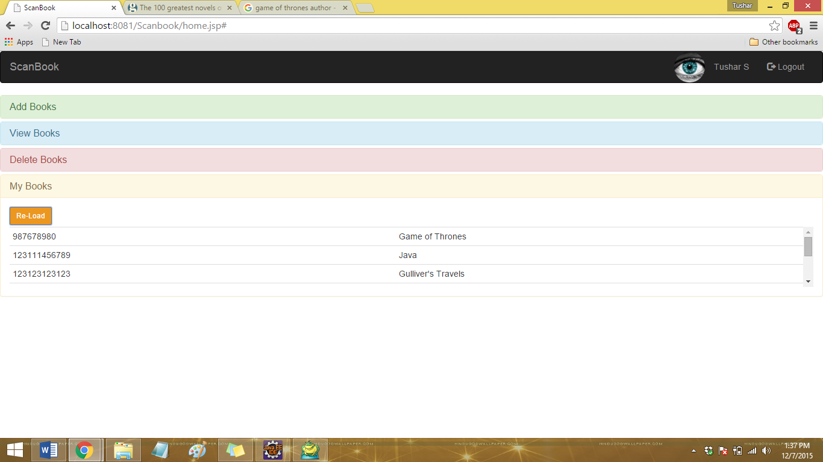

**Delete Books – User can delete a book based on the barcode**

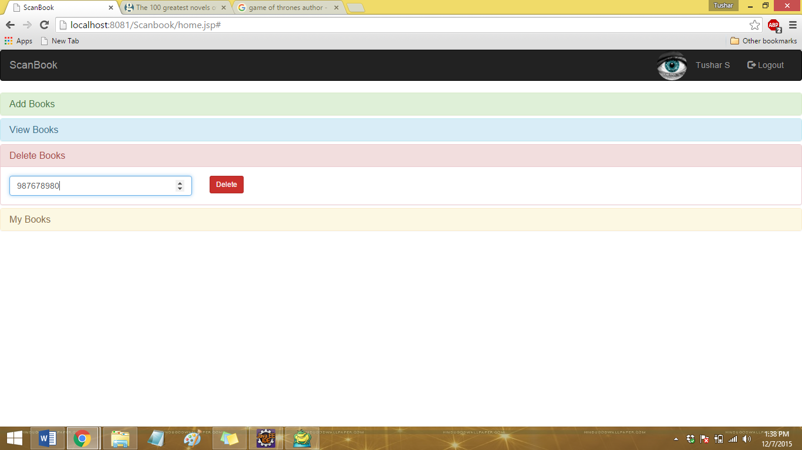

**Delete Books – Books deleted successfully – Prompt after deleting all the book.**

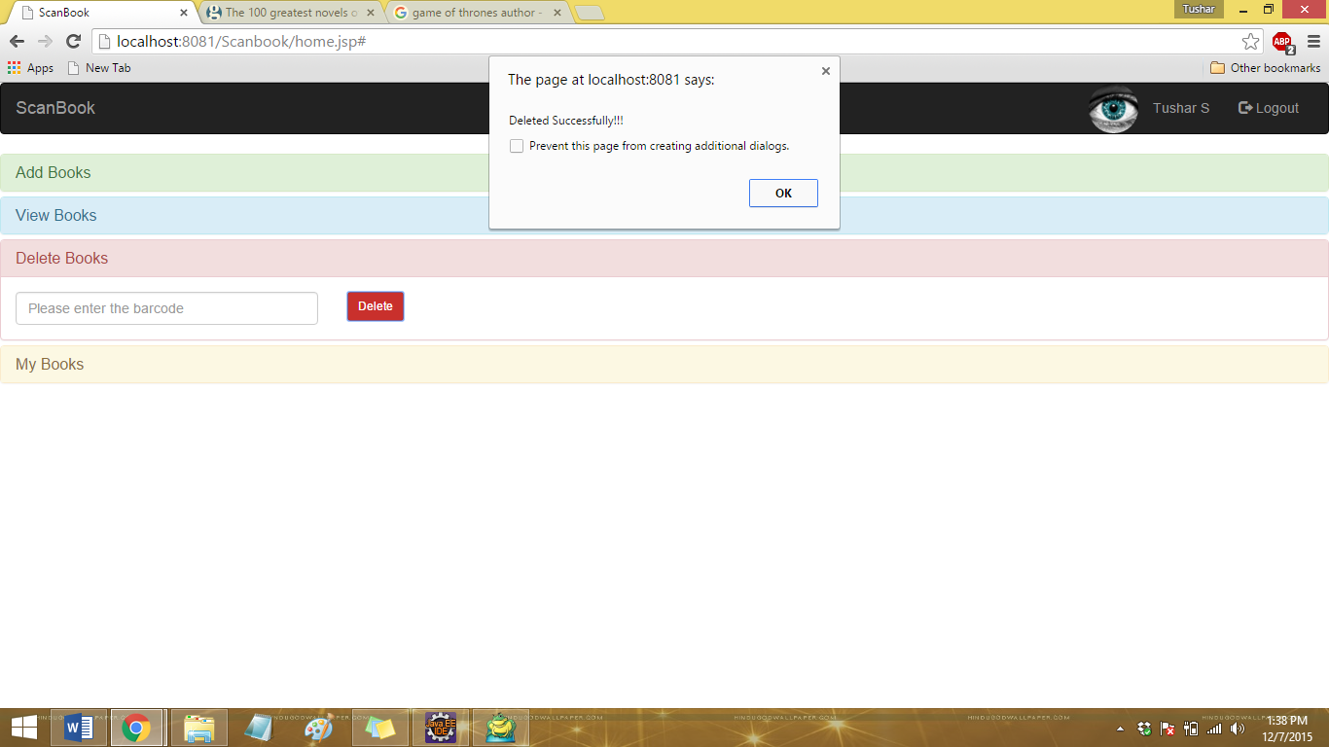

**My Books – Book removed from user’s inventory after deletion**

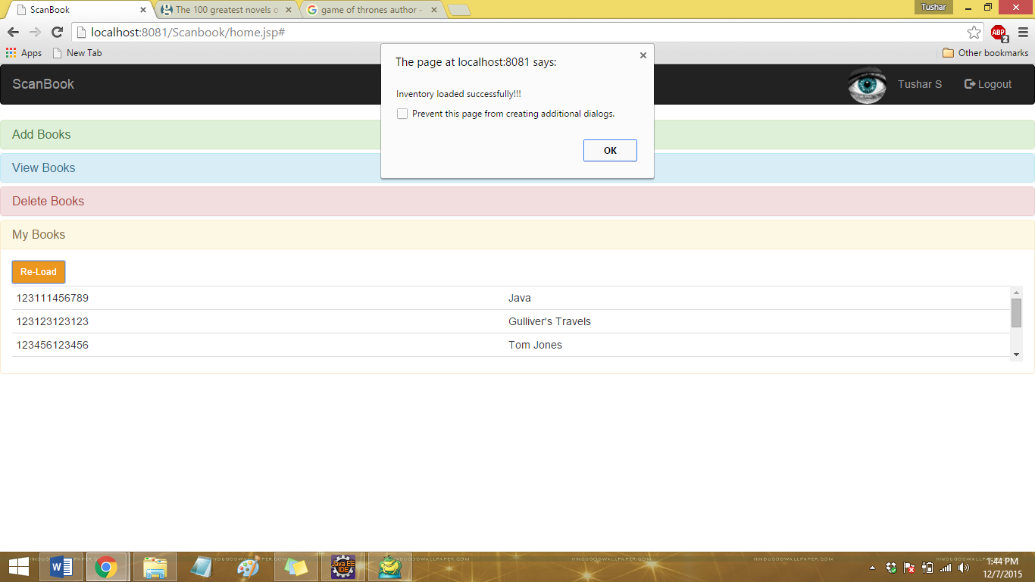

**Different User Login**

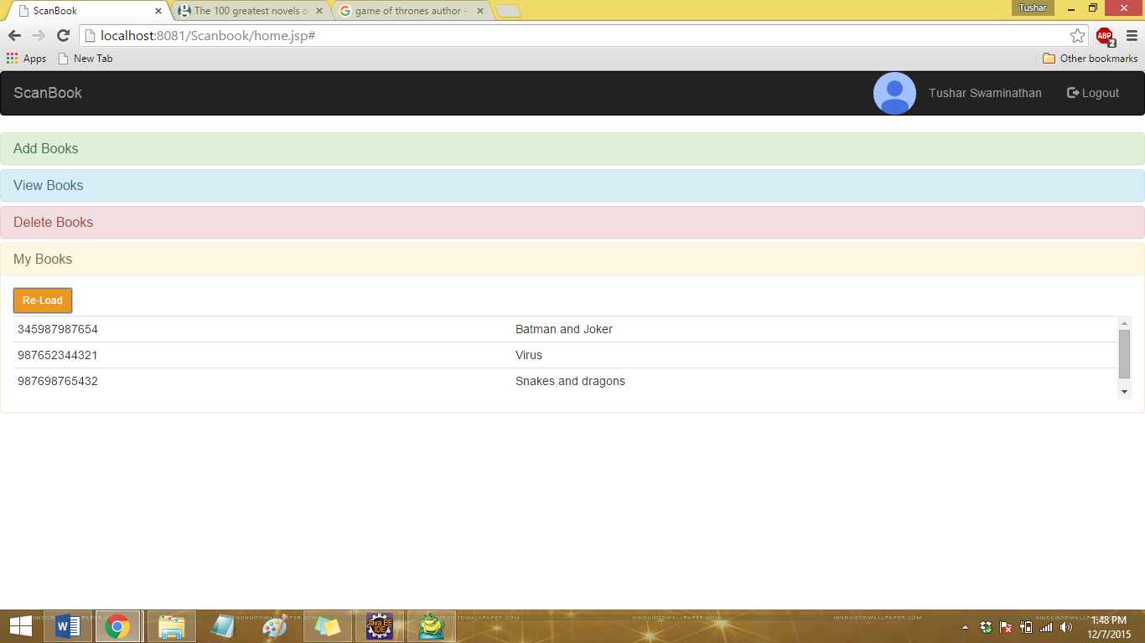

**Responsive design – UI changes to fit the screen size**

|  |  |
| --- | --- |
| Apple IPhones | Android Phones |
|  |  |
| Apple IPad | |
|  | |