**Login Using your Gmail Account for saving the user info…..**

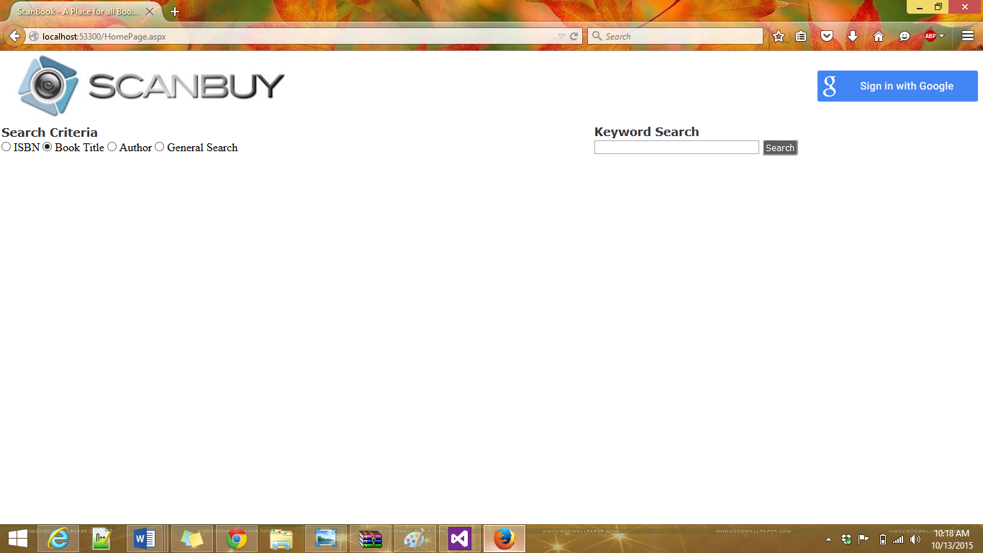

**Account login screen ……**

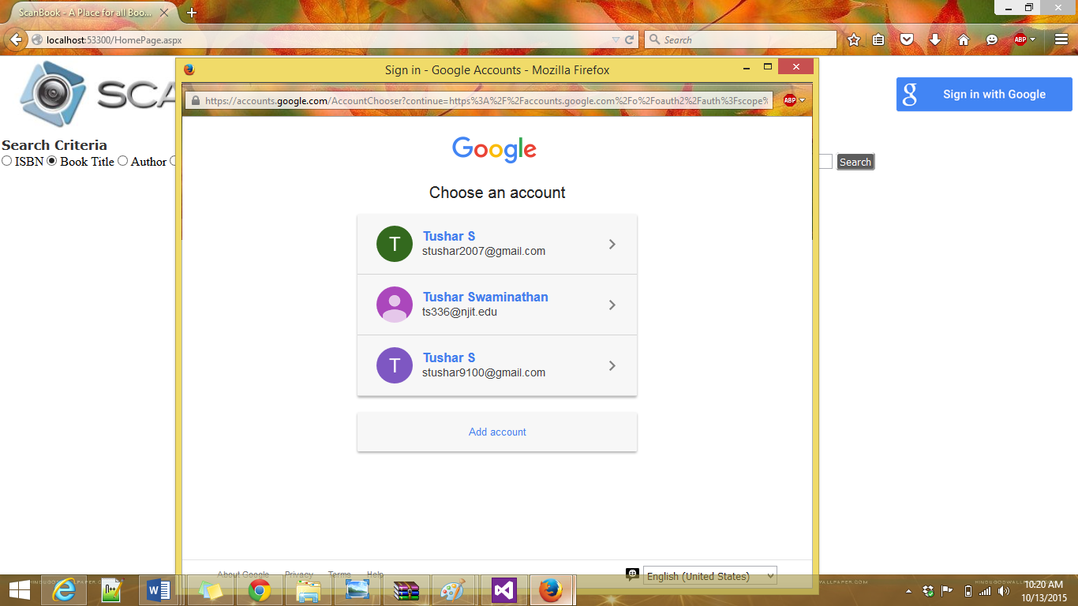

**Select “Search Criteria” and enter the “Keyword” to search…Gets books from google API (if not in DB)**

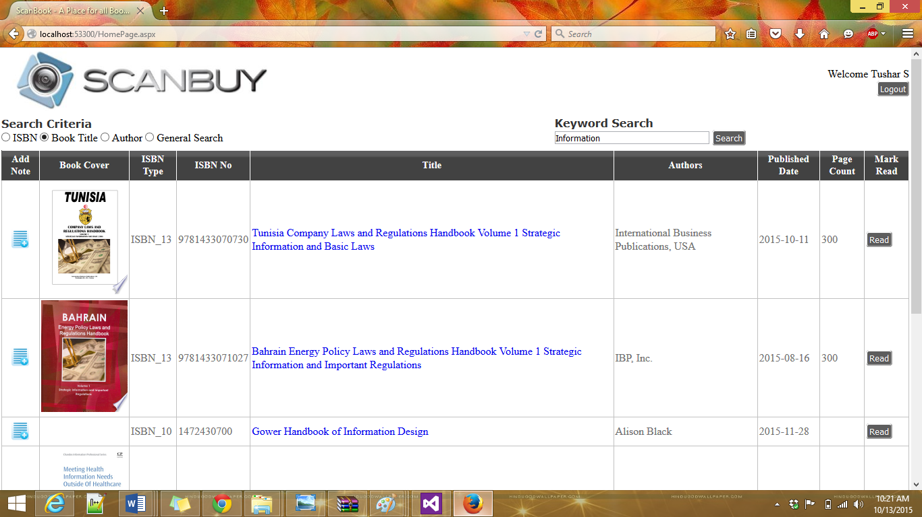

**Add Note section allows you to add a “Note” to the specific book you select…**

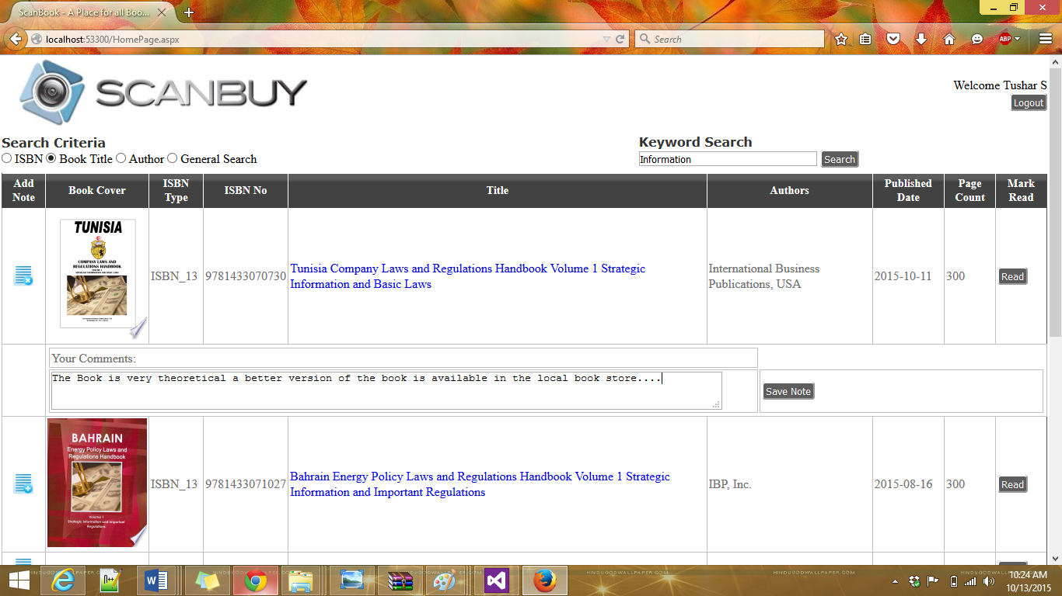

**Note Saved Successfully….**

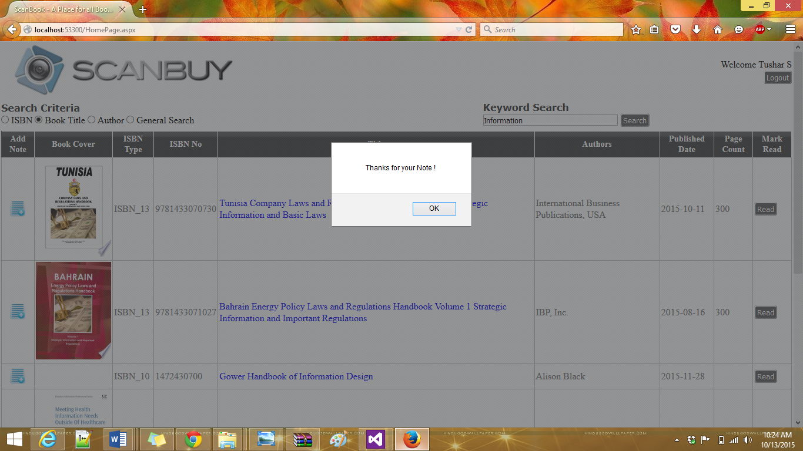

**Note is displayed along with the book…. and is now visible to all users…**

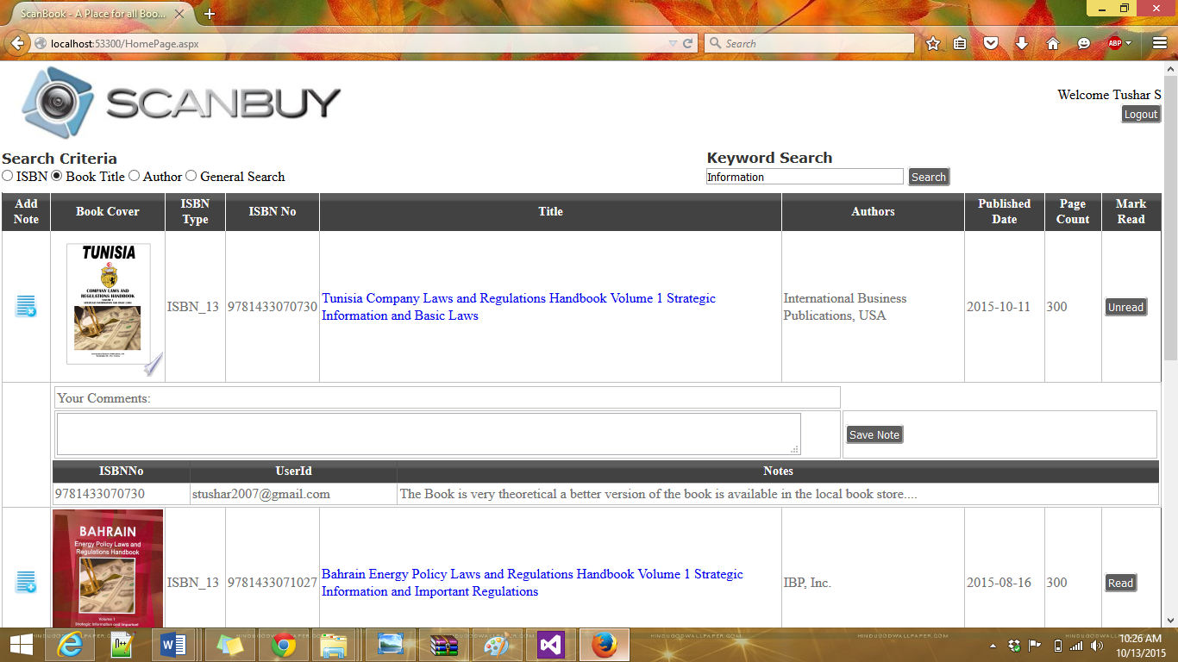

**Log Out of the current login….Message prompt to user…**

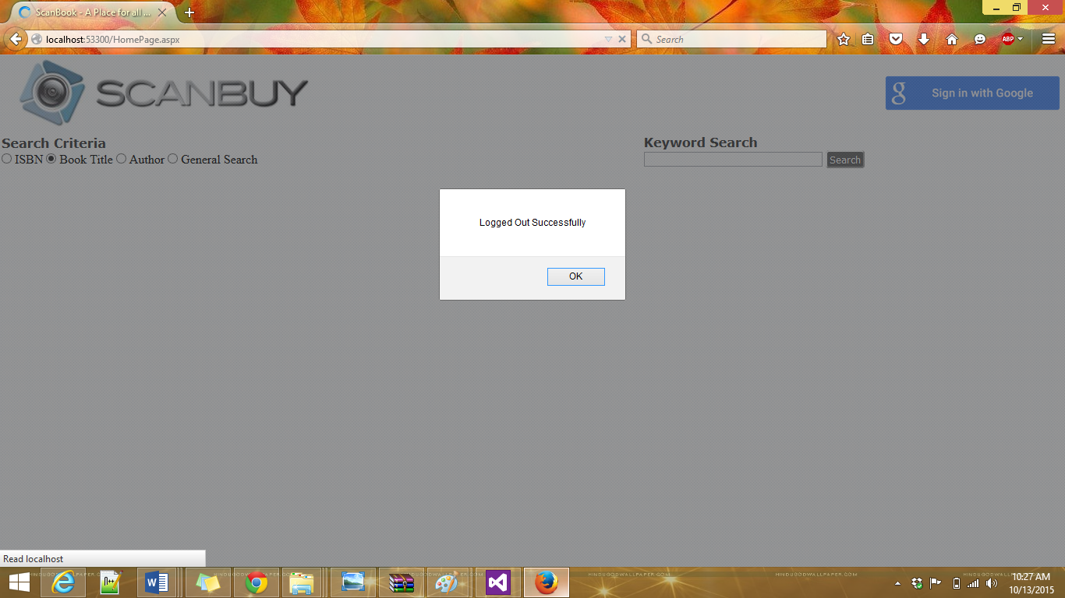

**Different User Login Screen……**

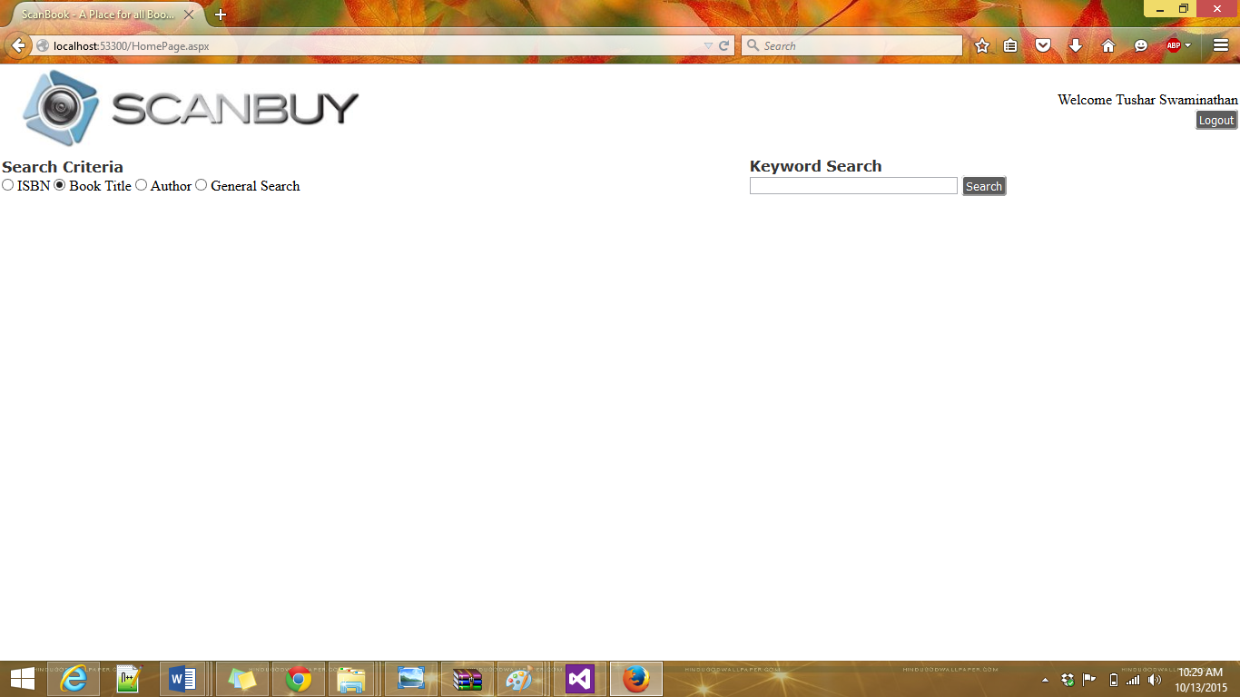

**Book is saved into database when previous user viewed the details…. So data is retrieved from database….**

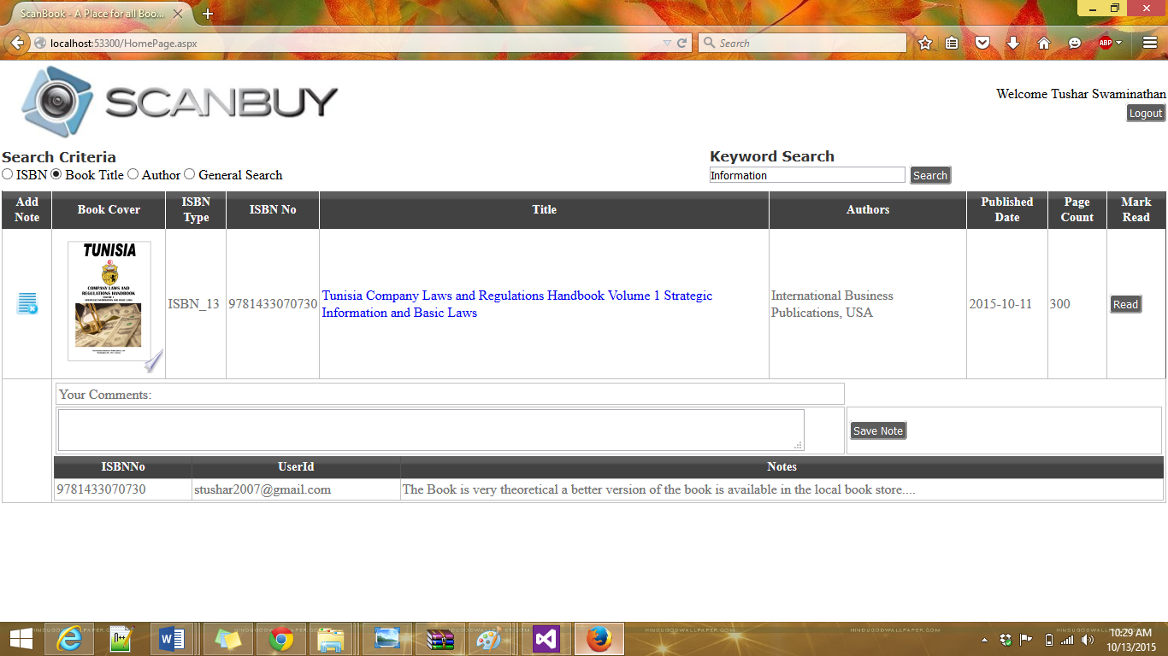

**New User enters comments for the same book……**

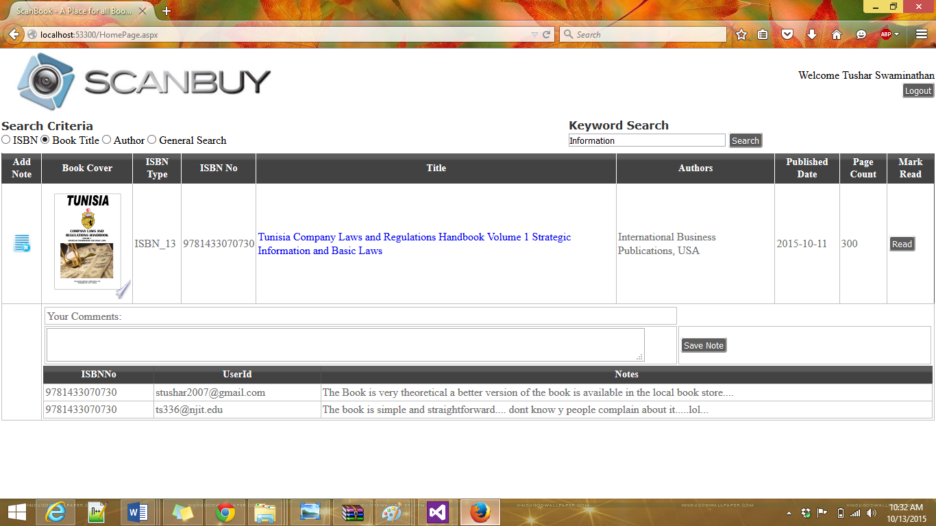

**ISBN Search… retrieves a single book…..**

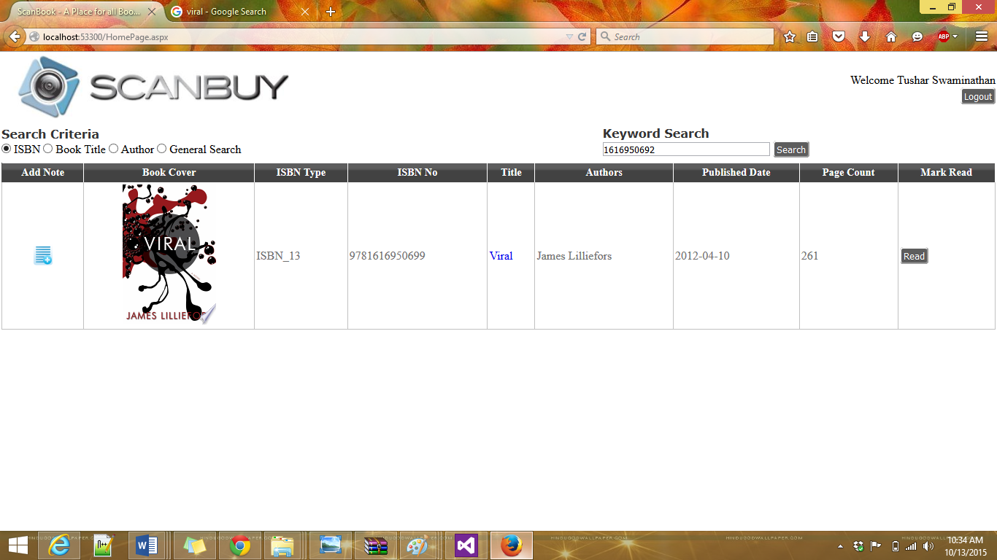

**Other Functionalities like client side validation, Async Await features are also used….**