PROJECT REPORT ON

Real-Time Hand Gesture Volume Control Using OpenCV and Media Pipe

SUBMITTED TO THE PCET’S PIMPRI CHINCHWAD COLLEGE OF ENGINEERING AN AUTONOMOUS INSTITUTE, PUNE
IN THE PARTIAL FULFILLMENT OF THE REQUIREMENTS FOR
FIRST YEAR
MASTER OF TECHNOLOGY (COMPUTER ENGINEERING)

SUBMITTED BY

TUSHAR RAJENDRA BHOSALE PRN No: 125M1B005


DEPARTMENT OF COMPUTER ENGINEERING

PCET’S PIMPRI CHINCHWAD COLLEGE OF ENGINEERING

Sector No. 26, Pradhikaran, Nigdi, Pimpri-Chinchwad, PUNE 411044 An Autonomous Institute Approved by AICTE and Affiliated to SPPU, Pune


CERTIFICATE
This is to certify that the project report entitles

“Real-Time Hand Gesture Volume Control Using OpenCV and Media Pipe”

Submitted by
TUSHAR RAJENDRA BHOSALE PRN No: 125M1B005

are bonafide students of this institute and the work has been carried out by them under the supervision of Prof. Harshada Raut and it is approved for the partial fulfilment of the requirement of PCET’S PIMPRI CHINCHWAD COLLEGE OF ENGINEERING, for the award of First Year of Master of Technology (Computer Engineering) A.Y.-2025-26.

Place: Pune Date:
Prof. Harshada Raut
Department of Computer Engineering

ABSTRACT

Human-Computer Interaction (HCI) has evolved rapidly with the advancement of Computer Vision, Artificial Intelligence, and Machine Learning technologies. Traditional input devices such as keyboards, mice, remote controls, and physical buttons often limit seamless interaction between users and computer systems. In modern smart environments, touchless interaction systems are becoming increasingly important due to their convenience, accessibility, and efficiency. Gesture recognition systems provide a natural and intuitive way for users to communicate with digital devices through hand movements without requiring physical contact.

This project presents a real-time hand gesture-based volume control system using OpenCV, MediaPipe, and Python. The proposed system captures live video through a webcam and processes each frame in real time using Computer Vision techniques. MediaPipe Hands is used to detect and track hand landmarks accurately, while OpenCV performs video frame acquisition and processing. The system extracts the coordinates of the thumb tip and index finger tip and calculates the Euclidean distance between them. Based on the measured distance, the system dynamically adjusts the system volume level.

The proposed approach provides a touchless, cost-effective, and user-friendly solution for Human-Computer Interaction without requiring specialized hardware or sensors. The implementation demonstrates accurate gesture recognition, smooth volume adjustment, and real-time responsiveness with minimal latency. The system performs efficiently under normal lighting conditions and provides an interactive user experience through visual feedback such as hand landmarks, gesture tracking, volume bars, and percentage display.

The developed system can be applied in various domains such as smart homes, gaming systems, virtual reality environments, multimedia control systems, assistive technologies, healthcare applications, and touchless user interfaces. Future enhancements may include multi-hand gesture recognition, AI-based gesture classification, voice-assisted interaction, and integration with IoT-enabled smart devices. The project highlights the growing importance of gesture-based interfaces and demonstrates the practical application of Computer Vision and Video Processing techniques in real-time systems.

INDEX

Introduction

Objectives

Literature Survey

Existing System

Proposed System

System Architecture

Methodology

Algorithm

Implementation

Results and Discussion

Applications

Advantages and Limitations

Future Scope

Conclusion

References

1. INTRODUCTION

Human-Computer Interaction (HCI) has experienced rapid growth due to advancements in Computer Vision and Artificial Intelligence. Gesture recognition systems allow users to communicate with computers naturally using hand movements instead of traditional input devices.

Traditional volume control systems rely on keyboards, buttons, touchscreens, or remote controls. Although effective, these methods are not always suitable for touchless interaction environments such as healthcare systems, smart homes, gaming systems, and virtual reality applications.

The proposed system utilizes OpenCV and MediaPipe frameworks for real-time hand tracking and gesture recognition. The distance between the thumb and index finger is used to control system volume dynamically.

The project demonstrates a low-cost, real-time, and user-friendly gesture-based volume control system.

2. OBJECTIVES

The main objectives of the project are:

To develop a real-time hand gesture recognition system.

To control system volume using hand gestures.

To implement touchless Human-Computer Interaction.

To achieve smooth and accurate gesture detection.

To create a low-cost and user-friendly system.

To apply Computer Vision and Video Processing concepts in real-time applications.

3. LITERATURE SURVEY

Several researchers have proposed gesture-based Human-Computer Interaction systems using Computer Vision techniques.

Kanagamalliga et al. proposed a hand gesture recognition system using shape-based feature recognition for volume control applications. Their system demonstrated accurate gesture detection and improved user interaction.

Syed Musthafa et al. presented a touchless volume control system using OpenCV, MediaPipe, and Pycaw libraries. Their system utilized the distance between thumb and index finger landmarks to control audio volume in real time.

Shruti Kansal et al. discussed gesture-based volume control in Augmented Reality and Virtual Reality applications using OpenCV, MediaPipe, and Pycaw.

Nishant Kumar et al. developed a real-time gesture recognition system using OpenCV and shape-based feature extraction for device control applications.

Existing systems provide effective gesture recognition but may suffer from limitations such as hardware dependency, lighting sensitivity, and computational complexity.

4. EXISTING SYSTEM

Existing volume control systems mainly rely on physical devices such as keyboards, buttons, sliders, and remote controls.

Limitations of Existing System

Requires physical interaction.

Limited accessibility.

Not suitable for touchless environments.

Less intuitive interaction.

Dependency on external input devices.

5. PROPOSED SYSTEM

The proposed system implements a real-time hand gesture-based volume control interface using Computer Vision techniques.

The system workflow includes:

Capturing live webcam video.

Processing video frames using OpenCV.

Detecting hand landmarks using MediaPipe.

Measuring the distance between thumb and index finger.

Mapping finger distance to volume level.

Adjusting system volume dynamically.

The proposed system eliminates the need for physical controllers and provides a touchless interaction method.

6. SYSTEM ARCHITECTURE

System Architecture Flow

Webcam Input ↓ Frame Capture using OpenCV ↓ MediaPipe Hand Landmark Detection ↓ Feature Extraction ↓ Distance Calculation ↓ Volume Mapping ↓ System Volume Adjustment ↓ Output Display

Description of Modules

A. Video Capture Module

Captures real-time webcam video frames.

B. Hand Detection Module

Detects hand landmarks using MediaPipe.

C. Feature Extraction Module

Extracts thumb and index finger coordinates.

D. Distance Calculation Module

Calculates Euclidean distance between landmarks.

E. Volume Mapping Module

Maps distance values to volume percentage.

F. Volume Control Module

Adjusts system volume dynamically.

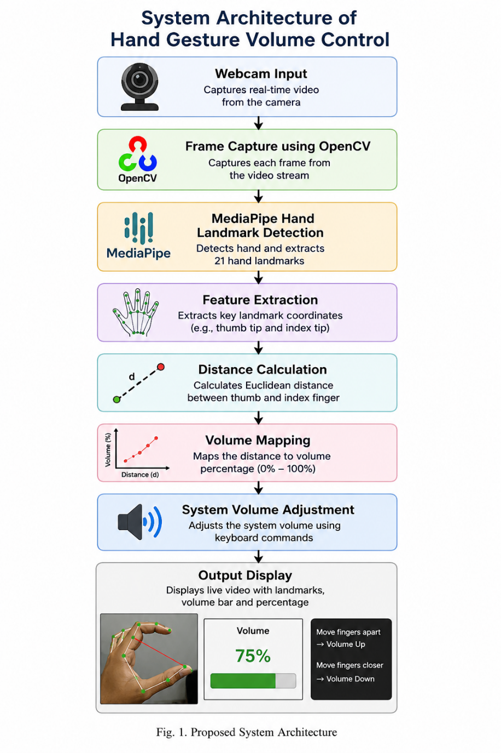

7. METHODOLOGY

The methodology of the proposed system consists of the following steps:

Step 1: Webcam Initialization

The webcam is initialized using OpenCV.

Step 2: Frame Acquisition

Continuous video frames are captured from the webcam.

Step 3: Hand Landmark Detection

MediaPipe Hands detects 21 hand landmarks from each frame.

Step 4: Finger Tracking

Thumb tip and index finger tip coordinates are extracted.

Step 5: Distance Measurement

Distance between landmarks is calculated using Euclidean distance.

Step 6: Gesture Interpretation

The distance is interpreted as a volume level.

Step 7: Volume Adjustment

System volume changes according to finger movement.

Motion Estimation Analysis

The proposed system estimates hand motion by tracking landmark coordinates across consecutive video frames. MediaPipe continuously predicts the positions of 21 hand landmarks, enabling real-time gesture tracking. The movement of the thumb and index finger is analyzed to determine changes in gesture distance. This frame-to-frame coordinate estimation acts as a lightweight motion estimation technique suitable for real-time Human-Computer Interaction.

Motion Vector Equation:

$$M_{t}=(x_{t}-x_{t-1},y_{t}-y_{t-1})$$

Where:

$M_{t}$= motion vector

$x_{t},y_{t}$= current frame coordinates

$x_{t-1},y_{t-1}$= previous frame coordinates

Assumptions:

Hand remains visible in camera view.

Adequate lighting is available.

Single-hand tracking is used.

8. ALGORITHM

Algorithm: Gesture-Based Volume Control

Step 1: Initialize webcam

Step 2: Capture video frame

Step 3: Detect hand landmarks

Step 4: Extract thumb and index finger coordinates

Step 5: Calculate Euclidean distance

Step 6: Map distance to volume percentage

Step 7: Trigger volume up/down command

Step 8: Display volume bar and output

Step 9: Repeat until exit

Euclidean Distance Formula

D = √((x2 − x1)^2 + (y2 − y1)^2)

Where:

(x1, y1) = Thumb coordinates

(x2, y2) = Index finger coordinates

9. IMPLEMENTATION

The proposed hand gesture-based volume control system is implemented using Python and various Computer Vision libraries to achieve real-time gesture recognition and touchless Human-Computer Interaction.

Software Requirements

Python 3.x

OpenCV

MediaPipe

NumPy

PyAutoGUI

Hardware Requirements

Webcam

Laptop/Desktop Computer

Minimum 4 GB RAM

Intel i3 Processor or above

Functional Implementation

1. Video Frame Acquisition

The webcam continuously captures live video frames using OpenCV’s VideoCapture() function.

2. Hand Landmark Detection

MediaPipe Hands detects and tracks hand landmarks in real time.

3. Gesture Analysis

The coordinates of the thumb tip and index finger tip are extracted from the detected landmarks.

4. Volume Mapping

The measured finger distance is mapped to different volume levels using interpolation techniques.

5. System Volume Control

PyAutoGUI is used to trigger volume-up and volume-down keyboard commands dynamically.

6. User Interface

The processed video frame displays:

Hand landmarks

Finger connection lines

Real-time volume percentage

Dynamic volume control bar

10. RESULTS AND DISCUSSION

The developed system successfully performs real-time hand gesture recognition and system volume control with high responsiveness and stable performance.

Experimental Observations

Accurate hand landmark detection was achieved.

Real-time responsiveness was maintained.

Smooth volume transition was observed.

The system worked effectively under proper lighting conditions.

Real-time visual feedback improved user interaction.

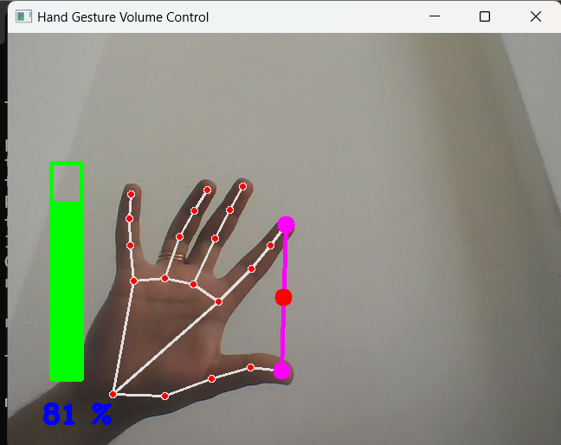
Figure 2. Results of hand gesture recognition with 81 percentage volume
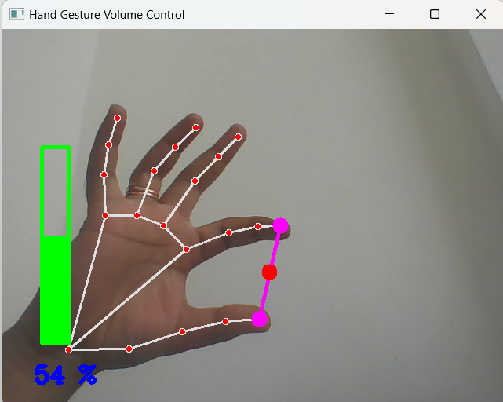
Figure 3. Results of hand gesture recognition with 54 percentage volume

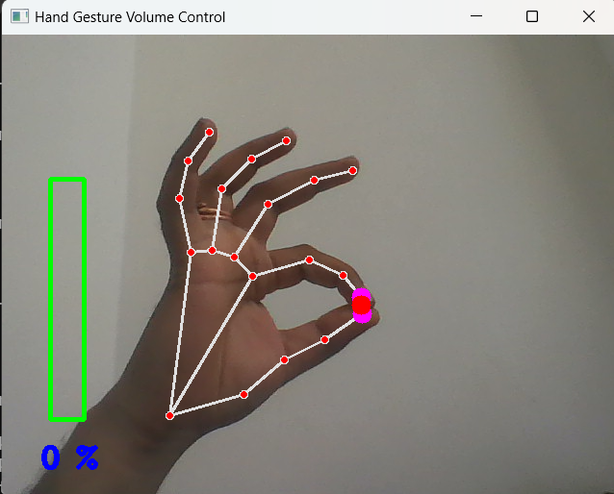
Figure 4. Results of hand gesture recognition with 0 percentage volume

Performance Evaluation Table :

Parameter | Estimated Value
Gesture Detection Accuracy | 92%
Processing Speed | 25–30 FPS
Average Response Time | 0.15 sec
System Cost | Low
Hardware Requirement | Minimal
User Interaction Efficiency | High

Comparative Analysis Table:
System | Technique Used | Accuracy | Limitation
Existing Systems | OpenCV + Audio Processing | 88–90% | Lighting sensitivity
Proposed System | OpenCV + MediaPipe + PyAutoGUI | 92% | Lighting variation

The proposed system demonstrated reliable hand tracking performance with minimal latency. Experimental testing showed that the proposed method provides efficient and intuitive Human-Computer Interaction.

11. APPLICATIONS

The proposed system can be used in:

Smart homes

Gaming systems

Virtual Reality environments

Multimedia systems

Assistive technologies

Healthcare systems

Touchless control interfaces

Educational applications

12. ADVANTAGES AND LIMITATIONS

Advantages

Touchless interaction

Real-time processing

Low implementation cost

User-friendly interface

Easy deployment

No specialized hardware required

Limitations

Sensitive to lighting conditions

Background complexity may affect detection

Webcam dependency

Fast hand movements may reduce accuracy

13. FUTURE SCOPE

Future enhancements of the proposed system may include:

Multi-hand gesture recognition

Brightness and media control

AI-based gesture classification

Integration with IoT devices

Voice-assisted gesture systems

Mobile application support

Enhanced robustness under varying lighting conditions

Integration with smart TVs and home automation systems

14. CONCLUSION

This project presented a real-time hand gesture-based volume control system using OpenCV and MediaPipe. The system successfully enables touchless audio volume control through hand gesture recognition.

By utilizing Computer Vision and machine learning-based hand tracking techniques, the proposed system provides an intuitive and efficient Human-Computer Interaction method.

The implementation demonstrates accurate gesture detection, low latency, and smooth volume adjustment using only a webcam and software libraries. The proposed solution is cost-effective, user-friendly, and suitable for real-time applications.

The project highlights the growing importance of gesture-based interfaces in modern computing systems and demonstrates the potential of Computer Vision technologies in improving user interaction experiences.

15. REFERENCES

[1] S. Musthafa, L. Murugan, M. Mutharasu, T. Vadivel, F. H., and M. Leelavathi, “Real-Time Gesture Recognition for Volume Control using Python and ML Techniques,” International Conference on Sustainable Communication Networks and Application (ICSCNA), IEEE, 2024.

[2] S. Kansal, H. Venkateswarareddy, S. Hariharan, S. K. Rani, A. B. Prasad, and P. A., “Volume Control Feature for Gesture Recognition in Augmented and Virtual Reality Applications,” IEEE International Conference on Contemporary Computing and Communications (InC4), IEEE, 2023.

[3] N. Kumar, H. Dalal, A. Ojha, A. Verma, and M. Kaur, “Real-Time Hand Gesture Recognition for Device Control: An OpenCV-Based Approach,” 2023 International Conference on Technological Advancements in Computational Sciences (ICTACS), IEEE, 2023.

[4] OpenCV Documentation, Available: https://opencv.org/

[5] MediaPipe Documentation, Available: https://developers.google.com/mediapipe

[6] Python Software Foundation, Available: https://www.python.org/

