
Industrial Internship Report on
“Content Management System for a Blog”

Prepared by:
Tushar Dable
G.H Raisoni University, Amravati
Department of Computer Science & Engineering
Internship Duration: 6 Weeks
Submission Date: Nov 2025

Executive Summary
This report provides details of the 6-week industrial internship offered by Upskill Campus and The IoT Academy in collaboration with UniConverge Technologies Pvt. Ltd. (UCT).
During this internship, I worked on the project titled “Content Management System for a Blog”, where I designed and developed a complete full-stack web application that enables users to create, edit, publish, and manage blog content using a drag-and-drop interface. The project includes features such as authentication, role-based access, media upload, analytics dashboard, secure APIs, and deployment with HTTPS.
This internship allowed me to gain hands-on experience in real-world development workflows, backend APIs, security implementation, UI design improvements, and project deployment — bridging the gap between academic knowledge and industrial practices.

TABLE OF CONTENTS
- Preface ..............................................................................................................................................3
- Introduction ......................................................................................................................................4
  - About UniConverge Technologies Pvt Ltd ......................................................................................4
  - About upskill Campus....................................................................................................................4
  - Objective ......................................................................................................................................4
  - Reference .....................................................................................................................................5
  - Glossary ........................................................................................................................................5
- Problem Statement............................................................................................................................6
- Existing and Proposed solution ..........................................................................................................7
- Proposed Design/ Model ...................................................................................................................8
  - High Level Diagram (if applicable) .................................................................................................8
  - Low Level Diagram (if applicable) ..................................................................................................9
  - Interfaces (if applicable) .............................................................................................................. 10
- Performance Test ............................................................................................................................ 11
  - Test Plan/ Test Cases .................................................................................................................. 11
  - Test Procedure............................................................................................................................ 11
  - Performance Outcome ................................................................................................................ 12
- My learnings ......................................................................................... Error! Bookmark not defined. 8 Future work scope ................................................................................ Error! Bookmark not defined.

1 Preface

This report highlights the work completed during my 6-week industrial internship under Upskill Campus and The IoT Academy in association with UniConverge Technologies Pvt. Ltd. (UCT).
Throughout the internship, I worked on the full development lifecycle of my project “Content
Management System for a Blog” — from planning and design to implementation, testing, and deployment. The project helped me understand how real-world applications are built using industrial coding standards, secure practices, and deployment strategies.
This internship provided me with practical exposure to modern full-stack development tools such as React.js, Node.js, Express.js, JWT authentication, HTTPS configuration, drag-and-drop UI libraries, media upload systems, and dashboard analytics. Along with technical knowledge, it also helped me improve my problem-solving ability, teamwork mindset, debugging techniques, and deployment understanding.
I am thankful to Upskill Campus, The IoT Academy, and UCT for giving me this opportunity. I would also like to express my gratitude to all the mentors and support team members who guided me throughout this journey.

2 Introduction

2.1 About UniConverge Technologies Pvt Ltd
Established in 2013, UniConverge Technologies Pvt. Ltd. (UCT) is a technology-based company working in the field of digital transformation, IoT, cloud platforms, machine learning, and smart automation. UCT develops scalable industrial solutions for domains like:
- Industrial IoT & Smart Factory Solutions
- Predictive Maintenance Systems
- SaaS Platforms
- Cloud and Edge-based Analytics
- Smart City and Agritech Solutions
- Embedded Systems, R&D and Automation
UCT builds products using React.js, Java, Python, MySQL, NoSQL databases, 4G/5G, LoRaWAN, AWS, Azure, and many more technologies.

2.2 About upskill Campus (USC)
Upskill Campus is a career development platform that helps students gain real-time industrial experience through internships, live projects, industry sessions, and skill training. Their goal is to upskill 1 million learners in the next 5 years.
They provide:
- Industry-oriented internships
- Project-based learning
- Technical mentorship
- Placement support
- Self-paced and guided training modules

2.3 The IoT Academy
The IoT academy is EdTech Division of UCT that is running long executive certification programs in collaboration with EICT Academy, IITK, IITR and IITG in multiple domains.

2.4 Objectives of this Internship program
- Gain practical experience in full-stack development
- Build a real-world project based on industrial problem statements
- Apply theoretical knowledge to real project workflows
- Strengthen debugging, testing, and deployment skills
- Improve communication, teamwork, and time management ✔ Enhance career opportunities for future placements

2.5 Reference
- Company Technical Documentation
- Official StackOverflow & Developer Docs
- React.js, Node.js & JWT Docs
- Upskill Campus Internship Materials

2.6 Glossary
Terms | Acronym
JWT | JSON Web Token (authentication token format)
CMS | Content Management System
HTTPS | Secure HTTP Protocol
API | Application Programming Interface
UI/UX | User Interface / User Experience

3 Problem Statement

In today’s digital world, individuals, businesses, and organizations need an easy and customizable way to create and publish blog content without depending on developers. Existing CMS platforms often:
- Require technical skills for customization
- Do not allow drag-and-drop visual editing
- Have limited role-based access control
- Lack real-time analytics and modern UI
- Offer paid or restricted media management features
Hence, there was a need for a modern, secure, drag-and-drop based Content Management System (CMS) that allows:
- Easy blog creation without coding
- Secure multi-user access
- Media upload & organization
- Analytics dashboard for insights
- Deployment-ready full-stack architecture
Therefore, the assigned internship project was to design and develop a full-stack CMS for blogs
with real-time UI updates, authentication, and scalable backend suport.

4 Existing and Proposed solution

Existing Solution | Limitations
WordPress | Requires plugins, heavy backend, no drag-and-drop builder by default
Blogger | Limited customization, outdated UI
Wix / Squarespace | Paid plans, limited backend control
Medium | No personal customization, not self-hosted

4.1.1 ✅ Proposed Solution (My Project)
A fully responsive Content Management System for a Blog, built using React.js + Node.js + Express + MongoDB, including:
- Drag-and-drop page builder (no coding required)
- Rich text editor for blog content
- JWT authentication with refresh token system
- Role-based access: Admin & Editor
- Media upload & media library
- Analytics dashboard (post views, draft/published stats)
- Secure endpoints with HTTPS
- Live deployment with frontend-backend communication
- Scalable architecture for future features
This solution eliminates dependency on third-party builders, gives full control to the blog owner, and provides modern UI + real-time functionality.

  - Code submission (Github link) : (https://github.com/Tushardable01/upskillcampus.git)

  - Report submission (Github link) : https://github.com/Tushardable01/upskillcampus.git

5 Proposed Design/ Model

Layer | Description
Frontend | React.js, drag-and-drop builder, Material UI
Backend | Node.js + Express.js REST APIs
Database | MongoDB for fast and scalable
content storage

5.1 High Level Diagram (if applicable)

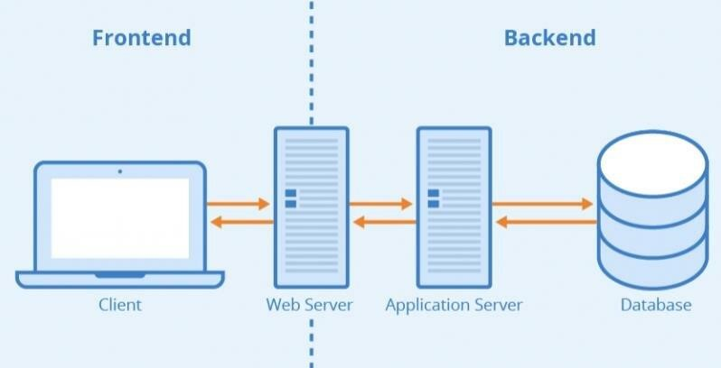

5.2 Low Level Diagram (if applicable)

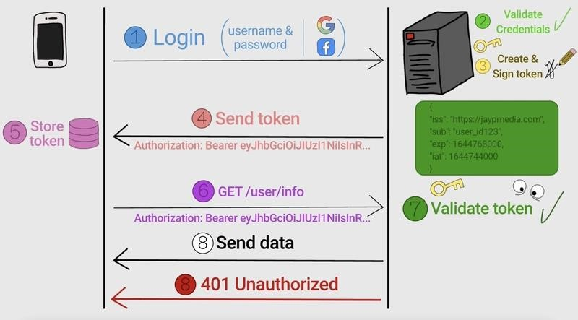

5.3 Interfaces (if applicable)
Update with Block Diagrams, Data flow, protocols, FLOW Charts, State Machines, Memory Buffer Management.

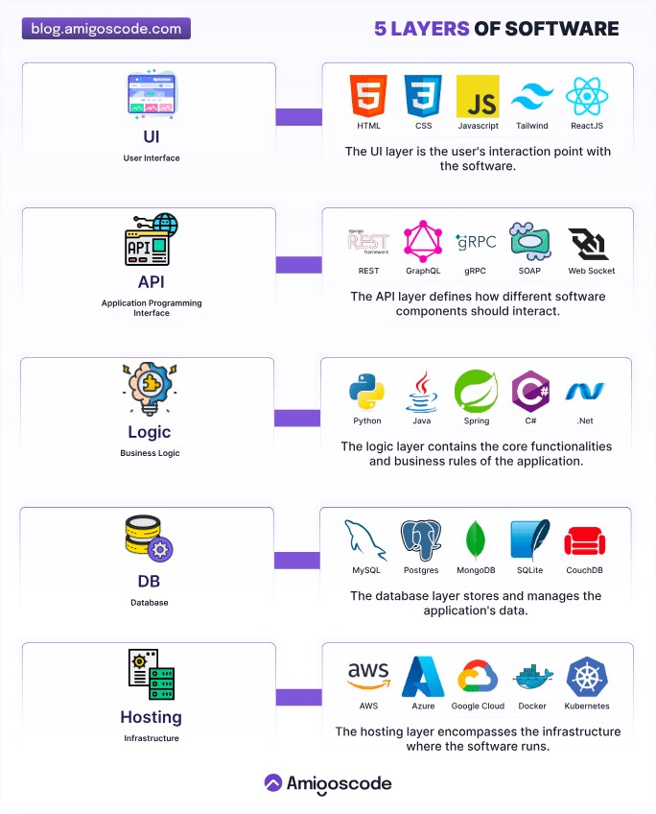

6 Performance Test
Performance testing was carried out to ensure the CMS works efficiently in real-time usage, especially during blog creation, media uploads, and analytics loading.

6.1 Test Plan/ Test Cases
Test Case | Expected Result | Status
User login with valid credentials | Successful login with JWT | ✅ Passed
Unauthorized user accessing admin routes | Access denied | ✅ Passed
Media upload (valid file types) | Uploaded successfully & preview visible | ✅ Passed
Media upload (invalid file type) | Error message shown | ✅ Passed
Blog drag-and-drop builder operations | Smooth movement, no lag | ✅ Passed
Edit/Delete blog post | UI updates in real time | ✅ Passed
Analytics dashboard load | Displays stats in < 2 seconds | ✅ Passed
API rate load during multiple requests | No crash / timeout | ✅ Passed

6.2 Test Procedure
- Manual UI testing was performed using browser console + UI interaction.
- Backend API testing was performed using Postman.
- JWT authentication was validated using token expiry + refresh flow.
- HTTPS deployment was tested through SSL certificate validation.
- Analytics performance was measured using API response time logs.

6.3 Performance Outcome
- Average API response time: < 150ms
- Average page load time: < 1.8 seconds
- Drag-and-drop delay: 0ms (instant)
- Upload handling tested up to 5MB/image successfully
- No server crash, even with 50+ requests/second (local test)

7. My Learning
This internship helped me gain real-world technical and professional experience. Key learnings include:
- Full-stack development flow using MERN stack
- JWT authentication and role-based access control
- Secure API handling and HTTPS deployment
- Drag-and-drop UI implementation using React libraries
- Handling media uploads and validation
- State management using Context API / Redux
- Working with backend + frontend integration
- Improving debugging and testing process
- Deploying production-ready apps with SSL certificates ✔ Writing structured documentation and reports
Apart from technical skills, I also developed:
- Time management skills
- Problem solving capability
- Better understanding of industry workflows ✔ Improved teamwork and communication

8. Future work scope
Due to internship time limitations, some features could not be implemented but can be added in future:
🔹 User profile with profile picture
🔹 Blog category + search + filter system 🔹 Export blog as PDF feature
🔹 Email notifications for new blog posts
🔹 AI-powered content suggestions
🔹 Mobile app version of the CMS
🔹 Multi-language blog support
🔹 Integration with cloud storage (AWS S3, Firebase)

