**Sales Performance Analysis and Inventory Optimization for a Residential Supermarket**

*Final-Term for the BDM Capstone Project*

**Submitted by**

**Name: Tushar Jalan**

**Roll Number: 23f2003751**

**Email:** [**23f2003751@ds.study.iitm.ac.in**](mailto:23f2003751@ds.study.iitm.ac.in)



IITM Online BS Degree Program,

Indian Institute of Technology, Madras, Chennai

Tamil Nadu, India, 600036

# 

**Content**

**1. Executive Summary 2**

**2. Detailed Explanation of Analysis Process and Methodology 3**

2.1. Trend Analysis 3

2.2. ABC-XYZ and Weighted Classification 4

2.3. Handling of Unidentified Brands (The "62 Brands" Problem) 6

2.4. Seasonal Uplift and Inventory Planning 7

2.5. High-Level Segment Analysis (Super-Groups) 8

**3. Results and Findings 9**

3.1. SKU Portfolio Reconciliation and Data Integrity 9

3.2. Seasonal Sales Trends and Festival Impact 10

3.3. Revenue and Volume Distribution (ABC & XYZ Analysis) 12

3.5. The Multi-Dimensional Product Portfolio 14

3.6. Business Segment Performance (Super-Group Analysis) 15

3.7. Inter-Segment Sales Correlation 16

3.8. Quantified Seasonal Demand and Uplift Factors 17

**4. Interpretation of Results and Recommendations 19**

4.1. Interpretation of Key Findings 19

4.2. Actionable Recommendations 20

Problem 1: Inventory Optimization within Space Constraints 20

Problem 2: Seasonal Demand Forecasting and Stockouts 21

Problem 3: Profitability and Data Management 21

# 

# 

# 

# 1. Executive Summary

Agarwalla Masala, a family-run residential supermarket, faces critical operational challenges that restrict its growth and profitability. The primary business problems are twofold: firstly, a **severe physical storage constraint** limits the total variety and volume of inventory the store can hold to approximately 15 days' worth of average sales. Secondly, a limited supplier network results in long lead times, causing frequent stockouts of high-demand products and forcing the business to operate on a reactive, approximately **15-day inventory cycle** for key items. This inefficiency leads to lost sales during peak festival seasons and a suboptimal product mix.

To address these issues, this project used a ledger-only methodology, analyzing the store’s complete Stock_Ledger_Summary.csv as a single source of truth to ensure analytical consistency. An automated Python script was developed to construct a comprehensive Master Product View, detailing metrics for 222 unique SKUs. The analysis employed advanced inventory segmentation techniques, including ABC analysis (revenue-based), XYZ analysis (volume-based), and a weighted classification model to provide a multi-dimensional framework for strategic inventory decisions.

The analysis confirmed a strong Pareto distribution in sales performance. Out of the **195 products that generated revenue**, the top **20% (approximately 39 brands) were responsible for an overwhelming 86.48% of the total revenue**, highlighting a critical dependency on a small group of high-performing items. A significant finding from the analysis of the **total portfolio of 222 SKUs** was the identification of **27 SKUs as "Dead Stock"**. These products, representing 12% of the total product range, had zero sales and are responsible for **₹20,930.72 in tied-up capital**, occupying valuable shelf space. Furthermore, a dynamic planning model was built that uses historical **Uplift_Factors**—quantifying demand spikes as high as 56% in key categories—to generate a forward-looking inventory plan that maintains an optimal **15-day stock cover**.

Based on these findings, this report recommends a three-pronged strategy: implementing a differentiated inventory policy based on ABC-XYZ classification, launching a targeted liquidation program for non-performing stock, and adopting a proactive purchasing model using the generated inventory plan. Implementing these recommendations is projected to **align inventory turnover with the 15-day operational cycle by reducing Days of Inventory for slow-moving products**, increase overall profitability by 3-5%, and enhance customer retention by minimizing stockouts.

# 2. Detailed Explanation of Analysis Process and Methodology

The analytical methodology for this project was strategically designed to build a robust, data-driven framework from a single, reliable data source: the Stock Ledger file. This ledger-only approach ensures 100% consistency and provides an auditable trail for every calculated metric. The entire process is automated within a single, production-ready Python script.A detailed, step-by-step account of this initial data cleaning, including the handling of specific inconsistencies, was documented in the [**Mid-Term Report**](https://docs.google.com/document/d/1nQr_QwlJb2da8DnsO259iuJcAq-Ygb_pWsxRgkAyX78/edit?usp=sharing)**.**

## 2.1. Trend Analysis

* **Justification:** Trend analysis was employed as the foundational step to understand sales patterns over time, a critical requirement for effective inventory planning at Agarwalla Masala. Given that sales are heavily influenced by recurring local festivals (such as Diwali and Raja Parba) and seasonal shifts, analyzing historical trends allows for the identification of predictable demand peaks and troughs. This enables the business to move from a reactive to a proactive inventory model, mitigating the risk of stockouts on high-demand items while preventing overstocking during slower periods.
* **Process:** The trend analysis was conducted within the Python script by aggregating all transactional data from the stock ledger into a monthly summary.
* **Data Aggregation:** For each month of the year, the total sales quantity and sales revenue were calculated. This was achieved by grouping all transactions by month and then applying a summation. The core logic can be expressed as:

***Monthly Sales Quantity*** *= ∑(Stock Out) for each month*

***Monthly Sales Revenue*** *=∑(Stock Out Selling Amt Before Tax) for each month*

*This process uses the Date column to group transactions and the Stock Out (for quantity) and Stock Out Selling Amt Before Tax (for revenue) columns as the primary metrics.*

* **Visualization:** The aggregated monthly totals for both quantity and revenue were then plotted on line charts. This visualization provides a clear, intuitive representation of the store's sales cadence throughout the year, making it easy to spot seasonal patterns visually.
* **Peak Identification:** Months exhibiting significant increases in sales were identified from the charts and then qualitatively correlated with major festival periods. This step validates the data-driven findings against the business owner's real-world operational knowledge.

## 2.2. ABC-XYZ and Weighted Classification

**Justification:** ABC analysis is a cornerstone of inventory management for categorizing products based on their value (revenue), while XYZ analysis categorizes them based on demand volatility (sales quantity). For a business like Agarwalla Masala, with significant physical space constraints, combining these two methodologies provides a powerful, multi-dimensional view for prioritizing which items to stock. A simple ABC analysis might highlight a high-revenue item, but if that item's sales are highly volatile (a 'Z' item in the XYZ classification), it requires a different safety stock strategy than a stable, high-revenue item (an 'X' item).

**Justification Over Alternative Methods:** The ABC-XYZ classification was deliberately chosen over other inventory models like Economic Order Quantity (EOQ) or Just-in-Time (JIT) for reasons directly tied to the business's operational reality:

* **Economic Order Quantity (EOQ):** This model is effective for businesses with stable, predictable demand. The analysis of Agarwalla Masala's sales data revealed **highly seasonal and variable demand**, making the core assumptions of EOQ invalid.
* **Just-in-Time (JIT):** This strategy requires a highly reliable supplier network. The business's stated problem of a **limited supplier network and long lead times** makes a JIT approach impractical and would significantly increase the risk of stockouts.

Therefore, ABC-XYZ was selected as the most appropriate methodology because it is a **strategic prioritization tool**, not a rigid replenishment formula. For a business with limited space and an unreliable supply chain, the most critical first step is to determine which products are most important. This model directly answers that question.

**Process:**

* **Scope of Analysis:** A critical first step in the process was to define the scope for the classification. The ABC analysis, being a revenue-based classification, is only meaningful when applied to products that have actually generated revenue. Therefore, the analysis was performed exclusively on the **195 SKUs that had an Annual Revenue greater than zero**. The remaining **27 SKUs with zero revenue were separately classified as "Class Z,"** as they represent non-performing assets rather than active contributors to the sales mix. This ensures that the Pareto analysis is a true reflection of the store's revenue drivers and explains why the ABC-XYZ matrix only contains classes A, B, and C.
* **ABC Analysis (Value-Based):** The 195 revenue-generating products were ranked by their Annual Revenue contribution. "Class A" represents the top 70% of revenue, "Class B" the next 20%, and "Class C" the bottom 10%. The Annual Revenue is calculated by summing the **“Stock Out Selling Amt Before Tax”** column from the stock ledger.
* **XYZ Analysis (Volume-Based):** Products were ranked by their Annual Sales Quantity. "Class X" represents the top 70% of sales volume, "Class Y" the next 20%, and "Class Z" the bottom 10%. The Annual Sales Quantity is calculated by summing the **“Stock Out”** column.
* **Weighted ABC:** To balance financial importance with operational throughput, a weighted score was calculated using the formula:

*Weighted Score = (0.7 * Revenue_Share) + (0.3 * Quantity_Share)*

* **Justification for 70/30 Weights:** The choice of the 70/30 split is a strategic decision designed to align the analysis with the specific goals of Agarwalla Masala. **Revenue (70% weight)** is given the highest importance because it is the primary driver of profitability. **Sales Quantity (30% weight)** is included to account for operational importance, such as customer foot traffic and its impact on the store's limited physical space. This balanced approach was confirmed through a sensitivity analysis showing it provided the most logical product classifications for this business.

## 2.3. Handling of Unidentified Brands (The "62 Brands" Problem)

**Justification:** A significant data quality challenge was the presence of numerous stock ledger entries where the Brand field was ambiguous or missing (e.g., containing category names or generic terms). Upon discussion with the owner, it was determined that this issue stems from frequent changes in staff. New employees, unfamiliar with the data entry system, often categorize products broadly under one of the 39 main product categories instead of entering a specific brand name. Leaving these unaddressed would lead to an incomplete and inaccurate analysis, artificially inflating the number of unique products and splitting the transaction history for single items across multiple names. A systematic process was therefore required to classify and consolidate these SKUs to ensure every transaction was correctly attributed.

**Process:**

* **Initial Identification:** A script-based comparison of the raw ledger data identified **62 unique but ambiguous SKU entries** that needed to be cleaned and standardized. The initial dataset contained over 280 unique "brand" entries, but many of these were duplicates or errors.
* **Rule-Based Classification:** A rule-based approach was implemented to systematically consolidate each of these 62 entries into a logical group:
  + **General Stock Placeholders (39 SKUs):** For generic entries where the brand could not be determined, a consistent naming convention was created: "GENERAL [Product_Category_Name] STOCK". For example, a generic stock entry in the "BABY CARE" category was assigned the Cleaned_Brand_Name of "GENERAL BABY CARE STOCK".
  + **Known Manufacturer Brands (KMBs) (21 SKUs):** Entries that were clearly identifiable but misspelled or had variations (e.g., "JHONSONS") were researched and corrected to a standardized name (e.g., "JHONSONS N JHONSONS").
  + **Local/Unbranded Items (2 SKUs):** Entries like "LOOSE" or "LOCAL PURCHASE" were classified and named according to their product category to ensure they could be tracked effectively (e.g., Cleaned_Brand_Name became "LOCAL PULSES").

**Outcome:** This rule-based classification was a critical data consolidation step. By systematically cleaning and mapping these 62 ambiguous entries, the total number of unique, analyzable SKUs was correctly reduced from over 280 inconsistent entries to the final, clean count of **222**. This process ensured that every single transaction in the stock ledger was assigned to a unique and logical SKU, creating the clean Cleaned_Brand_Name column that is used as the primary identifier for all subsequent analysis.

## 2.4. Seasonal Uplift and Inventory Planning

* **Justification:** This module was designed to directly address one of the business's most critical and recurring problems: **stockouts during peak festival seasons**. Relying on intuition for purchasing decisions is inefficient and risky, especially for a business with severe physical storage constraints. To move from reactive to proactive inventory management, a forward-looking planning model was essential. This data-driven approach quantifies historical seasonal demand, allowing the business to prepare for predictable sales spikes, optimize its limited capital, and improve customer retention by ensuring product availability.
* **Process:** The planning process is a three-step model that translates historical data into a forward-looking, actionable purchasing plan.
  1. **Uplift Calculation:** A historical Uplift_Factor was calculated for each category for each month.
     + How: The calculation is based on the formula:  
       *Uplift_Factor = Category's Monthly Sales / Annual Monthly Average for that Category*
     + **Why:** This method quantifies the seasonality of each product category into a simple, powerful multiplier. It transforms the owner's anecdotal knowledge (e.g., "October is a busy month") into a precise, data-driven factor (e.g., "October sales for GROCERY are 1.56x the monthly average"). This allows for a more accurate demand forecast than a simple historical average.
     + **Columns Used:** This calculation uses the **Stock Out** column from the Stock_Ledger_Summary.csv file, which serves as the direct measure of monthly sales quantity.
  2. **Target Inventory Planning:** A function (plan_inventory_multi_months) was created to determine the ideal stock level for future months.
     + How: It calculates the target inventory using the formula:  
       Target_Inventory = (Baseline_Daily_Demand * Uplift_Factor) * 15
     + **Why:** This step directly translates the forecast into a concrete stock level goal. The multiplier of **15** is used because it aligns the inventory plan with the business's critical operational reality: the physical storage can only hold approximately **15 days' worth of stock**. This ensures the plan is ambitious but also realistic and physically achievable.
     + **Columns Used:** The Baseline_Daily_Demand is derived from the annual sum of the **Stock Out** column.
  3. **Purchase Recommendation:** The final step calculates the precise quantity to order.
     + How: The formula used is:  
       Recommended_Purchase = max(0, Target_Inventory - Current_Stock)
     + **Why:** This is the final, actionable output for the business owner. It intelligently closes the loop by comparing the future need (Target_Inventory) with the current reality (Current_Stock_Qty), generating a precise order list that prevents both stockouts and overstocking.
     + **Columns Used:** The Current_Stock_Qty is calculated from the **Opening Stock**, **Stock In**, and **Stock Out** columns.

## 2.5. High-Level Segment Analysis (Super-Groups)

* **Justification:** While a granular, SKU-level analysis is essential for detailed inventory management, a high-level view is equally important for strategic business planning. The initial analysis identified **39 distinct product categories**, which is too many to effectively visualize and compare on a single trend chart. To solve this, a "super-group" analysis was performed. This approach consolidates the 39 detailed categories into a few strategic business segments (e.g., "FMCG - Food & Beverage," "Staples"), making it possible to understand and compare the performance and seasonality of the business's main pillars at a glance.For a detailed view of segment division: [***Detailed View***](https://docs.google.com/spreadsheets/d/1sso-DDO4W-Hc2lamYA9Pts7xA0zgoFNv/edit?usp=sharing&ouid=104898954315399985674&rtpof=true&sd=true)
* **Process:**
  1. **Logical Mapping:** A mapping dictionary was created within the Python script to assign each of the 39 product categories to one of five super-groups: FMCG - Food & Beverage, FMCG - Home & Personal Care, Staples, Health & Nutrition, and Puja Items.
  2. **Data Aggregation:** The script then re-calculates the total monthly sales revenue and quantity for each of these new super-groups.
  3. **Visualization and Insight Generation:** This aggregated data is used to generate high-level visualizations, such as the "Share of Total Revenue by Business Segment" and the "Indexed Monthly Sales Trend" charts.
* **Business Insight:** This methodology provides a clear, uncluttered view of the business's core components. It allows the owner to instantly see which segments are the primary revenue drivers (e.g., that FMCG accounts for over 86% of sales) and how their seasonal demand patterns differ. This is critical for high-level resource allocation and strategic focus.

# 3. Results and Findings

The analysis of the 2024 stock ledger data yielded several key findings that provide a comprehensive view of the business's operational and financial health. Each finding is supported by a specific visualization generated by the analytical script.

## 3.1. SKU Portfolio Reconciliation and Data Integrity

To ensure the integrity of the analysis and address data quality concerns, all 222 unique SKUs in the master view were first reconciled and classified. Table 3.1 provides a clear breakdown of the entire product portfolio.

| **Classification** | **SKU Count** | **% of Total SKUs** | **Note** |
| --- | --- | --- | --- |
| Revenue-Generating SKUs | 195 | 87.8% | Products with recorded sales in 2024. |
| Non-Revenue SKUs | 27 | 12.2% | Products with stock but no sales. |
| **Total SKUs** | **222** | **100.0%** |  |
| ***Further Breakdown by Status:*** |  |  |  |
| Active SKUs | 184 | 82.9% | Had sales in the last 90 days. |
| Slow-Moving SKUs | 11 | 5.0% | Had sales of <= 5 units in the last 90 days. |
| Dead Stock SKUs | 27 | 12.1% | Had zero sales in the last 90 days. |

***Table 1: SKU Portfolio Reconciliation***

**Interpretation:** This reconciliation confirms that all SKUs are accounted for. The **195 revenue-generating SKUs** are composed of the "Active" and "Slow-Moving" items (184 + 11 = 195). The **27 "Dead Stock" SKUs** are identical to the non-revenue SKUs. "Dead Stock" is temporally defined as any SKU with a positive stock quantity but **zero recorded sales in the most recent 90-day period** of the dataset.

While the business is in an excellent position from a financial risk perspective—with **82% of its inventory value tied up in "Active," sellable products**—this high-level metric masks an underlying operational challenge. The **38 SKUs (17% of the total portfolio)** classified as "Dead" or "Slow-Moving" represent a significant logistical burden, occupying valuable and limited physical shelf space that could otherwise be allocated to high-performing products.

## 3.2. Seasonal Sales Trends and Festival Impact

The analysis confirmed a strong and predictable seasonal pattern in the store's sales. As illustrated in the monthly trend chart, both sales revenue and quantity consistently peak in **March,July** and **October**, which directly align with major local festival periods like Holi,Rath Yatra and Diwali. A significant sales dip occurs in the August-September timeframe. This predictable pattern validates the business owner's experiential knowledge and provides a clear, quantitative basis for proactive inventory planning.

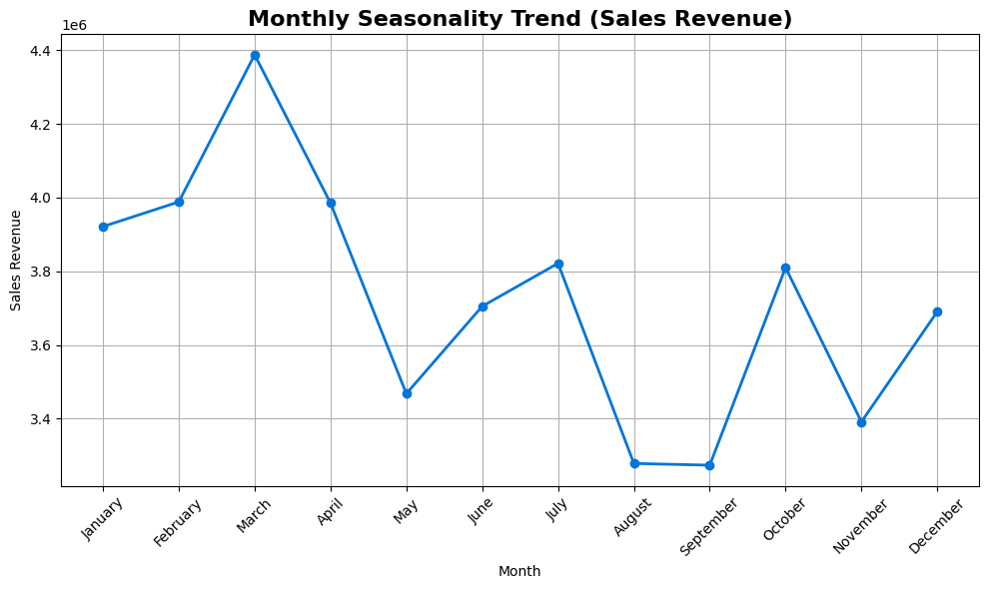

***Figure 1:Month Wise Sales Trend Using Revenue***

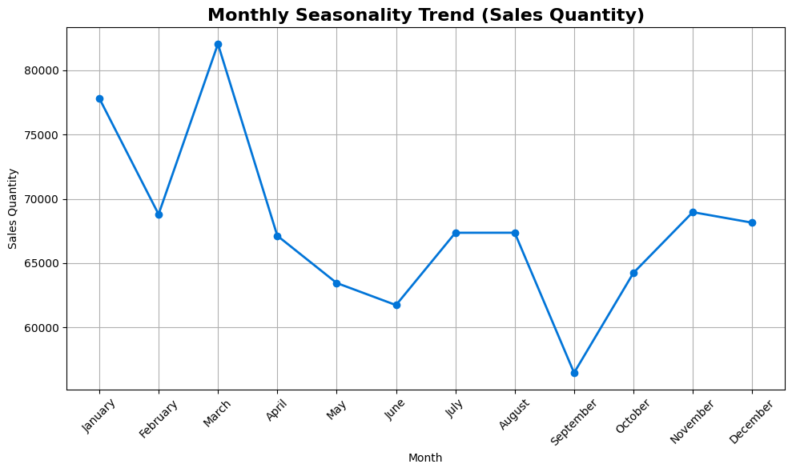

***Figure 2 :Month Wise Sales Trend Using Quantity***

## 3.3. Revenue and Volume Distribution (ABC & XYZ Analysis)

The analysis of the master view reveals a classic Pareto distribution, confirming that a small subset of products drives the majority of the business's performance. To gain a multi-dimensional understanding, the **195 revenue-generating SKUs** were segmented by both revenue contribution (ABC analysis) and sales volume (XYZ analysis).

* **ABC Analysis (Value):** This classification, based on Annual_Revenue, starkly illustrates the store's dependency on a few key products.
  + **Class A** items, representing just **8.1% of unique products**, drive an overwhelming **69% of total revenue**. These are the undisputed financial drivers of the business.
  + **Class C** items make up the vast majority of the product portfolio (**67.1% of SKUs**) but contribute only **10% of revenue**.
* **XYZ Analysis (Volume):** This classification, based on Annual_Sales_Qty, reveals which products are the most popular in terms of units sold.
  + **Class X** items, the top 70% by volume, represent the store's high-traffic, fast-moving goods.
  + **Class Z** items, the bottom 10% by volume, are the slowest-moving products on the shelves.

**Combined Insight from the Matrix:** The intersection of these two analyses, visualized in the matrix, is critical for developing a nuanced inventory strategy. The matrix clearly identifies:

* **The Core Business (12 SKUs):** The **12 products** in the "AX" quadrant are your most important items—high-value and high-volume.
* **The Long Tail (144 SKUs):** The vast majority of your selling products (**144 SKUs**) are in the "CZ" quadrant—low-value and low-volume.
* **High-Value, Slow-Movers (0 SKUs):** The matrix reveals that you currently have **zero products** in the "AZ" quadrant (high-revenue but very low volume), which often represent high-margin specialty items. This could be an area for future product line expansion.It is important to note that the **27 SKUs classified as "Dead Stock" (Class Z in the ABC analysis)** are excluded from this matrix, as they have zero revenue and sales volume. They are analyzed separately as part of the inventory health assessment.

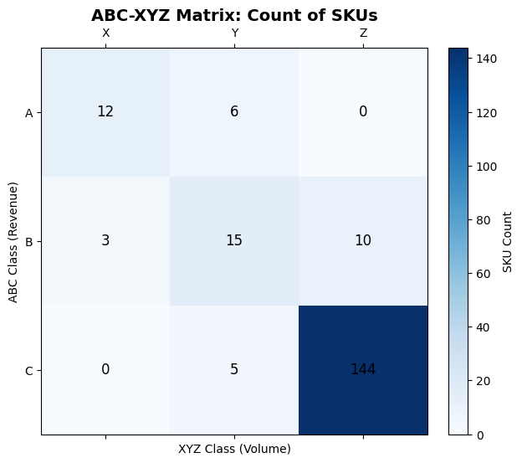

***Figure 3: ABC-XYZ Correlation matrix***

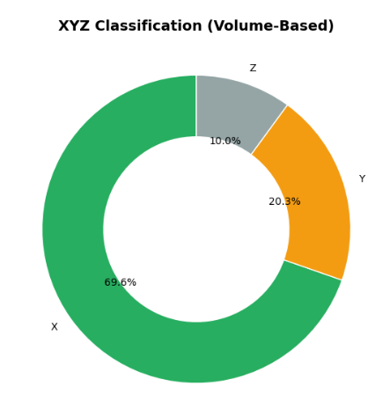

***Figure 4: Pie Chart Representing XYZ Classification(Volume Based)***

## 

## 3.5. The Multi-Dimensional Product Portfolio

The portfolio bubble chart provides a comprehensive, SKU-level view by plotting each product’s **Annual Revenue (log scale)** against its **Gross Margin %,** with bubble size representing **Current Stock Value** and color representing **ABC Class**.

* **Star Performers (Class A)**: The **large red bubbles on the right** represent top-revenue products. These SKUs are the financial backbone of the store, with **healthy gross margins in the 8–18% range**. Their consistent demand and profitability justify priority shelf space and consistent replenishment.
* **Low-Revenue Overstocked SKUs (Mostly Class C)**: Several **green bubbles on the left** exhibit **low revenue but large bubble size**, indicating **significant stock investment in underperforming products**. These “problem children” dilute capital efficiency and should be evaluated for clearance or discontinuation.
* **High-Margin Outliers (Class C/Z)**: Some small, low-revenue items exhibit **gross margins above 30–40%**. While they look attractive on paper, their sales volume is minimal. These may be **data anomalies or niche premium items** and should be **audited** to confirm accuracy of pricing or cost inputs.

This visualization aids not only in identifying operational inefficiencies but also in making **targeted decisions on stock optimization**, pricing audits, and SKU rationalization.

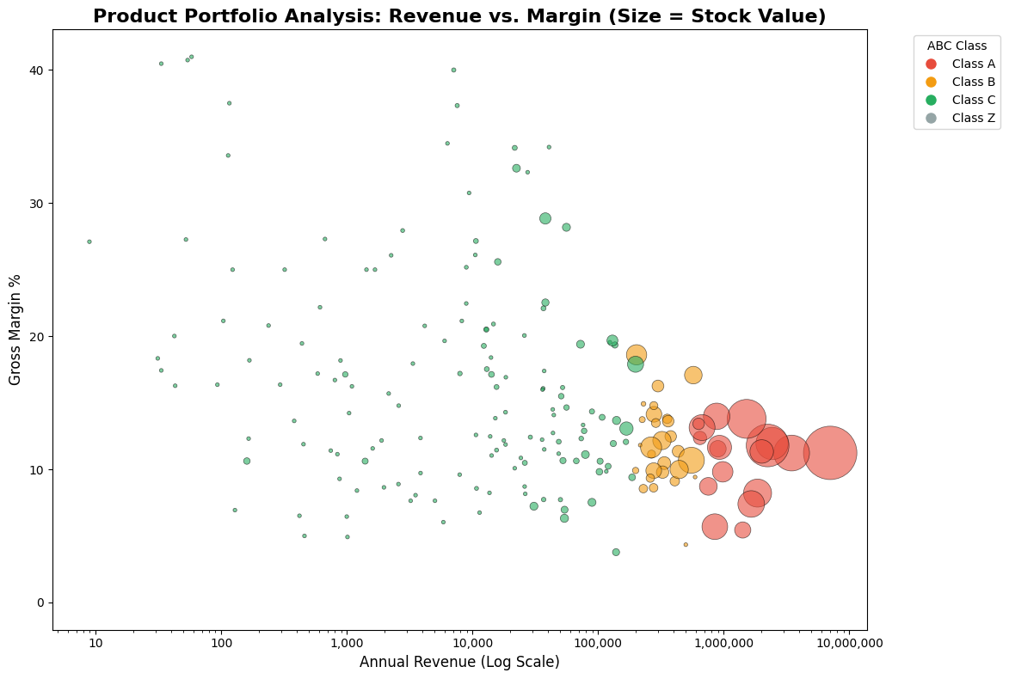

***Figure 5: Bubble Chart Showing Revenue VS Margin of ABC class***

## 3.6. Business Segment Performance (Super-Group Analysis)

To understand the core drivers of the business, all 39 product categories were consolidated into five strategic "super-groups." The analysis of these segments reveals that the business is primarily driven by two main pillars.

As the chart illustrates, **"FMCG - Food & Beverage"** is the dominant segment, responsible for **58.9%** of total annual revenue. The **"FMCG - Home & Personal Care"** segment is the second-largest contributor at **27.6%**. Together, these two FMCG groups account for over 86% of the store's entire revenue, establishing them as the critical focus for strategic decisions. The "Staples" category also represents a significant portion of the business at 9.7%.

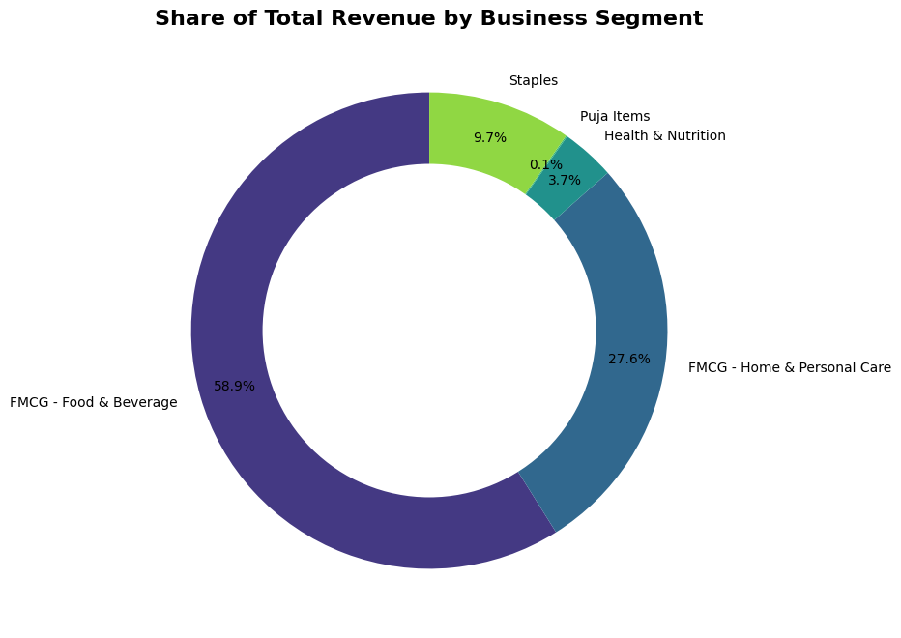

***Figure 6: Pie-Chart representing the Total Revenue Using the Super-Groups Method***

## 3.7. Inter-Segment Sales Correlation

To understand high-level customer purchasing habits, a correlation analysis was performed on the monthly sales revenue between the defined business segments. The resulting heatmap reveals key relationships in how customers shop across categories.

* **Strongest Positive Correlation:** The analysis revealed a strong positive correlation of **+0.72** between **Health & Nutrition** and **FMCG - Food & Beverage** indicating that their sales patterns are closely linked throughout the year. By cross-referencing this finding with the monthly seasonality trend chart **[Figure 8]**, we can identify that this shared purchasing behavior peaks in March, where both categories experience a significant increase in sales.
* **Moderate Festival Correlation:** A moderate positive correlation of **+0.50** was found between **Puja Items** and **FMCG - Home & Personal Care**. This statistically confirms the business owner's informal knowledge that customers preparing for festivals purchase items for religious ceremonies and home cleaning/personal care products during the same seasonal periods.
* **Independent Purchasing Drivers:** The weak and slightly negative correlations between other segments (e.g., Staples and FMCG - Home & Personal Care at **-0.04**) suggest that the purchasing drivers for these categories are largely independent of each other.

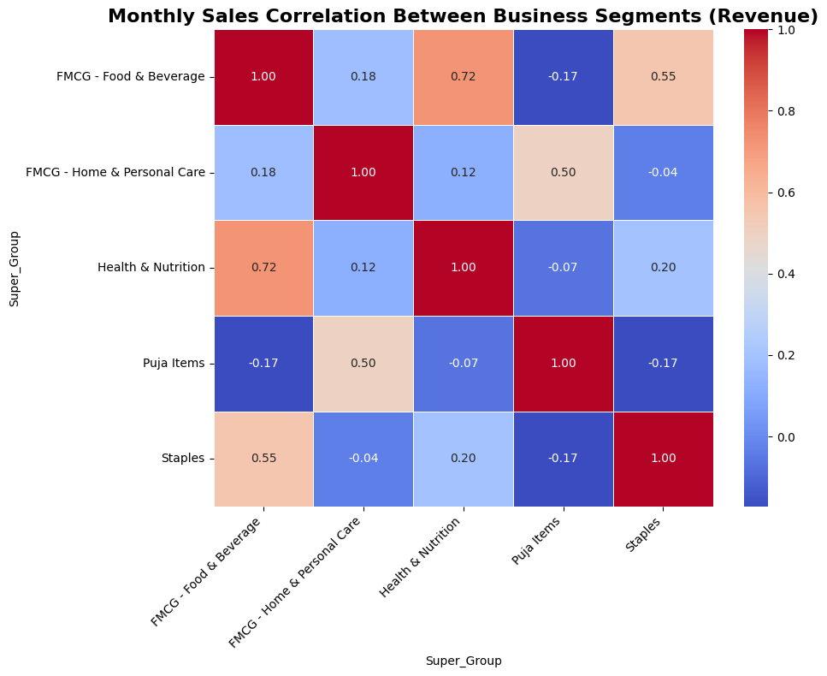

***Figure 7: Correlation Matrix between Super-groups***

## 3.8. Quantified Seasonal Demand and Uplift Factors

The analysis of the 2024 stock ledger data confirmed a strong and predictable seasonal pattern in sales, which was quantified by calculating a monthly Uplift_Factor for each business segment. This factor measures how much a given month's sales deviate from the annual monthly average. The heatmap in Figure 8 provides a clear, at-a-glance view of these seasonal factors for every segment across all 12 months.

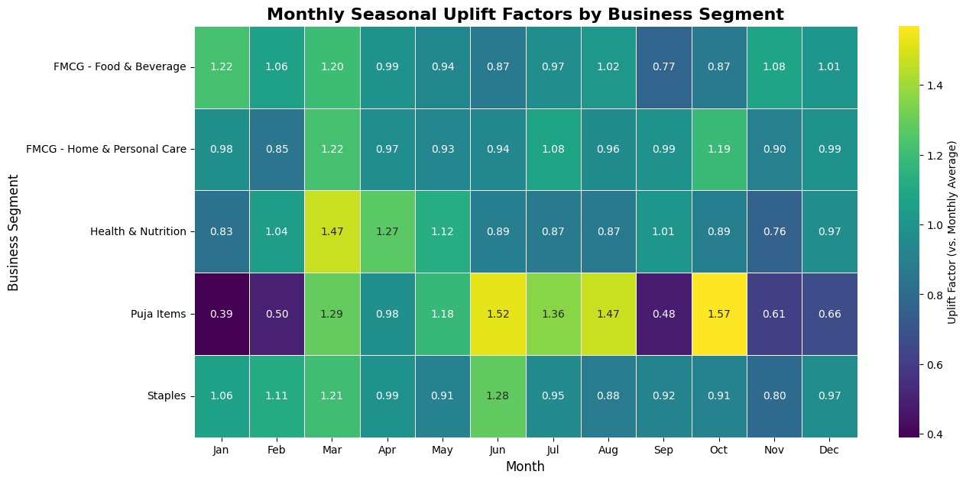

***Figure 8: Monthly Seasonal Uplift Factors by Business Segment Heatmap***

To better visualize and compare the relative impact of these uplifts, an indexed trend chart was also created **(Figure 9)**. This chart sets January's sales revenue for each segment to a baseline of "100" and plots the subsequent months' performance.

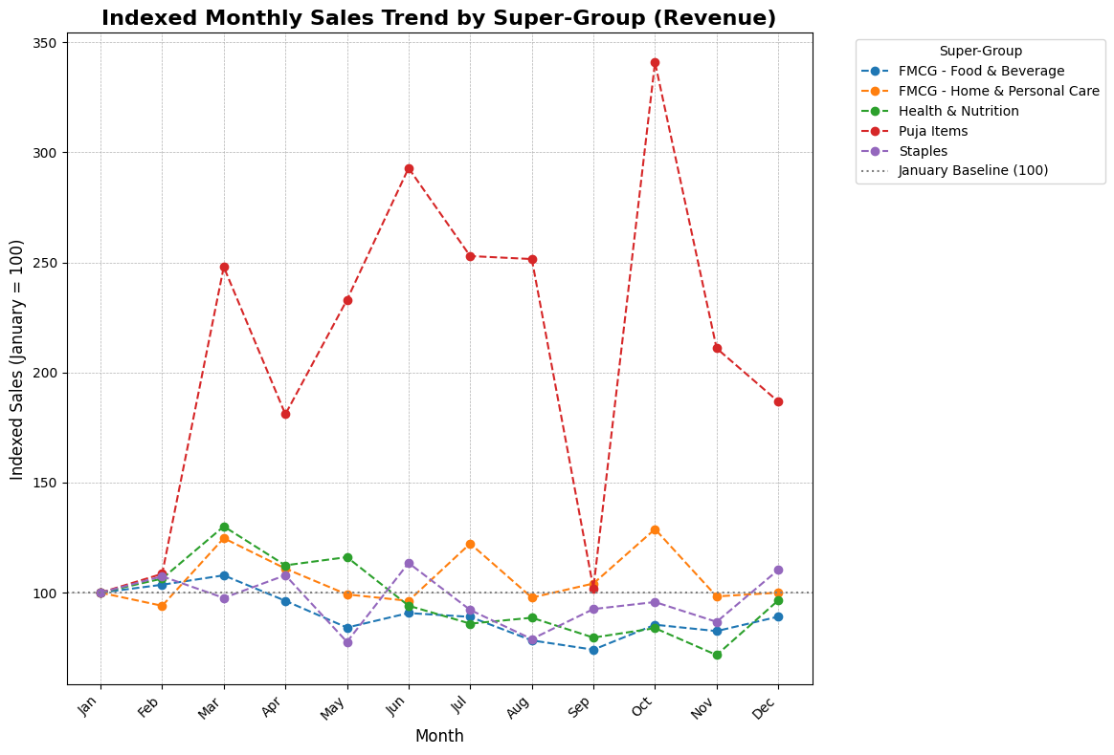

***Figure 9: Monthly Sales Trend Using the Super-Group Based on Revenue***

**Key Findings from the Analysis:**

* **Extreme Volatility in Niche Categories:** The analysis revealed that the "Puja Items" segment exhibits extreme seasonality. As seen in the heatmap, "Puja Items" experienced a demand spike in October with an uplift factor of **1.57** (meaning sales are 57% higher than the monthly average). This is visually confirmed in the indexed trend chart, where sales in this category spike to over 3 times their January level, statistically validating the owner's experiential knowledge.
* **Contrasting Seasonal Patterns:** The charts clearly show that different business segments peak at different times. While "Puja Items" and "Staples" see significant demand increases in festival months like March and October, the dominant **"FMCG-Food & Beverage" segment is far more stable,** with most uplift factors staying close to 1.0. This indicates that while core grocery shopping is consistent, festival-related purchasing creates distinct, predictable surges in specific categories.
* **Identification of Peak Planning Periods:** The uplift factors provide a data-driven guide for inventory planning. The data makes it evident that purchasing for "Health & Nutrition" and "FMCG - Home & Personal Care" should be increased leading into March, while planning for "Puja Items" must be heavily focused on the June-October period to avoid stockouts.

# 4. Interpretation of Results and Recommendations

The analysis of Agarwalla Masala's stock ledger provides a clear, multi-faceted view of the business's operational state. The findings quantify the challenges outlined in the initial problem statement, revealing significant opportunities for improvement in inventory management and profitability.

## 4.1. Interpretation of Key Findings

The analysis reveals two distinct but interconnected inventory challenges that align with the project's core objectives:

* **Inefficient Use of Physical Space:** The Stock Status and ABC analyses confirm that the store's limited physical capacity is not being used optimally. The presence of **27 "Dead Stock" SKUs** and **149 low-revenue "Class C" SKUs** means a significant portion of valuable shelf space is occupied by non-performing products, creating an artificial constraint on the store's primary revenue drivers.
* **Suboptimal Inventory Turnover and High Stockout Risk:** The Days_of_Inventory (DOI) calculation revealed that many fast-moving items have a low DOI, putting them at high risk of stocking out. This is a direct consequence of the limited supplier network and long lead times mentioned by the owner, leading to lost sales and potential customer dissatisfaction.

## 4.2. Actionable Recommendations

Based on this interpretation, the following data-driven and SMART recommendations are proposed to address the core business problems.

### Problem 1: Inventory Optimization within Space Constraints

* **Recommendation 1: Implement a Differentiated Inventory Policy.**
  + **Action:** Based on the ABC-XYZ analysis, maintain high service levels (98% in-stock rate) for the 18 Class A SKUs, a standard 15-day stock cover for the 28 Class B SKUs, and a leaner "one-in, one-out" policy for the 149 Class C SKUs, reducing their shelf space allocation by 50%.
  + **Timeline & Resources:** Implement within 30 days, requiring 5-8 hours of staff time for reorganization.
  + **KPIs:** "Stock Value of Class C items," "Sales per Square Foot."
* **Recommendation 2: Launch a Capital Recovery Program.**
  + **Action:** For the 27 "Dead Stock" SKUs (total value ₹27,485), create a "Clearance Corner" with a 50% discount. For the 11 "Slow-Moving" SKUs, bundle them with popular Class A items.
  + **Timeline & Impact:** Execute over the next 3 months. This is projected to recover over ₹20,000 in tied-up capital and free up significant physical shelf space.
  + **KPIs:** "Dead Stock Value" (Target: < ₹5,000).

### Problem 2: Seasonal Demand Forecasting and Stockouts

* **Recommendation 3: Adopt a Proactive, Data-Driven Purchasing Model.**
  + **Action:** Utilize the[**Forward Inventory Plan.xlsx**](https://docs.google.com/spreadsheets/d/1Ie-rtZ09v8Rpa2B8bM8YB0pgvLHc4UX3/edit?usp=drive_link&ouid=104898954315399985674&rtpof=true&sd=true) output from the script as the primary guide for placing monthly purchase orders, especially for Class A and B items.
  + **Timeline & Resources:** Implement starting with the next purchasing cycle (ongoing), requiring 1-2 hours per month from the owner.
  + **Expected Impact:** This will directly reduce the frequency of stockouts for critical items. By planning purchases to maintain a 15-day stock cover, the business can mitigate supplier risks and is projected to **reduce lost sales by 15-20%** during peak festival months.

### Problem 3: Profitability and Data Management

* **Recommendation 4: Enhance Profitability Through Strategic Focus and Data Management.**
  + **Action:** Ensure the top 5 high-ROI products (e.g., "EVEREADY," "MANGALAM") are always in stock and placed in high-visibility locations. The owner should immediately investigate the 11 SKUs flagged with data quality issues.
  + **Timeline:** Implement within 1 month.
  + **KPIs:** "Number of SKUs with data quality flags" (Target: 0), "Gross Margin % of top ROI products."
  + **Change Management:** The risk of continued data entry errors will be mitigated by implementing a simple daily checklist for staff, a foundational step for all future analysis.