**Sales Performance Analysis and Inventory Optimization for a Residential Supermarket**

*Proposal for the BDM Capstone Project*

**Submitted by**

**Name: Tushar Jalan**

**Roll Number: 23f2003751**

**Email:23f2003751@ds.study.iitm.ac.in**



IITM Online BS Degree Program,

Indian Institute of Technology, Madras, Chennai

Tamil Nadu, India, 600036

# **Declaration Statement**

I am working on a Project titled "**Sales Performance Analysis and Inventory Optimization for a Residential Supermarket**". I extend my appreciation to **Mr. Nanak Ram Agarwal**, for providing the necessary resources that enabled me to conduct my project.

I hereby assert that the data presented and assessed in this project report is genuine and precise to the utmost extent of my knowledge and capabilities. The data has been gathered through primary sources and carefully analyzed to assure its reliability.

Additionally, I affirm that all procedures employed for the purpose of data collection and analysis have been duly explained in this report. The outcomes and inferences derived from the data are an accurate depiction of the findings acquired through thorough analytical procedures. I am dedicated to adhering to the information of academic honesty and integrity, and I am receptive to any additional examination or validation of the data contained in this project report. I understand that the execution of this project is intended for individual completion and is not to be undertaken collectively.

I thus affirm that I am not engaged in any form of collaboration with other individuals, and that all the work undertaken has been solely conducted by me. If plagiarism is detected in the report at any stage of the project's completion, I am fully aware and prepared to accept disciplinary measures imposed by the relevant authority.

I agree that all the recommendations are business-specific and limited to this project exclusively and cannot be utilized for any other purpose with an IIT Madras tag. I understand that IIT Madras does not endorse this.

Signature of Candidate

Name: Tushar Jalan

Date: 10 May 2025

# **CONTENT**

**1. Executive Summary 3**

**2. Organization Background 3**

**3. Problem Statement 4**

3.1 Inventory Optimization within Space Constraints. 4

3.2 Seasonal Demand Forecasting 4

3.3 Product Category Performance Analysis. 4

**4. Background of the Problem 4**

**5. Problem Solving Approach 5**

5.1 Methods 5

5.2 Data Collection 6

5.3 Analysis Tools 6

**6. Expected Timeline 7**

6.1 Work Breakdown Structure 7

6.2 Gantt Chart 8

**7. Expected Outcome 8**

# **1. Executive Summary**

**Agarwalla Masala**, located at Shop No. 23 in the NALCO Market Complex in Angul, Odisha, has been a backbone of the local residential community for over three decades. Originally launched as a family-run grocery store, it has become a well-established supermarket. To better serve the customers and family with varying schedules, the store operates with extended business hours—from 8:00 AM to 2:00 PM and 4:00 PM to 10:00 PM everyday . It offers a broad selection of grocery items and household necessities, becoming well-known as a reliable local store.

Despite its history and loyal customer base, Agarwalla Masala faces notable operational hurdles that restrict its growth and profitability. Limited storage space supports only 15 days worth of inventory, leading to frequent stockouts during high-demand periods, especially festivals. Additionally, its location within a residential area reduces walk-in traffic and business visibility, further hampering expansion efforts.

This project aims to tackle these challenges through a detailed analysis of sales data, inventory trends, and financial metrics. Techniques such as time series forecasting, ABC classification, and margin analysis will be employed to design practical, data-driven strategies. Expected outcomes include a 15–20% reduction in stockouts and a 3–5% increase in gross margins, paving the way for sustainable business growth.

# 2. Organization Background

Agarwalla Store, owned by Mr. Nanak Ram Agarwal, is a well-established retail business in Angul, Odisha, serving the local community for over 30 years. Founded as a small family grocery store, Agarwalla Store has evolved into a full-service supermarket offering groceries and general household products. The business operates from Shop No. 23, Market Complex, NALCO, Angul (near UCO Bank).

The store serves approximately 150-200 customers daily, generating an estimated annual revenue of Rupees One crore. The supermarket follows a B2C model and operates from 8:00 AM to 2:00PM and again from 4:00 PM to 10:00 PM, allowing time in the afternoon for inventory work and rest for family members. Mr. Agarwal owns and manages the business, employing a small team to serve its residential customers, and its three-decade presence indicates sustainable operations.

The supermarket's competitive advantage comes from its deep community connections, personalized services like free delivery for long-term customers, and strategic pricing. Despite facing competition from other retail outlets, the business maintains customer loyalty through these value-added services. The residential location provides a stable customer base but creates challenges in foot traffic and staffing. Mr. Agarwal's business analysis focuses on customer retention, inventory optimization, and competitive pricing to ensure continued success in the local retail market.

# 3. Problem Statement

## 3.1 Inventory Optimization within Space Constraints: Develop strategies to maximize the efficiency of limited storage capacity (15-day inventory limit) by analyzing product turnover rates and identifying priority items for stocking to prevent stockouts while optimizing space utilization.

## **3.2** **Seasonal Demand Forecasting:** Create accurate forecasting models for seasonal variations and festival periods to minimize stock outs during high-demand periods despite storage limitations, ensuring customer satisfaction and maximizing sales opportunities.

## 3.3 Product Category Performance Analysis: Identify high-performing and underperforming product categories through sales data analysis to optimize product mix, maximize profitability within limited space, and develop targeted promotion strategies for high-margin products.

# **4. Background of the Problem**

**Internal Factors:** The biggest internal problem the business faces is its very limited storage space, which restricts inventory to approximately 15 days. This limitation affects nearly every aspect of operations, from purchasing decisions to customer satisfaction. Although there is potential additional storage space nearby, the property owner has been unwilling to lease it to Mr. Agarwal. As a result, the business is forced to operate within the existing limited space. Without the support of data-driven inventory management, this space is not being utilized effectively—frequent stockouts of high-demand items occur, while slower-moving products occupy valuable shelf space.

**External Factors:** The supermarket's location within a residential society, rather than a commercial zone, significantly reduces customer foot traffic and visibility. This directly limits daily customer volume and overall revenue potential. Additionally, nearby competing retailers put pressure on pricing, forcing Mr. Agarwal to introduce discounts and promotional offers to stay competitive.The location also makes it hard to find reliable staff because there aren’t many workers available nearby.

**Seasonal Factors:**The business experiences predictable but difficult-to-manage demand spikes during festival seasons. Key festival periods causing significant demand fluctuations include Diwali, Durga Puja, and Holi, when sales typically increase by 40–60%, while storage capacity remains unchanged. These seasonal surges often result in stockouts during peak sales periods, leading to lost revenue and customer dissatisfaction.

Combined, these internal, external, and seasonal factors create a challenging environment that requires smart, data-driven solutions to improve inventory management and overall performance.

# **5. Problem Solving Approach**

To address the inventory management and seasonal demand challenges faced by Mr. Agarwal’s business, a structured, data-driven approach is essential. This strategy will involve the systematic analysis of sales data, inventory records, and financial performance metrics to develop practical and sustainable solutions.

## 5.1 Methods

**Time Series Analysis:** This method will be applied to monthly sales data to identify seasonal trends and festival-driven demand spikes. By analyzing variables like “Month” and “MonthNo” alongside product category breakdowns, we aim to accurately forecast inventory requirements. This method is particularly relevant as it helps predict peak demand periods—such as Diwali, Durga Puja, and Holi—when sales can increase by 40–60%.

**ABC Analysis:** Based on sales quantity and revenue, products will be grouped into three categories (A, B, C) according to their contribution to total revenue. This classification supports efficient inventory prioritization within the store’s limited storage capacity, ensuring that top-performing products (Class A) receive priority in stocking decisions.

**Inventory Turnover Analysis:** By combining data from the stock ledger and sales records, turnover rates will be calculated for each product category. This helps identify which items sell quickly and which occupy space unnecessarily, guiding more efficient inventory rotation.

**Margin Analysis:** This involves analyzing gross margins and return on investment (ROI) by product category. Identifying high-margin products will help focus stocking strategies on the most profitable items, directly supporting efforts to improve overall profitability.

## 5.2 Data Collection

Three main datasets covering 12 months of data will be used:

* **Sales—Month-Wise Category Summary**: Includes quantity sold, discounts, and gross margin data by brand, category, and sub-category. This supports seasonal and category-level trend analysis.
* **Stock Ledger—Category Summary**: Tracks opening stock, incoming and outgoing inventory, and closing balances—key for turnover and stockout risk analysis.
* **Sales—Book Margin by Category**: Provides financial metrics like purchase costs, sales revenue, margins, and ROI, essential for profitability evaluation.

Additionally, **store observations** and **interviews with staff** will offer insights into on-the-ground challenges and customer behavior that are not visible in raw data.

## 5.3 Analysis Tools

* **MS Excel**: Excel will be used for initial data preprocessing, pivot table analysis, and KPI calculations. Its selection is justified by its accessibility for Mr. Agarwal, enabling him to understand and continue using the analysis framework after the project concludes.
* **Python**: Python libraries such as Pandas, NumPy will be used for advanced statistical analysis and predictive modeling. These tools are selected for their ability to handle complex relationships between inventory levels, sales patterns, and profitability metrics with greater statistical rigor than Excel alone.
* **Tableau** will be used to develop interactive dashboards, helping transform data insights into visual reports for easier business decision-making.

# **6. Expected Timeline**

## **6.1 Work Breakdown Structure**

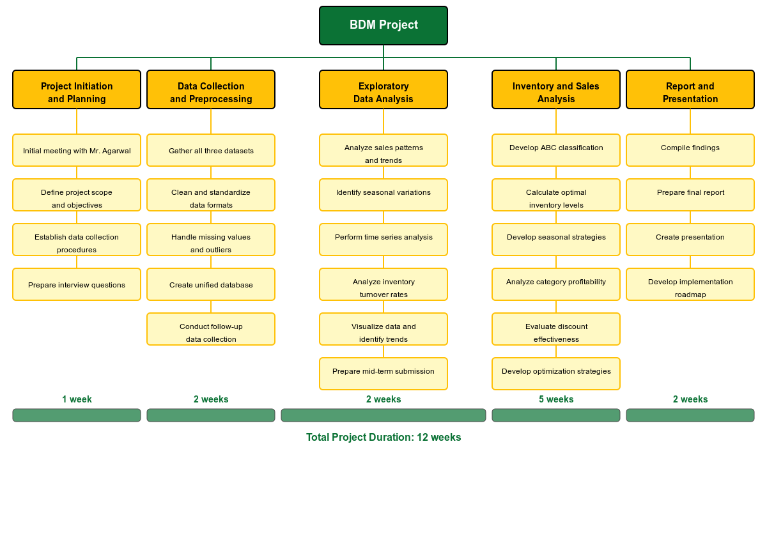

**Figure 1:Work Breakdown Structure**

**For a Better view [**[**BDM Work Breakdown Structure]**](https://drive.google.com/file/d/1h1w5Bd_bIKGkEXiiazQCKt_fx1vXEqqQ/view?usp=drive_link)

## 6.2 Gantt Chart

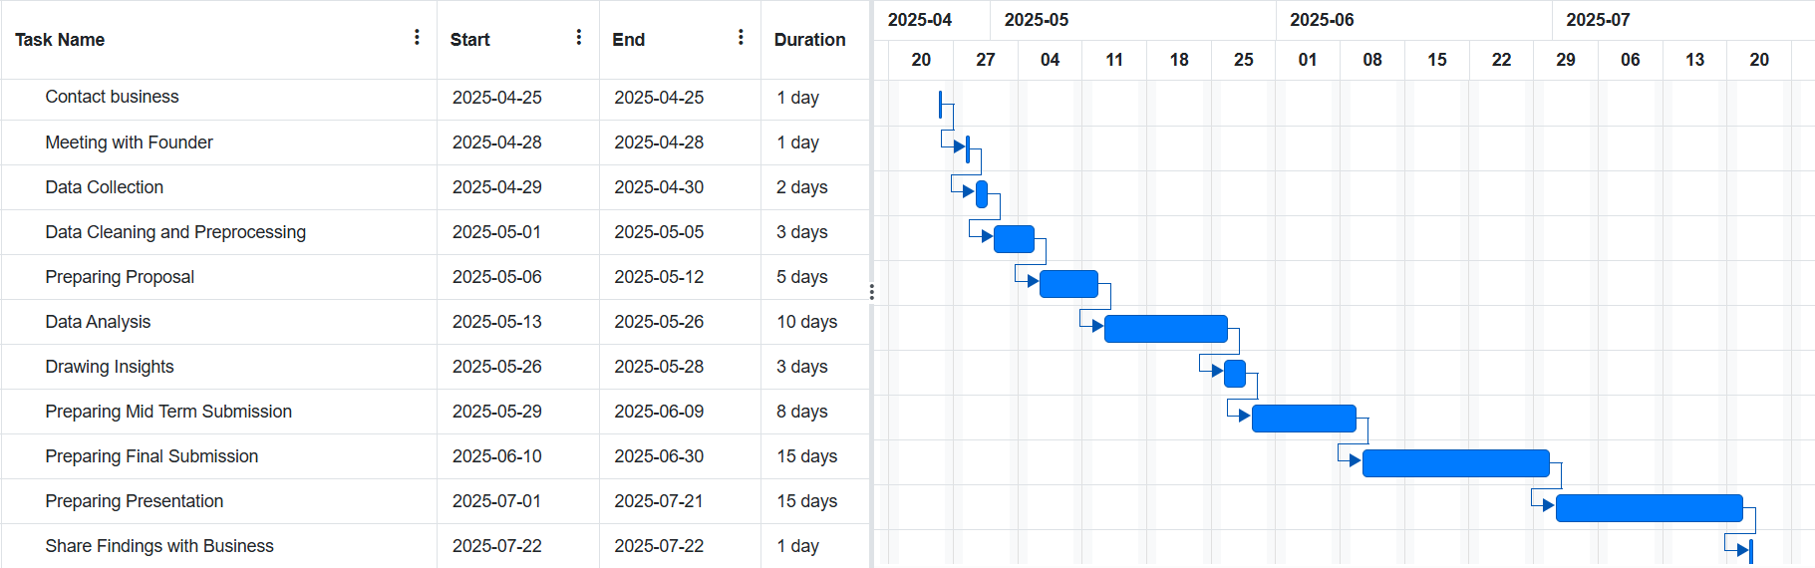

**Figure 2:Gantt chart**

**For a better view [**[**Gantt Chart**](https://docs.google.com/spreadsheets/d/147oh0wa3b-Fgk-nF8B5-YURE1JMoipJBMtnkHuBKQNQ/edit?usp=sharing)**]**

# 7. Expected Outcome

* **Deliverables:** A complete data-driven inventory optimization strategy with category-level stocking recommendations, calculated reorder points, and evidence-based space allocation framework; seasonal demand forecasting models accounting for multiple variables; and category performance dashboard with customizable KPI tracking.
* **Insights:** Detailed data analysis will reveal profit-driving product categories, precise seasonal demand patterns with lead time considerations, cross-category purchase correlations, and storage space optimization opportunities. All findings will derive exclusively from statistical evidence rather than subjective intuition or assumptions, ensuring reliable decision-making foundations.
* **Impact:** Implementation is projected to yield 15-20% reduction in stockouts, 10-15% higher inventory turnover, and 3-5% gross margin enhancement. These projections are calculated from historical performance metrics and industry benchmarks to provide clear business justification for each recommendation, ensuring executive alignment and successful implementation.