Steps :

1. Download top conversion path data in csv format from Google Analytics for a specific date range (Conversions > Multichannel Funnels > Top Conversion Paths)
2. Make sure you have selected all the rows while downloading the data
3. You can keep the filters as per your report requirement
4. After downloading the data remove first few unnecessary and blank rows

For e.g.

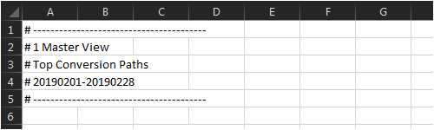

1. Data Cleaning part includes removing spaces from your first columns and converting conversions and revenue column into general format, which also includes removing currency symbol and commas
2. After cleaning part you can jump into R and follow the steps mentioned in comments