DESIGN DOCUMENT
AI-Assisted Forensic Sketch Generator
Interim Review–1 Submission

Research Team: Sradha, Tushar, Sandeep
Project Guide: Dr. Sukant K. Bisoyi
Dean & Professor, Department of CSE
C. V. Raman Global University

Document Type: Problem Specification, Introduction, Literature Survey,
Research Gap, Proposed Solution with Block Diagram, Results and Discussion

Minimum Requirement Alignment: ≥ 10 pages (formatted)

Contents
1. Problem Specification
2. Introduction
3. Literature Survey
4. Research Gap
5. Proposed Solution with Block Diagram
6. Results and Discussion
7. Ethical and Operational Notes
8. Summary for Interim Review–1
References

1. Problem Specification
Forensic composite creation begins with a cognitive interview: a witness recalls a suspect’s face, selects features from facial catalogs, and guides an artist through iterative revisions of proportions, characteristics, and shading—often over several hours. This process depends on scarce trained composite artists, is slowed by lengthy sessions, and is limited by communication gaps between verbal memory and drawn form. Existing software composites still require manual feature picking and an expert operator. We propose an AI-assisted pipeline that mirrors this workflow—conducting an artist-style structured interview, constructing a controllable facial representation, rendering a forensic-style sketch, and refining via witness feedback—producing usable composites in minutes.
2. Introduction
A facial composite (commonly called a forensic or police sketch) is a graphical reconstruction of a witness’s memory of a suspect’s face. When surveillance footage or biometric evidence is unavailable, composites remain a primary investigative aid: they support public alerts, help check leads, and assist identification in the critical early hours of a case.
In current practice, construction does not begin with free artistic drawing. It begins with a Cognitive Interview (CI)—and often a Holistic Cognitive Interview (H-CI)—recommended by forensic art guidelines and widely used by police. The witness is guided to reinstate the context of the crime in the “mind’s eye,” give uninterrupted free recall of the face, and then answer feature-focused prompts (eyes, nose, mouth, hair, scars, and so on). Reference catalogs such as the FBI Facial Identification Catalog or Steinberg-style feature libraries help the witness point to shapes when words alone fail. Only then does construction begin—by hand sketch (proportions, characteristics, shading) or by software composites such as Identikit, E-FIT, PRO-fit, FACES, and EvoFIT—always under continuous witness feedback.
Our research starts from this real forensic workflow, not from generic text-to-image generation. Certified composite artists are scarce, sessions last hours, and both hand and software methods still lose detail when verbal memory must be translated into a fixed feature library. We therefore propose an AI-Assisted Forensic Sketch Generator that mirrors the interview–catalog–construct–refine loop used by practitioners, while reducing turnaround from hours to minutes.
The proposed system is realized as an investigator-facing application in which an interactive interview agent asks questions in forensic-artist order, maintains a living face-feature profile, synthesizes a controllable face, renders a forensic pencil-style composite, and continues a guided refinement dialogue until the witness approves the likeness. Optional research validation metrics (for example, ArcFace / FaceNet similarity) support experimental assessment. The intended product is an investigator-assistive tool: it does not replace legal judgment or the witness, but digitizes the forensic artist’s construction steps so usable suspect sketches can be produced quickly, iteratively, and in a manner aligned with established composite practice.
3. Literature Survey
The present survey is organized around related forensic and text-to-face research papers available in the project repository. Foundational algorithm papers (StyleGAN2, ArcFace, FaceNet, Attention) are treated only as supporting building blocks; the design baseline is the direct Gen-AI forensic sketch paper and the related application studies below.
Base paper — Forensic sketch generation using Gen-AI (Soppari et al., 2026). This work proposes an end-to-end forensic pipeline: eyewitness text is cleaned and turned into a prompt; Stable Diffusion XL generates a forensic-style face; InsightFace and BiSeNet extract biometric and semantic features; FAISS performs hybrid mugshot retrieval. It demonstrates that text-to-sketch generation can be linked directly to suspect ranking, reducing artist dependency. Its own stated future work—iterative sketch refinement, stronger multimodal fusion, and richer marks such as scars—defines the research space our project extends. We therefore treat this paper as the primary base design reference: same forensic goal (description → sketch → identity support), with an interview-aligned modular architecture and explicit witness-refinement loop as our differentiation.
Text-to-face generation. Text2FaceGAN (Nasir et al.) generates faces from CelebA-derived captions using DCGAN, but only at low resolution (64×64) and with limited identity detail. Chen et al. (FTGAN) jointly train a text encoder and image decoder for fine-grained text-to-face synthesis and introduce SCU-Text2face, reporting about 59% average similarity to ground truth. Khan et al. (IEEE Access) likewise advocate fully trained GANs over frozen text encoders so word-level facial cues are not lost. TediGAN (Xia et al.) maps text into a pre-trained StyleGAN latent space for high-resolution (1024×1024) controllable faces, yet still inherits GAN instability and imperfect identity control. ST²FG (Oza et al.) uses BERT encoding and iterative user refinement—closest psychologically to a forensic interview—via an Affine Combination Module, but remains GAN-bound. Together these works motivate structured language understanding, attribute-to-latent mapping, and high-fidelity controllable face synthesis.
Sketch–photo forensic transformation. A large body of law-enforcement research assumes a sketch already exists and focuses on sketch-to-photo conversion for mugshot matching. Bushra and Maheswari review DCGAN-based forensic sketch-to-face transformation for crime investigation. Devakumar and Sarath convert pencil sketches to real images with DCGAN and report improved SSIM. Kazemi et al. propose attribute-conditioned CycleGAN for unpaired sketch-to-photo synthesis. Li et al. address few-shot sketch styles via global–local asymmetric translation (GLAS). Yu et al. improve face sketch recognition through adversarial sketch–photo transformation. CLIP4Sketch (Jain et al.) strengthens sketch–mugshot matching with diffusion-synthesized training data. These studies confirm identity-preserving cross-domain translation is essential—but they largely start after an artist or operator has already produced the sketch.
Synthesis for our design. Prior related work therefore splits into (i) text-to-face generators without a full forensic interview + sketch refinement loop, and (ii) sketch-to-photo / recognition systems that still need a hand-made composite. The base Gen-AI paper closes part of that loop with diffusion and FAISS matching, yet leaves iterative witness refinement and modular attribute editing as open enhancements. Our research adopts that forensic objective and redesigns the pipeline as artist-style interview → feature profile → controllable face composition → forensic sketch rendering → guided refinement, with optional biometric validation for research assessment.
4. Research Gap
4.1 Limitations of Current Research
From the surveyed papers, two strong but incomplete lines of work dominate. First, text-to-face generators can turn descriptions into faces, but usually stop at a photorealistic image, rarely produce a forensic pencil-style composite, and are typically one-shot systems without a structured witness interview loop. Second, sketch-to-photo and recognition systems improve matching once a sketch exists, yet still assume a forensic artist or operator has already drawn or assembled the composite. The base paper (Soppari et al., 2026) closes part of this loop by linking text → diffusion sketch → biometric/semantic mugshot matching. Even so, it remains largely a prompt → generate → search pipeline. Its own future-work section highlights missing pieces: iterative refinement without identity drift, richer marks (scars, tattoos), stronger multimodal fusion, and explainable scoring.
4.2 Gap Analysis Relative to Project Goals
Gap | Current State | Our Goal / Vision
Starting point | Many systems need a hand-drawn or software composite first | Begin from an AI-led forensic interview; no artist required for first draft
Workflow realism | One-shot generation or prompt rewriting | Mirror practice: interview → structure features → construct → refine
Feature control | Opaque prompt or whole-image regeneration | Living feature profile editable one trait at a time
Output form | Photo-like faces, or sketch-to-photo only | Explicit forensic pencil-style sketch output
Product interface | Notebooks / ad-hoc demos | Investigator-facing Next.js application
Assistive role | Often framed as full artist replacement | Assist investigators; witness remains authority

4.3 Contribution Statement
Research gap in one line: existing systems either generate faces from text or match sketches to photos; few unify artist-style interviewing, controllable face construction, forensic sketch rendering, iterative witness refinement, and research-time biometric evaluation in one investigator-aligned pipeline. Our contribution is to bridge that gap with a modular AI-assisted forensic sketch generator designed around real composite practice—assist investigators, shorten hours to minutes, and keep the witness-in-the-loop as the source of truth.
5. Proposed Solution with Block Diagram
5.1 Overview of the Proposed Framework
This work proposes an AI-assisted forensic sketch generation framework that digitizes the operational workflow of composite construction. In conventional practice, a trained forensic artist conducts a Cognitive Interview, elicits feature-level descriptions, constructs a likeness, and revises the composite under continuous witness guidance. The proposed system replicates this procedure computationally: an interactive interview agent elicits facial information in a structured sequence, maintains a feature profile, synthesizes a controllable facial representation, renders a forensic-style sketch, and supports iterative refinement until witness approval.
In contrast to end-to-end prompt-to-image approaches, including the base Gen-AI forensic pipeline that maps textual prompts directly to diffusion-generated sketches and mugshot retrieval, the present design prioritizes interview alignment, attribute-level controllability, explicit sketch rendering, and witness-in-the-loop revision. The framework is intended as an assistive investigative tool; it does not replace the witness as the source of recalled information, nor does it constitute a legal determination of identity.
5.2 System Architecture
The architecture comprises five operational modules and an optional research validation layer, as illustrated in Figure 1.
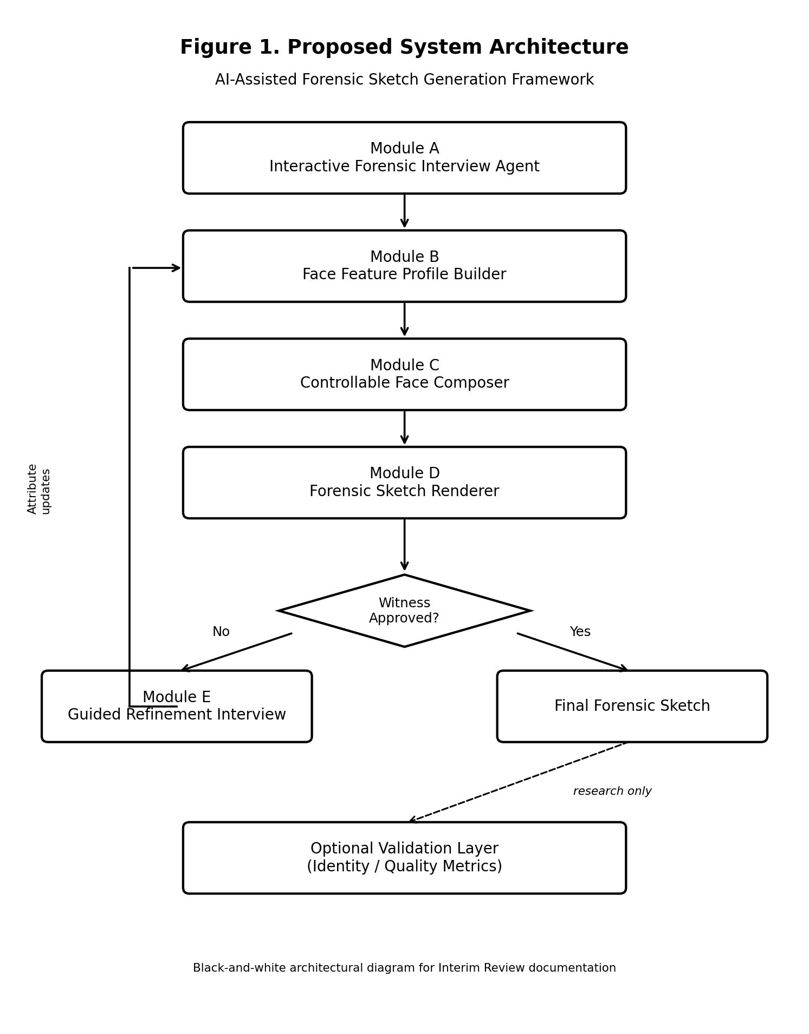
Figure 1. Block diagram of the proposed AI-assisted forensic sketch generation framework.
5.3 Correspondence to Forensic Practice
Conventional Forensic Procedure | Proposed System Component
Cognitive Interview and feature prompting | Module A — Interactive Forensic Interview Agent
Catalog-based feature selection and note-taking | Module B — Face Feature Profile Builder
Construction of facial likeness | Module C — Controllable Face Composer
Pencil rendering / composite styling | Module D — Forensic Sketch Renderer
Continuous revision with the witness | Module E — Guided Refinement Interview
Research-time identity / quality assessment | Optional Validation Layer

5.4 Interactive Interview Protocol
Module A implements an interview state machine inspired by Cognitive Interview (CI) and Holistic Cognitive Interview (H-CI) procedures used in composite construction. The agent progresses through: (1) context reinstatement; (2) free recall; (3) global descriptors (age/sex/build); (4) external features (hair, face shape); (5) internal features (eyes, eyebrows, nose, mouth, ears); (6) distinctive marks with spatial localization; (7) optional holistic verification; and (8) visual catalog assistance when verbalization is insufficient. The interview does not fabricate unstated attributes. Incomplete responses are retained as unknown and excluded from forced inference.
5.5 Module Specifications
Module A — Interactive Forensic Interview Agent. Manages dialogue state, question sequencing, and adaptive follow-up under a protocol-constrained language model and deterministic phase controller. Input: witness responses. Output: ordered interview turns and extracted descriptors.
Module B — Face Feature Profile Builder. Maintains a structured facial attribute profile updated incrementally across interview turns. This profile is the sole conditioning interface to generative stages.
Module C — Controllable Face Composer. Projects the feature profile into a generative latent representation and synthesizes a photorealistic face, enabling feature-level edits without identity reset. Model direction: attribute-conditioned StyleGAN2-ADA (or equivalent).
Module D — Forensic Sketch Renderer. Transforms the synthesized face into a monochrome pencil-style forensic composite using classical edge-based rendering and/or Pix2Pix/CycleGAN trained on CUFS/CUFSF-style pairs.
Module E — Guided Refinement Interview. After sketch presentation, conducts targeted revision dialogue analogous to mid-session artist adjustments. Only affected profile fields are updated before recomposition.
Optional Validation Layer. Computes experimental metrics (ArcFace/FaceNet cosine similarity, FID, attribute consistency). Supports research reporting; not required for operational sketch sessions.
5.6 Operational Workflow
1. An investigative session is initiated with the witness.
2. Module A executes the interview protocol; Module B constructs the feature profile.
3. Module C synthesizes a facial image; Module D renders the forensic sketch.
4. Module E conducts refinement until witness approval is obtained.
5. The approved sketch is exported as the session output.
6. Where ground-truth references exist, the validation layer may quantify identity preservation and generation quality.
5.7 Datasets
Dataset | Purpose
CelebA | Attribute vocabulary and conditional supervision
FFHQ | High-fidelity face generation prior
CUFS / CUFSF | Photo–sketch translation and sketch-domain evaluation

5.8 Technology Stack
Layer | Technology
Client application | Next.js (App Router), TypeScript, React
Application programming interface | Next.js Route Handlers and/or FastAPI inference service
Machine learning runtime | Python 3.10+, PyTorch 2.0+
Interview and language processing | Transformer / LLM dialogue models with protocol constraints
Computer vision | OpenCV, PIL; StyleGAN2-ADA; sketch translation networks
Experimental validation | ArcFace / FaceNet embedding comparison
Deployment | Docker; GPU-enabled inference worker as required

5.9 Anticipated Outcome
The proposed framework is expected to yield an investigator-facing Next.js application capable of conducting a structured forensic interview, constructing and refining forensic-style composites under witness guidance, and reducing composite turnaround from multi-hour manual sessions to minutes, while preserving alignment with established composite interviewing practice.
6. Results and Discussion
6.1 Present Research Status
At the time of Interim Review–1, the project is in the foundational research and early experimentation phase. Documentation, literature grounding, architecture design, and initial identity-evaluation experiments have been completed. Full end-to-end interview-to-sketch product integration (Next.js client with generative backend) remains in progress.
6.2 Experimental Outcomes to Date
Experiment 001 — ArcFace identity verification on CUHK sketches (Completed). Objective: measure how well pretrained ArcFace embeddings preserve identity when comparing photorealistic faces to hand-drawn sketches from the CUHK dataset.
Comparison | Average Cosine Similarity
Photo vs. Photo | 0.92
Photo vs. Sketch | 0.72

Discussion: The photo–photo baseline confirms strong identity clustering under ArcFace. The drop to 0.72 for photo–sketch pairs indicates a substantial domain shift introduced by sketch styling (exaggerated chin, thinned eyes, line abstraction). This justifies treating sketch rendering as a dedicated module and motivates future sketch-domain adaptation before operational matching.
Experiment 002 — Attribute-conditioned face generation using StyleGAN2-ADA (In progress). Preliminary observations indicate that conditioning on sparse or rare attributes (for example, scars or eyeglasses) shows tendency toward class collapse; improved modulation strategies are under investigation.
Experiment 003 — Sketch rendering method comparison (OpenCV edge-based shaders versus Pix2Pix) is scheduled and not yet started.
6.3 Discussion Relative to Project Goals
Current results support three design decisions: (1) identity validation is measurable but domain-sensitive; (2) controllable generation requires careful conditioning, reinforcing a structured Face Feature Profile rather than brittle one-shot prompts; (3) interview-first design remains the primary product differentiator, with Next.js session UI as the next integration milestone.
6.4 Expected Advantages and Current Limitations
Projected advantages include reduced turnaround, improved procedural consistency through protocol-constrained interviewing, feature-level refinement without full identity regeneration, and investigator-assistive deployment via Next.js. Current limitations include incomplete end-to-end integration, unstable conditioning for rare forensic marks, pending sketch-rendering comparison, possible demographic under-representation in CelebA/FFHQ, and the explicit status of the system as research-grade assistance rather than legal identification.
6.5 Next Steps and Interim Conclusion
Immediate next steps are: complete StyleGAN2-ADA conditioning improvements; execute Experiment 003; implement the interview state machine and Face Feature Profile APIs; deliver the Next.js investigator session interface; and re-evaluate identity metrics after sketch-domain adaptation. Interim outcomes demonstrate a viable research trajectory: the forensic interview-aligned architecture is specified; identity evaluation baselines are established (photo–sketch cosine similarity ≈ 0.72); and generative/rendering experiments are sequenced. The priority is closing the loop from structured interview responses to controllable sketch refinement within the application stack.
7. Ethical and Operational Notes
The proposed system is designed strictly as an investigative assistance aid. Generated composites reflect witness-reported memory and interview responses; they must not be treated as definitive biometric identification evidence. Operators should avoid suggestive questioning that could contaminate memory, consistent with Cognitive Interview best practice. Demographic bias in training corpora and the risk of over-trusting generative outputs are acknowledged as open concerns for subsequent fairness analysis and controlled user studies with domain experts.
Data handling for any future operational deployment must comply with applicable institutional and legal requirements for witness information, image retention, and access control. The present Interim Review document reports research design and preliminary laboratory experiments only; no claim is made of field-ready law-enforcement certification.
8. Summary for Interim Review–1
This design document specifies the problem, introduces forensic composite practice, surveys base and related research papers, identifies the research gap relative to interview-aligned generation, proposes a modular solution with block diagram, and reports interim experimental outcomes. The guiding principle is to digitize how forensic artists actually interview and revise composites—not to reduce the task to unconstrained prompt-based image generation. Completed baseline identity evaluation (photo–sketch ArcFace similarity ≈ 0.72) and an in-progress conditioned generation experiment provide empirical footing for the next integration phase on the Next.js application stack.
References
[1] Soppari, K., Pruthvi, A., Kiran, N. U., & Moses, V. S. (2026). Forensic sketch generation using Gen-AI. World Journal of Advanced Research and Reviews, 30(1), 164–171.
[2] Nasir, O. R., et al. (2019). Text2FaceGAN: Face generation from fine-grained textual descriptions. IEEE BigMM.
[3] Chen, X., Qing, L., He, X., Luo, X., & Xu, Y. (2019). FTGAN: A fully-trained generative adversarial network for text to face generation. arXiv:1904.05729.
[4] Khan, M. Z., et al. (2021). A realistic image generation of face from text description using the fully trained generative adversarial networks. IEEE Access, 9.
[5] Xia, W., Yang, Y., Xue, J.-H., & Wu, B. (2021). TediGAN: Text-guided diverse face image generation and manipulation. CVPR.
[6] Oza, M., et al. (2021). Semantic text-to-face GAN (ST²FG). arXiv:2107.10756.
[7] Devakumar, S., & Sarath, G. (2023). Forensic sketch to real image using DCGAN. Procedia Computer Science, 218, 1612–1620.
[8] Bushra, S. N., & Maheswari, K. U. (2021). Crime investigation using DCGAN by forensic sketch-to-face transformation (STF)—A review. ICCMC.
[9] Kazemi, H., et al. Facial attributes guided deep sketch-to-photo synthesis. West Virginia University.
[10] Li, Y., et al. (2024). Few-shot face sketch-to-photo synthesis via global-local asymmetric image-to-image translation. ACM TOMM.
[11] Yu, S., et al. (2019). Improving face sketch recognition via adversarial sketch-photo transformation. FG 2019.
[12] Jain, K. K., et al. (2024). CLIP4Sketch: Enhancing sketch-to-mugshot matching. IJCB.
[13] Karras, T., et al. (2020). Analyzing and improving the image quality of StyleGAN. CVPR.
[14] Deng, J., Guo, J., Xue, N., & Zafeiriou, S. (2019). ArcFace: Additive angular margin loss for deep face recognition. CVPR.
[15] Schroff, F., Kalenichenko, D., & Philbin, J. (2015). FaceNet: A unified embedding for face recognition and clustering. CVPR.

