TITLE: SDN BASED FIREWALL
GITHUB LINK:https://github.com/Tusharosaurus27/SDN-OpenFlow-Mininet-Project/tree/main

Abstract
This project demonstrates the implementation of Software Defined Networking (SDN) using Mininet, Open vSwitch, and the OpenFlow protocol. A virtual network topology consisting of multiple hosts and a switch was created and controlled through OpenFlow flow rules.
The project focuses on packet forwarding, traffic filtering, and network monitoring using SDN concepts. Flow table entries were configured to control communication between hosts and selectively block traffic from specific IP addresses. Network connectivity was verified using ping tests, and bandwidth performance was analyzed using iperf.
The implementation demonstrates how SDN enables centralized and programmable control over network traffic, improving flexibility, traffic management, and security in modern computer networks.
TOOLS USED:
• Ubuntu Virtual Machine
• Mininet
• Ryu Controller
• Open vSwitch

SCREENSHOTS:
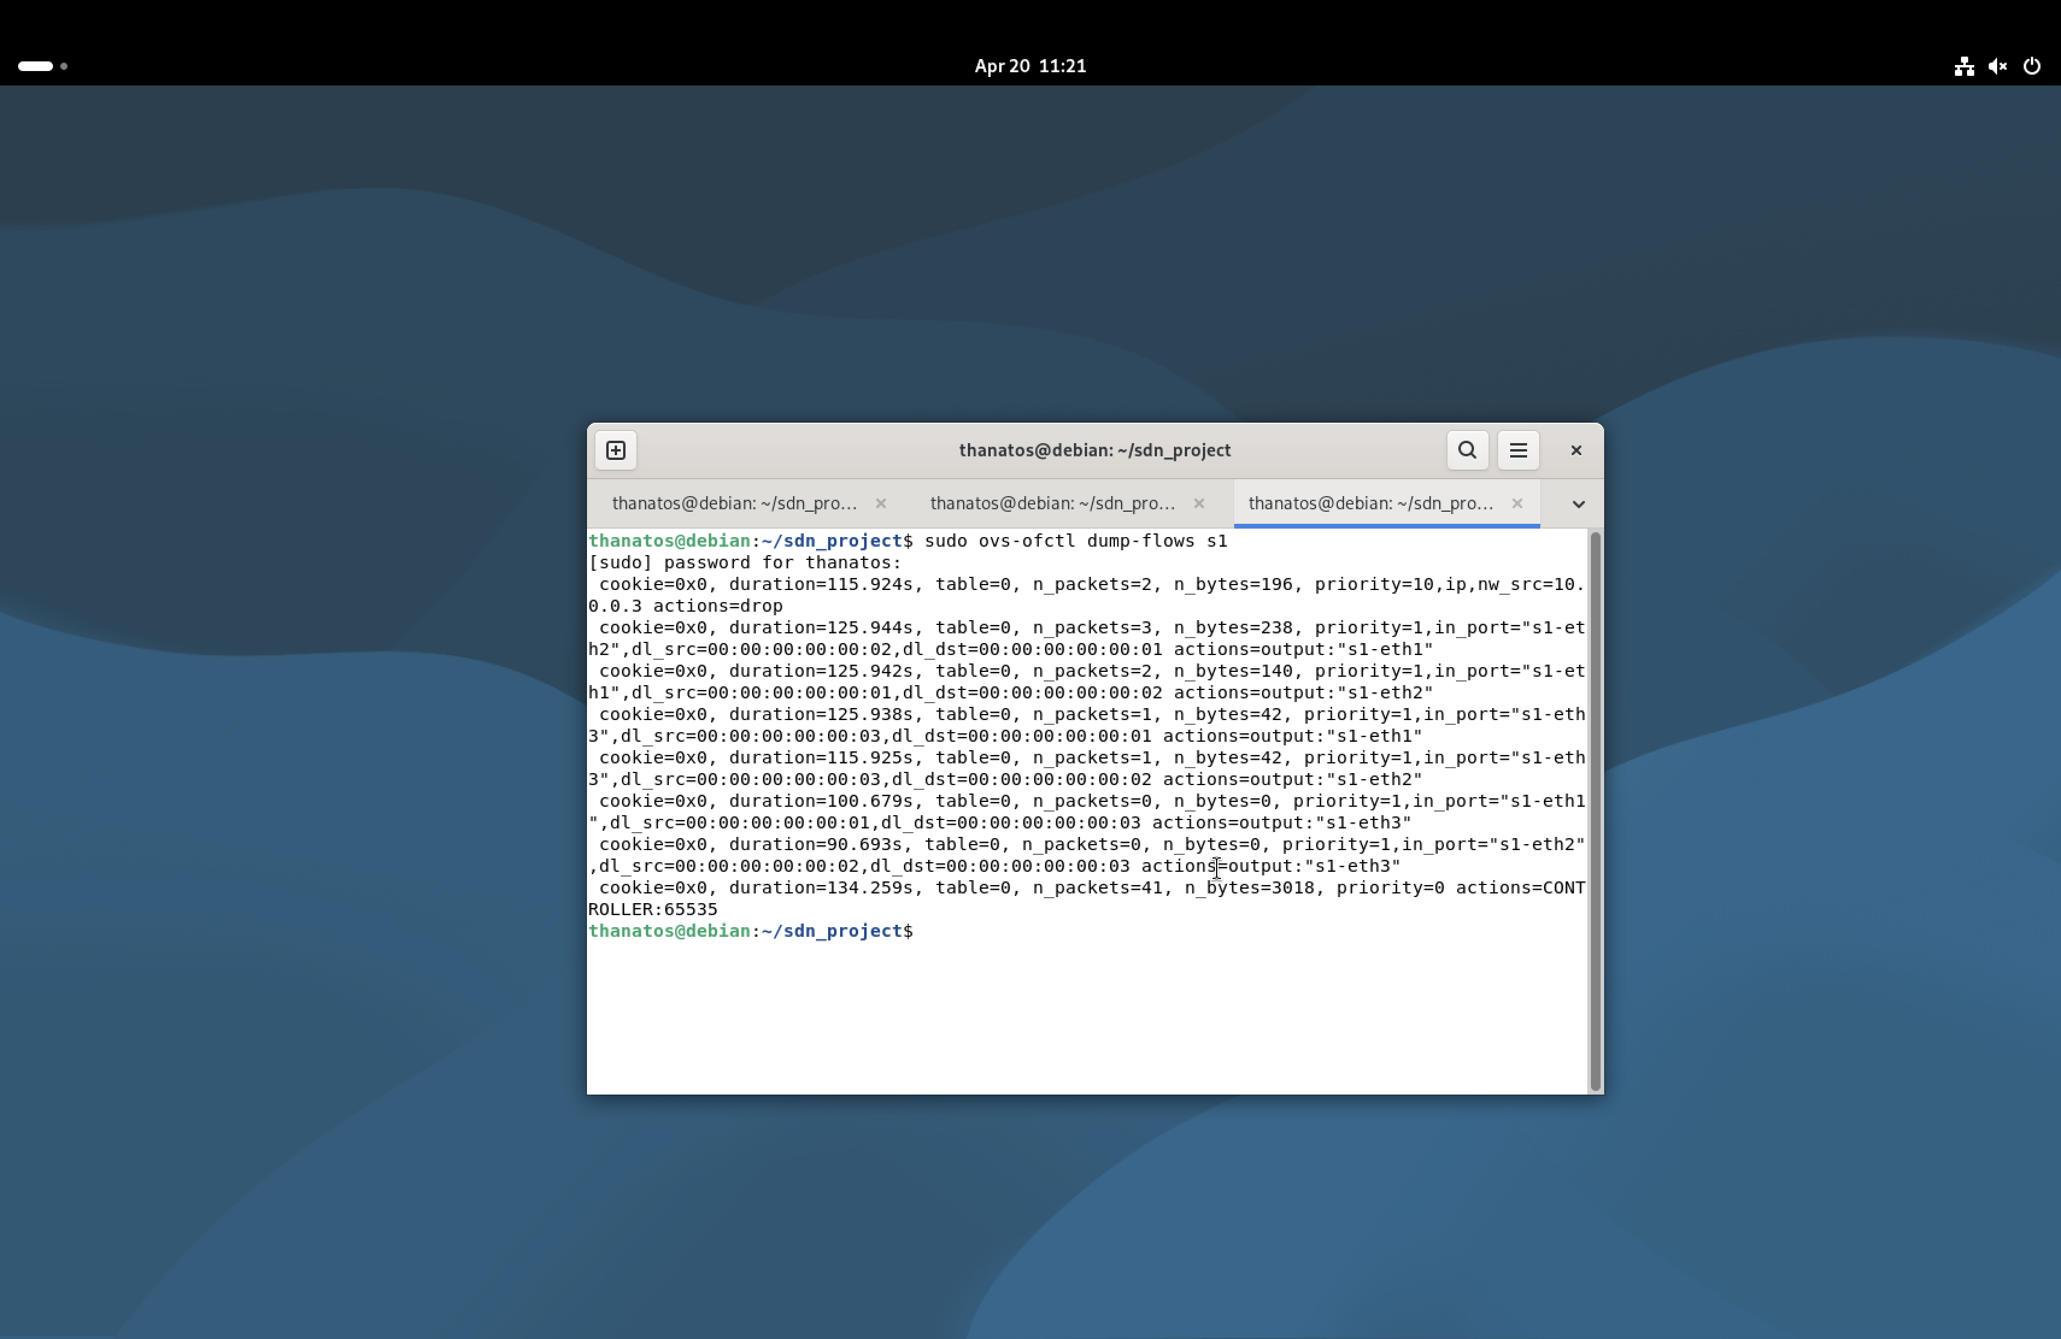
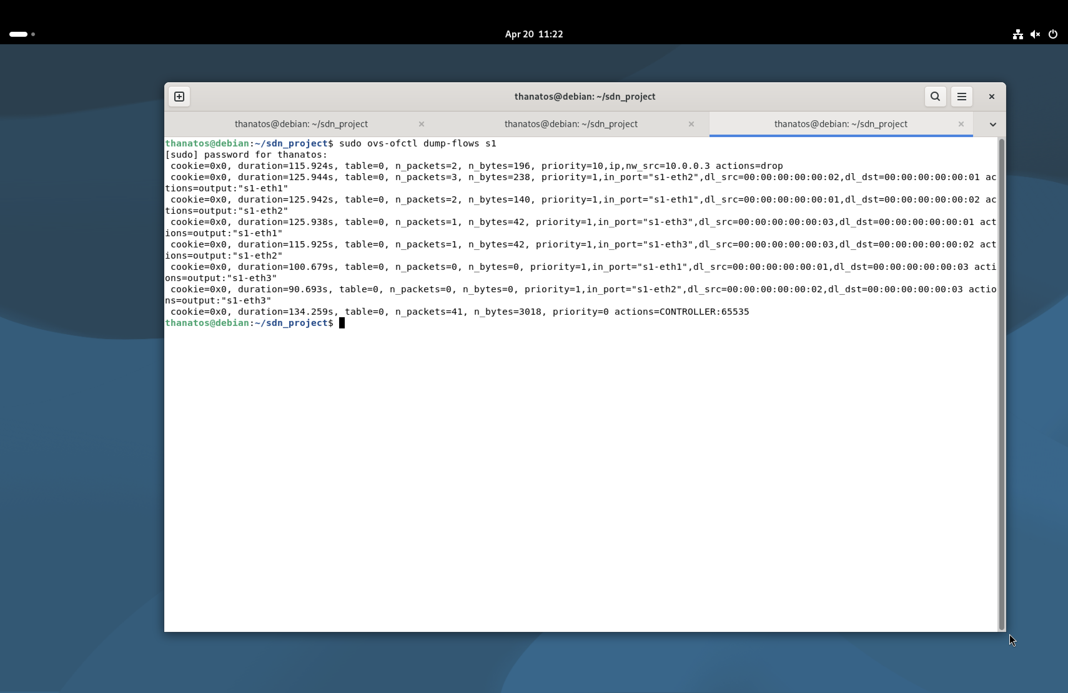
- MAC-based forwarding rules
- Output ports
- Drop rule for traffic from 10.0.0.3
- Controller flow entry
- OpenFlow dynamically controls packet forwarding.
- Rules define how packets are processed by the switch.
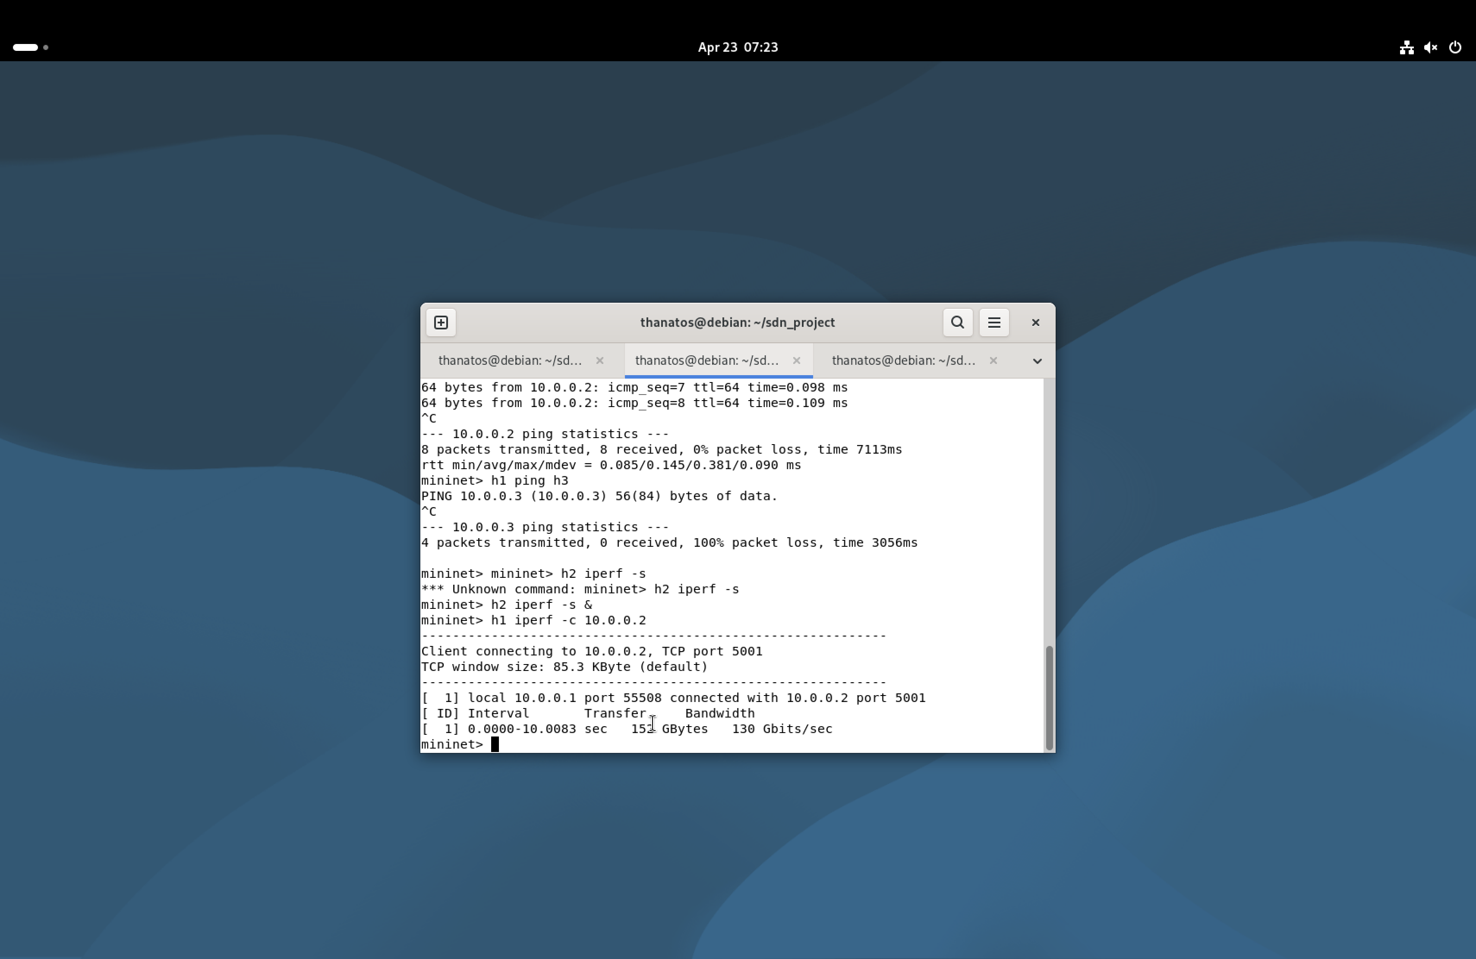
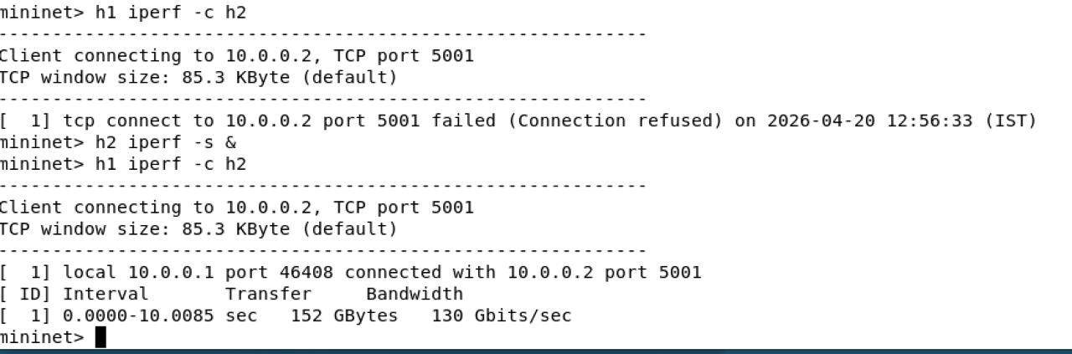
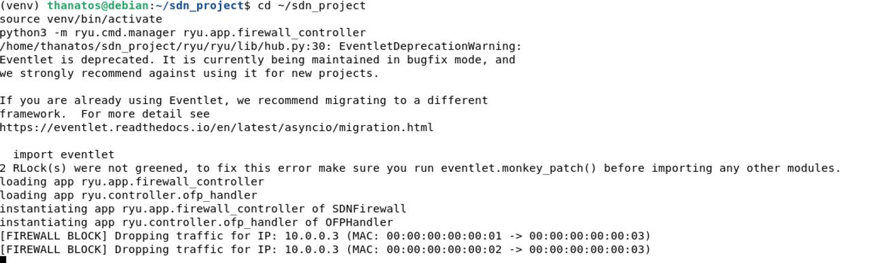
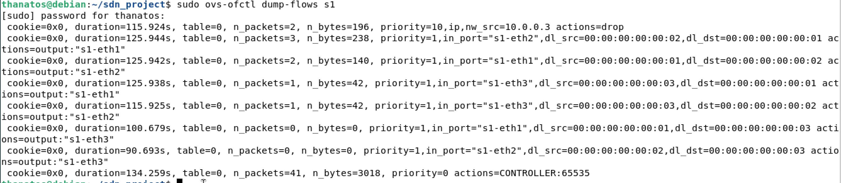
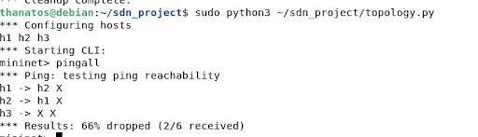
- h1 successfully communicates with h2
- h1 cannot communicate with h3 because of flow rules
- iperf measures TCP bandwidth between hosts
Important observation:
- 0% packet loss between allowed hosts
- 100% packet loss for blocked communication
REFRENCES:
• Ryu SDN Framework Documentation: https://ryu.readthedocs.io/
• Mininet Official Documentation: http://mininet.org/documentation/
• OpenFlow Switch Specification (v1.3): https://opennetworking.org/sdn-resources/openflow-switch-specification/
• Open vSwitch Documentation: https://docs.openvswitch.org/
• iperf Documentation: https://iperf.fr/

