Low Level Design

# Amazon Sales Data Analysis

|  |  |
| --- | --- |
| **Written By** | Tushar Padavi  Pooja Pawar  Dinesh Ingle  Chetan Mankar |
| **Document Version** | 0.3 |
| **Last Revised Date** | 17-11-2023 |

**DOCUMENT CONTROL**

## Change Record:

|  |  |  |  |
| --- | --- | --- | --- |
| **VERSION** | **DATE** | **AUTHOR** | **COMMENTS** |
| 0.1 | 15- Sep -  2023 | Tushar Padavi  Pooja Pawar  Dinesh Ingle  Chetan Mankar | Introduction and architecture defined |
| 0.2 | 16 - Sep -  2023 | Tushar Padavi  Pooja Pawar  Dinesh Ingle  Chetan Mankar | Architecture & Architecture description appended and  updated. |

**Reviews:**

|  |  |  |  |
| --- | --- | --- | --- |
| **VERSION** | **DATE** | **REVIEWER** | **COMMENTS** |
| 0.2 | 15- Nov -  2023 | Tushar Padavi  Pooja Pawar  Dinesh Ingle  Chetan Mankar | Architecture Description |

**Approval Status:**

|  |  |  |  |  |  |
| --- | --- | --- | --- | --- | --- |
| **VERSION** | **REVIEW**  **DATE** | **REVIEWED BY** |  | **APPROVED BY** | **COMMENTS** |
|  |  |  |  |  |  |

# Contents

#### Introduction 04

* 1. **What is Low-Level Design Document? 04**

|  |  |  |
| --- | --- | --- |
| **1.2** | | **Scope 04** |
| **2.** | **Architecture 05** | |
| **3.** | **Architecture Description 08** | |
|  | **3.1** | **Data Description 08** |
|  | **3.2** | **Data Transformation………………………………………………………………………………….08** |
|  |  |  |
|  |  |  |
|  |  |  |
|  |  |  |
|  |  |  |

# Introduction

## What is Low-Level design document?

The goal of the LDD or Low-level design document (LLDD) is to give the internal logic design of the actual program code for the House Price Prediction dashboard. LDD describes the class diagrams with the methods and relations between classes and programs specs. It describes the modules so that the programmer can directly code the program from the document.

## Scope

Low-level design (LLD) is a component-level design process that follows a step-by-step refinement process. The process can be used for designing data structures, required software architecture, source code and ultimately, performance algorithms. Overall, the data organization may be defined during requirement analysis and then refined during data design work.

# Architecture

**s**

**Power BI Server Architecture**

Power BI Report Server starts with the development of reports and dashboards using Power BI Desktop, which is a Windows application for creating data models and visualizations.

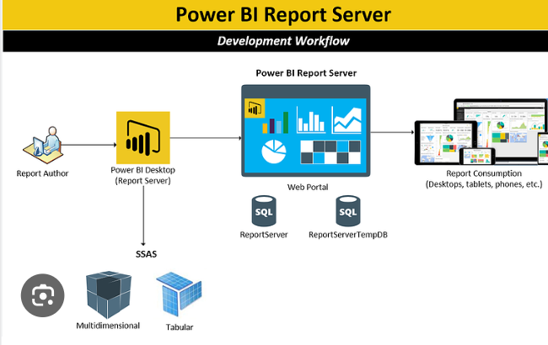The following diagram shows Power BI Server’s architecture:

**LOW LEVEL DESIGN**

**6**

Tableau Server is internally managed by the multiple server processes.

**1. Gateway/Load Balancer**

If your data sources are in the cloud, or youwant to refresh on-premises data from the Power BI Service, you can use the Power BI Gateway. This component facilitates secure data transfer between the Power BI Service and your on-premises network.

**2) Power BI Report Server**

For organizations that require on-premises deployment and data governance, Microsoft offers Power BI Report Server. This is a separate product that allows you to host Power BI reports and dashboards on your own servers within your organization's network. Power BI Report Server includes a web portal for users to access and interact with reports.

1. **VIZQL Server:-**

VizQL (Visual Query Language) is a proprietary technology used by Power BI to efficiently generate and render visualizations. The Power BI VizQL Server processes the data and instructions from the user interface to create the visual elements of reports and dashboards. It handles the rendering of charts, graphs, tables, and other visual elements, ensuring they are presented accurately and interactively to the end user.



1. **Data Engine:-**

The Data Engine in Power BI manages data extraction, transformation, modeling, and storage. It connects to various data sources, optimizes data for in-memory processing, supports advanced data modeling and calculations using DAX, and ensures data refresh and security, enabling fast and insightful report creation

# Architecture Description

## Data Description

The Dataset contains amazon sales records of countries. This dataset provides comprehensive sales data, including region, country, item type, sales channel, order details, and financial information, offering insights into sales performance and profitability.

* + 1. Region: It contains name of various Geographic regions.
    2. Country: It contains data of various countries.
    3. Item Type: The 'Item Type' column categorizes products by type, helping to classify and analyze the various product categories in the sales data.
    4. Sales Channel: The 'Sales Channel' column identifies the distribution channel through which sales transactions were made, offering insights into how products are sold, whether through online, retail, or other channels.
    5. Order Priority: The 'Order Priority' column indicates the level of urgency or importance assigned to each order, aiding in understanding the prioritization of orders in the dataset, such as high-priority versus low-priority orders.
    6. Order Date: The 'Order Date' column records the date when each sales order was placed, providing a time reference for tracking when customer orders were initiated.
    7. Order ID: The 'Order ID' column uniquely identifies each sales order, serving as a reference number for tracking and managing individual customer orders.
    8. Ship Date: The 'Ship Date' column captures the date when each sales order was shipped, offering a timeline for when customer orders were fulfilled and products were dispatched.
    9. Units Sold: Units Sold' column records the quantity of products sold in each sales order, helping to understand the sales volume for each product and order.
    10. Unit Price: The 'Unit Price' column represents the price at which each unit of a product is sold, providing insights into the pricing structure and revenue generation per product unit.



* + 1. Unit Cost: The 'Unit Cost' column reflects the cost associated with producing or procuring each unit of a product, helping to assess the cost structure and profit margins per product unit.

12.Total Revenue: The 'Total Revenue' column represents the cumulative revenue generated from each sales order, offering a comprehensive view of the overall income resulting from product sales.

* + 1. Total Cost: The 'Total Cost' column aggregates the total cost associated with fulfilling each sales order, aiding in understanding the overall cost incurred for product sales.
    2. Total Profit: The 'Total Profit' column calculates the overall profit generated from each sales order, providing a holistic view of the profitability resulting from product sales after considering costs.

## Data Transformation

In the Transformation Process, we will convert our original datasets with other necessary attributes format.