Amazon Sales

***Wireframe Documentation***

Homepage

As per the problem statement, we have divided analysis into three sections: -

# Impact of Profit on Item :

In this section we designed our first dashboard and tried to interpret the followings

* + Relation between Region wise Profit and Profit on Items
  + 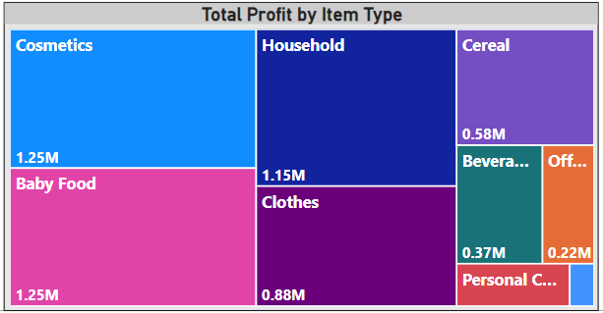Total Profit by the Item type

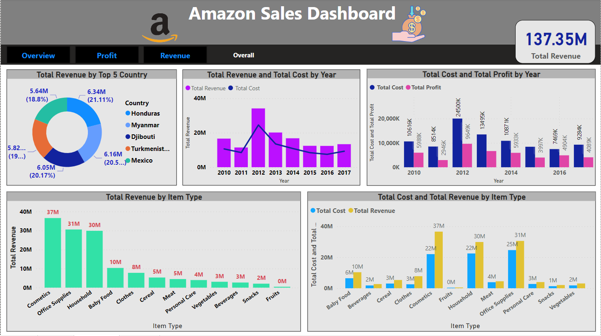

* + Relation Between Revenue of the year with Cost and Sold

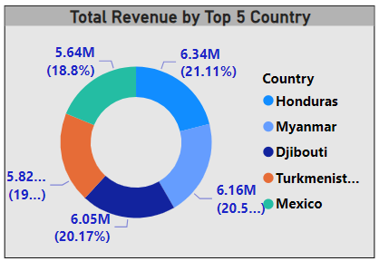

* + Total Revenue by the Top 5 Countries

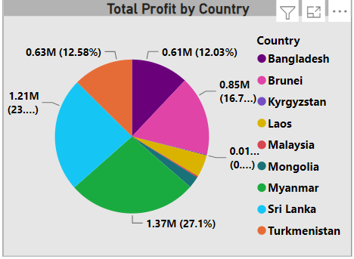

* + Total Profit by Countries

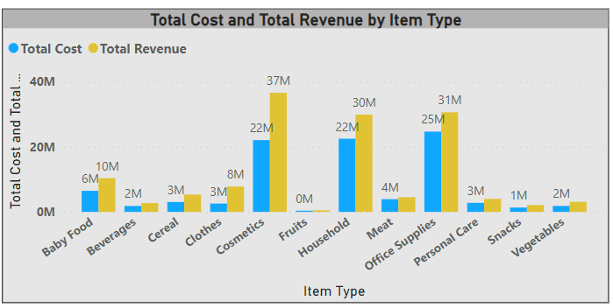

* + Relation between Total Cost and Total Revenue by the Item Types

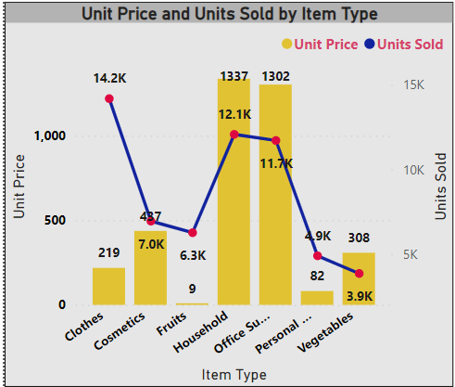

* + Relation Between Price and Cost with Item

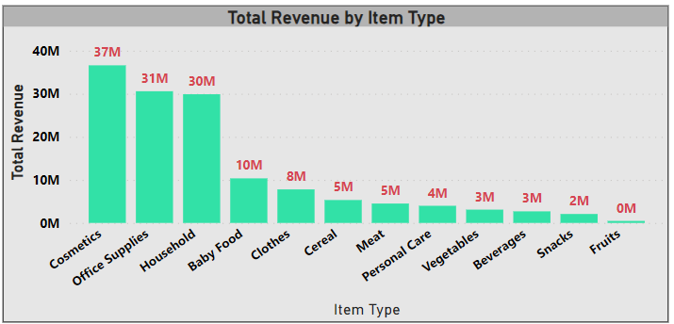

* + 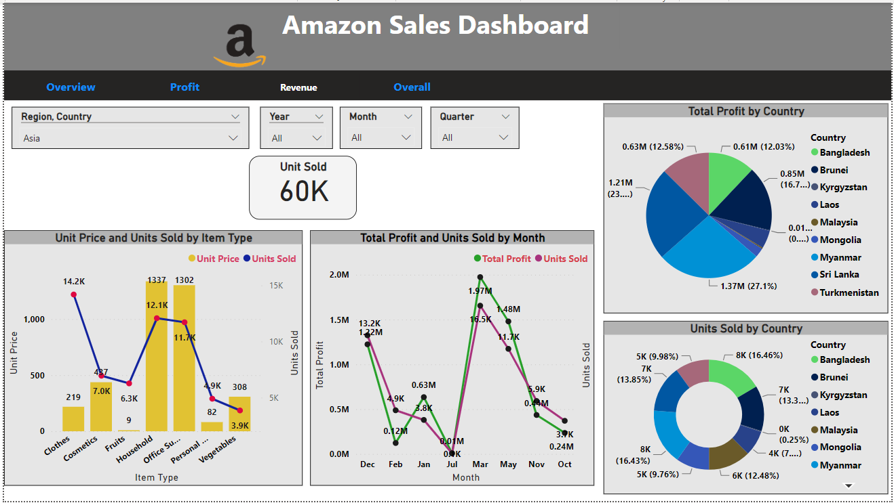Total Revenue by the Item