**Assignment - Solved**

**Question 1: Programming Skills**

Answer 1: Powershell file attached in folder, screenshot below after execution:

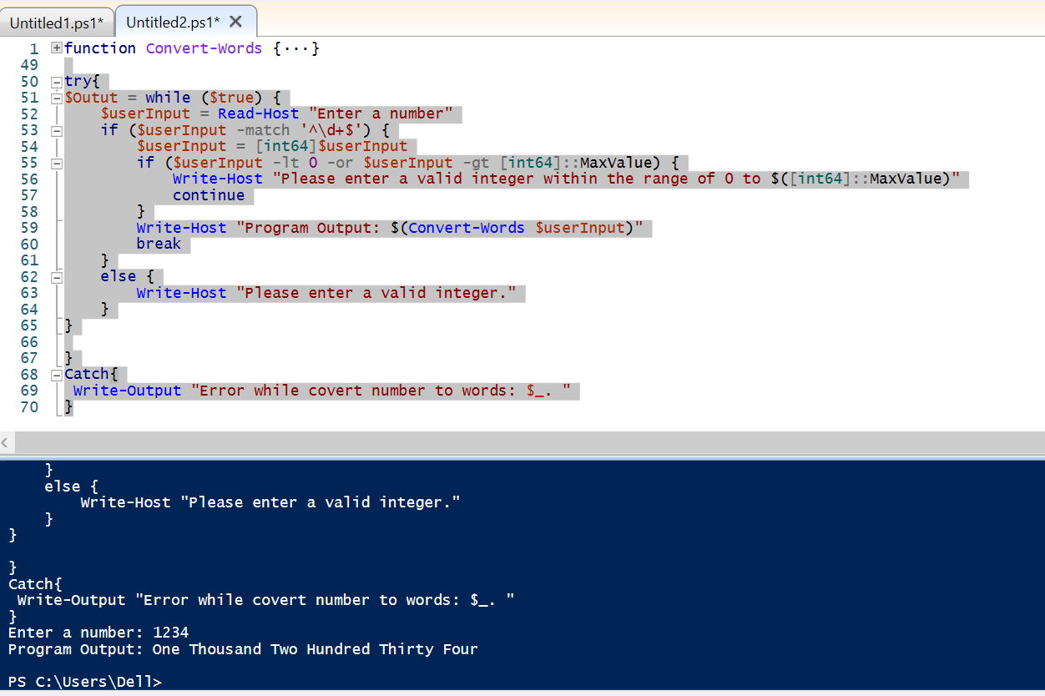

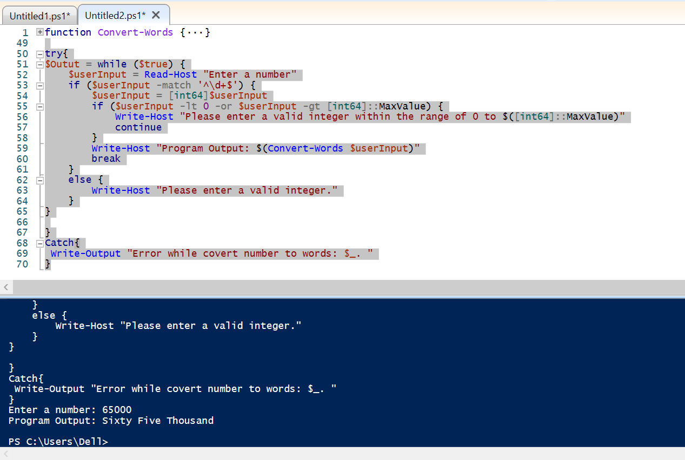

**Question 2: IAC Skills**

Answer 2:

Zip file attached with tfstate file and terraform file as “answer_2.zip”.

**Question 3: Web Services**

Answer 3:

I am working on windows so executed the same requirement in Powershell.

try{

$EmployeeCount = Invoke-WebRequest -Uri "https://dummy.restapiexample.com/api/v1/employees" | Select-Object -ExpandProperty Content | ConvertFrom-Json | Select-Object -ExpandProperty data | Where-Object { $_.employee_salary -ge 100000 -and $_.employee_salary -le 200000 } | Measure-Object | Select-Object -ExpandProperty Count

Write-Output "Number of employees whose salary is between 100000 and 200000 is $($EmployeeCount)."

}

Catch{

Write-Output "Error while fetching salary deatils $_. "

}

Please find screenshot below:

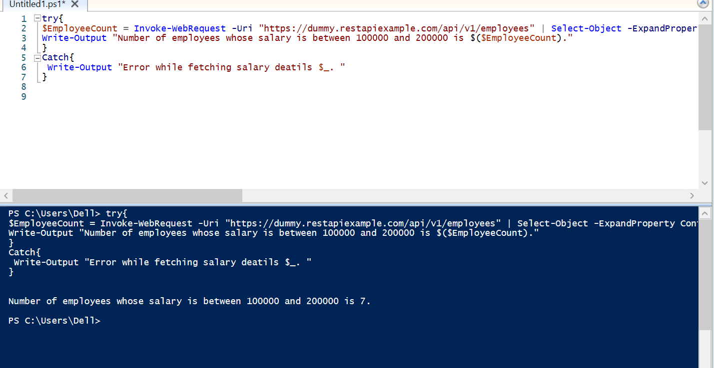

**Question 4: REGEX**

Answer 4:

Script:

function Test-Regex {

param(

[string]$InputUrl

)

$RegexPattern = "https?://(?:www\.)?ramsoft\.com(?:\/[\w-]+)*(?:\/)?(?:index\.html)?"

if ($InputUrl -match $regexPattern) {

Write-Output "URL matches the regex pattern."

} else {

Write-Output "URL does not match the regex pattern."

}

}

try{

$URL = Read-Host "Enter URL"

Test-Regex $URL

}

Catch{

Write-Output "Error while matching regex: $_. "

}

Screenshot:

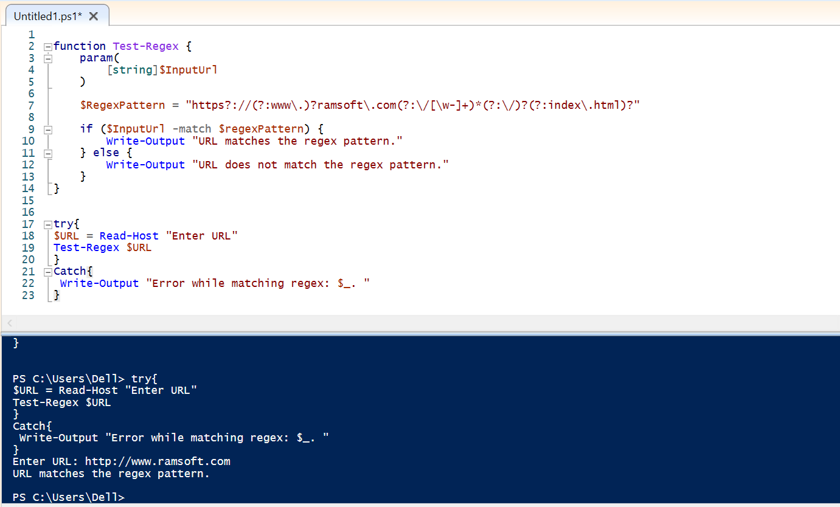

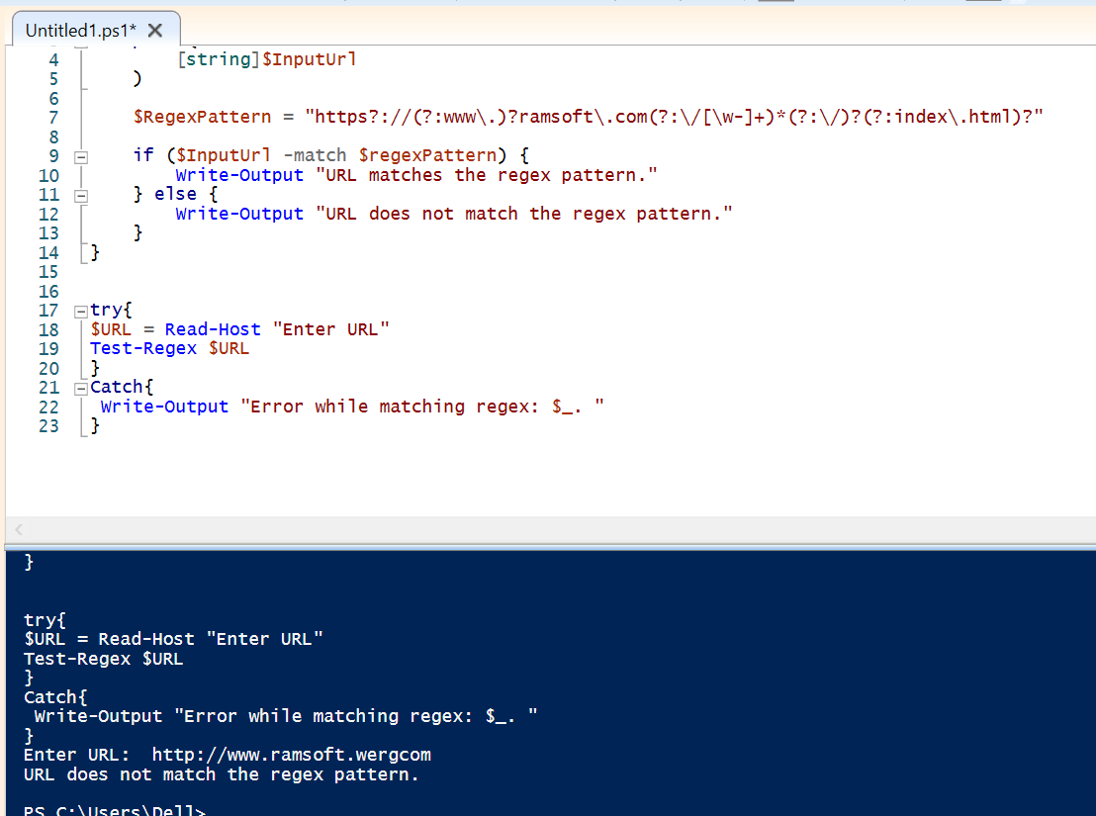

**Question 5: Containers and Networking**

Answer 5: Run Container1:

docker run -d --name ubuntul ubuntu:18.04 sleep infinity

Run Container2:

docker run -d --name ubuntu2 ubuntu:18.04 sleep infinity

Exec into Container1 and Container2:

docker exec ubuntul ps -eo user,pid,%cpu,%mem,vsz,rss,tty,stat,start,time,command

docker exec ubuntu2 ps -eo user,pid,%cpu,%mem,vsz,rss,tty,stat,start,time,command



To cleanup after the containers are done with any operation, you can use the “ –rm flag” when running the containers. This will automatically remove the container when it exits.

**Question 6: Container Orchestration**

Answer 6:

Coomand: kubectl get pods -o custom-columns=NAME:.metadata.name,POD_IP:.status.podIP --no-headers | awk '{print $1 "\t|\t" $2}

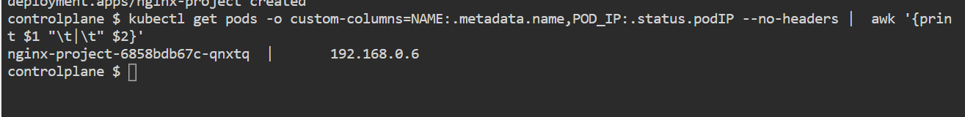

**Question 7: Cloud Administration**

Answer 7: Script attached named as “Answer_7.ps1” using az cli commands.

Screenshot below: Substitute your value while calling function.

