CUSTOMER SHOPPING
BEHAVIOR ANALYSIS
Data Analysis Project Report
Tools: Python (Pandas), SQL (MySQL), Power BI
Dataset: customer_shopping_behavior.csv | 3,900 customer records
Prepared as a portfolio-ready report based on the supplied dataset, notebook, SQL queries, and dashboard screenshot.

1. Executive Summary
This project explores customer shopping behavior to understand revenue distribution, product-category performance, seasonal patterns, subscription uptake, discount usage, and customer characteristics. The dataset contains 3,900 records and 18 columns. Total purchase amount is $233,081, with an average purchase amount of $59.76 per record.
Customer records | Total purchase amount | Average purchase | Average review rating
3,900 | $233,081 | $59.76 | 3.75 / 5
Key takeaways: Clothing contributes the largest share of revenue; Fall has the highest seasonal revenue; only about 27% of records are marked as subscribed; and review ratings contain 37 missing values.

2. Project Objectives
- Measure total and average purchase amounts.
- Compare revenue across product categories, seasons, and gender.
- Examine subscription status, discounts, shipping, and payment methods.
- Explore customer age, purchase history, and review ratings.
- Use SQL aggregation and filtering to answer business questions, then communicate findings in a Power BI dashboard.

3. Dataset Overview
The supplied CSV contains 3,900 rows and 18 columns, including customer ID, age, gender, item purchased, category, purchase amount (USD), location, size, color, season, review rating, subscription status, shipping type, discount applied, promo code used, previous purchases, payment method, and frequency of purchases.
Data quality check: 37 values are missing in Review Rating (about 0.95% of rows); the other columns have no missing values in the original CSV. Customer ID is unique in this dataset. Review-rating analysis should document how missing values are handled rather than silently dropping them.

4. Analysis and Findings

4.1 Overall purchasing
Total purchase amount: $233,081. Average purchase amount: $59.76; median: $60. Purchase amounts range from $20 to $100. The average customer age is 44.1 years (range 18–70). The mean available review rating is 3.75/5.

4.2 Revenue by category
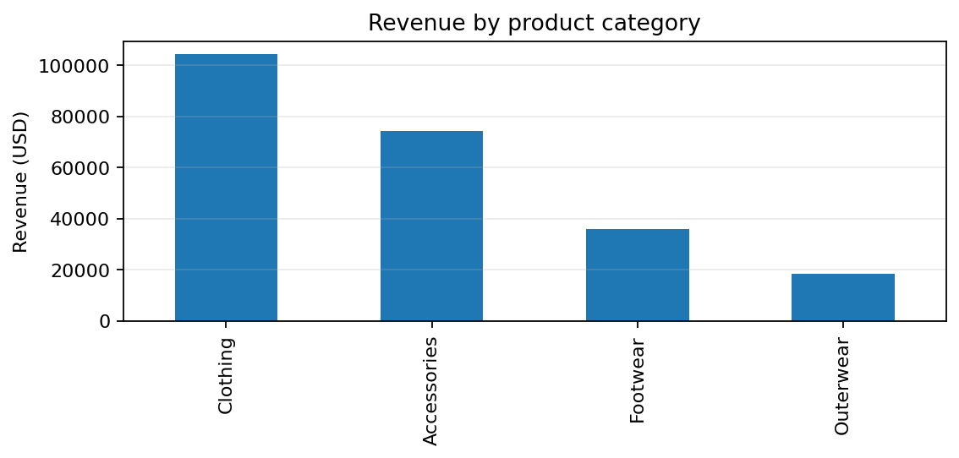
Clothing leads with $104,264 (44.7% of total purchase amount), followed by Accessories at $74,200 (31.8%). Footwear contributes $36,093, while Outerwear is lowest at $18,524. These results suggest category-level merchandising and inventory reviews should prioritize Clothing and Accessories.

4.3 Seasonal patterns
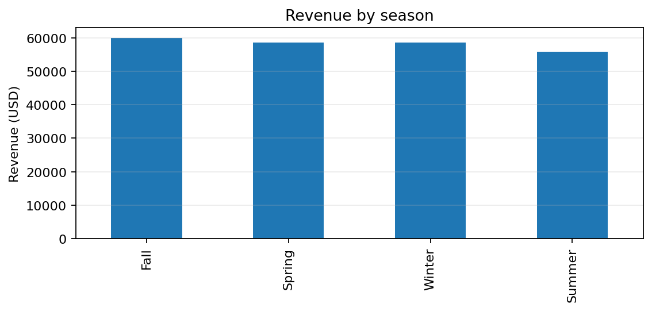
Fall is the highest-revenue season ($60,018), followed by Spring ($58,679) and Winter ($58,607). Summer is lowest ($55,777). The spread is modest, so seasonal campaigns can be tested without assuming a dramatic seasonal effect.

4.4 Customer subscription status
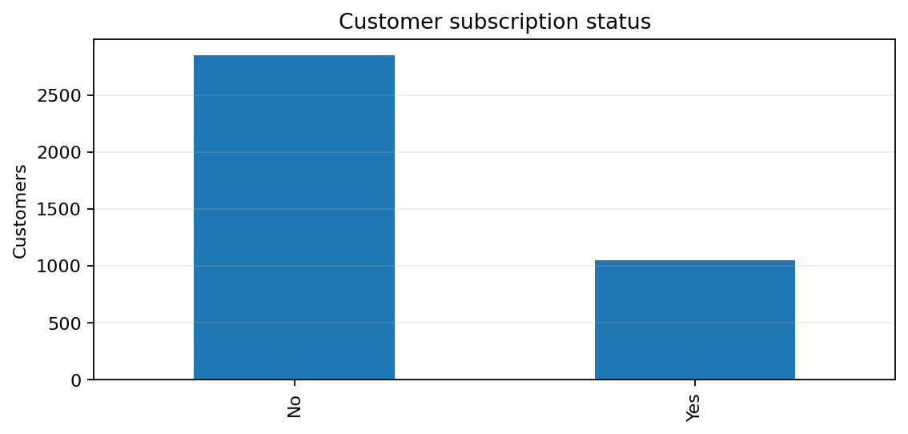
1,053 records (27.0%) are subscribed, compared with 2,847 (73.0%) not subscribed. Average purchase amount is $59.49 for subscribed records and $59.87 for non-subscribed records. This descriptive comparison does not show a higher average transaction amount among subscribers; retention benefits would need separate analysis.

4.5 Revenue by gender
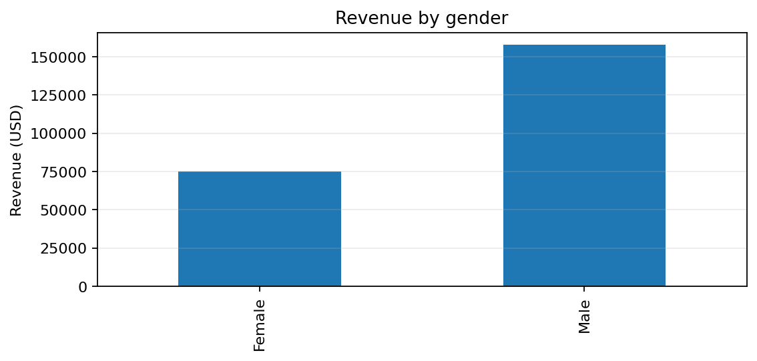
Male records contribute $157,890 and female records $75,191. There are 2,652 male records and 1,248 female records, so total revenue differences are influenced by the different record counts. Average purchase amounts are similar: $59.54 for male records and $60.25 for female records.

4.6 Discounts, shipping, payment, and reviews
Discounts are marked Yes in 1,677 records (43.0%) and No in 2,223 (57.0%). Average purchase amount is $59.28 when a discount is applied versus $60.13 without one. This is an association, not proof that discounts reduce spend.
Average purchase amount by shipping type ranges from $60.73 (2-Day Shipping) to $58.46 (Standard). Average review rating is 3.75/5 among non-missing ratings. Gloves has the highest average rating among items in the supplied data (about 3.86), but item-level differences should be interpreted cautiously.

5. SQL Analysis
The supplied SQL file demonstrates database creation and exploratory queries, including:
- Revenue grouped by gender.
- Customers whose purchase amount is above the overall average and who used a discount.
- Top five purchased items by average review rating.
- Average purchase amount by shipping type for Express and Standard shipping.
- Average and total purchase amount by subscription status.
- Discount rate by item purchased.
- Customer segmentation based on previous purchases.
Note: the SQL queries use a table named customers and column names such as purchase_amount, review_rating, and item_purchased. Confirm that the MySQL table schema matches these names (or rename columns consistently) before running the queries. Also, the segmentation rule in the SQL labels one previous purchase as New, 2–10 as Returning, and more than 10 as Loyal.

6. Python and Power BI Workflow
- Python/Pandas: load the CSV, inspect columns and missing values, standardize column names, create derived fields, and calculate summary statistics.
- MySQL: load the dataset into the project database and run aggregation, filtering, subquery, and CTE-based analyses.
- Power BI: connect to the cleaned data, create KPI cards for customer count and total revenue, and build charts for seasonal revenue, category revenue, discount usage, and subscription status.
The provided dashboard screenshot displays approximately 3.9K customers and 233K total revenue, consistent with the CSV's 3,900 rows and $233,081 total purchase amount. The dashboard's exact metric definitions and currency formatting should be made explicit in the final report.

7. Recommendations
- Prioritize Clothing and Accessories in category-level assortment and promotional planning because together they contribute about 76.6% of purchase amount.
- Review the Fall campaign calendar and compare product, discount, and customer-level results across seasons before increasing seasonal spend.
- Test targeted subscription campaigns and measure conversion, repeat purchase frequency, retention, and customer lifetime value rather than relying only on average transaction amount.
- Evaluate discounts using margin and incremental-sales measures, not revenue alone.
- Investigate missing review ratings and document a consistent cleaning method; avoid imputing ratings without validating the approach.
- Improve the dashboard with clear USD labels, descriptive chart titles, and consistent terminology (purchase amount vs. revenue).

8. Limitations
- The data is observational and contains no explicit transaction date, cost, profit, or margin field, so profitability and time trends cannot be assessed directly.
- The dataset has one row per customer ID in this file; revenue should be described as the sum of purchase amounts in the records, not necessarily lifetime revenue.
- Group differences are descriptive and do not establish causation.
- Thirty-seven review ratings are missing, which can affect rating summaries.

9. Conclusion
This project combines exploratory analysis in Python, SQL-based business queries, and a Power BI dashboard to summarize shopping behavior. The main findings are that Clothing is the largest category by purchase amount, Fall has the highest seasonal total, and subscription uptake is relatively low in the dataset. Next steps should focus on validated customer segmentation, margin-aware promotion analysis, and tracking repeat behavior over time.

Appendix: Key Metrics
Metric | Value | Definition
Records / customer IDs | 3,900 | Rows in the supplied CSV
Total purchase amount | $233,081 | Sum of Purchase Amount (USD)
Average purchase amount | $59.76 | Mean purchase amount per row
Median purchase amount | $60 | Median purchase amount
Average review rating | 3.75 / 5 | Mean of non-missing ratings
Missing review ratings | 37 | 0.95% of records
Subscribed records | 1,053 (27.0%) | Subscription Status = Yes
Discount-applied records | 1,677 (43.0%) | Discount Applied = Yes
Clothing share | 44.7% | Share of total purchase amount
Fall share | 25.8% | Share of total purchase amount

