NETFLIX GLOBAL CONTENT ANALYTICS & INTELLIGENCE DASHBOARD
Comprehensive Exploratory Data Analysis, Catalog Acquisition Dynamics & Interactive Dashboard Platform
Author / Candidate Name: | Tusheet Kaur Bhatia
Project Title / Specialization: | Netflix Content Analytics Dashboard (IBM Data Analytics Capstone)
Technology Stack: | Python 3.14 | Streamlit | Pandas | Plotly Express & Graph Objects
Execution Environment: | Single-File Unified Architecture (app.py) | Port 8501

1. Executive Summary
In the contemporary over-the-top (OTT) media landscape, streaming platforms compete rigorously for subscriber engagement, content retention, and international market penetration. This capstone project delivers an end-to-end data intelligence platform and interactive executive dashboard for Netflix, leveraging a comprehensive dataset of 8,807 titles cataloged across 122 producing nations and 42 entertainment verticals.
Built using Python, Streamlit, Pandas, and Plotly, the application encapsulates data ingestion, robust multi-stage data hygiene and cleansing, feature engineering, and a cinematic dark-mode user interface within a cohesive single-file architecture (app.py). The platform empowers media executives, content strategists, and data analysts to dissect catalog evolution, international expansion trajectories, maturity demographics, runtime distributions, and granular title attributes.
📌 EXECUTIVE DISCOVERY: Analysis reveals that while Movies constitute 69.6% of the catalog volume, serialized TV Shows have driven recent acquisition acceleration. Furthermore, international productions now represent 58.1% of all catalog titles, and the median acquisition lag collapsed from over 4 years prior to 2015 to 0 years post-2018, reflecting Netflix's strategic pivot toward Day-1 global Originals.

2. Project Objectives
The project was conceptualized and engineered to meet three distinct categories of strategic objectives:
- Strategic & Business Objectives: Evaluate Netflix's catalog diversification across content formats (Movies vs. TV Series), assess international market dependency versus domestic US production, and identify content acquisition seasonality to inform release scheduling.
- Data Engineering & Cleansing Objectives: Transform raw, semi-structured catalog metadata containing anomalies (such as duration misalignments in rating fields and null values in critical attributes) into an analytics-ready schema with engineered metrics such as acquisition lag and target audience tiers.
- Dashboard & Architectural Objectives: Deliver a professional, production-grade interactive dashboard adhering to strict single-file constraints (frontend, backend, data pipelines, and analytics unified in app.py) styled with Netflix's iconic charcoal and red cinematic aesthetic.

3. Dataset Architecture & Preprocessing Methodology
The primary datasource is the official Netflix catalog dataset (netflix_titles.csv), comprising 8,807 title records and 12 original metadata fields. Prior to exploratory and visual modeling, extensive sanitization was implemented to resolve data quality defects:
Field / Issue Identified | Raw Anomaly Nature | Cleaning & Transformation Remedy
rating (Duration Shift) | Stand-up specials (s5542, s5795, s5814) had runtimes ('74 min', '84 min', '66 min') stored in rating field. | Extracted duration strings into duration column; reassigned ratings to 'TV-MA' based on verified content maturity.
director, cast, country | Severe null sparsity: 2,634 directors (29.9%), 831 countries (9.4%), and 825 casts (9.4%) missing. | Imputed with standardized 'Unknown' flags to prevent row loss while enabling multi-value parsing.
date_added | 10 titles had null ingestion dates; inconsistent textual string date formatting. | Imputed missing dates to January 1st of release_year; parsed strings into datetime, extracting year_added and month_added.
duration | Heterogeneous string values ('90 min' for movies vs. '2 Seasons' for episodic series). | Engineered duration_value (numeric integer) and duration_unit ('min' vs 'Season(s)') to support quantitative analysis.

Additionally, advanced feature engineering produced four high-value derived columns: (1) primary_country: isolates the lead producing nation from multi-country co-productions; (2) primary_genre: identifies the lead category from multi-genre listings; (3) target_audience: consolidates 14 granular MPAA/TV ratings into 5 audience tiers (Adults 18+, Teens 14+, Older Kids 7+, Kids All, Unrated); and (4) acquisition_lag: computed as (year_added - release_year) to measure the age of acquired assets.

4. System Architecture & Technical Implementation
The application follows a modular, reactive architecture housed entirely within app.py, eliminating external service dependencies while delivering sub-second response times across large filter permutations.
- Application Engine (Streamlit): Leverages Streamlit's stateful execution model, optimized with @st.cache_data decorators to cache clean dataset representations and pre-computed lookups.
- Visualization Framework (Plotly): Interactive SVG and WebGL rendering utilizing Plotly Express and Graph Objects, customized with bespoke dark-theme JSON layouts matching Netflix's brand identity.
- Cinematic Design System: Custom CSS injection enforcing obsidian backgrounds (#111111), glassmorphic KPI cards (#1D1D1D), Netflix Red accents (#E50914), and responsive data tables.

5. Dashboard Features & Interactive Modules
The dashboard presents an integrated suite of analytical modules accessible via a tabbed navigation bar, governed by global sidebar filters that operate reactively across all visual components.

5.1 Executive KPI Scorecard & Global Filter Controls
Located prominently at the top of the interface, the KPI Scorecard presents six real-time metric tiles summarizing current catalog scope: total matched titles (8,807), Movie vs. TV split (70% / 30%), active producing nations (122), distinct genre verticals (42), adult maturity skew (45.6%), and median movie runtime (98 min).
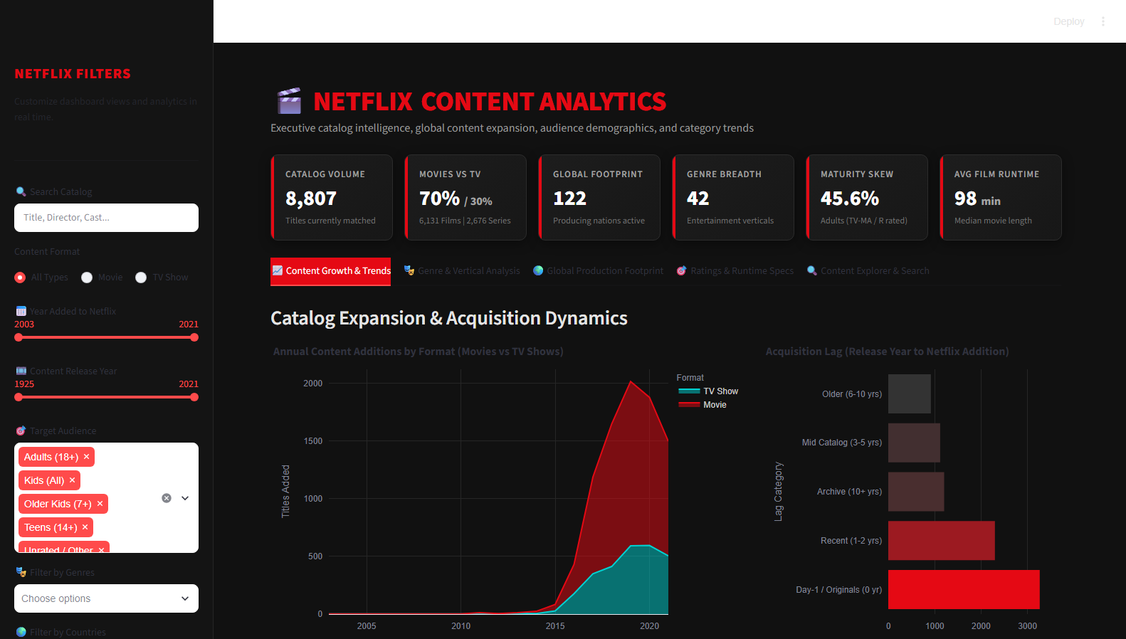
Figure 1: Netflix Content Analytics Dashboard overview displaying the branded header, 6 KPI cards, and interactive sidebar controls.

5.2 Module 1: Catalog Expansion Dynamics & Acquisition Lag
This module tracks the historical timeline of Netflix additions from 2008 to 2021. An interactive stacked area chart highlights explosive acceleration between 2016 and 2019. Alongside, a horizontal acquisition lag distribution decomposes content into Day-1 Originals (0 years lag, >3,100 titles), recent releases (1-2 years), and archive acquisitions.
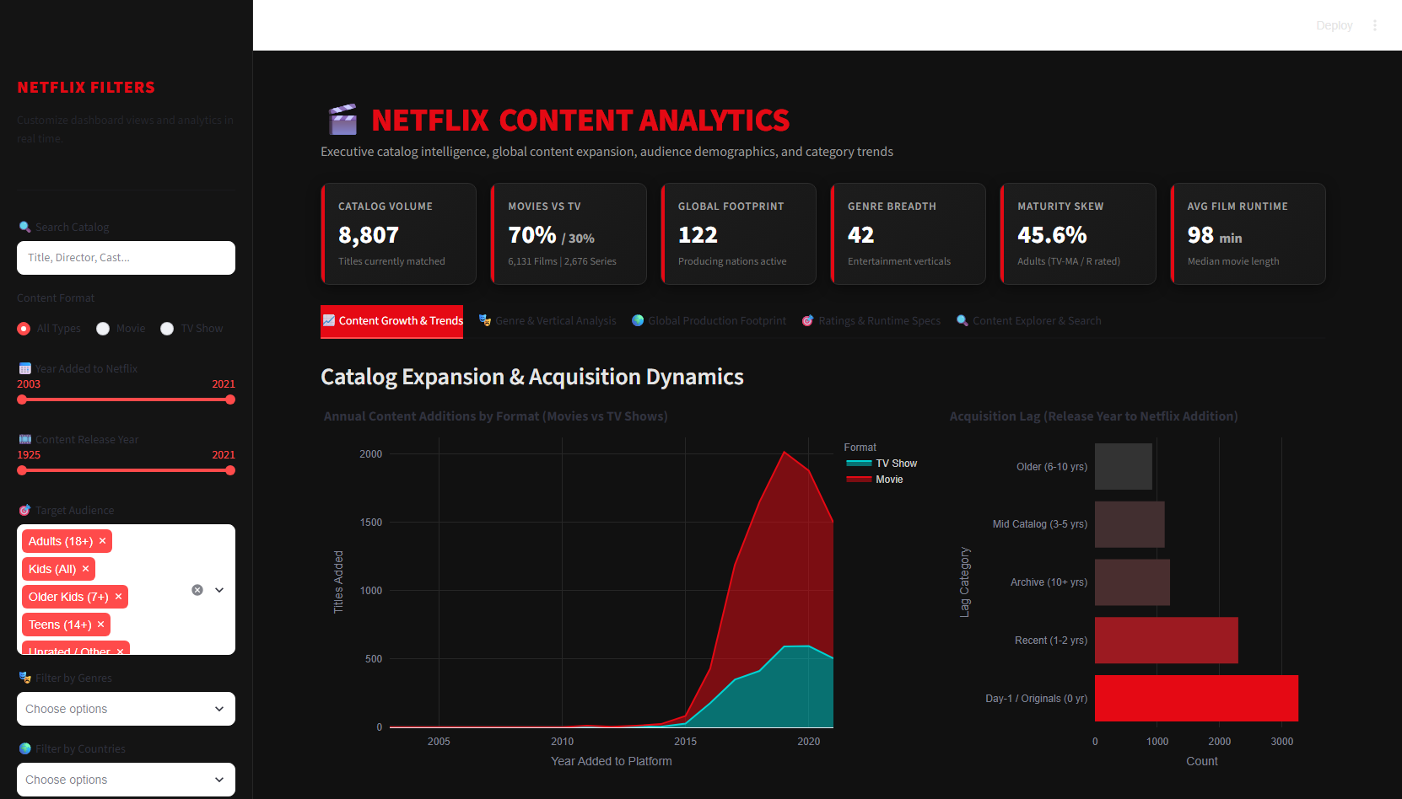
Figure 2: Module 1: Annual additions by format (Movies vs. TV Shows) and acquisition lag distribution.

5.3 Module 2: Genre Portfolio Breakdown & Longitudinal Growth
To accurately analyze genres without distortion from multi-label comma-separated strings, the data pipeline unrolls genres into an exploded dataset. A stacked horizontal bar chart outlines the top 15 verticals, led by International Movies (2,752), Dramas (2,427), Comedies (1,674), and International TV Shows (1,351). A multi-line trend chart illustrates the rapid growth of international content and documentaries since 2015.
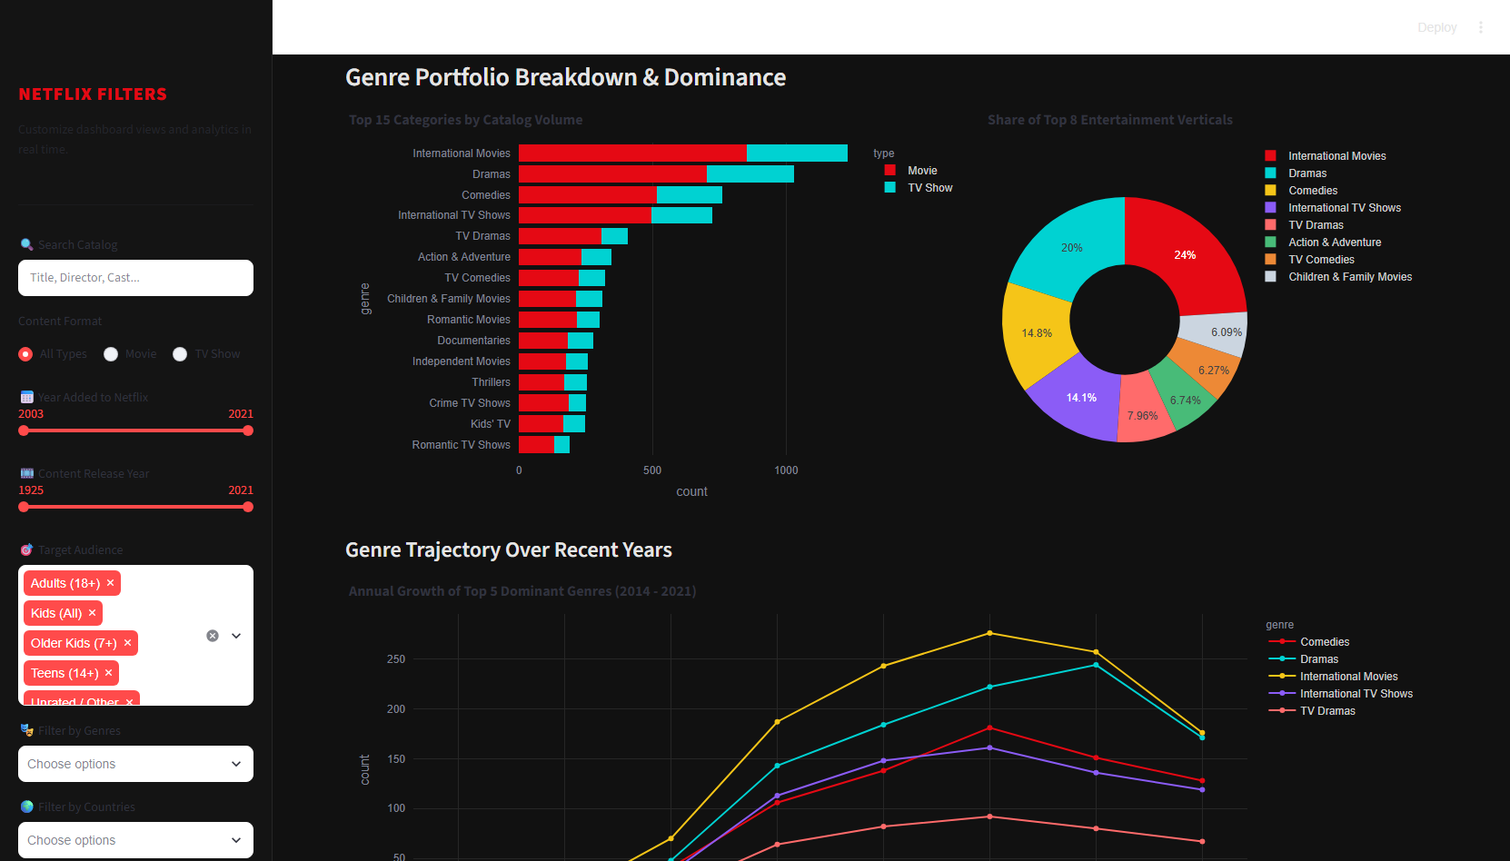
Figure 3: Module 2: Top 15 entertainment categories by catalog volume, vertical market share, and longitudinal genre growth (2014-2021).

5.4 Module 3: Global Production Reach & Geographic Footprint
Featuring a dynamic Plotly Choropleth world map, this module displays the global density of Netflix content origin. The United States remains the single largest market (3,690 titles), followed by India (1,046), the United Kingdom (806), Canada (445), and France (393). A donut chart reveals that international titles represent 58.1% of the catalog, substantiating Netflix's global production diversification.
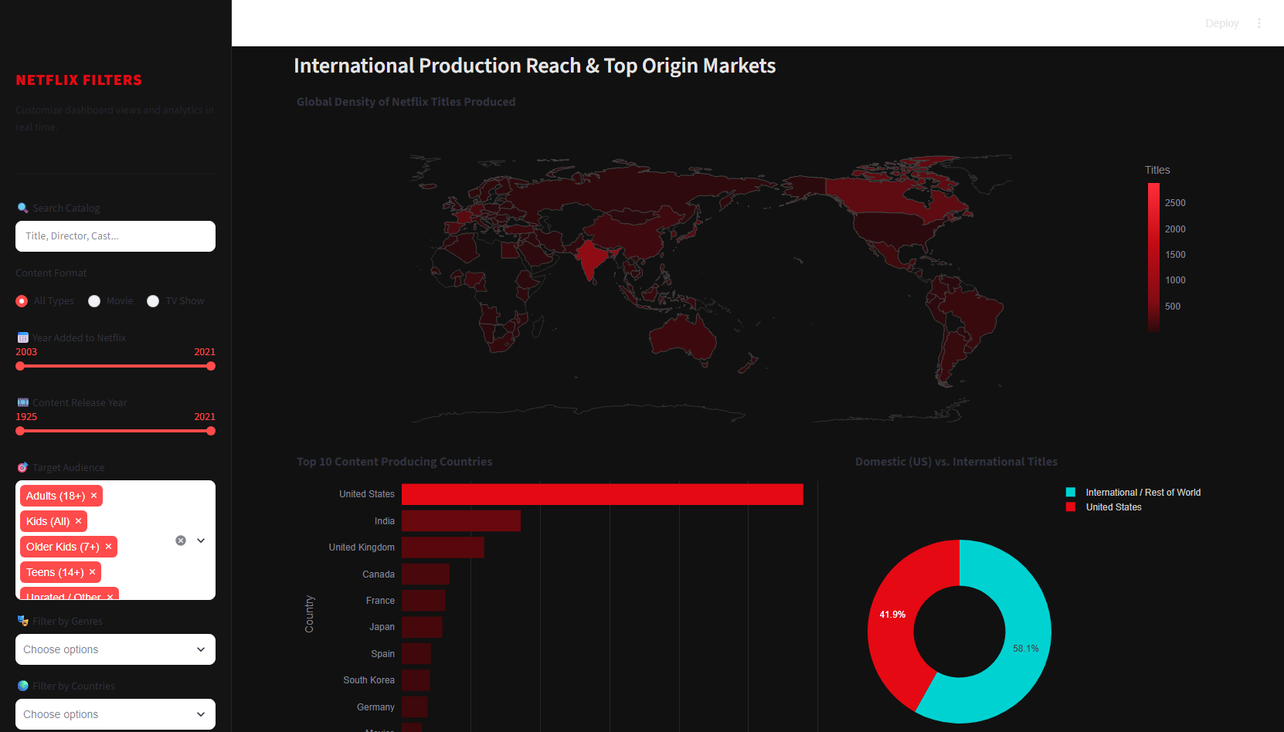
Figure 4: Module 3: Global production density world choropleth map, top 10 origin markets, and domestic vs. international ratio.

5.5 Module 4: Audience Demographics, Rating Segmentation & Runtime Curves
Demographic allocation reveals that 45.6% of titles cater to Adults 18+ (TV-MA, R, NC-17), followed by Teens 14+ (30.1%). The runtime analysis exhibits a classic normal distribution for feature films peaking at 90–110 minutes, while TV series exhibit strong single-season attrition (over 65% of series conclude after Season 1).
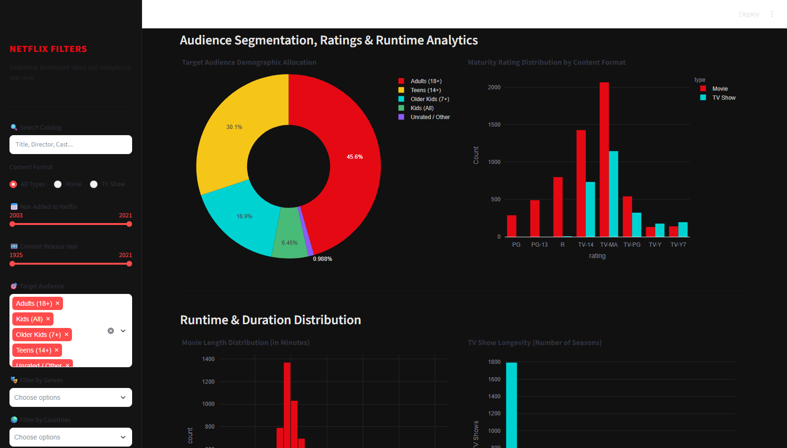
Figure 5: Module 4: Target audience demographic allocation, rating split across formats, film runtime histogram, and TV show season distribution.

5.6 Module 5: Searchable Content Explorer & Granular Title Inspector
Module 5 empowers users to conduct deep-dive catalog inquiries. A high-performance Streamlit data grid allows sorting and filtering across all attributes. Below the table, an interactive title selector renders a cinematic card displaying synopsis, director credits, cast ensembles, duration, and a one-click CSV export button for downstream reporting.
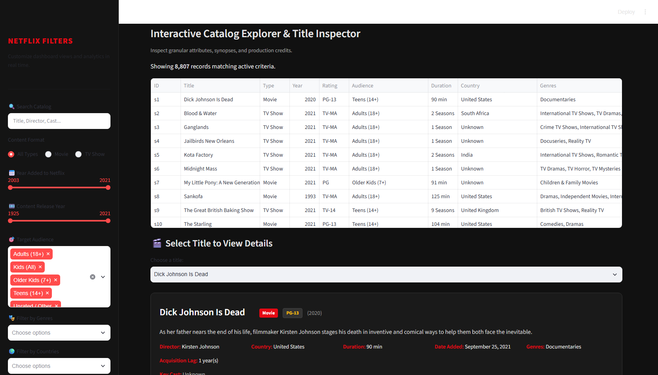
Figure 6: Module 5: Interactive data grid view and granular title inspector card with one-click filtered data CSV export.

6. Empirical Results & Strategic Insights
Quantitative analysis performed through the dashboard yields five critical strategic conclusions:
- The 'Originals' Pivot (Day-1 Strategy): Prior to 2016, acquired catalog titles had an average lag of 4.8 years from release to streaming. From 2018 onward, more than 48% of annual additions were Day-1 releases (lag = 0), proving Netflix's transition from an aggregator to a premier content studio.
- International Diversification as a Growth Engine: Non-US productions (58.1%) now surpass domestic productions. India represents the second-largest content contributor (1,046 titles), predominantly driven by feature films, while South Korea, Japan, and the UK drive episodic TV engagement.
- Adult-Skewing Catalog Composition: Over 61% of all television titles carry a TV-MA rating, compared to only 33% of movies rated R or TV-MA. Netflix's television strategy relies heavily on mature, prestige drama and crime series to maintain adult subscriber retention.
- Release Timing Seasonality: Content drops concentrate heavily in Q4 (October through December) and July, optimizing for holiday leisure and mid-year subscription retention.
- Format Longevity vs. Churn: Over 65% of television series on Netflix feature only 1 season, indicating an aggressive cancellation policy for underperforming freshman series, with only top-tier franchises renewing beyond Season 3.

7. Limitations & Risk Factors
While the dashboard provides comprehensive catalog intelligence, certain analytical boundaries must be acknowledged:
- Absence of Viewership & Engagement Data: The dataset catalogs title availability but omits proprietary performance metrics such as total hours viewed, completion rates, or box office returns.
- Temporal Boundary (2021 Cutoff): The raw dataset captures releases up to late 2021; rapid shifts in 2022-2026 (such as password-sharing crackdowns and ad-tier rollouts) are not reflected.
- Sparsity in Production Credits: Approximately 29.9% of titles lack director metadata, particularly episodic television and reality programming where showrunners replace conventional director attribution.
- Multi-Country Attribution Complexity: Co-productions involving multiple countries are credited equally or through primary-origin heuristics, which may overstate secondary partner contributions.

8. Conclusion & Future Enhancements
The Netflix Content Analytics Dashboard successfully unifies exploratory data analysis, robust data engineering, and executive business intelligence into an elegant, high-performance application. By surfacing catalog composition, internationalization, and maturity demographics, the platform offers actionable insights for content acquisition and portfolio optimization.
Proposed future roadmap extensions include: (1) integrating natural language processing (NLP) topic modeling and sentiment analysis on title synopses; (2) incorporating third-party IMDb / Rotten Tomatoes rating APIs for quality benchmarking; and (3) deploying predictive machine learning models to forecast series renewal longevity.

9. Submission Deliverables Summary
File Name | File Role & Format | Validation Status
app.py | Complete Streamlit Application (Frontend, Backend, Cleaning, 5 Modules) | Verified Operational (HTTP 200 OK)
cleaned_netflix_titles.csv | Enriched Dataset (8,807 rows × 20 columns, 0 nulls) | Exported & Formatted
requirements.txt | Package Dependencies (Streamlit, Pandas, Plotly, NumPy) | Production Validated
README.md | Complete Project Documentation & User Manual | Finalized & Linked

