**CSIS 3540 – 001**

**CLIENT SERVER SYSTEMS**

**PROJECT NAME: BrewCrew**

**Due Date: April 12th, 2020**

**Instructor: Michael Hrybryk**

**Submitted By:**

**Jasmine Kaur (300294054)**

**Tushit Nag Kanuri (300298577)**

Table of Contents

1 PROJECT TEAM 3

2 PROJECT DESCRIPTION 3

2.1 OUR MISSION 3

2.2 PROJECT SCOPE 3

2.3 PROJECT REQUIREMENTS 4

2.4 PROJECT DELIVERABLES 4

3 PROCESS MODEL 5

4 DATABASE MODEL 6

5 USER MANUAL 7

6 PROJECT PLAN 14

7 SUMMARY 15

# PROJECT TEAM

The development team (Team 03) for the final project for CSIS 3540 Client Server Systems consists of two team members. They are as follows:

* Jasmine Kaur (Team Lead)
* Tushit Nag Kanuri (Team Member)

# PROJECT DESCRIPTION

## OUR MISSION

The project entitled BrewCrew is a C# based application for a bubble tea café. Bubble tea is Taiwanese tea-based drink with flavors of milk and sugar, and jelly-based toppings usually called “pearls”. The application allows potential users to sign in/ sign up with the BrewCrew application, browse through the café menu and build an order which could be picked up from the tea shop using a confirmation QR code generated by the application on order completion.

BrewCrew is being developed to work as a virtual kiosk for the customers to cut through huge line ups and waiting times during rush hours at a café. The users of the application can order customized drinks by browsing and selecting through the bubble tea flavors and toppings option. The admin of the application has the privilege to edit the bubble tea menu and browse through all the customers and orders given by those customers. The admin has ample of controls available to them to sort and filter order data based on their requirements. Moreover, the admin also has the option to save the whole database to an XML file for backup purposes.

## PROJECT SCOPE

The application entitled BrewCrew is a virtual tea ordering kiosk for a bubble tea café. The project solves the problem faced by customers to stand in queues to order their favorite drink.

Through BrewCrew, customers can order from anywhere and anytime, cut through waiting times, confirm their order through a QR code generated by the application and save time during rush hours. The project grants the admin to back up the application database to an xml file. The admin can create, retrieve, update and delete the café menu items and can view all the customers as well as customer orders. The admin can also filter order data based on their requirements.

## PROJECT REQUIREMENTS

The requirements for this application (BrewCrew) to develop can be broadly classified into two parts. First, the business requirements are as follows:

* The user must sign in/ sign up to place an order.
* The user must select one or more drink and topping combination to add it to the order.
* The quantity of the drink and topping combination in the order must be greater than or equal to one.
* The user can delete the drink and topping combination before order confirmation.
* The user can view tea combination total price and order total price before confirmation.
* The user gets a QR code only after order confirmation.
* The admin must sign into the application so access records.
* The admin can edit the menu of the application.
* The admin can only view all the customers
* The admin can only view the orders of the customer.
* The admin can back up the database to an XML file.

Second, the technical requirements are as follows:

* The development team must use C# framework concepts to develop the project and its database.
* The team can switch to Windows Presentation Foundation to enhance the application UI.
* The team must create a database to hold all the customer, menu and transaction details.
* The team must use Entity – Framework concepts using the Code First approach to develop the application.

## PROJECT DELIVERABLES

The following goals were achieved throughout the development process of the application - BrewCrew.

* The user can sign in/ sign up with the application to access the BrewCrew menu.
* The user can browse through the menu, select drinks and their toppings and enter the combination quantity to add to an order cart.
* The user can view the order details with each combination price separately in the cart and the order total before confirmation.
* The user can delete any tea combination from the order cart before order confirmation.
* The user cannot place an order if no tea combination is selected.
* The user can view the order number, order date, order details and total on order confirmation.
* The user gets a QR code based on the order number which is used to confirm the order at the café.
* The admin can sign into the application.
* The admin can implement CRUD concepts on the café menu.
* The admin can view all the customer details with the total number of customers.
* The admin can view customer orders.
* The admin can filter through customer orders to find an order and view reports describing the total orders and profits earned based on the filter selections.
* The admin can back up the database to an XML file.
* The admin/ user can Sign Out of the application at any point of time.

# PROCESS MODEL

The following diagram is a UML use case diagram describing the actors and their processes associated with the subsystem BrewCrew.

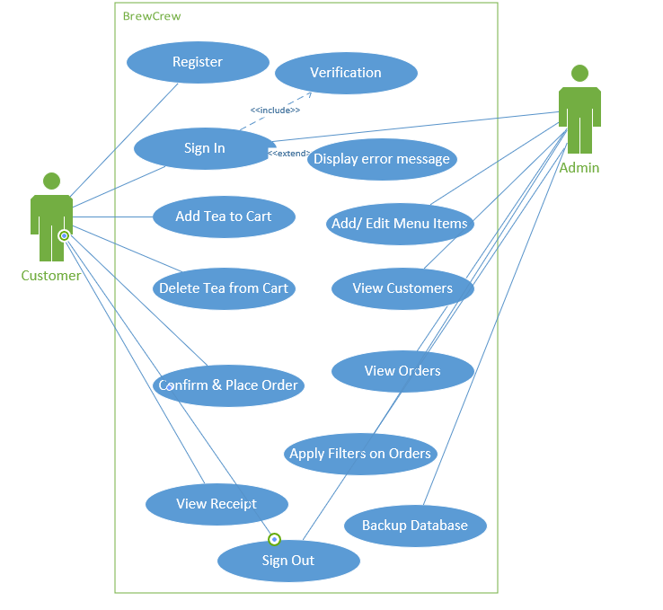

*Figure 1: UML Diagram for BrewCrew*

The processes for each actor in the above diagram match the set of deliverables that were achieved during project development. The functionality of each of the process is explained briefly in Section 5.

# DATABASE MODEL

The following diagram is a database diagram for the application entitled BrewCrew. The database consists of five tables as follows:

* Customer table: This table holds the customer data and is used to match the user credentials when they login to the application. Data entered while signing up with the application is stored here.
* Order table: This table holds the record of all the orders made by a customer. The customer is identified using the customer id, the TotalPrice and Date corresponds to the order total and date of the day the order was placed respectively.
* Drinks table: This table holds all the drinks in the menu of the café with their description, caloric value and price.
* Toppings table: This table holds all the different topping choices that can be added to the drinks.
* OrderDetails table: This table holds the record of all the combination of drinks and toppings with their quantity in various orders.

The relationship among the tables are as follows:

* One or more customers can have zero or more orders.
* One order can have one or more drinks with toppings.

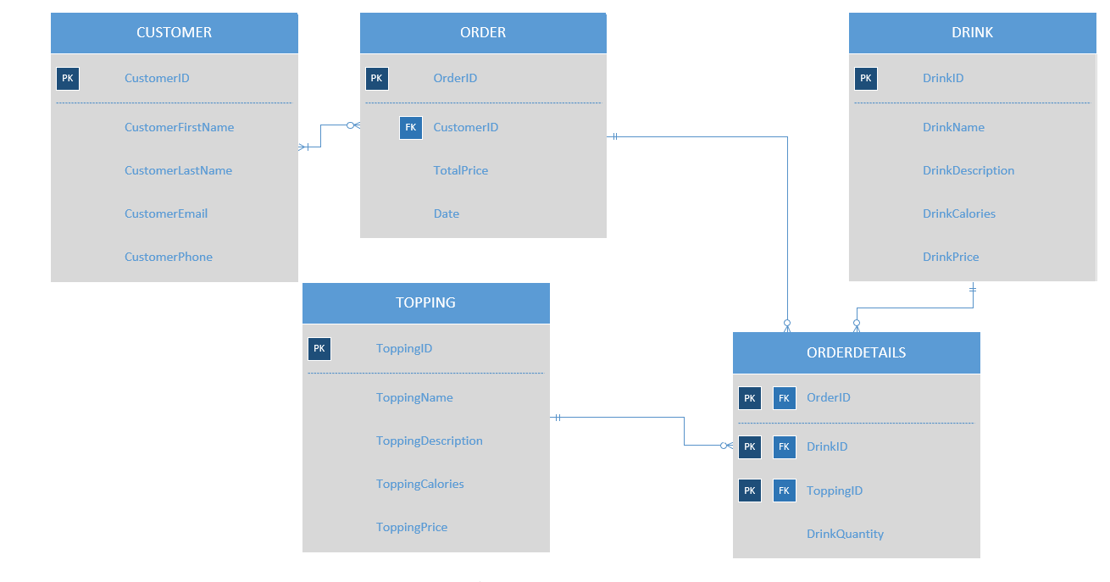

*Figure 2: Database Diagram for BrewCrew Database*

The following diagram is an entity-relationship model for the database of the application BrewCrew.

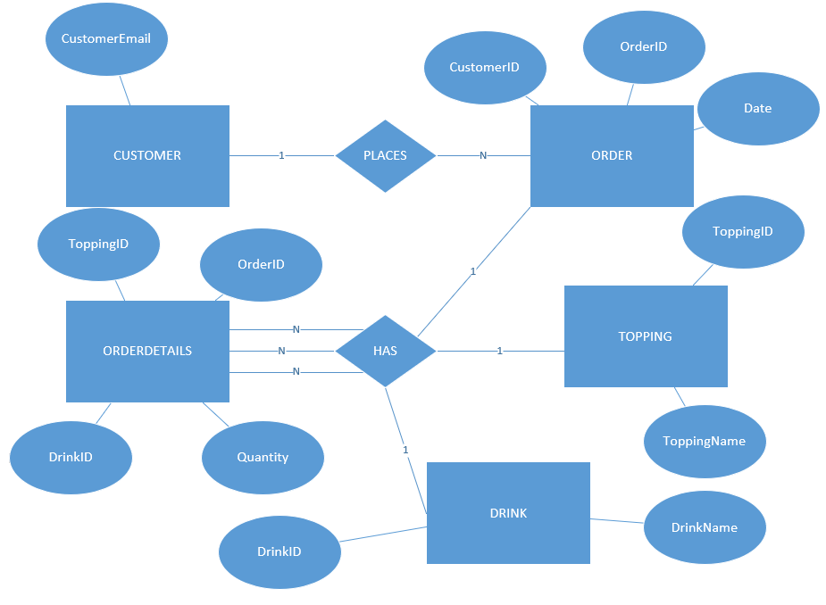

*Figure 3: ER Diagram for BrewCrew Database*

# USER MANUAL

BrewCrew is a virtual bubble tea ordering application. BrewCrew has two major modules, that is, the Admin module and the Customer module. In addition to this, the project also has a sign up/sign in page to log into the BrewCrew system. This manual explains the working of each of the module and acts as a walkthrough for the users of BrewCrew.

**SIGN IN SCREEN**

The application begins with the sign-in page. User email can dictate if the individual is a customer or an admin. There is a Register button leading the customer to the sign-up screen of the application.

The credential for the admin is: [admin@brewcrew.com](mailto:admin@brewcrew.com)

The credential for the user is: [tushit@gmail.com](mailto:tushit@gmail.com)

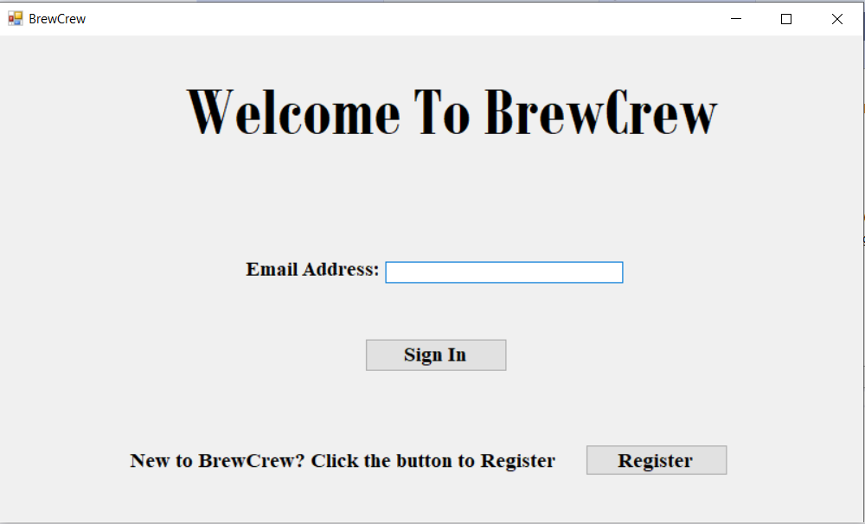

**SIGN IN SCREEN**

Sign up page is a form of four text boxes for customer email, first name, last name, and phone number and a button for submission. When the customer fills up the form and hits the Sign Up button, the data is first validated and then saved into the Customer table in the database. The Sign In form pops up for the newly registered customer to Sign In.

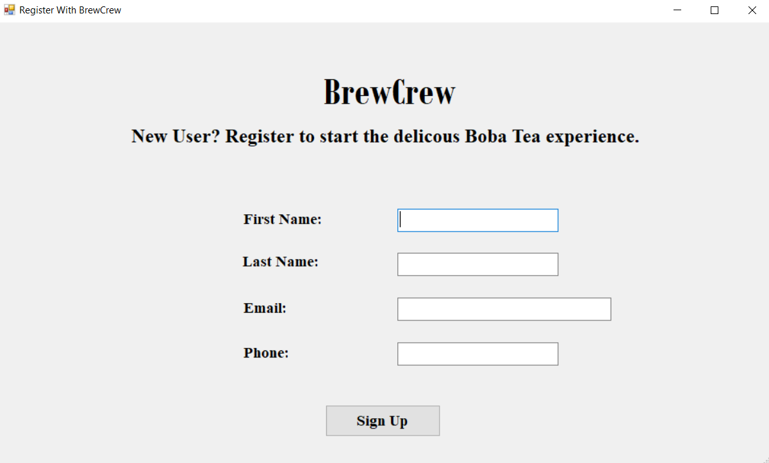

**CUSTOMER MODULE**

**MENU SCREEN**

This screen displays the various drink and topping options available in the menu of BrewCrew. The customer can select one drink with one topping at a time and must enter the combo quantity in order to add it to the order cart. The customer can Sign Out of the application by clicking the Sign Out button and return to the main Sign In screen.

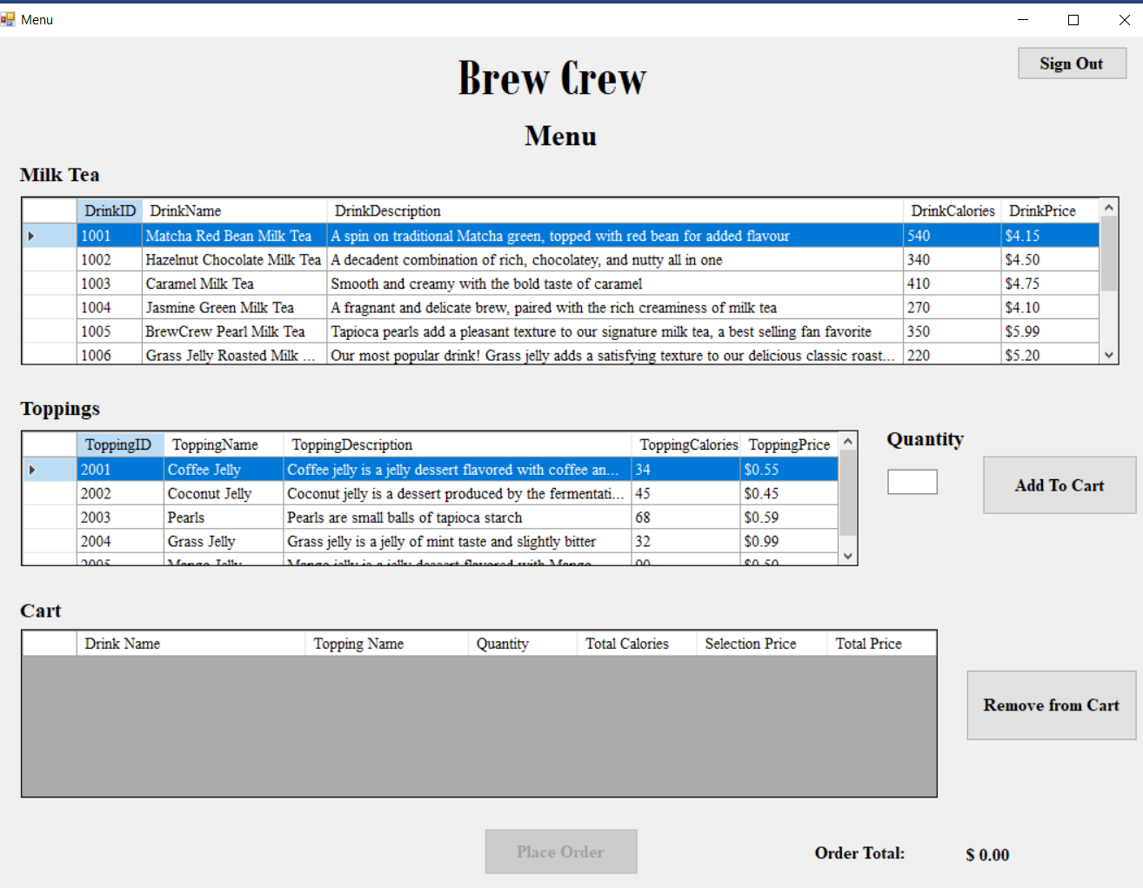

It can be noted, if no selection is made, the customer cannot click on the place order button.

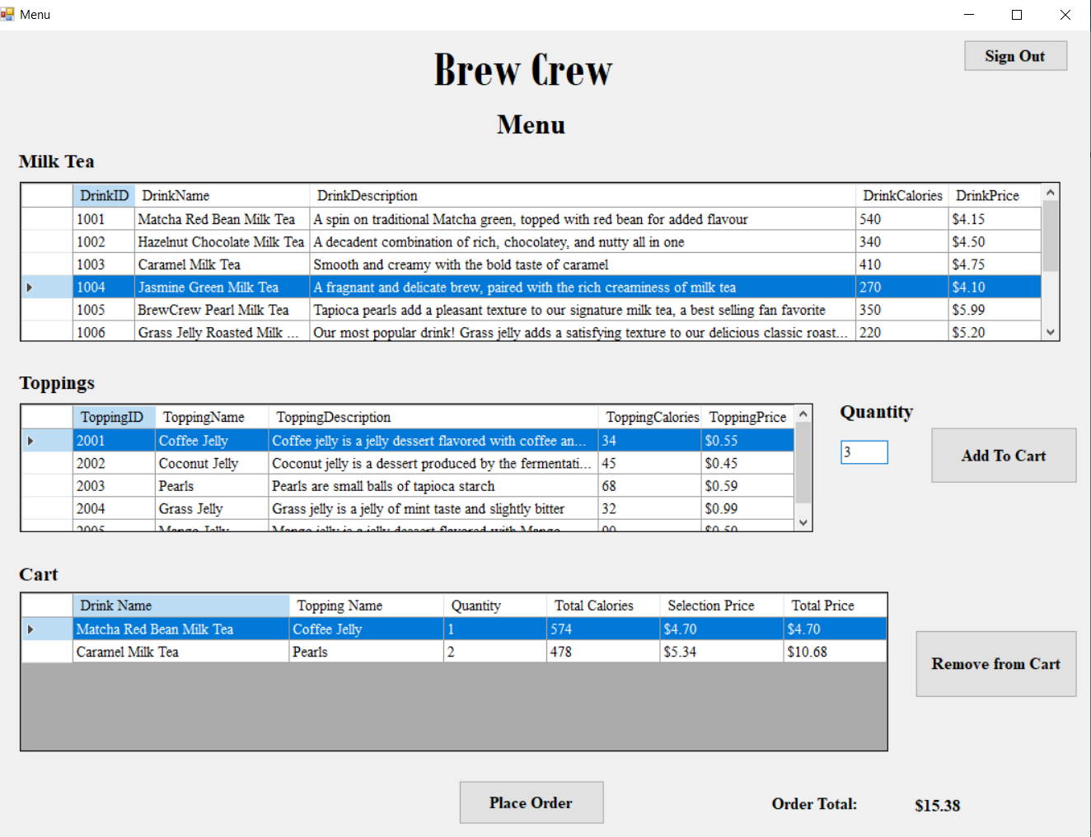

Once a tea combo has been added to the cart, the Place Order button becomes enabled. The order total can be seen at the bottom of the screen. The customer also has the option to remove an item from cart by selecting it and clicking the Remove from Cart button.

The DataGrid view displaying the items in the cart, displays the sum of drink and topping price as the Selection price and the product of selection price and quantity as the Total price.

**ORDER RECEIPT SCREEN**

Once the Place Order button is clicked, data in the cart is saved in the Order and OrderDetails table in the database and the Order Receipt screen pops up. This form displays all the order details, with the order ID, order date and a QR Code for order confirmation at the café.

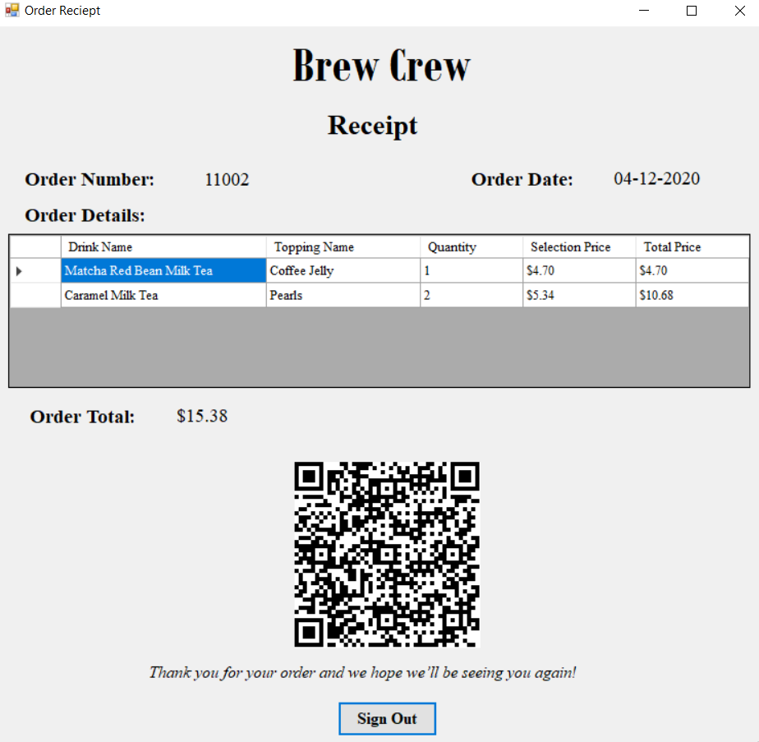

**ADMIN MODULE**

**ADMIN DASHBOARD SCREEN**

When the admin Logs in to the BrewCrew application, this screen appears. On this screen, three DataGrid views can be seen one for each of the drinks, toppings in the menu and one for the customers of the application. The total number of customers can also be seen. The Sign Out button logs the admin out the Admin Dashboard to the Sign In screen. The Backup Database button backs up the database of BrewCrew to an XML file.

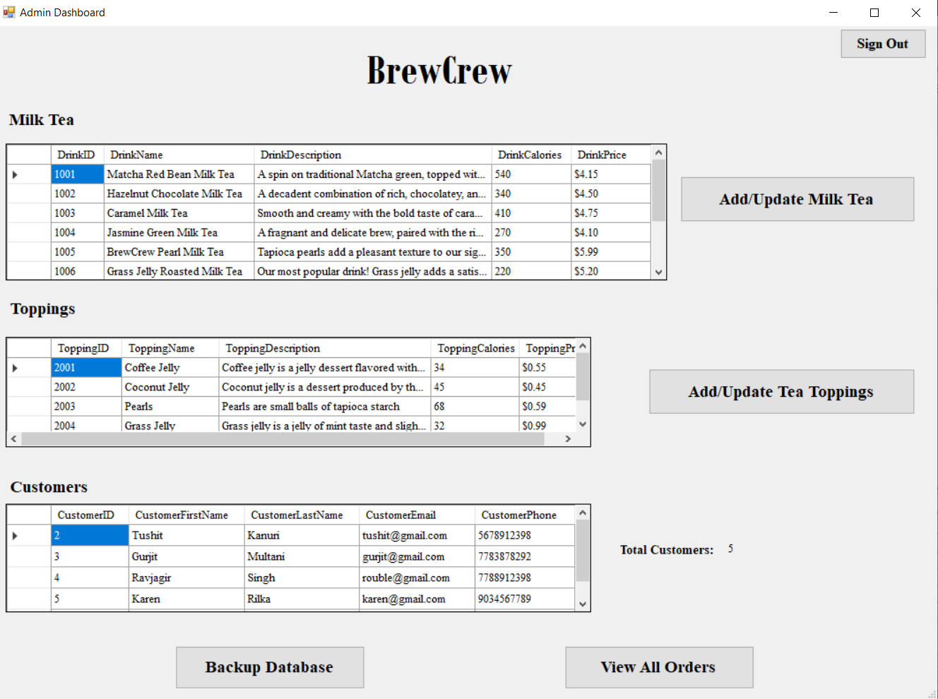

If the Add/ Update Milk Tea button is clicked, a sub form to add/ edit the drinks opens. The admin can select any drink from the list box in the sub form to edit it. To add a new drink, the admin must simply fill the respective textboxes and click on the Add button. To delete a drink/ topping the admin can simply select the drink/ topping from the Admin Dashboard form and press the delete key on the keyboard.

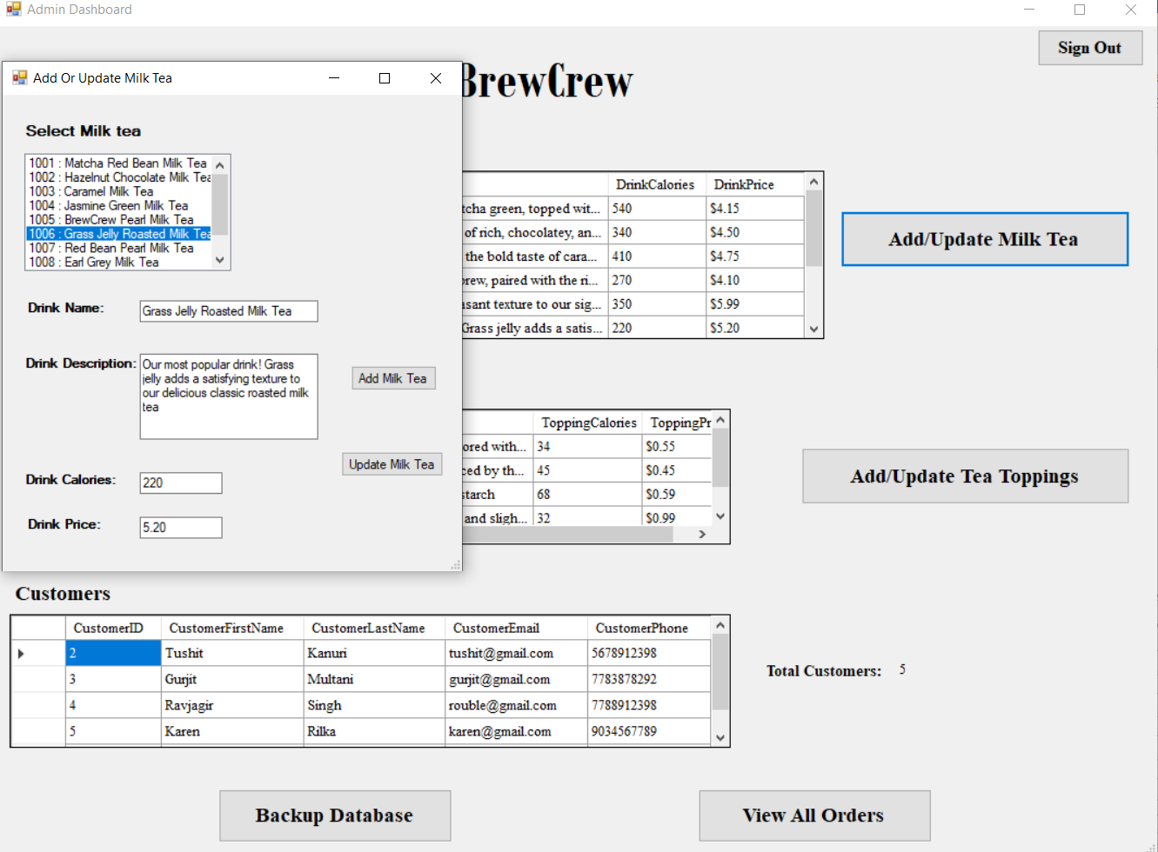

Similarly, to add/ update a drink topping, the admin can click on Add/ Update Tea Toppings button to open the sub form.

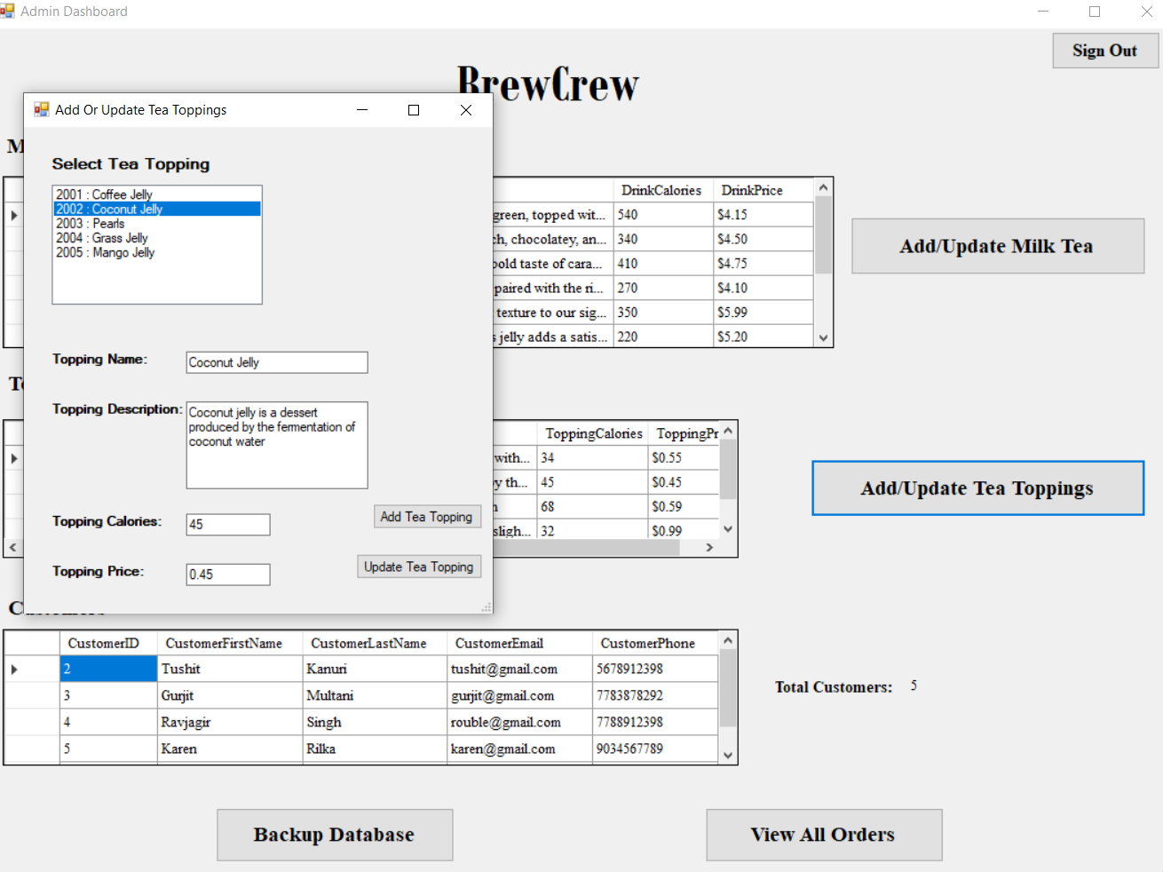

Last, when the admin clicks on the View All Orders button, a sub form opens displaying all the orders made by the customer. The admin can then choose from various filters to filter the order data. The total number of orders and the total profit earned can also be seen. The admin can also filter data based on the date. To display all orders on a date, the admin can select a date from the date time picker and select the Display Data by Date radio button. To display all the orders from a day to today’s date, the admin must select Display Data till Today radio button. To search an order by its Order ID, the admin can enter the ID in the designated textbox, and check the Display Data by Order ID checkbox

The reset button resets all the filters to their original selections.

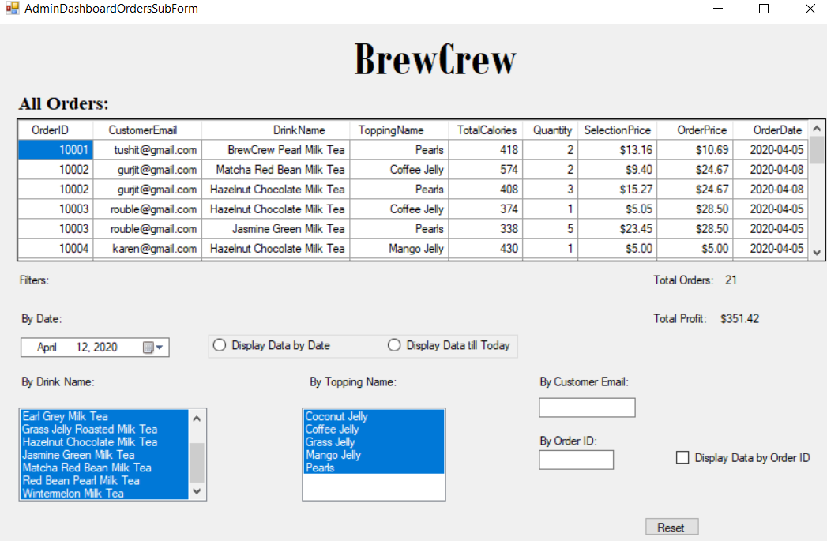

# PROJECT PLAN

The following diagram is a Gantt Chart describing the project schedule.

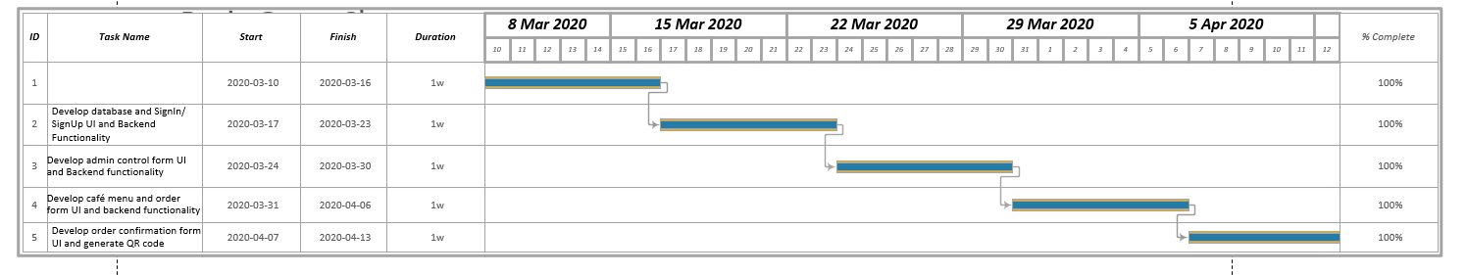

*Figure 4: Gantt Chart for FoodBoard*

By following the Gantt Chart, all the project deliverables were completed on time, resulting in project completion before the submission deadline.

The following table describes the division of tasks among team members:

|  |  |
| --- | --- |
| **Task Name** | **Team Member Name** |
| Database and Entity Framework creation | Tushit Nag Kanuri |
| Reseed file creation | Jasmine Kaur and Tushit Nag Kanuri |
| Sign In/ Sign up page UI and backend functioning | Tushit Nag Kanuri |
| Test Sign In/ Sign up page functioning | Tushit Nag Kanuri |
| Admin dashboard form UI and backend functioning | Jasmine Kaur |
| Test Admin control form | Jasmine Kaur |
| Admin Sub form UI, Backend Development and Testing | Jasmine Kaur |
| Café menu and order form UI and backend functionality | Tushit Nag Kanuri |
| Test café menu and order form functionality | Jasmine Kaur |
| Order confirmation form UI and functionality | Tushit Nag Kanuri |
| QR code generation | Tushit Nag Kanuri |
| Test order confirmation page | Jasmine Kaur |
| Integration and Testing of application | Jasmine Kaur and Tushit Nag Kanuri |
| Reporting | Jasmine Kaur |

*Table 1: Task Division of BrewCrew*

# SUMMARY

The project entitled BrewCrew is an application for a bubble tea café. The application allows the customers to select from a variety of drinks and their toppings and specify the combo quantity to make an order. The customer can add/ delete drink combo from the cart before confirming their order. On confirmation, an order receipt with a QR code is generated for authentication purposes on order collection from the Café. On the other hand, the admin of the application can add/ delete/ edit the menu items as well as view the customer and their order details. The project was completed on time by its development team by following a strict timeline. At the end, the application is a virtual kiosk which would help customers to cut wait time when ordering their favorite tea.