**SSH Assessment**

**Objective:**

* Install and configure SSH for secure remote access.
* Modify settings for enhanced security.
* Establish SSH connections from a client to a server.

**Install SSH Server**

* Installs the OpenSSH server and client packages on the system using yum.
* The -y flag allows automatic installation without prompting for confirmation.

**yum install openssh* -y**

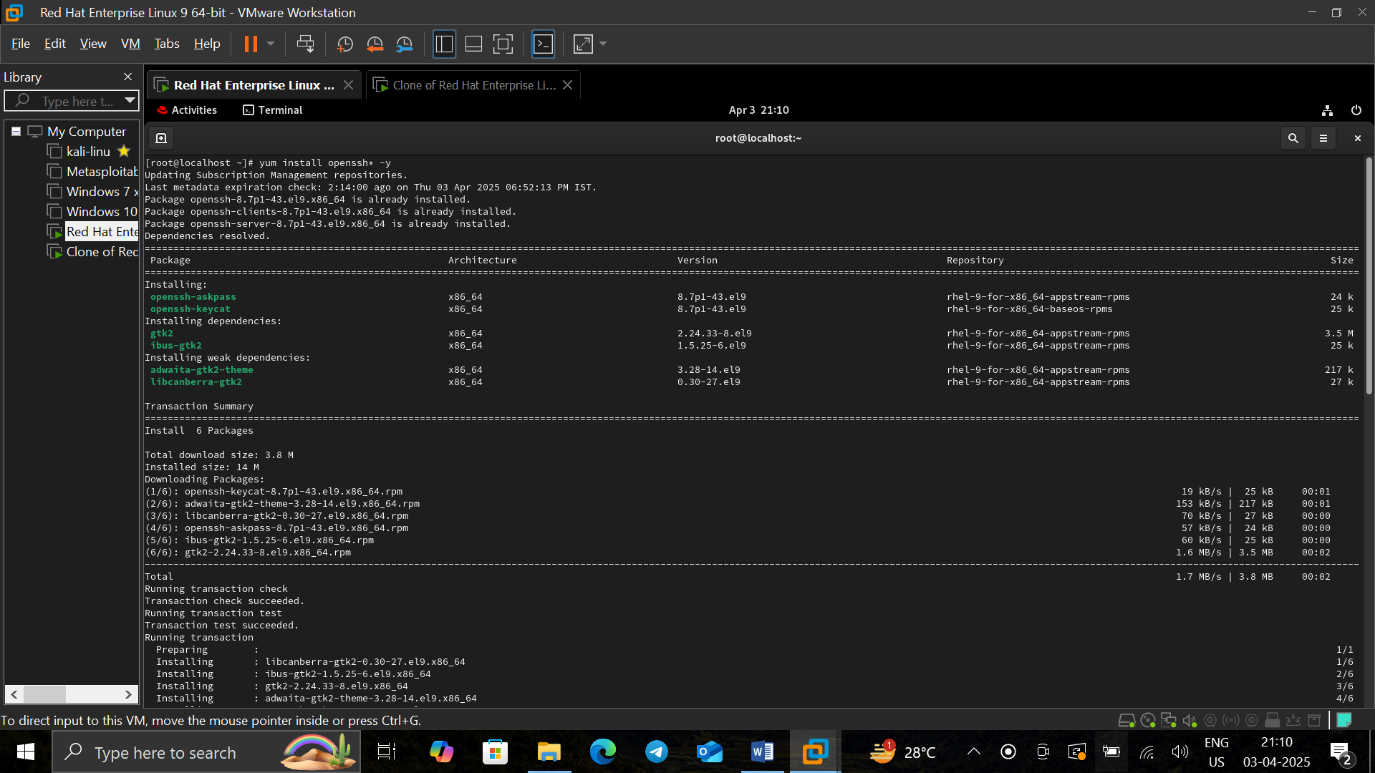

**yum install ssh* -y**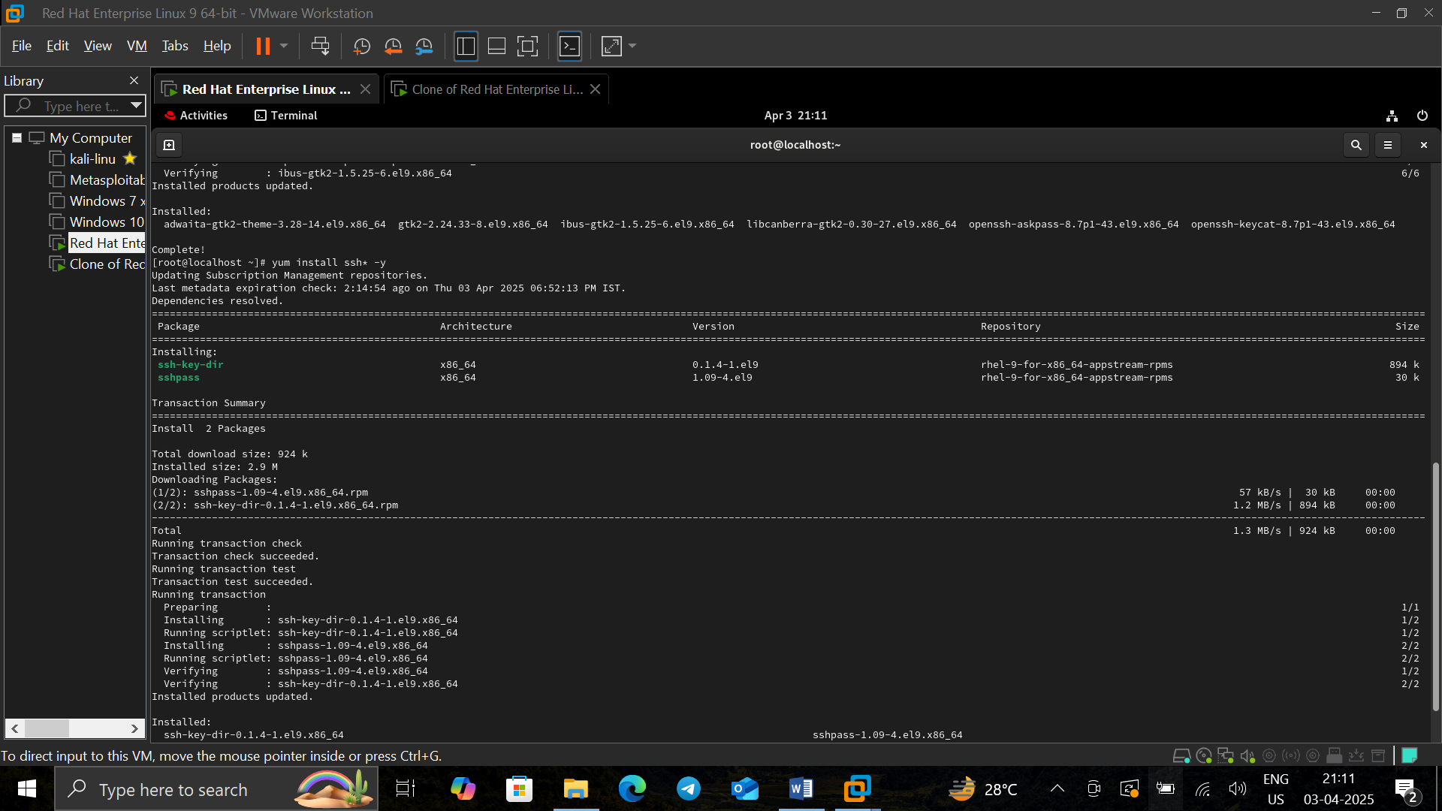

**Modify SSH Configuration**

* Opens the SSH daemon configuration file in vim.
* This allows you to modify settings like port number, authentication methods, and access control.

**vim /etc/ssh/sshd_config**

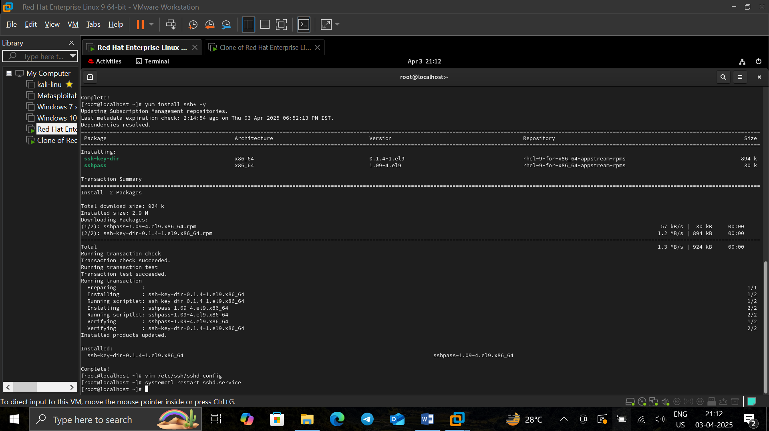

Restart SSH Service

* Restarts the SSH service to apply the configuration changes.

**systemctl restart sshd.service**



**Client**

**Connect to SSH Server (Client-Side)**

* Initiates an SSH connection to the server with IP 192.168.42.134 using the root account.

**ssh root@192.168.42.134**